University of Wales Trinity Saint David

School of Engineering

Pollution Control Report (ACMA 6006)

Nathan Scott Morgan

1902731

2nd December 2022

Abstract
In this report, a risk assessment is conducted to locate potential pollution hazards. Over 40 hazards were identified, and a mitigation strategy was put in place. Most hazards were mitigated to minimal hazards, leaving 6 hazards to make further considerations. Regulations were used to persuade the management team to move to a compliance strategy, listing the benefits vs loses. An estimated cost of equipment and personal protective equipment was calculated.

Table of Contents
1 Abstract ii
2 Introduction 1
2.1 Aims 1
2.2 Objectives 1
3 Literature Review 2
3.1 Control of Noise at Work Regulation 2005 2
3.1.1 Employers Legal Duty 2
3.1.2 Exposure Limits 2
3.2 Control of Substances Hazardous to Health Regulations 2002 2
3.2.1 Employers Legal Duty 3
3.3 The Environmental Permitting (England and Wales) Regulations 2016 4
3.3.1 Enforcement Notice 4
3.3.2 Suspension Notice 4
3.3.3 Failure to Comply 4
4 Methodology 5
4.1 Hierarchy of Control 5
4.2 Risk Assessments 5
4.2.1 RAMP 5
4.2.2 HSE Risk Assessment 5
4.2.3 Risk Assessment Used 6
4.3 Cost Tier List 7
5 Results 8
6 Discussion – Mitigation Strategy 16
6.1 Spray Equipment Noise Pollution 16
6.2 Spray Tool Vibration 16
6.3 Chrome plating (Chromic Acid) 17
6.4 Breathing Grinding Fumes and Hot Matter 17
6.5 Breathing Welding Fumes 18
6.6 Chemically Contaminated Scattered Booths 19
6.7 Heavy Machinery Noise in Residential Area 19
6.8 Breathing Galvanising Chemicals 19
6.9 Ingestion of Galvanizing Chemicals 20
6.10 Cost of Compliance 21
6.10.1 Estimated Costs 21
6.10.2 Cost of Compliance vs Non-Compliance 21
7 Conclusion 22
8 References 23

Figure 1- Marking Changing Dates by UK.GOV 2
Figure 2 - Legal Duties for Employer by HSE 3
Figure 3 - Hierarchy of Control by NIOSH 5
Figure 4 - HSE Risk Assessment Template 6
Figure 5 - Risk Rating 6
Figure 6 - Risk Assessment Template Used 7
Figure 7 - Risk Assessment (1) 8
Figure 8 - Risk Assessment (2) 8
Figure 9 - Risk Assessment (3) 8
Figure 10 - Risk Assessment (4) 9
Figure 11 - Risk Assessment (5) 9
Figure 12 - Risk Assessment (6) 9
Figure 13 - Risk Assessment (7) 10
Figure 14 - Risk Assessment (8) 10
Figure 15 - Risk Assessment (9) 11
Figure 16 - Risk Assessment (10) 11
Figure 17 - Risk Assessment (11) 12
Figure 18 - Risk Assessment (12) 12
Figure 19 - Risk Assessment (13) 13
Figure 20 - Risk Assessment (14) 13
Figure 21 - Risk Assessment (15) 13
Figure 22 - Risk Assessment (16) 14
Figure 23 - Risk Assessment (17) 14
Figure 24 - Risk Assessment (18) 15
Figure 25 - Risk Assessment (19) 15

Introduction
Engineers and organisations must not only “be alert to the ways in which their work and behaviour might affect others” but also “protect, and where possible improve, the quality of build and natural environments” (Royal Academy of Engineering and the Engineering Council, 2005). Risk assessments prove to be a fundamental component to protecting others and the environment that sustains life. Without it, there would only be harm to others and the environment.
The “London matchgirls’ strike” (Isaac, 2018)is a classic example of the lack of risk assessment and mitigation withing the matchmaking industry. The lack of any safeguards led a disease called “Phosphorus Necrosis of The Jaw (J. P. W. Hughes, 1962)” also widely known as “Phossy Jaw”. Corporate greed led to the deaths of hundreds of women working 8 hours a day, 6 days a week over several years. All because the inclusion of - “white phosphorous (ACS, 2020)” made igniting a match easier.

Aims
This report sets out the following overall outcomes to be achieved as follows:
- Instruct the management team on how to integrate the mitigation strategy.
- Justify the need for cost of compliance
- Regain reputation and trust from stakeholders (Residents, Local Economy, and Environment)

Objectives
I have identified the following objectives for this report, related to the potential pollution risks that might be encountered during manufacturing, coating and spraying metal component operations.
- Produce a risk assessment highlighting all potential pollution risks that might be encountered.
- Produce a mitigation strategy for all high pollution risks.
- Identify appropriate pollution control equipment with estimated costs.
- Complete a review into regulations and legislation surrounding the risks involved.

Literature Review

Control of Noise at Work Regulation 2005
The law requires employers to “eliminate or reduce risks to health and safety from noise pollution at work” (Health and Safety Executive, 2011/2012).
Noise at work can cause permanent or temporary impaired hearing such as hearing loss, partial hearing loss or “tinnitus” (National Institute on Deafness and Other Communications Disorders, 2014), which can lead to other impacts such as interference in communication, lack of awareness to surroundings, and make warnings such as fire alarms or shouting harder to hear. These impairments can cause significant decline in quality of life for the injured person and connected families.

Employers Legal Duty
Legal duties include complying with exposure limits (Exposure Limits), maintaining equipment or personal hearing protection that the employer has provided, compliance with “Provision and Use of Work Equipment Regulations 1998 (Health and Safety Executive, 2014)” and “The Supply of Machinery (Safety) Regulation 2008 (UK Government, 2008)” which states that equipment provided should be “UKCA or CE (alternatively until 31 December 2024) affixed (Office for Product Safety & Standards, 2022)”.
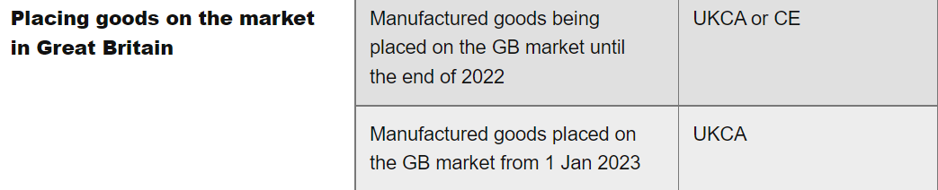
Figure 1- Marking Changing Dates by UK.GOV

Exposure Limits
If the employee is using personal hearing protection, noise must not exceed:
- 87 decibels for daily or weekly personal noise exposure
- 140 decibels for peak sound pressure

Control of Substances Hazardous to Health Regulations 2002
“COSHH applies to a wide range of substances and preparations (mixtures of two or more substances) which have the potential to cause harm to health if they are ingested, inhaled, or are absorbed by, or come into contact with, the skin, eyes, or other body membranes” (Health and Safety Executive, 2013)
Hazardous Substances can cause prolonged impairments such as cancer or inherited genetic damage. Hazardous substances can cause fatalities, which have the potential to be passed on to a third party (e.g., Family and Friends).

Employers Legal Duty
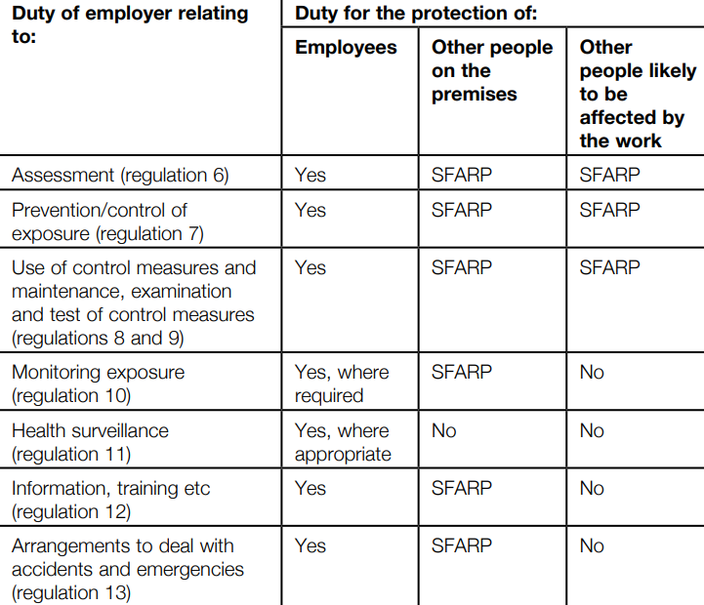
Figure 2 - Legal Duties for Employer by HSE
“Every employer shall ensure that the exposure of his employees to substances hazardous to health is either prevented or, where this is not reasonably practicable, adequately controlled” (Health and Safety Executive, 2013). Employers should explore every option in ways to prevent hazardous substances, through means of removing, replacing the risk or changing process. In cases where prevention is not reasonable, “The employer shall then comply with his/her duty of control” (Health and Safety Executive, 2013).
Chrome plating, also known as electroplating, is a process that involves applying a thin layer of chromium to a metal surface to improve its appearance, corrosion resistance and other properties. Chromic acid is commonly diluted with water to form an electrolyte solution that is used to electroplate a thin layer of chromium on a metal surface. Chromic acid is highly corrosive.
For chromic acid “the current biological monitoring guidance value (BMGV) of 10 μmol/mol creatinine is appropriate” (Chris Keen MFOH, 2013) over an 8-hour shift. This would be within workplace exposure limits between 0.01mg.m^-3 – 0.025mg.m^-3.
Biological monitoring through urine samples should be conducted to assess exposure levels in operators.

The Environmental Permitting (England and Wales) Regulations 2016

Enforcement Notice
If a company has breached regulations, Natural Resources Wales (Regulator) may issue an enforcement notice. An enforcement notice is a declaration to the company that they are breaching regulation and must align to industry standards. If the company isn’t compliant, then Natural Resources Wales have the authority to issue a suspension notice.

Suspension Notice
Suspension notices can be served if the regulator considers the “risk of detrimental impact on drainage” and “risk of harm to the environment” (UK Statutory Instruments, 2016) such as pollution. A suspension notice would temporarily terminate an environmental permit. Having a massive effect on the company net income.

Failure to Comply
Failure to comply with an enforcement and suspension notice is an offence “under regulation 61 without reasonable excuse” (UK Statutory Instrument, 2016). Punishable by penalties.
A penalty can led to a fine or imprisonment. Summary conviction can lead to a fine or imprisonment for 12 months maximum, or both. Indictment can lead to a fine or imprisonment for 5 years, or both.

Methodology

Hierarchy of Control
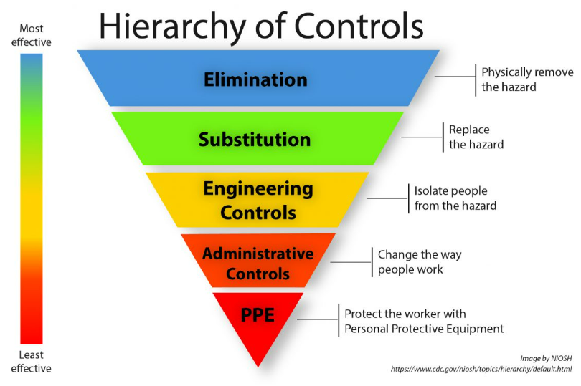
Figure 3 - Hierarchy of Control by NIOSH
The ‘Hierarchy of Control’ (Figure 3) is the most effective way of eliminated or controlling risk. Elimination remains the best form of prevention of risk, whereas PPE remains the last option as protection against human error.

Risk Assessments

RAMP
Risk assessments come in different forms such as risk assessments catered towards project management such as the ‘RAMP’ model which “emphasis on strategic and financial aspects” (The Institution of Civil Engineers and the Institute and Faculty of Actuaries, 2014). However, this provides a method to quantitively and qualitatively measure risk.

HSE Risk Assessment
Health and Safety Executive provide a simple but effective template (Figure 4), which highlight the risks involved and what action has been taken. However, further information is needed in order to evaluate qualitatively the level of risk involved in each activity.
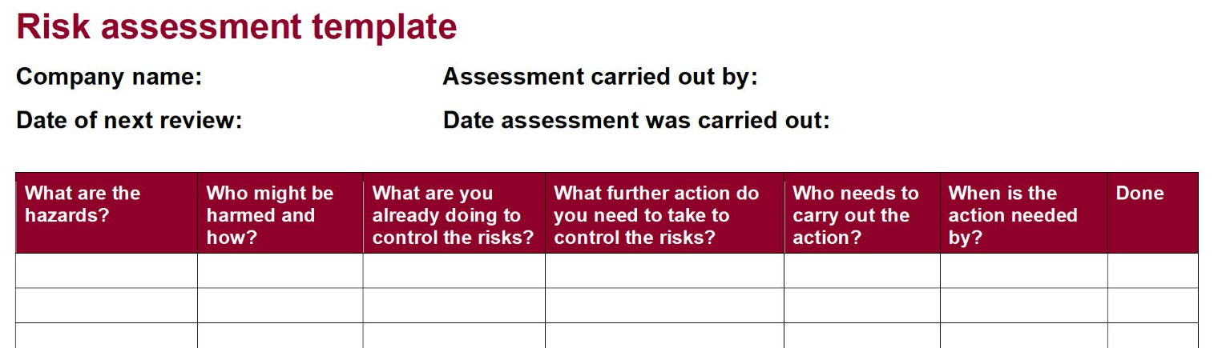
Figure 4 - HSE Risk Assessment Template

Risk Assessment Used
The risk assessment model used in this report, comprises of three elements.
- Listing the hazard, potential harm, risk rating before mitigation, mitigation, residual risk rating.
- Estimating the risk rating from the probability of occurrence and severity of incident (Figure 5)
- Hierarchy of Control (Figure 3)
All three elements provide a description of the level of risk involved in each hazard. Therefore, allowing the risk management to take appropriate action.

Estimating Probability of Occurrence and Severity of Incident
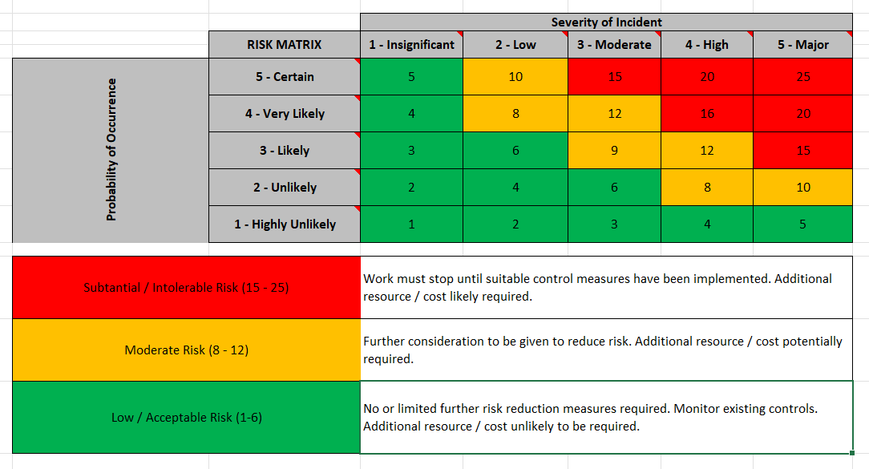
Figure 5 - Risk Rating

Risk Assessment Template Used
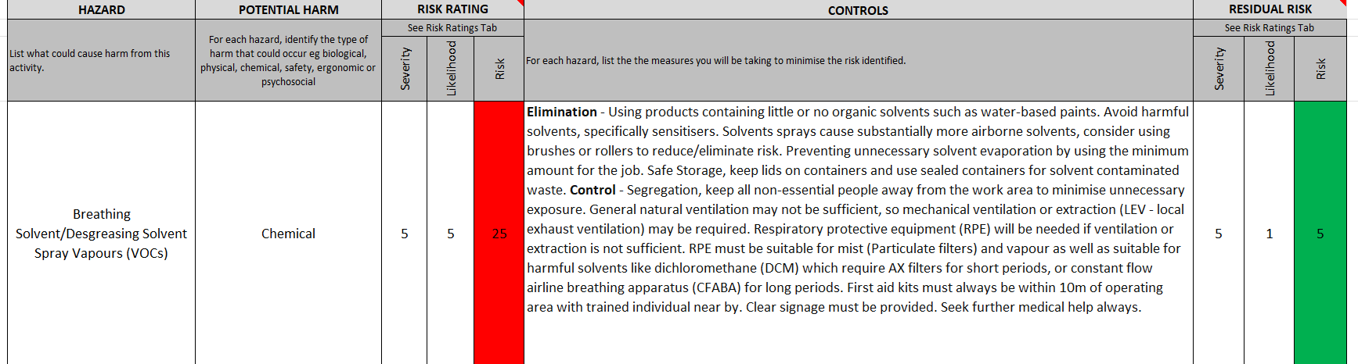
Figure 6 - Risk Assessment Template Used
The risk assessment used in this report combines all three elements. Showing the hazard, potential risk, current risk involved (Figure 5). Then mitigation (Figure 3), and adjusted risk involved (Figure 5).

Cost Tier List
Table 1 - Cost Tier List
Tier 1 | £1,000 - £25,000
Tier 2 | £25,000 - £100,000
Tier 3 | £100,000 - £500,000
Tier 4 | £500,000 - £2,500,000
Tier 5 | £2,500,000 - £5,000,000

Results
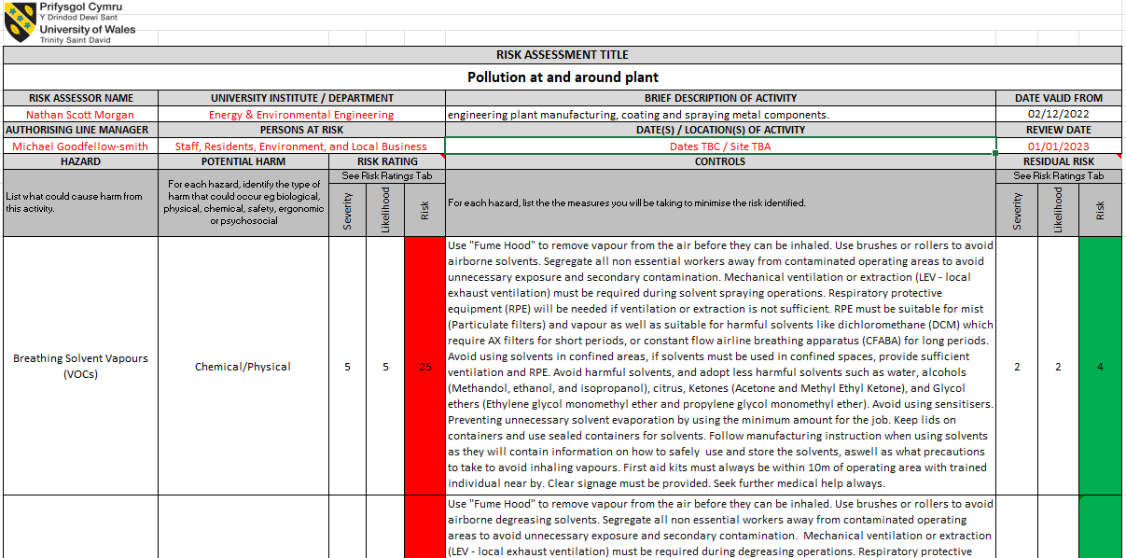
Figure 7 - Risk Assessment (1)
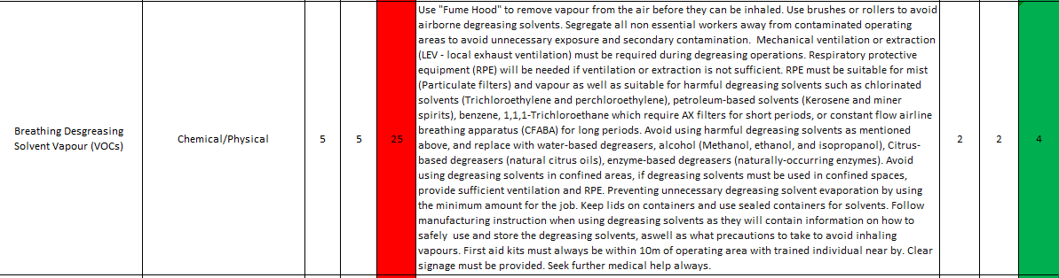
Figure 8 - Risk Assessment (2)
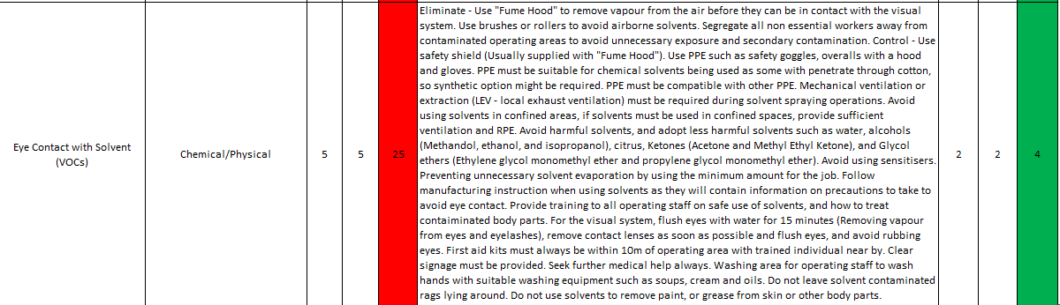
Figure 9 - Risk Assessment (3)
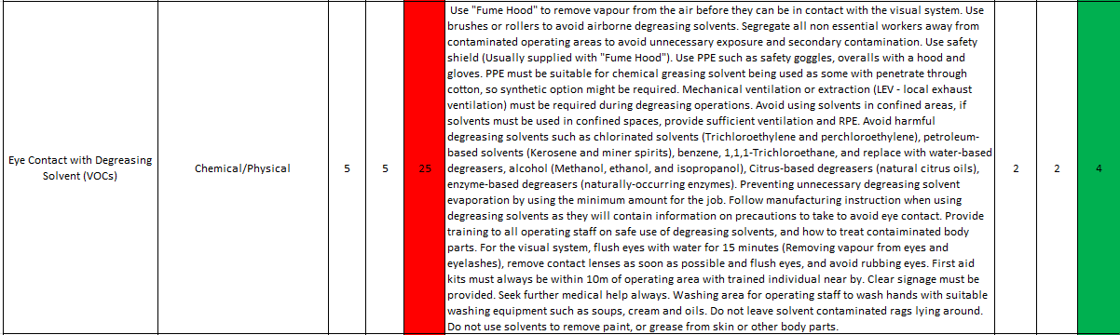
Figure 10 - Risk Assessment (4)
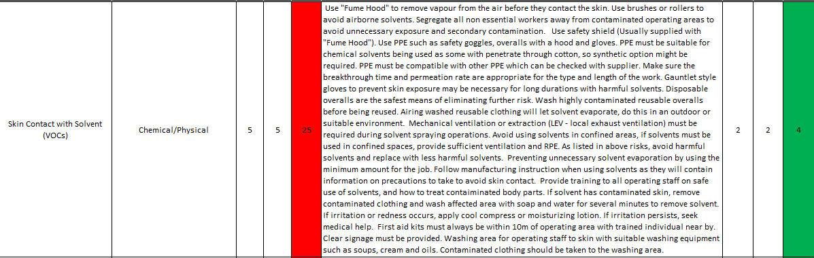
Figure 11 - Risk Assessment (5)
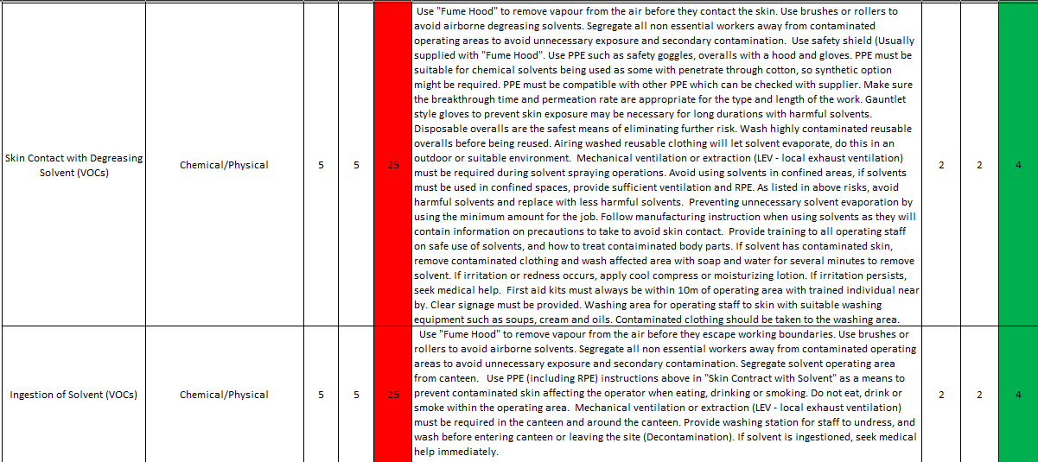
Figure 12 - Risk Assessment (6)
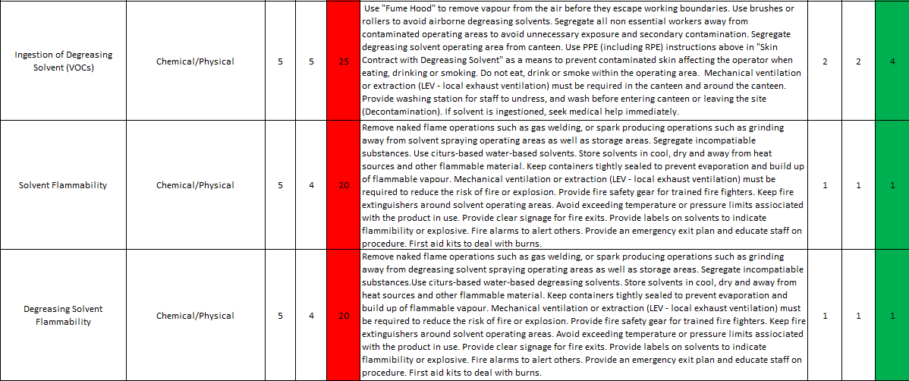
Figure 13 - Risk Assessment (7)
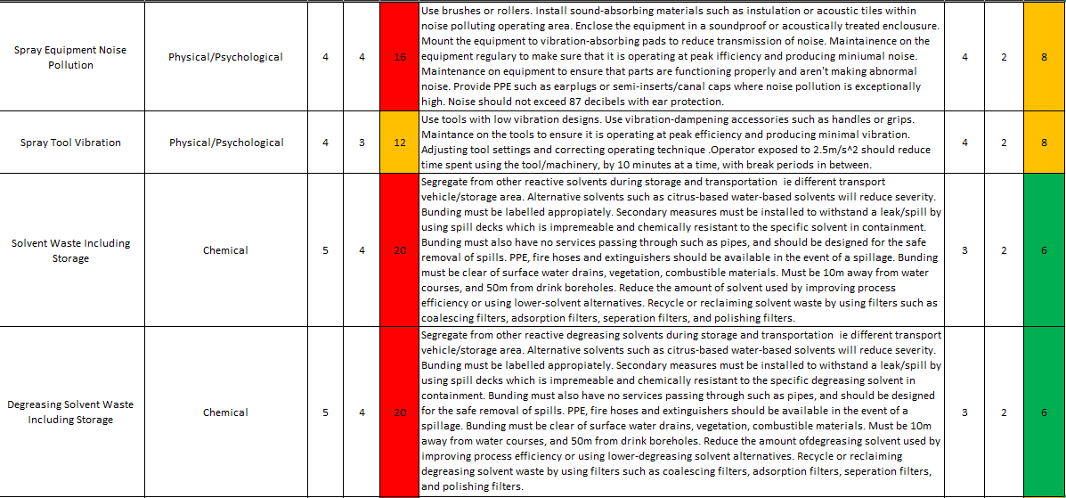
Figure 14 - Risk Assessment (8)
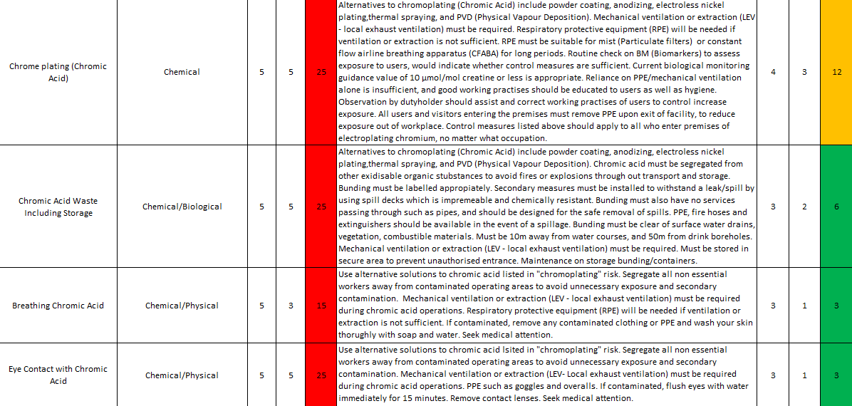
Figure 15 - Risk Assessment (9)
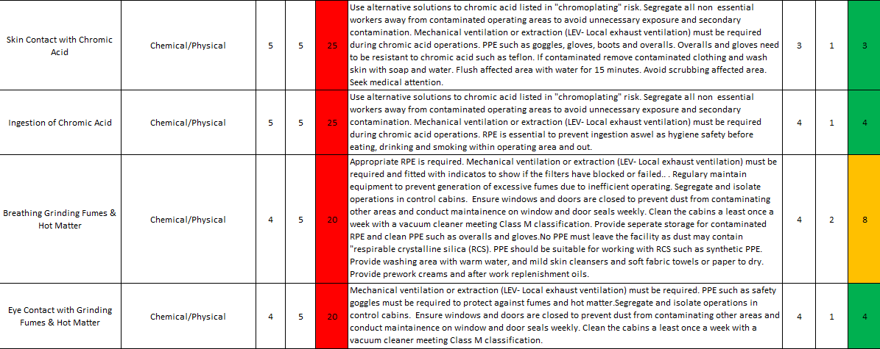
Figure 16 - Risk Assessment (10)
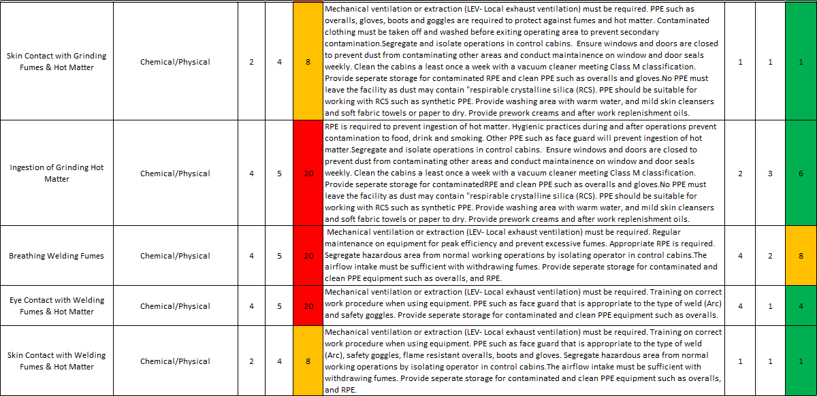
Figure 17 - Risk Assessment (11)
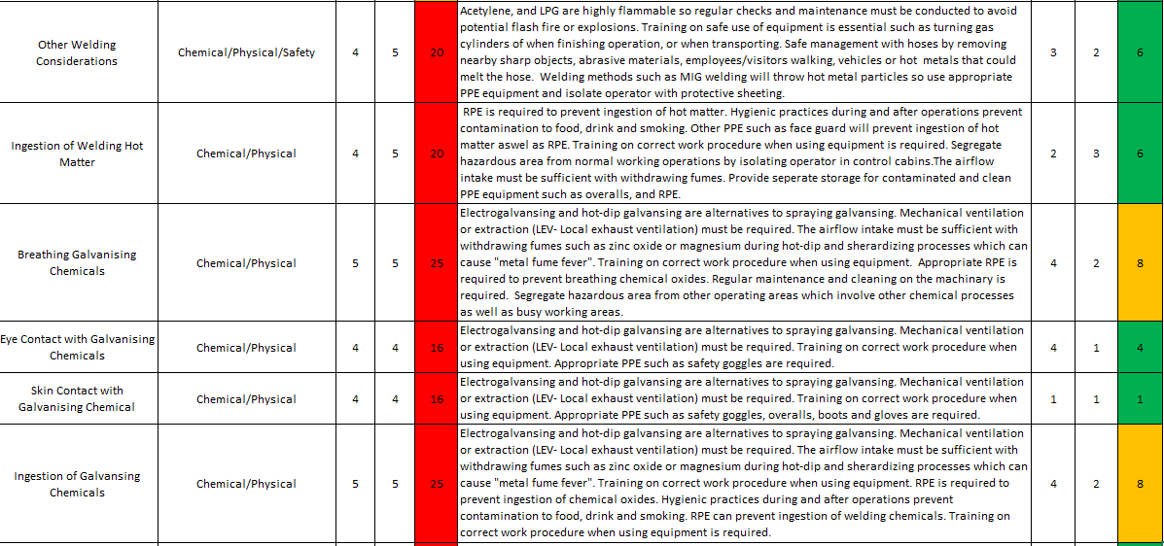
Figure 18 - Risk Assessment (12)
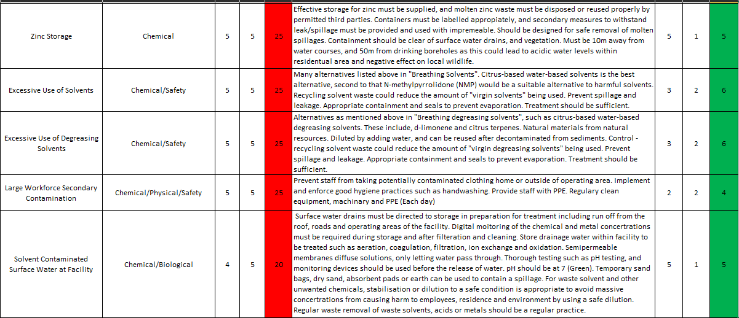
Figure 19 - Risk Assessment (13)
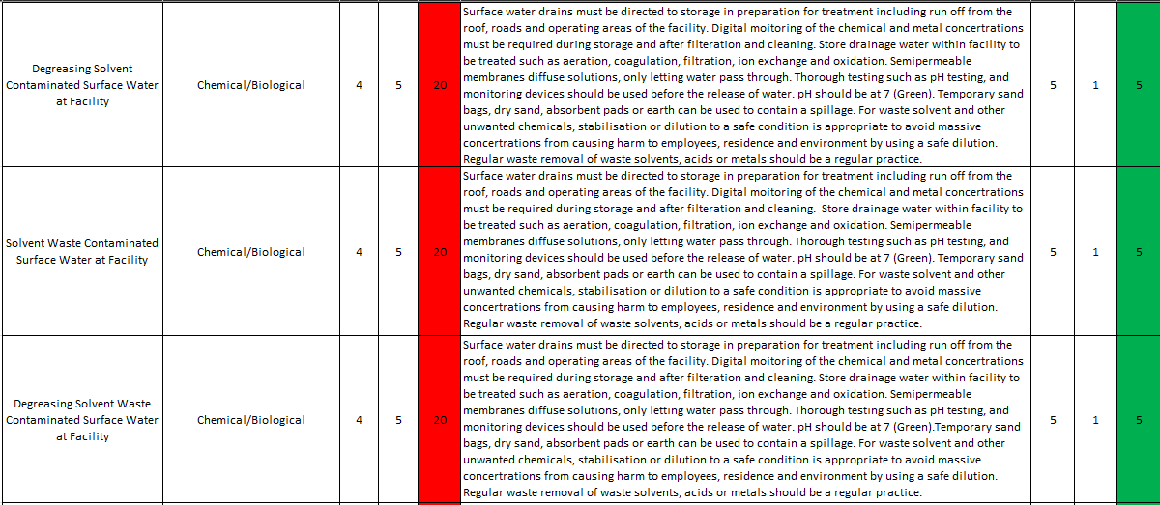
Figure 20 - Risk Assessment (14)
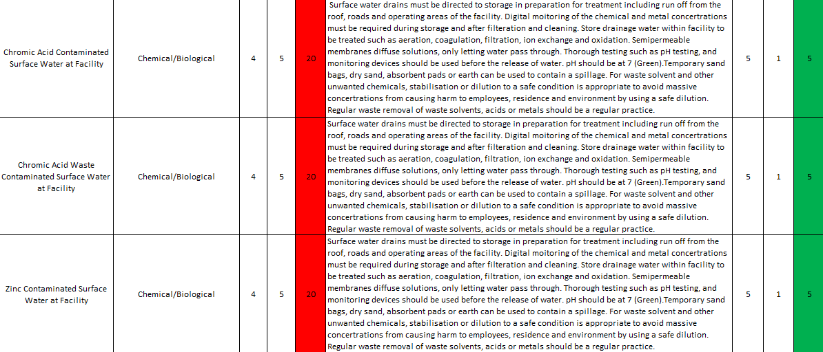
Figure 21 - Risk Assessment (15)
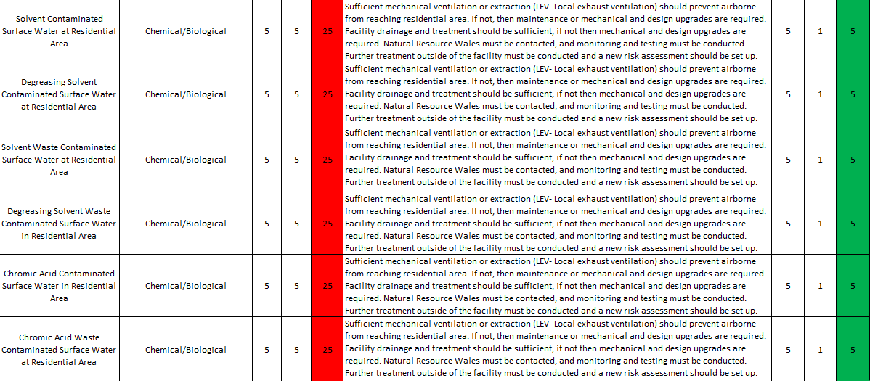
Figure 22 - Risk Assessment (16)
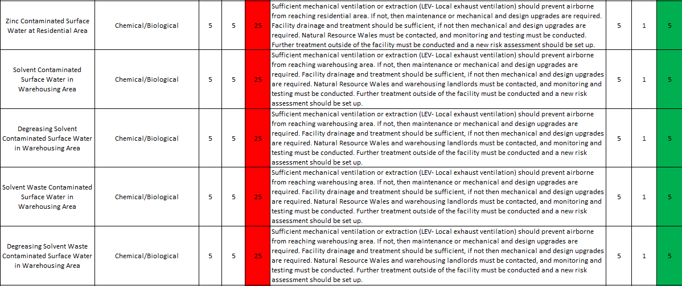
Figure 23 - Risk Assessment (17)
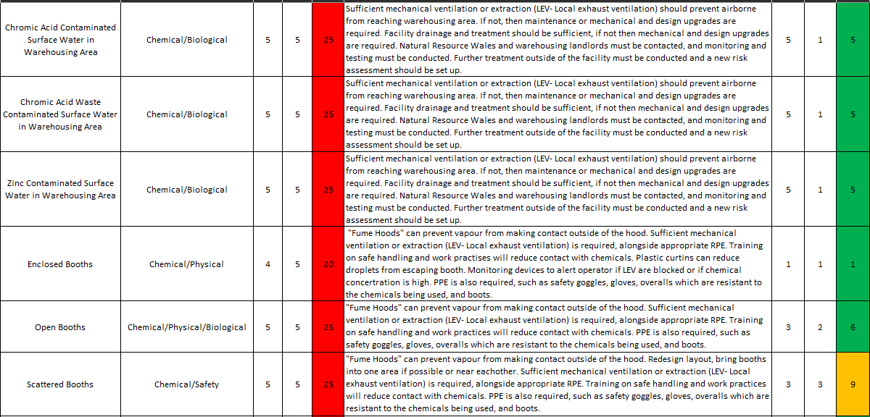
Figure 24 - Risk Assessment (18)
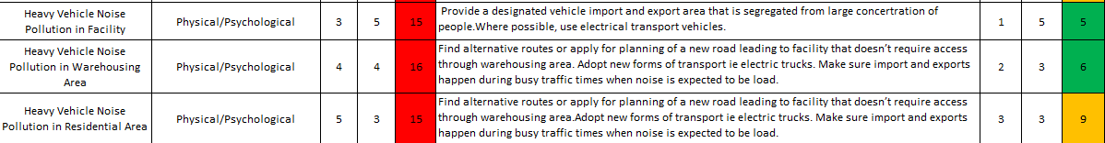
Figure 25 - Risk Assessment (19)

Discussion – Mitigation Strategy

Spray Equipment Noise Pollution
Hazard Description: Exposure to high levels of noise from spray equipment can have a range of adverse effects on health and well-being. Exposure can have a risk to productivity and product accuracy, leading to higher costs.
List of mitigation suggestions can be viewed in the risk assessment (Figure 14)
Risk Rating – Orange (8)
Elimination – Using brushes or rollers to apply solvents, degreasing solvents or metal components.
Engineering Control – Using quieter spray equipment accessories such as mufflers or sound-absorbing materials. Install sound-absorbing such as installation, acoustic tiles, or drywall with coating (Totunov & Ivanov, 2020) withing operating area. Enclose the equipment in soundproof or acoustically treated enclosure. Mount the equipment to vibration-absorbing pads to reduce transmission of noise.
Administrative Control – Train operator on how to handle and direct equipment to reduce noise pollution.
PPE – Personal protective equipment should be required for all operators and staff or visitors entering area with exposure to high levels of noise. PPE include the following: earplugs or semi-insert/canal caps.

Spray Tool Vibration
Hazard Description: Vibration from tools can have a number of negative effects, such as causing discomfort, fatigue, or injury to the operator, and reducing the accuracy, precision or effectiveness of the tool. Vibration from tools can also cause damage to the tool itself, or to the workpiece, and can create additional noise or other forms of pollution.
List of mitigation suggestions can be viewed in the risk assessment (Figure 14)
Risk Rating – Orange (8)
Eliminate - Using brushes or rollers to apply solvents, degreasing solvents or metal components.
Engineering Controls – Using tools with low vibration designs. Using vibration-dampening accessories such as handles or grips. Adjusting tool settings to operate at lower speeds. Mount the equipment to vibration-absorbing pads to reduce vibrations.
Administrative Controls – Maintenance on the tools to ensure it is operating at peak efficiency and producing minimal vibration. Train operator on how to handle the equipment safely and effectively, to reduce time spent on equipment. Operator exposed to 2.5m/s^2 (exposure action value also known as EAV) daily, should reduce time spent using the tool, by taking breaks every 10-15 minutes. Operator exposed to 5m/s^2 (exposure limit value also known as ELV) daily, should stop operating the device immediately (Health and Safety Executive, 2011/2012). These figures are provided under the Control of Vibration at Work Regulations 2005 (UK Statutory Instrument, 2005).
PPE – “Velcro finger adapted” (Hamouda, et al., 2018) gloves can be used to reduce vibrations while maintaining a reliable grip.

Chrome plating (Chromic Acid)
Hazard Description: Chrome plating poses a risk to the environment and human health, such as exposure to toxic chemicals, pollution, and occupational hazards.
List of mitigation suggestions can be viewed in the risk assessment (Figure 15)
Risk Rating – Orange (12)
Substitute – Switch to the anodizing process. For the electrolyte solution, use a buffer solution which uses an acid and a base or a weak acid and a salt of the weak acid to maintain a constant pH. Saline solution can also be used for the electrolyte solution which contains a mixture of sodium and chloride ions.
Engineering Controls – Mechanical ventilation or extraction (LEV -local exhaust ventilation) must be required.
Administrative Control – Training operators on effective working practises is required. Observation by the duty holder should assist and correct working practises to reduce the exposure to operators.
PPE - Respiratory protective equipment (RPE) or air-purifying respirators (APR) will be required if ventilation or extraction is not sufficient for the levels of chemical vapour. RPE such as constant flow airline breathing apparatus (CFABA) should be used for long durations. This will apply to visitors entering the premises.

Breathing Grinding Fumes and Hot Matter
Hazard Description: Grinding poses a serious health hazard, as the grinding fumes and hot matter can contain a variety of harmful substances, such as metal particles, abrasive dust, chemical, and other toxic substances.
List of mitigation suggestions can be viewed in the risk assessment (Figure 16)
Risk Rating – Orange (8)
Substitute – milling, turning, planing, and sanding are all substitutes. Sanding is the safest process alternative to grinding.
Engineering Control – Mechanical ventilation or extraction (LEV- Local exhaust ventilation) is required (Health and Safety Executive, 2016) and to be fitted with indicators to show if the filters have blocked or failed. Isolate operations in control cabins.
Administrative Control – Regular maintenance to prevent generation of excessive fumes due to inefficient operating conditions. Ensure windows and doors are closed to prevent dust from contaminating other areas and conduct maintenance on window and door seals regularly. Clean the cabins at least once a week with a vacuum cleaner, Class M classification. Train operators on hygiene, such as storing contaminated PPE and RPE in a washroom within operation premises, and washing area with warm water, mild skin cleansers, and soft fabric towels. Provide prework creams and after work replenishment oils. Training operators on effective working practises is required. Observation by the duty holder should assist and correct working practises to reduce the exposure to operators.
PPE – RPE is required to prevent metallic fumes and hot matter from entering airway. Head guard is required to prevent hot matter from approaching operators face.

Breathing Welding Fumes
Hazard Description: Breathing in welding fumes can cause a range of health effects, depending on the specific substances that are present in the fumes and the duration and intensity of the exposure (Health and Safety Executive, 2012).
List of mitigation suggestions can be viewed in the risk assessment (Figure 17)
Risk Rating – Orange (8)
Substitute – Brazing as an alternative is reliable and causes less harm to the environment and operators.
Engineering Control – Mechanical ventilation or extraction (LEV- Local exhaust ventilation) is required and to be fitted with indicators to show if the filters have blocked or failed. The airflow intake must be sufficient with withdrawing fumes. Isolate operators in control cabins.
Administrative Control – Regular maintenance on equipment for peak efficiency and prevent excessive fumes. Appropriate RPE is required.
PPE – RPE is required to prevent metallic fumes and hot matter from entering airway. Head guard is required to prevent hot matter from approaching operators face.

Chemically Contaminated Scattered Booths
Hazard Description: Scattered booths can create several problems, such as reducing productivity, efficiency, and communication amount workers, and increasing the risk of accidents, injuries, and other hazards such as the spreading harmful chemicals.
List of mitigation suggestions can be viewed in the risk assessment (Figure 24)
Risk Rating – Orange (9)
Eliminate – Modular layout of booths. “Fume hoods” prevent vapour from chemicals escaping.
Substitute – Use citrus-based water-based solvents.
Engineering Control - Sufficient mechanical ventilation or extraction (LEV- Local exhaust ventilation) is required, alongside appropriate RPE.
Administrative Controls – Training on safe handling and good work practices will reduce contact with chemicals.
PPE – Safety goggles, gloves, overalls which are resistant to the chemicals being used, and boots.

Heavy Machinery Noise in Residential Area
Hazard Description: Heavy machinery noise can be disruptive, annoying, and potentially harmful to the people who live or work in the area, and can cause a range of problems, such as sleep disturbances, stress, and health problems. “Traffic noise is the leading cause of environmental issues” (Ahmed & Pradhan, 2019)
List of mitigation suggestions can be viewed in the risk assessment (Figure 25)
Risk Rating – Orange (9)
Substitute – Find alternative routes or apply for planning permission of a new road development leading to the facility that avoids residential area.
Engineering Control - Adopt electrical vehicles such as trucks and vans.
Administrative Control – Make sure imports and exports happen during busy traffic times or during work hours when noise is expected to be loud. Avoid hours in the evening and morning. Reduce speed.

Breathing Galvanising Chemicals
Hazard Description: Breathing in galvanizing chemicals can cause a range of health effects, depending on the specific substances that are present in the fumes and the duration and intensity of the exposure.
List of mitigation suggestions can be viewed in the risk assessment (Figure 18)
Risk Rating – Orange (8)
Substitution – Electro galvanizing, and hot-dip galvanising are safer alternatives to spray galvanising (EONCOAT, 2017)
Engineering Controls - Mechanical ventilation or extraction (LEV- Local exhaust ventilation) must be required. The airflow intake must be sufficient with withdrawing fumes such as zinc oxide or magnesium (EONCOAT, 2017) during hot-dip and sherardizing processes. Segregate hazardous area from other operating areas which involve other chemical processes as well as congested working areas.
Administrative Controls – Training on correct work procedures when using equipment. Regular maintenance and cleaning on the machinery is required.
PPE – Appropriate RPE is required to prevent breathing in chemical oxides.

Ingestion of Galvanizing Chemicals
Hazard Description: Ingestion of galvanizing chemicals can cause a range of health effects, depending on the specific substances that are present in the fumes or solution, and the duration and amount swallowed.
List of mitigation suggestions can be viewed in the risk assessment (Figure 18)
Risk Rating – Orange (8)
Substitute - Electro galvanizing, and hot-dip galvanising are safer alternatives to spray galvanising (EONCOAT, 2017).
Engineering Controls - Mechanical ventilation or extraction (LEV- Local exhaust ventilation) must be required. The airflow intake must be sufficient with withdrawing fumes such as zinc oxide or magnesium (EONCOAT, 2017) during hot-dip and sherardizing processes. Segregate hazardous area from other operating areas which involve other chemical processes as well as congested working areas.
Administrative Controls - Training on correct work procedures when using equipment. Regular maintenance and cleaning on the machinery is required. Hygienic practices during and after operations prevent contamination to food, drink, and smoking.
PPE – Appropriate RPE is required to prevent breathing in chemical oxides and hot splashes from entering mouth. Face guard to prevent splashes from entering mouth.

Cost of Compliance
The equipment mentioned in the risk assessment and mitigation strategy will assist in complying with regulations set up by the UK Government. Failure to do so with result in enforcement notices, suspension notices (3.3.1, 3.3.2)

Estimated Costs
An estimate for all the major equipment such as, fume hoods, ventilation and extraction, defibrillators, new processing equipment which include installation will be more than £2,000,000. Personal protective equipment such as RPE, safety goggles, hygiene appliances and liquids will be more than £750,000 if the company provides the equipment. If staff pay for the equipment such as overalls, gloves, and boots. Then personal protective equipment will be less than £500,000. This is assumed based on the average prices of personal protective equipment for 3,000 workers (average of £250 per person). Bulk discount will not be applied if staff pay for personal protective equipment. The total estimated cost would bring it into a Tier 5 category (Table 1).
New machinery process will have an investment cost, but the operating costs will be reduced (Kennedy, 1994). Overtime, debt will be paid off and with operating costs lower, net income will rise.

Cost of Compliance vs Non-Compliance
The cost for non-compliance is the risk to legal action daily, from workers, unions, and regulators. The cost of regulator fines (3.3.3). The cost of non-compliance is also reputation within the industry with other companies that supply materials or buy products. If media backlash occurs, then partnerships will fall, and the company will financially suffer. The reputation of the company will also be decided based on the experience of the local population, with bad reputation the local council can take action based on public interest against the company.
The cost of compliance encourages local residents are safe from chemicals and that the land is protected. Ensures workers are protected, which will gain trust. Other companies who want to be associated with good reputation will consider buying or supplying which will drive net income and profits. The investment in compliance will be greater for long term profitability. Alongside compliance, the company will be leading the protection of the environment. It also presents the opportunity to be leading a front on developing regulatory solutions with the “public and stakeholders"

Conclusion
In conclusion, most risks can be prevented and minimized to reduce the impact on staff and residents. Alternative chemical solutions and processes can be used to reduce the impact on the environment as well as improve the working conditions of the staff working for the long-term. The lack of compliance with regulations within the facility is not only damaging to the staff and local population but also damaging to the company itself. Without compliance, the risk to others is ignored. Compliance is the only safe, secure, and profitable way in growing a company, not just economically but environmentally friendly. The large investment will cause debt, but with lower operating costs and reduction in legal fines, it economically benefits the company. Further research into the cost of equipment and PPE would make better judgement and decisions possible for the company to take the next step.

References
ACS, 2020. Molecule of the Week Archive : White Phosphrous. [Online]
Available at: https://www.acs.org/content/acs/en/molecule-of-the-week/archive/w/white-phosphorus.html
[Accessed 26 11 2022].
Ahmed, A. A. & Pradhan, B., 2019. Vehicular traffic noise prediction and propagation modelling using neural networks and geospatial information system. 191(3), p. 17.
Chris Keen MFOH, E. T. J. M. P. W. P. S., 2013. Exposure to hexavalent chromium, Derbyshire: Health and Safety Executive.
EONCOAT, 2017. WHAT IS METAL GALVANIZATION AND WHAT ARE THE DANGERS?. [Online]
Available at: https://eoncoat.com/what-is-metal-galvanization-and-what-are-the-dangers/
[Accessed 1 12 2022].
Hamouda, K., Rakheja, S. & Dewangan, K. a. M., 2018. Fingers' vibration transmission and grip strength preservation performance of vibration reducing gloves. Volume 66, pp. 121-138.
Health and Safety Executive, 2011/2012. Hand-arm vibration at work. [Online]
Available at: https://www.hse.gov.uk/pubns/indg175.pdf
[Accessed 22 11 2022].
Health and Safety Executive, 2011/2012. Noise at work : A brief guide to controlling the risks. [Online]
Available at: https://www.hse.gov.uk/pubns/indg362.pdf
[Accessed 20 11 2022].
Health and Safety Executive, 2012. Safety in gas welding, cutting. [Online]
Available at: https://www.hse.gov.uk/pubns/indg297.pdf
[Accessed 1 11 2022].
Health and Safety Executive, 2013. Control of Substances Hazardous to Health. [Online]
Available at: https://www.hse.gov.uk/pubns/priced/l5.pdf
[Accessed 21 11 22].
Health and Safety Executive, 2014. Safe use of work equipment : Provision and Use of Work Equipment Regulations 1998. [Online]
Available at: https://www.hse.gov.uk/pubns/priced/l22.pdf
[Accessed 20 11 2022].
Health and Safety Executive, 2016. Dry Grinding. [Online]
Available at: https://www.hse.gov.uk/pubns/guidance/qy6.pdf
[Accessed 23 11 2022].
Isaac, S., 2018. “Phossy jaw” and the matchgirls: a nineteenth-century industrial disease. [Online]
Available at: https://www.rcseng.ac.uk/library-and-publications/library/blog/phossy-jaw-and-the-matchgirls/
[Accessed 2022 11 26].
J. P. W. Hughes, R. B. D. H. B. M. A. C. J. D. C. D. P. D. A. W. G. P. W. J. P. a. A. P., 1962. Phosphorus Necrosis of the Jaw: A Present-day Study. 4, pp. 83-99.
Kennedy, M., 1994. THE COST OF CHANGING, Massachusetts: Toxics Use Reduction Institute.
Kramer, S. et al., 2020. Environmental Permitting and Compliance Cost Reduction Strategies for the MHK Industry: Lessons Learned from Other Industries. 8(8), pp. 18-19.
National Institute on Deafness and Other Communications Disorders, 2014. Tinnitus. [Online]
Available at: https://www.nidcd.nih.gov/sites/default/files/Documents/health/hearing/NIDCD-Tinnitus.pdf
[Accessed 20 11 2022].
Office for Product Safety & Standards, 2022. Statutory Guidance : Supply of Machinery (Safety) Regulations 2008: Great Britain. [Online]
Available at: https://www.gov.uk/government/publications/supply-of-machinery-safety-regulations-2008/supply-of-machinery-safety-regulations-2008-great-britain
[Accessed 20 11 2022].
Royal Academy of Engineering and the Engineering Council, 2005. Statement of Ethical Principles. [Online]
Available at: https://www.engc.org.uk/standards-guidance/guidance/statement-of-ethical-principles/#:~:text=The%20Engineering%20Council%20and%20the%20Royal%20Academy%20of,include%20in%20their%20curricula%20as%20they%20see%20fit.
[Accessed 2022 11 28].
The Institution of Civil Engineers and the Institute and Faculty of Actuaries, 2014. Risk Analysis and Management for Project. Third ed. London: ICE Publishing.
Totunov, S. & Ivanov, M. a. I., 2020. The study of the effectiveness of sound insulation of gypsum wall boards with “Shimast” coating. MATEC Web of Conferences, Volume 320, p. 33.
UK Government, 2008. The Supply of Machinery (Safety) Regulations 2008. [Online]
Available at: https://www.legislation.gov.uk/uksi/2008/1597/contents/made
[Accessed 20 11 2022].
UK Statutory Instrument, 2005. The Control of Vibration at Work Regulations. [Online]
Available at: https://www.legislation.gov.uk/uksi/2005/1093/regulation/4/made
[Accessed 2022 11 2022].
UK Statutory Instrument, 2016. The Environmental Permissing (England and Wales) Regulation. [Online]
Available at: https://www.legislation.gov.uk/uksi/2016/1154/regulation/61/made#regulation-61-1
[Accessed 01 12 2022].
UK Statutory Instruments, 2016. The Environmental Permitting (England and Wales) Regulation. [Online]
Available at: https://www.legislation.gov.uk/uksi/2016/1154/part/4/made
[Accessed 1 12 2022].

