

MODULE CODE: LCBB5000
MODULE TITLE: DATA HANDLING AND BUSINESS INTELLIGENCE
ASSIGNMENT 1: WRITTEN REPORT ON BUSINESS INTELLIGENCE
STUDENT NAME: FARIDA AHMED
STUDENT ID: 2123556

s
Table of Contents
1. Introduction 3
2. Current Trends in Business Intelligence in the Healthcare Sector 3
2.1 Overview of the Healthcare Sector 3
2.2 Analysis of Current Trends 3
2.3 Big Data Types Relevant to Healthcare 4
2.4 Tools and Platforms for Handling Big Data 5
2.5 Future Prospects of Big Data Analytics in Healthcare 6
3. Conclusion 6
Reference List 7

1. Introduction
BI has become a vital technology-enabled process for collecting data and preparing precise and meaningful information for agenda which creatively assists global business in decision-making since the volume and heterogeneity of information is constantly rising in the healthcare industry due to greater data (Rane et al., 2024). ​In this regard, the importance of BI can be viewed in the potential for improving data assimilation, for providing sophisticated analytical tools, and for promoting the culture of decision-making based on data among caregivers as well.​
The four key dimensions of BI, namely data integration, analytical capability, and decision-making culture are quite crucial to support the health care centres with better results and efficient operation. This report will focus on the modern trends in healthcare BI adjusting the views expressed by Larson and Chang, (2016) on agile BI and data analytics, and Puklavec et al., (2018) on the key factors influencing stages of BI system adoption in SMEs as the theoretical background.

2. Current Trends in Business Intelligence in the Healthcare Sector

2.1 Overview of the Healthcare Sector
The healthcare sector intends to encompass a vast network of services, systems, and providers. All these services, systems, and providers are highly dedicated to the diagnosis, treatment, and prevention of illness and disease. It intends to include hospitals, clinics, pharmaceutical companies, insurance providers, and medical technology firms. The healthcare sector also requires high-skill professionals, ranging from doctors and nurses to pharmacists (Waszyk-Nowaczyk et al., 2022). Being a vital part of the international economy, the healthcare sector faces constant innovation in numerous areas. The areas may range from telemedicine and artificial intelligence to biotechnology. Growing life expectancy and increasing prevalence of chronic diseases may have a direct participation in driving demand.

2.2 Analysis of Current Trends
- Trend 1: AI and Machine Learning can be incorporated
Indications for AI and/or ML have improved the accuracy of the predictions made by healthcare companies and their affiliated academic institutions through the analysis of large datasets, including the EHRs and diagnostic test results themselves. ​According to Dixon et al., (2024), AI algorithms can learn, analyse data and find correlations for healthcare providers to predict the progression of a disease, how to best treat a patient, and ensure positive results within a patient’s recovery.
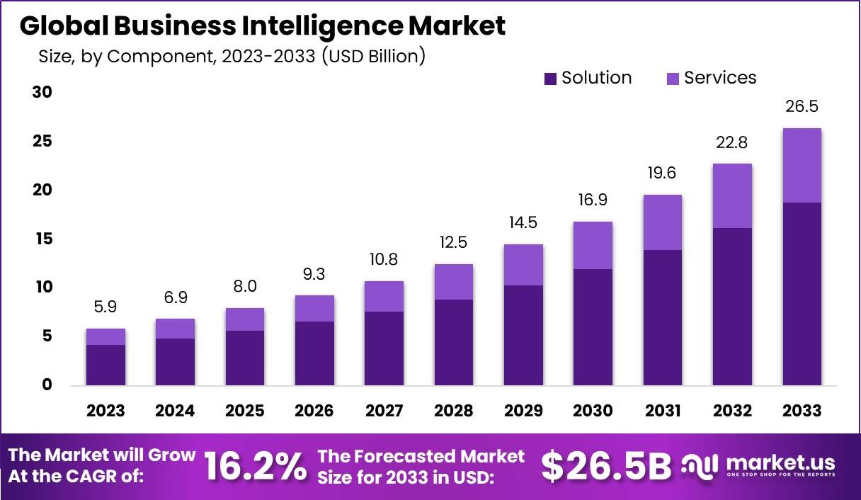
Figure 2.2: Global Business Intelligence Market
(Sources: Market.us, 2024)
Also, the Global Business Intelligence Market will experience fresh progress: it is projected to increase its value to USD 26.5 billion by 2033 with a CAGR of 16.2% during 2024-2033 (Market.us, 2024). Decision-making incorporates the gathering, processing, and reporting of data for business enhancement, and a vital aspect of BI is applied to healthcare.
- Trend 2: Rise of Self-Service BI Tools
Self-service BI changes the approach in which healthcare professionals analyse data and use BI to perform their tasks without necessarily involving IT for support. According to Touroo, (2022), this democratisation of data increases organisational success by improving business method proficiency and also increases treatment effectiveness by giving clinicians the option to generate personalised reports and other interfaces for patient information.
- Trend 3: Real-Time Data Processing
Deploying RATH in emergency care is necessary to fulfil the growing need for real-time analytics of the situation required for efficient management of the resources and patient flow. As stated by Peiris, (2023), real-time data processing can be used to optimise patient delays, assess the necessity of the staff, and improve the workflows in a hospital.
- Trend 4: Cloud-Based BI Solutions
Cloud technology in health care has therefore several advantages such as; enhanced accessibility and the ability to share in the management of patient information (Shah and Konda, 2022). Storing information in a centralised location improves data compatibility, making it easy for practitioners in the field to share the data.

2.3 Big Data Types Relevant to Healthcare
- Structured Data
About the structured data in healthcare, the data is quite arranged in such a way that it provides a means to undertake extraction and analysis of data (Larson and Chang, 2016). Examples include Electronic Medical Records (EMRs), where data like patient details, history, and treatments include characteristic and relational database information (Cox, 2024). ​Such data help support clinical decisions as well as aid with compliance issues and as such, is vital to daily operations.
- Unstructured Data
These are the data in different presentations not having any standardised format and include clinical notes, medical images, and patients’ feedback. While often difficult to study, the quality of this kind of data speaks volumes about patient care (Cox, 2024). NLP is among the commonly used tools in the analysis of clinical narratives to improve decision-making.
- Semi-structured Data
Since it is semi-structured, there will be a mix of order and complication making it possible to work across systems. Standards like XML are very valuable for the interconnection of healthcare systems as well as the integration of different kinds of data (Cox, 2024). This flexibility is very important in enhancing the flow of patient information from one platform to the other.

2.4 Tools and Platforms for Handling Big Data
In the context of healthcare, tools, and platforms for dealing with big data play a vital role in enhancing patient care. It is ideal for optimizing operational competence. Key platforms are ideal for managing large volumes of healthcare data by providing effective solutions. Numerous key platforms may range from Apache Hadoop to Apache Spark. It can be performed by empowering efficient data storage, processing, and analysis. In addition, Hadoop’s distributed storage system may have a direct inspiration in permitting healthcare organizations to store huge data sets cost-effectively (Tahir et al., 2020). On the other hand, Spark’s real-time processing competencies may be proficient in analyzing patient data quickly. It is ideal for making it irreplaceable for critical decision-making. In addition, database systems, ranging from NoSQL to Cassandra are supreme for providing ascendable storage options. It is supreme for allowing healthcare providers to entree and retrieve data from numerous sources (Tahir et al., 2020). The sources may range from electronic health records to wearable devices. It is superlative for understanding patient needs in a more precise way.
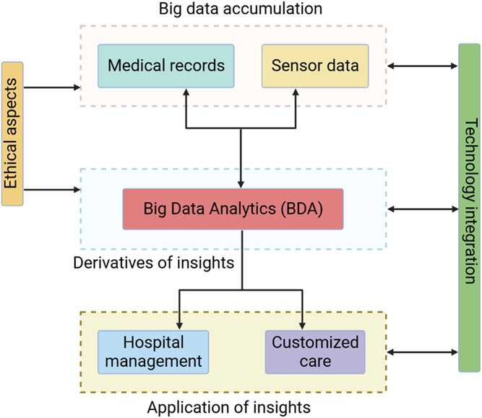
Figure 2: Systematic application of big data in healthcare
(Source: Author)
In addition, cloud-based platforms and advanced analytical tools further drive big data innovation in healthcare. They are driven to provide scalable, secure, and accessible storage and analytics abilities. All these platforms are Amazon Web Services and Microsoft Azure (Sharma et al., 2020). The primary intention of all these platforms is to permit healthcare providers to leverage artificial intelligence and machine learning. It may have a direct part in foreseeing patient outcomes, personalizing treatment plans, and enlightening population health management. For example, AWS HealthLake intends to suggest healthcare-specific data management tools. All these tools may have a direct contribution in establishing and investigating data in line with HIPAA compliance. As shown in Figure 2, BDA is useful for enforcing efficient tackling of the hospitals. At the same time, it is possible to manifest customisation in care due to Big Data Analytics. The approach of integrating big data platforms is superlative for enhancing visualization (Sharma et al., 2020). The tools are Tableau and Power BI. The integration of such tools is ideal for enabling healthcare professionals to interpret complex datasets. It supports deriving actionable insights. The increasing implementation of these big data platforms in healthcare may have a direct influence on fostering evidence-based care. It leads to progressions in genomics, predictive analytics, and preventive medicine.

2.5 Future Prospects of Big Data Analytics in Healthcare
The future of big data analytics in healthcare may have a direct part in promising potential to revolutionize patient care. On the other hand, operational efficiency, and medical research are other two areas that are highly focused on by big data analytics in healthcare. Advanced analytics may have a direct participation in supporting personalized medicine, and tailoring treatments. The treatments intend to be based on lifestyle, medical history, and individual genetics. The successful integration of predictive analytics is ideal for preventing disease outbreaks (Adegoke et al., 2024). It can be performed by identifying patterns and trends. Real-time data from wearable devices may be considered ideal in enabling continuous monitoring of patient health. In addition, big data may have a direct part in streamlining administrative processes (Kaya and Yildirim, 2024). It is also ideal for reducing costs and enlightening resource allocation. The idea of integrating both machine learning and artificial intelligence will have a direct part in enhancing diagnostic accuracy and accelerating drug discovery.

3. Conclusion
The successful integration of big data analytics is set to transform healthcare. The primary intention of data analytics is to foster personalized, proactive, and efficient care. All these advancements promise better health outcomes and cost efficiency. It can be performed by enhancing diagnostics, treatment precision, and operational efficiency.

Reference List
Adegoke, B.O., Odugbose, T. and Adeyemi, C., 2024. Data analytics for predicting disease outbreaks: A review of models and tools. International journal of life science research updates [online], 2(2), pp.1-9. https://orionjournals.com/ijlsru/sites/default/files/IJLSRU-2024-0023.pdf
Cox, D. (2024). Working with Semi-Structured & Unstructured Data in Healthcare. [online] Hakkoda. Available at: https://hakkoda.io/resources/unstructured-data-in-healthcare/ [Accessed 6 Nov. 2024].
Dixon, D., Sattar, H., Moros, N., Kesireddy, S.R., Ahsan, H., Lakkimsetti, M., Fatima, M., Doshi, D., Sadhu, K. and Hassan, M.J., 2024. Unveiling the Influence of AI Predictive Analytics on Patient Outcomes: A Comprehensive Narrative Review. Cureus, 16(5). https://www.ncbi.nlm.nih.gov/pmc/articles/PMC11161909/
Kaya, M. and Yildirim, E., 2024. Strategic Optimization of High-Volume Data Management: Advanced Techniques for Enhancing Scalability, Efficiency, and Reliability in Large-Scale Distributed Systems. Journal of Intelligent Connectivity and Emerging Technologies, 9(9), pp.16-44. https://questsquare.org/index.php/JOUNALICET/article/view/78
Larson, D. and Chang, V., 2016. A review and future direction of agile, business intelligence, analytics and data science. International Journal of Information Management, 36(5), pp.700-710. https://eprints.soton.ac.uk/392806/1/direction_of_agile_BI_analytics_big_data.pdf
Market.us (2024). Introduction The Global Business Intelligence Market is anticipated to witness remarkable growth, with an estimated value of USD 26.5 billion by 2033, exhibiting a robust Compound Annual Growth Rate (CAGR) of 16. [online] Linkedin.com. Available at: https://www.linkedin.com/pulse/business-intelligence-market-size-worth-usd-265-billion-2033-xm9rc/ [Accessed 14 Nov. 2024].
Peiris, T.R., 2023. Maximizing Resource Allocation and Workflow Efficiency in Healthcare via Computer Vision and AI: Creating Intelligent Systems for Managing Patient Flow, Staffing, and Equipment Utilization. Journal of Applied Smart HealthCare Informatics, 13(12), pp.31-40. https://orientreview.com/index.php/JASHI/article/download/63/76
Puklavec, B., Oliveira, T. and Popovič, A., 2018. Understanding the determinants of business intelligence system adoption stages: An empirical study of SMEs. Industrial Management & Data Systems, 118(1), pp.236-261. https://research.unl.pt/ws/files/14739018/Puklavec_TOliveira_APopovic_2018.pdf
Rane, N., Paramesha, M., Choudhary, S. and Rane, J., 2024. Business Intelligence through Artificial Intelligence: A Review. Available at SSRN 4831916. https://papers.ssrn.com/sol3/Delivery.cfm?abstractid=4831916
Shah, V. and Konda, S.R., 2022. Cloud Computing in Healthcare: Opportunities, Risks, and Compliance. Revista Espanola de Documentacion Cientifica, 16(3), pp.50-71. https://www.researchgate.net/profile/Varun-Shah-27/publication/378396122_Cloud_Computing_in_Healthcare_Opportunities_Risks_and_Compliance_Introduction/links/664d0d86bc86444c72f5fc99/Cloud-Computing-in-Healthcare-Opportunities-Risks-and-Compliance-Introduction.pdf
Sharma, V., Nigam, V. and Sharma, A.K., 2020. Cognitive analysis of deploying web applications on microsoft windows azure and amazon web services in global scenario. Materials Today: Proceedings, 11. https://www.researchgate.net/profile/Vaibhav-Sharma-49/publication/349366803_Cognitive_analysis_of_deploying_web_applications_on_microsoft_windows_azure_and_amazon_web_services_in_global_scenario/links/602ccffc4585158939ad6fc3/Cognitive-analysis-of-deploying-web-applications-on-microsoft-windows-azure-and-amazon-web-services-in-global-scenario.pdf
Tahir, A., Chen, F., Khan, H.U., Ming, Z., Ahmad, A., Nazir, S. and Shafiq, M., 2020. A systematic review on cloud storage mechanisms concerning e-healthcare systems. Sensors, 20(18), p.5392. https://www.mdpi.com/1424-8220/20/18/5392
Touroo, T. (2022). Self-Service Analytics: How to Use Healthcare Business Intelligence. [online] Health Catalyst. Available at: https://www.healthcatalyst.com/insights/self-service-analytics-how-use-healthcare-business-intelligence [Accessed 6 Nov. 2024].
Waszyk-Nowaczyk, M., Guzenda, W., Dragun, P., Olsztyńska, L., Liwarska, J., Michalak, M., Ferlak, J., Drozd, M. and Sobiechowska, R., 2022. Interdisciplinary Cooperation between Pharmacists and Nurses—Experiences and Expectations. International Journal of Environmental Research and Public Health, 19(18), p.11713. https://www.mdpi.com/1660-4601/19/18/11713

