

The Effectiveness of Cybersecurity Awareness Training on Employee Behaviour in UK Small and Medium-Sized Enterprises (SMEs)

A dissertation submitted in partial fulfilment of the requirements for the degree of
BA (Hons) Leadership and Management Skills in the Workplace

Yanis Popov
Student ID: 2241239
Module: Independent Project
Module Code: LCLM6005
University of Wales Trinity Saint David

Abstract
This study looks at how well cybersecurity awareness training affects employee behaviour in UK small and medium-sized businesses (SMEs). Understanding the role of human factors in organisational security has become more crucial as cyber threats targeting SMEs have increased. To provide a thorough analysis of cybersecurity awareness practices, the study uses a mixed-methods approach, combining quantitative survey data (n = 25) with qualitative semi-structured interviews (n = 5).
The results show that although most SMEs offer cybersecurity awareness training, its efficacy varies based on organisational support, frequency, and mode of delivery. Although most employees show a basic understanding of cybersecurity, there are still gaps in their ability to recognise more complex threats, especially phishing attacks. The findings also show that, in comparison to infrequent or theoretical training, training provided through ongoing, practical techniques—like phishing simulations—is more successful in enhancing employee behaviour.
The study also identifies organisational limitations, time constraints, and human error as the main issues influencing cybersecurity practices in SMEs. The results highlight the significance of role-specific training and management support in raising awareness and lowering security risks.
The study concludes that enhancing cybersecurity in SMEs necessitates a comprehensive strategy that incorporates organisational commitment, behavioural understanding, and ongoing training. To help SMEs improve their cybersecurity awareness strategies, useful suggestions are offered.

Table of Contents
Abstract 2
List of Figures 5
Chapter 1 – Introduction 6
1.1 Background and Context 6
1.2 Problem Statement 6
1.3 Research Gap 7
1.4 Research Aim and Objectives 8
Research Aim 8
Research Objectives 8
1.5 Research Questions 8
1.6 Structure of the Dissertation 8
Chapter 2 – Literature review 9
2.1 Cybersecurity Threat Landscape in UK SMEs 9
2.2 The Human Factor in Cybersecurity 10
Psychological and Cognitive Determinants of Security Behaviour 10
Organisational and Cultural Determinants of Security Behaviour 11
2.3 Cybersecurity Awareness Training Models and Effectiveness 11
2.4 SME-Specific Constraints and Cybersecurity Training Challenges 12
2.5 Critical Synthesis and Refined Research Gap 13
Chapter 3 – Methodology 15
3.1 Research Philosophy 15
3.2 Research Approach 15
3.3 Research Design 16
3.4 Sampling Strategy 17
3.5 Data Collection Methods 18
3.6 Data Analysis Methods 19
Quantitative Analysis 19
Qualitative Analysis 19
3.7 Reliability and Validity 20
3.8 Ethical Considerations 21
Chapter 4 – Results and Findings 21
4.1 Introduction 21
4.2 Demographic Profile of Participants 21
Role of Participants 21
Years of Experience 22
Organisation Size 22
Industry Sector 23
4.3 Cybersecurity Training Exposure 23
Training Participation 23
Training Frequency 24
Types of Training 24
4.4 Perceived Effectiveness of Training 25
4.5 Employee Cybersecurity Behaviour 26
4.6 Open-Ended Responses: Key Challenges 26
4.7 Qualitative Findings from Interviews 27
Integration of Findings 28
4.8 Chapter Summary 28
Chapter 5 – Discussion 28
5.1 Introduction 28
5.2 Cybersecurity Awareness in SMEs 28
5.3 Effectiveness of Cybersecurity Training 29
5.4 Human Factors and Cybersecurity Behaviour 29
5.5 Organisational Factors Influencing Cybersecurity 30
Management Support 30
Resource Constraints in SMEs 30
5.6 Key Challenges in Cybersecurity Awareness 30
5.7 Integration of Quantitative and Qualitative Findings 31
5.8 Implications of the Findings 31
5.9 Chapter Summary 31
Chapter 6 – Conclusion and Recommendations 32
6.1 Introduction 32
6.2 Summary of Key Findings 32
6.3 Conclusion 33
6.4 Recommendations 33
Implement Continuous Training Programmes 33
Use Practical and Interactive Training Methods 33
Develop Role-Specific Training 33
Strengthen Management Involvement 33
Address Human Behaviour Factors 34
Allocate Resources for Cybersecurity 34
6.5 Limitations of the Study 34
6.6 Future Research 34
6.7 Final Remarks 35
Reference: 36
Appendices 39
Appendix A: Survey Questionnaire 39
Appendix B: Interview Questions 41

List of Figures
Figure 4.1 Role of Survey Participants ..................................................................................21
Figure 4.2 Length of Employment .........................................................................................22
Figure 4.3 Organisation Size .................................................................................................22
Figure 4.4 Industry Sector Distribution ..................................................................................23
Figure 4.5 Cybersecurity Training Received (Last 12 Months) .............................................23
Figure 4.6 Frequency of Training ..........................................................................................24
Figure 4.7 Type of Training Provided ....................................................................................24
Figure 4.8 Training Relevance and Effectiveness .................................................................25
Figure 4.9 Employee Cybersecurity Behaviour .....................................................................25

Chapter 1 – Introduction

Background and Context
More than 99 percent of all businesses in the UK are small and medium-sized enterprises (SMEs), which play a major role in job creation and economic expansion (Beck and Demirgüç-Kunt, 2006). SMEs are becoming more susceptible to cybersecurity risks despite their economic significance. According to the UK Government's Cyber Security Breaches Survey, a significant percentage of SMEs experience security breaches every year, with phishing continuing to be the most frequent type of cyber incident affecting small businesses (Department for Science, Innovation and Technology, 2023). SMEs are more vulnerable to cyber risks than large organisations because they frequently lack specialised cybersecurity staff, sophisticated technical infrastructure, and formalised governance frameworks (Alshaikh, 2020).
Research continuously identifies the human element as one of the main causes of cybersecurity incidents, despite the frequent emphasis on technological vulnerabilities. According to research, employee actions like clicking on malicious links, creating weak passwords, mishandling private information, or disregarding security guidelines are major contributors to organisational security breaches (Parsons et al., 2014; Hadlington, 2017). As a result, workers are acknowledged as both possible security risks and an essential part of an organization's cyber resilience.
Organisations have been implementing cybersecurity awareness training programs more frequently in response to these behavioural vulnerabilities. These programs aim to improve knowledge, raise threat perception, and encourage secure practices (Bulgurcu et al., 2010). Even though awareness campaigns are widely used, there is ongoing discussion about how effective they are at bringing about long-lasting behavioural change, especially in the context of SMEs with limited resources.

Problem Statement
Cyber incidents involving SMEs are still on the rise, even with the increasing adoption of cybersecurity awareness programs. Although the goal of awareness training is to increase employee knowledge and compliance, research indicates that greater awareness does not always result in safe behaviour (Bada and Nurse, 2019). In cybersecurity contexts, perceived threat severity, coping effectiveness, and organisational culture all have an impact on behavioural change in addition to knowledge acquisition (Rogers, 1975; Alshaikh, 2020).
According to the Protection Motivation Theory (PMT), people act in ways that are protective when they consider threats to be serious and think they can lessen them (Rogers, 1975). Formal training initiatives may be less effective in SME environments due to a lack of resources, informal structures, and conflicting business priorities. Additionally, rather than measuring observable behavioural outcomes, a large portion of the current research measures awareness or self-reported compliance (Parsons et al., 2014).
A crucial problem thus arises although cybersecurity awareness training is extensively advocated as a remedy for human-related cyber risk, its quantifiable influence on employee conduct in UK SMEs is still unclear. Enhancing organisational resilience and making sure that the limited resources of SMEs are allocated effectively require an understanding of whether such training changes behaviour.

Research Gap
Despite the extensive research on cybersecurity awareness, there are still a few gaps in the body of knowledge. First, a lot of empirical research concentrates on big businesses or public sector establishments, which restricts the applicability of results to SMEs, which have different structural and financial limitations (Bada and Nurse, 2019). SMEs frequently lack cybersecurity maturity and formalised governance frameworks, which may have an impact on how training programs are implemented and perform.
Second, rather than measuring observable behavioural change, previous research usually evaluates awareness levels or intentions to comply with policies. Although tools like the HAIS-Q offer insightful information about attitudes and knowledge (Parsons et al., 2014), awareness by itself does not ensure safe behaviour. Social norms, cultural reinforcement mechanisms, and perceived self-efficacy are among the organisational and psychological elements that influence behavioural security outcomes (Rogers, 1975; Bulgurcu, Cavusoglu, and Benbasat, 2010).
Third, the effectiveness of cybersecurity awareness training for SMEs operating under the UK regulatory framework, including GDPR obligations, has not been thoroughly studied empirically in the UK. More context-specific research is needed considering the growing emphasis on human-cantered cybersecurity strategies in UK policy discourse (Department for Science, Innovation and Technology, 2023).
To fill in these conceptual, methodological, and contextual gaps, this study uses a mixed-methods approach to empirically assess the impact of cybersecurity awareness training on employee behaviour in UK SMEs.

Research Aim and Objectives

Research Aim
This study's objective is to assess how well cybersecurity awareness training affects employees' cybersecurity behaviour in small and medium-sized businesses (SMEs) in the United Kingdom.

Research Objectives
To achieve this aim, the study will pursue the following objectives:
- To investigate the kinds and regularity of cybersecurity awareness training that UK SMEs implement.
- To evaluate the connection between employee cybersecurity behaviour and cybersecurity awareness training.
- To investigate how managers and staff view the value of cybersecurity awareness training.
- To determine the organisational elements that help or impede UK SMEs' successful adoption of cybersecurity awareness campaigns.

Research Questions
In line with the research aim and objectives, this study seeks to address the following research questions:
- RQ1: What kinds of cybersecurity awareness training are used in UK SMEs, and how often are they given?
- RQ2: How much does cybersecurity awareness training affect UK SMEs' employees' cybersecurity behaviour?
- RQ3: What is the opinion of managers and staff regarding the efficacy of cybersecurity awareness training?
- RQ4: What organisational elements influence the effective execution of cybersecurity awareness programs in UK SMEs?

Structure of the Dissertation
This dissertation is divided into six chapters, each of which addresses a distinct facet of the research process and collectively contributes to addressing the research aim and objectives, to guarantee a clear, logical, and systematic progression of ideas.
By describing the research background, defining the problem area, and emphasising the research gap, Chapter 1 offers an introduction to the study. Additionally, it outlines the goals, objectives, and research questions that direct the study's course.
A thorough and critical analysis of the body of research on cybersecurity risks in SMEs, employee conduct, and the efficacy of cybersecurity awareness training is provided in Chapter 2. A theoretical foundation is established by looking at pertinent theories and earlier research, which results in the creation of a conceptual framework for the study.
The research methodology used for this study is described in Chapter 3. It explains sampling strategies, data collection methods (interviews and surveys), data analysis procedures, and the research philosophy and approach. It also provides justification for the use of a mixed-methods strategy. This chapter also discusses data protection and ethical issues.
The results from the qualitative interviews and quantitative survey are presented and analysed in Chapter 4. A clear summary of the findings is provided by the data, which is arranged into major themes and backed up by tables, charts, and direct quotes.
The results are discussed in Chapter 5 considering the body of literature that was reviewed in Chapter 2. It analyses how the findings answer the research questions, interprets the data, and finds important trends and connections. Additionally considered are the consequences for SMEs and cybersecurity procedures.
The dissertation is finally concluded in Chapter 6, which summarises the main conclusions, considers the goals of the study, and discusses the study's overall contribution. Additionally, it describes the research's limitations and offers suggestions for further study and real-world application in SMEs.

Chapter 2 – Literature review

2.1 Cybersecurity Threat Landscape in UK SMEs
Due to their limited cybersecurity budgets, lack of dedicated IT staff, and immature cyber governance practices, small and medium-sized enterprises (SMEs) are increasingly targeted by the ongoing global increase in cyber threats (Verizon, 2023). Phishing, which preys on human behaviour rather than technical flaws, is still one of the most common attack types that impact SMEs (Verizon, 2023). Additionally, ransomware incidents have increased, frequently causing organisations without established recovery protocols to experience significant financial loss and operational disruption (ENISA, 2022).
Human-related risk factors are central to cybersecurity incidents, according to research on organisational security behaviour. Hadlington (2018) emphasises that employee risky behaviours, like clicking on malicious links or using weak passwords, frequently lead to breaches, highlighting the fact that cybersecurity is both a behavioural and a technical challenge. In a similar vein, Greitzer et al. (2014) show that psychosocial variables and employee behaviour patterns can predict insider security threats, suggesting that people are still a constant source of vulnerability.
The General Data Protection Regulation (GDPR), which mandates that organisations exhibit accountability for data protection practices, is one of the regulatory pressures that SMEs in the UK must contend with. However, unless backed by strong organisational culture and training, compliance mandates do not automatically guarantee secure behaviour, even though they may increase awareness (Siponen and Vance, 2010). High threat exposure, regulatory scrutiny, and behavioural risk all work together to emphasise how important it is to view cybersecurity as a socio-technical problem as well as a technical one, particularly in the context of SMEs.

2.2 The Human Factor in Cybersecurity

Psychological and Cognitive Determinants of Security Behaviour
Instead of being solely technical awareness, cybersecurity behaviour is increasingly being conceptualised as a function of individual cognition and psychological appraisal processes. The Theory of Planned Behaviour (TPB) is one of the most important frameworks in behavioural research (Ajzen, 1991). According to TPB, perceptions of behavioural control, subjective norms, and attitudes toward the behaviour all influence behaviour. When employees believe that acting securely is advantageous, socially acceptable, and within their capabilities, they are more likely to follow security policies in cybersecurity contexts.
TPB's explanatory power is demonstrated by empirical research that applies it to information security. Ifinedo (2012) discovered that employees' intentions to adhere to the organization's information security policies were significantly predicted by their attitudes and perceptions of behavioural control. Similarly, a meta-analysis by Sommestad, Karlzén, and Hallberg (2015) verified that TPB constructs accurately explain security compliance behaviour.
The way that threat perception affects behavioural responses is further explained by the Protection Motivation Theory (PMT) (Rogers, 1975). According to PMT, people assess threats using coping assessments like self-efficacy and response efficacy in addition to severity and vulnerability assessments. According to empirical research by Johnston and Warkentin (2010), fear appeals and perceived efficacy have a major impact on protective security behaviours.
However, logical threat assessment may be compromised by cognitive biases. The Suspicion, Cognition, and Automaticity Model, put forth by Vishwanath et al. (2018), demonstrates that people frequently react to phishing emails instinctively rather than critically. This implies that awareness training needs to target automatic cognitive functions rather than just knowledge deficiencies.
Together, these psychological viewpoints show that perceived capability, motivational appraisal, and cognitive evaluation all influence secure behaviour, underscoring the difficulty of changing behaviour in cybersecurity settings.

Organisational and Cultural Determinants of Security Behaviour
Individual decision-making is explained by psychological models, but organisational context also influences cybersecurity behaviour. Research on security compliance shows that organisational norms, cultural expectations, and leadership influence have a big impact on what employees do (Herath and Rao, 2009).
Perceived penalties have an impact on policy compliance, according to deterrence theory (Herath and Rao, 2009). However, if punishment is used excessively, intrinsic motivation may be weakened. Employees use neutralisation strategies to justify policy violations, according to Siponen and Vance (2010), who contend that moral alignment and organisational culture are essential for long-term compliance.
According to security culture research, secure behaviour is highly predicted by leadership commitment and shared values (Da Veiga and Martins, 2015). Managerial modelling may have a particularly strong normative influence in SME environments, where leadership visibility is high and organisational hierarchies are flatter.
D'Arcy and Greene (2014) discovered that a positive security culture lowers policy violations, which supports the notion that training interventions alone are insufficient for behavioural cybersecurity. Initiatives to raise awareness must instead be incorporated into organisational frameworks that are supportive.
As a result, the interplay between organisational culture and individual cognition produces cybersecurity behaviour. Although awareness training may change people's perceptions of knowledge and threats, its long-term efficacy depends on reinforcement from structural accountability mechanisms, leadership, and norms.

2.3 Cybersecurity Awareness Training Models and Effectiveness
One of the most popular organisational interventions for reducing human-related cyber risk is cybersecurity awareness training, or CSAT. Conventional awareness strategies, like policy briefings and compliance modules, were mainly concerned with disseminating information. But according to recent studies, passive knowledge transfer by itself is not enough to result in long-lasting behavioural change (Bada, Sasse, and Nurse, 2019).
Behavioural science concepts, such as gamification, reinforcement-based learning, and simulated phishing exercises, are increasingly incorporated into contemporary training models (Jansson and von Solms, 2013). For example, simulated phishing campaigns aim to improve threat recognition and behavioural vigilance by exposing staff members to realistic attack scenarios and offering prompt feedback. According to empirical data, phishing simulations can gradually lower click-through rates when repeatedly presented, though gains might stall in the absence of continuous reinforcement (Jampen et al., 2020).
Numerous factors, such as frequency, relevance, interactivity, and organisational support, influence how effective training is, according to meta-analytic and empirical research (Sommestad, Hallberg, Lundholm, and Bengtsson, 2014). Longitudinal studies indicate that behavioural decay may occur when training is infrequent or poorly integrated into organisational culture, although short-term increases in awareness are common (Parsons et al., 2017).
Additionally, studies show that contextual factors moderate the effectiveness of training. For instance, Puhakainen and Siponen (2010) contend that to guarantee significant change, awareness campaigns need to be based on behavioural theory. Their research shows that interventions with a theoretical foundation have a higher chance of influencing policy compliance than general awareness campaigns.
Critical viewpoints contend that many awareness campaigns prioritise compliance metrics over behavioural resilience, despite their broad adoption (Bada, Sasse, and Nurse, 2019). Awareness programs are frequently informal, irregular, or externally outsourced in SMEs, where training budgets and expertise may be limited, which raises concerns about their long-term efficacy.
Overall, the research that is currently available shows that cybersecurity awareness training can affect behaviour in specific situations, but its effects are neither automatic nor consistently maintained. This emphasises the necessity of conducting empirical research in particular organisational contexts, especially UK SMEs, to ascertain whether training results in quantifiable behavioural change.

2.4 SME-Specific Constraints and Cybersecurity Training Challenges
Although cybersecurity awareness training has shown promise in controlled organisational settings, SMEs are subject to structural and contextual limitations that could affect the way the training is implemented and how it turns out. Smaller IT teams, less formalised governance structures, and limited financial resources are common characteristics of SMEs in contrast to large corporations (Thong, 1999). These restrictions frequently limit funding for thorough and ongoing cybersecurity training initiatives.
According to research, owner-managers are usually at the centre of SME decision-making, and their individual perspectives on cybersecurity have a big impact on organisational priorities (Rahayu and Day, 2015). Training programs may be implemented reactively rather than strategically if cybersecurity is seen as a secondary concern in comparison to operational survival. This reactive approach may limit the sustainability of awareness campaigns and lessen long-term behavioural reinforcement.
Moreover, formal security policies and organised compliance monitoring systems are frequently absent from SMEs (Heidt et al., 2019). Awareness training might not result in consistent behavioural practice if policy enforcement or cultural reinforcement are lacking. Research indicates that SMEs frequently contract out cybersecurity services, including awareness training, which could result in generic training materials that are not tailored to the specific needs of the organization (Bada and Nurse, 2019).
Pressures from digital transformation make the problem even more complex. SME attack surfaces have grown due to the quick adoption of cloud services, remote working methods, and mobile technologies, which has increased behavioural susceptibility to social engineering and phishing threats (ENISA, 2022). Training sophistication and frequency, however, might not be able to keep up with changing threat environments.
Measurement is another major obstacle. According to Jansen and Van Schaik (2018), SMEs frequently lack internal systems for evaluating behavioural outcomes after training implementation. In the absence of behavioural metrics, like the outcomes of phishing simulations or compliance audits, organisations might presume efficacy without empirical support.
All things considered, these contextual and structural limitations imply that the efficacy of cybersecurity awareness training in SMEs cannot be presumed based on data from larger organisations. Rather, to ascertain whether training results in quantifiable behavioural change in UK SME environments, empirical research is needed.

2.5 Critical Synthesis and Refined Research Gap
The review above shows how a complex interplay of organisational, motivational, and cognitive factors affects cybersecurity behaviour. Strong explanatory frameworks for comprehending individual compliance intentions are offered by psychological models like the Protection Motivation Theory (Rogers, 1975) and the Theory of Planned Behaviour (Ajzen, 1991). According to empirical research, employees' decisions about security are greatly influenced by perceived severity, self-efficacy, and social norms (Ifinedo, 2012; Johnston and Warkentin, 2010). However, rather than explaining consistent behavioural practice, these models mainly explain behavioural intention.
Additionally, studies on awareness training indicate that although there are noticeable short-term gains in phishing detection and policy compliance, long-term behavioural resilience is still erratic (Jampen et al., 2020; Bada et al., 2019). Many awareness campaigns do not incorporate behavioural reinforcement mechanisms into organisational culture; instead, they rely on recurring training sessions or simulated phishing exercises. Improvements might therefore be the result of transient attention to detail rather than a structural change in behaviour.
Furthermore, a significant portion of the empirical literature uses samples from public institutions or large organisations (Sommestad, Hallberg, Lundholm, and Bengtsson, 2014). Dedicated security teams, formalised governance structures, and compliance monitoring systems are common in these settings. It's unclear if these findings apply to SMEs, which are distinguished by their centralised leadership, informal structures, and limited resources (Heidt et al., 2019).
Measurement is another limitation. Instead of evaluating objective behavioural outcomes, many studies evaluate self-reported compliance or awareness levels (Parsons et al., 2017). Self-report measures may overestimate actual compliance behaviour and are susceptible to social desirability bias. It is still challenging to determine the true effect of awareness training without triangulation using behavioural metrics or mixed-method approaches.
Furthermore, accountability requirements for UK SMEs have increased due to regulatory pressures like GDPR; however, compliance-driven training may put legal adherence ahead of changing the behavioural culture. According to research, mandates for compliance that are imposed from outside sources do not always result in an internal incentive to behave securely (Siponen and Vance, 2010).
Taken together, the literature reveals several interconnected gaps:
- Contextual Gap: There isn't much empirical research that focuses on UK SMEs.
- Over-reliance on cross-sectional, self-reported survey data is a methodological flaw.
- Behavioural Gap: Inadequate proof of long-term behavioural change as opposed to awareness or intention.
- Integration Gap: There is a dearth of mixed-method studies that combine qualitative contextual insights with quantitative behavioural measures.
To improve knowledge of whether cybersecurity awareness training significantly affects employee behaviour in resource-constrained SME environments, it is imperative that these gaps be filled. To assess training efficacy in UK SMEs, this study uses a mixed-methods approach that combines behavioural measurement with qualitative investigation of organisational context.

Chapter 3 – Methodology

3.1 Research Philosophy
The research philosophy used in this study is pragmatic. Pragmatism is based on the idea that rather than adhering to a single epistemological stance, research methods should be chosen for their practical suitability in solving the research problem (Saunders et al., 2019). A pragmatic approach enables the integration of quantitative and qualitative data to provide a thorough understanding of training effectiveness, as cybersecurity awareness training encompasses both quantifiable behavioural outcomes and subjective organisational perceptions.
Pragmatism acknowledges that organisational phenomena frequently have both observable and socially constructed dimensions, in contrast to positivism, which emphasises objective measurement, and interpretivism, which only considers subjective meaning. Measurable behavioural indicators, such as self-reported secure practices, coexist with organisational culture, leadership influence, and employee perceptions in the context of cybersecurity behaviour. As a result, a pragmatic approach encourages the use of mixed methods to improve explanatory depth and triangulate findings.
This study prioritises practical insight into whether cybersecurity awareness training has a significant impact on employee behaviour in UK SMEs by adopting a pragmatic approach. This is consistent with the applied character of cybersecurity management research and the goal of the study, which is to produce practical suggestions.

3.2 Research Approach
This research uses a mixed deductive-inductive methodology, which is in line with its pragmatic philosophical stance. Established behavioural theories, such as the Protection Motivation Theory (Rogers, 1975) and the Theory of Planned Behaviour (Ajzen, 1991), which contend that protective behavioural intentions are influenced by self-efficacy, social norms, and perceived threat, serve as the foundation for the deductive component. The development of survey measures intended to assess the connection between cybersecurity awareness training and employee cybersecurity behaviour in UK SMEs is guided by these theoretical frameworks.
Deductive reasoning, however, may not adequately capture the organisational and contextual dynamics that influence behavioural outcomes in SME environments, even though it makes it possible to test theoretically informed constructs empirically. Strictly deductive designs run the risk of ignoring emergent insights that come from participants lived experiences, as Bryman (2016) points out. Exploratory qualitative research is required to supplement structured quantitative measurement because informal leadership structures and resource limitations frequently impact SME cybersecurity practices.
As a result, semi-structured interviews are used in this study to add an inductive component. This makes it possible to identify emerging themes pertaining to organisational culture, implementation difficulties, and the value of training. An abductive approach is reflected in the combination of deductive and inductive reasoning, whereby empirical data are repeatedly interpreted considering preexisting theoretical frameworks (Timmermans and Tavory, 2012). In applied organisational research, where theoretical concepts must be investigated in intricate real-world contexts, abduction is especially suitable.
Creswell and Plano Clark (2018) contend that integrating quantitative and qualitative methods improves explanatory power by facilitating methodological triangulation, which is consistent with the use of a mixed-methods approach. While interview data provides contextual insight into organisational influences and the perceived efficacy of training initiatives, survey data in this study offers quantifiable behavioural indicators. This integration improves the validity of findings about the efficacy of cybersecurity awareness training in UK SMEs and deepens the analysis.

3.3 Research Design
A cross-sectional explanatory mixed-methods research design is used in this study. When quantitative data is gathered first to find quantifiable patterns and then qualitative research is conducted to provide contextual interpretation, an explanatory design is suitable (Creswell and Plano Clark, 2018). While semi-structured interviews offer a deeper understanding of organisational factors influencing training effectiveness, survey data is used in this study to investigate the relationship between cybersecurity awareness training and employee cybersecurity behaviour.
A Microsoft Forms-administered online survey makes up the quantitative component. Likert-scale items measuring self-reported cybersecurity behaviour, questions evaluating training exposure and frequency, and a few demographic variables like organisational role and SME size are all included in the survey. Likert scales facilitate the construction and statistical analysis of behavioural indices that support regression and correlation testing (Bryman, 2016).
Eight semi-structured interviews with managers and staff from UK SMEs make up the qualitative component. Semi-structured interviews provide flexibility to explore emergent themes while maintaining consistency among participants (Kallio et al., 2016). This method works especially well for looking at contextual factors like perceived training relevance, organisational culture, and leadership influence.
The study uses a cross-sectional design, gathering data all at once. Although longitudinal designs are frequently better for evaluating behavioural sustainability, cross-sectional methods are required for undergraduate research due to time and resource constraints. Chapter 5 acknowledges and discusses this limitation.
Since it would be difficult and unethical to manipulate training exposure within organisational settings, an experimental design was not used. Rather, in line with applied organisational research practices, the study assesses naturally occurring variation in training exposure across SMEs.
The research design allows for methodological triangulation, which strengthens internal validity and improves the explanatory depth of findings by combining quantitative measurement with qualitative investigation (Flick, 2018).

3.4 Sampling Strategy
Purposive and convenience sampling techniques are combined in the study's non-probability sampling strategy. When access to participants is limited by time, organisational gatekeeping, and resource constraints, non-probability sampling is frequently employed in organisational research (Bryman, 2016).
Employees of small and medium-sized businesses (SMEs) in the UK make up the target population for the quantitative component. The UK government defines SMEs as businesses with fewer than 250 employees. Participants had to fulfil two requirements to be eligible: (1) they had to be employed in a small and medium-sized enterprise (SME) setting; and (2) they had to regularly use organisational digital systems like email, cloud services, or internal platforms that could put them at risk for cybersecurity threats.
Participants for the survey will be found via a variety of methods, such as personal professional contacts, direct email invitations to SMEs, and LinkedIn professional networks. Microsoft Forms will be used to administer the survey online. To guarantee adequate data for descriptive and correlational statistical analysis, the study seeks to collect roughly 80 survey responses, with a minimum acceptable threshold of 50 responses.
Eight participants will be chosen as a purposive sample for semi-structured interviews as part of the qualitative component. Participants in the interviews will be managers or employees of SMEs with knowledge of organisational cybersecurity procedures or awareness campaigns. Purposive selection guarantees that participants have the necessary expertise to offer significant insights into organisational training procedures and behavioural influences.
Non-probability sampling is suitable for exploratory organisational research where participant access is restricted, even though it restricts statistical generalisability to the larger SME population (Saunders, Lewis, and Thornhill, 2019). While methodological triangulation is made possible by the integration of survey and interview data, the use of multiple recruitment channels contributes to increased sample diversity.

3.5 Data Collection Methods
Two main techniques will be used to gather data for this study: semi-structured interviews and an online survey. Methodological triangulation is supported and a more thorough analysis of the efficacy of cybersecurity awareness training within UK SMEs is made possible using both quantitative and qualitative data collection techniques.
Microsoft Forms will be used to distribute an online questionnaire for the quantitative component. Because they allow for effective data collection from geographically dispersed participants while preserving respondent anonymity, online surveys are frequently used in organisational research (Bryman, 2016). There will be three primary sections to the questionnaire. Using Likert-scale items that capture the frequency of secure practices, like identifying suspicious emails or adhering to organisational security policies, the first section will gauge employee cybersecurity behaviour. The second section will evaluate participants' exposure to cybersecurity awareness training, including whether they have received it and how frequently. Limited demographic data, such as participants' organisational role, years of experience, and organization size, will be gathered in the last section. A shareable link shared via LinkedIn networks, email invitations to SMEs, and professional contacts will be used to distribute the survey via Microsoft Forms.
Eight semi-structured interviews using Microsoft Teams will make up the qualitative component. According to Kallio et al. (2016), semi-structured interviews are appropriate for delving into participants' perspectives and experiences while providing flexibility to explore emerging themes. It is anticipated that each interview will run between thirty and forty-five minutes. Participants' experiences with cybersecurity awareness training, the perceived efficacy of training programs, organisational cybersecurity procedures, and the difficulties of putting security behaviours into practice in SME settings will all be covered in the interview questions.
Interviews will be audio recorded using Microsoft Teams' recording feature with participants' permission to guarantee accurate response capture. After that, the recordings will be transcribed for examination. Before the data is analysed, participants will be made aware of their right to withdraw at any time.
The study intends to gather quantifiable behavioural trends and contextual insights into how cybersecurity awareness training is applied and viewed within SME organisations by combining survey data with in-depth interviews.

3.6 Data Analysis Methods
The study examines the efficacy of cybersecurity awareness training in UK SMEs using both quantitative and qualitative data analysis techniques. A mixed-methods research design is supported, and findings can be triangulated through the integration of statistical analysis and thematic interpretation.

Quantitative Analysis
For preliminary data organization and cleaning, survey data gathered via Microsoft Forms will be exported into Microsoft Excel. Incomplete responses will be eliminated, variables will be arranged, and the dataset will be ready for statistical analysis using Excel. To give an overview of participant characteristics and overall cybersecurity behaviour patterns, descriptive statistics such as frequencies, means, and standard deviations will be produced.
The dataset will be imported into SPSS (Statistical Package for the Social Sciences) for additional analysis after it has been prepared. In social science research, SPSS is frequently used to analyse quantitative survey data (Field, 2018). There will be multiple phases to the analysis.
First, behavioural patterns and training exposure among SME employees will be compiled using descriptive statistical analysis. Second, the internal consistency of the Likert-scale behavioural measures will be evaluated through reliability analysis using Cronbach's alpha. Third, the association between employee cybersecurity behaviour and exposure to cybersecurity awareness training will be investigated through correlation analysis. The predictive relationship between training frequency and behavioural outcomes can also be evaluated, when appropriate, using simple regression analysis.
The study can determine whether employees who receive cybersecurity awareness training exhibit higher levels of secure behavioural practices thanks to these statistical techniques.

Qualitative Analysis
Thematic analysis will be used to examine interview data in accordance with Braun and Clarke's (2006) six-step framework. In qualitative research, thematic analysis is frequently employed to find recurrent themes and patterns in textual data.
The interview transcripts will be familiarised, meaningful statements will be initially coded, and codes will be grouped into more general themes pertaining to organisational procedures, behavioural influences, and cybersecurity training experiences. Following that, the themes will be analysed considering the quantitative results and the theoretical frameworks covered in Chapter 2.
The study's ability to provide quantifiable evidence and contextual explanation about the efficacy of cybersecurity awareness training in SMEs is made possible by the integration of quantitative statistical analysis and qualitative thematic analysis.

3.7 Reliability and Validity
Maintaining the validity and reliability of research findings is crucial to their credibility. In quantitative research, validity refers to how well an instrument measures the intended construct, whereas reliability is the consistency of measurement tools (Bryman, 2016).
The study uses several Likert-scale items to gauge employee cybersecurity behaviour to improve survey instrument reliability. Internal consistency is increased and measurement error is decreased when a single construct is measured using several items. Cronbach's alpha in SPSS will be used to statistically assess reliability. Values above 0.7 are typically regarded as acceptable for social science research, and Cronbach's alpha is frequently used to evaluate the internal consistency of scale-based survey instruments (Field, 2018).
Several approaches will be used to address validity. By basing survey questions on well-known cybersecurity behaviour literature and theoretical frameworks like the Theory of Planned Behaviour and Protection Motivation Theory covered in Chapter 2, content validity is guaranteed. To ensure alignment with the study's research objectives, the survey questions are also designed to capture both training exposure and behavioural practices.
Several approaches will be used to address validity. By basing survey questions on well-known cybersecurity behaviour literature and theoretical frameworks like the Theory of Planned Behaviour and Protection Motivation Theory covered in Chapter 2, content validity is guaranteed. To ensure alignment with the study's research objectives, the survey questions are also designed to capture both training exposure and behavioural practices.
A semi-structured interview guide will be used to improve reliability for the qualitative component. This will guarantee that all participants are asked the same fundamental questions while providing flexibility for more in-depth discussion of pertinent themes. Careful transcription and methodical thematic analysis using the framework suggested by Braun and Clarke (2006) will increase the credibility of qualitative research.
The combination of quantitative and qualitative data offers methodological triangulation, which improves the overall validity of the research findings even though self-reported survey data may introduce potential bias (Flick, 2018).

3.8 Ethical Considerations
A crucial element of responsible research practice is ethical considerations. To protect participants and handle data responsibly, this study complies with accepted ethical standards for social science research (Saunders et al., 2019).
An information sheet outlining the study's goals, the voluntary nature of participation, and the intended use of the data will be sent to each respondent prior to their involvement. Before completing the survey or taking part in interviews, participants must give their informed consent. The consent procedure guarantees that participants are aware of their rights and the extent of the study.
Both the survey and the interviews will be completely voluntary, and participants will be free to leave the study at any time before data analysis starts without giving a reason. No personally identifiable information will be gathered for the survey to maintain participant confidentiality, and interview transcripts will be anonymised during analysis.
All information gathered will be safely kept on password-protected devices and used only for this dissertation's academic objectives. Only the researcher and, if needed, the academic supervisor will have access to the data. Data will only be kept for as long as necessary to comply with university research policies before being safely erased.
These protocols guarantee that the study complies with ethical research guidelines and protects each participant's autonomy, privacy, and confidentiality.

Chapter 4 – Results and Findings

4.1 Introduction
The results of the study on employee behaviour and cybersecurity awareness in UK SMEs are presented in this chapter. The findings are based on information gathered from a qualitative semi-structured interview (n = 5) and a quantitative survey (n = 25). The results are presented in an organised fashion, starting with participant demographics and moving on to employee behaviour, cybersecurity training methods, and qualitative insights.

4.2 Demographic Profile of Participants

Role of Participants

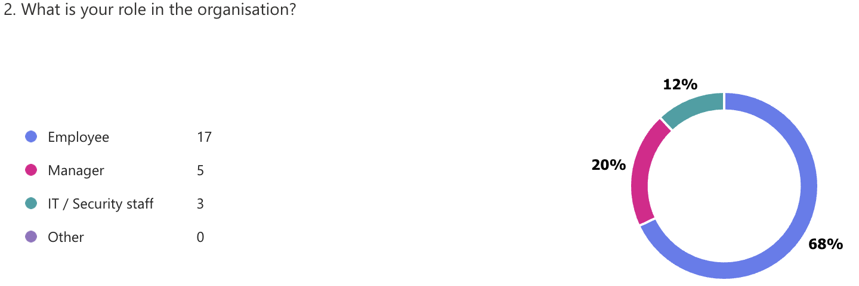
Figure 4.1: Participant Roles
Most participants were employees (68%), followed by managers (20%) and IT/security staff (12%). This indicates that the findings primarily reflect the perspectives of operational staff while still incorporating managerial and technical viewpoints.

Years of Experience
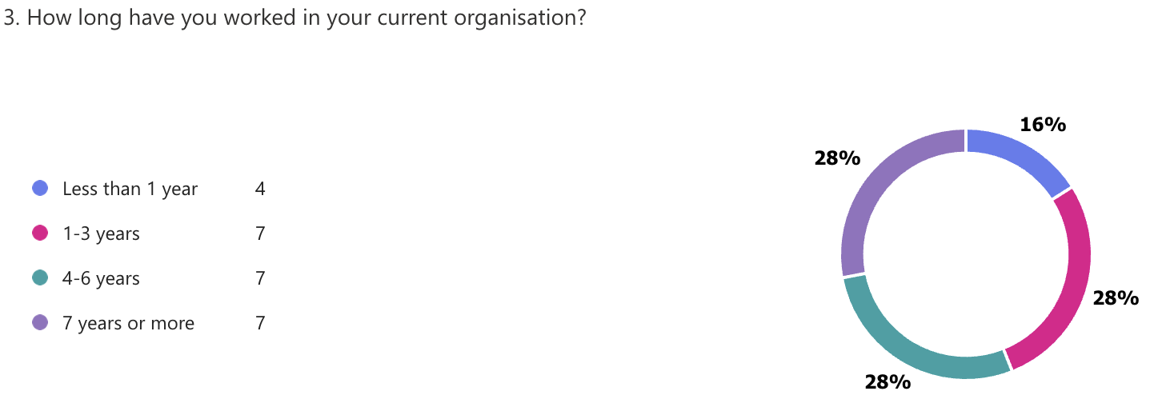
Figure 4.2: Years of Experience

The distribution of experience levels is comparatively balanced, according to the results. 16% of participants had less than a year of experience, and about 28% had one to three years, four to six years, and seven or more years. This implies that both seasoned and inexperienced workers are included in the sample.

Organisation Size

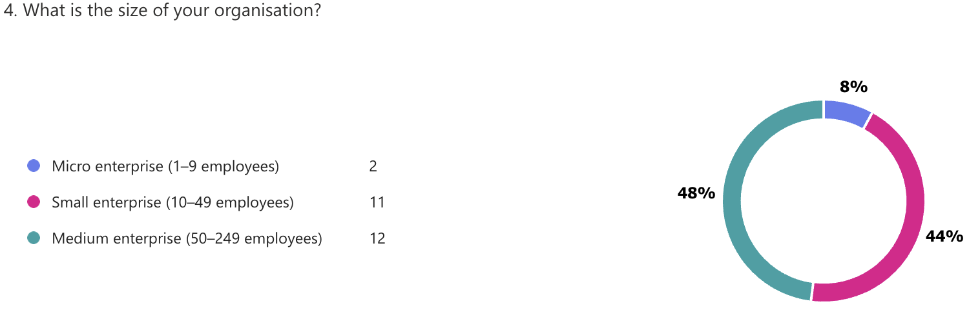
Figure 4.3: Organisation Size

Most participants came from medium-sized businesses (48%), which were followed by small businesses (44%) and microbusinesses (8%). This demonstrates that SMEs are adequately represented in the study.

Industry Sector
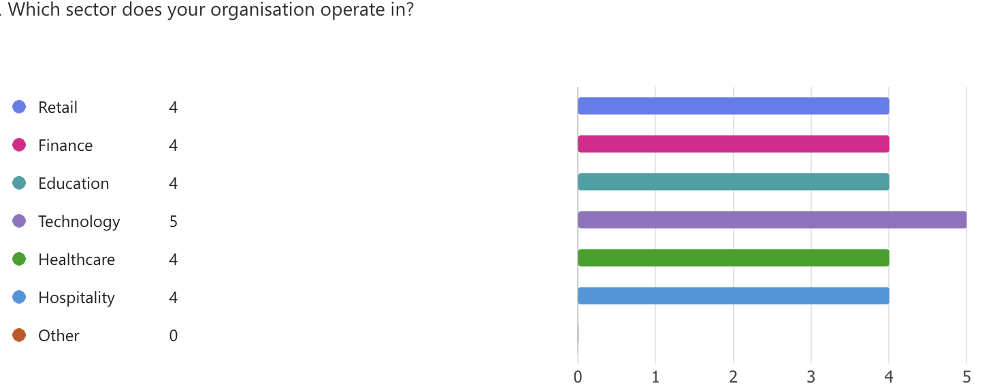
Figure 4.4: Industry Sector

A variety of industries, including technology, retail, finance, education, healthcare, and hospitality, were represented among the participants. The results were more broadly applicable because the technology sector was the most represented while the other sectors were distributed equally.

4.3 Cybersecurity Training Exposure

Training Participation

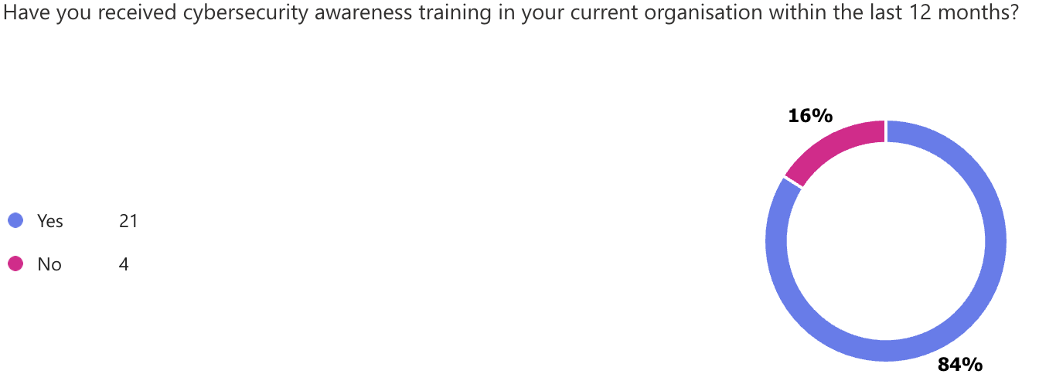
Figure 4.5: Cybersecurity Training Received
A large majority of participants (84%) reported receiving cybersecurity awareness training within the last 12 months, while 16% indicated they had not received any training. This suggests that although most SMEs implement training, gaps still exist.

Training Frequency

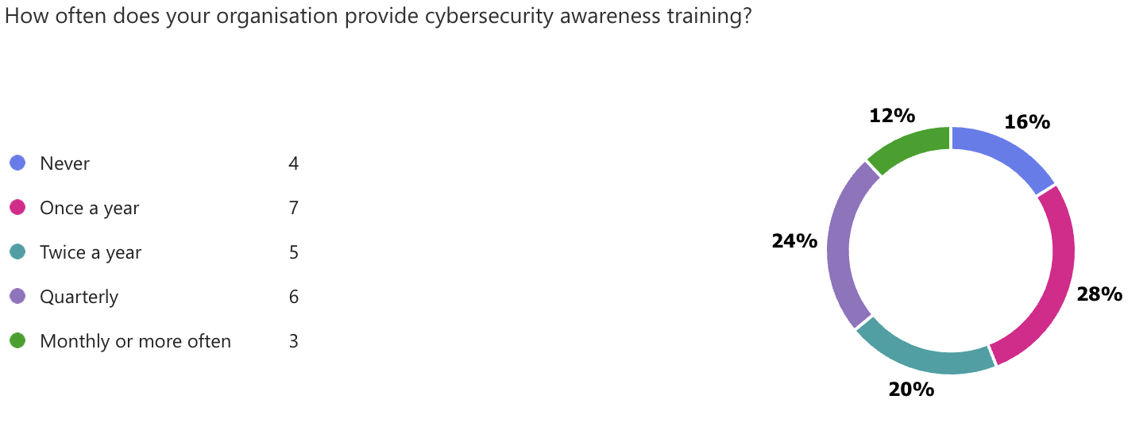
Figure 4.6: Training Frequency

The frequency of training varied greatly. Once a year (28%) was the most frequent frequency, followed by quarterly (24%) and twice a year (20%). Just 12% said they received training on a monthly or more frequent basis, and 16% said they had never received any training. This suggests that different SMEs use different training methods.

Types of Training

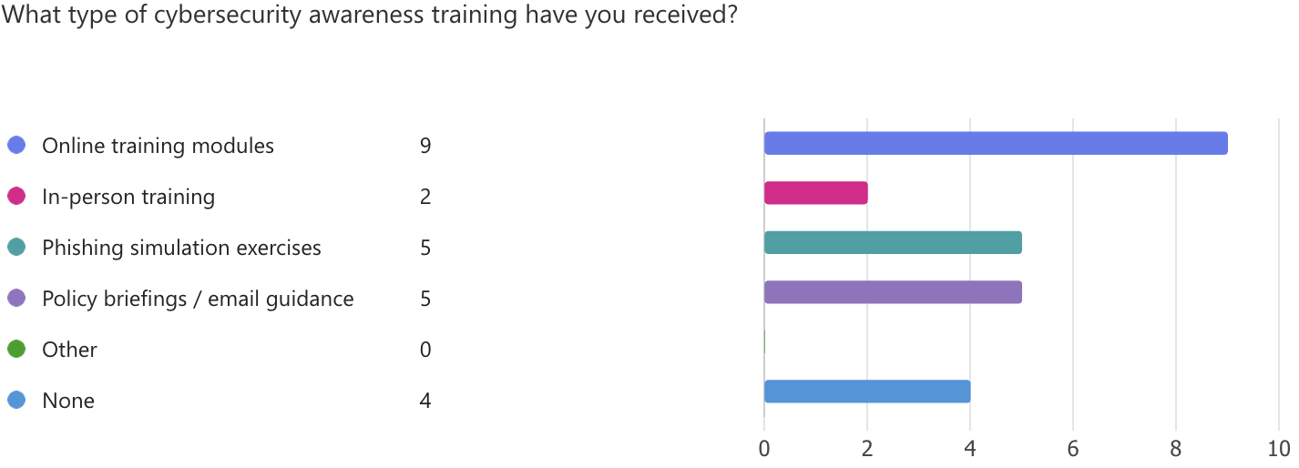
Figure 4.7: Types of Training

The most popular approach was online training modules (36%), which were followed by policy briefings (20%) and phishing simulation exercises (20%). 16% of participants reported receiving no training, while in-person training was less common (8%). This implies a dependence on digital techniques rather than hands-on involvement.

4.4 Perceived Effectiveness of Training
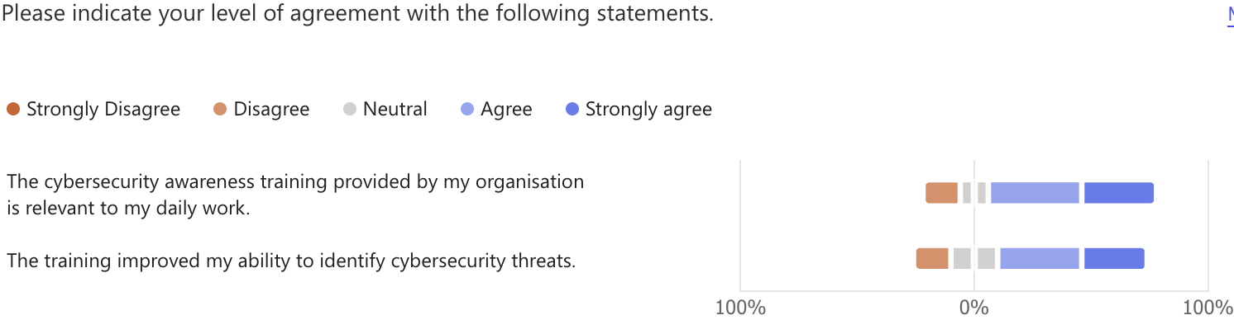
Figure 4.8: Training Effectiveness Perception

Most participants agreed or strongly agreed that cybersecurity training enhances their ability to recognise threats and is applicable to their day-to-day work. However, a tiny percentage held neutral or unfavourable opinions, suggesting that training quality varies.

4.5 Employee Cybersecurity Behaviour
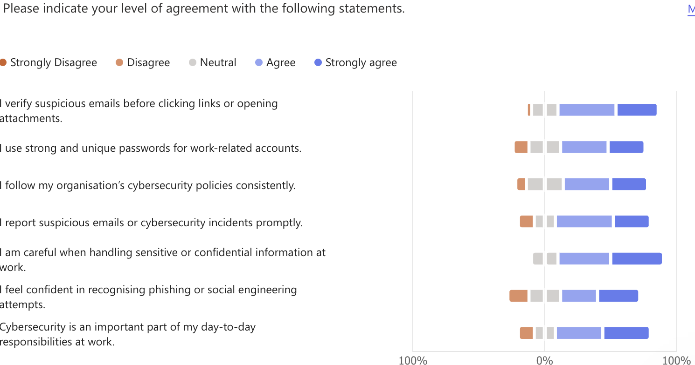
Figure 4.9: Employee Behaviour

Positive cybersecurity behaviours, such as using strong passwords, checking suspicious emails, and adhering to company policies, were generally reported by participants. Additionally, there was a high degree of agreement regarding the careful handling of sensitive information.
There may be a disconnect between advanced threat detection and general awareness, as evidenced by the slightly lower confidence in identifying sophisticated phishing attacks.

4.6 Open-Ended Responses: Key Challenges
Several significant obstacles to upholding sound cybersecurity practices were identified by the open-ended responses:
- Human error
- Insufficient knowledge of cybersecurity
- Time constraints
- Over time, forgetting training
- Phishing attacks' complexity
- Insufficient organisational assistance
These answers demonstrate how organisational and individual factors affect cybersecurity effectiveness.

4.7 Qualitative Findings from Interviews

Theme 1: Practicality and Frequency Determine Training Effectiveness
Participants emphasised that yearly or theoretical training is less effective than regular, hands-on training.
“Training is conducted monthly… and it is very effective due to its frequency and practical approach.”
In contrast:
“It is usually provided once a year… but many employees forget what they learned over time.”

Theme 2: Human Error Remains a Major Risk
In every interview, human error was found to be a major problem.
“Employees are more careful with emails, but mistakes still occur.”
“Some employees ignore guidelines or underestimate risks.”

Theme 3: Common Cybersecurity Threats
Phishing was consistently cited by participants as the most frequent threat.
“Phishing attacks and weak password practices are the most common risks.”
In sensitive sectors:
“Data breaches and accidental sharing of sensitive information are common.”

Theme 4: Organisational Barriers
Several organisational issues were brought up by the participants:
- Time pressure
- Limited resources
- Weak enforcement
“Employees face time constraints…”
“Management mentions cybersecurity but does not strongly enforce it.”

Theme 5: Importance of Management Support
Strong leadership improves cybersecurity practices.
“Management actively supports training and ensures compliance…”

Theme 6: Need for Improved Training Approaches
Participants recommended:
- More practical training
- Role-specific content
- More frequent sessions
“More interactive and role-specific training would improve effectiveness.”

Integration of Findings
By offering a deeper understanding of employee behaviour and organisational challenges, the interview findings corroborate the survey results. Interviews uncover underlying problems like organisational constraints, human error, and training limitations, while survey data shows general awareness.

4.8 Chapter Summary
The study's results were presented in this chapter, emphasising significant developments in employee behaviour, training methods, and cybersecurity awareness in SMEs. The findings indicate that although cybersecurity training is offered by most organisations, its frequency and efficacy differ. Organisational limitations and human error continue to be major obstacles.
These results will be discussed in the following chapter along with the goals of the research and the body of existing literature.

Chapter 5 – Discussion

5.1 Introduction
This chapter examines the results from Chapter 4 considering the goals of the study and the body of current literature. The objective is to critically assess employee behaviour and cybersecurity awareness in UK SMEs, spot important trends, and discuss the implications of the findings. To give a thorough grasp of the subject, the discussion incorporates both quantitative and qualitative findings.

5.2 Cybersecurity Awareness in SMEs
The results show that employees are generally aware of cybersecurity, with most participants exhibiting knowledge of fundamental security procedures like email verification, creating strong passwords, and handling sensitive data with caution. This is consistent with earlier studies that indicate awareness campaigns can enhance worker behaviour and knowledge (Alshaikh, 2020).
Despite this widespread awareness, the findings also show that employees' capacity to identify more complex threats, like phishing attacks, varies. This bolsters the claim made by Parsons et al. (2017) that although awareness training enhances general knowledge, it does not always result in appropriate behaviour in challenging circumstances.
This problem is further supported by the qualitative results, which showed that employees frequently have trouble spotting sophisticated phishing attempts. This implies that awareness on its own is inadequate and needs to be reinforced by more useful and ongoing training methods.

5.3 Effectiveness of Cybersecurity Training
The findings show that most SMEs offer cybersecurity awareness training; 84% of participants said they had received training in the previous 12 months. This reflects organisations' increasing awareness of the value of cybersecurity training (Bada et al., 2019).
However, the frequency and mode of delivery of training seem to have a significant impact on its efficacy. The results demonstrate that many organisations only offer training once a year, which participants deemed inadequate. This confirms earlier studies showing that knowledge deteriorates with time due to infrequent training (Puhakainen and Siponen, 2010).
On the other hand, companies that regularly conducted hands-on training, like workshops and phishing simulations, reported greater efficacy. This is consistent with the findings of Kumaraguru et al. (2010), who contend that experiential learning techniques outperform conventional training methods in terms of improving user behaviour.
The interviews also show that training works best when it is:
- Regular
- Practical
- Relevant to employees’ daily tasks
This implies that SMEs should switch from one-time training sessions to strategies for ongoing learning.

5.4 Human Factors and Cybersecurity Behaviour
The importance of human factors in cybersecurity is one of the study's most important conclusions. Human error continues to be a significant contributor to security risks, according to survey and interview data.
Participants mentioned difficulties like:
- Forgetting training over time
- Ignoring security policies
- Misjudging phishing emails
These results corroborate the work of Workman (2008), who emphasises insider threats brought on by employee actions, and Hadnagy (2018), who emphasises the significance of human behaviour in social engineering attacks.
Inconsistencies persist, especially in more complicated scenarios, even though participants reported generally positive behaviours, such as using strong passwords and verifying emails. This suggests what is known as the "security behaviour gap," a discrepancy between behaviour and knowledge.
The results imply that enhancing cybersecurity in SMEs necessitates a focus on behavioural modification in addition to technical fixes.

5.5 Organisational Factors Influencing Cybersecurity
The study emphasises how important organisational factors are in determining cybersecurity practices.

Management Support
The findings indicate that cybersecurity awareness and compliance are higher in organisations with strong management support. This is consistent with Ifinedo's (2014) research, which highlights the significance of leadership in shaping employee security behaviour.
Participants in the interviews pointed out that more effective training results are a result of management involvement, explicit policies, and enforcement mechanisms.

Resource Constraints in SMEs
SMEs frequently encounter constraints related to:
- Budget
- Time
- Expertise
Both survey and interview results showed these limitations, with participants reporting infrequent training and a dearth of specialised cybersecurity resources.
This corroborates previous research (Bada et al., 2019), which emphasises that SMEs are especially vulnerable because they have fewer resources and give cybersecurity less priority.
Training Design and Relevance
The results imply that the degree to which training is applicable to employees' roles affects its efficacy. Role-specific and practical training was seen as more advantageous than generic training, which was frequently thought to be less effective.
This is consistent with adult learning theory, which contends that learning is more successful when it is immediately applicable to practical tasks.

5.6 Key Challenges in Cybersecurity Awareness
The study found a few significant obstacles that organisations and employees must overcome:
- Human error
- Lack of continuous training
- Time pressure
- Limited awareness in smaller organisations
- Increasing complexity of cyber threats
These difficulties show that cybersecurity is a human and organisational issue in addition to a technical one.
Employees find it more challenging to identify risks due to the growing sophistication of cyberthreats, especially phishing attacks, which emphasises the necessity of continual training and assistance.

5.7 Integration of Quantitative and Qualitative Findings
A more thorough understanding of cybersecurity awareness in SMEs is provided by the combination of survey and interview data.
- The results of the survey reveal broad patterns, including high training participation and favourable self-reported behaviours.
- The results of interviews offer more in-depth understanding of the causes of these patterns.
For example:
- High levels of awareness are suggested by survey data.
- Underlying problems like forgetting training, lax enforcement, and organisational limitations are revealed by interview data.
This mixed-method approach emphasises the intricacy of cybersecurity behaviour while bolstering the validity of the results.

5.8 Implications of the Findings
The study's conclusions have a few useful ramifications for SMEs:
- Training should be continuous rather than annual
- Practical methods such as phishing simulations should be prioritised
- Management must actively support cybersecurity initiatives
- Training should be tailored to specific roles and industries
- Organisations should address human behaviour, not just technical risks
These ramifications imply that enhancing cybersecurity in SMEs necessitates a comprehensive strategy that incorporates organisational support, leadership, and training.

5.9 Chapter Summary
This chapter examined the study's results considering the goals of the research and the body of current literature. The findings demonstrate that although cybersecurity awareness exists in SMEs, organisational factors, human behaviour, and training methods all affect how effective it is.
The next chapter will present the conclusion and recommendations based on these findings.

Chapter 6 – Conclusion and Recommendations

6.1 Introduction
This chapter summarises the study's main findings, makes conclusions about the goals of the research, and offers doable suggestions for raising cybersecurity awareness and employee conduct in UK SMEs. The chapter also identifies the study's shortcomings and makes recommendations for further research.

6.2 Summary of Key Findings
The purpose of this study was to investigate how employee behaviour in UK SMEs is influenced by cybersecurity awareness. The results show that although cybersecurity training is offered by most organisations, its efficacy varies greatly based on a few factors.
First, the findings show that most workers are familiar with the fundamentals of cybersecurity procedures, such as identifying dubious emails and creating secure passwords. Their capacity to recognise more sophisticated threats, especially phishing and social engineering attacks, is still lacking, though.
Second, the study discovered that although cybersecurity training is widely used, it is not always provided in an efficient manner. The yearly training sessions that many SMEs depend on were deemed inadequate by the participants. On the other hand, companies that regularly offered hands-on training—like phishing simulations—reported improved employee awareness and behaviour.
Thirdly, a significant contributor to cybersecurity risks was found to be human factors. Problems like lack of focus, time constraints, and forgetting training material were frequently mentioned. These results demonstrate that cybersecurity is a behavioural problem in addition to a technical one.
Lastly, it was discovered that organisational elements like training design, resource availability, and management support have a big impact on cybersecurity practices. SMEs with well-organised training programs and strong leadership outperformed those with little funding or lax enforcement.

6.3 Conclusion
The results indicate that employee behaviour in SMEs is significantly influenced by cybersecurity awareness. But awareness by itself is insufficient to guarantee safe behaviour.
The study demonstrates that a few elements, such as ongoing training, hands-on learning strategies, strong management support, and organisational commitment, are necessary for effective cybersecurity practices. Even though a lot of SMEs understand how important cybersecurity is, there are still gaps in employee engagement, training frequency, and consistent behaviour.
Therefore, rather than depending only on technical fixes or one-time training programs, enhancing cybersecurity in SMEs necessitates a comprehensive strategy that takes organisational and human factors into account.

6.4 Recommendations
Based on the findings of this study, the following recommendations are proposed:

Implement Continuous Training Programmes
SMEs should switch from yearly training sessions to ongoing cybersecurity awareness initiatives. Employees are less likely to forget crucial security procedures when they receive regular training.

Use Practical and Interactive Training Methods
Training should include practical elements such as:
- Training should include practical elements such as:
- Real-world case studies
- Scenario-based learning
These methods are more effective in improving employee behaviour compared to purely theoretical training.

Develop Role-Specific Training
The roles and responsibilities of employees should be taken into consideration when designing cybersecurity training. For instance, compared to general staff, employees who handle sensitive data ought to receive more specialised training.

Strengthen Management Involvement
To actively support cybersecurity initiatives, management should:
- Enforcing policies
- Encouraging reporting of incidents
- Promoting a security-focused organisational culture
Strong leadership plays a key role in influencing employee behaviour.

Address Human Behaviour Factors
Businesses should acknowledge that human error poses a significant risk and take action to lower it by:
- Simplifying security policies
- Reducing complexity in procedures
- Providing clear and easy-to-follow guidelines

Allocate Resources for Cybersecurity
SMEs should give cybersecurity top priority by setting aside enough funds for knowledge, equipment, and training. Investing in awareness programs can greatly lower risks, even with tight budgets.

6.5 Limitations of the Study
There are a few limitations to this study that should be considered.
First off, the results may not be as broadly applicable due to the small sample size (25 survey respondents and 5 interviewees).
Second, participants may overestimate their cybersecurity behaviour because the data was based on self-reported responses, which could be biased.
Thirdly, because the study's focus was on SMEs in the UK, its conclusions might not apply to larger organisations or other geographical settings.
Notwithstanding these drawbacks, the study offers insightful information about employee behaviour and cybersecurity awareness in SMEs.

6.6 Future Research
Future research could build on this study in several ways:
- Future research could build on this study in several ways:
- Conduct studies with larger sample sizes to improve generalisability
- Investigate the long-term impact of continuous training programmes
- Examine the effectiveness of specific training methods, such as gamification
Such research would contribute to a deeper understanding of how to improve cybersecurity practices in organisations.

6.7 Final Remarks
In conclusion, an essential part of organisational security in SMEs is cybersecurity awareness. Even though training programs have been implemented more successfully, there are still many obstacles to overcome to guarantee consistent and productive employee behaviour.
SMEs can improve their cybersecurity posture and lower the risks related to human error by implementing ongoing, useful, and well-supported training methods.

Reference:

Ajzen, I., 1991. The theory of planned behavior. Organizational behavior and human decision processes, 50(2), pp.179-211.

Alshaikh, M., 2020. Developing cybersecurity culture to influence employee behavior: A practice perspective. Computers & Security, 98, p.102003.

Bada, M., Sasse, A.M. and Nurse, J.R., 2019. Cyber security awareness campaigns: Why do they fail to change behaviour?. arXiv preprint arXiv:1901.02672.

Beck, T. and Demirguc-Kunt, A., 2006. Small and medium-size enterprises: Access to finance as a growth constraint. Journal of Banking & finance, 30(11), pp.2931-2943.

Braun, V. and Clarke, V., 2006. Using thematic analysis in psychology. Qualitative research in psychology, 3(2), pp.77-101.

Bryman, A., 2016. Social research methods. Oxford university press.

Bulgurcu, B., Cavusoglu, H. and Benbasat, I., 2010. Information security policy compliance: an empirical study of rationality-based beliefs and information security Awareness1. MIS quarterly, 34(3), pp.523-548.

Creswell, J.W. and Clark, V.L.P., 2017. Designing and conducting mixed methods research. Sage publications.

Creswell, J.W. and Clark, V.P., 2007. Mixed methods research. Thousand Oaks, CA.

D'Arcy, J. and Greene, G., 2014. Security culture and the employment relationship as drivers of employees’ security compliance. Information Management & Computer Security, 22(5), pp.474-489.

Da Veiga, A. and Martins, N., 2015. Improving the information security culture through monitoring and implementation actions illustrated through a case study. Computers & Security, 49, pp.162-176.
Department for Science, Innovation and Technology (2023) Cyber Security Breaches Survey 2023. London: UK Government.
Enterprise, V., 2018. Verizon 2018 data breach investigations report (DBIR)
European Union Agency for Cybersecurity (ENISA) (2022) ENISA Threat Landscape Report 2022.

Field, A., 2024. Discovering statistics using IBM SPSS statistics. Sage publications limited.

Flick, U., 2022. An introduction to qualitative research.

Greitzer, F.L., Kangas, L.J., Noonan, C.F., Dalton, A.C. and Hohimer, R.E., 2012, January. Identifying at-risk employees: Modeling psychosocial precursors of potential insider threats. In 2012 45th Hawaii International Conference on System Sciences (pp. 2392-2401). IEEE.

Hadlington, L. and Ryding, C., 2025. Human Factors and Cybersecurity: The Psychology of Online Safety and Security. Taylor & Francis.

Hadlington, L., 2017. Human factors in cybersecurity; examining the link between Internet addiction, impulsivity, attitudes towards cybersecurity, and risky cybersecurity behaviours. Heliyon, 3(7).

Heidt, M., Gerlach, J.P. and Buxmann, P., 2019. Investigating the security divide between SME and large companies: How SME characteristics influence organizational IT security investments. Information Systems Frontiers, 21(6), pp.1285-1305.

Herath, T. and Rao, H.R., 2009. Encouraging information security behaviors in organizations: Role of penalties, pressures and perceived effectiveness. Decision support systems, 47(2), pp.154-165.
Ifinedo, P., 2012. Understanding information systems security policy compliance: An integration of the theory of planned behavior and the protection motivation theory. Computers & security, 31(1), pp.83-95.

Jampen, D., Gür, G., Sutter, T. and Tellenbach, B., 2020. Don’t click: towards an effective anti-phishing training. A comparative literature review. Human-centric Computing and Information Sciences, 10(1), p.33.

Jampen, D., Gür, G., Sutter, T. and Tellenbach, B., 2020. Don’t click: towards an effective anti-phishing training. A comparative literature review. Human-centric Computing and Information Sciences, 10(1), p.33.

Jansen, J. and Van Schaik, P., 2018. Persuading end users to act cautiously online: A fear appeals study on phishing. Information & Computer Security, 26(3), pp.264-276.

Jansson, K. and von Solms, R., 2013. Phishing for phishing awareness. Behaviour & information technology, 32(6), pp.584-593.

Johnston, A.C. and Warkentin, M., 2010. Fear Appeals and Information Security Behaviors: An Empirical Study1. MIS quarterly, 34(3), pp.549-566.

Kallio, H., Pietilä, A.M., Johnson, M. and Kangasniemi, M., 2016. Systematic methodological review: developing a framework for a qualitative semi‐structured interview guide. Journal of advanced nursing, 72(12), pp.2954-2965.

Parsons, K., Calic, D., Pattinson, M., Butavicius, M., McCormac, A. and Zwaans, T., 2017. The human aspects of information security questionnaire (HAIS-Q): two further validation studies. Computers & Security, 66, pp.40-51.

Parsons, K., McCormac, A., Butavicius, M., Pattinson, M. and Jerram, C., 2014. Determining employee awareness using the human aspects of information security questionnaire (HAIS-Q). Computers & security, 42, pp.165-176.

Puhakainen, P. and Siponen, M., 2010. Improving Employees' Compliance Through Information Systems Security Training: An Action Research Study1. MIS quarterly, 34(4), pp.757-778.

Rahayu, R. and Day, J., 2015. Determinant factors of e-commerce adoption by SMEs in developing country: evidence from Indonesia. Procedia-social and behavioral sciences, 195, pp.142-150.

Rogers, R.W., 1975. A protection motivation theory of fear appeals and attitude change1. The journal of psychology, 91(1), pp.93-114.

Saunders, M., Lewis, P. and Thornhill, A., 2009. Research methods for business students. Pearson education.

Siponen, M. and Vance, A., 2010. Neutralization: new insights into the problem of employee information systems security policy violations1. MIS quarterly, 34(3), pp.487-502.

Sommestad, T., Hallberg, J., Lundholm, K. and Bengtsson, J., 2014. Variables influencing information security policy compliance: A systematic review of quantitative studies. Information Management & Computer Security, 22(1), pp.42-75.

Sommestad, T., Karlzén, H. and Hallberg, J., 2015. The sufficiency of the theory of planned behavior for explaining information security policy compliance. Information & Computer Security, 23(2), pp.200-217.

Thong, J.Y., 1999. An integrated model of information systems adoption in small businesses. Journal of management information systems, 15(4), pp.187-214.

Timmermans, S. and Tavory, I., 2012. Theory construction in qualitative research: From grounded theory to abductive analysis. Sociological theory, 30(3), pp.167-186.

Vishwanath, A., Harrison, B. and Ng, Y.J., 2018. Suspicion, cognition, and automaticity model of phishing susceptibility. Communication research, 45(8), pp.1146-1166.

Appendices
Cybersecurity Awareness and Training in UK SMEs
This survey is part of an academic study exploring cybersecurity awareness and training in UK small and medium-sized enterprises (SMEs). Participation is voluntary and anonymous.

Appendix A: Survey Questionnaire
Section A: Participant Information

1: What is your role in the organisation?
- Employee
- Manager
- IT / Security staff
- Other

2: How long have you worked in your current organisation?
- Less than 1 year
- 1–3 years
- 4–6 years
- 7 years or more

3: What is the size of your organisation?
- Micro enterprise (1–9 employees)
- Small enterprise (10–49 employees)
- Medium enterprise (50–249 employees)

4: Which sector does your organisation operate in?
- Retail
- Finance
- Education
- Technology
- Healthcare
- Hospitality
- Other

Section B: Cybersecurity Awareness Training

5: Have you received cybersecurity awareness training in your current organisation within the last 12 months?
- Yes
- No

6: How often does your organisation provide cybersecurity awareness training?
- Never
- Once a year
- Twice a year
- Quarterly
- Monthly or more often

7: What type of cybersecurity awareness training have you received?
- Online training modules
- In-person training
- Phishing simulation exercises
- Policy briefings / email guidance
- Other
- None

8: The cybersecurity awareness training provided by my organisation is relevant to my daily work.
(5-point Likert scale)

9: The training improved my ability to identify cybersecurity threats.
(5-point Likert scale)

Section C: Employee Cybersecurity Behaviour

10: I verify suspicious emails before clicking links or opening attachments.
(5-point Likert scale)

11: I use strong and unique passwords for work-related accounts.
(5-point Likert scale)
12:I follow my organisation’s cybersecurity policies consistently.
(5-point Likert scale)
13: I report suspicious emails or cybersecurity incidents promptly.
(5-point Likert scale)
14: I am careful when handling sensitive or confidential information at work.
(5-point Likert scale)
15: I feel confident in recognising phishing or social engineering attempts.
(5-point Likert scale)
16: Cybersecurity is an important part of my day-to-day responsibilities at work.
(5-point Likert scale)
Section D: Open Question
17: In your view, what is the biggest challenge in following good cybersecurity practices at work?

Appendix B: Interview Questions
1: Can you describe the cybersecurity awareness training used in your organisation?
2: How often is this training provided, and who usually takes part in it?
3: In your opinion, how effective is the training in improving employee cybersecurity behaviour?
4: Have you noticed any changes in employee behaviour after training?
Please give examples if possible.
5: What types of cybersecurity risks are most common in your organisation?
6: What difficulties do employees face when trying to follow secure cybersecurity practices?
7: How does management support or influence cybersecurity awareness in your organisation?
8: Do you think the current training is relevant to the daily work of employees? Why or why not?
9: What organisational factors make cybersecurity training more effective or less effective?
10: What improvements would you recommend for cybersecurity awareness training in SMEs?

