  FUNDAMENTALS OF CONSTRUCTION TECHNOLOGY  Site Investigation Case study | MODULE: Fundamentals of Construction Technology. MODULE CODE: ACBA4001  Mustafa Omar (2015656)

Table of contents

Introduction

Location

History of the Site

Summary

Investigation

History/current Land Use

Pollution incidents

Landfill/Waste site

Ground Conditions

Made Ground

Chemical Test Results

Geotechnical Testing

Risk Assessment

Historical Maps and Figures

referencing

introduction

“City and County of Swansea and Marriot Hotels joint agreement to create a new ice-cream parlour on Swansea foreshore, the proposal will also include manager’s apartment and staff welfare facilities. the building, which is to share parts of the car park of both existing adjacent facilities, is to have a GIA (Gross Internal Area) at ground floor level of approximately 300 square metres.”
The Desk Study Report (Mustafa Omar, Report NO2015656 17/11/2020) details include of the ground conditions, history of the site and the presence of the neighbouring, also include the following
- risk assessment
- geotechnical parameters
- summary of the ground conditions
This report reviews the desk study figures. and gives a summary of the ground conditions.

Location
The site is currently part of Swansea civic centre and Marriot Hotel. It is in an area which is believed to have been a flood plain and was poorly drained. The site is used for a car park, (51°36′47.″N 3°56′44″W) approximately 3km on each side, coving surface of approximately 300 square metres. the site overlooking the Swansea Marina, shows (figure 1)
Proposed Development
“the building is to contain the restaurant, café bar, ice-cream parlour, kitchen, food stores etc. At second floor level, there is to be a self-contained manager’s apartment and staff welfare facilities.”

History of the site

From historical mapping, the Site is indicated to have been housing from the earliest map edition to the current map edition. Historical map and site history dating back to 1950s and the present day shows (figure 2)
the site of the years shows surrounding area have been developed since 1980s and the site itself has been used for a car park for both Swansea Library and the Marriott Hotel.
Period | Distance m Direction | Comment
1956 – 1964? | On site | Unknown use
1964 to present | On site | Car Park

Since the redevelopment of the surrounding area, the site itself has not been develop or had a major construction built.

Summary

Swansea’s South Dock closed in 1971 and The North Dock closed in 1930 but each area was redeveloped in the 1980s and since then the site has been used for public car park.

Investigation

Current Land Uses

Currently the site is between two car park Swansea civic centre on the west and part of Marriott hotel car park on the east of the site, shown on figure 1.

Pollution
Based on the history of the site and surrounding area
Waste, transfer and disposal, there are no listings for waste treatment, recorded withing 15m to 20m
The following is a summary of the main points for the Waste section and Pollution:
Waste | No entries within 15m
Contamination | There are (0) recorded contaminated
Pollution | There are (0) recorded pollution
contamination or pollution: recorded (0) entries or notices on the Contaminated Land Register listed on, within 150m of the site.

Ground Condition

Made Ground
Made ground It contain grey gravels of rock sub-base below a surface layer of grey concrete of 200mm thick which did not appear to comprise reinforcing bars.
more investigation of the Swansea Clay sequence beneath a covering of made ground as follows:
Stratum | Depth to base | Thickness
Made Ground | 0.22m to >0.95 | 1.3m to >1.5
Swansea Clay | Proven to 6.2m | 5.2m proven

Groundwater in Standpipe
Groundwater was recorded at depths of between 1.3 to 3.9 m bbl. DS103 was dry to the base at 2.9 m.

Geotechnical Testing
The results of Geotechnical testing are yet to be reported.

Monitoring soil Gas
No information is available currently.

Chemical Analysis
The result and the sample are yet to be reported.

RISK ASSESSMENT
in order or to take in to account the above discussion, the assessment risks are as follow:
Source hazard | Pathway | Receptor | Explanation | Assessed risk
Contaminated soil:  Site and off-site sources made ground | Contact | Construction Workers | - No visual/factory evidence of soil contamination and all contamination were below threshold level  - any risks to construction workers will be controlled using appropriate PPE  - A watching brief should be kept during construction and if obvious or suspected contamination is encountered this should be dealt immediately. | Low
Contaminated Soil: on site |  | Surface water | The site is in a low environmental sensitive setting | low
Ground Gas: site and off-site | Migration | End user building | Gas monitoring has not been undertaken, but a very low risk is considered applicable at this site | Very low

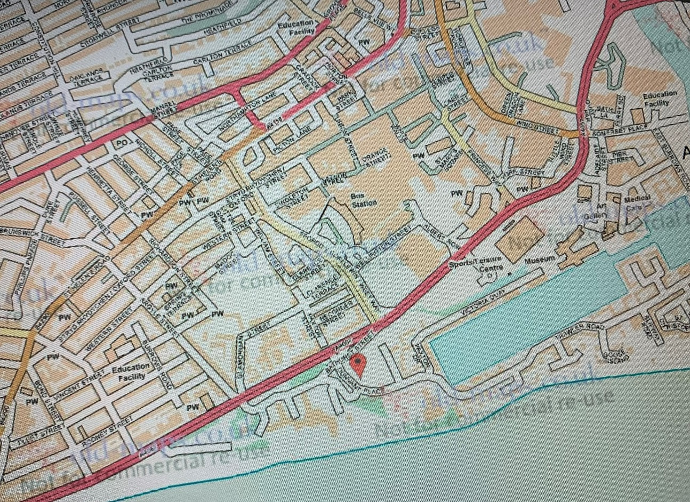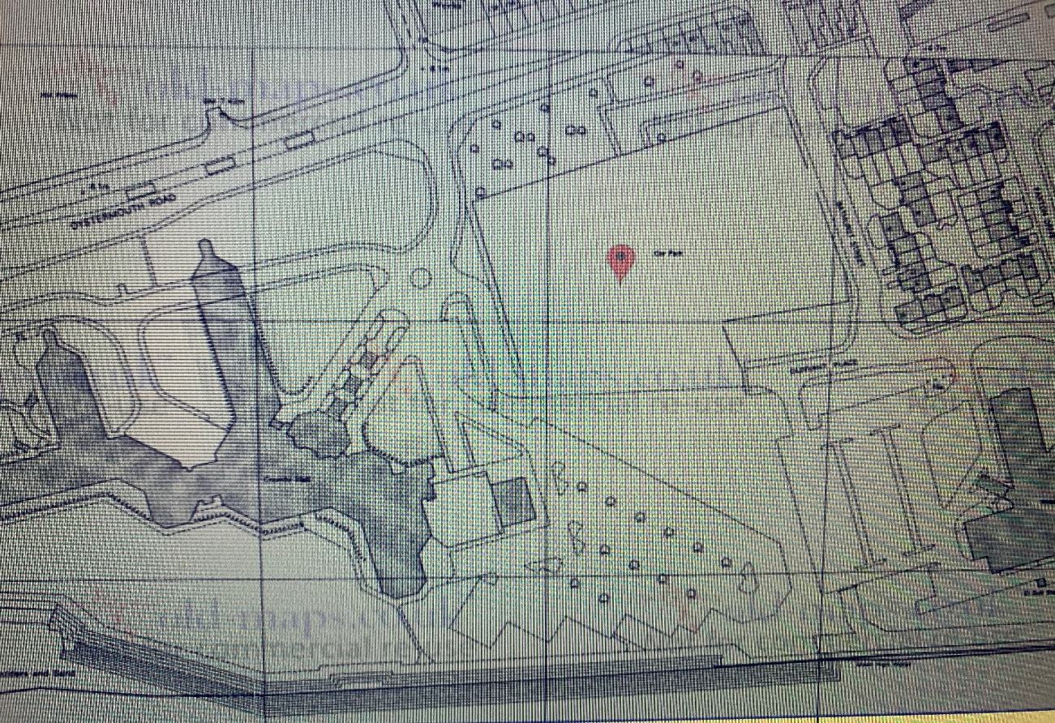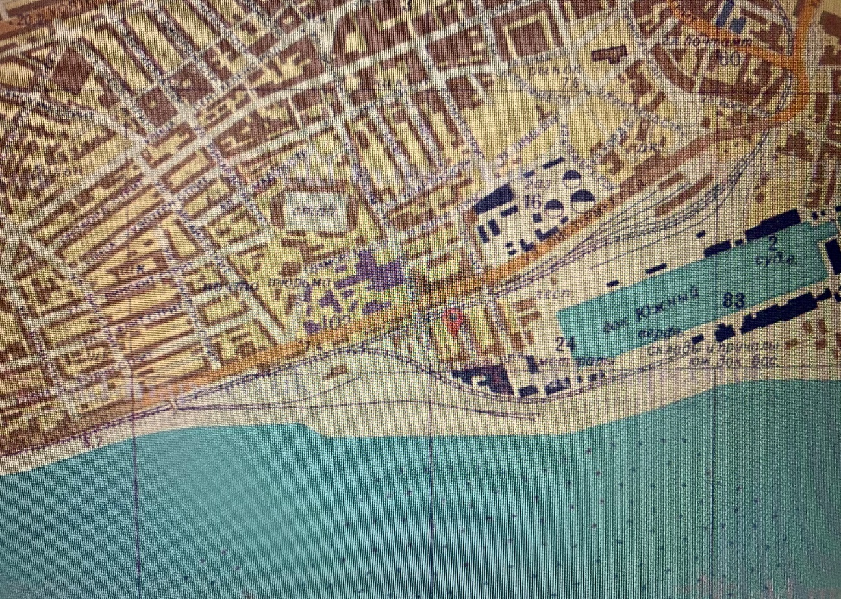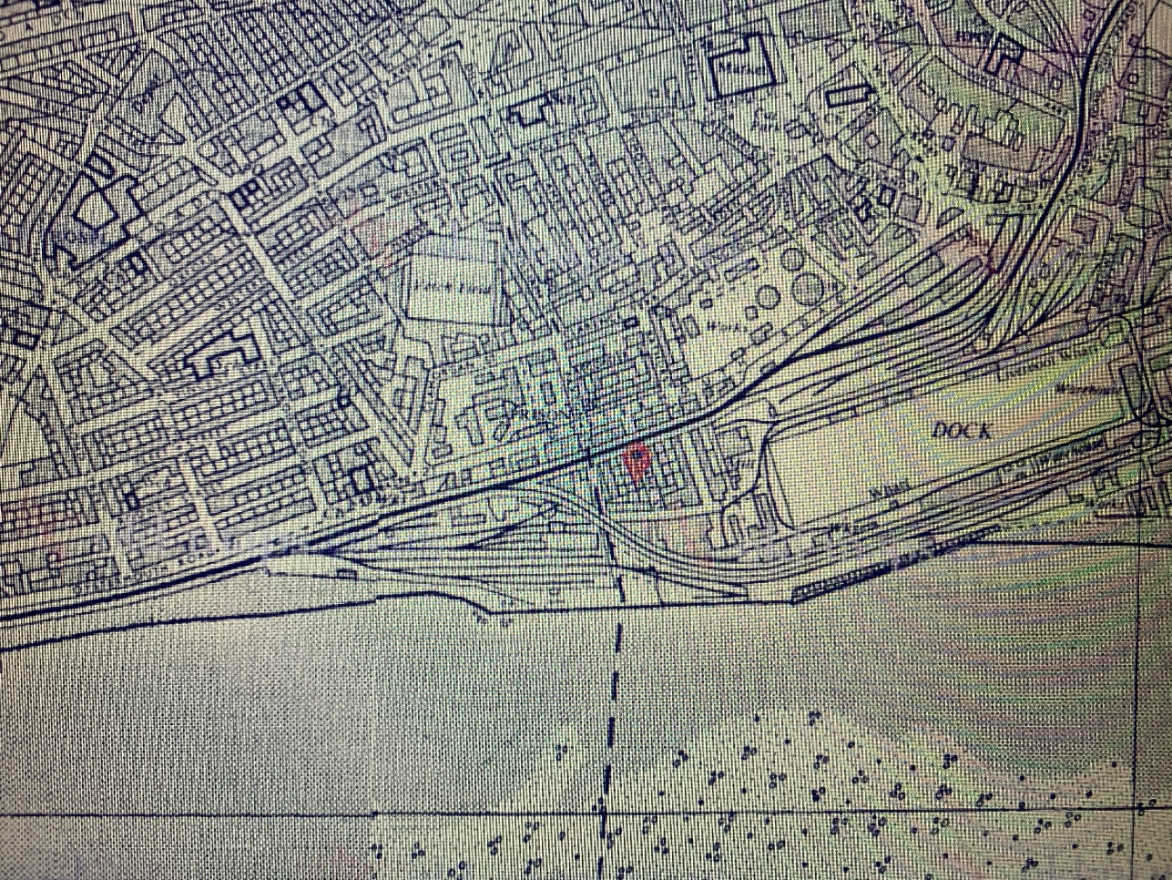 (n.a n.d.)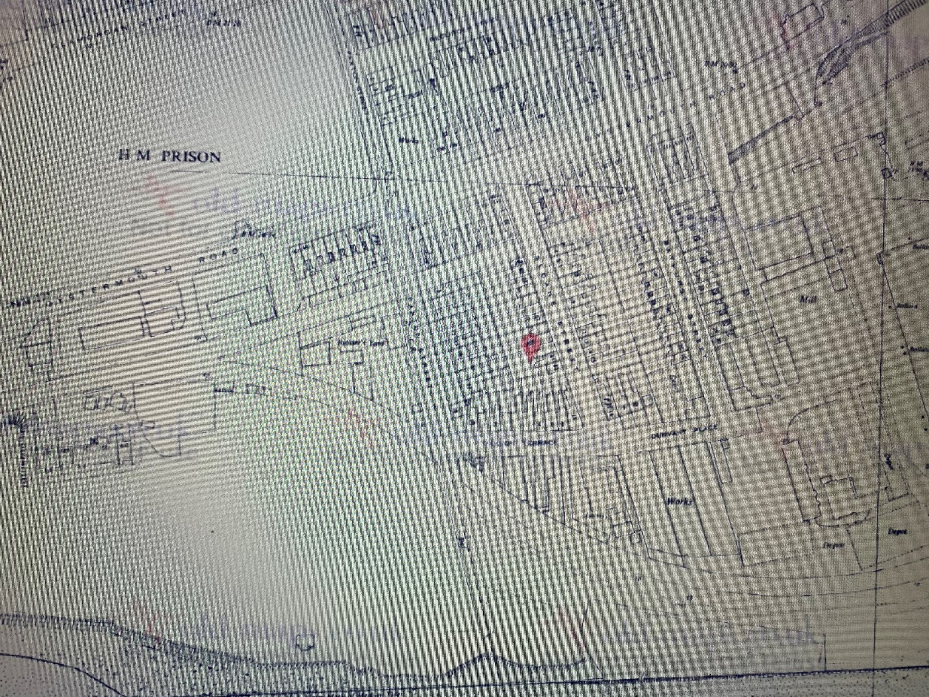 (n.a n.d.)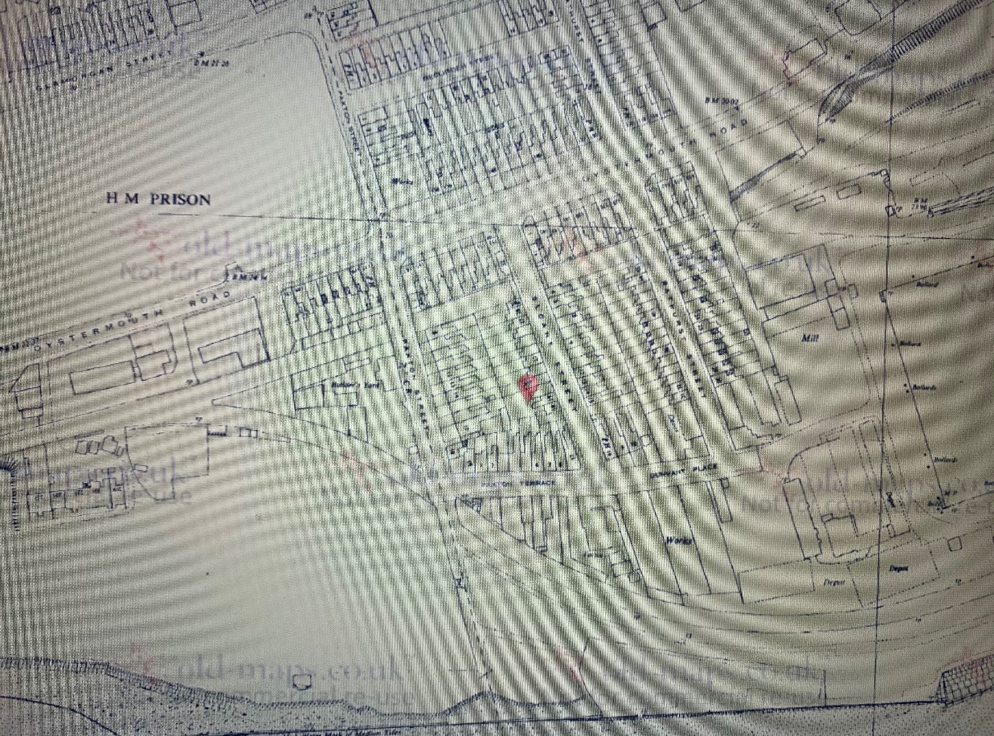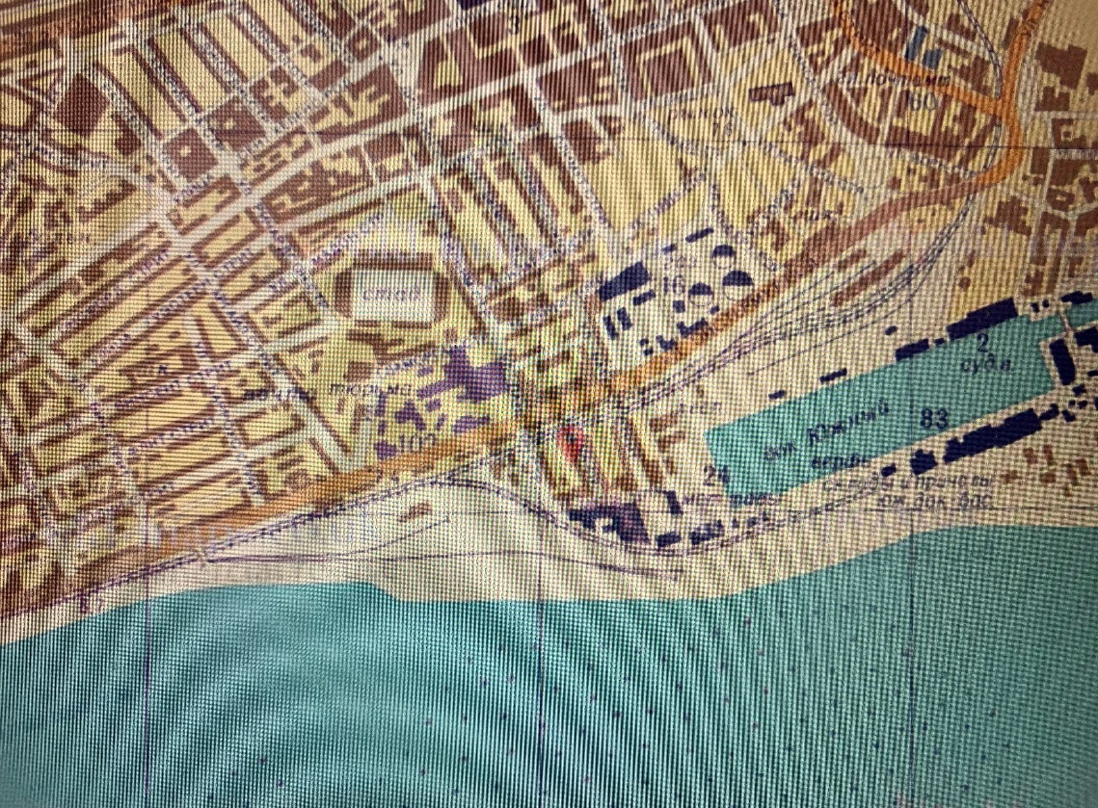 (n.a n.d.)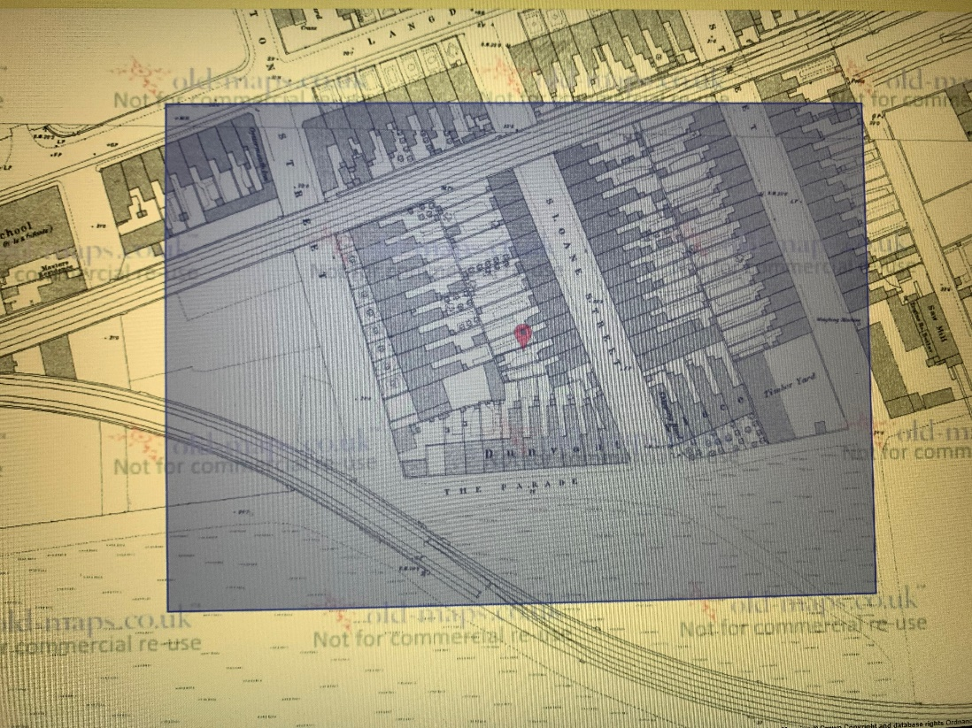 (n.a n.d.)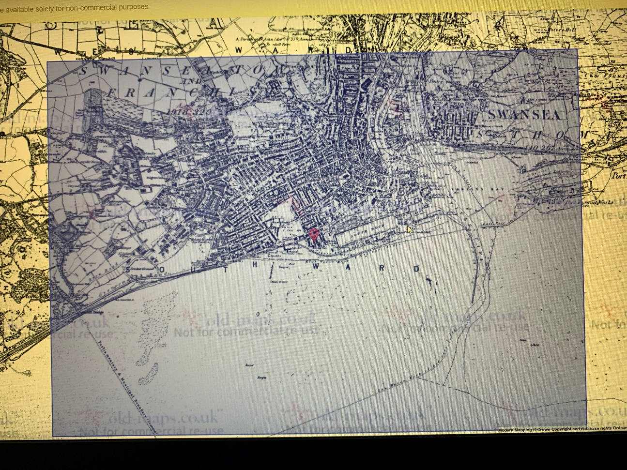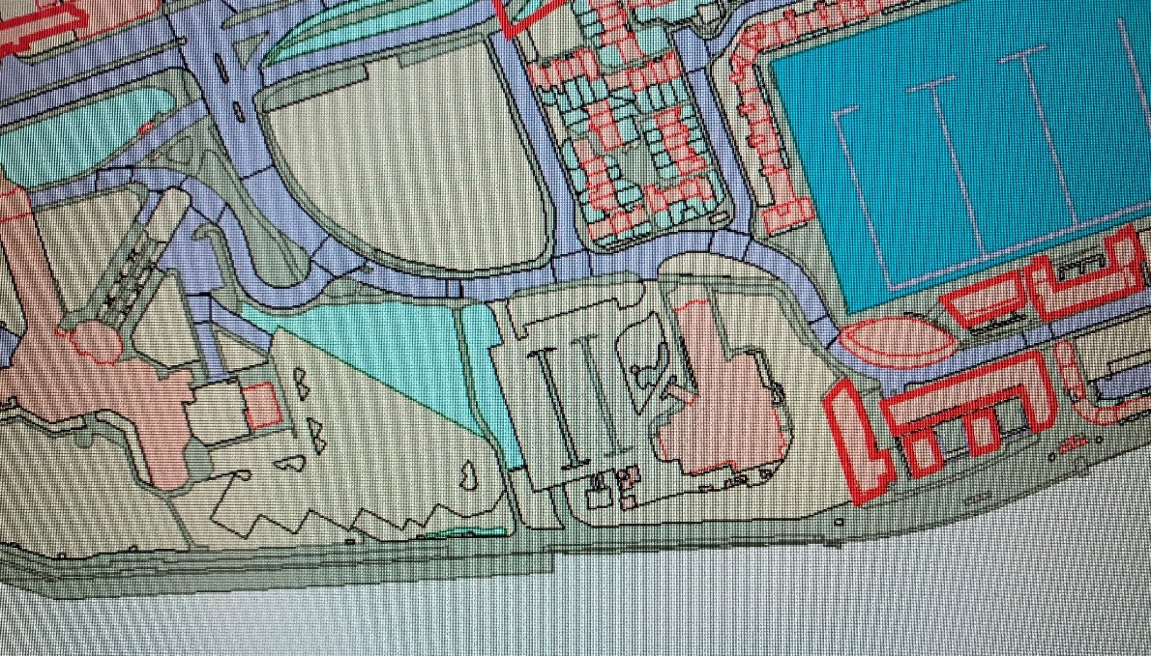 (n.a n.d.)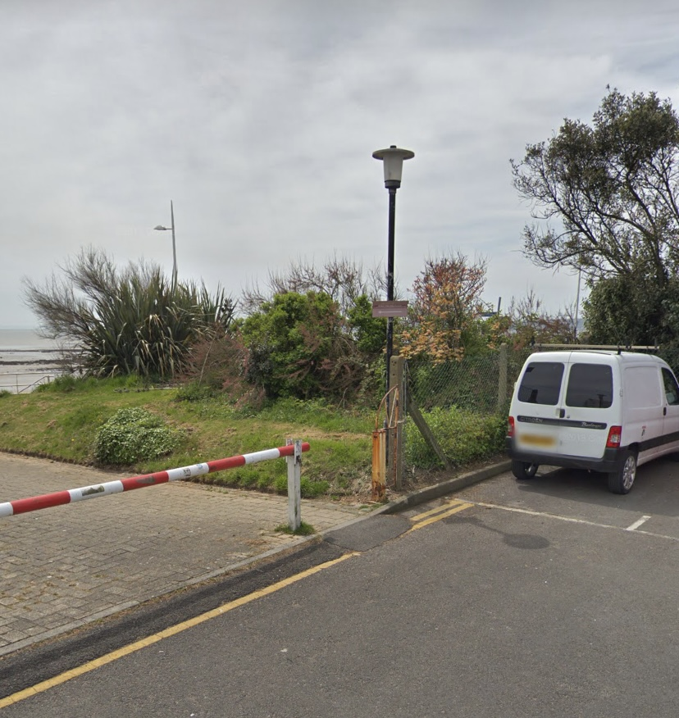 (google n.d.)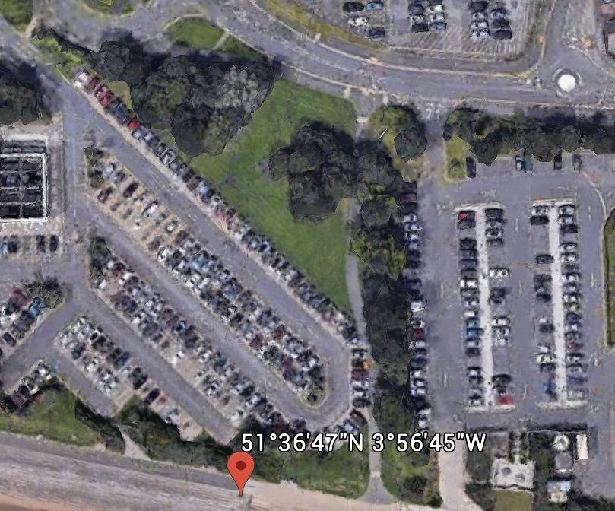 (google n.d.)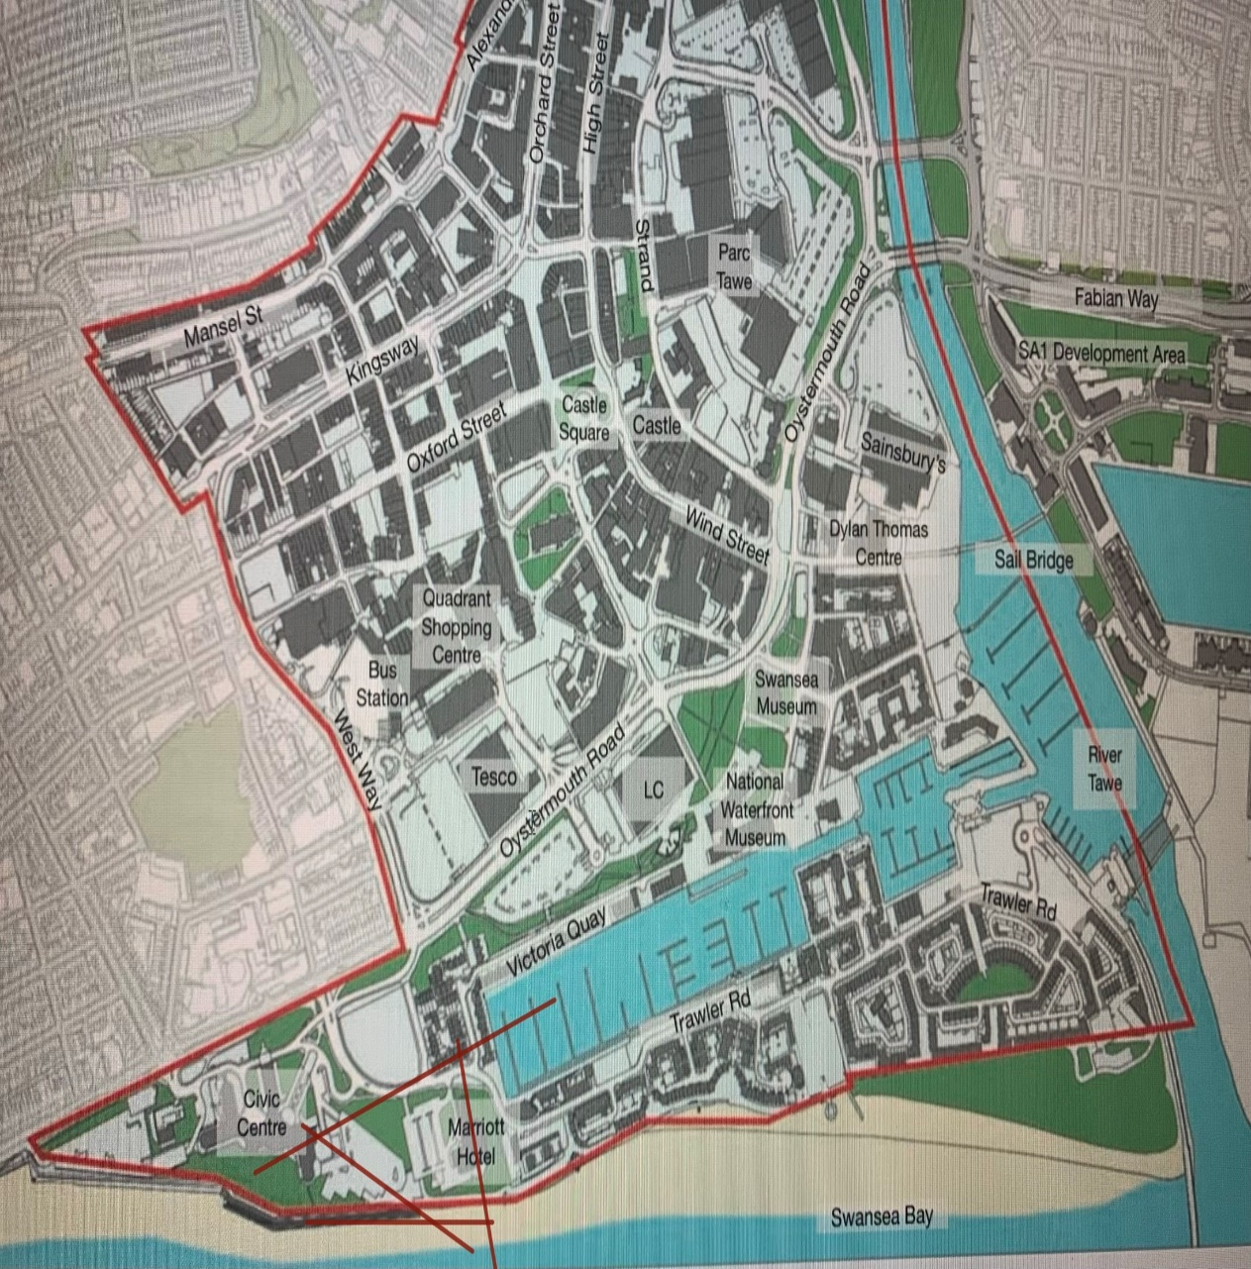 (n.a n.d.)
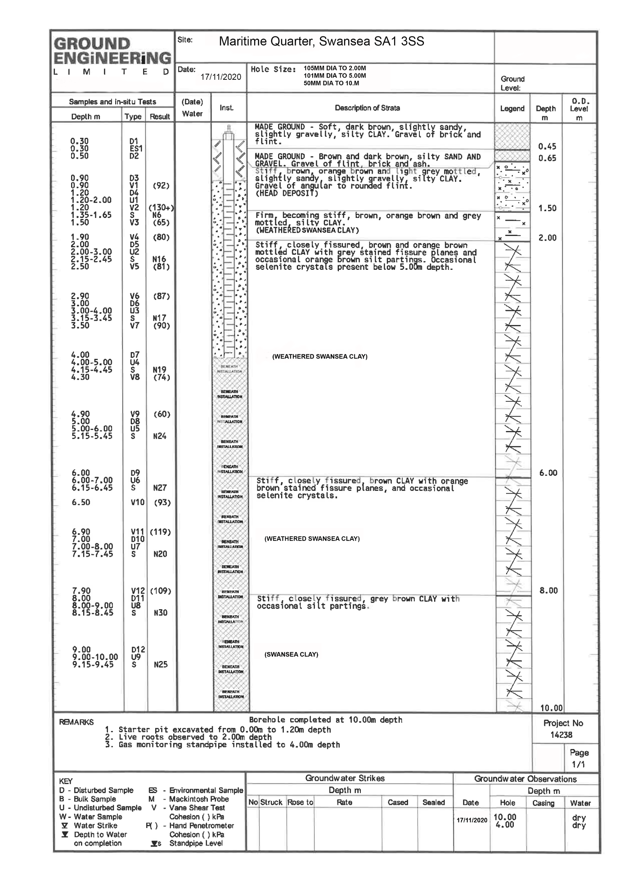

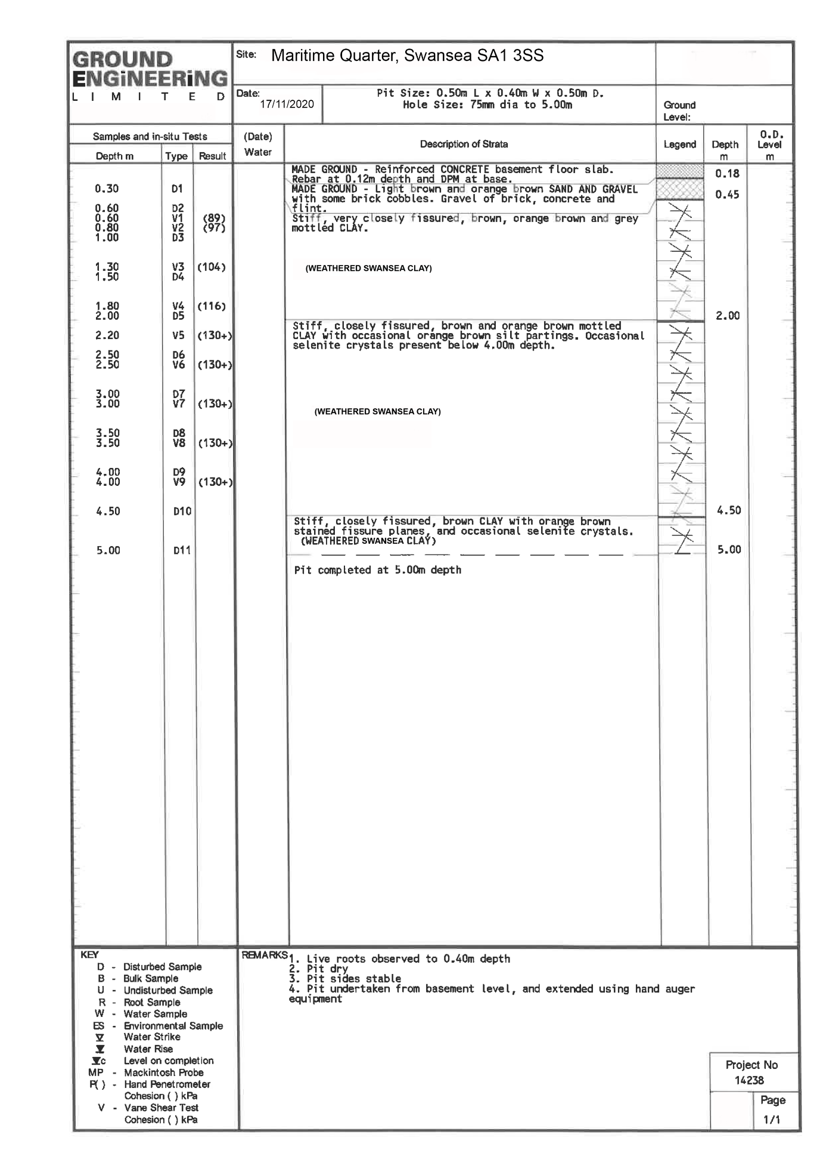

Reference
file:///C:/Users/44730/Downloads/UDP_Written_Statement_Final_Version%20(1).pdf

https://property.swansea.gov.uk/online-applications/ (planning application reference 2015/2506). Where possible, these primary sources of information are included in the annexes of this report. Other, secondary, sources of information that have

https://www.library.wales/discover/digital-gallery/maps/

(n.a n.d.)
(google n.d.)

