
Student Name: Sai kiran Reddy Chitukula
Student ID: 2126691
Submission: Rework
Module: Marketing management
Module code: LCMB7001
Module Component: Assignment 1

A report on marketing analysis of the company Samsung
Table of contents:
Introduction……………………………………………………………………………………………………………2
Discussion and analysis…………………………………………………………………………………………….3
Integrated Marketing Communication………………………………………………………………………4
- Offline Promotional strategy………………………………………………………………………....5
- Online promotional Strategy………………………………………………………………………….5
Keller’s brand Equity Model………………………………………………………………………………………6
Five Challenges of company……………………………………………………………………………………...8
Importance of marketing strategies…………………………………………………………………………10
Stages in customer Journey……………………………………………………………………………………11
Touchpoints of Samsung…………………………………………………………………………………………12
Customer Journey Map…………………………………………………………………………………………..13
Advantages and disadvantages of Customer Journey Map……………………………………..13
Conclusion…………………………………………………………………………………………………….14
References…………………………………………………………………………………………………….15

1. Introduction
The company Samsung, is a huge company that runs its business all over the world. It is a South Korean company and this company is counted as the world’s largest electronic devices producer, the company Samsung specialized in a wide variety of industrial and consumer electronics which includes integrated systems, memory chips, semiconductors, and, digital media devices. This company has become one of the most recognizable names in south Korea as it supplies about of fifths Koreas exports (Shamoun and Elayan,2020). The company Samsung started its business with a grocery store in 1938 in the month of March 1 by a person named Lee Byung-Chull. He started his business in a place called Taegu which was situated in Korea. Lee-Byung-Chull use to use to trade the noodles and other goods produced around the city and used to export those to the country of China. The company Samsung involves in various fields such as semiconductors, home appliances, electronics, aerospace industries, and various textiles (Hidirgolu, 021).
In the year 1980, the company Samsung received the Gumi-based Hanguk Jeonja Tongsin and ten entered the marketing of telecommunications hardware. Samsung use to produce hardware like switchboards which were developed in the fax manufacturing systems and telephones which later on became developed into the fax and telephone manufacturing systems and became the very vast mobile phone manufacturing systems. The company Samsung has produced about 800 million phones today (Shamoun and Elayan, 2020). In the year 1987, the founder of the Samsung company Lee expired after his death the company Samsung was divided into five business groups named as JoongAng group, Hansol Group, CJ Group, Shinsegae Group, and Samsung group. The Shinsegae departmental store was considered the original part of Samsung. From the year Samsung company started their heavy investment in development and research, which was very critical to push the company above the global industries. In the year 1982 the company Samsung built a television whose assembly parts were made in Portugal; in 1984 Samsung set up its plants in New York, one in Tokyo in the year 1985, and in the year 1987 they built their company with various facilities in the country England, later on, the spread their business in Texas and Austin in the year 1987. The company had invested about US $ 13,000,000,000 in the facility of Austin. This investment that Samsung made in Austin made it the largest foreign investment in the place of Texas which was the world’s single largest investment in the United States (Hidirgolu, 2021).
In the year 1987, the United States made an argument over the company Samsung group of South Korea that they were selling computer chips unlawfully in the markets of the United States. Which made Samsung pay a large amount of penalty to the Texas instruments which the company had to pay in the recent week only (Shamoun and Elayan, 2020). And it was said by the United States that if the company does not pay the penalty the selling of the chips would be banned in the country. After the year 1990, the company Samsung had globalized increasingly in its activities and electronics, the source of mobile phones and semiconductors had become its main source of income. In the 1990s the company had a big time when it raised its corporation internationally (Toma and Catana, 2021). The branch of construction of Samsung was been awarded one of the Burj Khalifa in the United Arab, Tapei 101 in Taiwan, and two Petronas towers in Malaysia. In the year 1993, the company sold its ten of groups of subsidiaries which downsized the company, and the company was merged and was fully concentrated in the three industries which were chemicals, electronics, and engineering. And in the year 1996, the company Samsung received the group and made a foundation at the Sungkyunwan university. In 1992 Samsung had become the largest producer of memory chips. In the marketing competition with Intel Samsung came after it, as Intel was the best maker of memory chips. This way Samsung had entered the most powerful marketing in the world (Hidirgolu, 2021).

2. Discussion and Analysis

Marketing strategies of the company Samsung
The brand ambassador Samsung uses its best strategies to get the best in their marketing, as the company wants to promote their devices, Samsung has used the strategy to combine with the celebrities so, the celebrities use to promote their businesses and phones through different media and social media platforms through advertising. As the company use to collab with the A grade celebrities, as they have a very large fan base it helps the company to get a huge promotion for their products and especially mobile phones (Toma and Catana, 2021). The strategy of digital marketing and having great success is assigned to its accomplishment of the social currency and good marketing results. The social currency is characterized as the brand being completely engaged with the customers and always being ready for sharing their knowledge with the customers. The company always provides a very good experience to their customers as Samsung experiences and makes brand loyalists and share the customer experience in the Samsung circle only.

Integrated Marketing Communication:
The concept of IMC emerged in the late twentieth century, the importance of Information technology is growing over in time and shows a impact on marketing communication, this brings a change in domain in marketing in terms of communication (Kitchen, 2004)
This impact of communication change, make a way and open different ways to reach out customers effectively, and maintain a long term relation with them, IMC can help you in creating a strong and consistent message towards customers in various channels, this method is helps to find the right target audience by using medium of platforms like Social media, direct messages, emails, to make them aware about our products. (Kitchen, 2004) IMC approach alings short and Long term marketing to avoid the conflicts in organizations, and IMC is clear approach basically for targeted audience, mostly the one-to-one communication is recommended to see growth leads to synergy and finacial benefits increases.

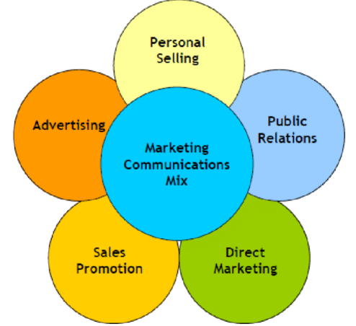
Source: (researchgate, 2015)
Offline promotion strategy:
We all know that Samsung is price sensitive product, they offer a lot of variants in mobile prices by covering all economic classes, from high-end smartphones to budget smartphones. But they are still lacking in the race, I suggest some offline promotional strategies that add some value to their present offline strategies.
Samsung opened the world’s largest store in India which is 3300 Sqft named an opera house ( (Gill, 2018) we all know that India is the second largest country in terms of population after china, so the reach of products of Samsung are more. This is considered one of the most advantages of Samsung because their rivals like Apple and google don’t have flagship stores in India.
Having the world’s largest store, Samsung could use this opportunity to increase its offline sales, after the pandemic people become more cautious about what they touch, and where they go, so the store should be well-maintained and follow necessary safety precautions to attract more customers to visit the stores often. So I recommend an in-store environment is more favorable to customers to tackle their fear.
By Merging Technology with physical touch, most people tend to touch premium products and feel the quality of products, I recommend Samsung need to start a Virtual Room in each store that demonstrates, how to use their devices effectively, how the device add more value to their daily life, an virtual reality proto of customers that immerse own characters into different games while exploring their products. This virtual room will create a new feeling of exploring the technology within the store.
Exclusivity campaign most of the products of Samsung are in premium pricing also, keeping that in mind I recommend an exclusivity campaign should be implemented, in the most popular countries, like the US, UK, India, and China. The exclusivity campaign includes a showcase of their future technology advancement in selected stores, to touch and feel their products exclusively before the release of the product in online channels the latest Samsung products, by continuing the same aesthetic experience of shopping for their loyal customers.
Online marketing strategy
The brand representative of Samsung company uses the best strategies of her company and these strategies were helps us to the g of the ‘company Samsung has used the strategy to combine with the celebrities so, celebrities use to promote their businesses and phones through different media and social media platforms through advertising. As the company uses to collab with the A grade celebrities, as they have a very large fan base which helps the company to get a huge promotion for their products and especially mobile phones and some methods of online marketing strategies is Online advertising interconnects clientele with e-mails, chat, social media. Offline promotion connects the consumer with their cell phone number and team They are constantly doing this to sustain their reputation as well as fame, and they must go to work hard in charge to do so. When it happens to social mass media advertising, they use Instagram, Facebook, and YouTube to assist them in creating good revenues as well as making a big impact on operators and followers
Keller’s Brand Equity Model:
The Brand identity can create a positive impact in customers mind, this brand equity model is proposed by Keller, a professor in America, this model discuss about need of Brand equity for a company and how the customers feels towards your brand, and Keller states that in his studies that the brand equity can create strong loyal –base customers.
There are some major steps in this model based on customer prescriptive, states that specific value of brand from customers view point basically the series of steps can be followed after completion of each step. Keller use pyramid to showcase his model with 4 steps
WHO are you (brand identity),What are you (Brand meaning), What about You (response of brand), What about relationship with brand
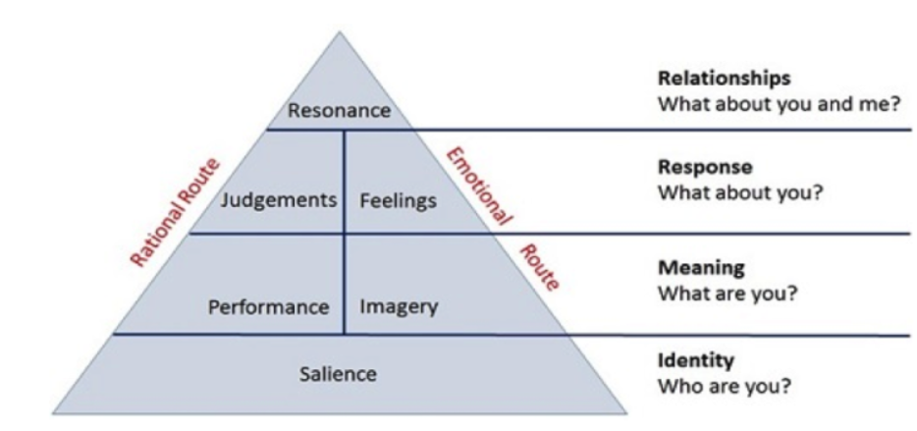
Source: Keller brand equity Model (2019)
Brand Identity:
Customers should aware and know about your company, the key component in this stage is to develop a strong brand identity, this stage is called “brand salience” this is the base or first step in the pyramid, if the base is strong then rest of the stages are more strong.( Bhasin, 2019) Samsung has a strong heritage background back from 1969, a Korean company which impacts an world wide mobile market, in Korean Samsung means 3 stars, the company moto is to shine like a star founded by Byung Chull’s (Samsung, 2023) and the iconic logo of Samsung is sleek and Eye catching logo created in 2005 and they are updating their letter marks to current trends.

Brand Performance:
This is the key step, the performance of the brand is important for customers, the companies Like Samsung, Apple, Google, became popular because of brand performance, because the performance of the brand over time is loved by customers, here Samsung gains a huge market share by its performance, mostly Samsung products are right fit for current technology, the brand has good monetary value, the product category especially in mobile sector is high cost as well as affordable prices of brand. The brand value of Samsung is USD 87.7(Samsung, 2022) billion which compared to 17% increase in 2021-2022 and became the top valuable electronic brands in the world this shows the performance of Samsung in electronic segment is dominating the other Mobile and electronic brands all over the world.
Brand Response:
This refers how the response of customers to the brand products, the customers has some expectations, whenever they buy products, the response or Judgement passed is based on the satisfaction of customers after they use the products (Bhasin, 2019) Samsung has good social media handles at various social media platforms, mostly Samsung response to all the customer queries and responding to the major issues all over the world, like climatic conditions, covid-19 and many more.
Brand Relationship:
There are only few brands to reach this level, in this level there is a need of huge psychological and social connect of brand with the customer, the brand need to develop a strong emotional connect nature, and make them as a repeated customers. Samsung mostly focus on brand relationship, (Bhasin, 2019) Samsung created a strong chain of customer support cell to build a strong relationship over customers, they have a strong VOC management to resolve the customer issues and listen to their customer actively, they have many departments like claim management, RMA, PCN, (Samsung, 2021) this relationship is not a overnight, it takes years to build a strong relationship with customers for Samsung.

five challenges of the company
The five challenges faced by the company are of various types if a person is using a Samsung mobile for more than three months. it causes various issues which pop-ups, which are found to be very common in all devices of Samsung. as Samsung company is one of the worlds leading manufacturers of the world which distributes its products all over the world. In about ten years the company has got massive growth in its marketing. The biggest marketing challenge faced by the company is selling smartphones of the company (Toma and Catana, 2021). And this is happening with Samsung, as it is facing problems as the buyers which are organizational are not trusting the company’s product anymore. So, it becomes a very big challenge for the company and as the company wants to succeed in its current market, and the company cannot avoid this market, the company says that the buyers which are organizational are very important to the company. Multinational companies are heavily dependent on this kind of device which needs a very good performance (Piispa, 2018).
The main reason why smartphones of Samsung are becoming less popular among organizational buyers is because of not have good security whereas the companies like Apple and Blackberry are at the top because they have the most powerful security. Samsung mobile phones run based on the open-source of google and the android OS. And it has been analyzed that the operating system of Samsung mobile phones is more vulnerable to viruses, and said that mobile phones can be easily hacked which is said by the companies like Apple and Blackberry (Piispa, 2018). The chief executive officer of the company Samsung has also admitted to it and said that the smartphones of our company have lots of security problems (Phayakkaphon et al., 2021).
This complaint arrived from many buyers which are organizations who were using Samsung devices since the early days. They got challenges like customer complaining of breaching the data from their phone because the phone has a poor security system. The complaint was also raised that the device becomes slow in the time of work as the malware used to interfere with their work also the viruses easily enter into the devices and cause lots of problems (Toma and Catana, 2021).
When these kinds of various problems arrived, it caused Samsung company a negative image in the whole global market. The buyers which are organizational did not trust the company’s product anymore. To have good competition in the market and various strategies of production which are not to be accessed by the firms of the rivals (Piispa, 2018). To solve this kind of challenge the company needs various communication gadgets which can protect the database of the phone internally, even if the system goes online. But it has been proved that the gadgets of Samsung cannot give proper security. And this arises the biggest problem for the Samsung company. as private data is stolen by the parties that are third causing various problems which depend on the data which are been stolen. As it is been seen that hackers use to destroy the important files of the user, and this behavior of the hackers cannot be addressed properly. And if the company Samsung wants to address again to the organizational buyers, the company has to strengthen the weak points of the company and its products of the company. But what is seen in the challenges of the company it will take a very long time to regain the trust of the customers (Thinh, 2021).
Also, Samsung electronics face major problems with the company of Taiwan, because of the TSMC stripping semiconductor markets as it has a share with the South Korean manufacturers. This results in tech giants giving reports that the market had fallen by 16% in the profits of the company in the division of semiconductors which is the future of Samsung company’s products (Thinh, 2021). Memory chips make an account for 60% of Samsung company’s total sales and analysts. It makes fall of the company Samsung behind the other companies that are making the same semiconductors in a very advanced way. The analysts claim that the competitiveness of Samsung is spread beyond the chip business of the company (Phayakkaphon et al., 2021).
Another type of problem faced by the company is that the brand company Apple always cuts back on using the technology of Samsung and always manufactures its components. The various types of challenges which unleash Samsung company energy can fulfill its all challenges by the 21st century. But as technology is renowned as the biggest factor of the challenge for the company Samsung. technology refers to the tools and methods used by the company to make its products (Phanichat et al., 2019). The company Samsung is affected by the technology upgradation and the environment of the technology. Environmental technology is characterized by the influence of changes in the operations of the business (Chatpiyaphat et al., 2021).
This kind of business is needed to invest heavily in development and various research and make good products and satisfy the customers. And as the development of technology varies in every country so it is needed for the most powerful technology to be globally utilized. The various opportunities which are involved in the business internationally make marketing globally and give the chance to various entrepreneurs (Chatpiyaphat et al., 2021). As the process of marketing is a product that is potentially dedicated to every consumer, so it is necessary to make the customers happy with the company`s products. The company Samsung has the biggest challenge in technology and security problems, as the competitor Apple is growing very rapidly in the global market. So, there are various challenges for Samsung company (Sumruayphol et al., 2020).

Importance of the marketing strategies
The various marketing strategies are very important in the marketing field, to grow the business globally, it is considered as the extensive plan formulated only to achieve the goals of the marketing related to the aims of a particular company such as Samsung (Phanichat et al., 2019).
To choose the target in the market, as it says about the company and what the company wants to sell in their products. There are various marketing strategies which are been given guaranteed profits, some of the segments also give very good potential but it has to go through various obstacles to enter the market. As the barriers are there to entering the market a perfect choice is to be made, and various types of research are to be done before entering the market (Chatpiyaphat et al., 2021).
The second strategy to be made is to gather marketing in the mix, this strategy explains how the company has to sell its products. Any company like Samsung which wants to sell its products has to gather the 4ps of the market in proper combination. Gathering the market mix is a crucial matter (Sumruayphol et al., 2020). The strategy of marketing provides a big organization to compete against its competitors. This helps in developing various services and goods to make good potential services. It helps to grow the various organizational tools as per the customer needs. Using the strategy helps effective departmental coordination (Phayakkaphon et al., 2021).
A consumer’s whole series of interactions with their preferred business or brand is referred to as their customer journey. The customer journey captures the entire experience of being a potential customer, albeit only focusing on certain aspects or transitions. A client may meet every potential organizational touchpoint during the service exchange process, according to customer journey mapping (Sumruayphol et al., 2020).

Stages in the consumer journey

The 5 most important stages of the customer journey are awareness, consideration, purchase, retention, and advocacy awareness is the first stage and it explains the Detection phase, via various promotion approaches, data assembly, the investigation stage, looking for pure messaging, and early tricky resolution. Your advertising will usually represent which access point your consumer came at, whether business or specific the messaging would indicate the stage they’re in.
The second stage is consideration - Discussing choices, conceivably yours vs a new product, contemplating estimating, which is the most excellent explanation, and considering includes and advantages. Product perception can perform an essential part at this time, brand friendliness, known record, and apparent excellence and maintenance can influence a sale to the more than usual or more favored brand name. Look to boost brand recognition in this product space.
The third stage is purchase- The judgment is done, and the buyer has gone into the future, this is currently the knot for urgent activity. Do not give a void between this stage and the first contact. The consumer wants to be recognized. Start up your pleasant messaging device to develop the trip with a great understanding and an opportunity to go into additional stages.
Four stage is retention- Retaining a consumer is challenging, and this is where several wants fall off the procedure if they’re not adequately encouraged. Maintain consumer fulfillment and “consent score” by ongoing to solve this crisis – and foresee future obstacles you can help your customer along with. This is where our consumer understanding team supports our clients to progress their knowledge with Ordinary Box still additional. It’s a great chance to look at what your consumer wants. Constant interaction is key to improving customer reliability.
The fifth and most important stage is - At this point approval and incentive are a great increase to enhance transactions. Dropbox increased exponentially because pleased consumers were able to expand the message and advantage from enhanced product types like further storage capacity. The business bellowed and its advertising financial plan was increased through a pyramid type transactions development.

Touchpoints of Samsung consumer
The touchpoint of Samsung consumers is some brand promises because these promises would be very helpful for business growth. consumer belief that promises and sold the products for those promises and it also helps to the expansion of company growth and second most important touchpoint is explaining the brand story of any consumer so that consumers know the background process of making better-quality products, and the third touchpoint is innovation time to time changes were a major help to create a better product and fulfill customers satisfaction and last touchpoint is celebrate every purchase moment.

Purchase and post-purchase of Samsung

In Samsung, Customer judgment production requires a constant flow of connections between environmental considerations and developmental activities. The method of customer judgment-making includes pre-purchase data and post-purchase results.
Post-purchase behavior is the response of the customer, it gives a thought of his cares and dislikes, inclinations and thoughts, and satisfaction in the direction of the product. It suggests whether the buying motives have been accomplished. Purchase is the process, and post-purchase is the end. We're concentrating on changing the action of repeat assets, but that doesn't suggest we can disregard thoughts & emotions. A general belief: if people are feeling great.
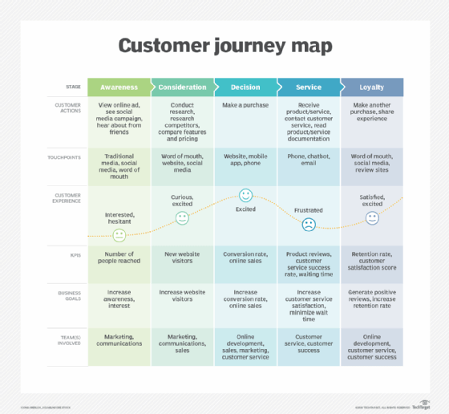
Figure 1 customer journey map (Chatpiyaphat et al., 2021).
Advantages and Disadvantages of Customer Journey Map:
In the customer Journey Map of Samsung, there are some points to be considered, some of the touch points really worked well, the strengths to be observed here are, the products of Samsung went very well into the market by customer considerations based on the product research, about product pricing, word of mouth, social media. This results from the increase in website visitors, new website visitors add more value to the company.
Recently Samsung has focused on improving their innovation to prove themselves, they are at the top of technology, as a technological brand, Samsung offers an excellent instore shopping experience where their staff take care of customers while giving valuable suggestions on their purchase, but there are some disadvantages related to their service, some of the customers are not satisfied with their services offered, this need to be considered by Samsung and made a right decision to avoid these types of mistakes, recent statistics show that Samsung developing their strong partnerships with CISCO, Spotify, (Samsung, 2022) a strategic alliance will help a company to improve the better quality of products, at last, the company faces several criticisms and the customer’s comments on social media is getting limited.

3. Conclusion
Samsung company is known it is the main brand of mobile phones which has very high-end specifications. The company usually deals with memory cards, home appliances, smart televisions, and especially mobile phones. It is becoming a global brand competing in the market. The customers are always loyal to the company and many are fans of the company Samsung, who are continuing to develop the relationship with the Samsung brand. The marketing strategies that are being used by the company are very awesome, and the company is dealing with and overcoming its challenges. So Samsung is a brand-leading company globally.

4. References:
Bhasin, H. (2019) Keller’s brand equity model. Available at: https://www.marketing91.com/kellers-brand-equity-model/ (Accessed: 17 Dec 2019).

Shamout, M.D. and Elayan, M.B., 2020. A Comparative Analysis of Strategic Planning Practices in Gulf Cooperation Council Region: A Case Study of Huawei and Samsung Companies. Journal of Talent Development and Excellence, 12(1), pp.4891-4910.
Samsung (2022) Samsung Partners. Available at: https://www.samsung.com/in/business/partners/mobile/ (Accessed: 2022).
Hidiroglu, D., 2021. The Strategies in Global Semiconductor Industry: The SWOT Analysts of Samsung Electronics Company. American Journal of Management, 21(2), pp.107-118.
Toma, S.G. and Catană, Ş.A., 2021. Innovative entrepreneurship in the business of electronics: The case of Samsung company. Network Intelligence Studies, (18), pp.131-135.
Toma, S.G. and Catană, Ş.A., 2021. Innovative entrepreneurship in the business of electronics: The case of Samsung company. Network Intelligence Studies, (18), pp.131-135.
Fernando, S., 2019. Insecurity and Self-Acceptance Portrayed in Samsung Galaxy A8 Advertisement “Lets You Be You”: A Multimodal Analysis. K@ ta Kita, 7(2), pp.260-268.
Roozitalab, A., 2022. Employing strategic management to study the effect of brand awareness on customer's loyalty: Exploring the mediation effect of perceived brand quality and brand communication: A study of Samsung electronics company in Tehran branch. SMART Journal of Business Management Studies, 18(1), pp.38-46.
Andi, R.T. and Ali, M.M., 2019. Analysis of the Influence of Lifestyle on Purchasing Decisions for Samsung Smartphone Products in Jakarta. European Journal of Business and Management Research, 4(4).
Endrődi-Kovács, V., Kutasi, G. and Magasházi, A., 2018. Visegrád Group Expertise and Position in the Samsung Global Value Chain: A Case Study of Samsung Electronics in the V4 Countries. Central European Business Review, 7(1), p.14.
Curran, J., 2018. Apple iPhone and Samsung Phone Brand Analysis Paper.
Pipa, K., 2018. Scandals, Shamans, and Samsung: framing analysis of media coverage on the Choi Soon-Sil Gate.
Thinh, T.T.X., 2021. Textual Analysis of Content Strategy on the Facebook Fanpage of Samsung Galaxy A Series during Its Launched Campaigns in Vietnam.
Phanitchat, T., Apiwathnasorn, C., Sungvornyothin, S., Samung, Y., Dujardin, S., Dujardin, J.P. and Sumruayphol, S., 2019. Geometric morphometric analysis of the effect of temperature on wing size and shape in Aedes albopictus. Medical and Veterinary Entomology, 33(4), pp.476-484.Ccc.
Chatpiyaphat, K., Sumruayphol, S., Dujardin, J.P., Samung, Y., Phayakkaphon, A., Cui, L., Ruangsittichai, J., Sungvornyothin, S., Sattabongkot, J. and Sriwichai, P., 2021. Geometric morphometrics to distinguish the cryptic species Anopheles minimus and An. Harrison in malaria hot spot villages, western Thailand. Medical and veterinary entomology, 35(3), pp.293-301.
Sumruayphol, S., Chaiphongpachara, T., Samung, Y., Ruangsittichai, J., Cui, L., Zhong, D., Sattabongkot, J. and Sriwichai, P., 2020. Seasonal dynamics and molecular differentiation of three natural Anopheles species (Diptera: Culicidae) of the Maculatus group (Neocellia series) in malaria hotspot villages of Thailand. Parasites & vectors, 13(1), pp.1-11.
Samsung (2023) Samsung the letter mark. Available at: https://www.samsung.com/uk/about-us/brand-identity/logo/ (Accessed: 2023 ).
Samsung (2023) Samsung global electronic brand value. Available at: https://news.samsung.com/global/samsung-electronics-brand-value-makes-double-digit-increase-taking-a-spot-in-the-list-of-top-five-best-global-brands-2022#:~:text=Each%20year%2C%20Interbrand%20announces%20the,three%20years%20in%20a%20row . (Accessed: 2023 ).
Samsung (2023) Samsung customer service relationship. Available at: https://semiconductor.samsung.com/support/quality-support/customer-service/. (Accessed: 2023).
Phayakkaphon, A., Dathong, P., Ransibrahmanakul, N., Sarovath, N., Samung, Y. and Sakulpanich, A., 2021. Oral toxicity of various Stemona collinsiae crude extracts against nymph and adult stages of the American cockroach, Periplaneta americana (Dictyoptera: Blattodea). Heliyon, 7(9), p.e07970.
Kitchen, P.J. and Burgmann, I., 2010. Integrated marketing communication. Wiley international encyclopedia of marketing.
Kim, Y., Lee, D., Hur, Y., Byun, J., Cho, T. and Kang, S., 2019, March. Samsung Fan-out Panel Level Package Solutions. In 2019 Electron Devices Technology and Manufacturing Conference (EDTM) (pp. 77-79). IEEE. (Kim et al., 2019).
Maneeroth, N., Noonanant, N., Thongkhao, K. and Pengsakul, T., 2020. Morphometric analysis of sand fly (Diptera: Psychodidae: Phlebotominae), Sergentomyia anodontia Quate and Fairchild, 1961, populations in caves of southern Thailand. Asian Pacific Journal of Tropical Medicine, 13(9), p.415. (Maneeroth et al., 2020).
Prabhjote, G. (2018) Samsung's biggest store in the world. Available at: https://www.businessinsider.in/Samsungs-biggest-store-worldwide-opens-in-the-worlds-second-largest-smartphone-market/articleshow/65784998.cms (Accessed: 18 Sep 2018).

