

University of Wales Trinity Saint David
School of Engineering

Calum McGowan Franklin
1803213
Motorsport Engineering/HNC/HND
Date 01/12/2019
Module code
M4X02198

Contents
List of figures 3
Introduction 5
Equipment 5
Methodology 1: Static Ride Height Suspension Co-ordinates. 6
Results 10
Evaluation 11
Methodology 2: Measuring suspension Kinematic Behaviour. 12
Results 14
Analysis 16
Evaluation 17
Role centre 17
Methodology 3: Calculating the Vehicle Spring Rate. 19
Results 19
Calculation of spring rate 20
Calculation of suspension leverage 20
Calculation of wheel rate 20
Methodology 4: Spring Rate and Unsprung Mass 21
Analysis 21
References 23

List of figures
Figure 1. Vernier calliper used to measure steering linkage.
Figure 2. Measuring vehicle hub boss diameter.
Figure 3. setting out the vehicles X axis.
Figure 4. Marking the X axis.
Figure 5. using vertical set square against tie rod.
Figure 6. Taking measurement between set square and tie rod bolt.
Figure 7. taking distance between set square on rear of hub and tie rod bolt.
Figure 8. Taking Y axis dimensions.
Figure 9. digital height gauge on engineers block used to find Z axis dimension.
Figure 10. Measured co-ordinates inserted into WinGeo software
Figure 11. WinGeo schematic with manual hardpoint co-ordinates entered.
Figure 12. measurement of damper travel allowance.
Figure 13. Toe span gauge setup on hub.
Figure 14. Inclinometer set up on inside of hub.
Figure 15.Wingeo roll centre position diagram, full schematic.
Figure 16. Wingeo Roll centre position diagram, expanded.
Figure 17. Wingeo results against measured results, camber vs ride height
Figure 18. Wingeo results against measured results, Toe vs ride height.
Figure 19. coil spring tester.
Table 1. Measured co-ordinates at static ride height.
Table 2. WinGeo vs Manual incline angle check for tie rod arm.
Table 3. Wingeo data for camber and toe angle through 50mm of ride travel.
Table 4. Measured data for camber and toe angle from static ride height to full bump.
Table 5. Noted values of spring ratio, through 1 inch of travel, also converted to N/mm.

Introduction
The purpose of this practical study is to model, measure and analyse a vehicles suspension system and explore the kinematic behaviour through the suspensions travel.
This study will be looking at how the vehicles contact patch varies through various ride heights exploring the change in camber and toe angle as the suspension system travels through rebound and compression.
This report will inform how apparatus is to be set up to conduct the investigation, the method carried out to perform a successful investigation, the calculations used to collect derived data, the tables and graphs to illustrate these calculations and a conclusion of the results found from conducting the investigation.

Equipment

The following equipment was used when carrying out the investigation;
Long acre flatbed.
Vernier callipers.
Engineers block.
Digital height gauge.
Set squares.
Steel rules.
Paper and masking tape.
WinGeo3 software.
Toe span gauge.
Inclinometer.
Scales.
Coil spring tester.
Notepad and pen.

Methodology 1: Static Ride Height Suspension Co-ordinates.

In order to measure suspension component co-ordinates at static ride height it is imperative that the steering rack is centralised and fixed throughout the session. This is achieved by firstly turning the steering wheel to full lock and measuring the length of the steering linkage, this is noted at 62mm, this value is halved, the Vernier calliper is then set to 31mm and locked. Using the calliper on both sides of the steering linkage exposed from the sleeve, attain a 31mm measurement ensuring a straight steering rack. This is fixed into place using a pinch bolt to secure the steering wheel.

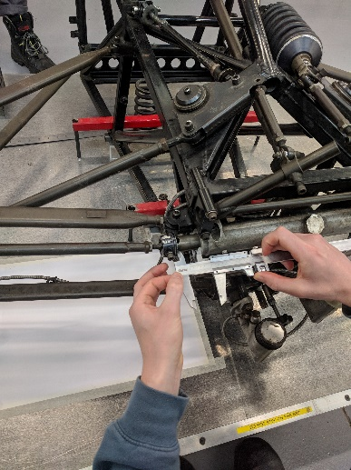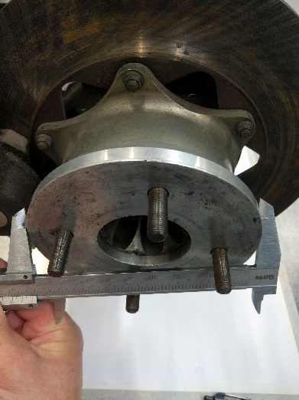
Figure 1. Vernier calliper used to measure steering linkage. Figure 2. Measuring vehicle hub boss diameter.

To be able to identify the co-ordinates of the suspension system components, it is first necessary to determine the X and Y axis from which measurements will be taken. Firstly, the X axis is determined and is taken as the centreline of the wheel hub boss.
The wheel hub boss diameter is measured using Vernier callipers, the wheel hub boss was measured at; Ø 140mm
Using paper secured to the bed with masking tape the X axis can be drawn. This is achieved by using a vertical set square set flush with the side of the wheel hub boss and square against another set square laying flush against the bed rim to ensure the angles are straight and true. The wheel hub boss radius is measured from the vertical set square and marked. using a long rule, a straight line is run from this point. Use the rim of the flat bed as a datum point to ensure the line is drawn square. Note, Infront of the hub is negative value and behind is positive.

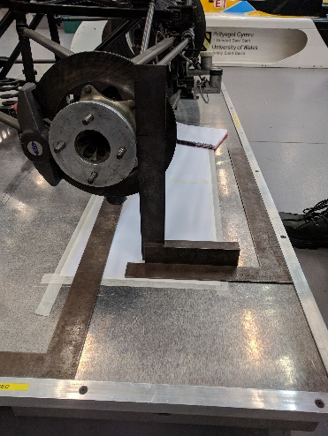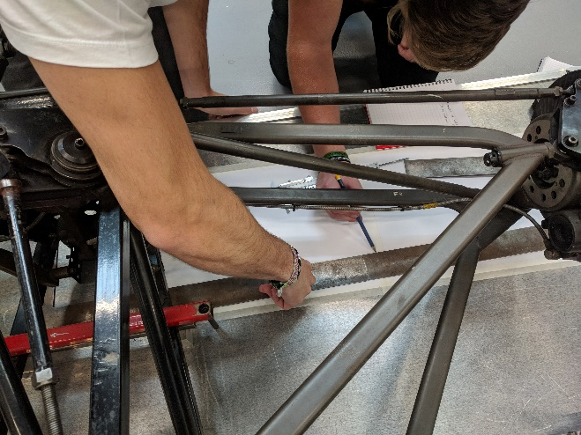
Figure 3. setting out the vehicles X axis. Figure 4. Marking the X axis.

It is imperative when taking measurements that it is square from the datum point, being the flat bed rim as this is engineered to be perfectly square, this is achieved by using set squares and drawing the axis perpendicular from the bed rim. Another method to ensure accurate results is to have all measurements taken twice and checked by another group member.
The Y axis is taken as the centre line of the car, this is already marked on the bed and is square with the vehicle.
With the X and Y axis determined it is possible to obtain the co-ordinates for the suspension components, for this investigation the hard points to be analysed will be the centre point of the inboard and outboard tie rod end bolts.
The outboard tie rod bolt centre was mapped first. To achieve this, first the bolt diameter is measured from the outside tie rod end; Ø 9.2mm
Secondly the distance is needed between the outside edge of the tie rod end and tie rod securing bolt, to obtain this measurement a set square is used lying flat on the bed perpendicular to the bed rim and another set square positioned vertically against this and pushed flat against the tie rod end. The gap between the tie rod bolt and the vertical set square is noted at 7.4mm
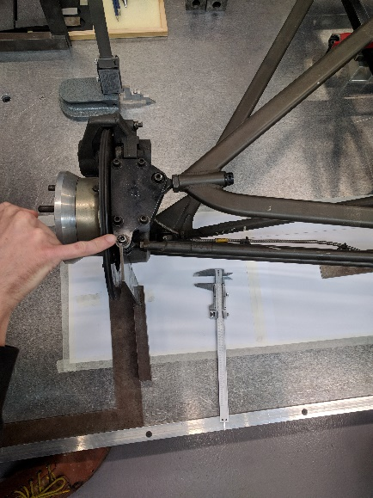 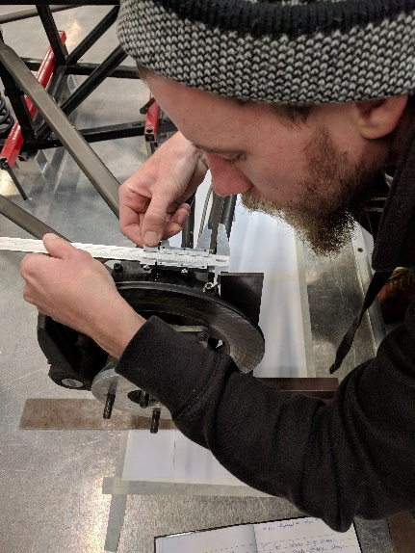 Figure 5. using vertical set square against tie rod. Figure 6. Taking measurement between set square and tie rod bolt.
This measurement and bolt radius give a total of 12mm, this measurement is the bolts centre point and is transferred onto the sheet of paper lying on the bed.
The distance between the X axis and the bolts centre line is noted at 64.2mm, the X axis dimension.
To obtain the co-ordinates for the bolts centre point along the Y axis, a set square is pushed flush against the back of the wheel hub and the distance taken from the vertical set square to the tie rod bolt. Noted at 27.1mm, this is then added to the bolt radius giving a total of 31.77mm, using this measurement from the vertical set square, the bolts centreline can be transferred onto the paper.
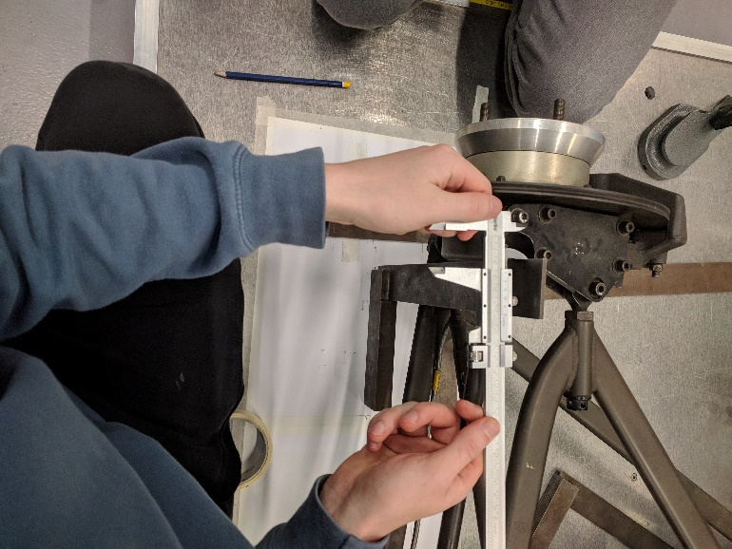 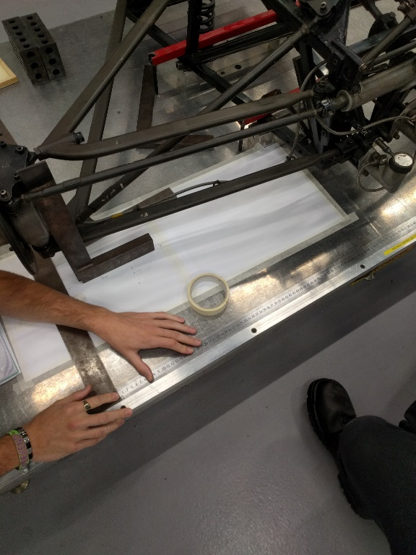Figure 7. taking distance between set square Figure 8. Taking Y axis dimensions.
on rear of hub and tie rod bolt.The distance between the Y axis and the bolts centre line is noted at 744.5mm, the Y axis dimension.
To determine the co-ordinates for the Z axis the thickness of the tie rod swivel bearing is taken, measured at 7mm this value is halved in order to obtain the centre line, 3.5mm.
Secondly the height of the tie rod swivel bearing from the bed must be measured. As the digital height gauge is the optimum tool to obtain precise measurements, engineers blocks are used to build up to the height which the digital height gauge can be used. The engineers block measures precisely 50.8mm, the height from the engineers block to the top of the tie rod measures 261.1mm , 311.9mm. Overall, deducting half the thickness of the tie rod swivel bearing to obtain the centre line of the swivel bearing height. 308.4mm is the dimension of the z axis.
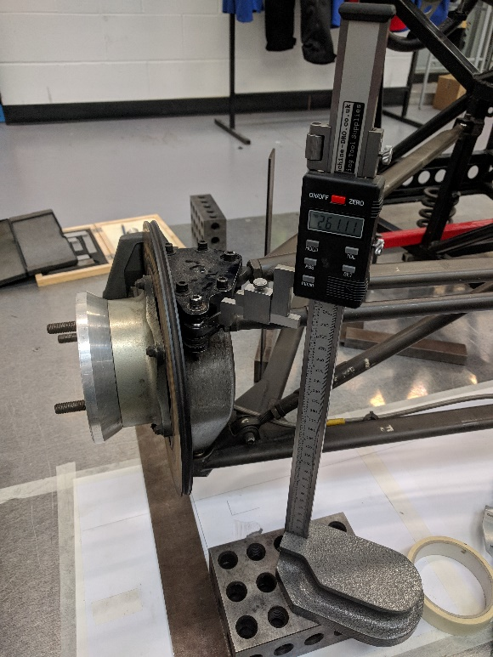
Figure 9. digital height gauge on engineers block used to find Z axis dimension.

The same method is used when finding the co-ordinates for the inside tie rod end bolt.
The measured co-ordinates are then modelled using Wingeo 3 software. To do this, Wingeo 3 is opened. Select parts and choose steering from the drop-down menu, Input the data for the X, Y and Z co-ordinates for the inboard and outboard tie rod bolts and select compute. The check inclination function from S to T gives WinGeo`s estimated angle of the tie rod arm, compare this value against a manual measurement of the tie rod arm, taken using an inclinometer.

Results
Axis | inboard | outboard
X | -150.3 | -64.2
Y | 186.9 | 744.5
Z | 310.81 | 308.4
Table 1. Measured co ordinates at static ride height.
Wingeo check incline | Manual check incline
-0.24 | -0.23
Table 2. WinGeo vs Manual incline angle check for tie rod arm.

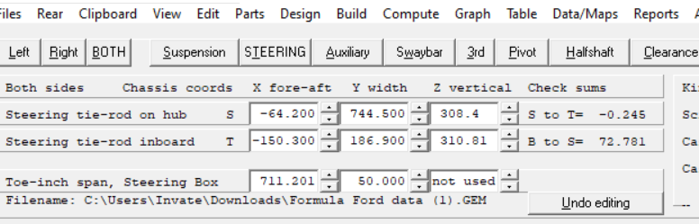
Figure 10. Measured co-ordinates inserted into WinGeo software
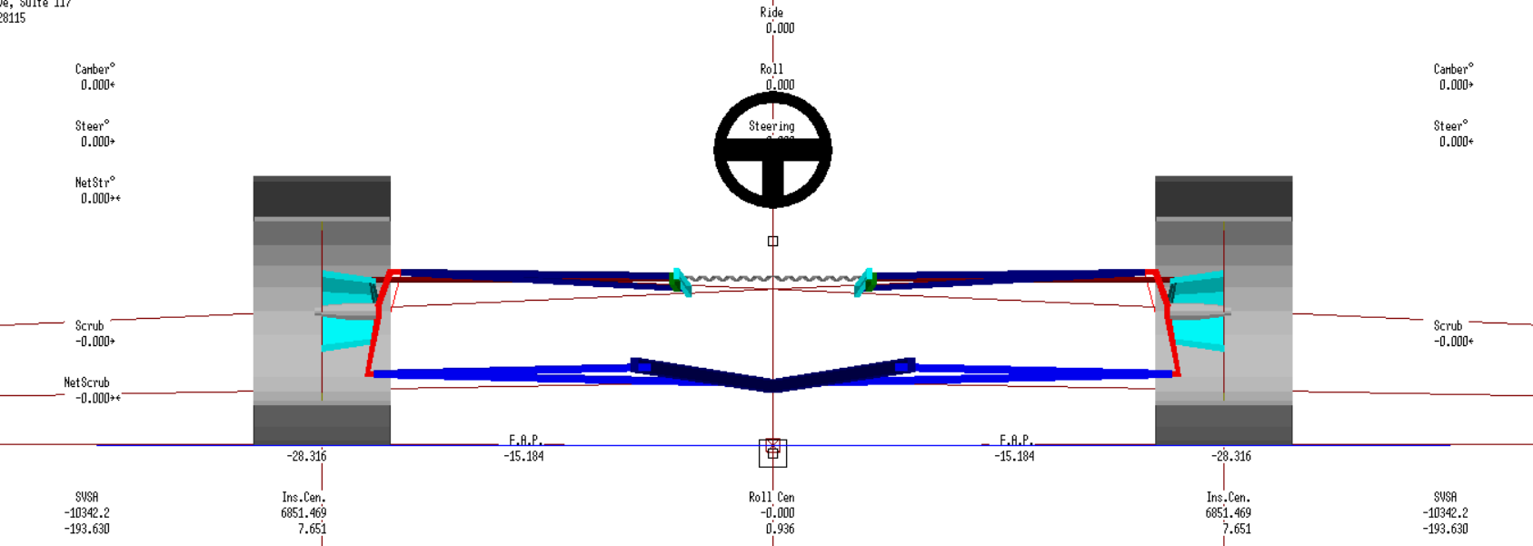
Figure 11. WinGeo schematic with manual hardpoint co-ordinates entered.

Evaluation
The check incline value from WinGeo shows a difference of 0.01 degree to the measured value, this could be due to either an uneven test bed, a bent tie rod arm, human error or an inaccuracy with the height gauge or inclinometer. The flatbed was confirmed as flush using an inclinometer.
This method could be improved by using a Vernier height gauge as it is impervious to digital malfunctions.

Methodology 2: Measuring suspension Kinematic Behaviour.

To manually investigate camber and toe change during suspension travel the following steps are taken;
Firstly, the suspension damper travel allowance is measured with Vernier callipers. The measuring apparatus is then set up.

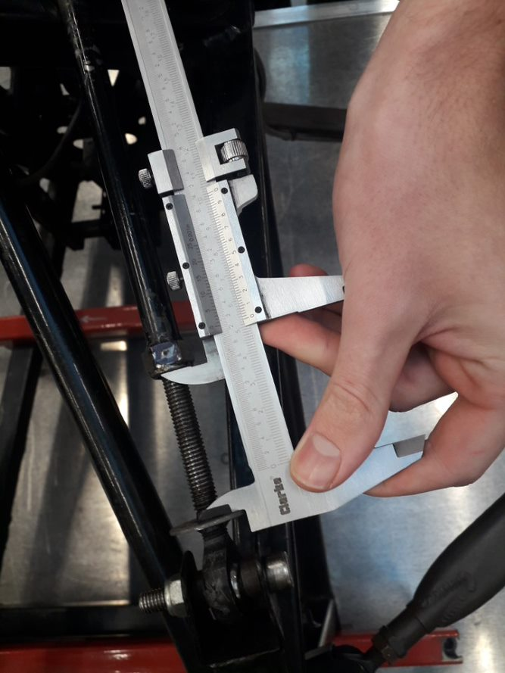
Figure 12. measurement of damper travel allowance.
An inclinometer is attached to the inside of the hub to measure the camber angle. Note, as this is attached to the inside of the hub, the values are positive, however as the angle under scrutiny is the outside, the inverse of the value is taken as negative camber.
A toe span gauge is set up on the right hub, making sure the gauge is level using the integrated sprit level, secure a backing plate to the hub and set up the DTI gauge uprights so that the contact points are in contact with the plate. The hub plate is graduated in thousandths of an inch.
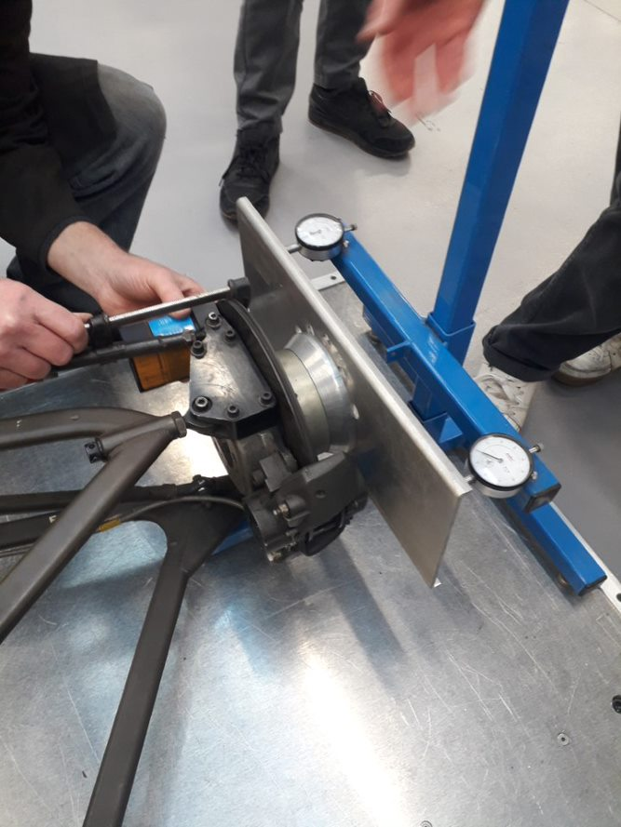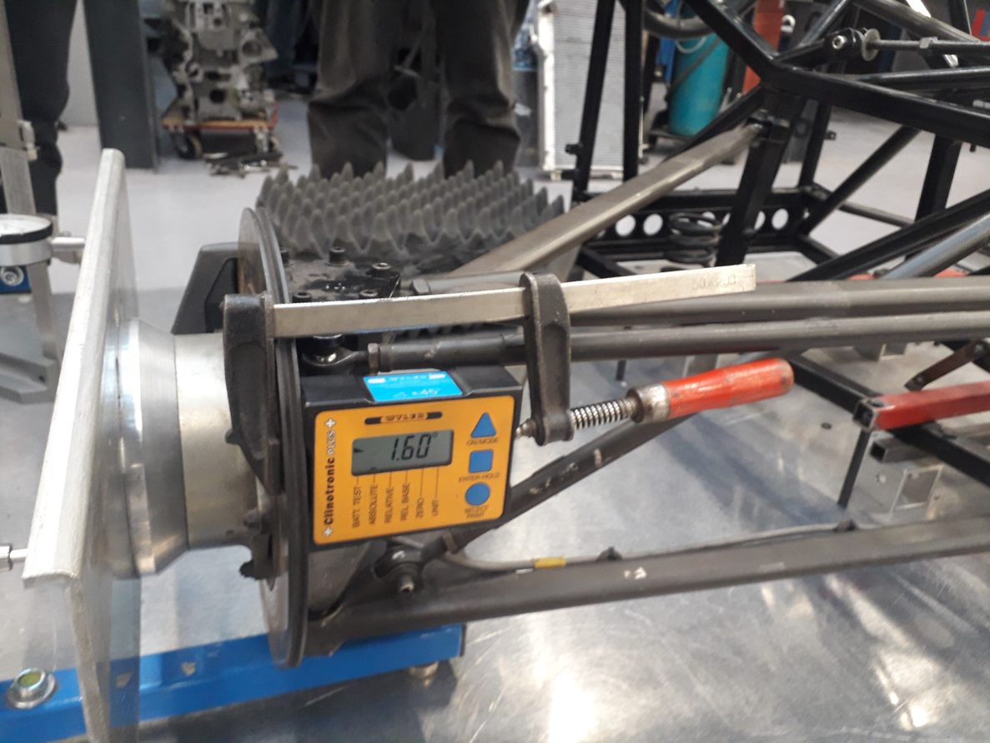
Figure 13. Toe span gauge setup on hub. Figure 14. Inclinometer set up on inside of hub.
The backing plate is set at level on the hub by using a pinch bolt that locks the braking system ensuring the plate stays level throughout the entirety of the session.
A digital height gauge is set up to record the change in height of the hub. This is taken from the bottom of the toe span gauge backing plate bolted to the hub.
To begin, the damper is set at full rebound, the dial indicators on the span gauge are set to zero along with the inclinometer and the height gauge.
To follow, the nut on the damper is turned two revolutions to mimic approximately 3mm of compression. It is important the nut is not overturned as it is not be possible to simply slacken the nut back due to thread backlash which would give false readings.
The values for camber angle, wheel height and toe angle are noted.
The process is repeated, recording each value every two revolutions of the nut for ten sets, through 27mm of compression.
With all manual measurements taken and recorded the Wingeo software is used to model the kinematic behaviour of the suspension components from full rebound to full bump, this is achieved by recording right wheel camber angle and toe angle whilst adjusting ride height in 5 mm increments within the software.
To model this behaviour in Wingeo, the programme must be opened with the schematic of the formula ford displayed. Select the table function and from the dropdown list, check show table, enter 25mm in the ride height function to mimic full rebound and select compute. Then sequentially in 5mm increments follow this procedure through to -25mm ride height to express full bump.
Note the data for the steer right column, this expresses toe angle, and the camber right column. This data represents WinGeo`s simulation of the manual task carried out.
Another function used within Wingeo to aid the analysis of suspension articulation and vehicle behaviour is role centre.
The model is taken to -25mm ride height and put through 3 degrees of role in 0.1mm increments, once this is completed the model must be taken to 25mm ride height and the role reduced until zero is achieved, to carry this task out. The mark RC button must be checked. And compute must be selected after each iteration to map the movement.

Results

Ride Height | Camber Angle | Toe Angle
(mm) | (°) | (°)
25 | -0.046 | -0.869
20 | -0.043 | -0.697
15 | -0.036 | -0.524
10 | -0.027 | -0.35
5 | -0.015 | -0.175
0 | 0 | 0
-5 | -0.018 | 0.176
-10 | -0.038 | 0.353
-15 | -0.062 | 0.532
-20 | -0.088 | 0.711
-25 | -0.117 | 0.891
Table 3. Wingeo data for camber and toe angle through 50mm of ride travel.

wheel height | DTI A (inches) | DTI B (inches) | toe steer angle (degrees) | Camber  (degrees)
0 | 0.000 | 0.000 | 0.000 | -1.6
6.53 | 0.026 | 0.012 | 0.060 | -1.68
12.6 | 0.049 | 0.022 | 0.115 | -1.75
19.08 | 0.069 | 0.031 | 0.162 | -1.81
25.35 | 0.087 | 0.037 | 0.213 | -1.9
28.68 | 0.095 | 0.039 | 0.237 | -1.94
32.01 | 0.102 | 0.041 | 0.260 | -1.98
35.73 | 0.116 | 0.044 | 0.307 | -2.05
44.53 | 0.127 | 0.043 | 0.358 | -2.11
51.33 | 0.138 | 0.040 | 0.418 | -2.18
57.69 | 0.145 | 0.037 | 0.460 | -2.25
Table 4. Measured data for camber and toe angle.

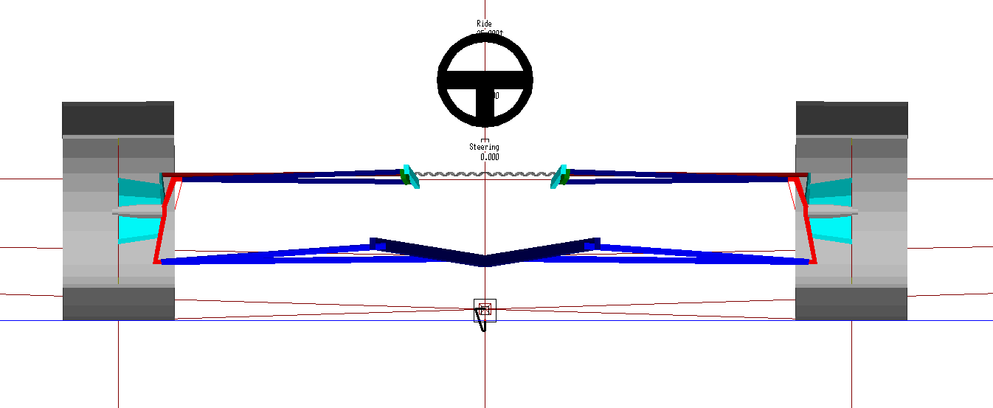
Figure 15.Wingeo roll centre position diagram, full schematic.

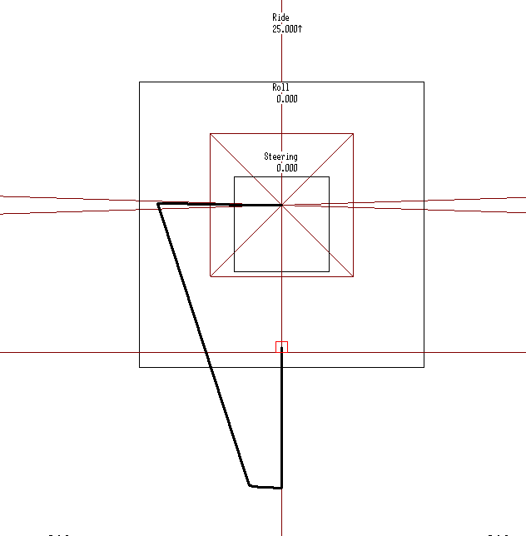
Figure 16. Wingeo Roll centre position diagram, expanded.

Analysis

Figure 17. Wingeo results against measured results, camber vs ride height
As can be seen from graph above, the measured and WinGeo results follow a similar pattern, both express a positive linear trendline.

Figure 18. Wingeo results against measured results, Toe vs ride height.
Figure 18 expresses both the measured and Wingeo data following a related negative trendline.

Evaluation

Table 3 expresses that as the vehicle moves through 25mm of rebound, the camber angle has a total adjustment of 0.046° negative camber and 0.869° of toe angle change. through suspension compression, a negative camber change of 0.117° and 0.891° of toe angle.
It is noted that DTI A gauge is on the back side of the hub and DTI B on the front. From Table 4 it is stated that DTI A gauge has a larger value than DTI B through wheel ascent, this expresses a toe in angle increase as the wheel rises and suspension compresses.
Figure 17 indicates that as the ride height increases and thus the suspension rebounds the amount of camber increases, equally as the suspension compresses, represented by a decreasing ride height, the negative camber decreases.
Figure 18 determines that as ride height decreases from static, expressing compression of the suspension system the toe angle rises and as the ride height increases representing suspension rebound the toe angle declines.
The differences in data between the Wingeo and measured results is partly due to the Wingeo ride height being recorded in 5mm increments whilst the measured is taken in approximately 3mm increments of the suspension damper, other reasons could be due to human error when recording or a contrast in the co-ordinates for the formula ford within the WinGeo software.
An in improvement on this investigation would be to update the Wingeo software and take a secondary reading of all the formula ford linkage co-ordinates to confirm correlation.

Role centre
Role centre is the immediate axis about which the sprung mass rotates. It is located by following the trajectory of the suspension arms and the trajectory of the contact path of the tyre, where this intersects with the vehicles centre line is the role centre.
The distance between the vehicle’s role centre and centre of gravity is the considered the role moment, this is determined by the lateral forces whilst driving and the distance between the vehicles centre of gravity and roll centre. By minimising this distance, the vehicle is subjected to less role. (Bosch, 2000)
$F*d=role moment$
This is achievable by changing the geometry of the suspension linkage but in turn this can alter camber and toe geometry.
Wingeo produced a roll centre position diagram at 25mm of rebound and 25mm of compression around a 3 degrees role. as is illustrated in figure 16 the role centre changes through travel. This data along with the vehicles centre of gravity can be used to determine and manipulate roll characteristics.

Methodology 3: Calculating the Vehicle Spring Rate.

The formula ford suspension spring rate is measured using a compression rig. The rig consists of a jack that will apply pressure to the spring in question alongside a gauge that will indicate the pressure applied.
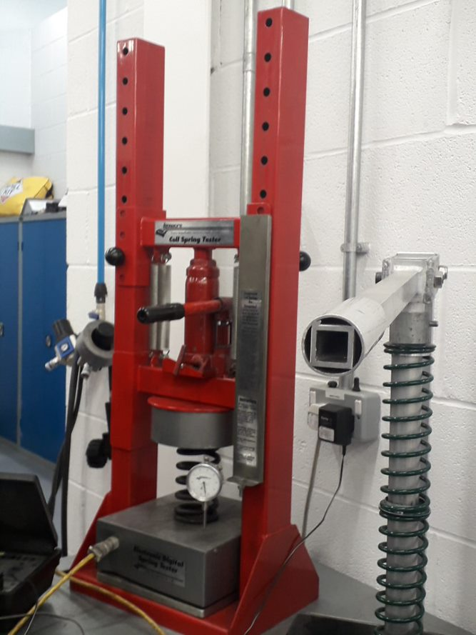
Figure 19. coil spring tester.
The linear coil spring from the formula ford is installed into the rig and measured in pounds of pressure per inch of travel through 1inch. The gauge set on the rig was zeroed and pressure is applied to the jack until 1/10 of an inch is compressed and the pressure recorded, this is repeated 10 times through 1 inch of compression.

Results
mm | N
2.54 | 173.48
5.08 | 342.51
7.62 | 520.44
10.16 | 698.37
12.7 | 871.85
15.24 | 1049.78
17.78 | 1227.71
20.32 | 1405.64
22.86 | 1583.66
25.4 | 1761.50

Inch | lbs
0.1 | 39
0.2 | 77
0.3 | 117
0.4 | 157
0.5 | 196
0.6 | 236
0.7 | 276
0.8 | 316
0.9 | 356
1 | 396
Table 5. Noted values of spring ratio, through 1 inch of travel, also converted to N/mm.

Calculation of spring rate
To obtain the spring rate in NM calculations needed to be made, these are as follows;
$396$(mass)$* 9.81$, this converts the mass into a force.
$3884.76 m/s^2$ , this value is then divided by 2.2 to convert from lbs to kg
$$3884.76/2.2= 1765.8$$
$1765.8$ , this value is then divided by 25.4 to convert inch/mm
$=69.52 N/mm$, this value is $* 1000$to convert mm/m
$$KS=69519.69 N/m$$

Calculation of suspension leverage
Suspension leverage is the ratio between the wheel height and the damper length.
This is calculated as follows;
57.69mm= total change in wheel height
This value is divided by the total change in the damper length
27mm=total change in damper length
$$57.69/27=2.14$$
As this calculation is a ratio no further calculations are needed to get values into base units.
$$SL=2.14$$

Calculation of wheel rate
The wheel rate needs to be calculated as this takes the geometry of the vehicle suspension system into consideration unlike the spring rate, as the formula ford has a bell crank system the compression ratio alters and the wheel rate gives the effect of spring rate at the vehicles contact patch.
The wheel rate is calculated as follows;
$$KS/SL^2$$
$$69519.69/2.14^2$$
$$KW=15.18KN/m$$

Methodology 4: Spring Rate and Unsprung Mass
To determine the natural frequency of the formula fords front suspension and unsprung mass.
First the total mass of the front left side of the vehicle was weighed to obtain a value for the unsprung mass.
Secondly the mass of the individual was weighed as to establish a total mass for the “on the start grid” condition.

Analysis
The total mass of the vehicle as noted gives a value of $425kg$
The total value of the unsprung mass weighed is $21.5kg$
The mass of myself is $69.8kg$
Tyre spring rate $(Kt)= 256,000Nm$

To find the value of Ms,
$$Ms=425(mass of vehicle)-\left(21.5*4\right)+69.8(weight of driver)$$
$$Ms=408.8kg$$
$\frac{Ms}{4}=value for one corner of vehicle$=$102.2$
The natural frequency of the sprung mas is calculated as follows;
$$f=\frac{1}{2π}√\frac{Kw}{Ms}$$
Therefore;
$$f=\frac{1}{2π}√\frac{15222.95}{102.2}$$
$$f=1.942hz$$
The natural frequency of the unsprung mass is calculated as follows;
$$fus=\frac{1}{2π}√\frac{Kw+Kt}{Mus}$$
Therefore;
$$fus=\frac{1}{2π}√\frac{15222.95+256000}{21.5}$$
$fus=17.875hz$

References

Robert Bosch (2000). Automotive handbook. Germany: Bentley. 353.

