Ways of Thinking Essay-
The photo series that I am going to be focusing on is the work of Pixy Liao. This essay will aim to focus on deconstructing the meaning of the artwork relating to the representation of gender. ‘De-construct the meaning of an artwork in relation to the politics of representation from one of the following perspectives: gender studies’
Pixy Liao is an artist based in Brooklyn, NY, originally from Shanghai, China. Liao has received numerous awards such as the, ‘NYFA Fellowship in Photography, the Santo Foundation Individual Artist Award, and the Madame Figaro Women Photographers Award.’

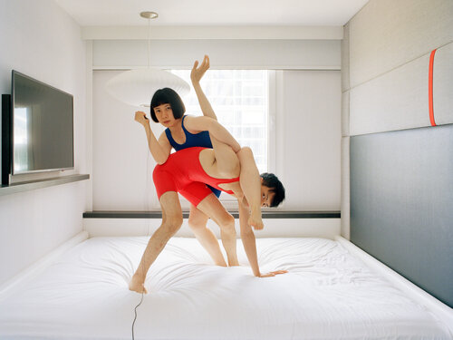
Untitled: Experimental Relationship (Pixy Liao) (2007- Now)

This photograph by Pixy Liao’s work diverts traditional roles in heterosexual relationships placing herself in a more dominant role. Pixy Liao and her boyfriend, Moro, are playfully wrestling in a red and blue body suits. This photo takes place in a bleak white room surrounded by a bed frame on the right side of the room and a TV on the left. There is a bright window behind them with an overexposed building that is just visible, filling up the window.

The people in the room are Pixy Liao and her boyfriend. You can see Pixy Liao with control to the camera flash as she is holding it up next to her head with the wire leading out of the frame towards the camera. Pixy Liao holding the camera flash, if I didn’t know that this was her photoshoot, shows that she is the one who orchestrated and planned the shoot. As well as this the position that she chose for the shoot indicates that they are more equal. As they are wrestling in some way you can see that the photographer is currently winning the match with her boyfriend being constrained by her, but not aggressively.

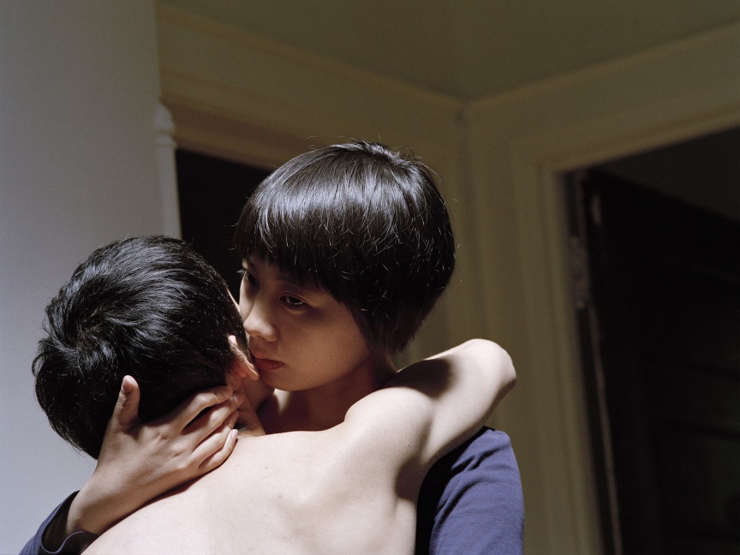
Some words are just between us: Experimental Relationship (Pixy Liao) (2007- Now)
This image shows Liao embracing her boyfriend, Moro, close to her, showing his bare back to the camera. This shows intimacy but is also subverts the traditional trope of the male gaze. By positioning herself looking down at Moro and being clothed unlike him, as well as the comforting grip she has of him shows the control she has in this situation.
The camera focuses on the expression on Liao’s face, it appears to me that she is whispering something into his ear that could be to comfort him.

Liao’s work fights the normal dynamic of heterosexual relationships,
As a woman brought up in China, I used to think I could only love someone who is older and more mature than me, who can be my protector and mentor. Then I met my current boyfriend, Moro. Since he is 5 years younger than me, I felt that the whole concept of relationships changed, all the way around.
Because of the context of her being from a different country, I do not fully understand the cultural context to how different this is for how she grew up. But even for western standards it is more uncommon for a heterosexual relationship to be considered in this way and shows that individuals can have their own ways of having relationships. This photoshoot in particular addresses this directly physically and literally; fighting the standard dynamic that is known.
Because of the new way that Liao learned how relationships could be, with her having more of a male role from her being older made her want to experiment with the ways that this could be seen. “Moro made me realize that heterosexual relationships don't need to be standardized.” The difference in their relationship came from how Liao realized that she, being the older of the two in the relationship, changed her whole idea of what a standard relationship could be like.

"One is not born, but rather becomes, a woman." (The Second Sex, 1949). Explores the idea that gender shaped by society and is different to our biology. Meaning that as people grow into adults, they are taught how they should behave with the role that has been given to them by the gender that people have fitted them with, creating expectations for different behaviors that are considered normal. Judith Butler also adds that gender is performative, meaning that they are not natural; just acted out as part of our roles. This also goes into how heterosexual relationships work as traditionally men and women have different roles. Even now there are still roles that are given to each gender, whether we notice them or not, traditional roles have loosened, but they are still there. Liao’s photography is shown in a way that could make the audience feel uncomfortable with how intimate they are, just by showing the man as the less dominant in the relationship reversing the gender roles in her relationship with Moro. It causes you to question either the photos and brush them off or question the way you see heterosexual relationships and the roles that are within them. Lioa’s work questions the idea that men must have the dominant role in a relationship.

“Men act and women appear. Men look at women. Women watch themselves being looked at.” (Ways of Seeing, 1972). This is challenged by Liao’s work in her series. She controls the gaze of the work as well a subject, challenging how both, men and women are represented in art. The way that she represents herself and Moro is flipped, inviting gaze to Moro that is usually how women are viewed, showing him as vulnerable and dependent; this is while Liao controls the situation. Mulvey, L., (Visual and Other Pleasures,1989) " The male gaze projects its fantasy onto the female form, which is then stylized to fit that fantasy." Liao forces the viewer's gaze in the second image with the lighting being focused on Moro’s back emphasizing the roles of their relationship with Liao being older than him. It also goes against the male gaze in the way that it is not sexualizing Moro, it is just showing how he is vulnerable in the image which challenges how the male body is normally shown in art and pop culture around the world. Because of the way that males have been represented in society this would be conceded as a weak thing to do as male roles idolize having little shown emotions as well as being in control of all situations.

Hush, Baby: Experimental Relationship (Pixy Liao) (2007- Now)
This image shows a portrait of Moro looking into the camera with Lioa holding out her arm into frame putting her thumb over Moro’s lips. Using her thumb instead of her index finger to hush him is more sensual than if she did it normally, in a way taking ownership of him with the act. By this I mean the way that she shows her affection towards him is nonverbally showing emotional ownership. Her thumb over his lip is a gentle gesture and is a way of highlighting the reversal of the roles. Having an intimate gesture like these publicly displayed challenges expectations of both Western and astern ideas of relationships.

“To love is to relinquish a part of oneself and give that part to someone else.” The Second Sex (1949). While Lioa shows her affection towards Moro he isn’t defensive, they are exchanging and giving away parts of the relationship roles that they feel that they fall into. This gives them more freedom to be themselves and express themselves more freely within their relationship. Lioa’s photography is playful with how it deals with the topics that it is displaying; they are to poke fun at the weirdness of why we need to even have roles in the first place. Lioa focuses on playing with these ideas in a way that could be easily understood or with other images in the series, making light of different parts of her and Moro’s backgrounds and cultures and how they are seen in the Western world.

References
Liao, P. (n.d.) Experimental Relationship. Available at: https://www.pixyliao.com/experimental-relationship.
utler, J. (1990) Gender Trouble: Feminism and the Subversion of Identity. New York: Routledge.
Mulvey, L. (1989) Visual and Other Pleasures. 2nd edn. London: Palgrave Macmillan.
Sartre, S. (1949) The Second Sex. Translated by H.M. Parshley. New York: Alfred A. Knopf.
Ways of Seeing (1972) Directed by J. Berger. London: BBC.

