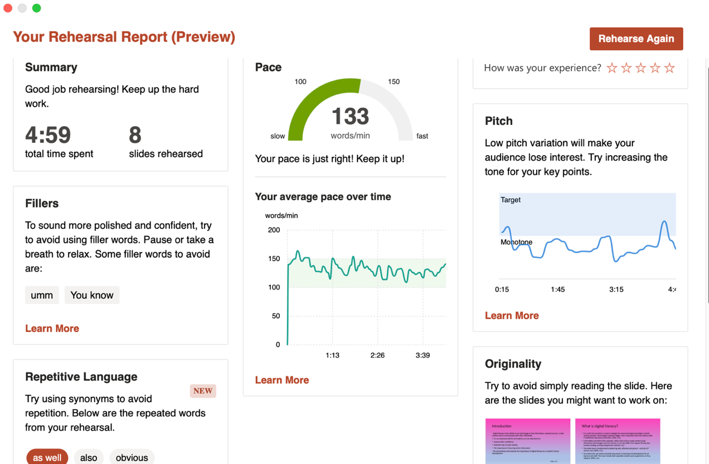

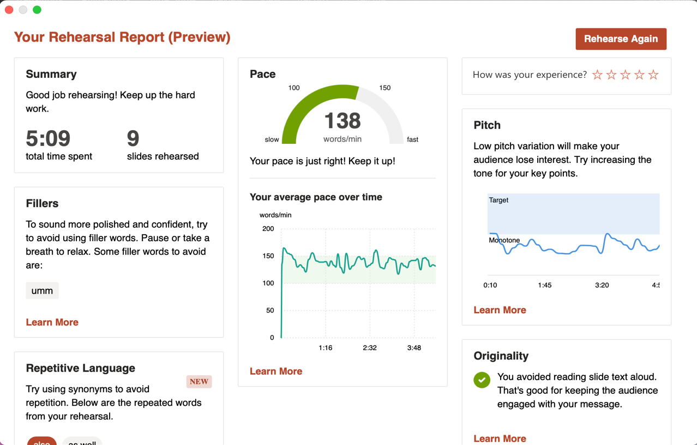

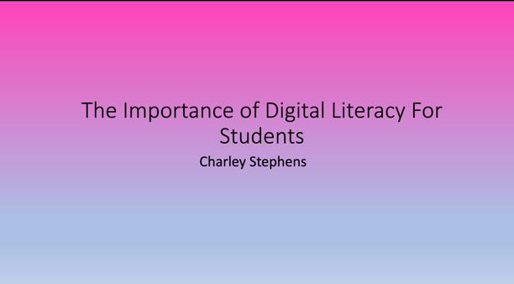
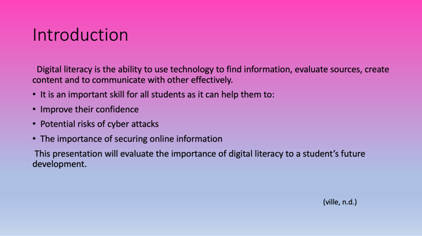

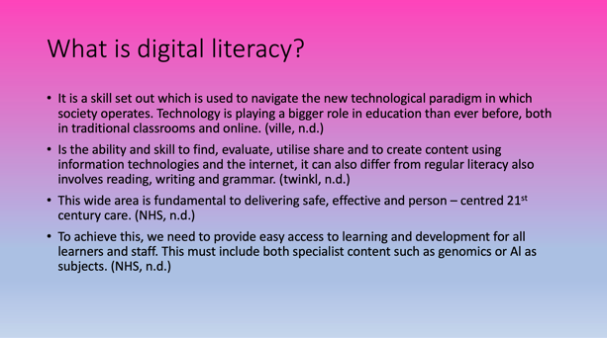
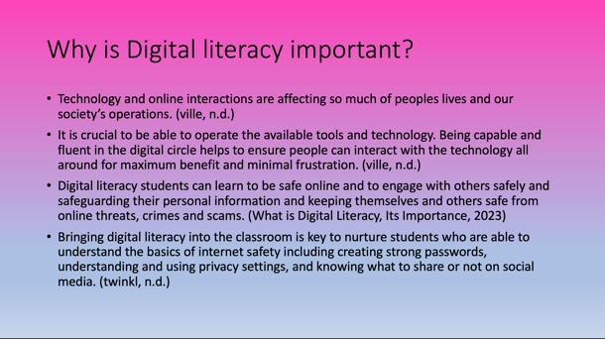

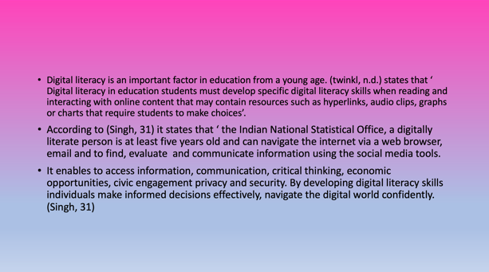
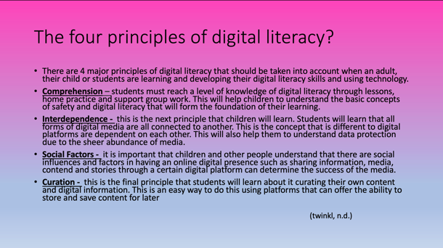

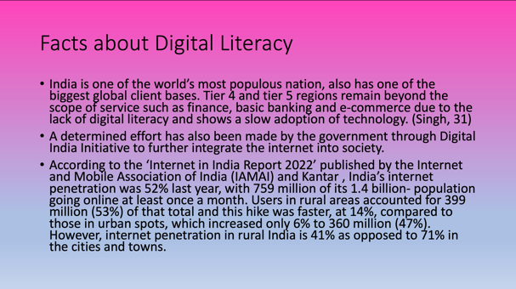
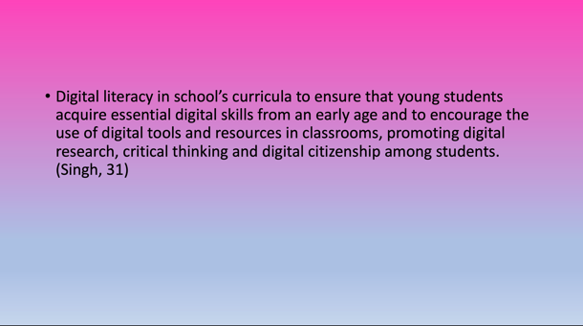

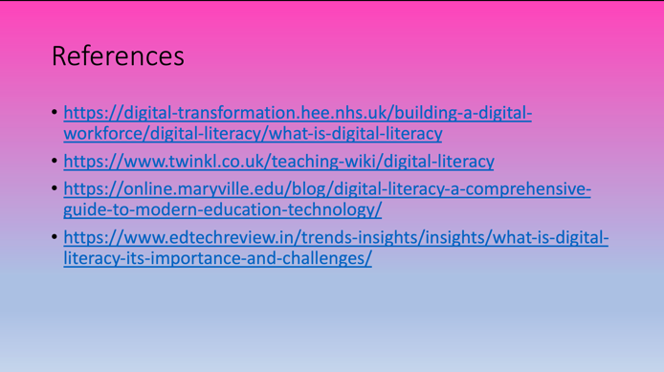

https://uowtsd-my.sharepoint.com/:v:/g/personal/2306714_student_uwtsd_ac_uk/EYKQbF0zgMNFlDN4dIT2woQBcPYgpspuE2-SCos9JzORqQ

I decided to do my presentation on digital literacy as I think it will help students during their future development and I think it is important for students to understand why digital literacy can be important and how it can help with them with their degree or further studies and jobs. To be digitally literate, individuals require more than just proficiency in using computers. They must possess a variety of abilities, such as utilizing technology to search for and generate content, finding solutions to problems, and fostering innovation. They must also be capable of communicating and connecting effectively online, while learning, collaborating with peers, and exploring and disseminating new information. (Cambridge University Press & Assessment,2023). (Assessment, 07 )While doing my research on digital literacy I found it hard to find information about digital literacy and why it is important in education as some websites may not be up to date, be relevant or may not be trustworthy and may not be in the U.K. While presenting my presentation I found it difficult as I was presenting it to a screen and not to people in my class or friends, the reason why I found it hard as I have never presented a presentation to a screen and then sent the link of myself to someone. Overall carrying out the presentation I found was easy however I found it difficult to use different words and phrases. I will practice my presentation skills in order for me to make my presentation better in the future.

As you can see from the presenter coach rehearsal, my pace was good as I did not deliver my presentation too fast, or it was not to slow it was just the correct pace for a presentation to be delivered so the people who are listening can understand what is being said perfectly and they will not have any struggle in understanding what is being said. While rehearsing my presentation I found it tough trying to change my pitch of my voice to avoid the audience losing interest on my presentation and to increase my tone for my key points in my presentation. Another thing I found tough was trying to use different words as I was using the same words i.e. also, like which was difficult to do. Another thing I struggled and found hard was trying to summarise my key points on my presentation and not reading off the slides in my presentation. If I was do my presentation again, I would choose a different topic and not read off my presentation and use different words and phrases and summarise the important key points that would attract the listeners and outsiders to be intrigued to my presentation.

During my rehearsal which you will see at the top I was told to avoid from reading off the slides which I found very difficult as some of the key points could not be summarised and some could also, I found hard was trying not to go over the time limit which took some time to get it correct. After I rehearsed my presentation and had some practice, I then went on to record my presentation for the final time and found it easier to deliver my presentation as I was able to summarise my slides and key points and not read off each slide word by word. I found presenter coach helpful as it gives good feedback and shows what you need to work on to make your presentation better e.g. using repetitive language such as also obviously and the pitch and pace of your voice, while I was presenting my presentation it shows you feedback as you speak which is good as it tells you if you are talking to fast or too slow. Even though being able to read and find content online shows a level of digital literacy, reading print isn’t much different. Digital literacy involves a collection of skills that enables users to effectively use digital tools for finding, creating, sharing and evaluating information. This is with the aim of creating a unique experience for all users. (WHAT IS DIGITAL LITERACY AND WHY IS IT IMPORTANT?, 2022).

There are good reasons to why digital literacy is important because it gives a wide variety and helpful resources for students to develop and make their skills better for their future, this is because of how advanced technology is being used throughout the world. There are many advantages of digital literacy because since the beginning of covid 2020 everyone in the world went to remote learning to avoid being in close contact with people who had been or had covid. Here is an example of two advantages on why digital literacy is important. Accessing the classes from a wide range of places, one of the major pros of remote learning is that both students and teachers can attend classes from any location they are in. It saves time by cutting down the hours spent commuting to schools and then back home. Moreover, this is also cost-effective as there is no need to buy extra public-transport tickets or car fuel.

Recorded lectures aid understanding, most online lectures can be easily recorded by pushing a single button, which means that students can re-watch them as many times as they need to understand the material. For pupils who learn or take notes slower, this is extremely useful and helps them catch up with their classmates. In addition, students who cannot attend (e.g. due to illness) a class also benefit from recorded lectures, because they won’t miss out on anything and don’t have to ask others for notes. (The Biggest Pros & Cons of Digital Learning, 2022)

There are some disadvantages as well here is an example, Technology problems this is one of the biggest setbacks for digital education is internet connectivity, that most people struggle with on a daily basis. (The Biggest Pros & Cons of Digital Learning, 2022)

Bibliography
(2022, October 26). Retrieved from WHAT IS DIGITAL LITERACY AND WHY IS IT IMPORTANT?: https://potomac.edu/what-is-digital-literacy/
Assessment, c. u. (07 , April 2022). Retrieved from More than just using computers: understanding and developing Digital Literacy with our new guide: https://www.cambridge.org/elt/blog/2022/04/07/understanding-developing-digital-literacy/

