RETROFIT ASSESSMENT

12 Cadogan Close
Heathgate Gardens
Johnston
Haverfordwest
Pembrokeshire
SA62 3QN

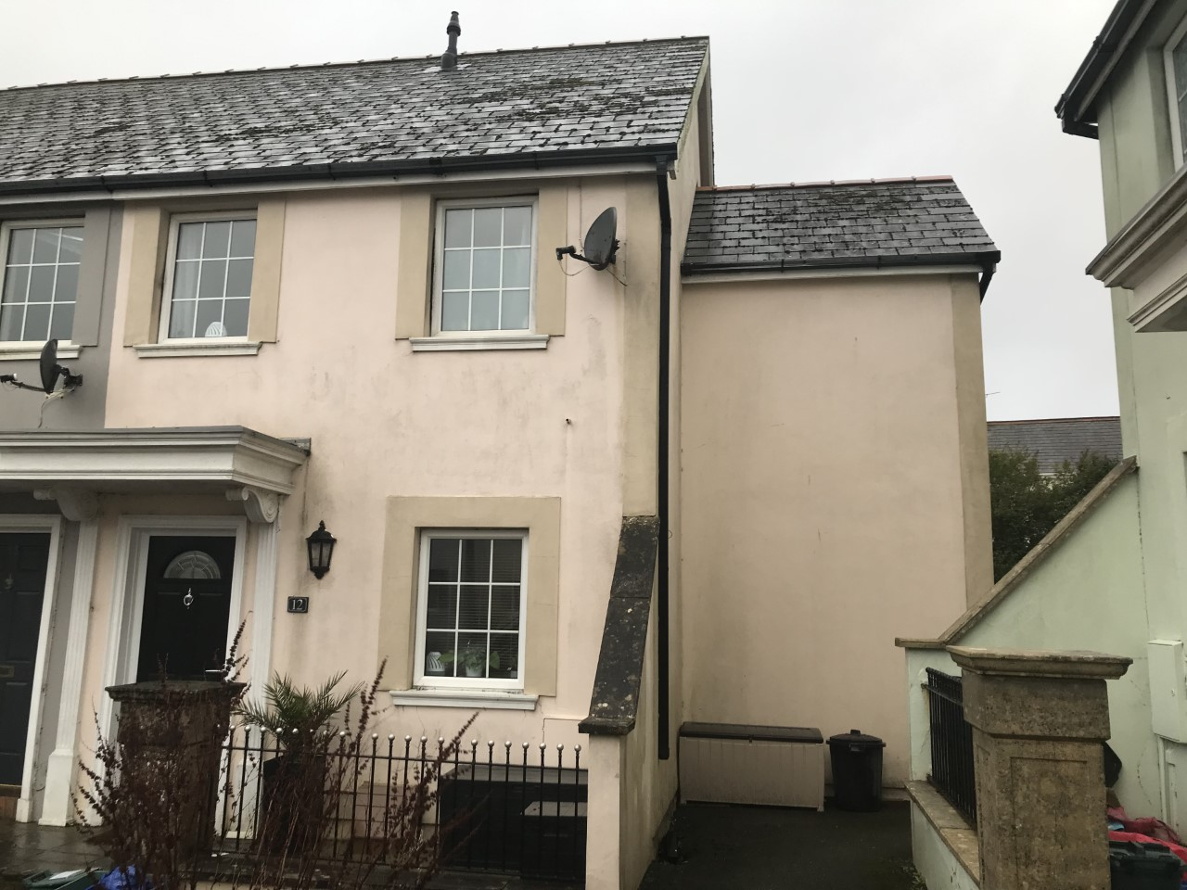

Task 1
Retrofit Assessment
Retrofit Coordination & Management
Mark Preston

1st January 2025

CONTENTS:
- Introduction to the report
- About the property
- About the inspection
- Condition ratings
- External elements
- Internal elements
- Services
- External Grounds
- Asbestos
- Other Risks
- Building Plans
- Occupancy Assessment Data:
- Energy Usage Assessment
- Fuel Data – Electricity & Main Gas
- Heating Systems
- Heating Controls
- Hot Water System
- Openings Schedule
- Radiator Schedule
- Openings & Windows Floor Plans
- Retrofit Options
- References

A. Introduction to the report
This Retrofit assessment has been produced and provides an objective opinion about the condition of the property at the time of inspection and to provide what retrofit options are available to the client. A thorough audit has been carried out to understand the most suitable improvements for the building. The survey will indicate the improvements needed to cut fuel bills and carbon emissions and improve comfort and health. It will consider things like flood and radon gas risk levels and whether the existing ventilation system is adequate, alongside suggesting energy-efficiency improvements and options for heating. It will be tailored not just to the property but to the needs of the identified clients.
The Retrofit Assessment aims to tell you about:
- The construction and condition of the property on the date of inspection.
- Retrofit options available to the client. This will include:
- Potential upgrades which directly affect operational carbon/energy use.
- A ventilation strategy, compliant with current Building regulations and considers the
Upgrades.
- Embodied carbon /energy of the potential upgrades

B. About the property
This house was part of a development 35 years ago called Heathgate Gardens. Cadogan Close which includes 16 houses was Phase 1 of the project. They were released onto the market in June 1990 and sold by September 1990. It comprised of modern terraced houses for that time on an estate and is situated in the large village of Johnston, just off the main road with good access to the towns of Haverfordwest (3 ½ miles north) and Milford Haven (3 ½ miles south). The properties are freehold, and the roads have been adopted by the local council and prices are inclusive of road charges.
The property is an end of terraced house and was built in 1990. Accommodation consists of a ground floor hall, sitting room (15’8’’ x 13’4’’) with patio doors to garden, fitted kitchen (8’7’’ x 8’) and dining room (9’6’’ x 8’1’’) with single patio door to garden). The first floor consists of a landing with an airing cupboard, Bedroom 1 (13’4’’ x 9’10’’), Bedroom 2 (14’ x 7’7’’), Bedroom 3 (9’6’’ x 8’1’’) and a bathroom.
The house is of traditional cavity block wall construction with rendered elevations under 2 different height pitched slate roofs. It is designed Georgian styled with doubled glazed UPVC windows. Internally the ground floor appears to be of solid masonry construction. The first floor is of suspended timber construction. The internal walls appear to be of dot & dab / stud dry lined walls as well as structural walls.
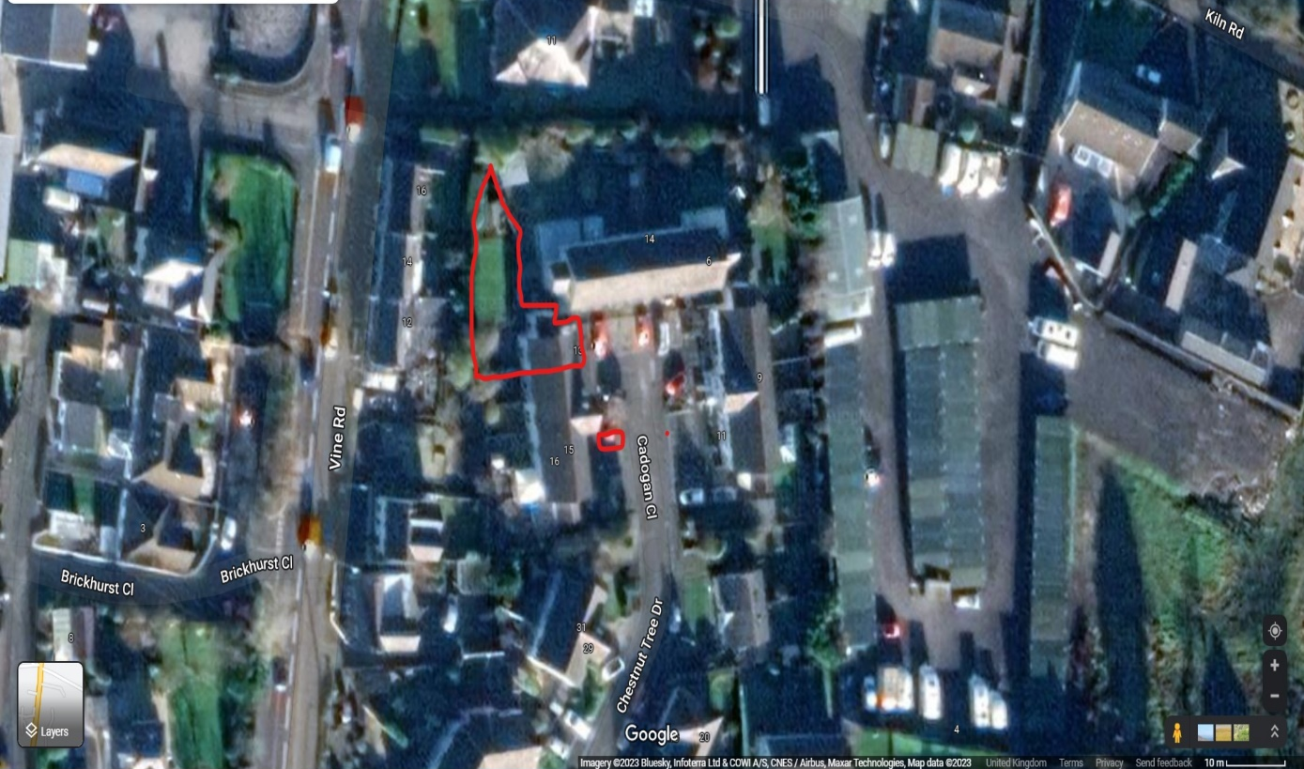

C. About the inspection
Inspectors name: Mark Preston
Date and time of the inspection: 01st January 2025
Full address and postcode of the property: 12 Cadogan Close, Heathgate Gardens, Johnston, Haverfordwest, Pembrokeshire, SA62 3QN
Weather conditions when the inspection took place: Dry, cold.
The status of the property when the inspection took place: The building has been occupied by the client for 5 years. I have full access to the building and the inspection took approximately 2.5 hours. The property is fully furnished with fitted floor coverings in place.
I inspected the inside and outside of the main building and all permanent outbuildings, but I do not force or open up the fabric. I also inspect the parts of the electricity, gas/oil, water and drainage services that can be seen, but these are not tested.
D. Condition Ratings
This report includes condition ratings given to the main parts (the ‘elements’) of the building, and outside elements within the curtilage. The condition ratings are as follows.
Condition Rating 3 – defects that are serious and/or need to be repaired, replaced or investigated urgently.
Condition Rating 2 – defects that need repairing or replacing but are not considered to be either serious or urgent. The property must be maintained in the normal way.
Condition Rating 1 – no repair is currently needed. The property must be maintained in the normal way.
NI – not inspected.

E. External Elements
E1. Roof coverings: The two roofs are pitched and are covered with the original stained dark grey mineral slates (lifespan 50 to 100 years +) with moss, mildew and algae growths apparent. Although the slates seem to be in good condition from a ground level visual inspection, the growths need to be removed/cleaned/ treated for general maintenance & to prevent future damage. The tiles are finished with red clay capped angled ridge tiles set in cement mortar and look to be in good condition. The lead flashings also appear to be in good condition. Condition Rating 1.
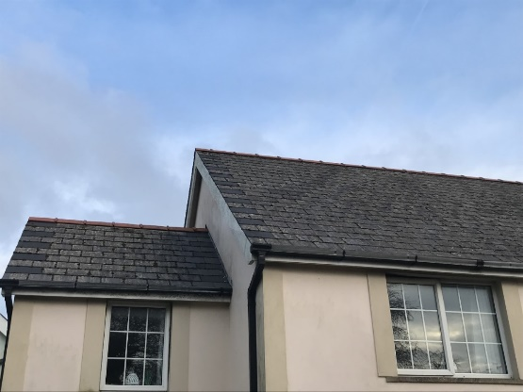
E2. Rainwater outlets/ pipes and gutters: The rainwater outlets comprise of black UPVC gutters / downpipes and appear to be in good condition considering they are original. Although, the bottom section of the downpipes has fallen off so need securing to the wall. Also, the drain guards are loose which will also need securing to prevent the build-up of debris and blockages (refer to Key 1 on plans). It was dry at the time of the inspection; therefore, I can’t check the water tightness of the water outlets. The gutters should be monitored when heavy rainfall is present and any repairs can be scheduled afterwards. In any event the gutters should be periodically inspected for debris and blockages. Condition Rating 2.
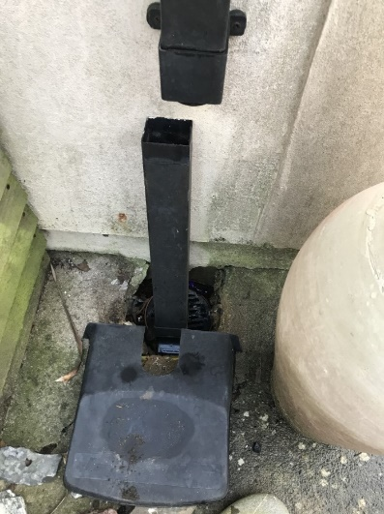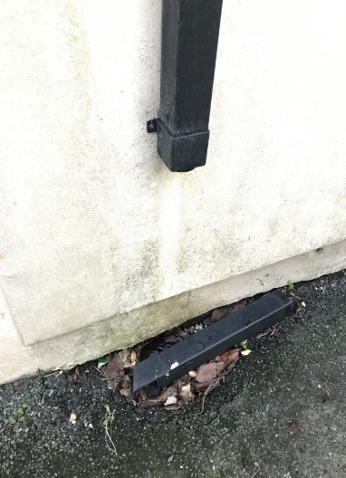

E3. Main walls: The main walls to the subject property are of cavity wall block construction with rendered external elevations. The walls appear structurally satisfactory with no evidence of current subsidence, settlement or other forms of significant movement. There are a few hairline cracks in the external render and render bands, more than likely due to thermal expansion (refer to Key 2 on plans). This could lead to penetrating damp, therefore they need filling and waterproofing. Mould/mildew and algae is vastly present around the external walls of the house. This should be cleaned/removed using the right products and painting the house would be recommended with proprietary solvent based exterior paint which would help protect against weathering.
The cavity was filled with bead insulation roughly 13 years ago according to the client. This is apparent as there are a series of holes filled around the external walls which are roughly 1 inch in diameter. In cavity construction, the inner and outer leaves are joined together by cavity ties. The cavity has not been inspected, therefore unable to know the condition of the ties or if there is any waste material which may block or obstruct the cavity. Metal wall ties may corrode in certain cavity walls and this process can happen before visible signs appear. Although there is no evidence of this happening is this instance. Condition Rating 2 – Cracks in render to be filled and sealed as soon as possible.
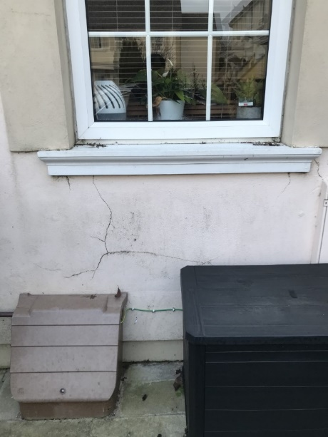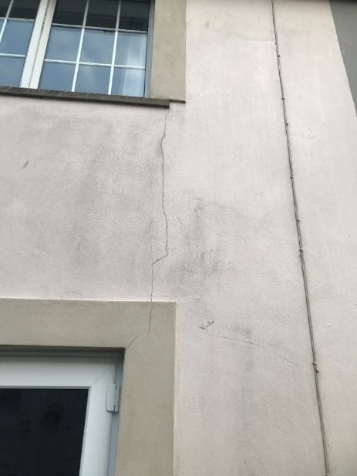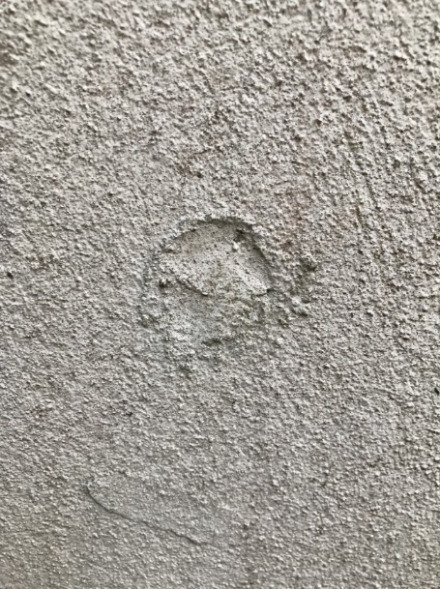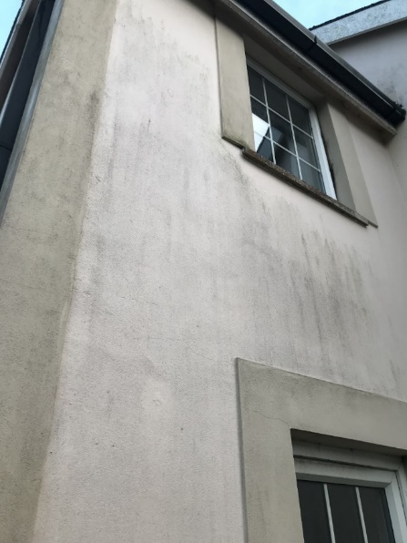
E4. Windows: The UPVC double glazed windows are the original windows (35 years old) and are present throughout the property. The recommended replacement time is every 15 to 20 years. Signs that they need replacing is when they become difficult to open, uncomfortable drafts and there is outside noise (poor energy efficiency). All three signs are present in this case for most of the original windows. There are also slight signs of water damage on the window sills and mold / mildew around the windows; I believe this is due to excess moisture in the property and lack of ventilation as the original windows do not have trickle vents, which would improve ventilation. Also, the joints between the sealed units seem tired and are beginning to separate, and this may result in misting of the voids. I recommend all windows to be replaced when possible (refer to Key 3 on plans). Condition Rating 2.
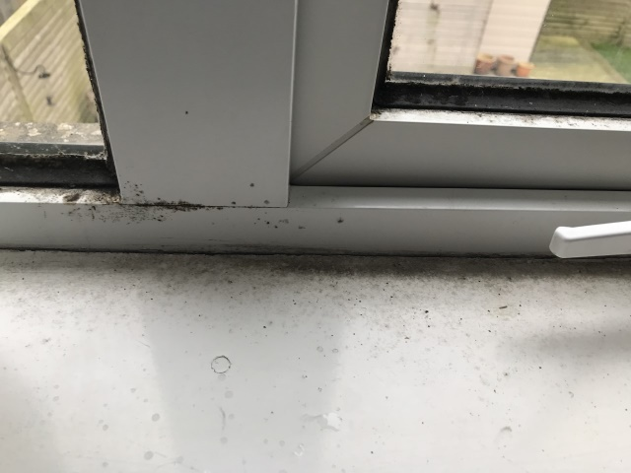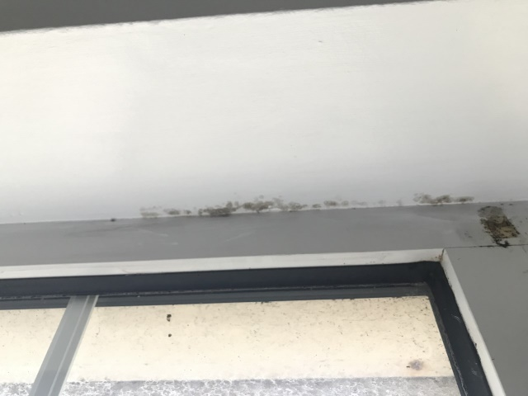
E5. External doors: A new UPVC front door is apparent, as well as fairly new patio double glazed doors to the rear of the property. The original single external double-glazed door in the dining room is recommended to be replaced as it is the same age and has the same issues as the windows with reduced energy efficiency. (refer to key 4 on plans). Condition Rating 2.
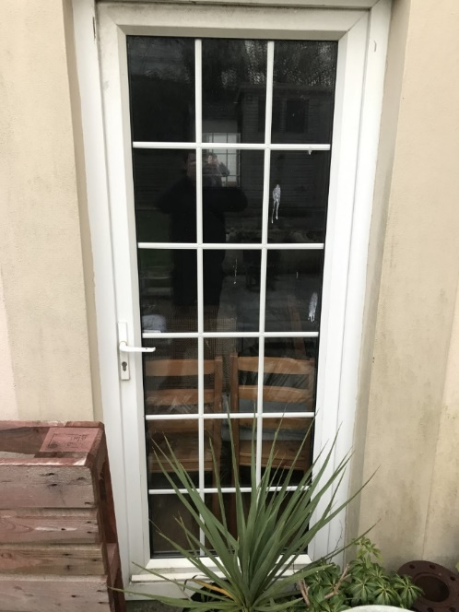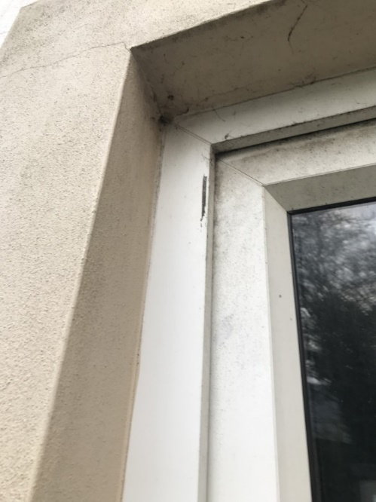
E6. Other joinery and finishes. The other external joinery generally comprises of over fitted UPVC fascia’s and barge boards to the original wooden ones, and the original wooden soffit boards are still in place. The wooden soffits seem in good to fair condition, therefore would recommend treating, redecorating, waterproofing and the UPVC material requires cleaning down, as per general maintenance. Condition Rating 1.
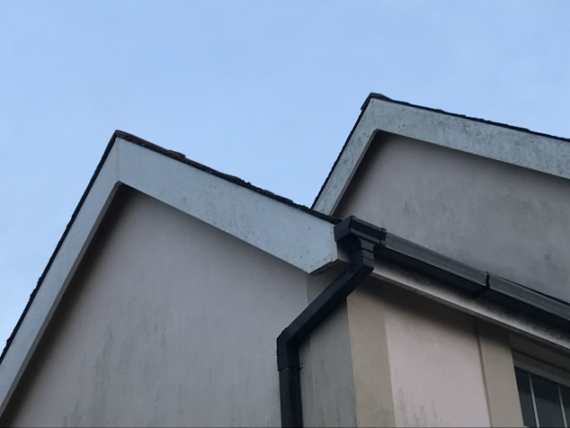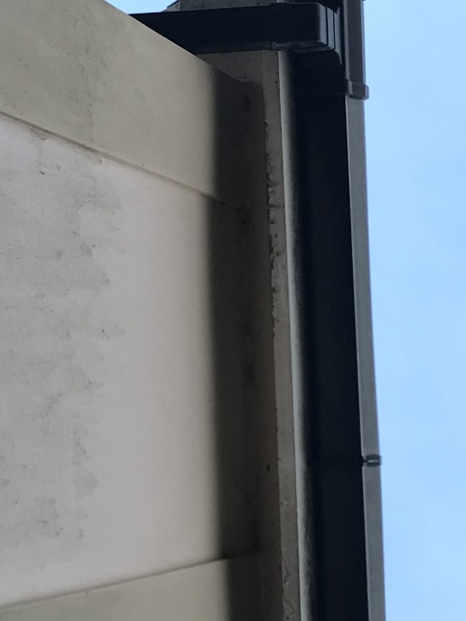
F. Internal Elements
F1. Roof Structure: Access to the separate roof spaces are gained via a hatch in the landing ceiling and in Bedroom 3. The roofs are constructed of timber pre-formed trusses. The roof slopes are lined with felt, which provides secondary protection against water and snow penetration. The roof frame appears to be free from any unwarranted distortion, bending or concern. There is not a sign of timber decay, rot or deterioration, although there are small water droplets present on the roofing felt, resulting with some moisture on the rafters. This could lead to rotting of timbers, compromising the roof framework and could cause damp appearing on ceilings.
The felt may possibly be impermeable roofing felt, although breathing membranes were introduced in 1980’s. The client should consider adding soffit vents as there do not appear to be any, (although may contain asbestos. Having said this, properties built since the mid-1980s are very unlikely to contain asbestos in the fabric of the building. But there is still a chance.) If unsure, contact a professional. As well as roof vents which would help extract excessive moisture. There are items stored in the attic which also affects ventilation. The insulation provided between the joists in the roof space is now below the recommended standard; would not meet current building regulations and is advisable to be upgraded to include insulating the loft access hatches. Condition Rating 2.
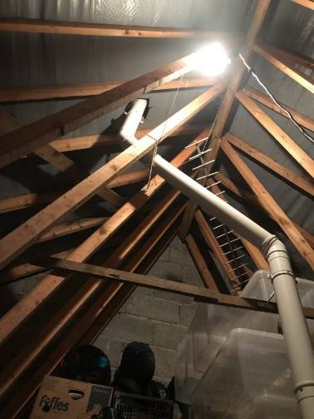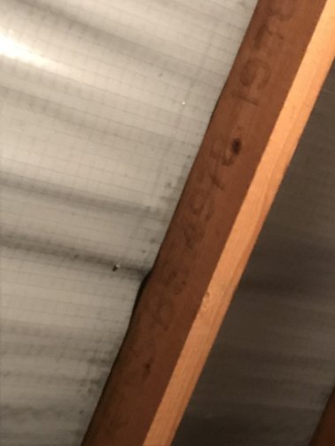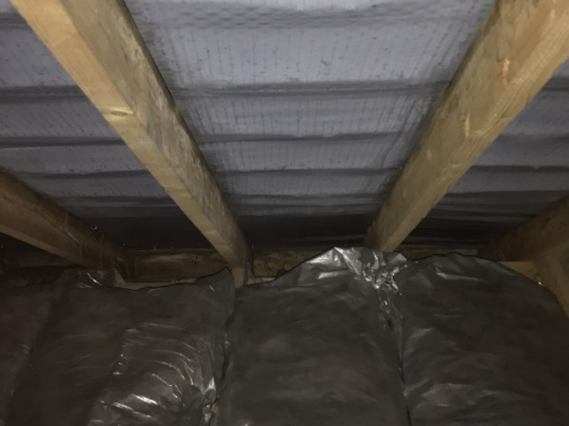
F2. Ceilings: The ceilings within the property are of plaster board specification. The plasterboard ceilings overall are in good condition. There is a previous sign of a leak in bedroom 2 but the issue has clearly now resolved (refer to Key 5 on plans). There are signs of mould/mildew in the bathroom (to be treated). Obvious resolution of this is more ventilation, possibly installing an extractor fan resulting in excess moisture extracted. Bedroom 3 has mould present in the right-hand corner of the room. This may be caused by lack of insulation in the corner of the attic, providing a cold spot, where moisture is attracted. (refer to key 6 on plans). To be treated and to check if insulation is covered this area in the attic space and any water ingress. Condition Rating 2.
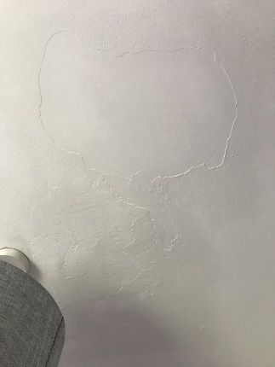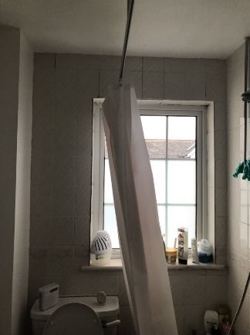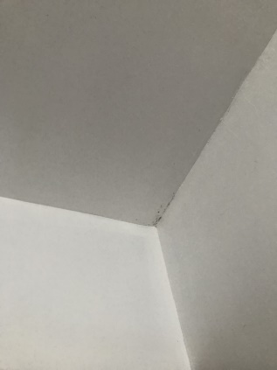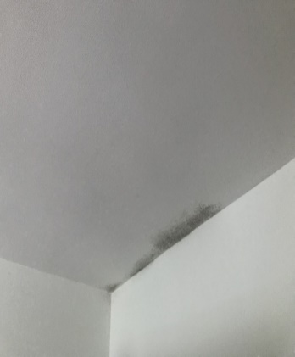
F3. Walls and partitions: The internal walls to the subject property are again of plasterboard specification using the dot and dab technique for all the cavity wall inner leaf ground floor, first floor and all structural walls. All other walls appear to be stud dry lined walls. The internal walls look structurally satisfactory with no significant evidence of internal structural movement. The client is clearly in the process of freshening up and redecorating the house. Condition Rating 1.
F4. Floors: The ground floor to the subject property is all of solid construction, with timber suspended flooring at first floor level. I could not inspect these timbers due newly floor coverings being in place to advise of any defects. Generally, seem to be in good condition; there was no creaking or loose floorboards apparent. Condition Rating 1.
F5. Fireplaces, Chimney Breasts and Flues: There is a newly installed boiler flue that is attached to the combi boiler on the first floor in the airing cupboard, which runs up through to the attic space and through the roof. Condition Rating 1.
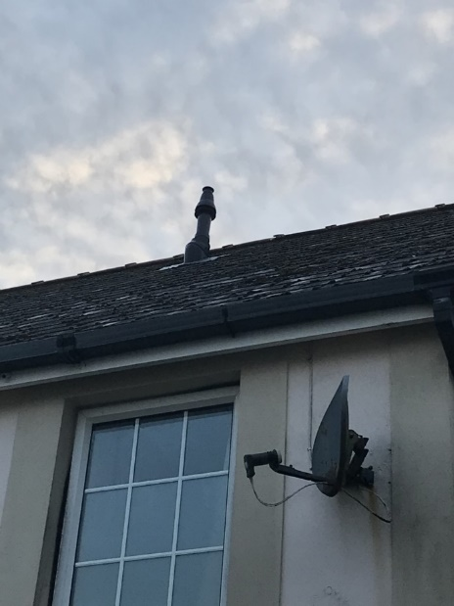
F6. Built-in fittings: Kitchen: The fully fitted kitchen was re-placed in 2009, is in good condition and still fairly modern. The cooker extractor only filters and does not extract the air outside. There is also no other extractor so I recommend for an extractor to be installed. Condition Rating 1.
F7. Woodwork (e.g. staircase & joinery) A range of skirtings, architraves and timber doors have been provided with a timber stairs connecting the ground to the first floor accommodation. Internal joinery items appeared in good condition. Condition Rating 1.
F8. Bathroom & Cloakroom Fittings: The bathroom fittings are the original fittings, therefore are slightly dated but still in full working order. Condition Rating 1.
F9. Other – Detectors: There are 2 battery operated smoke detectors in the property. One located towards the front of the property between the kitchen and lounge ceiling, the other on the ceiling of the 1st floor landing. Condition Rating 1.
G. Services
G1. Electricity: The property has the original wiring and is likely to need updating, at least in part, to meet modern standards, including replacing the fuse box with a modern consumer unit (refer to Key 7 on plans). A sign a rewire is needed, is dated rubber, fabric or lead insulated cable. Modern wiring is PVCu coated, coloured grey or white and twin earthed. Condition Rating 2. A mains electrical supply is provided to the property with a smart meter outside located at the front in an enclosed box.
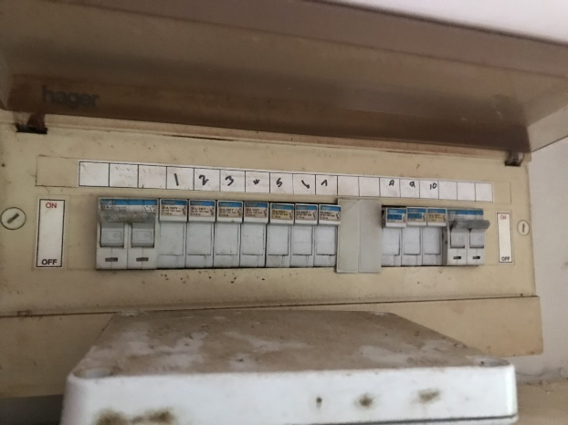
G2. Gas and Oil: Mains gas is now connected to the property. This happened in December 2021 as the main gas services extended into the close in the spring/summer of 2021. The gas meter is again at the front of the property in an enclosed box. Condition Rating 1.
G3. Water: Mains water is connected to the property. The location of the rising main and stop cock was identified. The plumbing system, where visible, comprises of modern pipe work. Condition Rating 1.
G4. Heating: A newly wall mounted gas fired combination boiler is located within the first-floor airing cupboard, providing heat to the convector radiators throughout the house on demand. Condition Rating 1.
G5. Water heating: A wall mounted gas fired combination boiler is provided; this provides hot water on demand. Condition Rating 1.
G6. Drainage: The property is connected to the mains drainage system. The inspection covers were lifted and no problems with debris were noted at the time of inspection. Condition Rating 1.
G7. Common services: Broadband Internet is provided at the property and seems to be in good working order on a visual inspection. Condition Rating 1.
H. External Grounds
H1. Car Park: The property has its own private car parking space outside the front of the property where there are parking bays. The parking space looks to be in good condition with no sign of pot holes, or surface crumbling. Condition Rating 1. There is no garage at the property. NI.
H2. Other: There is a fairly new timber shed in the rear of the property (September 2015) as well as a timber summer house north of the garden area (October 2018). Both in good condition but should be regularly treated to prolong their life. Electrics have been run to both outbuildings. Condition Rating 1.
I. Asbestos
An assumption has been made that there is no asbestos present based on the property’s age and type. Properties built after 1990 are extremely unlikely to contain asbestos anywhere in the building. NI.
J. Other Risks
J1. Risks to the building: Inspection of the main walls did not reveal any signs of any significant movement and there are no signs of current movement.
J2. Risks to the grounds: No particular risks to the grounds were noted.
J3. Risks to people: The presence of mold in the house in minor. Although, exposure to damp and moldy environments may cause a variety of health effects, or none at all. It is important to properly clean and dry the area as you can still have an allergic reaction to parts of the dead mold and mold contamination may recur if there is still a source of moisture. Recommendations have been put in place to help prevent re-occurrence. Condition Rating 2.
J4: Other Risks:
Radon: The property is in the category of 10–30 % radon. From information, a full radon test should be carried out by a professional to see if full radon protection should be in place.
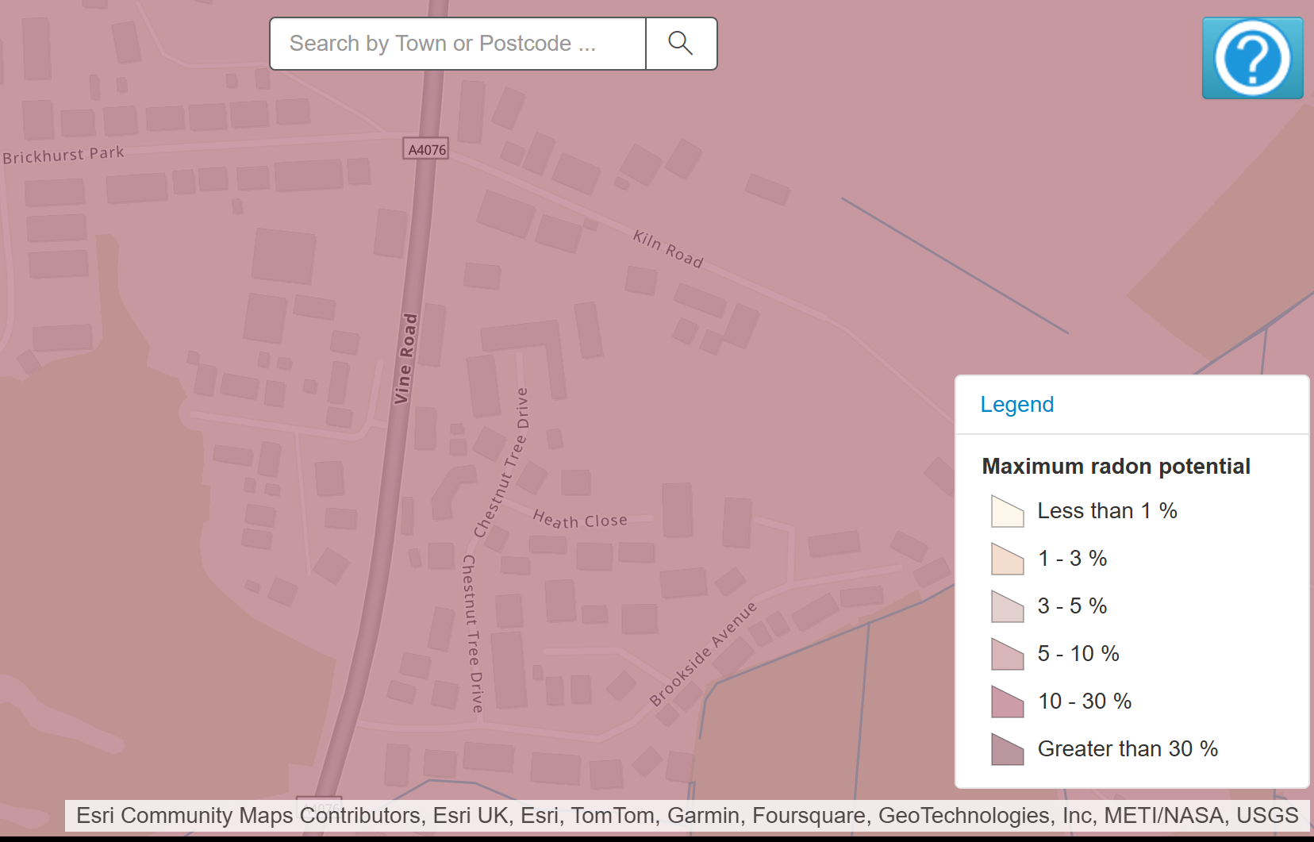 (UKradon, 2022)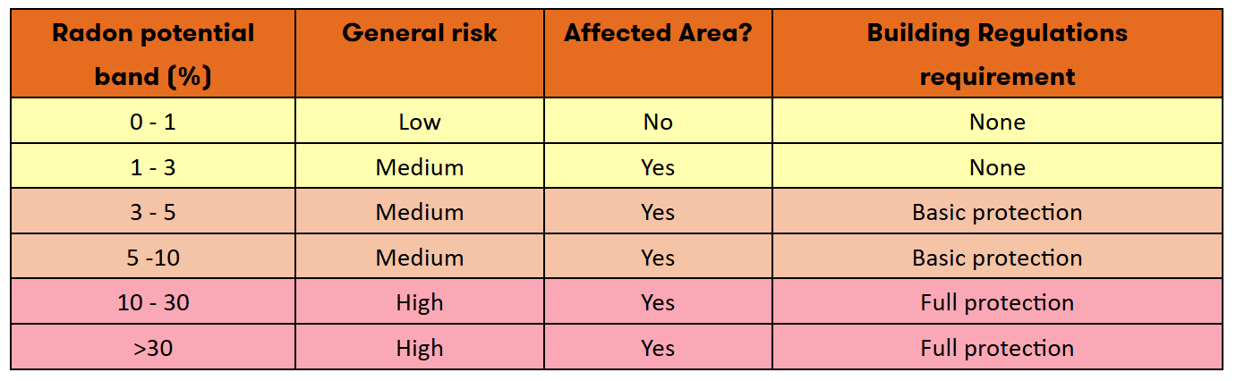 (LABC, 2023)
Flood Risk: As per the information below this property is very low risk from any type of flooding.
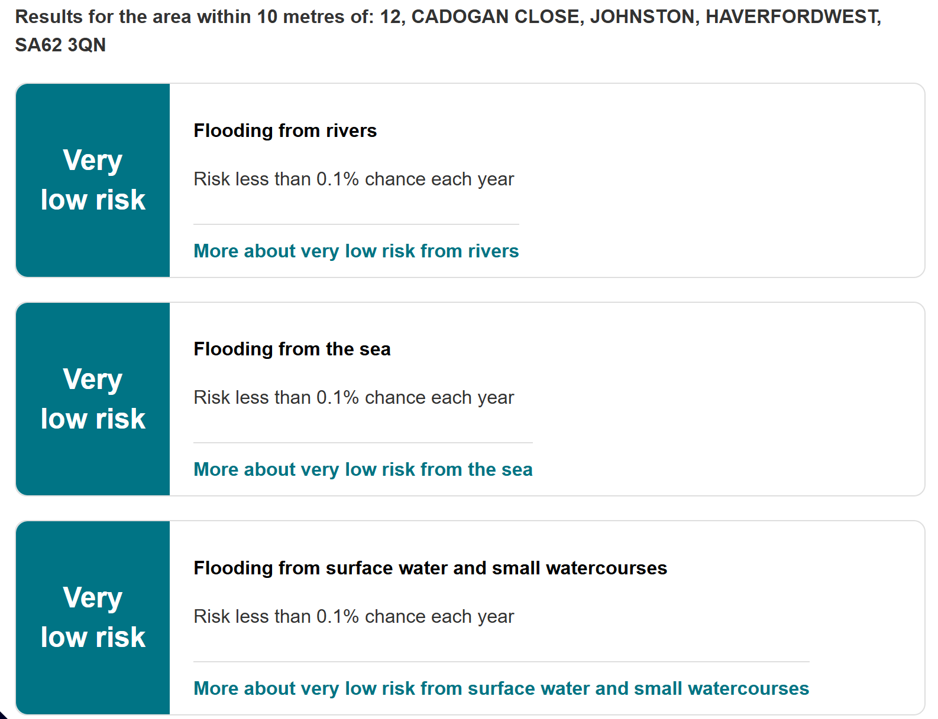
(Natural Resources Wales, 2025)
K. Building Plans
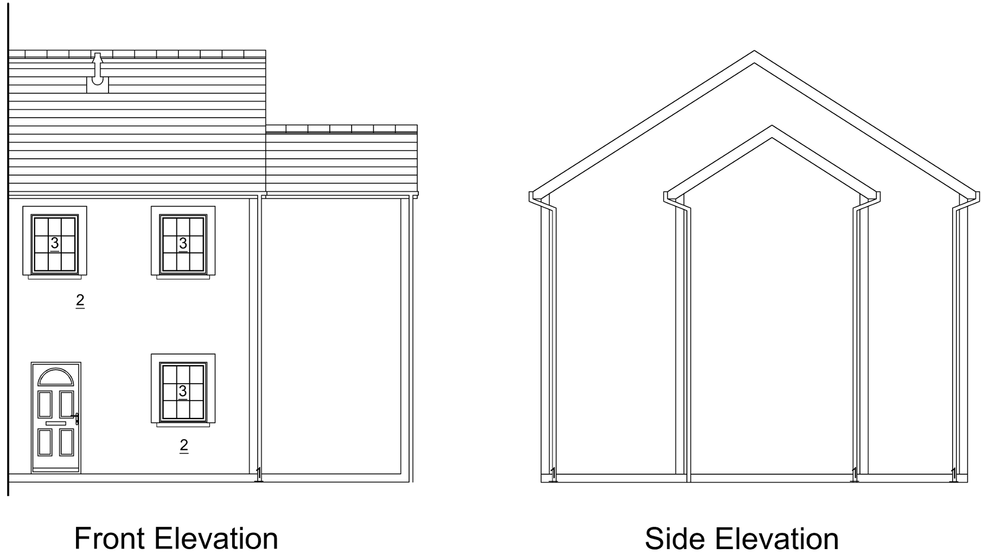
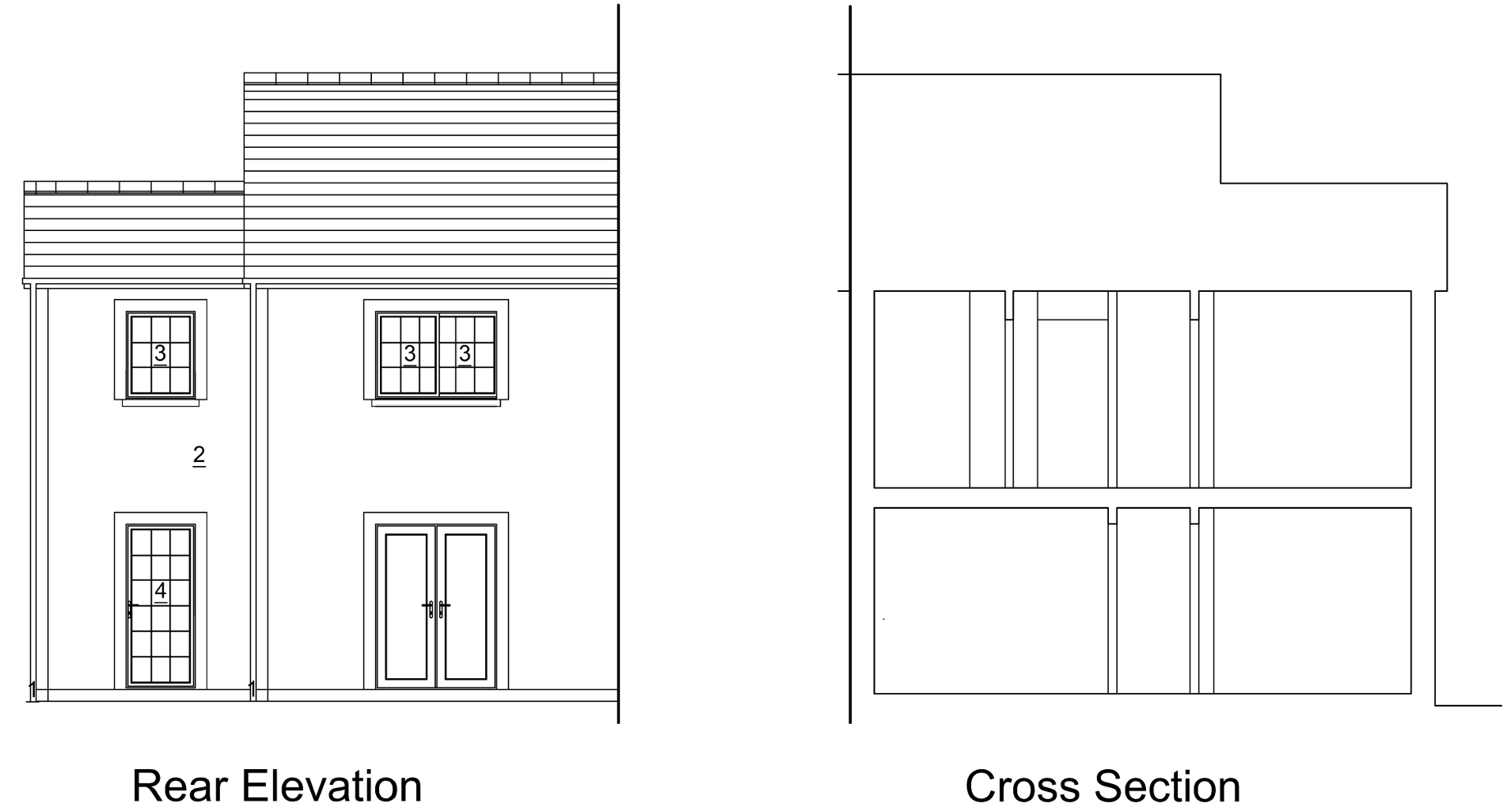

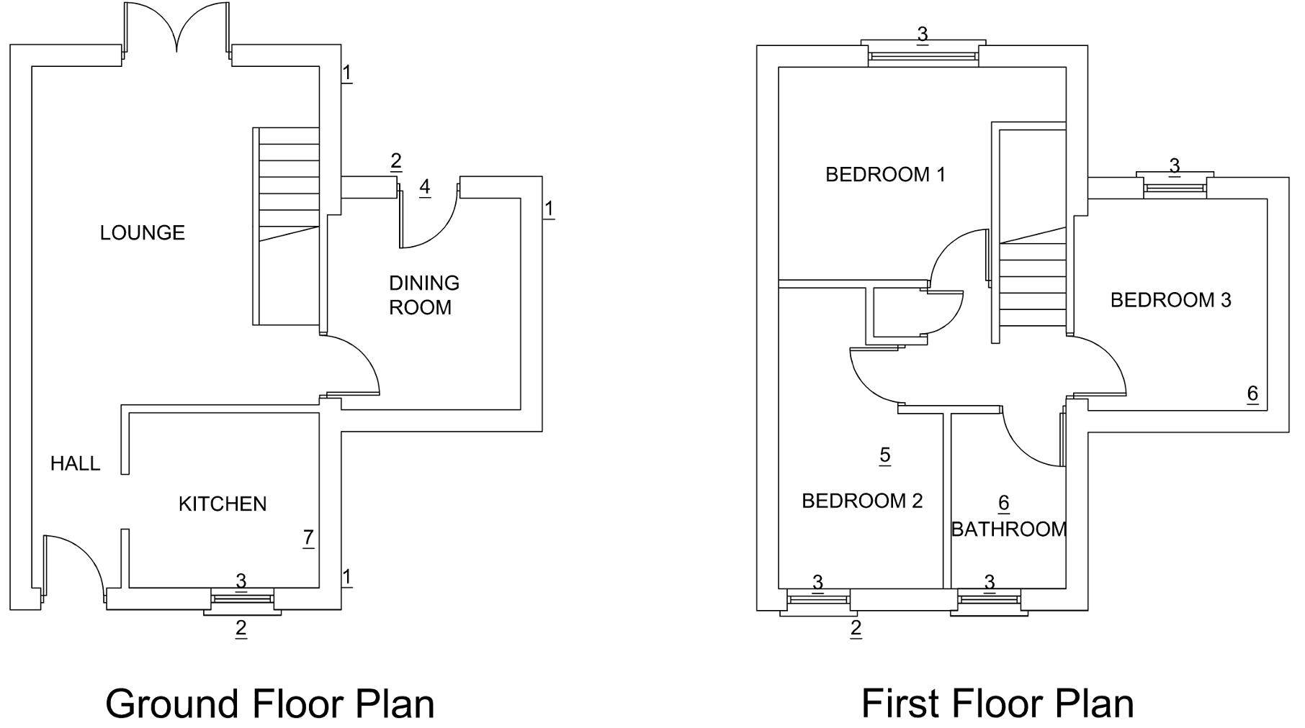
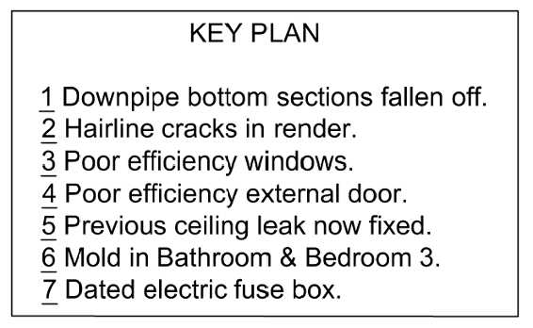
L. Occupancy Assessment Data
Name of Occupant | Miss O’Leary
Status of Occupant | Owner
Who is the electricity bill payer | Homeowner
Property Tenure | Freehold
No. of Occupants in the dwelling | 2
Shower Typer | Mains Bath / Shower
Showers Per Day / Week | 14 per Week
Baths per Day / Week | 0
Orientation of sloping roofs suitable for PV / Water? | North East and South West

Energy Usage Assessment
Heating Settings
Room Stat Temp | 18 degrees centigrade
Thermostat Location | 1st Floor Landing
Heating Pattern | On 1 | Off 1 | On 2 | Off 2 | On 3 | Off 3 | On 4 | Off 4
Normal | 6.20am | 8.00am | 6.00pm | 21.30pm
Notes

Hot Water Settings
Room Stat Temp | 58 degrees centigrade
Thermostat Location | Programmer on combination boiler in 1st floor airing cupboard.
Heating Pattern | On 1 | Off 1 | On 2 | Off 2 | On 3 | Off 3 | On 4 | Off 4
Notes | Works on demand

Household Appliances
No. of Fridges, Freezers or Fridge Freezers: | 1 Fridge freezer
Cooker Type: | Electric hob & fan oven
Washing Machine | Washer Dryer
Tumble Dryer | As above
Space for outdoor drying? | Yes
Unusual Energy Using Items (Fuel affected & Description) | Dehumidifiers in Dining Room & Bedroom 3.
Photos:
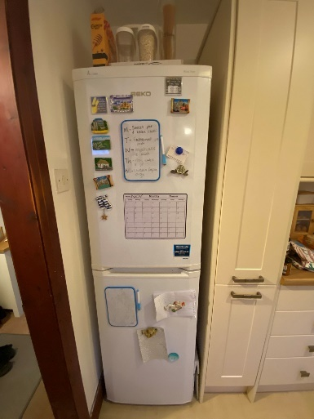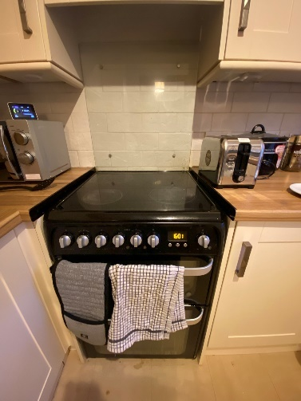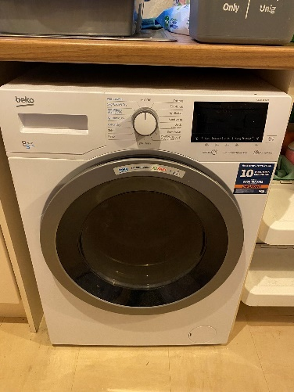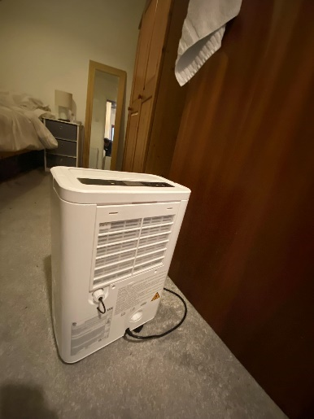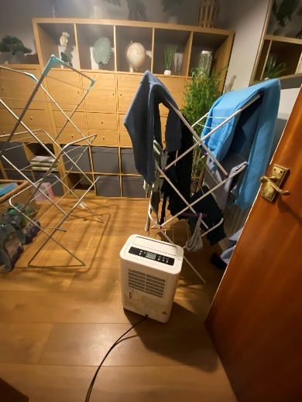

Fuel Data
Electricity
Metering
Meter Type | Smart
Meter Readings (provided by client)
Daily Example of electricity used at 12 Cadogan Close per kWh
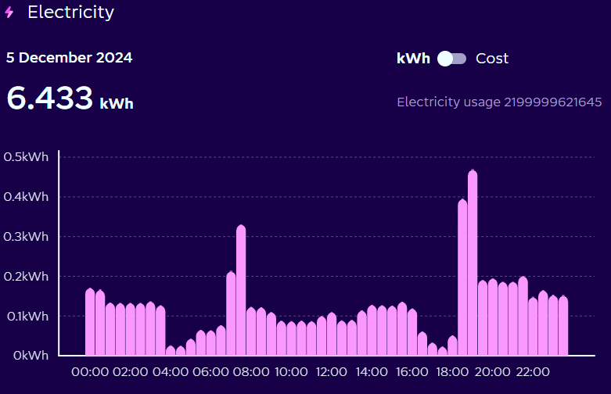
(octopus energy, 2025)
Weekly Example of electricity used at 12 Cadogan Close per kWh
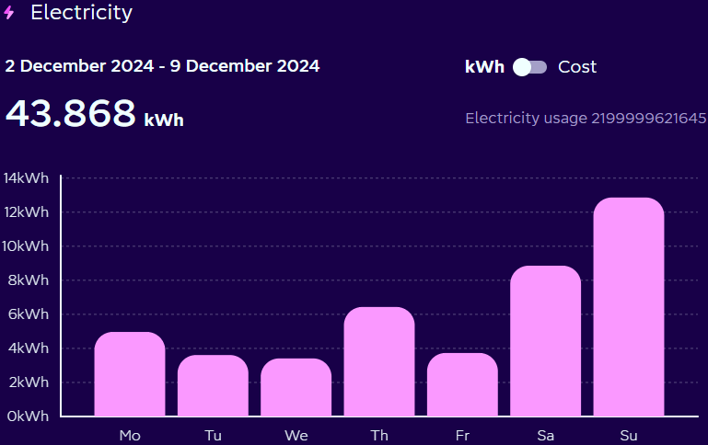
(octopus energy, 2025)

Monthly Example of electricity used at 12 Cadogan Close per kWh
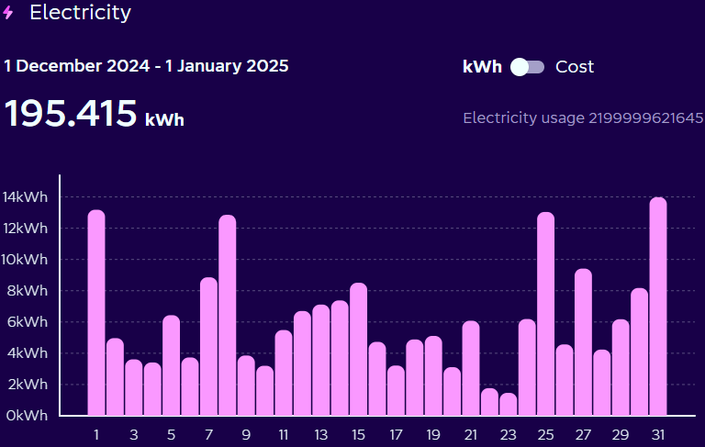
(octopus energy, 2025)
Annual Example of electricity used at 12 Cadogan Close per kWh
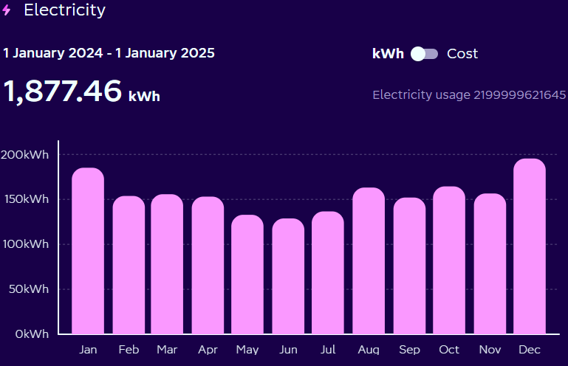
(octopus energy, 2025)
Annual Example of cost of electricity used at 12 Cadogan Close
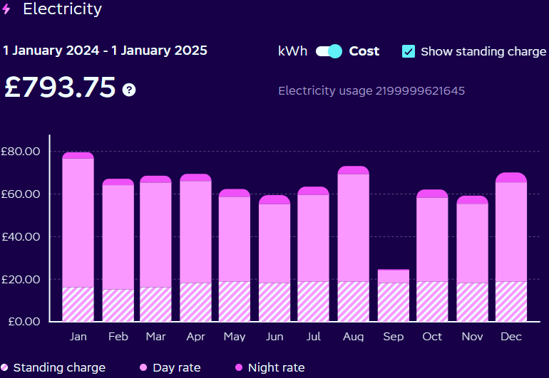
(octopus energy, 2025)
Photo(s) of Meter:
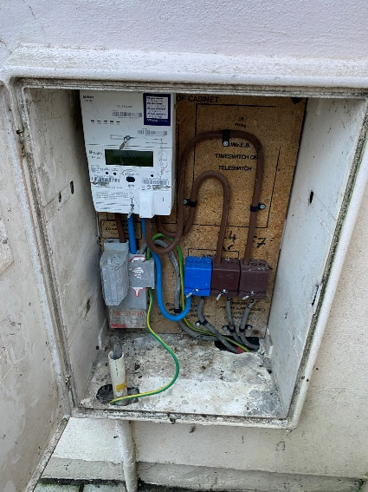

Gas
Metering
Meter Type | Smart
Meter Readings (provided by client)
Daily Example of gas used at 12 Cadogan Close per kWh
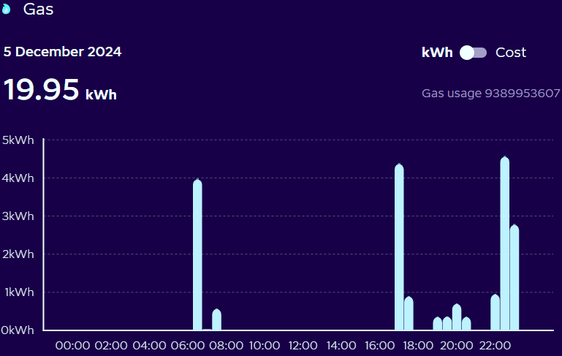
(octopus energy, 2025)
Weekly Example of gas used at 12 Cadogan Close per kWh
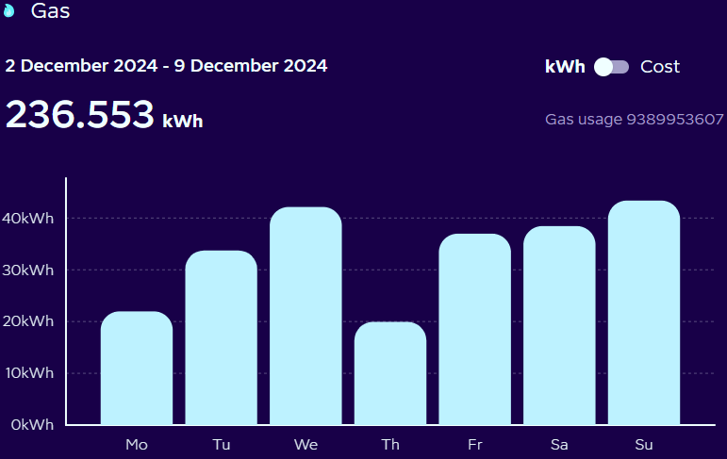
(octopus energy, 2025)

Monthly Example of gas used at 12 Cadogan Close per kWh
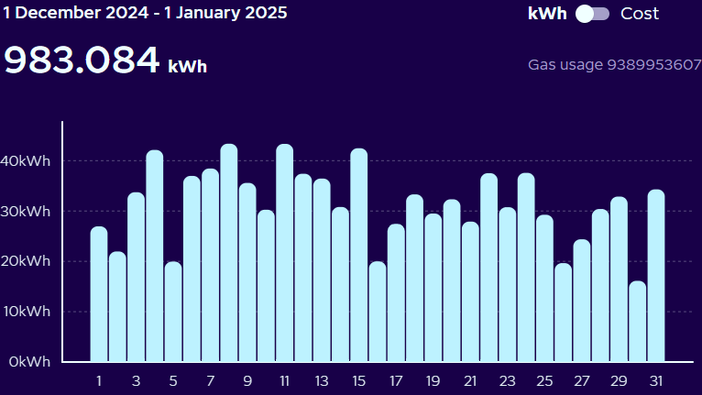
(octopus energy, 2025)
Annual Example of gas used at 12 Cadogan Close per kWh
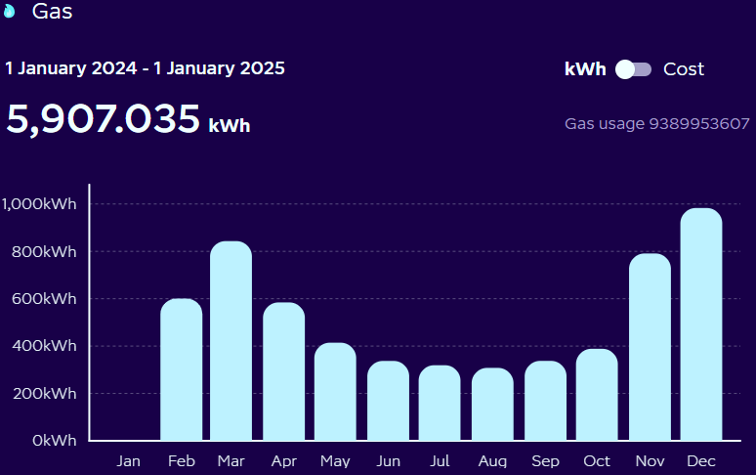
(octopus energy, 2025)
Annual Example of cost of electricity used at 12 Cadogan Close
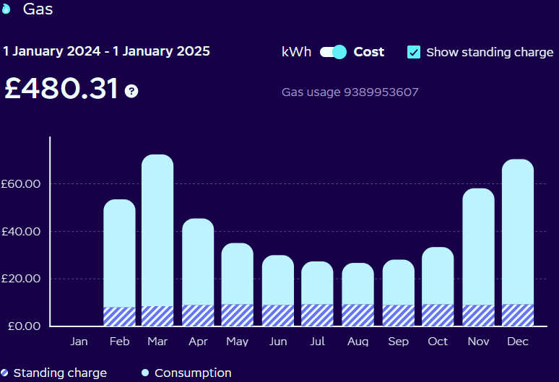
(octopus energy, 2025)
Photos of Meter:
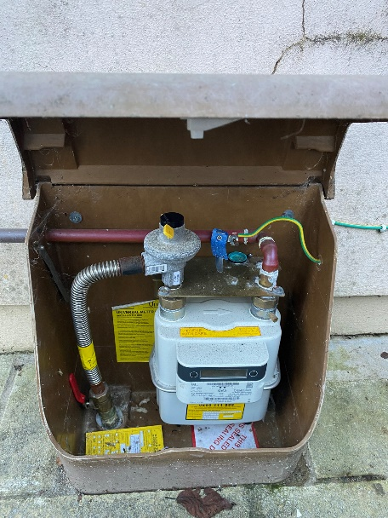

Heating Systems
Primary Heating System
Description / Type | Combination Boiler
Fuel Type | Gas
Manufacturer | Ideal
Model | Logic Combi c30
Heat Emitters | Radiator with TRV’s
Secondary Heating System(s) | N/A
Photos of Heating System:
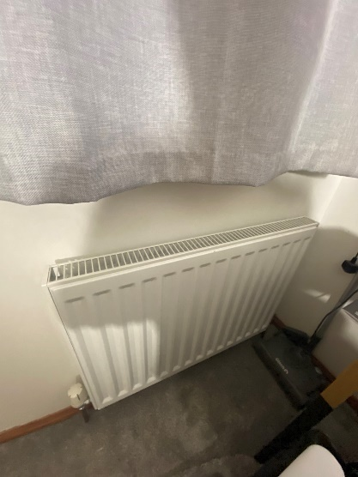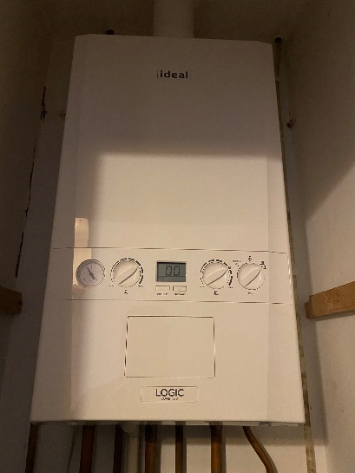

Heating Controls
Programmer | Yes
Room Stat | Yes
TRV’s | Yes
Zone Control | No
Photos of Heating Controls:
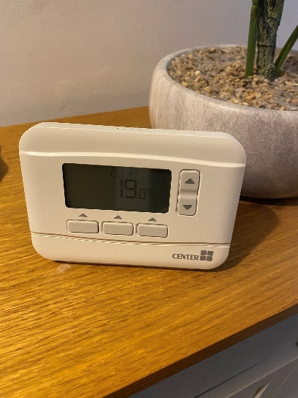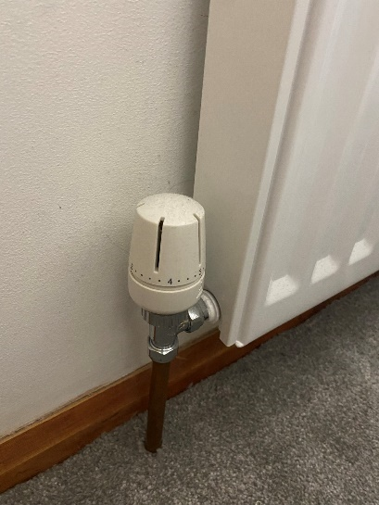

Hot Water System
Description / Type | Combination Boiler
Primary Source | Central Heating
Manufacturer | Ideal
Model | Logic Combi c30
Photos of Hot Water System:

Openings Schedule
Element | Floor | Room | Orientation | Glazing Type / Thickness | Frame Type | Width(mm) x Height (mm) | Openable | Condition | Trickle Vents
Window | G | Kitchen | NE | Double 12mm | PVC | 867 x 1110 | Yes | Poor | 0
Window | F | Bedroom 1 | SW | Double 12mm | PVC | 1521 x 1110 | Yes | Poor | 0
Window | F | Bedroom 2 | NE | Double 12mm | PVC | 867 x 1110 | Yes | Poor | 0
Window | F | Bedroom 3 | SW | Double 12mm | PVC | 867 x 1110 | Yes | Poor | 0
Window | F | Bathroom | NE | Double 12mm | PVC | 867 x 1110 | Yes | Poor | 0
Door | G | Hallway | NE | Double 12mm | PVC | 907 x 2045 | Yes | Good | 0
Door | G | Living Room | SW | Double 12mm | PVC | 1521 x 2080 | Yes | Okay | 0
Door | G | Dining Room | SW | Double 12mm | PVC | 867 x 2080 | Yes | Poor | 0

Radiator Schedule
Radiator Mark | Room | Width (mm) | Height (mm) | Single / Double | TRV
RG1 | Hallway | 600 | 600 | Double | Yes
RG2 | Living Room | 1200 | 600 | Double | Yes
RG3 | Dining Room | 100 | 600 | Double | Yes
RF1 | Bedroom 1 | 600 | 600 | Double | Yes
RF2 | Bedroom 2 | 800 | 600 | Double | Yes
RF3 | Bedroom 3 | 600 | 600 | Double | Yes
RF4 | Bathroom | 400 | 600 | Double | Yes

Openings & Windows Floor Plans
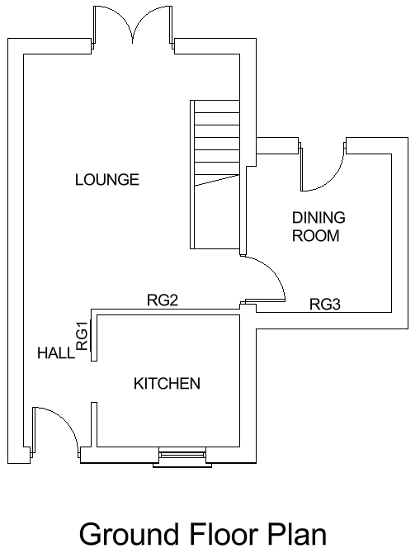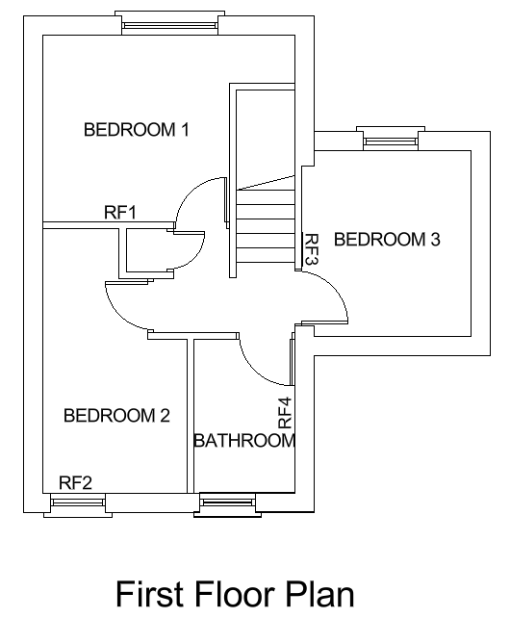

M. Retrofit Options
Below are Heat loss percentages from a typical house.

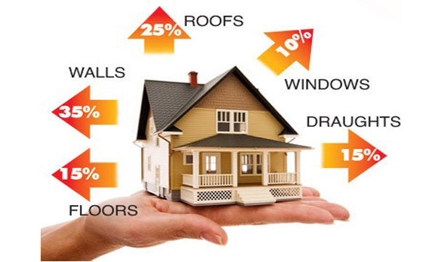
(CREDITON IN & AROUND, 2023)

Furthermore, the diagram below shows heat gains and loss by a passive house, modern house and leaky house.

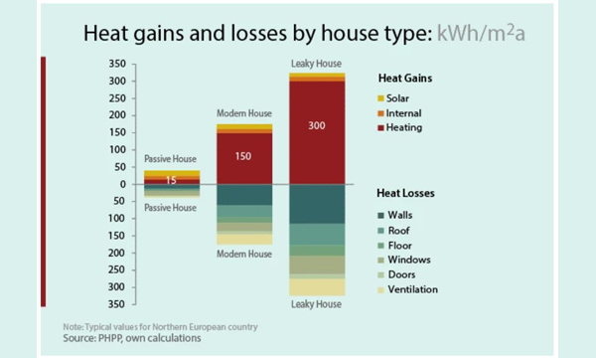
CREDITON IN & AROUND. (2023).

Potential upgrades which directly affect operational carbon/energy use

Insulation

Adding or improving insulation in walls, roofs, and floors can reduce heat loss and lower energy consumption for heating and cooling. My preference would be to use wood fibre insulation for the walls roof and even floor for benefits discussed shortly.

External Wall Insulation / Internal Wall Insulation

The client didn’t want to go down the route of external wall insulation due the property being an end terraced house and it potentially being out of sought compared to all the other terraced houses on the estate. The client was also not keen of the idea of internal wall insulation as the house is already modest in size and did not want to lose any more space as well as the interruption it may cause.

Cavity wall insulation is already in place at the property in the form of beads. Internal Wall insulation involves adding an insulating layer to the inside surface of your external walls. It usually consists of insulation boards or stud walls filled with insulation material. By combining both types of insulation, you would a achieve better overall thermal performance and energy savings.

Attic Insulation

I have found a product for the attic insulation which can be argued as being very energy efficient and sustainable. Gutex Thermoflex can be used on Timber frame walls, roofs and floors and as loft insulation installed between ceiling joists in a loft space. Features include:
- Easy to install
- Superb thermal performance
- Excellent winter thermal performance and summer overheating reduction
- Breathable
- Excellent acoustics
- Sustainable
The thickness of insulation I would choose is 220m as this provides a thermal conductivity of 0.036 W/mk. The building regulations require that the insulation material used must have a declared thermal conductivity not exceeding 0.040 W/mK. (Exactly Energy, n.d.)
The cost to purchase the product for 46m2 would be £1707.00 + labour. Renewing attic insulation is a less intrusive practice, but if the opportunity was ever given, it would be beneficial to install this between the intermediate floors also.

Images of potential attic insulation (wood Fibre)

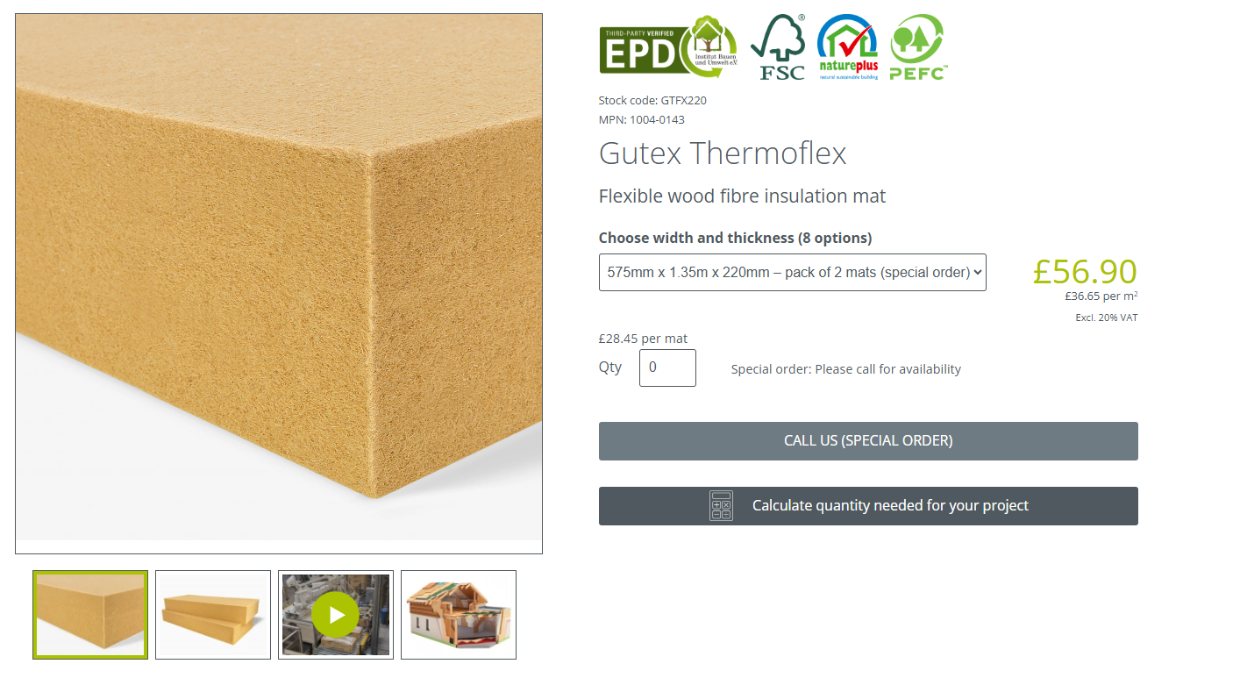
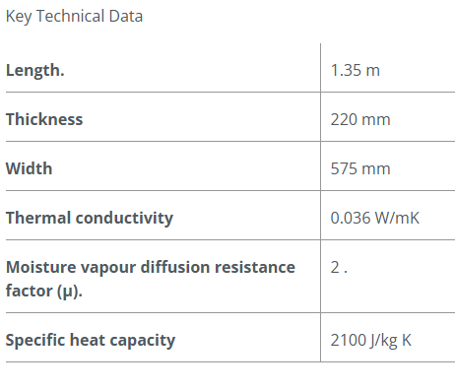

(Ecological Building Systems, n.d)
Energy-Efficient Doors & Windows: Replacing old windows with double or triple-glazed windows can help retain heat and reduce the need for artificial heating. Doors follow similar principles. Reducing the openings such as taking away the letterbox would help with energy efficiency. Having a stand alone letter box could be an option. The client currently has 35 years old double glazed pvc Georgian style windows. To replace for the same style of window, the u-value would be greater than if there wasn’t any beads in the window. On average, it would be Uw 1.25 instead of Uw 1.16. This is not a huge amount but every little helps. The client would be happy to make this aesthetic sacrifice to save money. Also, others on the estate have done the same.
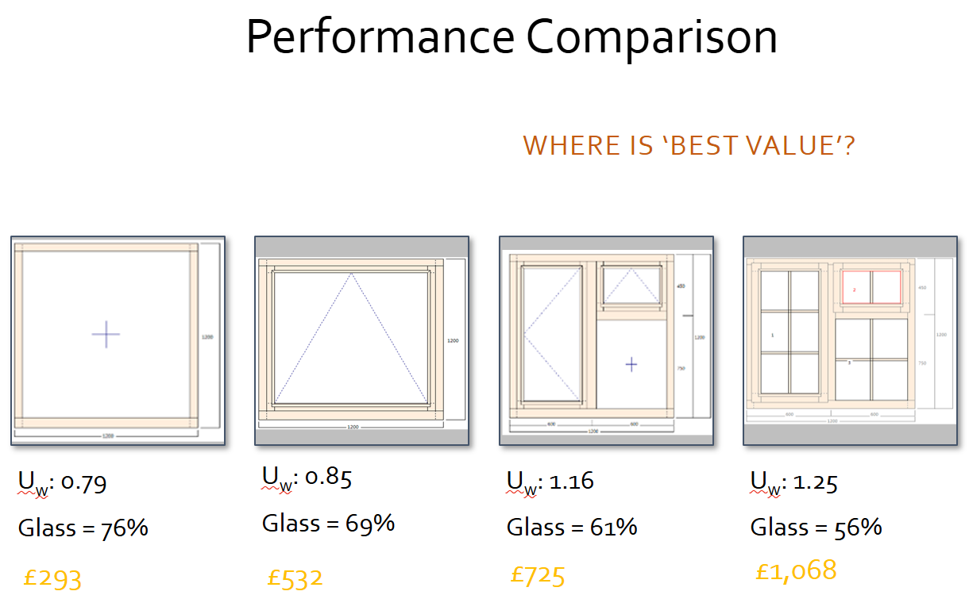
(Brown I, 2025)
LED Lighting: Switching to LED lighting can significantly reduce electricity use and heat generation. This is a simple change that can be made straight away. Most of the bulbs in the property seem to be energy efficient. The Client has kindly shown me the box of the light bulbs used.

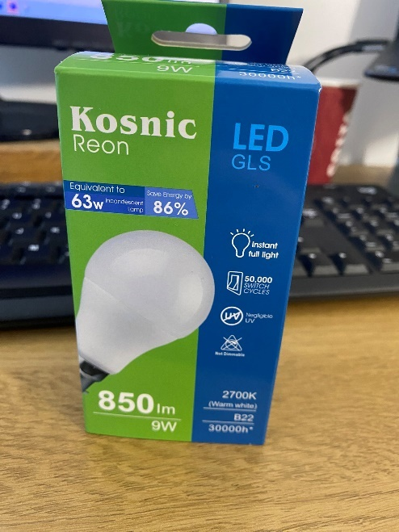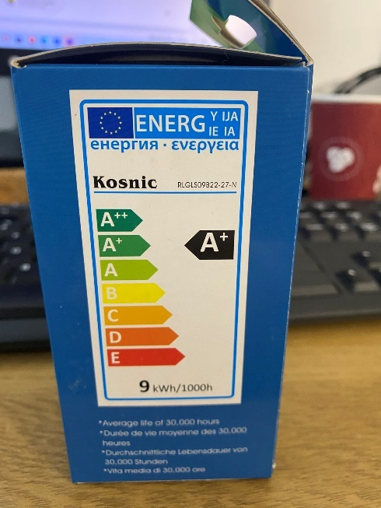
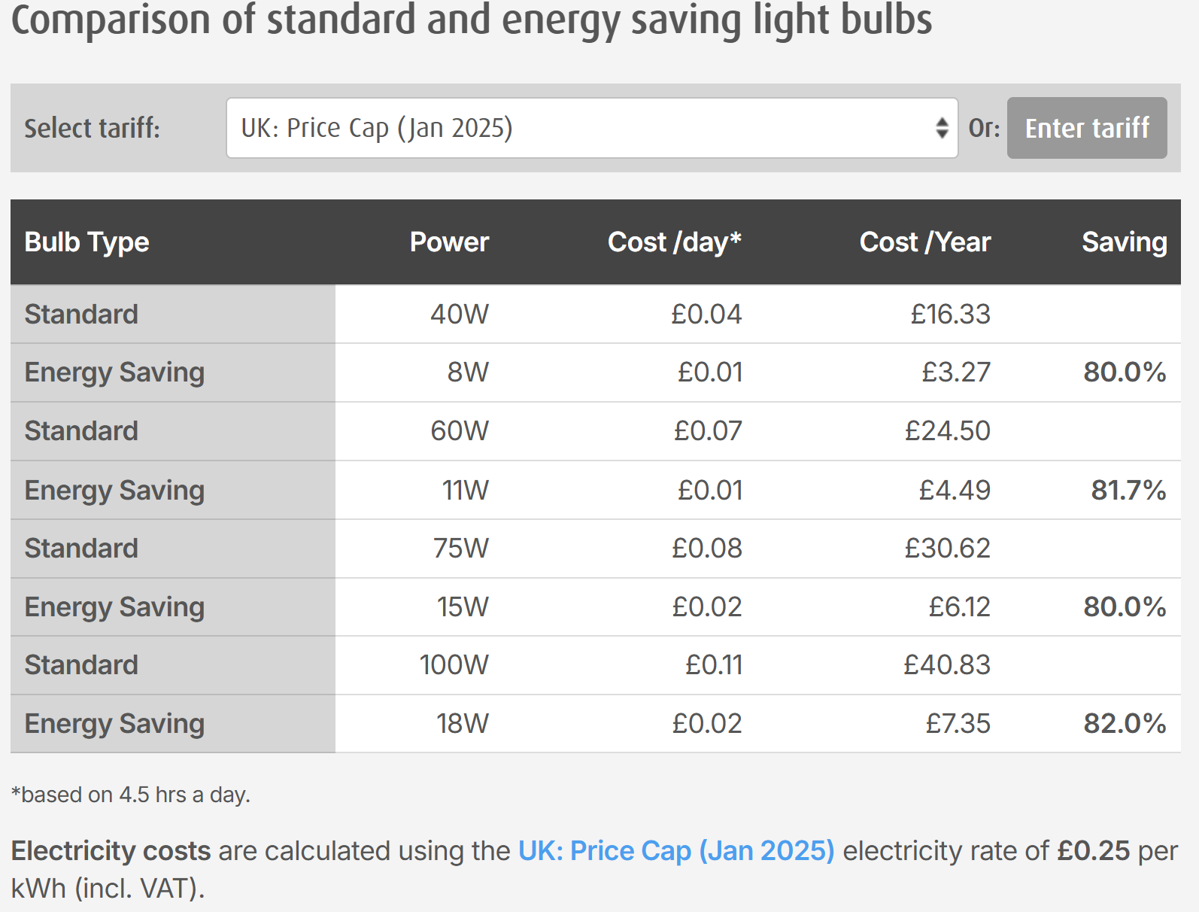
(Sust-it.net, n.d.)
Renewable Energy Sources: Installing solar panels or other renewable energy systems can offset energy consumption from non-renewable sources. Although the house is Northeast facing, solar panels may still be a viable option (Sout facing would be optimal). An example with the client’s current provider shows with 10 panels (no storage battery), there could be electricity bill savings of 94-155%. There is an installation fee of £9,199 for 10 panels only, therefore just over 15 months and the client will be getting free energy. Other tariffs would be available to include batteries, electric fuel for the future.

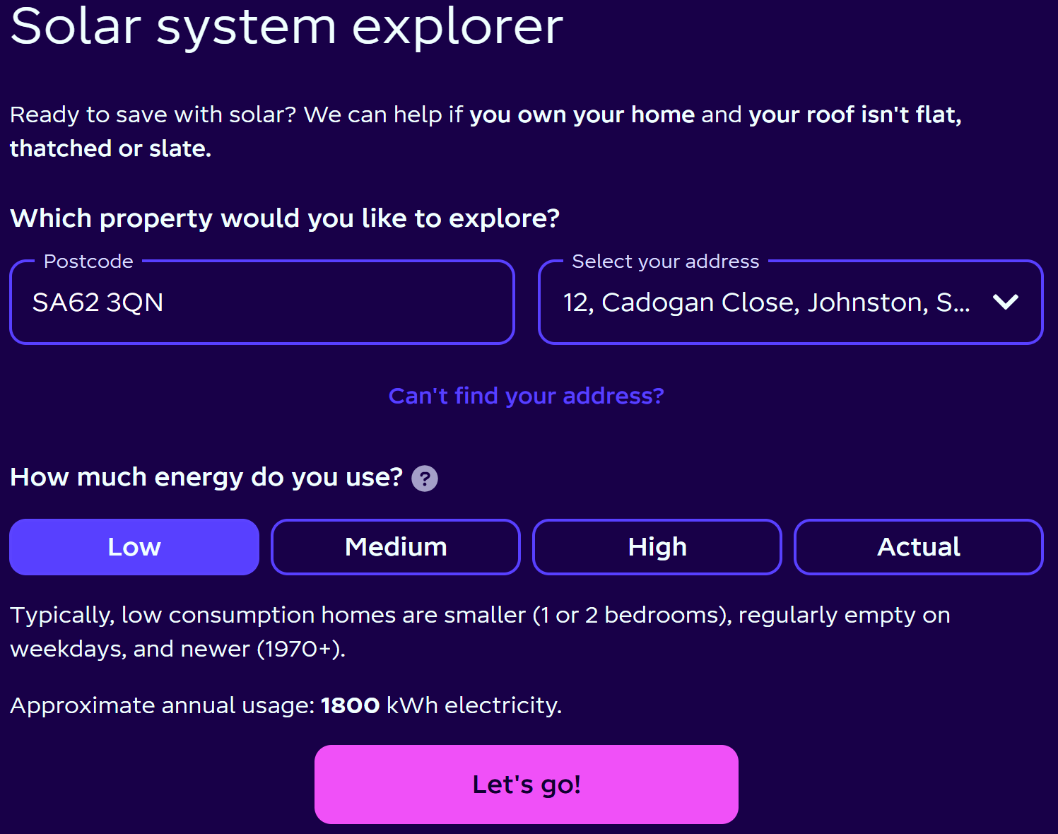 (octopus energy, 2025)
Water Efficiency: Upgrading to low-flow fixtures (toilet, shower head, taps, etc) and implementing rainwater harvesting systems can reduce water consumption and the energy needed to heat water. For free water efficiency home visits, you can contact Welsh Water. They also provide free products such as flow regulating shower heads, tap aerators and water displacement bags for a toilet cistern. (Welsh Water, 2025)
Heating: As the client has just had mains gas installed to include a combination gas boiler and radiators, she is happy with what’s in place.
A ventilation strategy, compliant with current Building regulations and considers the upgrades
‘The Approved Document F of the current Building Regulations outlines the requirements for ventilation to maintain indoor air quality. Key points include:
- Combination of Passive and Mechanical Ventilation: This ensures both natural airflow and mechanical extraction where necessary.
- Intermittent Extract Ventilation (IEV): Required in wet rooms like kitchens and bathrooms.
- Background Ventilation: Trickle vents in windows or wall vents to allow fresh air into living spaces. ‘
(GOV.UK, 2010)
‘According to PAS 2035, a standard for energy efficiency retrofit measures, the following should be considered:
- Assessment of Existing Ventilation: Check for signs of inadequate ventilation, such as condensation or mold growth.
- Intermittent Extract Ventilation (IEV): Ensure correct sizing and placement of extract fans in wet rooms.
- Background Ventilation: Install or upgrade background ventilators to maintain fresh air supply.’
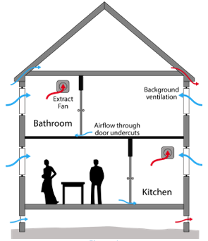
(ecmk, 2022)

Decentralised mvhr systems
The decentralised MVHR system works by removing stale air from inside the building through filters. At the same time, it captures and uses the heat from the outgoing air so it isn't wasted, and reuses it within the building. The filtered fresh air coming in is combined with the recovered heat and sent back into the building. This keeps the indoor air clean and prevents valuable heat from being lost. (ECOSTREAM, 2025)
A trial was carried out with dMVHRs installed only in the kitchen and bathroom. The rest of the house relied on natural air movement. During the winter, windows were closed, curtains were drawn, and internal doors were closed to keep warmth in each room. In the morning, curtains were opened, and internal doors were opened throughout the house to quickly get rid of any stale air.
As a result, the indoor temperature improved, making the house feel warmer and easier to heat compared to previous winters. This reduced the need for heating and lowered energy consumption. Also, the house felt warmer because the relative humidity decreased—from cold and damp to warm and dry. Humidity levels got much better throughout the house. High humidity levels in the kitchen and bathrooms didn't spread to other parts of the house.Air quality was consistently excellent throughout the home. When air quality issues happened, like using solvents or burning toast, good air quality returned quickly. People noticed that the house smelled fresh and aired out, never stale or stuffy like in previous winters due to airtightness. (Lewis S J, 2022)
Based on these results, I would say the decentralized system is less invasive, more affordable, highly efficient, and effective—a quicker, cheaper, and better whole-house solution.
dMVHR used for this trial
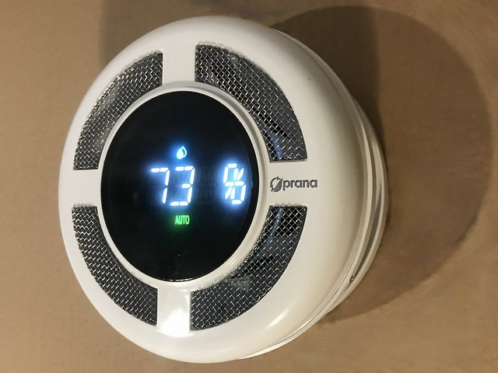
‘Prana Recuperator ERP PRO 210/160 – decentralised Mechanical Ventilation with Heat Recovery. Automated by Humidity, VOC and CO² sensors ~ unit cost £960 + installation £480 = £1440’
(Lewis S J, 2022)

dMVHRs working with Windows with Built-in Trickle Vents
dMVHR units continuously extracts stale air and recovers heat, while trickle vents add extra ventilation to ensure a steady supply of fresh air. Trickle vents help manage humidity levels, especially in airtight spaces, by allowing airflow when dMVHR units aren't running at full capacity. Having both systems ensures backup ventilation, maintaining fresh air even if one system fails or needs maintenance.
Embodied carbon /energy of the potential upgrades
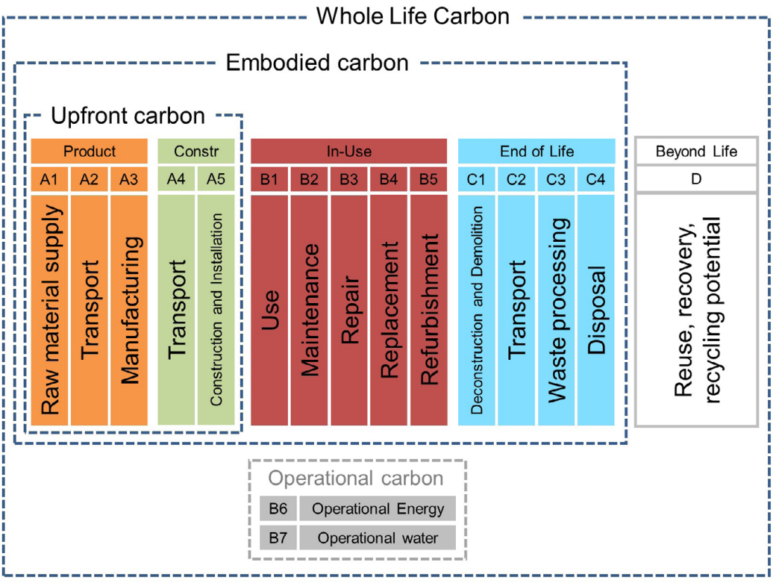
(ecomerchant,2023)
Wood Fibre Insulation
Wood fibre insulation has a relatively low embodied carbon compared to other insulation materials. Additionally, wood fibre insulation can store carbon dioxide, as wood naturally stores carbon absorbed by trees during their growth. This can help offset some of the carbon emissions associated with its production. (greenspec, 2025). Transportation would be high embodied energy on this occasion as the product is from Germany. Next time I will source a similar product locally if viable.
UPVC Windows
UPVC (unplasticized polyvinyl chloride) windows have a higher embodied carbon compared to other materials like wood. This means their production and transportation release more carbon dioxide. Specifically, UPVC windows have around 110 kg CO2e per window for double-glazed units. (Jones C, 2014).

Solar Panels
Solar panels have a relatively high embodied carbon, which means their production and transportation release a significant amount of carbon dioxide. However, they offset this carbon footprint over time by generating clean electricity and reducing reliance on fossil fuels. (circular ecology, 2025) On average, solar panels have a carbon payback period of about 1-4 years, meaning they save more carbon than they produce within this time. (Richardson J, 2024).
Decentralised MVHR units
Decentralised MVHR units have a moderate amount of embodied energy, which is the energy needed to make, transport, and install them. These units are built to be energy-efficient and save energy in heating and cooling over time, making up for their initial energy use.

N. References
Brown, I. (2025). Performance Comparison. [Online]. Microsoft Teams. Available at: https://uowtsd.sharepoint.com/:p:/r/teams/RetrofitCoordinationandManagementACBA5026_GRP/_layouts/15/ [Accessed 1 January 2025].

Cardiff Housing. (2023). Asbestos in the Home. [Online]. Cardiff Housing. Available at: https://www.cardiffhousing.co.uk/uploads/docs/docs_1354705446.pdf [Accessed 1 January 2025].

CDC. (2022). Basic Facts about Mold and Dampness. [Online]. CDC Centers for Disease Control and Prevention. Last Updated: 14 November 2022. Available at: https://www.cdc.gov/mold/faqs.htm# [Accessed 1 January 2025].

circular ecology. (2025). Embodied Carbon of Solar PV: Here's Why It Must Be Included In Net Zero Carbon Buildings. [Online]. circular ecology. Available at: https://circularecology.com/solar-pv-embodied-carbon.html?form=MG0AV3 [Accessed 1 January 2025].

CREDITON IN & AROUND. (2023). How to Reduce Your Energy Bills and Stay Warm. [Online]. CREDITON IN & AROUND. Last Updated: 1 March 2023. Available at: https://www.creditoninandaround.co.uk/posts/how-to-reduce-your-energy-bills-and-stay-warm [Accessed 1 January 2025].

ECOSTREAM. (2025). Domestic MVHR (Domestic heat recovery system). [Online]. ECOSTREAM. Available at: https://ecostream.org.uk/products/domestic/ [Accessed 1 January 2025].

Exactly Energy. (n.d.). How much loft insulation do you need? Available at: https://www.exactlyenergy.co.uk/insulation-articles/how-much-loft-insulation-do-you-need (Accessed: 1 January 2025).

ecmk. (2022). Ventilation Technical Guidance PAS2035:2019+A1:2022 Compliance. [Online]. ecmk. Last Updated: 14.06.2022. Available at: file:///C:/Users/Prest/Downloads/Ventilation%20Technical%20Guidance%20(2).pdf [Accessed 1 January 2025].

GOV.UK. (2010). Statutory guidance Ventilation: Approved Document F. [Online]. GOV.UK. Last Updated: 15 June 2022. Available at: https://www.gov.uk/government/publications/ventilation-approved-document-f [Accessed 1 January 2025].

greenspec. (2025). Embodied Carbon of Insulation. [Online]. greenspec. Available at: https://www.greenspec.co.uk/building-design/embodied-carbon-of-insulation/?form=MG0AV3 [Accessed 1 January 2025].

Jones, C. (2014). Double or triple glazing? All pane and no gain?. [Online]. circular ecology. Last Updated: 21 January, 2014. Available at: https://circularecology.com/news/double-glazing-or-triple-glazing-all-pane-and-no-gain?form=MG0AV3 [Accessed 1 January 2025].

LABC. (2023). Do I need to consider radon?. [Online]. LABC. Last Updated: 22.05.2023. Available at: https://www.labc.co.uk/news/do-i-need-consider-radon [Accessed 1 January 2025].

Lewis, S J. (2022). Decentralised-MVHR – a quicker|cheaper|better whole-house solution?. [Online]. Neighbourhood Construction. Last Updated: 2 April 2022. Available at: https://www.neighbourhoodconstruction.org/2022/04/02/decentralised-mvhr-a-quickercheaperbetter-whole [Accessed 1 January 2025].

local electricians direct. (2023). When is rewiring a property necessary?. [Online]. local electricians direct - the price comparison site... for property services. Available at: https://www.localelectriciansdirect.co.uk/when-rewiring-property-necessary#:~:text=If%20a%20property [Accessed 1 January 2025].

Natural Resources Wales. (2025). Check your flood risk. [Online]. Natural Resources Wales. Available at: https://check-your-flood-risk.naturalresources.wales/home/GetRiskLevels?rnd=1736533315427&postcode=S [Accessed 1 January 2025].

octopus energy. (2025). My energy. [Online]. octopus energy. Available at: https://octopus.energy/dashboard/new/accounts/A-394DD1BD/my-energy [Accessed 1 January 2025].

Richardson, J. (2024). Solar Photovoltaics - Cradle-to-Grave Analysis and Environmental Cost 2025. [Online]. The Renewable Energy Hub UK. Last Updated: 31 December, 2024. Available at: https://www.renewableenergyhub.co.uk/main/solar-panels/solar-panels-carbon-analysis?form=MG0AV3 [Accessed 1 January 2025].

simpleshowing. (2023). Signs That You Need a Window Replacement. [Online]. simpleshowing. Last Updated: 31 January 2023. Available at: https://www.simpleshowing.com/blog/signs-that-you-need-a-window-replacement [Accessed 1 January 2025].

Ecological Building Systems. (n.d.). Thermoflex. Available at: https://www.ecologicalbuildingsystems.com/product/thermoflex(Accessed: 1 January 2025).

ecomerchant. (2023). UNDERSTANDING THE 2030 CARBON TARGETS. [Online]. ecomerchant. Available at: https://www.ecomerchant.co.uk/news/understanding-the-2030-carbon-targets/ [Accessed 1 January 2025].

Sust-it.net. (n.d.). Lighting Energy Calculator. Available at: https://www.sust-it.net/lighting-energy-calculator.php(Accessed: 10 January 2025).

UK Health Security Agency. (2023). UK maps of radon. [Online]. Ukradon. Last Updated: 01/12/2022. Available at: https://www.ukradon.org/information/ukmaps [Accessed 1 January 2025].

UKradon. (2022). UK maps of radon. [Online]. UK Health Security Agency. Last Updated: 1 December 2022. Available at: https://www.ukradon.org/information/ukmaps [Accessed 1 January 2025].

Welsh Water. (2025). Save water to save money. [Online]. Welsh Water. Available at: https://www.dwrcymru.com/en/blog/project-cartref-save-water-to-save-money [Accessed 1 January 2025].

