Design and Analysis of Electromagnetic Systems

  - Saffina H – 2322601
  - Electromagnetic Radiation – ACDC5009

Table of Contents

Table of Figures 3
Table of Equations 4
Table of Tables 4
Abstract 5
Task 1: Simulating Waveguides 5
1. Introduction 5
2. Methodology 5
3. Results 8
3.1. Vacuum Waveguide 8
3.2. Teflon Waveguide 14
4. Discussion 19
4.1. Vacuum Waveguide 19
4.2. Teflon Waveguide 20
4.3. Comparison 23
5. Conclusion 24
Task 2: Simulating a Halfwave Dipole 25
1. Introduction 25
2. Methodology 25
3. Results 28
3. Discussion 29
4. Conclusion 30
Task 3: Researching RADAR technology 31
1. Introduction 31
2. Literature Review 31
2.1. Key issues 31
2.2. Current capabilities 32
3. Discussion 32
3.1. Impacts 32
3.2. Solutions 33
4. Conclusion 34
7. References 35

Table of Figures

Figure 1: Dimensions of rectangular waveguide simulation 6
Figure 2: Walls of the rectangular waveguide assigned as a PEC 7
Figure 3: Either end of the rectangular waveguide assigned as a modal lumped port 7
Figure 4: Graph of the frequency sweep for the vacuum rectangular waveguide 8
Figure 5: Port field display on the vacuum waveguide port in mode 1 9
Figure 6: Port field display on the vacuum waveguide port in mode 2 9
Figure 7: Port field display on the vacuum waveguide port in mode 3 9
Figure 8: Graph of the frequency sweep for the Teflon rectangular waveguide 14
Figure 9: Port field display on the Teflon waveguide port in mode 1 15
Figure 10: Port field display on the Teflon waveguide port in mode 2 15
Figure 11: Port field display on the Teflon waveguide port in mode 3 15
Figure 12: cylindrical dipole created in HFSS 26
Figure 13: gap created in center of the dipole in HFSS 26
Figure 14: 50 ohm lumped port to provide excitation to the dipole 27
Figure 15: radiation boundary surrounding the dipole 27
Figure 16: S Parameter plot for halfwave dipole 28
Figure 17: 3D radiation pattern of halfwave dipole 29

Table of Equations

Equation 1: calculating the value of waveguide dimension ‘a’ 5
Equation 2: calculating the value of waveguide dimension ‘b’ 6
Equation 3: formula to calculate cutoff frequency 19
Equation 4: calculating cutoff frequency for the vacuum waveguide’s TE10 mode 19
Equation 5: calculating cutoff frequency for the vacuum waveguide’s TE20 mode 19
Equation 6: calculating cutoff frequency for the vacuum waveguide’s TE01 mode 20
Equation 7: calculating permittivity of Teflon 21
Equation 8: calculating permeability of Teflon 21
Equation 9: calculating speed of light in Teflon 21
Equation 10: calculating cutoff frequency for the Teflon waveguide’s TE10 mode 22
Equation 11: calculating cutoff frequency for the Teflon waveguide’s TE20 mode 22
Equation 12: calculating cutoff frequency for the Teflon waveguide’s TE01 mode 22
Equation 13: calculating length of a halfwave dipole 25
Equation 14: calculating theoretical cutoff frequency of the dipole 25

Table of Tables

Table 1: Table of results for the electric and magnetic fields of the vacuum waveguide 13
Table 2: Table of results for the electric and magnetic fields of the Teflon waveguide 18
Table 3: Table of theoretical and simulated cutoff frequencies for the vacuum waveguide 20
Table 4: Table of theoretical and simulated cutoff frequencies for the Teflon waveguide 23

Abstract

This report is written in three sections. The first outlines the methods and results of simulated rectangular waveguides, one made of a vacuum and the other of Teflon. The second section looks at a simulated half-wave dipole antenna, and its’ radiation characteristics. The third section conducts research on current UAV (unmanned aerial vehicle) detection RADAR, recent developments, and potential future improvements and impact.

Task 1: Simulating Waveguides

1. Introduction
This report looks at the theory behind waveguides. It calculates the dimensions of a waveguide, and the construction of two simulations, comparing the results between a vacuum and Teflon waveguide. The cutoff frequencies are measured and theoretical results calculated for each mode, as well as looking at the vector and magnitude of the electric and magnetic fields.

2. Methodology
The initial setup for creating the rectangular waveguides is performing the calculations specified in the brief, and calculating the dimensions as shown below in equations 1 and 2, using a student ID of 2322601.
$$a=first two numbers of student ID=23mm$$
Equation 1: calculating the value of waveguide dimension ‘a’
$$b= \frac{3rd and 4th numbers of student ID}{2}= \frac{22}{2}=11mm$$
Equation 2: calculating the value of waveguide dimension ‘b’
A waveguide was then created using the dimensions calculated and with a length of 50mm. The simulation is shown below in Figure 1. Both the Vacuum and Teflon waveguide were simulated in the same way, with the only change made being the material.
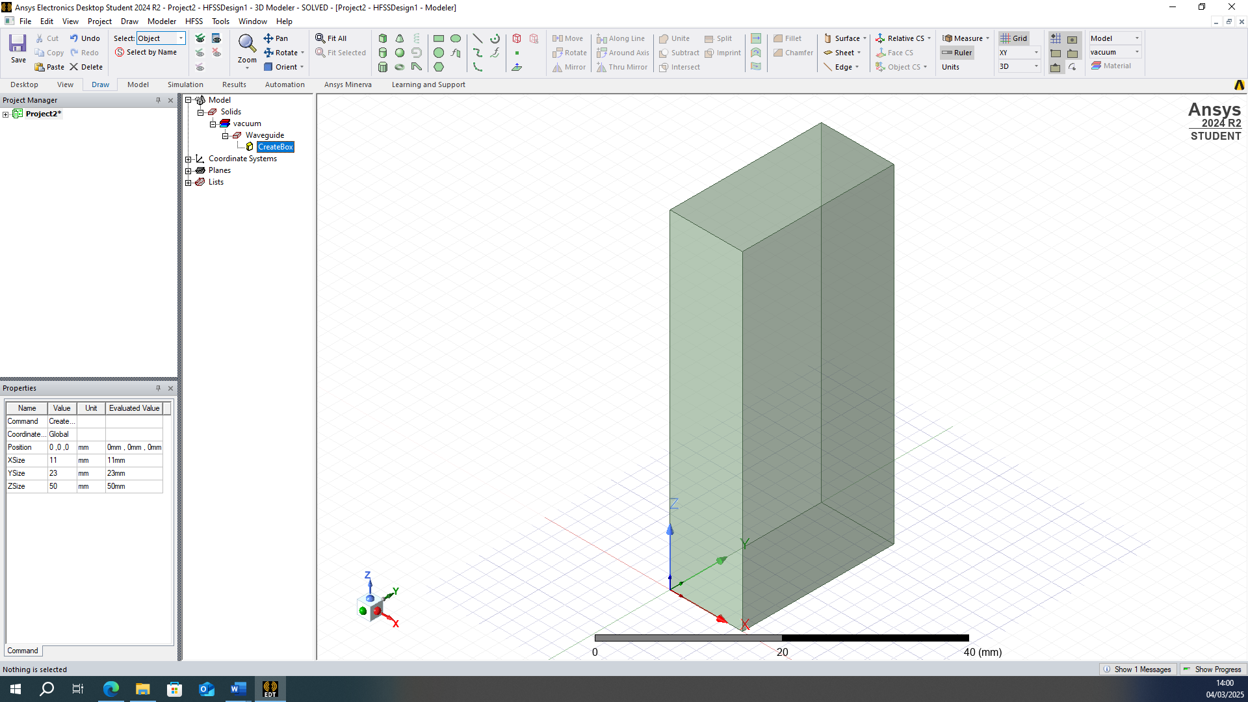
Figure 1: Dimensions of rectangular waveguide simulation

To simulate this, it was assumed to be a “perfect waveguide”; it was created as a perfect box, the conductor was perfect (PEC) and of negligible width, and that the material and vacuum were uniform throughout.
The walls of the waveguide, shown below in Figure 2 were assigned a material of PEC (perfect electrical conductor), shown in Figure 2 below.
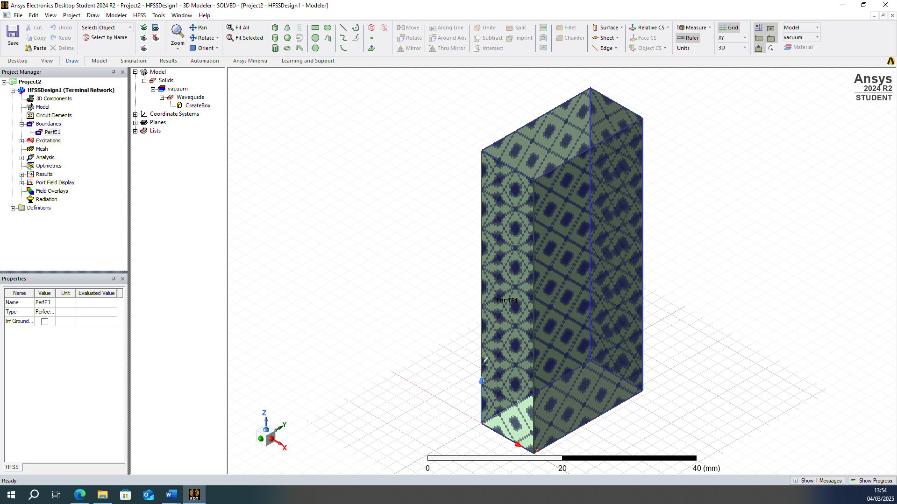
Figure 2: Walls of the rectangular waveguide assigned as a PEC

Either end of the waveguide was assigned as a modal lumped port, shown below in Figure 3.
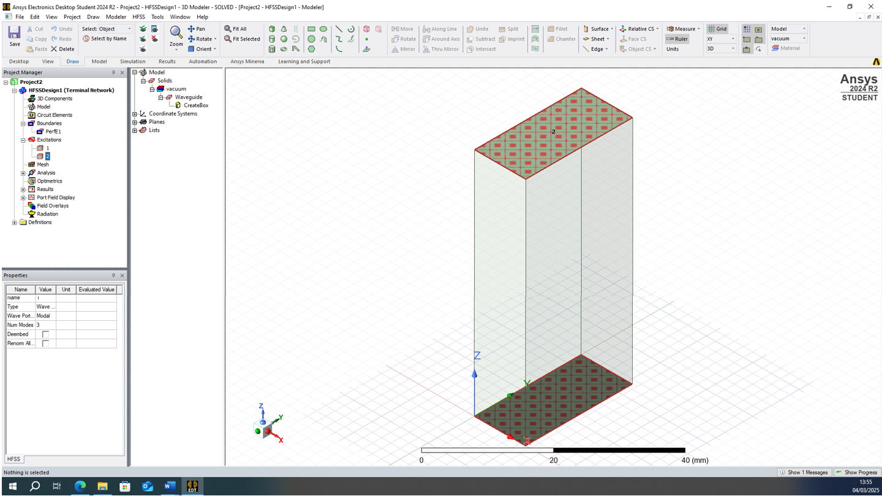
Figure 3: Either end of the rectangular waveguide assigned as a modal lumped port

3. Results

3.1. Vacuum Waveguide

3.1.1. Gamma Plot
A Gamma Plot was created, with a frequency sweep ranging from 0–30GHz, allowing the cutoff frequency of each mode to be detected.
The graph of results for the vacuum rectangular waveguide is shown below in Figure 4.
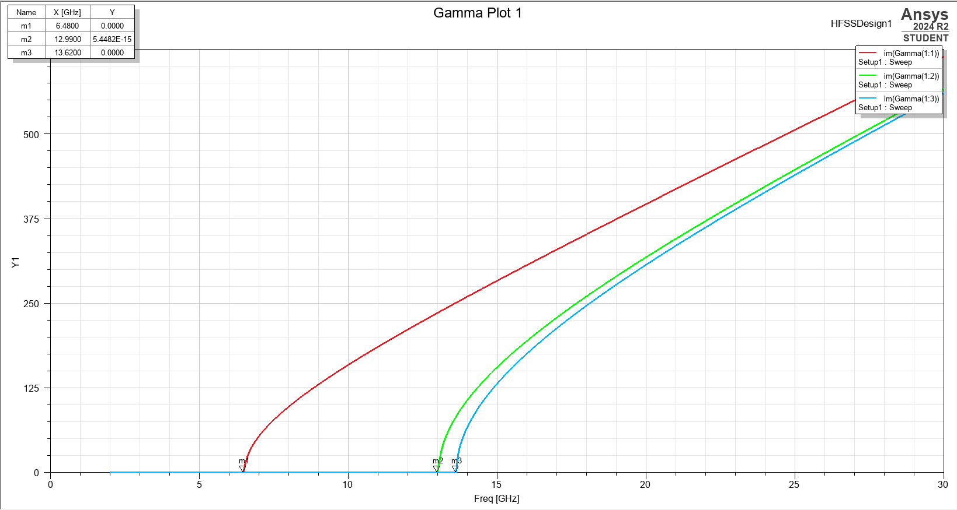
Figure 4: Graph of the frequency sweep for the vacuum rectangular waveguide

3.1.2. Modes
The Gamma plot shows three different modes; using the cursors, the intersection between each plot and the x-axis was measured. This provides the value of the cutoff frequency for each mode:
- M1 = 6.84GHz
- M2 = 12.99GHz
- M3 = 13.62GHz
Screenshots were then taken of the port field display for each mode, shown in Figures 5-7

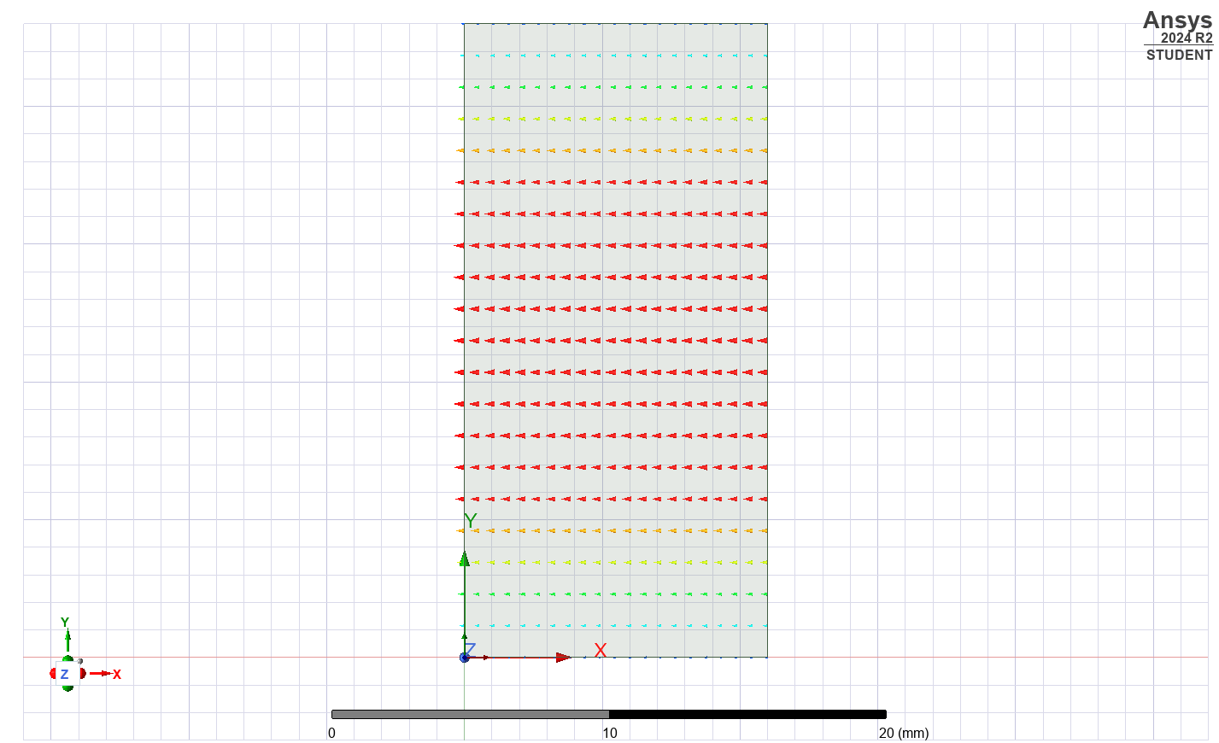
Figure 5: Port field display on the vacuum waveguide port in mode 1

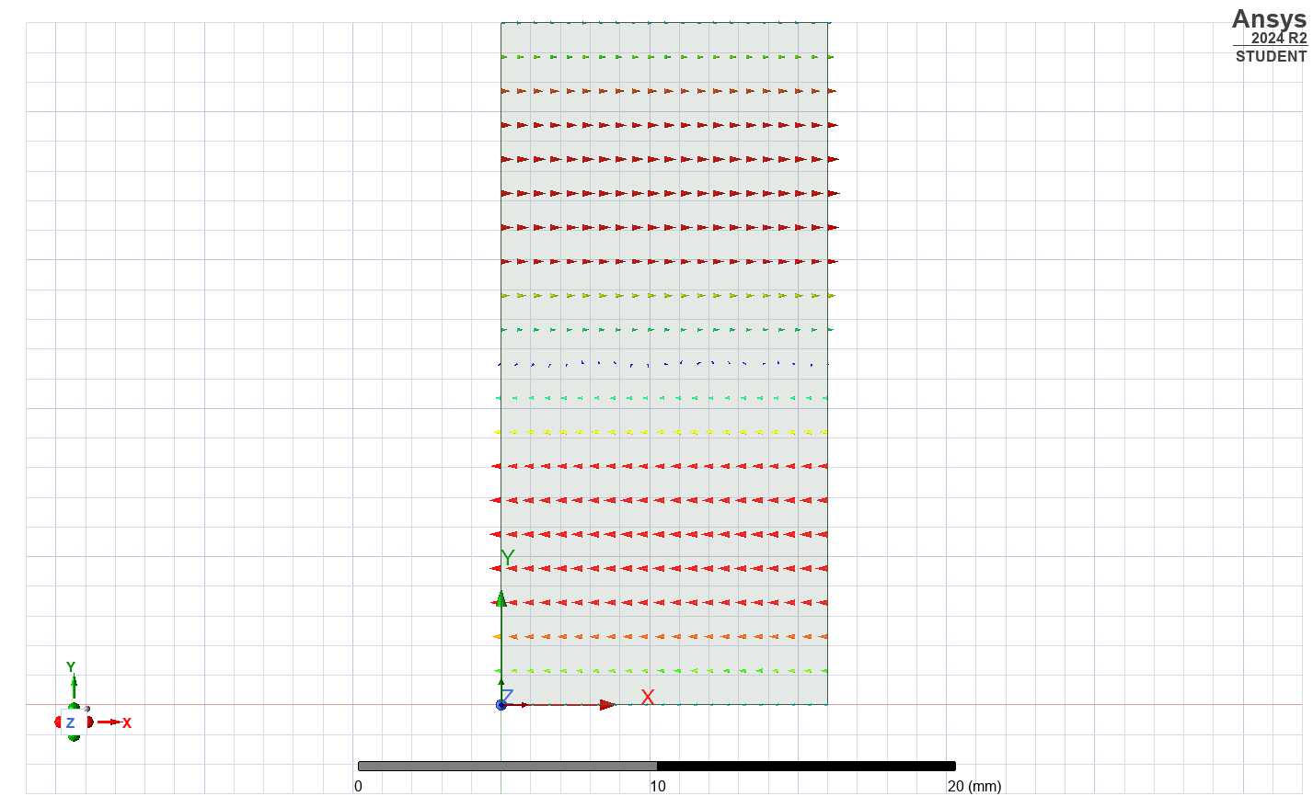
Figure 6: Port field display on the vacuum waveguide port in mode 2
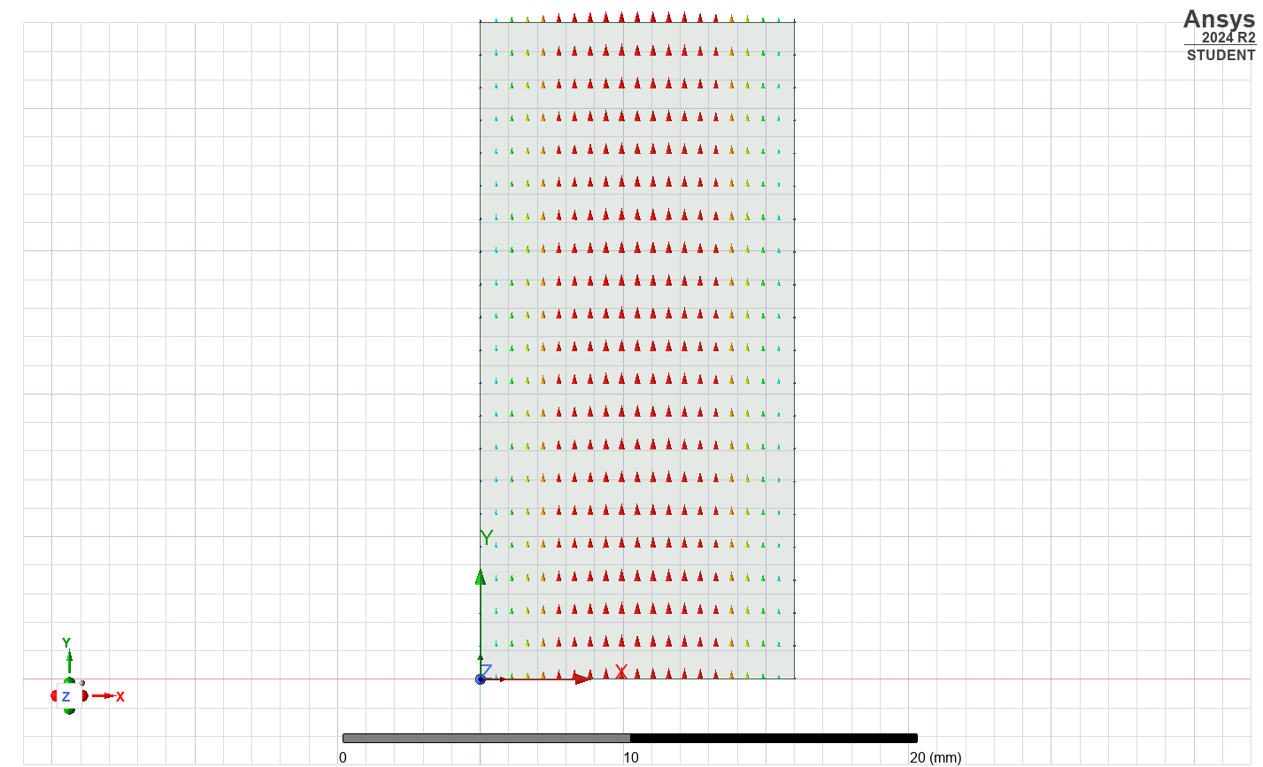
Figure 7: Port field display on the vacuum waveguide port in mode 3
From these images, each mode was identified by looking at the number of half wavelengths and fields variations along each direction.
- Mode M1:
  - One wavelength in x-direction = azimuthal mode number = m = 1
  - No wavelengths in y-direction = radial mode number = n = 0
  - M1 = TE_{mn} = TE₁₀

- Mode M2:
  - Two wavelengths in x-direction = azimuthal mode number = m = 2
  - No wavelengths in y-direction = radial mode number = n = 0
  - M1 = TE_{mn} = TE₂₀

- Mode M3:
  - No wavelengths in x-direction = azimuthal mode number = m = 0
  - One wavelength in y-direction = radial mode number = n = 1
  - M1 = TE_{mn} = TE₀₁

3.1.3. Magnitude and Vector fields
A table of results from overlaying the magnitude and vector electric and magnetic fields of the vacuum waveguide is shown below in Table 1. It was simulated both at the maximum sweep frequency (30GHz), and a frequency close to the cutoff frequency of mode 1 (7GHz).

Vector or Magnitude | Electric or Magnetic field | Frequency | Results
Magnitude | Electric | 30GHz | 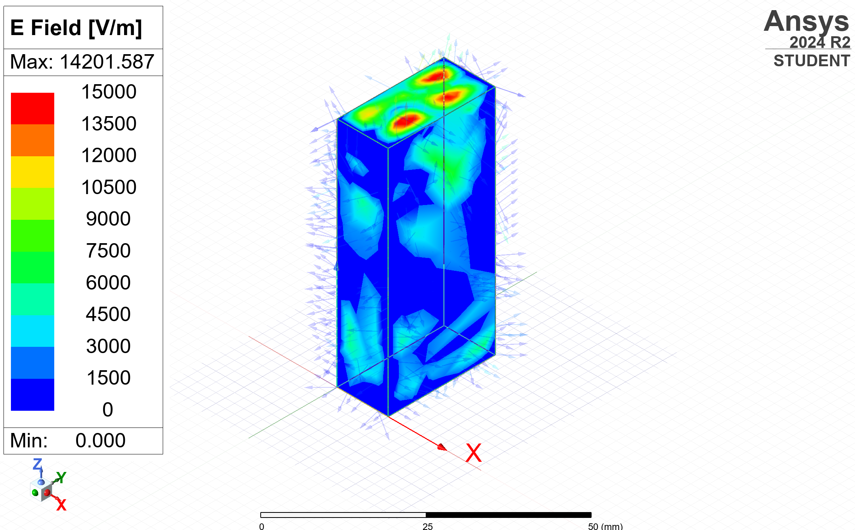
Magnitude | Electric | 7GHz | 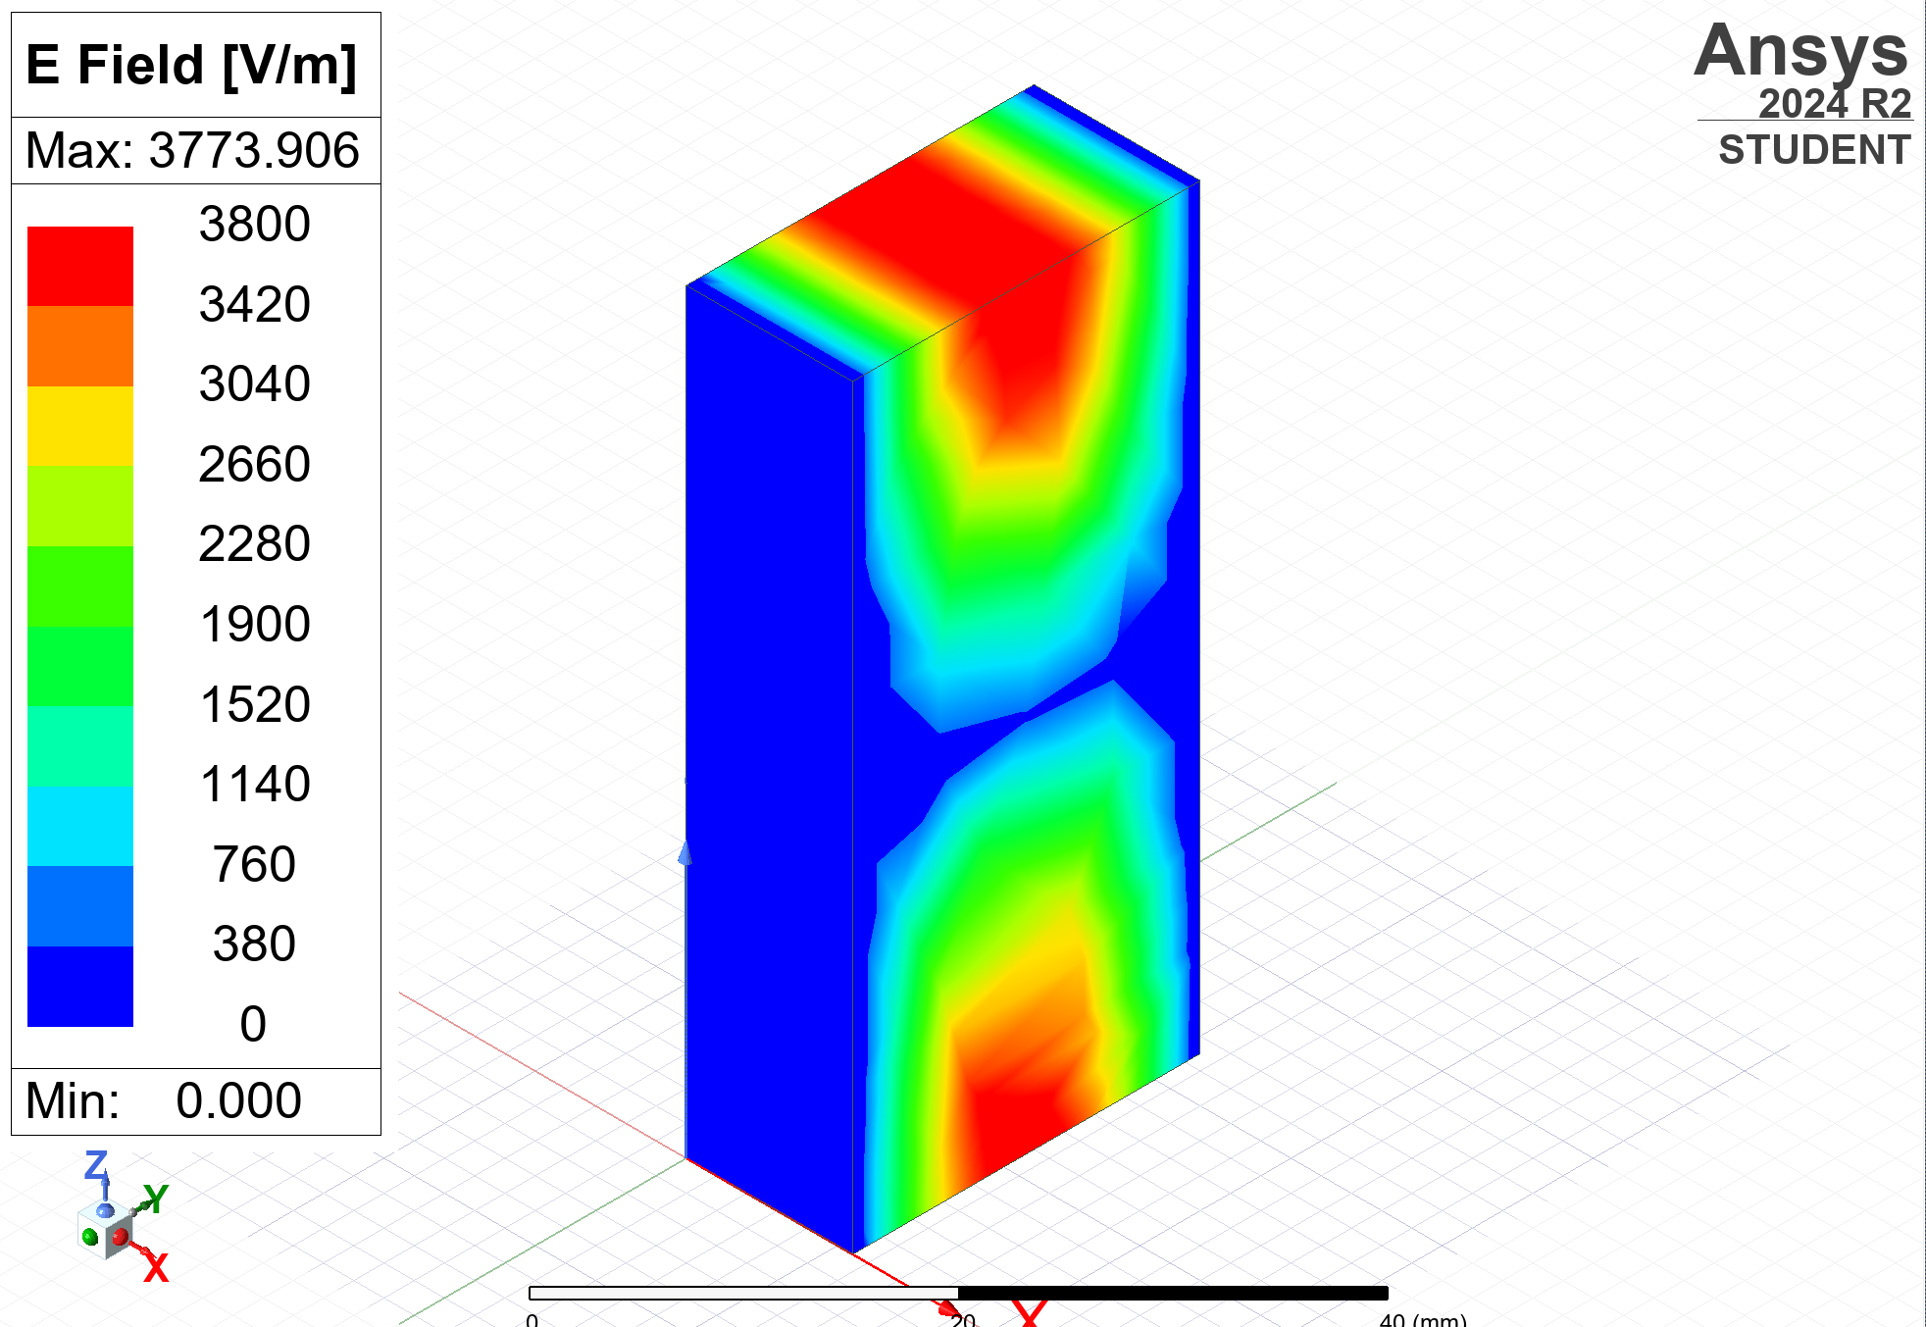
Vector | Electric | 30GHz | 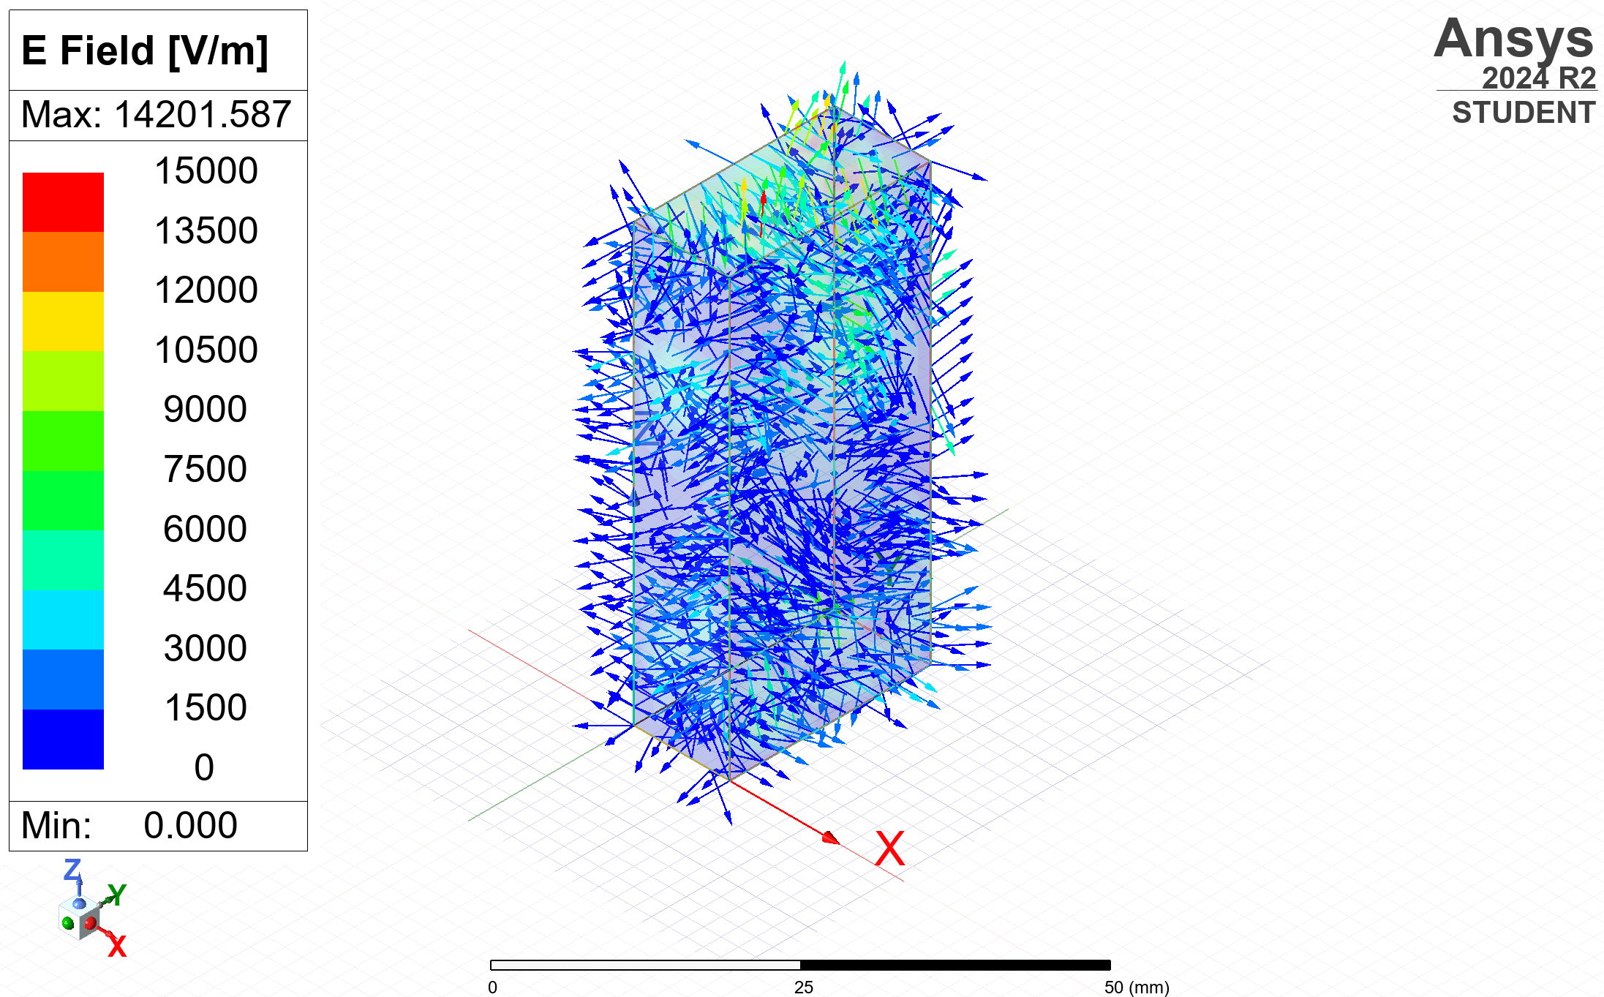
Vector | Electric | 7GHz | 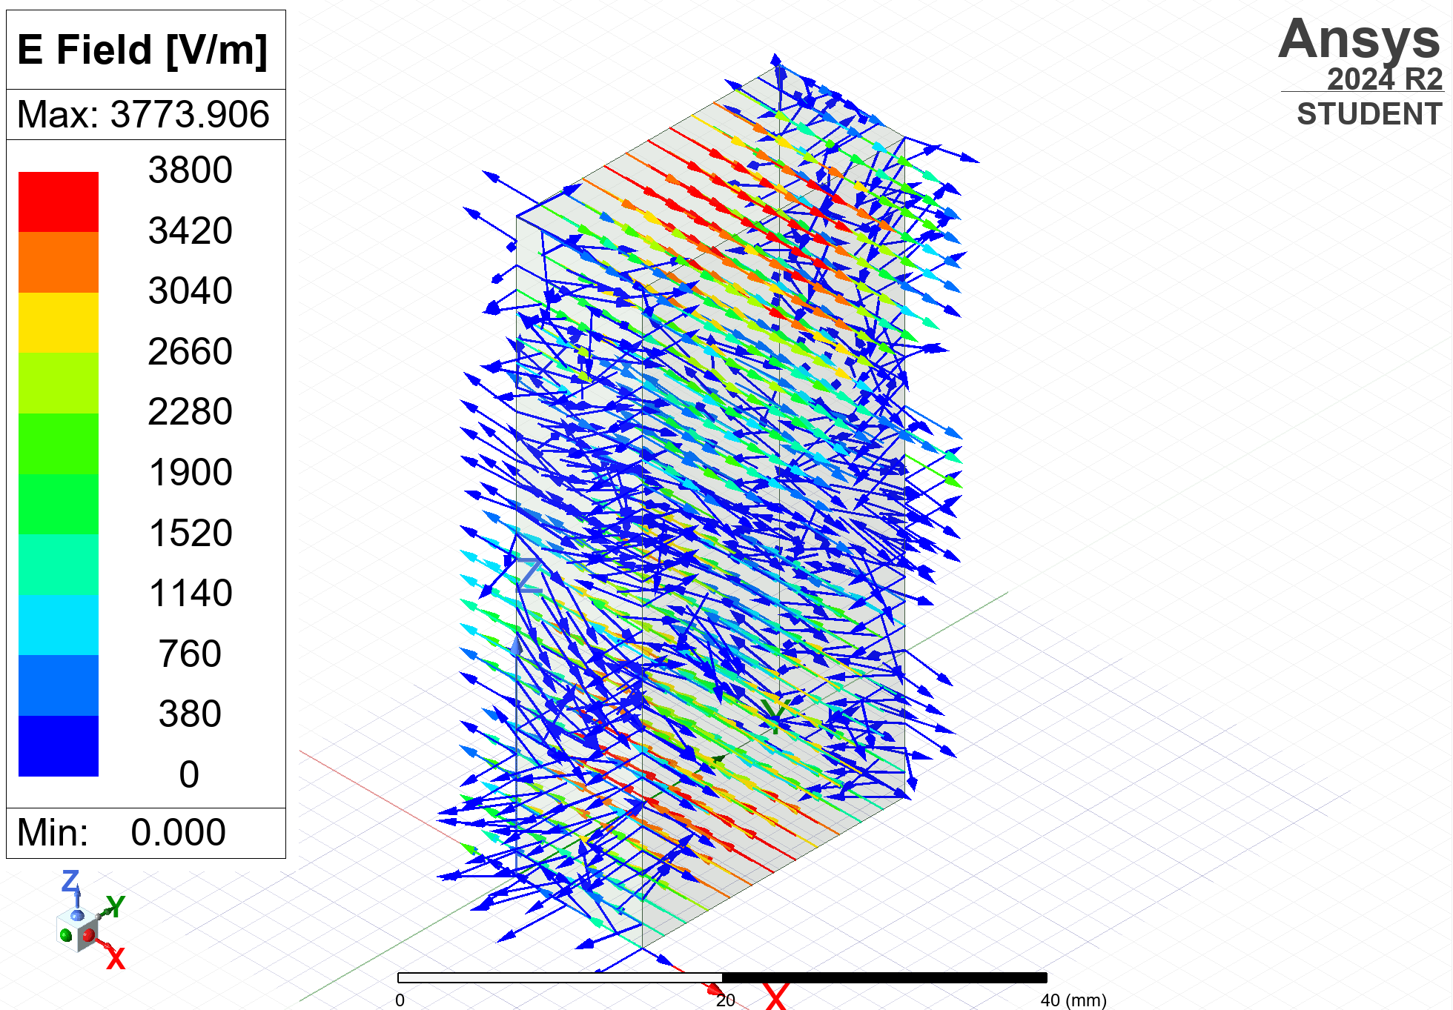
Magnitude | Magnetic | 30GHz | 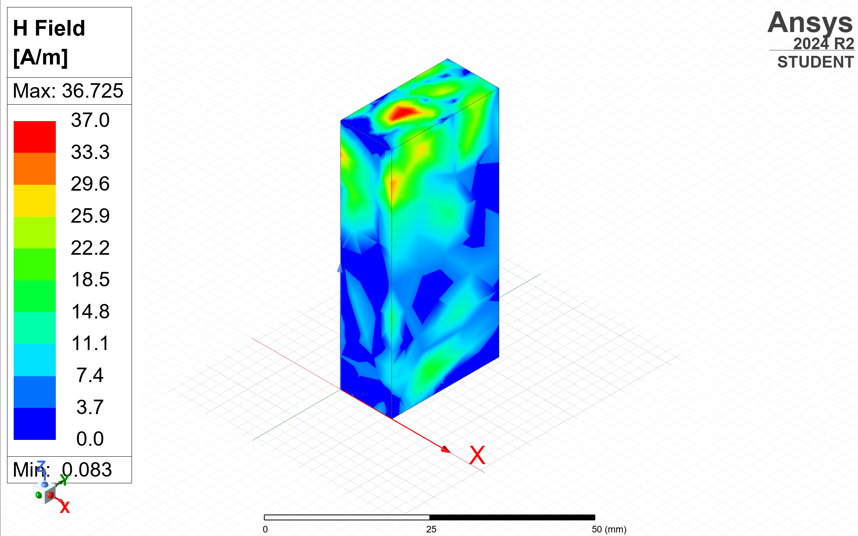
Magnitude | Magnetic | 7GHz | 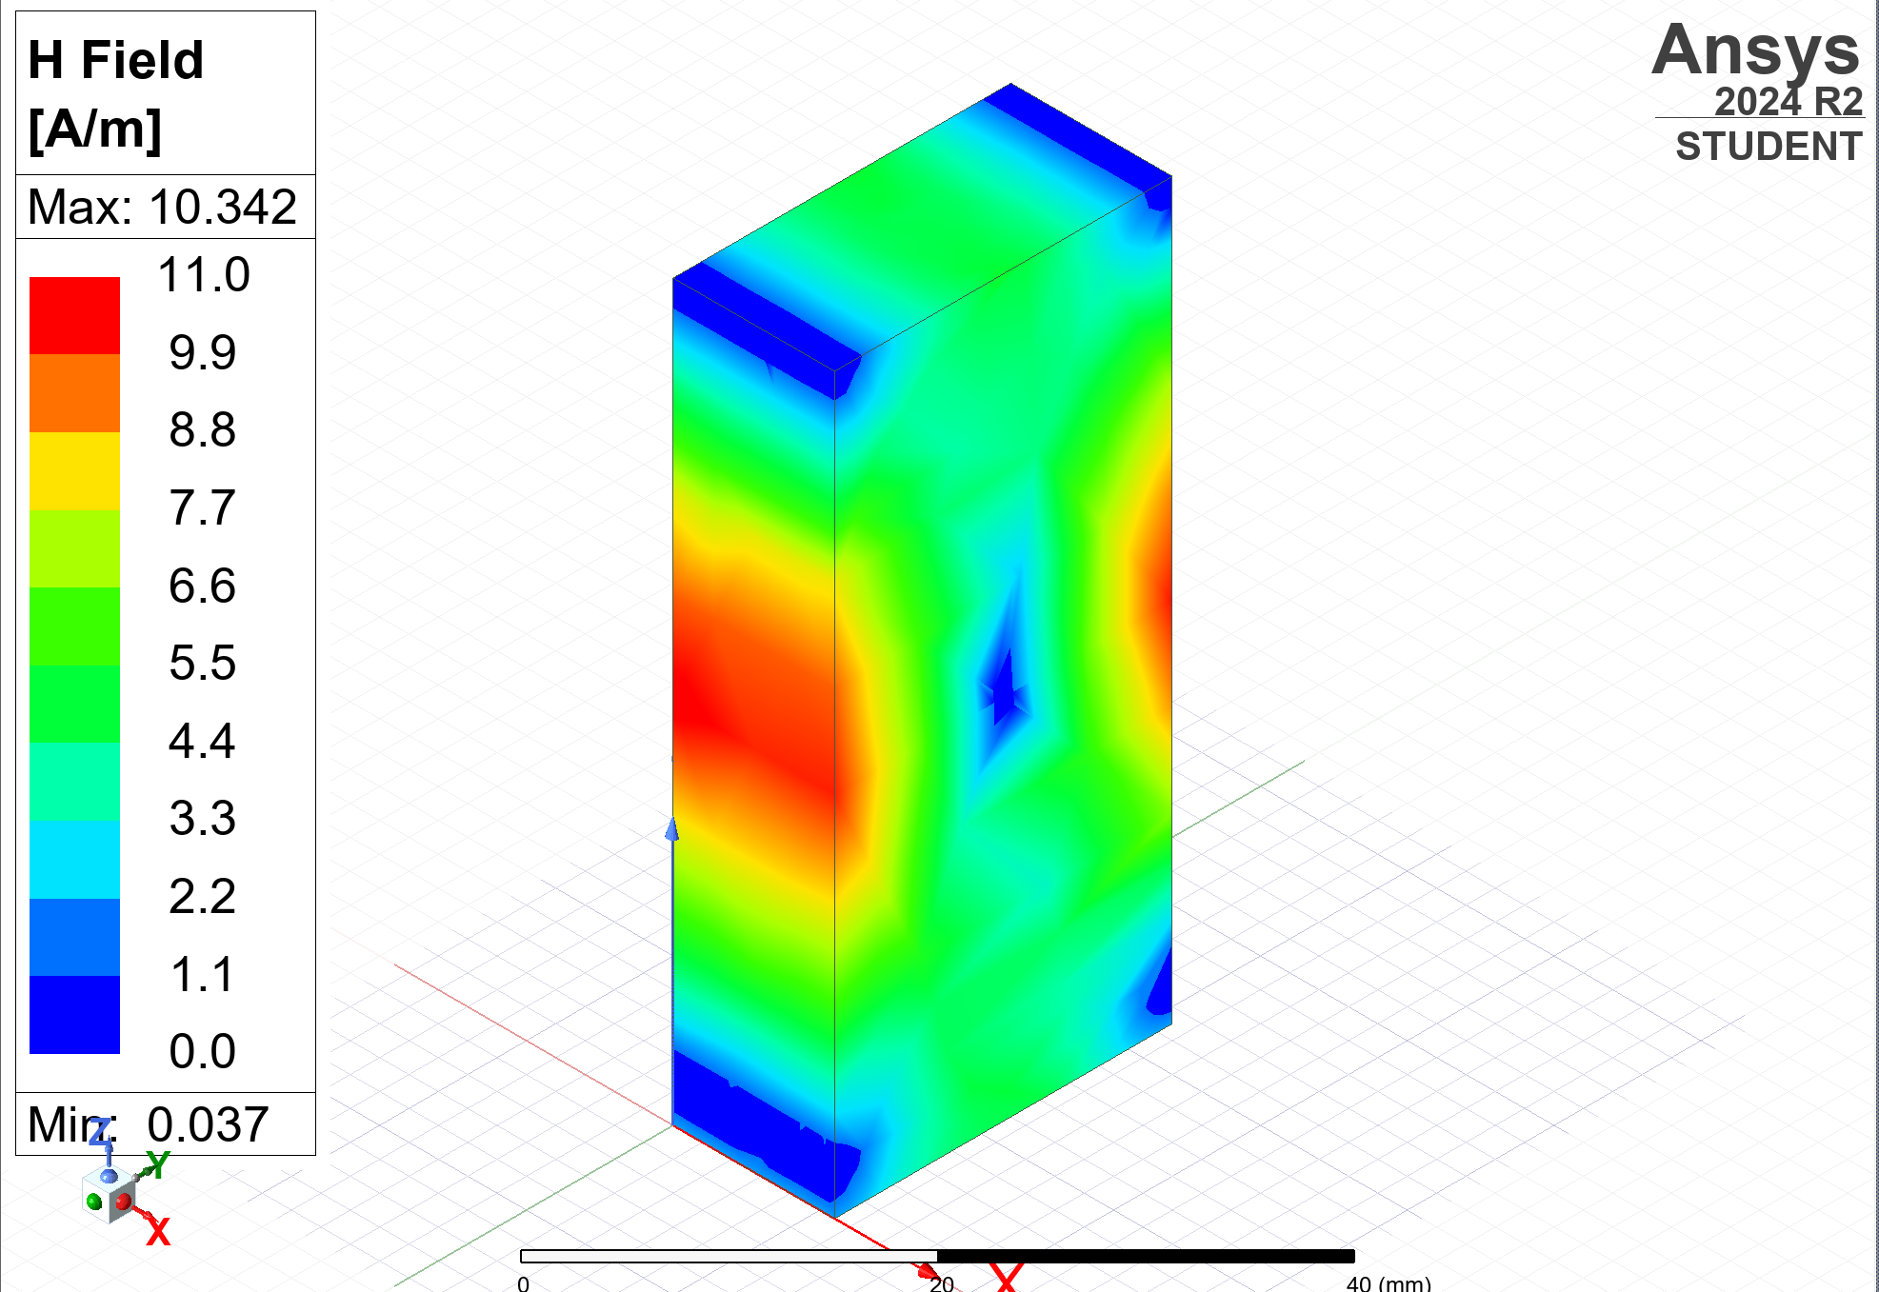
Vector | Magnetic | 30GHz | 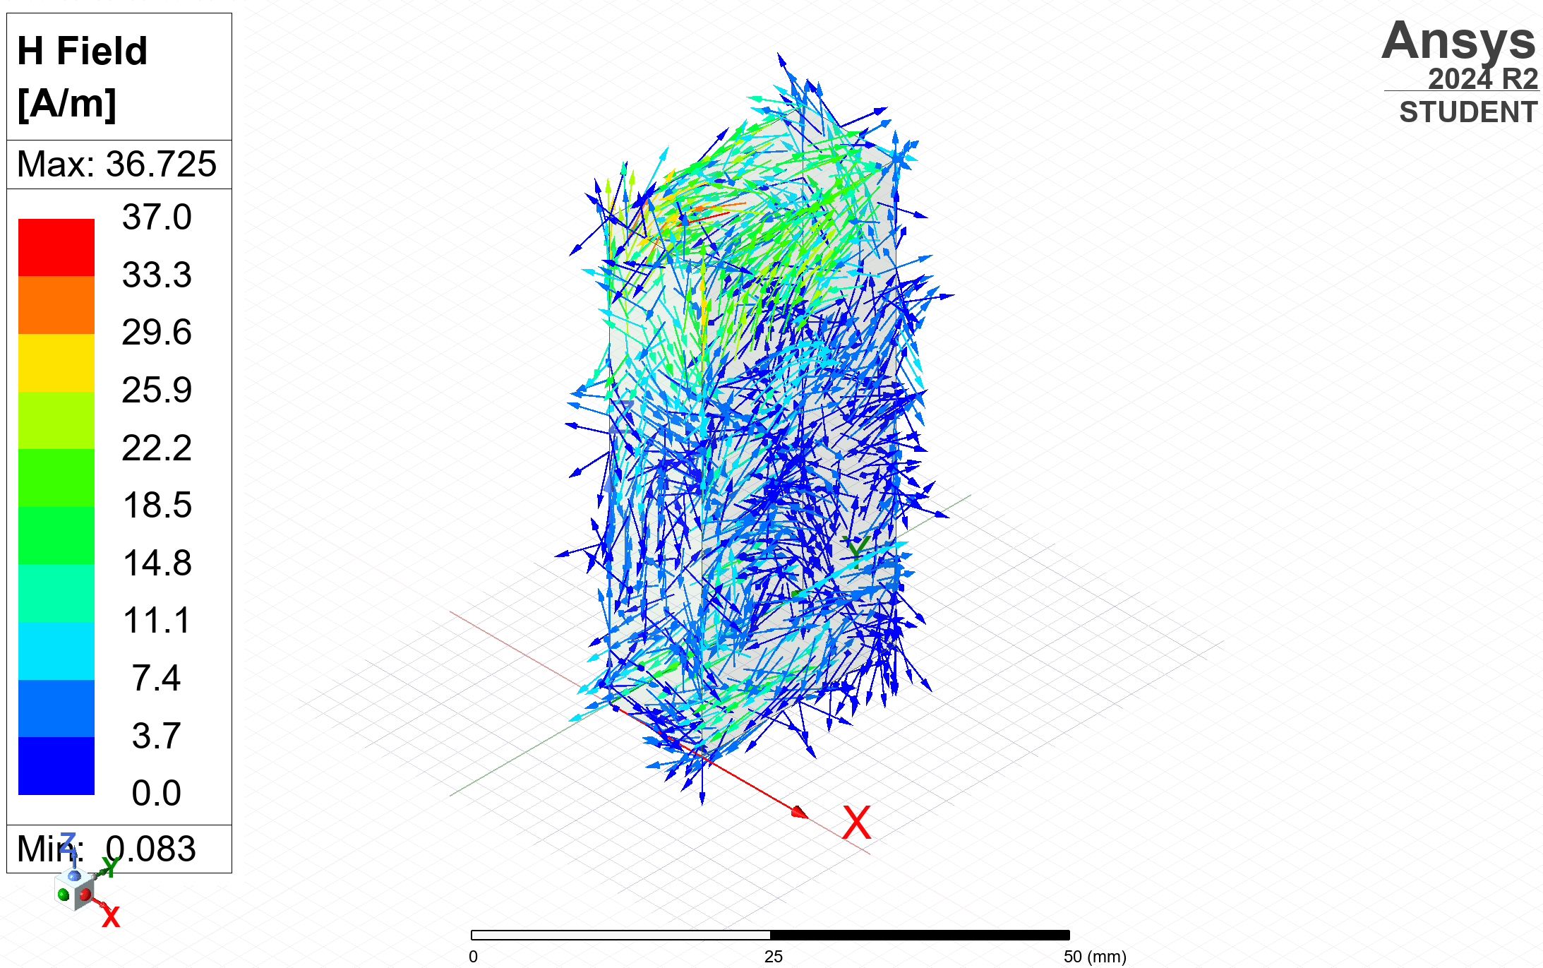
Vector | Magnetic | 7GHz | 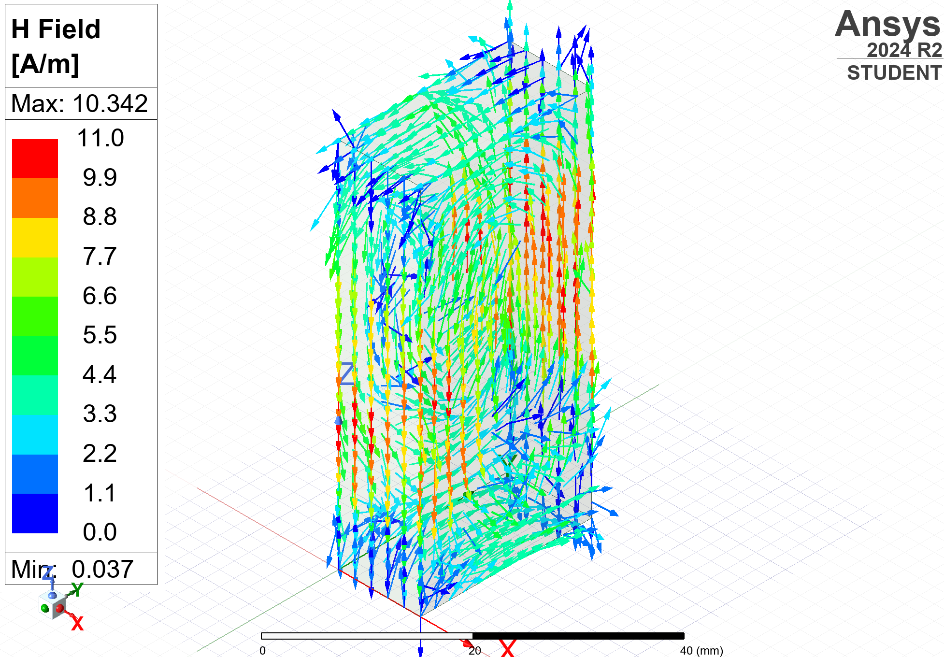
Table 1: Table of results for the electric and magnetic fields of the vacuum waveguide

3.2. Teflon Waveguide

3.2.1. Gamma plot
The graph of results for the Teflon waveguide is shown below in Figure 8, with a gamma plot created over a sweep of 0-30GHz.
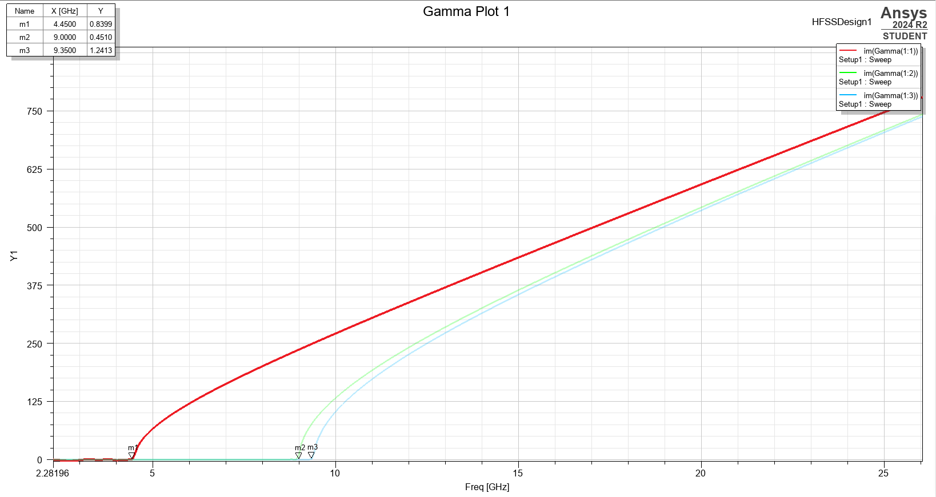
Figure 8: Graph of the frequency sweep for the Teflon rectangular waveguide

3.2.1. Modes
Again, the intersection between each plot and the x-axis was measured. This provides the value of the cutoff frequency for each mode:
- M1 = 4.45GHz
- M2 = 9.00GHz
- M3 = 9.35GHz

Then using the same method as described in section 3.1.2, screengrabs of the ports in each mode were taken and are shown below in Figures 9-11.
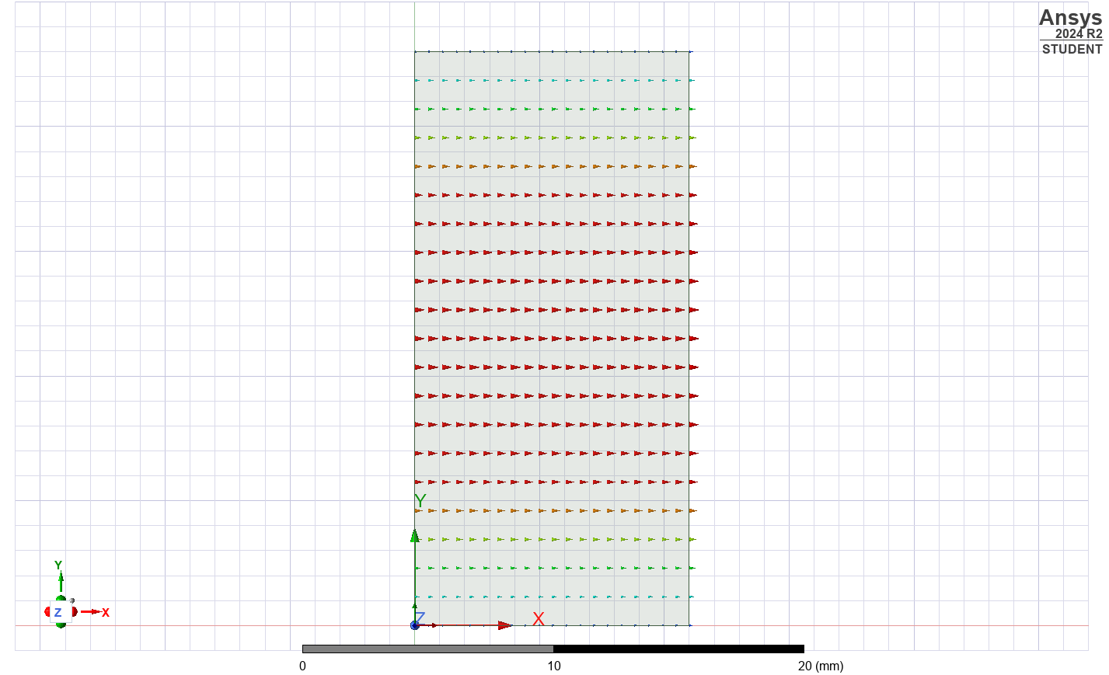
Figure 9: Port field display on the Teflon waveguide port in mode 1
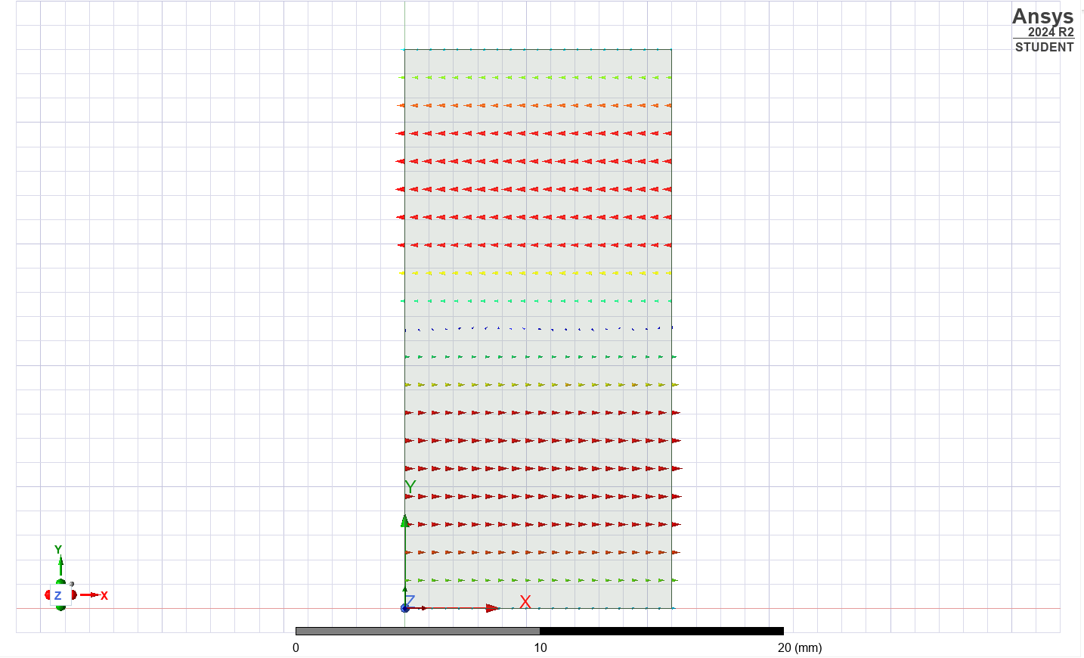
Figure 10: Port field display on the Teflon waveguide port in mode 2
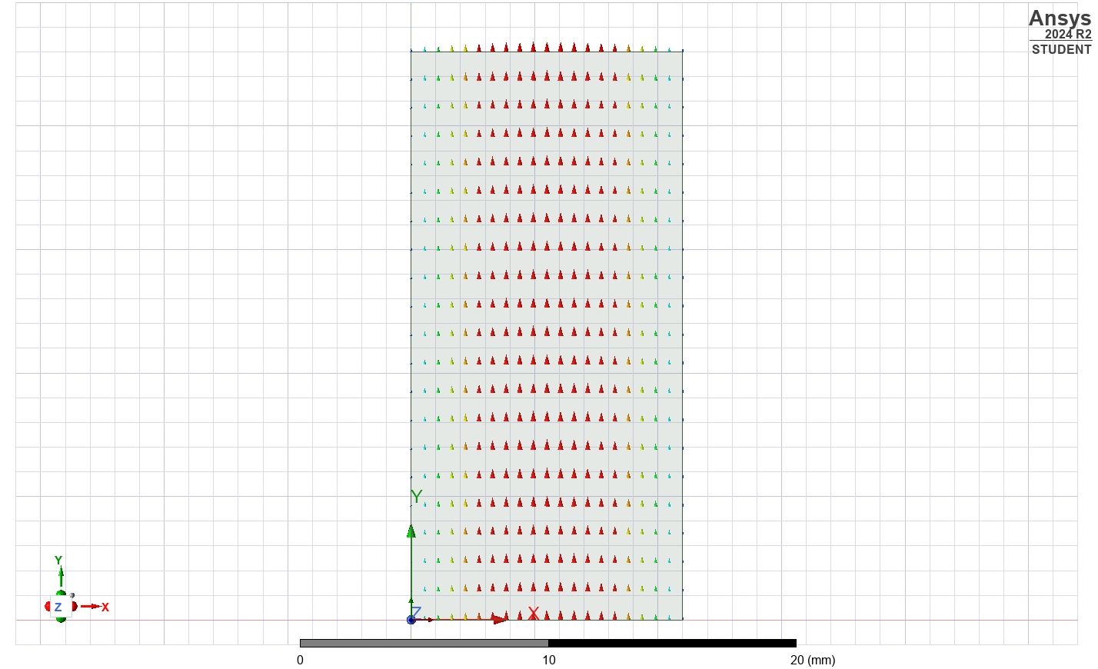
Figure 11: Port field display on the Teflon waveguide port in mode 3

The three modes are the same modes as the vacuum waveguide, meaning that it has the same TE modes as described in section 3.1.2:
- Mode M1 = TE₁₀
- Mode M2 = TE₂₀
- Mode M3 = TE₀₁

3.2.3. Electric and magnetic fields
A table of results from overlaying the magnitude and vector electric and magnetic fields of the Teflon waveguide is shown below in Table 2. It was simulated both at the maximum sweep frequency (30GHz), and a frequency close to the cutoff frequency of mode 1 (5GHz).

Vector or Magnitude | Electric or Magnetic field | Frequency | Results
Magnitude | Electric | 30GHz | 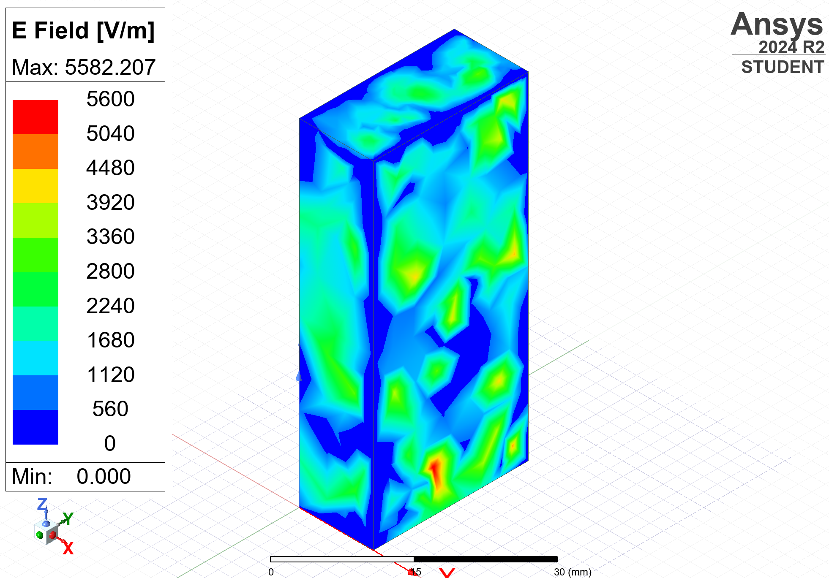
Magnitude | Electric | 5GHz | 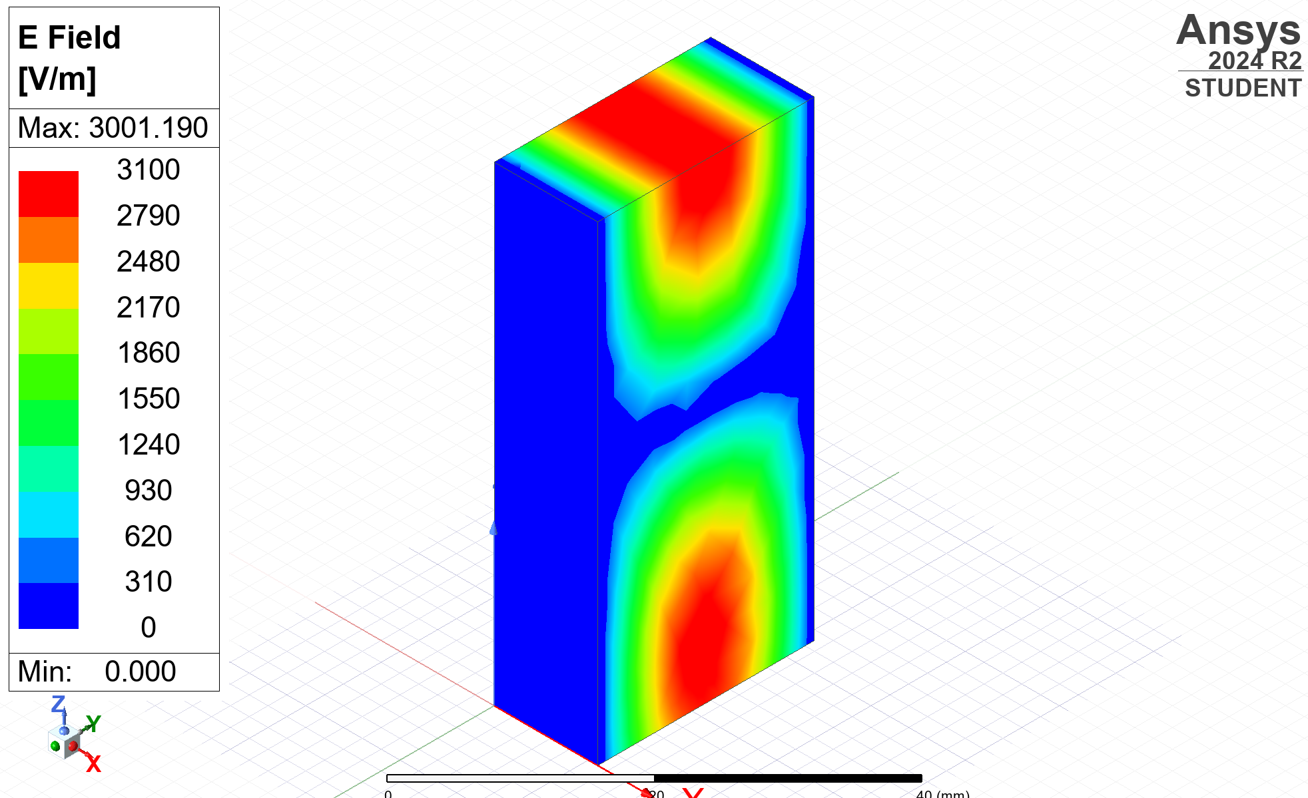
Vector | Electric | 30GHz | 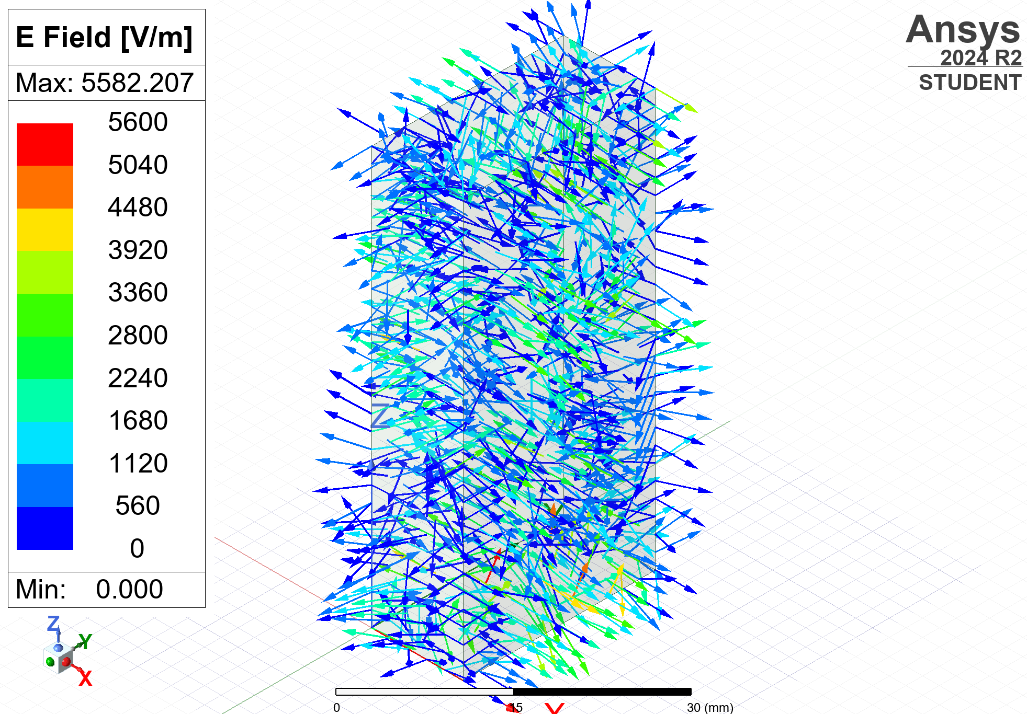
Vector | Electric | 5GHz | 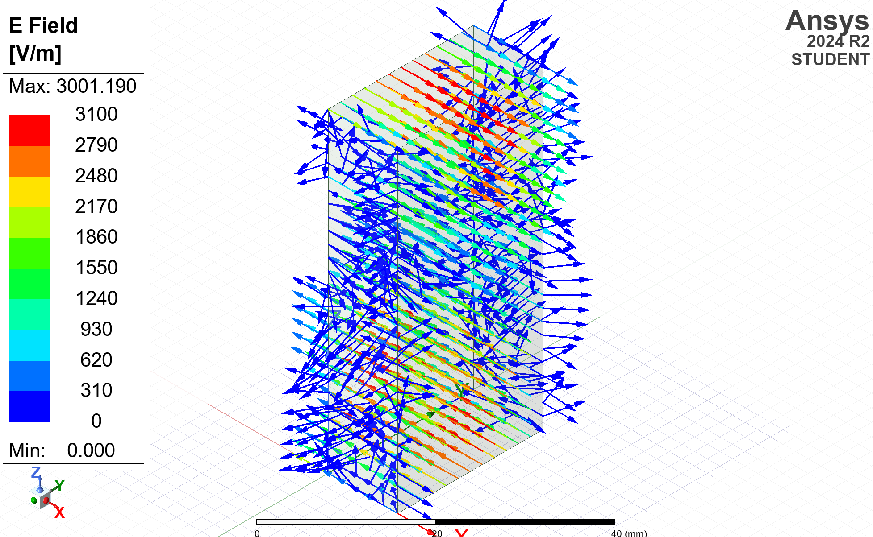
Magnitude | Magnetic | 30GHz | 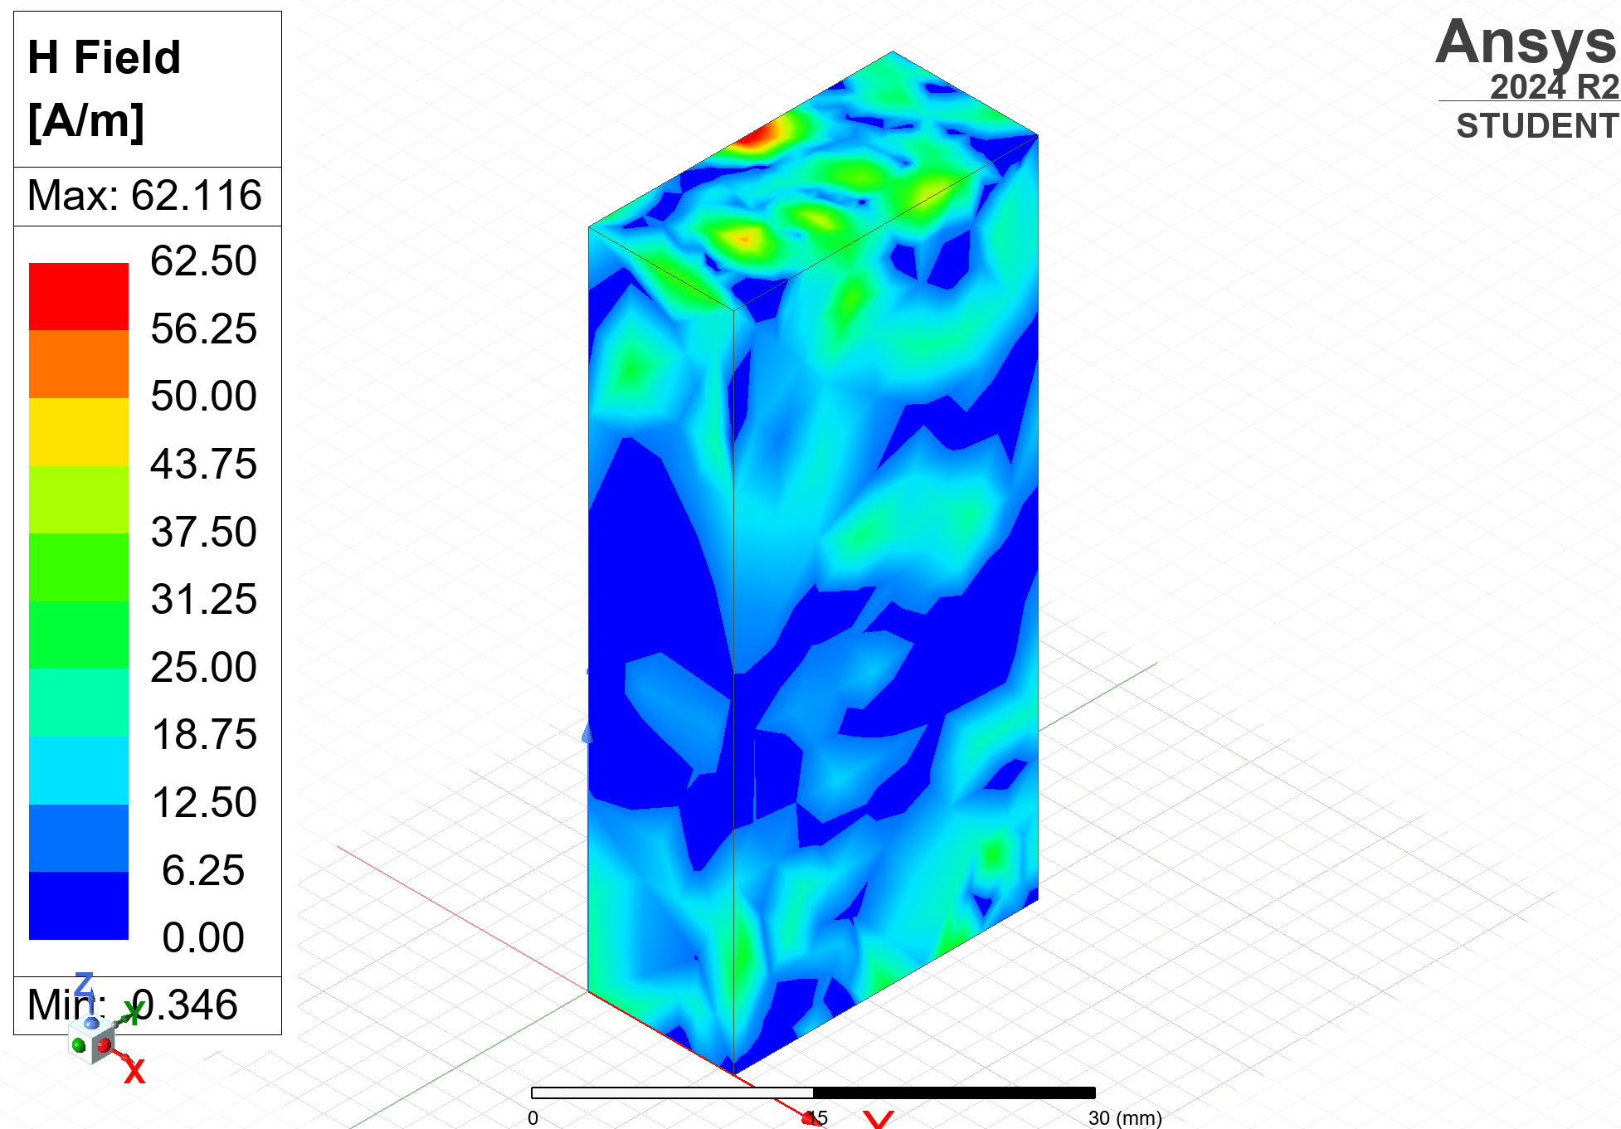
Magnitude | Magnetic | 5GHz | 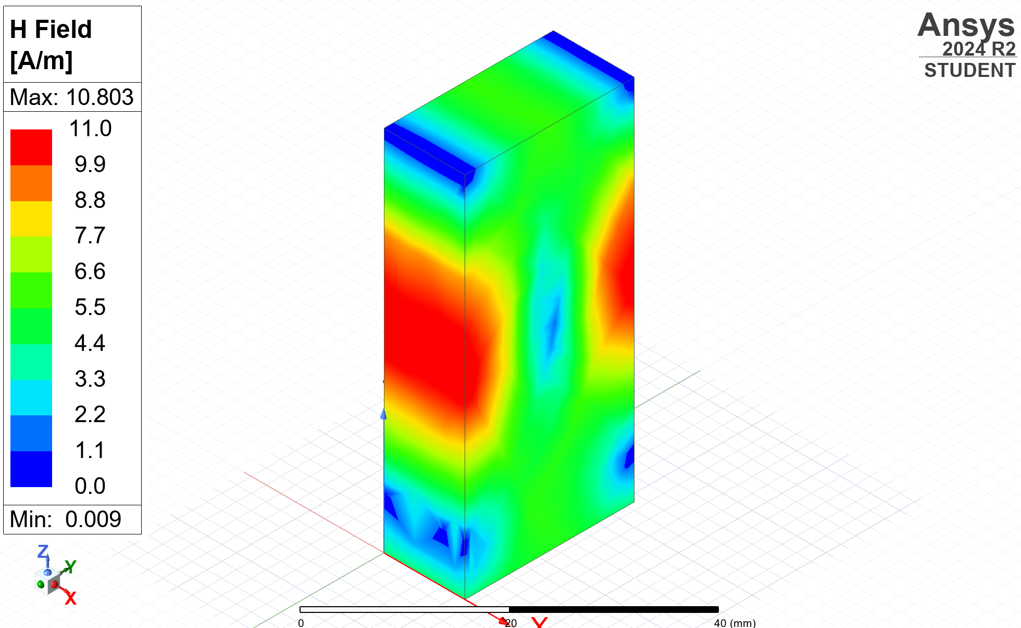
Vector | Magnetic | 30GHz | 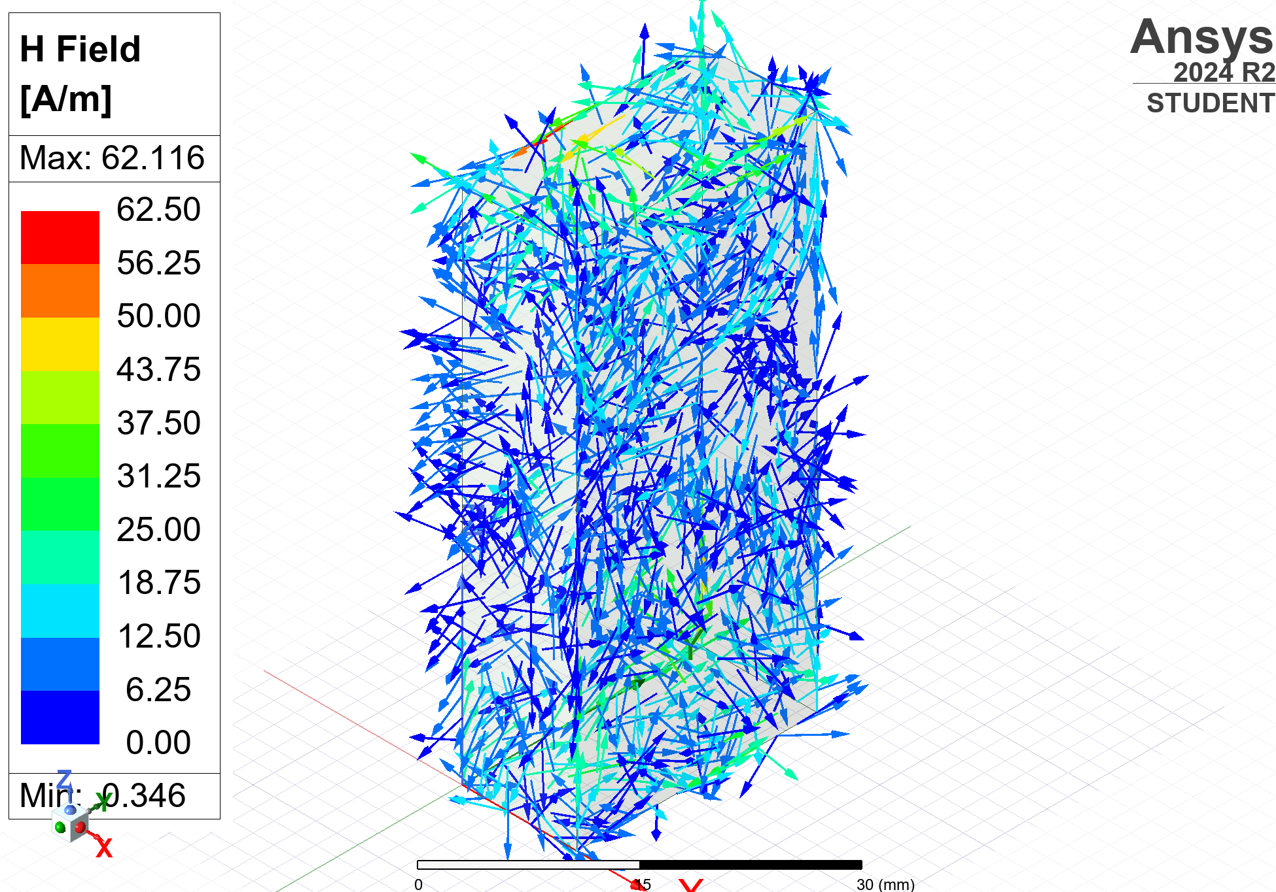
Vector | Magnetic | 5GHz | 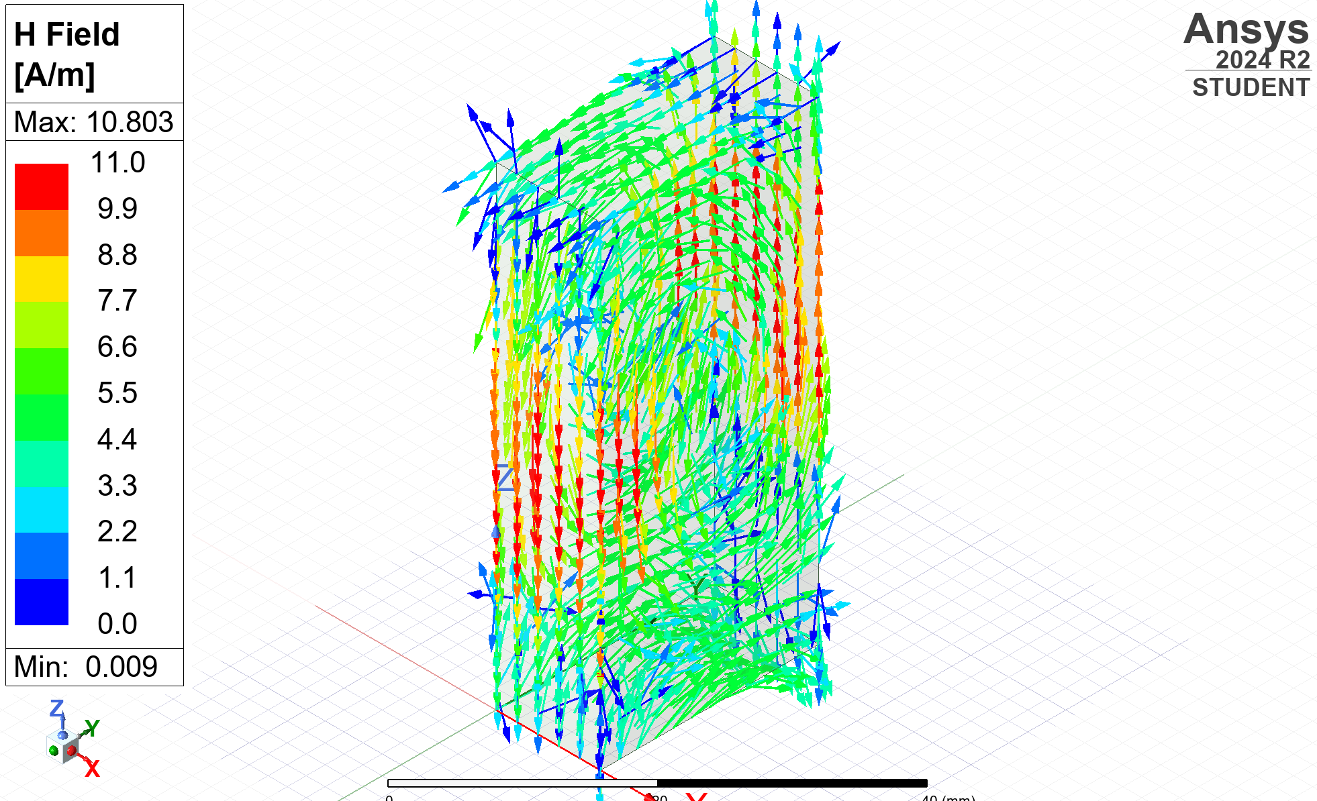
Table 2: Table of results for the electric and magnetic fields of the Teflon waveguide

4. Discussion

4.1. Vacuum Waveguide
Theoretical cutoff frequencies were then calculated using the formula: [1]
$$fc = \frac{c}{2}\sqrt{(\frac{m}{a})^{2}+(\frac{n}{b})^{2}}$$
Equation 3: formula to calculate cutoff frequency

The cutoff frequency was calculated for each mode for the vacuum waveguide, which is shown in Equations 4 to 6 below. $$= \frac{3×{10}^{8}}{2}\sqrt{(\frac{1}{0.023})^{2}+ (\frac{0}{0.011})^{2}} \\ = \left(1.5×{10}^{8}\right)×\sqrt{(\frac{1}{0.023})^{2}} \\ = \left(1.5×{10}^{8}\right)× \frac{1}{0.023} \\ = \left(1.5×{10}^{8}\right)× 43.47… \\ = 6.5217…×{10}^{9} \\ = 6.52 GHz (2dp)$$
Equation 4: calculating cutoff frequency for the vacuum waveguide’s TE10 mode

$$= \frac{3×{10}^{8}}{2}\sqrt{(\frac{2}{0.023})^{2}+ (\frac{0}{0.011})^{2}} \\ = \left(1.5×{10}^{8}\right)×\sqrt{(\frac{2}{0.023})^{2}} \\ = \left(1.5×{10}^{8}\right)× \frac{2}{0.023} \\ = \left(1.5×{10}^{8}\right)× 86.95… \\ = 1.3043…×{10}^{10} \\ = 13.04 GHz (2dp)$$
Equation 5: calculating cutoff frequency for the vacuum waveguide’s TE20 mode

$$= \frac{3×{10}^{8}}{2}\sqrt{(\frac{0}{0.023})^{2}+ (\frac{1}{0.011})^{2}} \\ = \left(1.5×{10}^{8}\right)×\sqrt{(\frac{1}{0.011})^{2}} \\ = \left(1.5×{10}^{8}\right)× \frac{1}{0.011} \\ = \left(1.5×{10}^{8}\right)× 90.90… \\ = 13.6363…×{10}^{10} \\ = 13.64 GHz (2dp)$$
Equation 6: calculating cutoff frequency for the vacuum waveguide’s TE01 mode

Table 1 shows the comparison between the theoretical and measured (simulated) values for the vacuum waveguide.
Mode | Theoretical cutoff frequency (GHz) | Simulated cutoff frequency (GHz)
TE₁₀ | 6.52 | 6.84
TE₂₀ | 13.04 | 12.99
TE₀₁ | 13.64 | 13.62
Table 3: Table of theoretical and simulated cutoff frequencies for the vacuum waveguide

The dominant mode for the Vacuum waveguide is therefore TE₁₀, as it can support the lowest frequency, and has greater response for all other frequencies, as seen in the Gamma plot. [1]

4.2. Teflon Waveguide
As the Teflon waveguide is made of a material other than a vacuum, its permittivity must be calculated based on its relative permittivity ($ε_{r}$) and the permittivity of free space ($ε_{0}$). This calculation is shown below in Equation 7.
$$ε= ε_{0}ε_{r}$$
$$ε_{r}=2.1 ε_{0}=8.854×{10}^{-12}$$
$$ε=2.21 ×\left(8.854×{10}^{-12}\right)$$
$$ε=1.8593… ×{10}^{-11} Fm^{-1}$$
Equation 7: calculating permittivity of Teflon

Similarly, its permeability must be calculated based on its relative permeability ($μ_{r}$) and the permeability of free space ($μ_{0}$). This calculation is shown below in Equation 8.
$$μ= μ_{0}μ_{r}$$
$$μ_{r}=1 μ_{0}=4π×{10}^{-7}$$
$$μ=1 ×\left(4π×{10}^{-7}\right)$$
$$μ=4π×{10}^{-7} Hm^{-1}$$
Equation 8: calculating permeability of Teflon

From the two values calculated above, the speed of light in Teflon can be calculated using the formula shown below in Equation 9 [2].
$$c=\frac{1}{\sqrt{εμ}}$$
$$c= \frac{1}{\sqrt{(1.8593… ×{10}^{-7})×(4π×{10}^{-7})}}$$
$$c=2.069×{10}^{8} ms^{-1}$$
Equation 9: calculating speed of light in Teflon

Using the same formula to calculate the cutoff frequency as used in section 4.1, the calculations for the cutoff frequency of each mode of the Teflon waveguide, shown below in Equations 10 to 12.$$= \frac{2.069×{10}^{8}}{2}\sqrt{(\frac{1}{0.023})^{2}+ (\frac{0}{0.011})^{2}} \\ = \left(1.0344×{10}^{8}\right)×\sqrt{(\frac{1}{0.023})^{2}} \\ = \left(1.0344×{10}^{8}\right)× \frac{1}{0.023} \\ = \left(1.0344×{10}^{8}\right)× 43.47… \\ = 4.4973…×{10}^{9} \\ = 4.50 GHz (3sf)$$
Equation 10: calculating cutoff frequency for the Teflon waveguide’s TE10 mode

$$= \frac{2.069×{10}^{8}}{2}\sqrt{(\frac{2}{0.023})^{2}+ (\frac{0}{0.011})^{2}} \\ = \left(1.0344×{10}^{8}\right)×\sqrt{(\frac{2}{0.023})^{2}} \\ = \left(1.0344×{10}^{8}\right)× \frac{2}{0.023} \\ = \left(1.0344×{10}^{8}\right)× 86.95… \\ = 8.9947…×{10}^{10} \\ = 8.99 GHz (3sf)$$
Equation 11: calculating cutoff frequency for the Teflon waveguide’s TE20 mode

$$fc = \frac{c}{2}\sqrt{(\frac{m}{a})^{2}+(\frac{n}{b})^{2}} \\ = \frac{2.069×{10}^{8}}{2}\sqrt{(\frac{0}{0.023})^{2}+ (\frac{1}{0.011})^{2}} \\ = \left(1.0344×{10}^{8}\right)×\sqrt{(\frac{1}{0.011})^{2}} \\ = \left(1.0344×{10}^{8}\right)× \frac{1}{0.011} \\ = \left(1.0344×{10}^{8}\right)× 90.90… \\ = 9.4036…×{10}^{10} \\ = 9.40 GHz (3sf)$$
Equation 12: calculating cutoff frequency for the Teflon waveguide’s TE01 mode

Table 4 shows the comparison between the theoretical and measured (simulated) values for the Teflon waveguide.
Mode | Theoretical cutoff frequency (GHz) | Simulated cutoff frequency (GHz)
TE₁₀ | 4.50 | 4.45
TE₂₀ | 8.99 | 9.00
TE₀₁ | 9.40 | 9.35
Table 4: Table of theoretical and simulated cutoff frequencies for the Teflon waveguide

The dominant mode for the Teflon waveguide is therefore TE₁₀, as it can support the lowest frequency, and has greater response for all other frequencies, as seen in the Gamma plot [1].

4.3. Comparison
Overall, the simulations are accurate to the calculated theoretical values, with nearly all being within 0.1GHz. This suggests that HFSS creates a good representation of an ‘ideal’ waveguide.
Some differences may be due to minor calculation changes, such as rounding at certain steps, which can cause a less precise result [3]. Additionally, HFSS may simulate the waveguide with a few minor errors; for example, with a non-infinite volume radiation boundary [4].

The two materials did have significantly different results. While the ratios of cutoff frequencies between each mode’s values were similar, the vacuum waveguide’s frequencies were greater for each mode. This is due to the change in the speed of light, as it is much slower in Teflon than it is in a vacuum due to its differences in dielectric properties. As Teflon has a lower cutoff frequency however, it can operate over a wider bandwidth.

For both waveguides, the frequency measured significantly impacted the magnitude and vector quantities of the electric and magnetic fields. Not only are magnitudes of the fields greater, but the directivity is also improved at the frequency close to the dominant mode’s cutoff frequency, as losses increase with frequency.

5. Conclusion
To summarize, this report has simulated and analyzed two separate waveguides, made of Teflon and a vacuum. It has looked at the vector and magnitude of the electric and magnetic fields of the waveguides, examining the significant differences between the maximum sweep frequency, and the frequency closer to the operating frequency. The cutoff frequencies for each waveguide were calculated and measured for each mode, then the minor differences compared and reasons for them suggested.

Task 2: Simulating a Halfwave Dipole

1. Introduction
This report aims to create and simulate a halfwave dipole antenna on HFSS. The dipole will be compared to theoretical dipoles, and the differences explored. The resonant frequency and radiation patterns will also be investigated.

2. Methodology
The radius of the antenna was specified in the brief to be 1mm, and the desired wavelength to be radiated is equal to the first 3 digits of the student ID. In this case the student ID = 2322601, giving a wavelength of 232mm. The length of the halfwave dipole antenna should be equal to half of the desired wavelength [5], shown in Equation 13:
$$length \left(mm\right)=\frac{232}{2} \\ =116 mm$$
Equation 13: calculating length of a halfwave dipole

Using the intended radiated wavelength of 232mm, with the formula shown below in Equation 14 the theoretical resonant frequency was determined $CITATION Hor15 \backslash l 2057 [6]$.
$$v=f \\ f=\frac{v}{} \\ f= \frac{3.0×{10}^{8}}{0.232} \\ f=1.2931034…×{10}^{9} \\ f=1.29 GHz (3sf)$$
Equation 14: calculating theoretical cutoff frequency of the dipole

To create the antenna, a cylinder with a radius of 1mm was made using PEC as a material. A smaller 1mm tall vacuum cylinder was cut out of the center, separating it into two separate parts. A 50 Ω lumped port was placed between each half, and excitation was applied. The simulation is shown below in Figures 12-14.
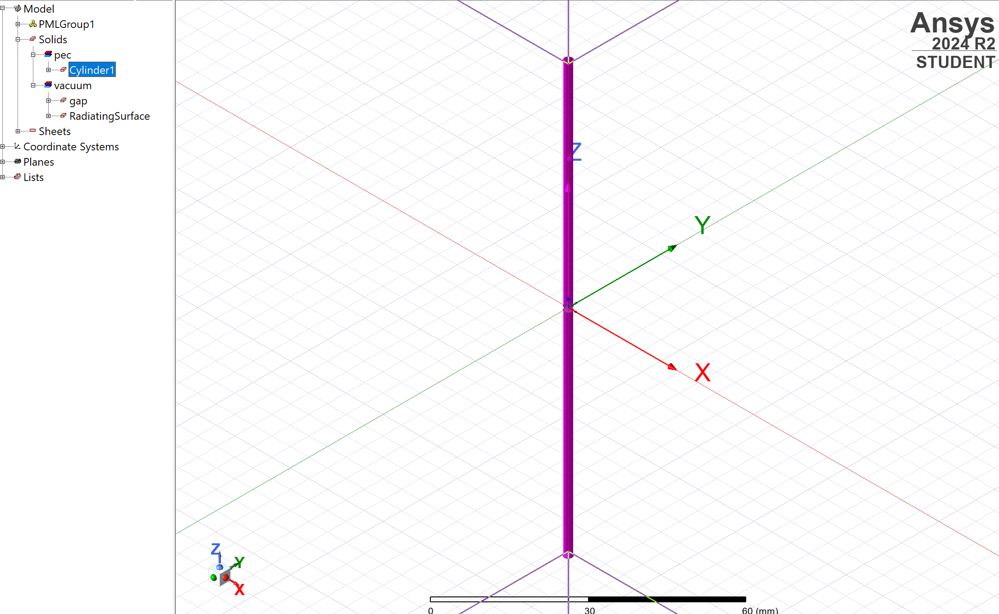
Figure 12: cylindrical dipole created in HFSS

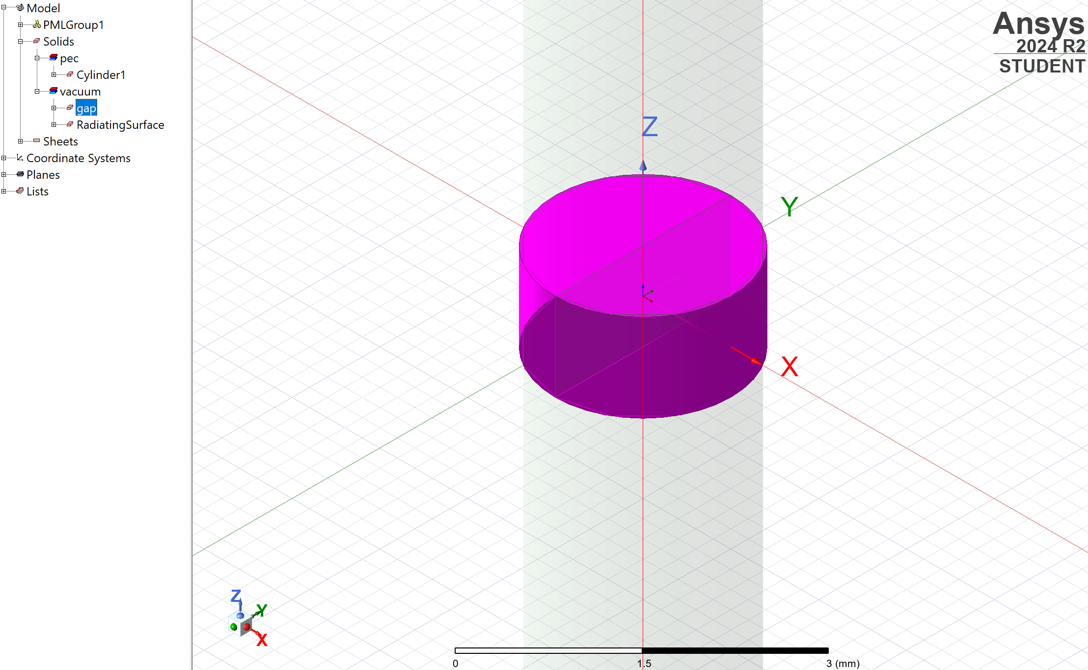
Figure 13: gap created in center of the dipole in HFSS
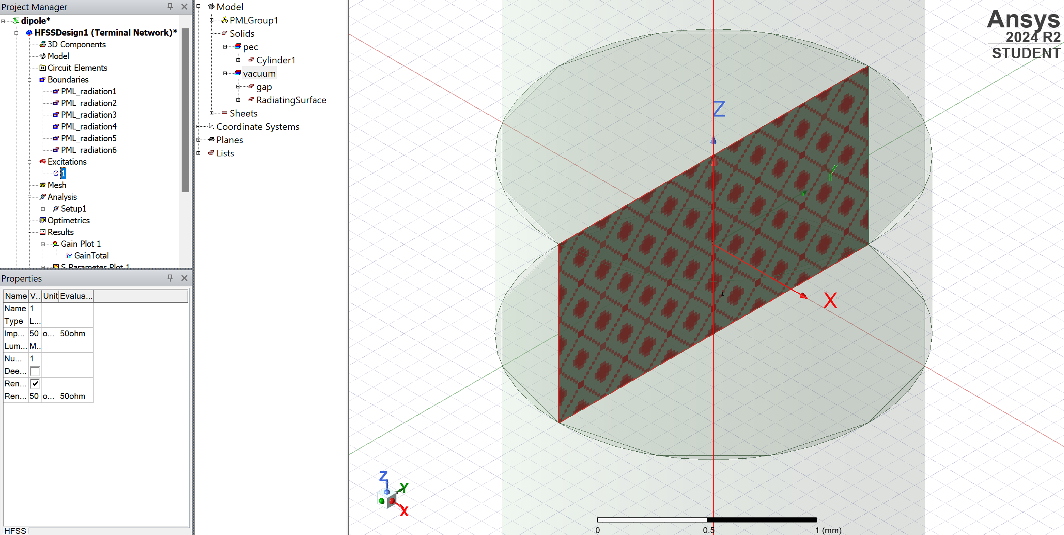
Figure 14: 50 ohm lumped port to provide excitation to the dipole

The antenna is surrounded by a box, shown in Figure 15 below, which was assigned as a radiation boundary, and will allow the radiation pattern of the antenna to be measured.
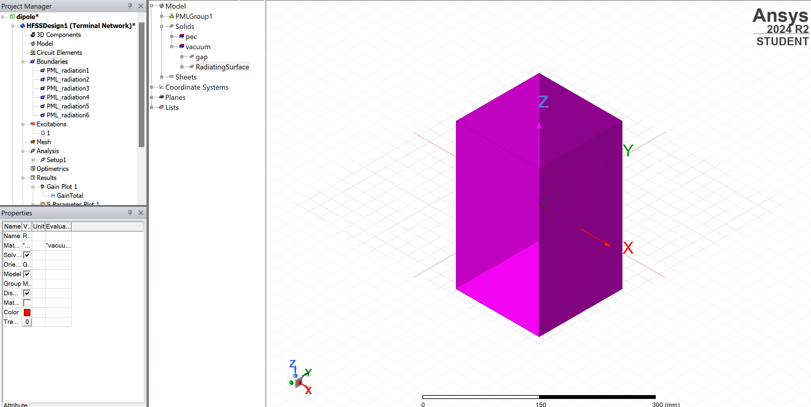
Figure 15: radiation boundary surrounding the dipole

3. Results
A sweep was set up covering 0.5-5GHz to measure the simulated resonant frequency. The S parameter plot is shown in Figure 16.
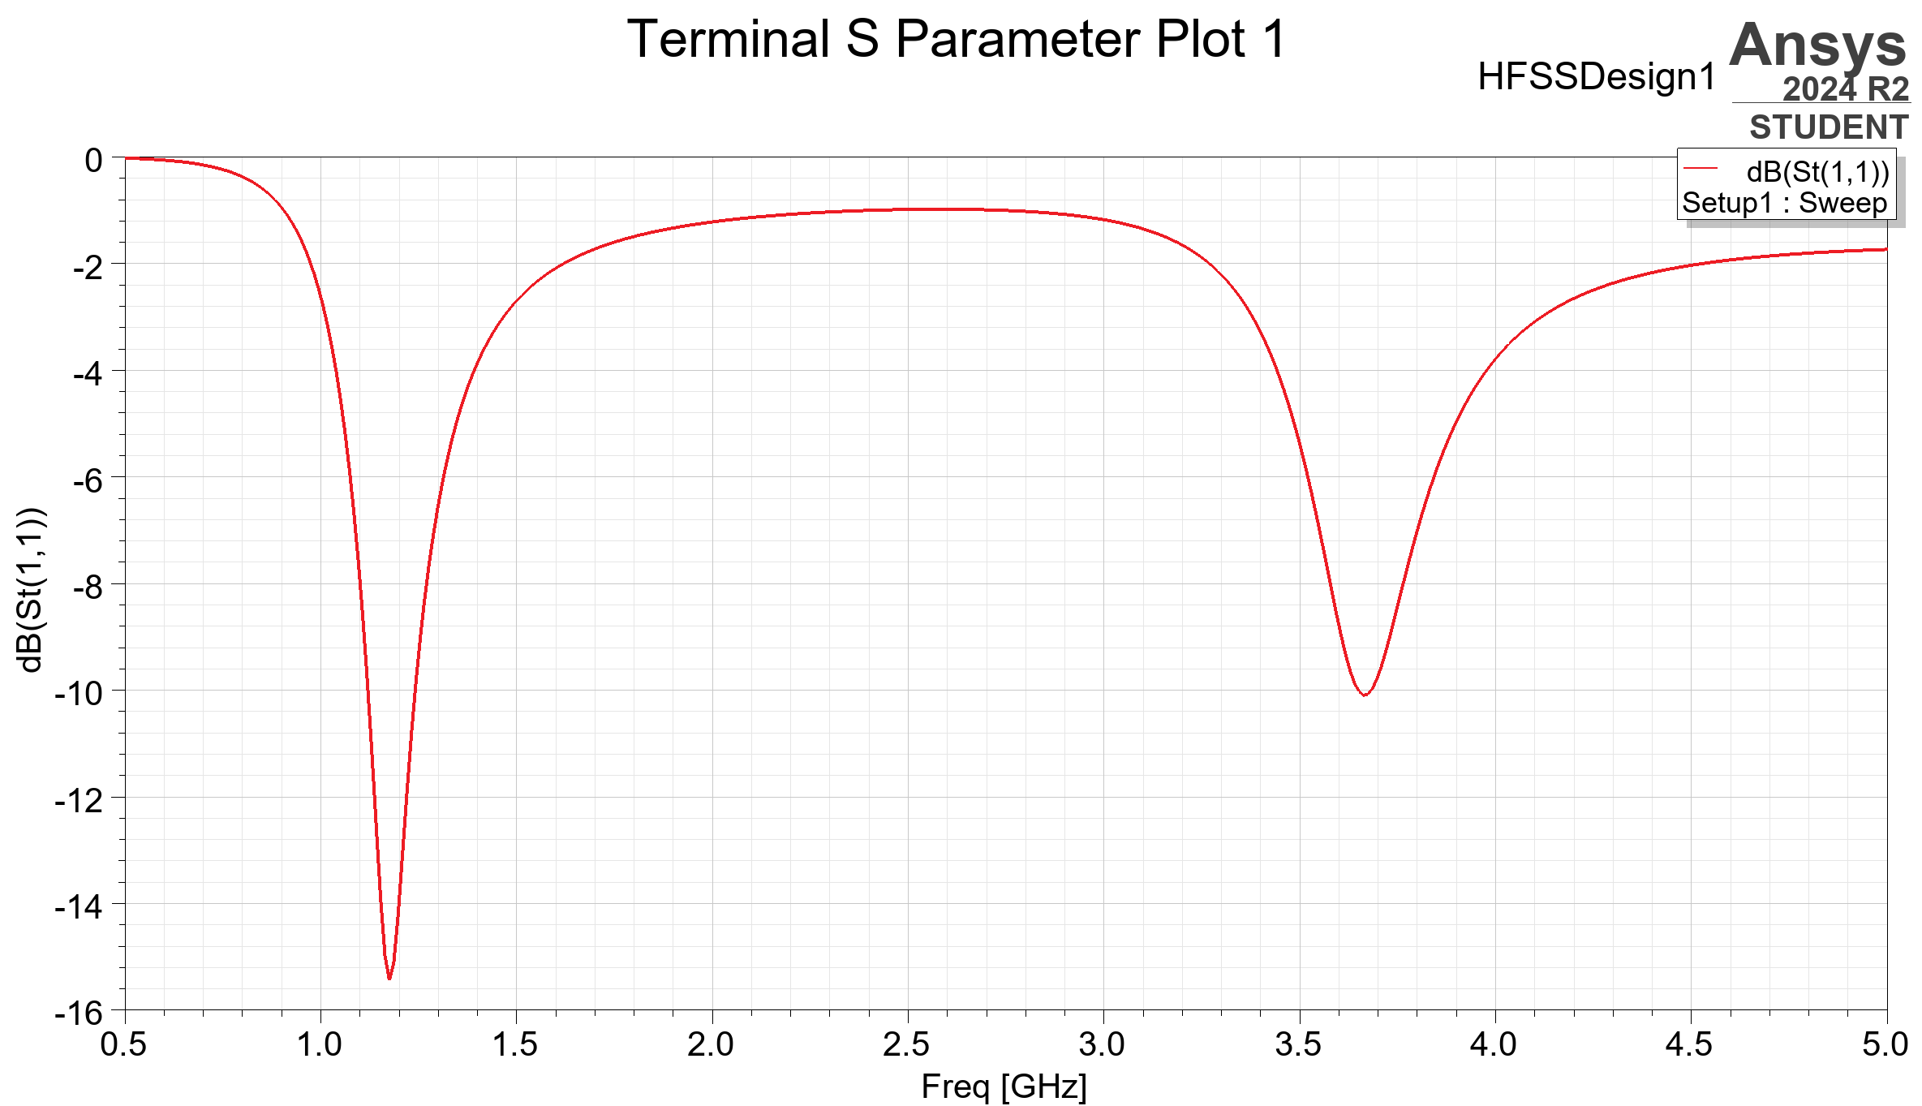
Figure 16: S Parameter plot for halfwave dipole

From this plot, it is observed that the simulation’s resonant frequency is around 1.18GHz, which is lower than the theoretical value.
A 3D polar plot was also simulated to measure the radiation pattern, gain, and directivity of the antenna. These results are shown below in Figure 17.
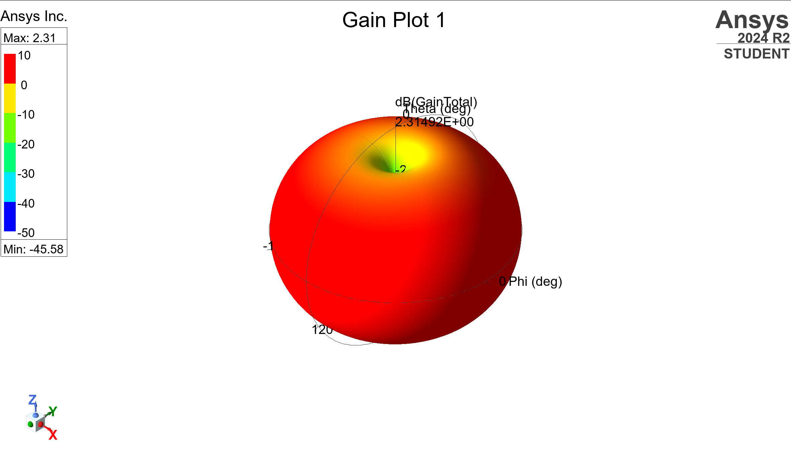
Figure 17: 3D radiation pattern of halfwave dipole

3. Discussion
Overall, the simulated directivity of the antenna matches a theoretically idea antenna, with a ‘donut’ shape. The dipole’s directivity is at a maximum in the azimuth plane, where it has equal gain omnidirectionally, and has minimum gain along the line of the antenna. This follows the characteristics of an ideal dipole antenna [2].
The key difference between the theoretical and simulated antenna is the resonant frequency. This can be due to losses in the transmission line, or antenna (dielectric, conduction, polarization etc.) [7]. Additionally, while the simulation could model the antenna as a perfect electrical conductor, the theoretical formula assumes that the dipole is infinitely thin (0mm radius) [8]; however, in the simulation, it was designed with a finite radius of 1mm, which could alter the value of the resonant frequency.
The other difference between the theoretical and simulated dipole is that the simulated dipole has a fringing field, where the electric and magnetic field extends beyond each end of the dipole [2].

4. Conclusion
In conclusion, this report has explored the differences between ideal and simulated dipoles, their differences in directivity and resonant frequency. This was done by successfully creating a halfwave dipole within HFSS and simulating it over a range of frequencies to observe its’ characteristics.

Task 3: Researching RADAR technology

1. Introduction
This report aims to analyze current studies on radar technology, specifically at drone-detection radar and current issues. The capabilities of these systems will be discussed, as well as their social and environmental impacts. To further the discussion, the most recent developments in this field will be explored and potential future advances and solutions suggested.

2. Literature Review

2.1. Key issues
The threat of drones is proven to be very prevalent, as researched in a study by V. Riabukha [9], they can pose a large threat to both military and private life. With drones becoming more easily available, an article from the IEEE sensors journal suggests that drones can present the following threats:
- Breaching no-fly zones and airspace
- Privacy invasion
- Cyber-attacks and hacking
- Terrorism attacks and smuggling [10]
Additionally, drone swarms are being seen more commonly in military applications, such as the Russia-Ukraine conflict, where they are used to execute remote strikes [11].

As explained in an article by Vilnius University [12], a common issue faced with UAV detection is the signal-to-noise ratio. As many systems don’t have clutter-rejection-system, radar doesn’t perform as well in urban or industrial areas, where there is a lot of noise and interference.
Drones vary greatly in size, shape, and speed; research performed by Seidaliyeva U. [13] discovered that drones can be very hard to identify, especially with characteristics like birds.

2.2. Current capabilities
A few key methods are typically implemented to detect UAVs using radar. These include:
- Active Radar
- Passive Radar
- Millimeter wave radar
- Micro-doppler analysis
A study by Tang et al. [14] compares the advantages between passive and active radar. Passive relies on existing EM sources, such as the communication systems to control UAVs. Active radar systems however send out EM pulses and measure returning signals, which can make them less suitable for populated areas.
Another paper, published by the University of Sofia [15], looks at the use of active radar to detect micro-doppler signatures. These signatures originate from the shift in frequency caused by the movement of the propeller blades, which can be differentiated from wings of a bird. This requires a high resolution. A further study by Rahman and Robertson supports the evidence that micro-doppler signatures can differentiate drones and birds [16].
Millimeter radar is a specific version of active radar, which was tested in a study by Zhang et al [17]. It was found that the periodic micro-motion (PMM) of the UAV can be detected at short range, and able to track position and velocity of drones at longer ranges, however presents issues as most COTS radar systems do not have enough transmission power.

3. Discussion

3.1. Impacts
While researching potential solutions for these issues with drone-detecting radar, there are many societal and environmental issues that must be considered.
For example, a study by Perdue University [18] tested the effects of radar on bird behavior, due to several species using the earth’s magnetic field to navigate. This research concluded that long term exposure to EM radiation caused changes in movement, foraging and mating habits, and slight population decline over a longer period. Additionally, to prevent this and to construct these systems, the natural habitats of birds and other creatures may have to be removed [19].
There are also be considerations for the construction, material and energy consumption of these systems, which can have a negative environmental impact due to the depletion of natural resources and the use of non-renewable energy [19].
Additionally, the introduction of new technology and radar systems may not be easily accepted socially. Concerns may include:
- The radar system being an eyesore
- Fear or lack of understanding of technology
- Invasion of privacy
- Restriction of flying for professionals and hobbyists
- How they will be built and integrated [20]
This could restrict both the advancements of the technology itself, and the rate that this technology can be implemented, which may not keep up with the rate that drone technology is advancing [21].
However, making drone-detection radar more mainstream, could allow individuals to feel safer and more secure from illegal uses of drones [22]. They are also crucial for airports and military applications, which can help with national security [9].

3.2. Solutions
A study [23] has explored the possibility of using AI within radar detection, which opens the possibility of combatting the current issues with identifying micro-doppler signatures, by better classifying objects detected. Additionally, radar systems could be combined with other sensors to improve effectiveness of detection. For example, if an object is detected by the radar, an imaging device could then be pointed at it and AI used to identify whether it is a threat, friendly drone or bird etc. Other sensors that could be implemented include RF, microphones, and IR [24], this will also provide a backup and remove any single points of failure in the radar.
Recently, UK troops successfully tested a radio weapon to interfere with drone swarm communications and neutralize them [25]. If this is implemented into drone detection radar in the future, it can improve security by safely eliminating unauthorized drones.
It could also be considered to increase the transmission power of the radar system. This will increase the range of detection; however, the power would have to increase a lot for a small increase in range [26]. This would significantly increase energy consumption, and the negative environmental effects of the radar system.

4. Conclusion
In conclusion, the world of UAV radar detection and drone technology is evolving at a fast rate. The current capabilities of detection can detect drones but have issues with reliability of distinguishing drones from birds, and interference with urban areas. The most advanced systems are currently too expensive and complex to commercially produce these systems, and the impact of them may be undesirable. The main improvements that could be made often involve the incorporation of other technologies, including sensors, or potentially machine learning.

7. References

[1] | M. D. Pozar, Microwave Engineering, 4th ed., A. Melhorn, Ed., John Wiley & Sons Inc., 2011.
[2] | J. D. Kraus and R. J. Marhefka, Antennas for all Applications, 3rd ed., E. J. Joseph, Ed., New York: McGraw-Hill, 2002.
[3] | J. Anseau, "Statistical literacy guide - Rounding and significantt plaecs," House of Commons Library, London, 2007.
[4] | ANSYS Inc, "An Introduction to HFSS," Canonsburg, 2013.
[5] | C. A. Balanis, Antenna Theory Analysis and Design, 3rd ed., Hoboken, New Jersey: John Wiley & Sons Inc., 2005, p. 182.
[6] | P. Horowitz and W. Hill, "The Art Of Electronics 3rd Edition," Cambridge University Press, 2015, pp. 71-73.
[7] | Nikolova, "Fundamental Antenna Parameters," McMaster, 2023.
[8] | B. S. Guru and H. R. Hiziroglu, Electromagnetic Field Theory Fundamentals, 2nd ed., Cambridge: Cambridge University Press, 2005.
[9] | V. P. Riabukha, "Radar Surveillance of Unmanned Aerial Vehicles (Review)," Radioelektronika, vol. 63, no. 11, pp. 655-669, 2020.
[10] | M. A. Khan and e. al., "On the DEtection of Unauthorized Drones - Techniques and Future Perspectives: A Review," IEEE Sensors Journal, vol. 22, no. 12, 2022.
[11] | E. Ward, "Ukraine's AI-Poered drone swarms signal the future of warfare and 'level the playing field' with Russia, report reveals," LBC News, 2024.
[12] | L. Andrius and et.al, "Investigation of Detection Possibility of UAVs Using Low Cost Marine RADAR," Aviation, vol. 23, no. 2, 2019.
[13] | U. Seidaliyeva and e. al., "Advances and Challenges in Drone Detection and Classification Techniques: A State of the Art Review," MDPI, vol. 24, no. 125, 26 10 2023.
[14] | Z. Tang, "UAV Detection with Passive Radar: Algorithms, Applications, and Challenges," MDPI, vol. 9, no. 76, 2025.
[15] | V. Demirev, "Drone Detection in Urban Environment - The New Challenge for the RADAR Systems Designers," International Scientific Journal, vol. 1, no. 3, pp. 114-116, 2017.
[16] | S. Rahman and D. A. Robertson, "Radar micro-Doppler signatures of drones and birds at K-band and W-band," Scientific Reports, vol. 8, 2018.
[17] | J. Zhang and e. al., "mmHawkeye: Passive UAV Detection with a COTS mmWave Radar," Tsinghua University, 2023.
[18] | E. Sheridan, J. Randolet, T. L. DeVault, T. W. Seamans and B. F. Blackwell, "The effects of radar on avian behavoir: Implications for wildlife management at airports," Elsevier, vol. 127, no. 171, 03 08 2015.
[19] | E. Team, "Exploring the Environmental Impact of Radar Technology," MilitarySphere.com, 28 07 2024. [Online]. Available: https://militarysphere.com/radar-environmental-impact/. [Accessed 28 04 2025].
[20] | J. Kraus, A. Kleczatsky and S. Hulinska, "Social, technological, and systemic issues of spreading the use of drones," Transport Research Procedia, vol. 51, pp. 3-10, 2020.
[21] | t. Sharrow, "Drone Detection on Radar: Separating Fact from Fiction," SoftHandTech, 04 04 2025. [Online]. Available: https://softhandtech.com/can-you-see-drones-on-radar/. [Accessed 28 04 2025].
[22] | R. Thampy, "The Rise of Drones - and a Way nto Monitor Them," Science Connected Magazine, 24 04 2025. [Online]. Available: https://magazine.scienceconnected.org/2025/04/the-rise-of-drones-and-a-way-to-monitor-them/. [Accessed 28 04 2025].
[23] | B. Taha and A. Shoufan, "Machine Learning-Based Drone Detection and Classification: State-of-the-Art in Research," IEEE Access, vol. 7, 2019.
[24] | E. Team, "What are the Different Drone Detection Techniques?," everythingRF, 15 06 2024. [Online]. Available: https://www.everythingrf.com/community/what-are-the-different-drone-detection-techniques. [Accessed 08 04 2025].
[25] | J. Layton, "UK’s new invisible radio wave weapon that can take down ‘drone swarms’," MSN, 2025.
[26] | C. Wolff, "radartutorial," 03 06 2021. [Online]. Available: https://www.radartutorial.eu/01.basics/pubs/Understanding_Radar_Equation.pdf. [Accessed 28 04 2025].
[27] | V. C. Chen, F. Li and H. Wechsler, "Analysis of Micro-doppler signatures," RADAR Sonar Navig, vol. 150, no. 4, 2003.

