MARKETING FUNDAMENTALS
  - LCBB4004
  - BLOGGING TO COMMUNICATE- ASSESSMENT 1
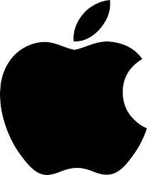

  - MATEI DENISA ANDREEA
  - Student Number: 1921544
  - LECTURER: RULA ALOUSI
BACKGROUND OF APPLE

Apple Inc is an American multinational technology company established in the year 1976 by Steve Jobs & Steve Wozniak and headquartered in Cupertino, California, U.S. Initially, the company was established in the house’s garage by the remarkable efforts of Jobs and Wozniak as they sold their HP-65 calculator and motorized medium of transportation (Microbus), altogether to gather finance to run the business. Using funds, Wozniak first invented Apple I- the original Apple computer in 1976 with convenient computer usability and circuitry. Steve Job’s legacy encompasses groundbreaking technology devices, ranging from Apple II to the iPhone (Greenspan, 2019).

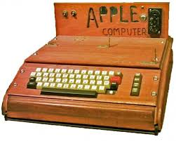
Steve Jobs and Steve Wozniak Apple Garage Apple I

APPLE LOGO

In 1981, a press conference was held where Steve Jobs was asked to share why he chose the name Apple where he simply replied “I love eating Apple”, they key notion was to bring simplicity to the people and nothing else. Thus, the statement was simple but strong stating “Apple- the fruit of creation”. Hence, it was all started with a fruit. Initial logo was given by Ronald Wayne- Apple’s co-founder with the idea of representing the law of gravity inspired by an apple, secondly a “rainbow-striped” apple logo was created, this was the first time where logo displayed colors with green color on top representing a leaf. Since 1998, the owners have been modifying the logo but with a similar shape representing the leaf, the apple and the bite.
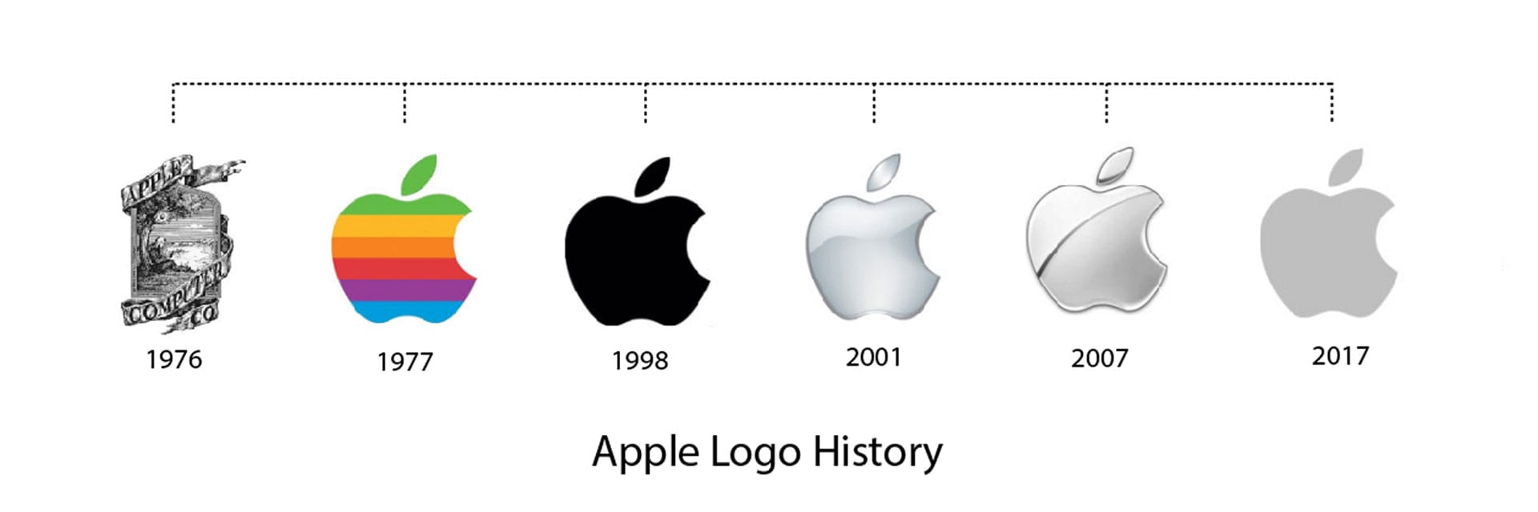
Apple Logo Evolution

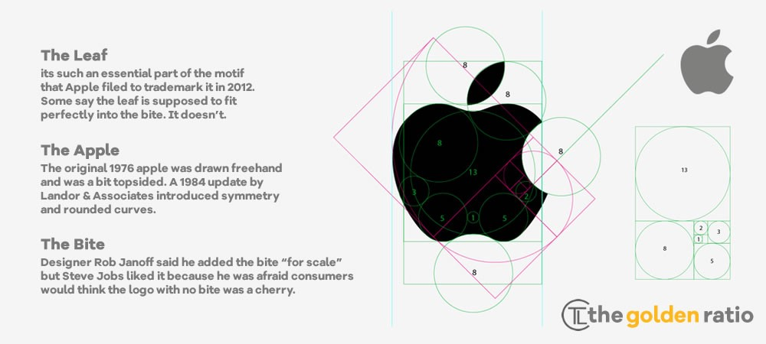
Apple logo design

APPLE MISSION AND VISION

The corporate mission of Apple is to serve the best personal computing devices that could support the students, designers, engineers, scientists, businessmen and consumers across the world. The purpose is to bring out the best user experience through unique range of software, hardware and services. The company is devoted to the empowerment of man- aimed at providing access to each & every individual to personal computing and help them change the way they work and communicate with people (Greenspan, 2019).

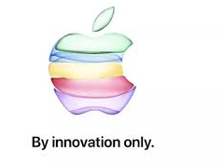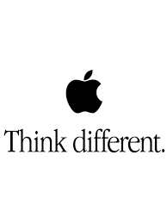
The corporate vision of Apple is to produce the best technology products on earth with the ultimate aim of making the world better than before. It is believed that creating best products is not enough, but to emphasize on environmental conservation, sustainability and improvement of ecological impact is too necessary. The company committed to continue novel innovation in the process of product development to become the world leader in product deign & development. In sun, Apple seeks to make a noticeable contribution to the world by producing products for the mind that advance humankind.

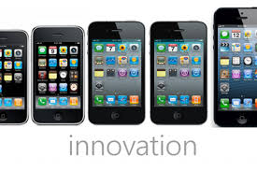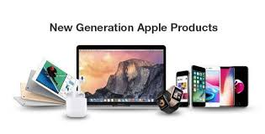

PRODUCTS OF APPLE

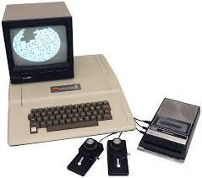
Apple II is an 8-bit home computer hand built by Steve Wozniak in 1977, after 1 year of establishing the first Apple computer. It was produced aiming at selling the real packed computer, as a result, it fetched $79m sales volume initially in 1979 and became the fastest-selling personal computer at that time (Calore and Perce, 2016).
The First Macintosh 128K was invested in 1984 with a Superbowl commercialization, no company even dared dreaming about flaunting computer in Superbowl slot, but Apple did. The Macintosh was easy to use as compared to others.
The iMac invested in 1998 justified the Apple’s statement “Think Different” as iMac has kickstarted Apple’s fortunes & boosted company performance.
The iPod was invented to transform the complete scenario of Apple by making in a mass-market electronics giant from a small computer company. This device sparked a revolution in digital music.
The iPhone was invented after half a decade of iPod until Apple has become the biggest player in digital music already. As time passed, iPhone became the Apple’s killer product as it hits the company’s revenue with a huge different and fulfil all consumer desires (Greenspan, 2019).
iTunes was introduced as all-in-one digital music program, a combination of internet radio, CD writing and of course MP3 playback.
The iPad- an oversized iPhone invented by Apple having 9.7in screen acted as a protector of the media industry and will likely increase company’s sales ratio in future.
iOS App Store, a new milestone invented in 2008 and year by year, it succeeded in becoming the cornerstone to the iPhone’s success.

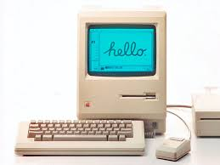
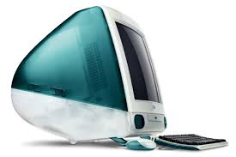
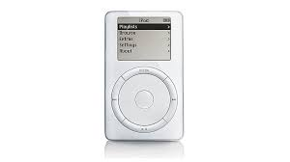
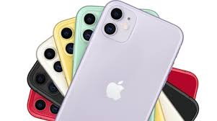
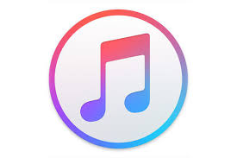
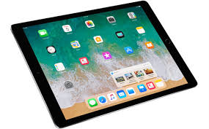

APPLE’S PRICING STRATEGY

Since the day, Tim Cook became the CEO of Apple, the company has been recognizing the point of maturity of the audience to convert them into potential customers. In an interview, Tim Cook has revealed that the company never thought about selling a phone in lower cost, the core aim has always been to provide a great experience by selling a great phone. To make profitability, Cook always had focused on four keys
- Providing small number of products’
- Emphasizing on the high end
- Developing a halo effect making consumers eager to buy Apple products
- Giving priority to profit above market share
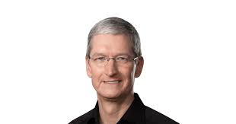
Tim Cook
Retail Pricing
Apple has incorporated many pricing tactics, out of which MAP turned out to be the best. It is a minimum advertised price retail strategy that prohibits dealers or resellers from promoting a product below certain minimum price. Apple contracted with two key resellers: Best Buy and Walmart to which it offers a marginal wholesale discount and maintain high-priced products. In this way, the customers pay a price which is very close the retail price suggested by the manufacturer. Apple offers monetary incentives to persuade retailers for selling goods at MAPs fixed by it.
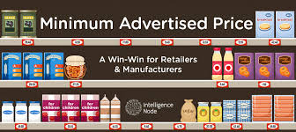
MAP Pricing Policy
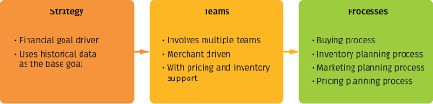
Retail price modeling

Premium Pricing Strategy
Since its inception, Apple aims at creating a premier product and selling it with a premier price. It is observed that the cheapest prices of Apple are often midrange, but it worth the product value and ensure a high-quality user experience. The user interface and the hardware are mainly designed to provide a value for the charged price, this keeps the profit high (Nielson, 2019).
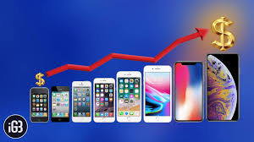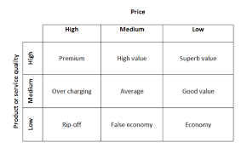
It is however observed that due to saturation in developed markets and intense competition from low-cost smartphone, Apple is gradually losing its “aspirational” status and thus applying premium pricing strategy is risky as per the current scenario.

APPLE STORES

At present, Apple is operating in more than 500 stores across 25 regions and countries, the very first store established by Apple in May, 2001, this ratio include the locations that are temporarily closed for expansion and renovations. In recent years, Apple has opened stores in Singapore, Thailand and Japan

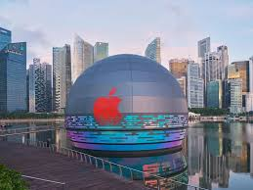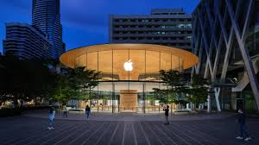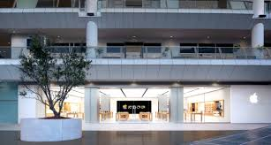
Maria Bay Sands, Singapore Central World, Bangkok Kawasaki, Japan



The retail footprint of Apple has expanded and crossed establishment of 510 stores spanning more than 25 countries including Australia, Brazil, France, China, Germany, Italy, Mexico, Singapore, South Korea, the UK, US, the United Arab Emirates, Sweden, Spain, Thailand, Taiwan and more. However, after the massive spread of coronavirus across the world, the company decided to keep some of its stores closed and where it is still operating, it has incorporated preventive measures to keep everyone safe, including temperature checks, increased cleaning, social distancing and limiting the ratio of visitors in the stores (MacRumors, 2020).

Company-owned website and online stores

An analysis of Apple’s 10-K filling suggested that nearly 31% of the company’s revenue came from its websites and online stores in 2019, the ratio was 28% in 2017 and 28% in 2018, this shows that there has been gradual increase in the percentage of online sales. Also, it has been observed that the company uses local URL and the in-market web addressed that help specifying its host location on the computer network, this makes sure that the company appears as local to the users. Through this, Apple makes everything looks intuitive and easy and hence the global online presence of Apple gets an A++ (Worthington, 2016).

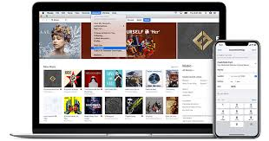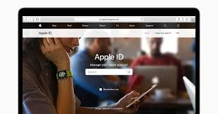

APPLE’S PROMOTION STRATEGY

As called the marketing communications mix, Apple’s promotional strategy identifies the communication tactics to reach the prospective consumers and turning them into potential customers. Apple uses both online and offline mediums of promotion to capture customer base from every possible source (Kodama, 2017). The key communication tactics include
Advertising: Apple has been a master always of advertising, all thanks to the campaign strategies the company utilizes since the days Steve Jobs used to handle the business. It is through technology news websites or Google’s digital advertising network. The iconic 1984 Mac commercial showcases the best marketing performance of Ridley Scott.
Personal Selling: Apple uses different distribution channels, for e.g. selling products at online stores, physical retail stores and other retail chains with Best Buy, Walmart, T-Mobile and many more. The employees make direct interact with consumers by selling products in-store, this way they can create better user experience.
Sales Promotion: Apple has signed agreements with number of resellers as mentioned above. Sales promotion usually happens at Apple authorized reseller locations.
Public Relations: Under this tactic, Apple optimizes corporate image by organizing exclusive interviews, press releases and other programs to maximize positive publicity.
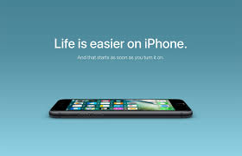
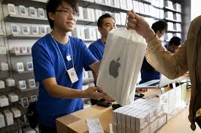
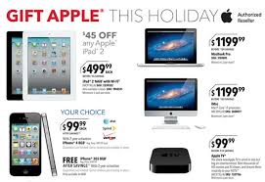
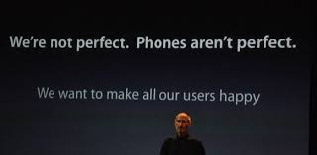

REFERENCES
- Calore, M. and Perce, D. (2016). 15 Products That Defined Apple's First 40 Years. Online available at https://www.wired.com/2016/04/apple-40th-birthday/. Last accessed at 26th December, 2020.
- Greenspan, R. (2019). Apple Inc.’s Marketing Mix or 4Ps (An Analysis). Online available at http://panmore.com/apple-inc-marketing-mix-4ps. Last accessed at 24th December, 2020.
- Kodama, M. (2017). Strategy Transformation Based on Holistic Leadership: A Case Study of Apple. In Developing Holistic Leadership. Emerald Publishing Limited.
- MacRumors. (2020). Apple Stores. Online available at https://www.macrumors.com/roundup/apple-retail-stores/. Last accessed at 22nd December, 2020.
- Nielson, S. (2019). Apple’s Premium Pricing Strategy, Product Differentiation. Online available at https://marketrealist.com/2014/02/apples-premium-pricing-strategy-product-differentiation/. Last accessed at 22nd December, 2020.
- Worthington, J. (2016). International business and technology blog. Apple's global online presence gets an A++. Online available at https://info.ibt.onl/international-business-and-technology-blog/a-for-apple. Last accessed at 24th December, 2020.

