7/30/2026
University of Wales and Saint Trinity
London Compus
Component 1- Coursework: Portfolio
Module Name: Software Solution for Business
Module Code: ACCA4026
Student Name: Abdul Basit Sedique
Student ID: 2540728
Group: 1
Lecturer’s Name: Rajeev Nath

Contents
Introduction 1
Task 1. e-Commerce Website builders/software solutions 1
1.1 WIX 1
1.2 Shopify 3
Task 2. Mind-map of contemporary software applications 4
2.1 Mind mapping and its benefits 4
2.2 Create a mind map of contemporary software applications 6
Task 3. Office Applications 7
3.1 Four office software solutions for business operations 7
Ms Word 8
Ms Excel 9
Ms PowerPoint 11
Ms Access 13
3.2 Test any two features 17
VLOOKUP 17
IF Statement 18
Task 4. Communication and Collaboration applications 19
4.1.1 Gmail 20
4.1.2 Zoom 22
4.2.1 Gmail 24
4.2.2 Zoom 25
Conclusion 27

Introduction
This assignment explores a range of software applications and tools that can be used to enhance business operations and improve workplace efficiency. It examines how different software solutions support productivity, communication, collaboration, and decision-making within an organisation. As part of this assignment, practical demonstrations are provided using selected applications, including e-commerce platforms such as Wix and Shopify, Microsoft Access for database management, Gmail for email communication, and Zoom for online meetings. The practical activities are based on simulated scenarios rather than real business data, demonstrating how these tools can be effectively used in a professional business environment.

Task 1. e-Commerce Website builders/software solutions


1.1 WIX
Wix is an online platform that allows individuals and businesses to build and manage professional websites without needing programming skills or advanced technical knowledge. It is widely used to develop business websites, online stores, portfolios, blogs, and personal websites through its simple drag-and-drop editor. This user-friendly interface allows users to customise their websites by adding and arranging text, images, videos, and other elements with ease, making it an ideal solution for beginners as well as small businesses [1].
Wix provides a wide range of ready-made templates that users can modify according to their business needs or personal preferences. It also has content management features that allow users to add new pages, change existing information, upload images, and regularly update their websites. In addition, the Wix App Market provides different applications that can add extra features to a website, such as contact forms, live chat, appointment booking, online payment options, and social media connections. These tools can help businesses communicate with customers more effectively and create a better experience for website visitors.
Wix also includes built-in Search Engine Optimisation (SEO) tools that help improve a website's visibility on search engines such as Google. These tools allow users to customise page titles, descriptions, and keywords, helping potential customers find the website more easily. Furthermore, Wix automatically creates mobile-friendly websites that work efficiently on desktops, tablets, and smartphones, ensuring a consistent user experience across different devices. The platform also provides secure cloud hosting, automatic software updates, and security features, allowing users to focus on managing their business rather than maintaining the technical aspects of the website. Overall, Wix is a reliable and easy-to-use website builder that helps users create and manage professional websites quickly and efficiently [2].

Figure 1 shows the Wix dashboard after logging in, where the Create New Site option is selected to begin creating a new website.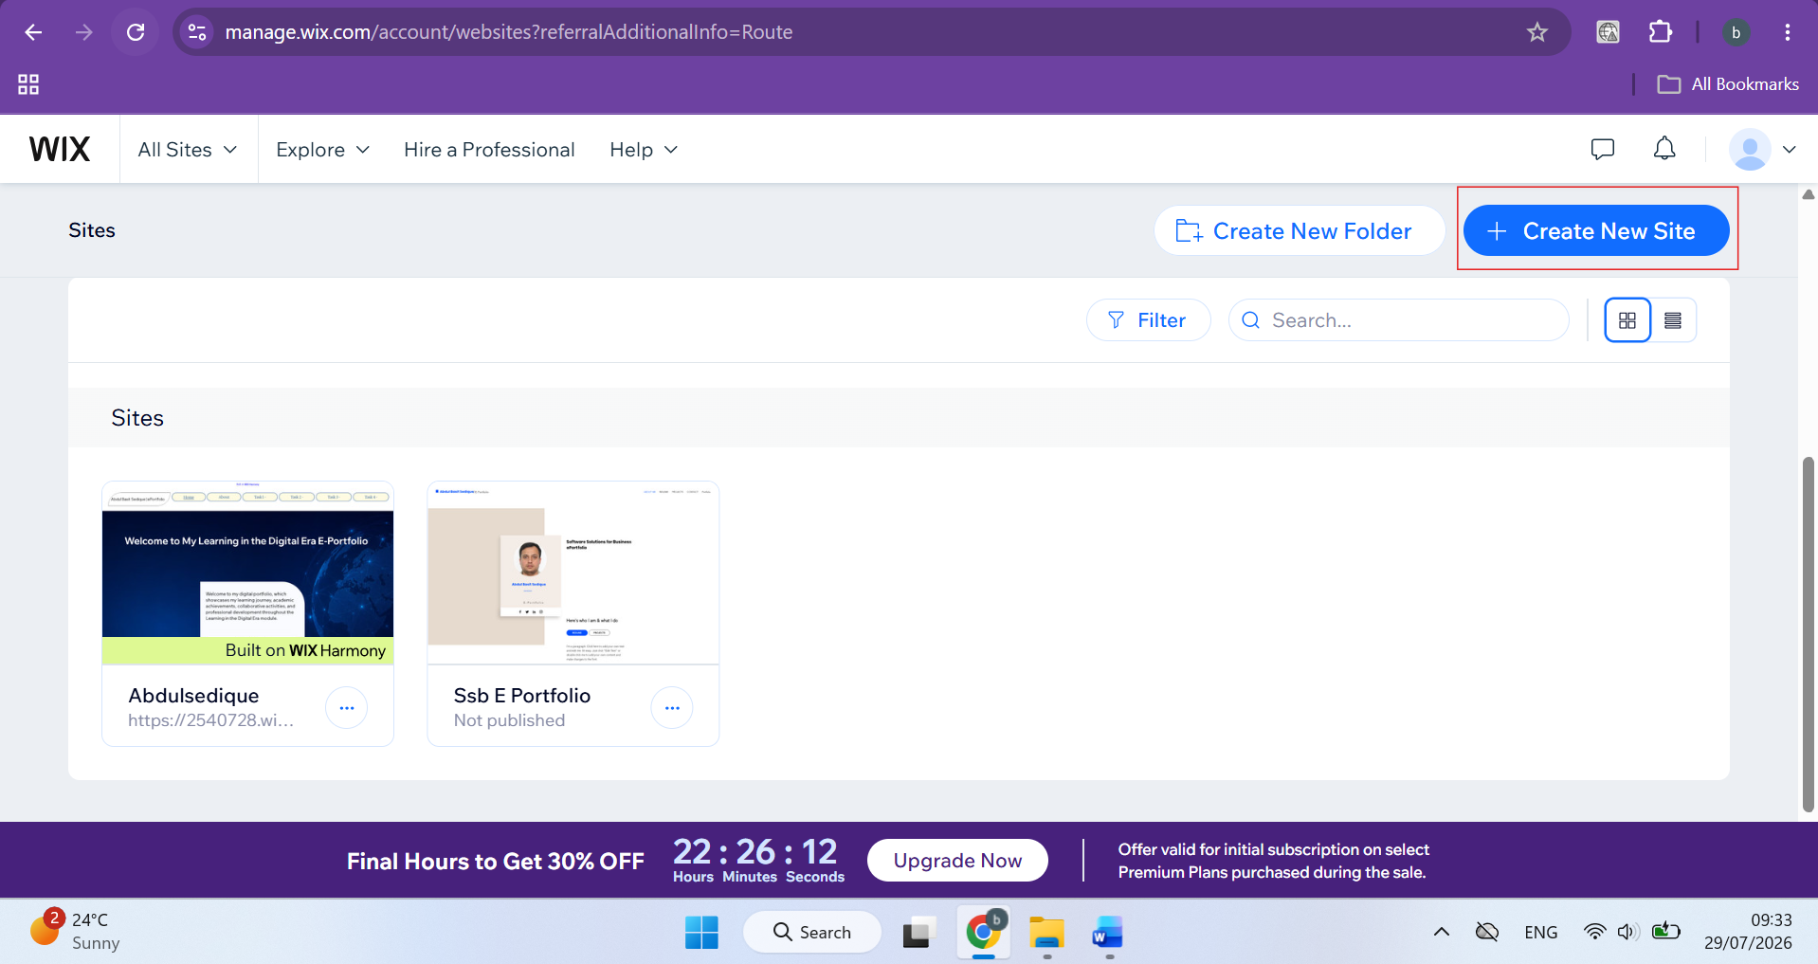
Figure 1: Wix dashboard

Figure 2 shows the Wix website editor, where users can design and customise the website by adding content, editing pages, managing settings, previewing changes, saving their work, and publishing the website.
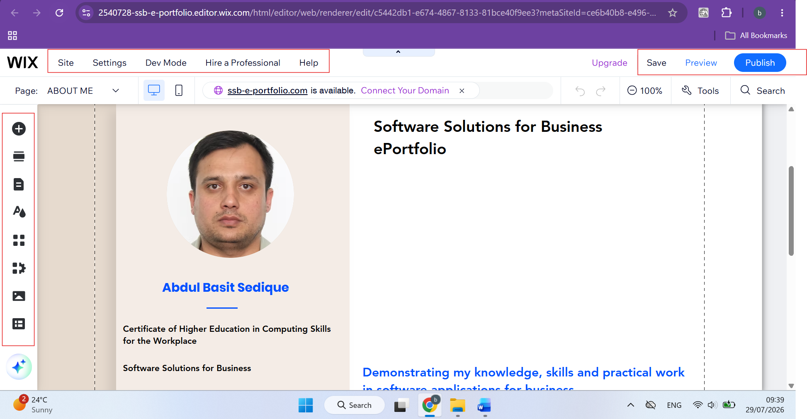
Figure 2: Wix website editor


1.2 Shopify
Shopify is a cloud-based e-commerce platform designed specifically to help individuals and businesses create, manage, and grow online stores. It provides an all-in-one solution that enables users to sell products online without requiring advanced programming or web development skills. Shopify is suitable for entrepreneurs, small businesses, and larger organisations that want to establish a professional online presence and manage their sales through a secure and reliable platform[3].
One of Shopify's main strengths is its online store builder, which offers a wide range of customisable templates that allow businesses to create attractive and professional e-commerce websites. The platform also provides comprehensive product management tools, enabling users to add products, organise categories, update prices, manage stock levels, and upload product images and descriptions. Shopify supports secure payment processing through various payment methods, including credit and debit cards, digital wallets, and other trusted payment gateways, providing customers with a safe online shopping experience.
In addition, Shopify includes powerful order and inventory management features that automatically track customer orders and monitor stock availability, helping businesses manage their operations more efficiently. Shopify has an App Store where businesses can find a wide range of third-party applications to add extra functions to their online stores. These applications can support activities such as email marketing, customer service, accounting, delivery management, and social media. Shopify also provides built-in SEO features that allow users to improve their website's visibility on search engines by editing page titles, meta descriptions, and other website content. In addition, Shopify provides analytics and reporting tools that help businesses understand their sales, customer activity, and website traffic. This information can help business owners make better decisions about their online stores. Shopify also provides secure hosting, automatic updates, and websites that can adjust to different screen sizes, including computers, tablets, and smartphones. Overall, Shopify provides a complete set of tools that businesses can use to create, manage, and develop their online stores [4].
Figure 3 shows the Shopify dashboard after logging in, where users can manage products, orders, customers, analytics, settings, and other store management features from a single interface.
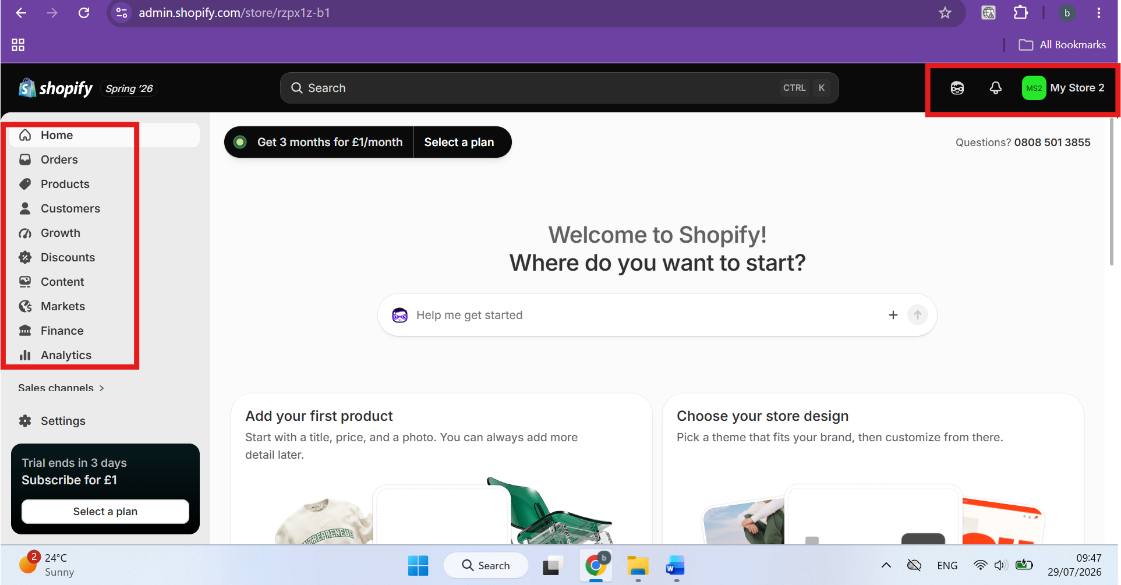
Figure 3: The Shopify dashboard

Task 2. Mind-map of contemporary software applications

2.1 Mind mapping and its benefits
A mind map is a visual method used to organise ideas, information, and concepts around a central topic. The main topic is normally placed in the centre of the mind map, while related ideas and subtopics are connected through branches. These branches can be further divided into smaller points, allowing complex information to be presented in a simple and organised way. Mind maps can include keywords, colours, symbols, images, and different levels of branches to make information easier to understand and remember. They are commonly used for brainstorming, learning, planning, problem-solving, project management, and organising information. mind mapping can support learning by helping people organise information and understand the relationships between different ideas [5].
Mind mapping can also be useful in business operations because businesses often need to manage a large amount of information and make decisions based on different ideas and priorities. For example, a manager could use a mind map when planning a new project. The project could be placed in the centre, with branches showing areas such as tasks, employees, resources, deadlines, costs, and expected outcomes. Each of these areas can then be divided into smaller tasks. This provides a clear overview of the project and can help managers understand what needs to be completed.
One important benefit of mind mapping is that it helps to organise complex information. Instead of having a large amount of information written in separate paragraphs or lists, related information can be connected visually. This makes it easier for employees to understand how different tasks or business activities are related. It can also help managers identify important information quickly when planning or reviewing a project.
Another benefit is brainstorming and creativity. During a business meeting, employees can use a mind map to share their ideas around a particular problem or objective. New ideas can be added as branches without having to follow a strict order. This can encourage employees to contribute their opinions and may help the team identify alternative solutions or new opportunities.
Mind mapping can also improve communication and collaboration. When a team works on the same mind map, members can see the ideas and responsibilities of other team members. This can make it easier to discuss priorities, allocate tasks, and understand how individual activities contribute to the overall business objective. It can therefore provide a common visual structure for team discussions [6].
In addition, mind mapping can support planning and decision-making. A business can use a mind map to compare different options by showing their advantages, disadvantages, resources, costs, and possible outcomes. This can help managers look at a situation from different perspectives before making a decision. Mind maps can also break a large task into smaller and more manageable activities, which can make project planning easier.
Mind mapping can further support learning and information retention because information is presented visually rather than only through continuous text. Research discussed by Shi et al. [6] highlights the value of mind-mapping-based approaches for cognitive learning outcomes. In a business environment, this can be useful when employees need to understand new processes, training information, or project requirements.
Overall, mind mapping is a useful tool for business operations because it can help organisations organise information, encourage creativity, improve communication, support planning, and assist decision-making. By presenting information in a clear visual structure, mind maps can make complex business activities easier to understand and manage.

2.2 Create a mind map of contemporary software applications
Figure 4 illustrates a mind map of contemporary software applications commonly used to support day-to-day business operations. The software is organised into categories including productivity software, communication software, cloud storage services, multimedia software, security software, web browsers, education software, business software, and development software. Each category contains examples of widely used applications that help organisations improve communication, collaboration, productivity, data management, security, and overall business efficiency.
Mind map Link: https://www.mindmeister.com/4038038146/contemporary-software-applications
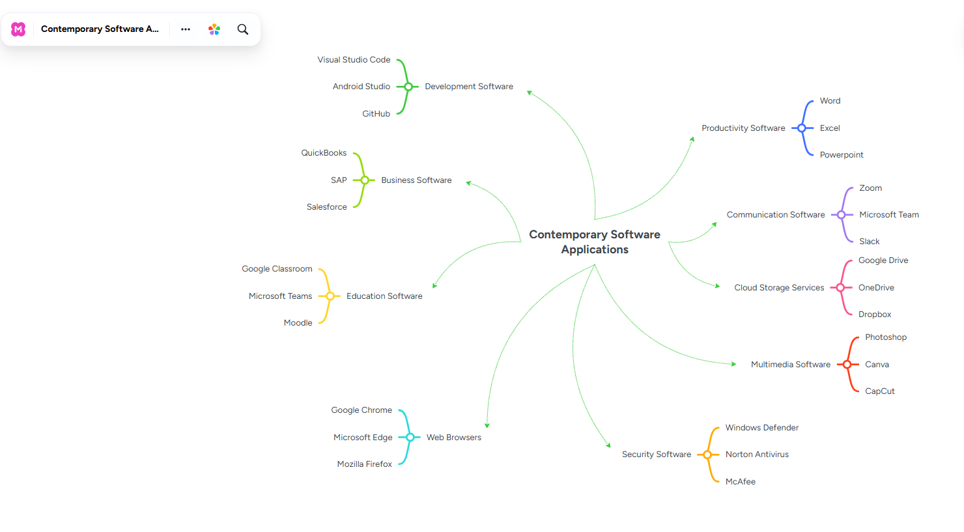 Figure 4: Mind Map image:

Task 3. Office Applications

3.1 Four office software solutions for business operations



Ms Word
Microsoft Word is a word-processing application developed by Microsoft and widely used by students, teachers, businesses, and professionals. It can be used to create, edit, store, and share different types of documents, including assignments, reports, letters, CVs, meeting notes, and business documents. Because Word is easy to use and provides many useful features, it is commonly used in both education and the workplace.
One of the main uses of Microsoft Word is creating and organising information. Users can type information and format it using different fonts, headings, bold or italic text, and numbered or bulleted lists. These features help make documents clear and easy to read. Users can also insert tables, pictures, charts, shapes, and page numbers to present information in a more organised way.
Word can also be used for storing information. Documents can be saved on a computer or another storage location and opened again when needed. Users can save documents in different formats, including Word and PDF. Saving a document as a PDF is useful when sharing it with others because it helps maintain the document's layout and appearance.
Another useful feature is the ability to use templates. Templates can help users create professional documents such as CVs, letters, and reports without designing everything from the beginning. Word also includes spell and grammar checking, which can help users identify writing errors and improve the quality of their documents.
Although Word is mainly designed for written documents, it can also support basic organisation and presentation of information. For example, users can place information into tables and use formatting to make important details easier to identify. However, more advanced calculations and numerical data analysis are better suited to applications such as Microsoft Excel.
Word also supports collaboration, allowing multiple users to work on the same document online. This can be useful when students or employees are working together on a report or other document.
Overall, Microsoft Word is an important office application for creating, storing, presenting, and organising information. Its formatting tools, tables, images, templates, checking features, storage options, and collaboration tools make it useful in both academic and professional environments [7].
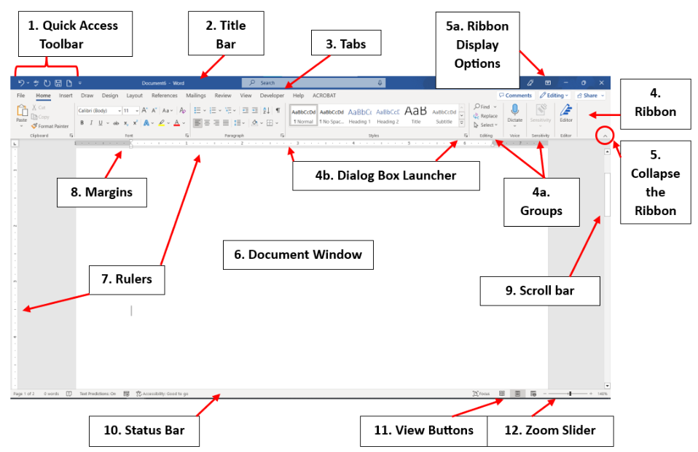
Figure 5: Overview of Word dashboard [8]



Ms Excel
Microsoft Excel is a spreadsheet application developed by Microsoft and included in the Microsoft 365 suite. It is widely used by students, businesses, and organisations to enter, organise, calculate, store, and analyse information. Excel is especially useful when working with numbers and larger amounts of structured data. For example, it can be used to create budgets, track expenses, manage records, prepare reports, and review business information.
One of the main uses of Excel is creating and storing data. Information can be entered into rows and columns, with each cell containing a specific piece of information. For example, a business could create a spreadsheet containing customer names, product details, prices, quantities, and sales dates. Organising information in this way makes it easier to find, update, and manage records.
Excel is also useful for performing calculations. Users can use formulas and built-in functions to calculate information automatically rather than doing calculations manually. For example, a business could use Excel to calculate total sales, expenses, profits, or average values. When new information is added, formulas can automatically update the results. This can save time and reduce mistakes when working with a large amount of data.
Another important use of Excel is analysing information. Features such as sorting and filtering allow users to look at data in different ways. For example, sales information can be sorted by date, product, or amount. A user can also filter the spreadsheet to display only specific information. This makes it easier to identify useful details and understand what the data shows.
Excel also allows users to present data visually by creating charts and graphs. For example, a business could create a chart showing monthly sales and compare its performance over different months. Presenting information visually can make data easier to understand, especially when it needs to be shared with managers or other employees.
Other features, including tables and conditional formatting, can also help users manage information. Conditional formatting can highlight particular values based on set conditions. For example, expenses that are higher than a planned budget could be highlighted so they can be reviewed.
Overall, Microsoft Excel is an important office application for creating, storing, calculating, presenting, and analysing data. Its formulas, functions, tables, charts, sorting, filtering, and formatting features make it useful in both academic and professional environments. It helps users manage information in a structured way, work more efficiently, and make better decisions based on the data available [9].
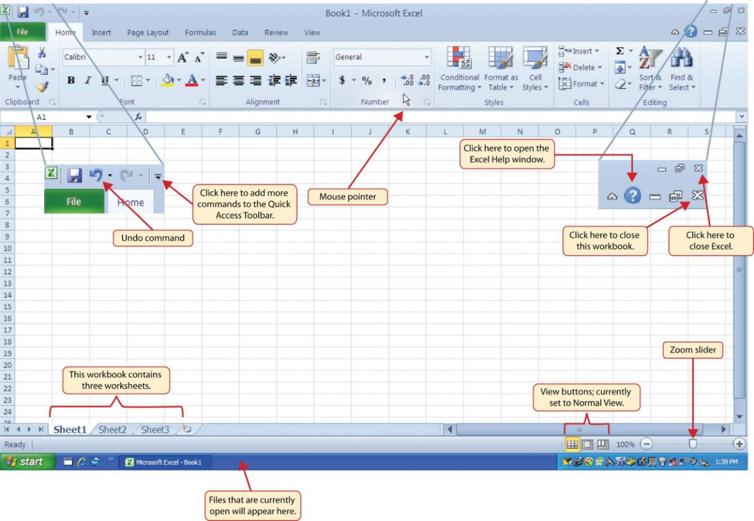
Figure 6: Overview of Excel dashboard [10]



Ms PowerPoint
Microsoft PowerPoint is a presentation application developed by Microsoft and included in the Microsoft 365 suite. It is widely used by students, teachers, businesses, and professionals to create presentations for different purposes. For example, it can be used for classroom presentations, business meetings, training sessions, project updates, and conferences. PowerPoint allows users to organise information into individual slides, making it easier to present ideas to an audience in a clear and structured way.
One of the main uses of PowerPoint is creating and presenting information. Users can create slides and add headings, text, images, tables, charts, and other information. Each slide can focus on a particular topic, allowing information to be presented step by step. For example, a business employee could create a presentation about a new project and use different slides to explain its objectives, activities, costs, and expected results.
PowerPoint also provides templates and themes that help users create professional-looking presentations. Instead of designing every slide from the beginning, users can select a suitable template and add their own information. This can save time and help keep the same style throughout the presentation. Users can also change fonts, text sizes, layouts, and other formatting options to make important information easier to understand.
Another useful feature is the ability to add images, charts, tables, and videos. These features allow information to be presented in different ways rather than relying only on written text. For example, a sales presentation could include a chart showing monthly sales, while a table could be used to compare different products. Images and videos can also help explain a topic and make the presentation more interesting for the audience.
PowerPoint also includes animations and transitions, which control how information appears between or within slides. These features can be useful when presenting information step by step. However, they should be used carefully because using too many effects could distract the audience from the main information.
PowerPoint can also be used to store and share information. Presentations can be saved and edited later, printed, or shared electronically with other people. This is useful in business when a presentation needs to be sent to colleagues or used during a meeting. Presentations can also be delivered online, allowing people in different locations to access the same information.
Overall, Microsoft PowerPoint is an important office application for creating, organising, storing, presenting, and communicating information. Its slides, templates, images, charts, tables, videos, animations, and sharing features help users present information in a clear and understandable way. It is therefore useful in both academic and professional environments where information needs to be explained to an audience in an organised and effective manner [11].
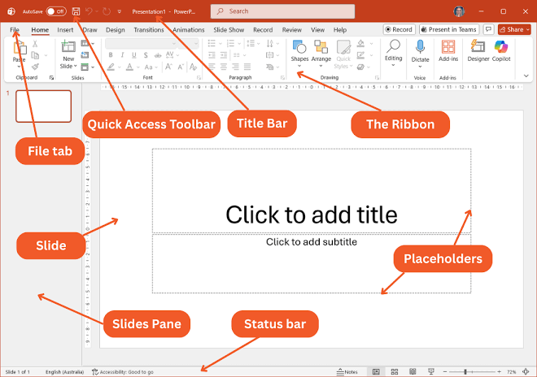
Figure 7: Overview of PowerPoint Dashboard [12]



Ms Access
Microsoft Access is a database management application developed by Microsoft and included in the Microsoft 365 suite. It is mainly used to create, store, organise, and manage information in a structured way. It can be useful for businesses, schools, and other organisations that need to keep records and find information quickly. For example, a business could use Access to store customer details, employee records, orders, products, or inventory information in one database.
One of the main features of Microsoft Access is tables, which are used to store information. A table contains fields and records, with each field representing a particular type of information. For example, an order table could include Order ID, Customer ID, Order Date, Quantity, Revenue, and Order Status. This helps users enter information in an organised way and makes records easier to manage. In the practical activity for this assignment, an Order table was created and sample records were entered to test the database.
Access also provides forms, which make entering and viewing information easier. Instead of entering information directly into a table, users can use a form to add or update records in a simpler way. This can be useful for businesses where employees need to enter information regularly.
Another important feature is queries. Queries allow users to search for specific information from one or more tables. For example, a business could use a query to find orders belonging to a particular customer or information that meets certain conditions. In the practical activity, a query was created by linking the Customers and Order tables using Customer ID and selecting the required fields. This showed how Access can be used to retrieve related information from a database.
Microsoft Access can also create reports, which present information from a database in a clear and organised format. For example, a business could create a report showing customer orders or sales information. This makes the information easier to review and share with other people.
Another benefit of Access is that it helps users organise information and reduce duplication. Related information can be connected within the database instead of being entered repeatedly. This can help improve the accuracy and consistency of records and make information easier to update.
Overall, Microsoft Access is a useful office application for creating, storing, organising, retrieving, and analysing structured data. Tables can store information, forms can support data entry, queries can retrieve specific records, and reports can present information clearly. The practical activities completed in this assignment demonstrate how Access can be used to create tables, enter records, connect related information, and create queries [13].
The figure 8 shows how we Opened the Create Table view in Microsoft Access as part of our class activity and began defining the table by adding the required columns and data types.
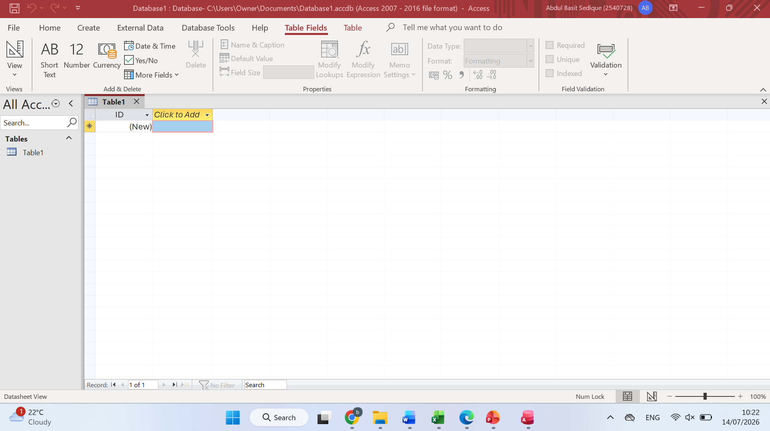
Figure 8: Create Table View

The figure 9 show as part our class activity Created the Order table in Microsoft Access and defined the appropriate data type for each field, including Order ID, Customer ID, Cookies Ordered, Order Date, Revenue, Order Filled, and Revenue per Cookie. This ensures the data is stored accurately and consistently.
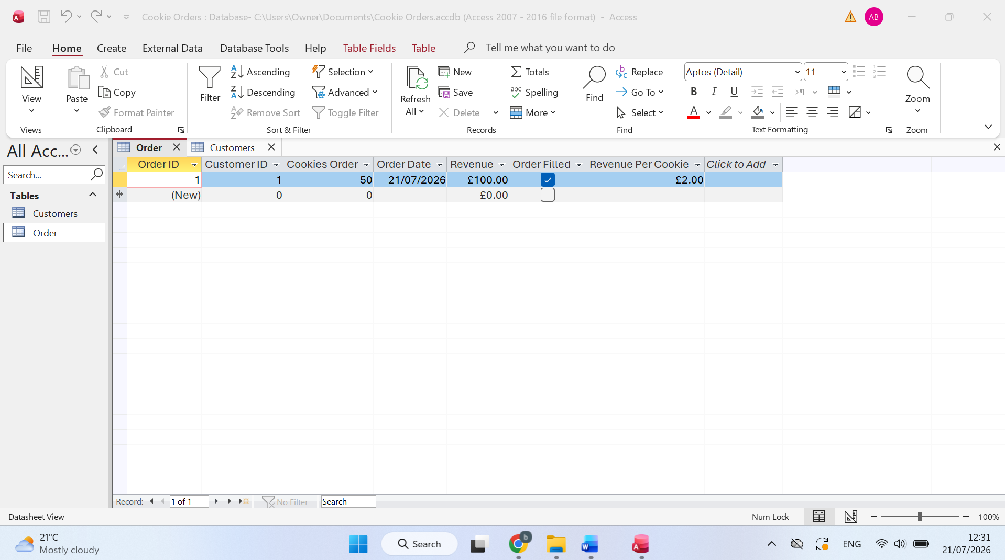
Figure 9: Order Table
The figure 10 shows adding records into the Order table to test the database. The data includes customer IDs, order quantities, order dates, revenue, order status, and revenue per cookie, ensuring the table is populated with valid information.
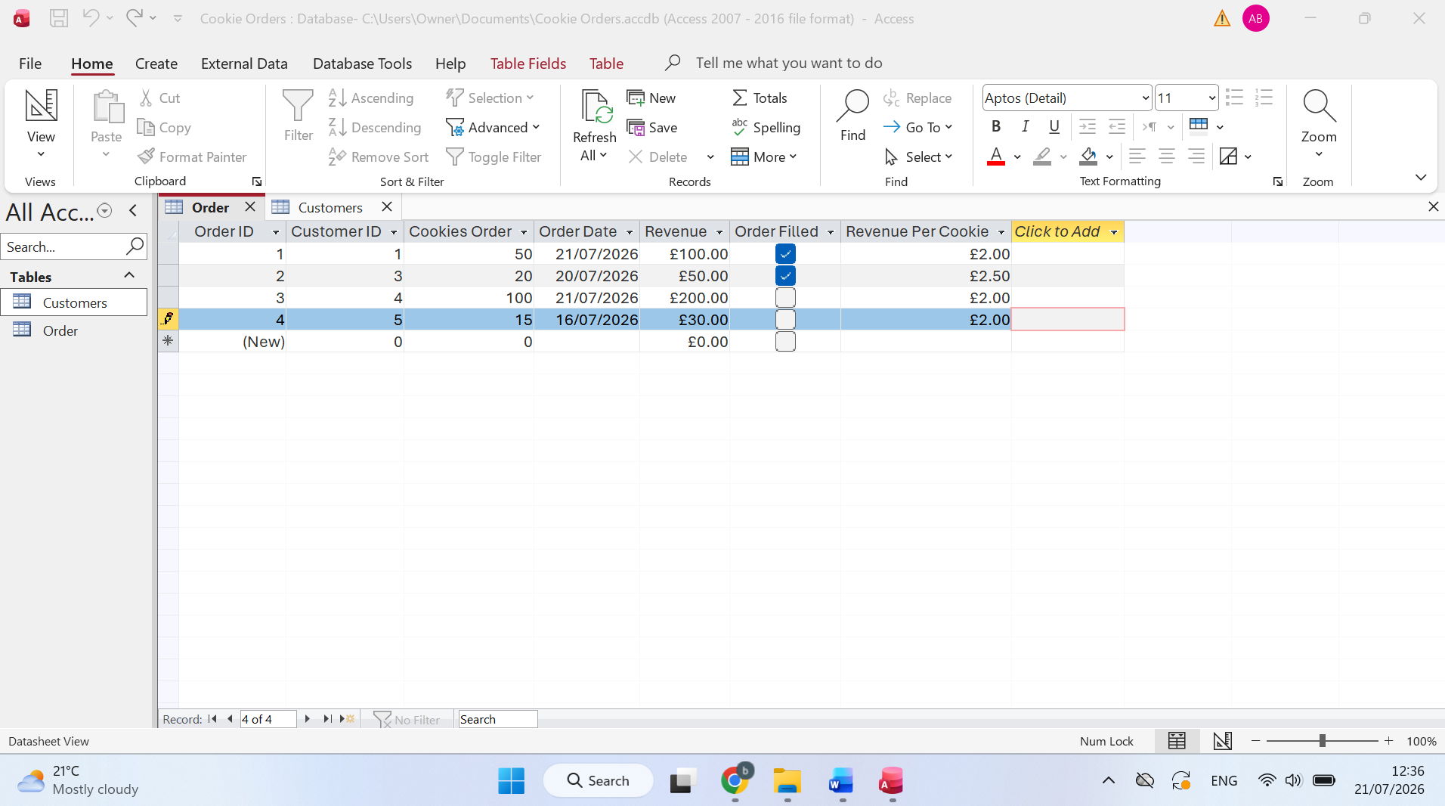
Figure 10: Entered sample records into the Order table to test the database.

The figure 11 creation of Creating a query by linking the Customers and Order tables through Customer ID and selecting the required fields to display related information.
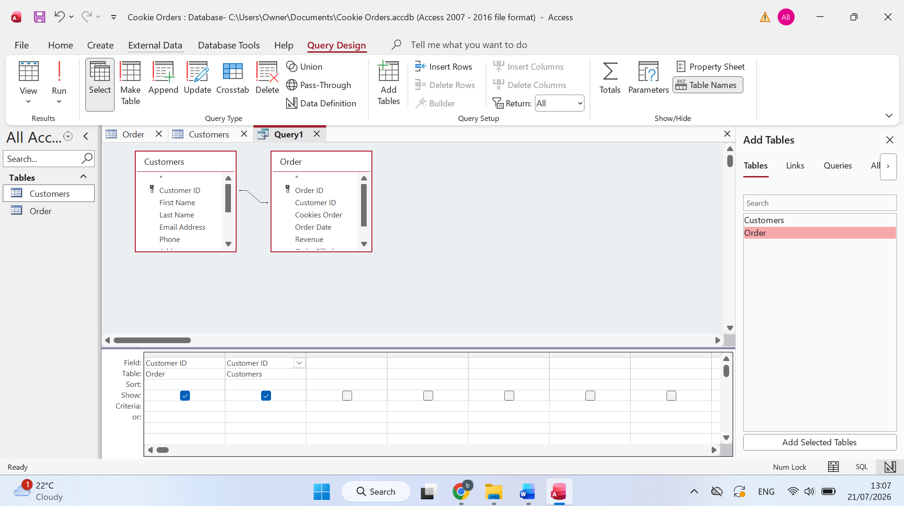
Figure 11: Query Design

3.2 Test any two features

VLOOKUP
The figure 12 below shows how we can find the speed of an animal using the formula =VLOOKUP(E1, A2:B11, 2, FALSE).
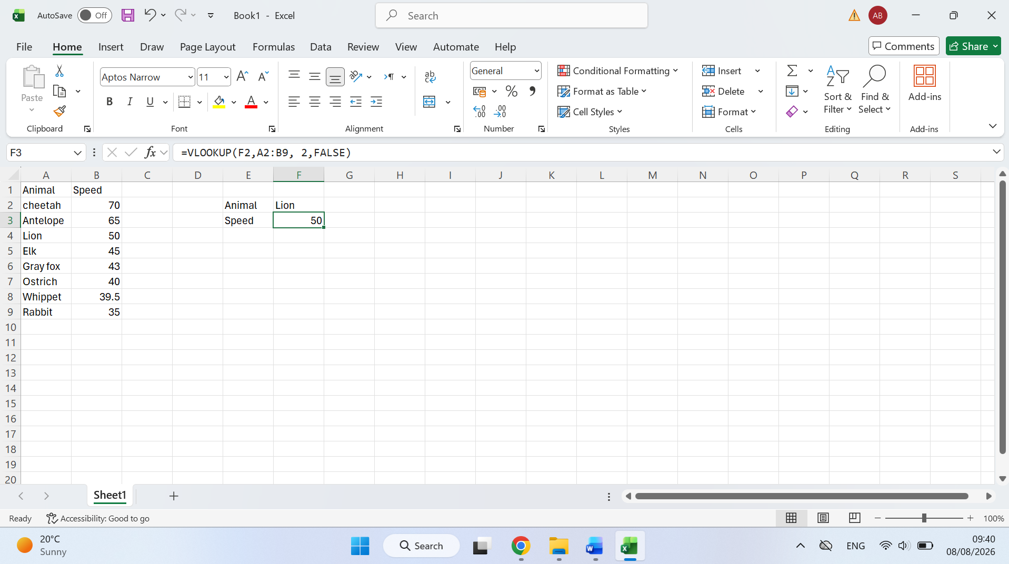
Figure 12 Searching for an item in the Excell sheet

The below figure 13 shows the formula =VLOOKUP(E1, A2:B11, 2, FALSE) is used to find the speed of an animal. Cell E1 contains "Lion", so Excel searches for Lion in the first column of the table, which is between cells A2 and B11. Once Excel finds Lion, it looks at the second column of the same row and returns the speed, which is 50 mph.
The 2 in the formula tells Excel to return information from the second column of the selected table. The word FALSE tells Excel that we want an exact match. Therefore, Excel must find exactly "Lion" rather than something similar.
In simple terms, VLOOKUP allows us to say to Excel: “Find this item in my table and give me the information connected to it.”


Figure 13 show how to find speed of animal in the table [14]

IF Statement
The figure 14 is the table shows the students' names, module marks, total marks, average marks, and grades. The IF function checks the average mark. If the average is 60 or more, the student is marked as Pass; if it is below 60, the student is marked as Fail.
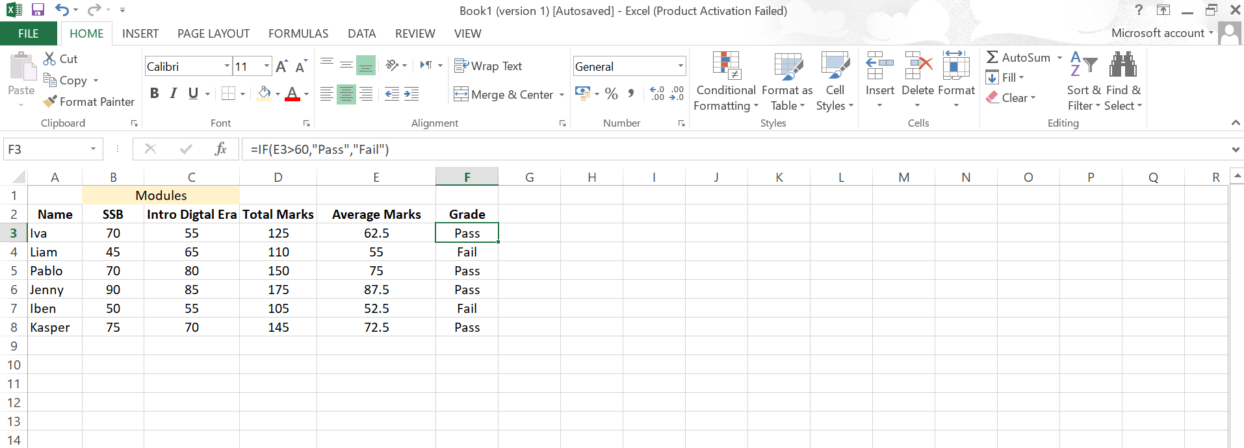
Figure 14 table included student names, modules, total marks, average marks, and grade.
Figure 15 shows the table included employee names, expenses, and budget. The IF function checks whether the expenses are higher than the budget. If the expenses are greater than the budget, it displays "Over Budget"; otherwise, it displays "Under Budget".
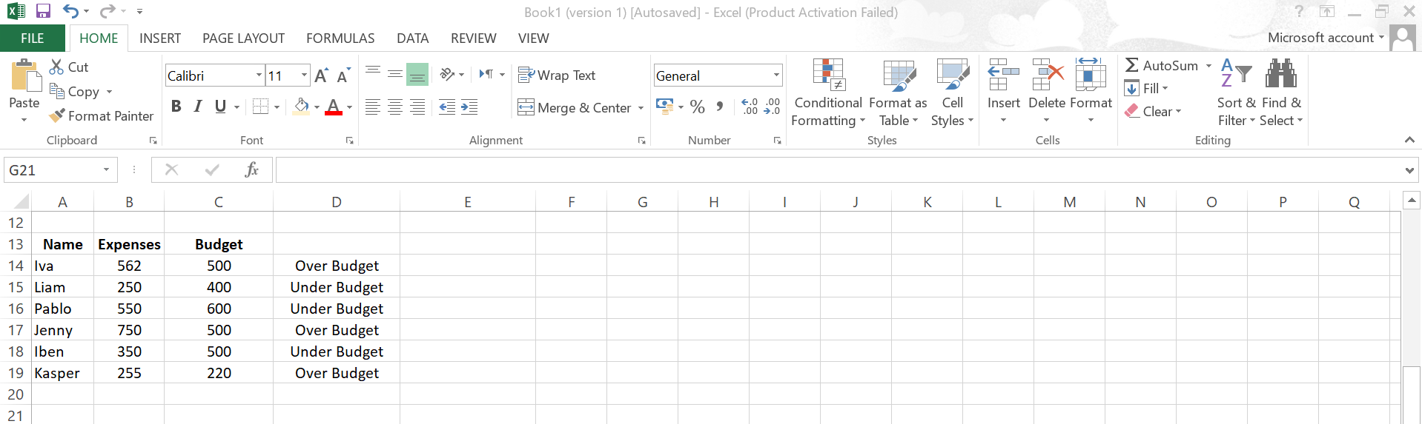
Figure 15 Table included names, expenses, and budget

Task 4. Communication and Collaboration applications



4.1.1 Gmail
Gmail is a free email service developed by Google that allows users to send, receive, organise, and manage emails over the internet. It is widely used by individuals, students, businesses, and organisations for both personal and professional communication. Gmail can be accessed through a web browser on a computer or through a mobile application on a smartphone or tablet. This makes it convenient for users to communicate and check their emails from different locations, as long as they have an internet connection.
One of the main advantages of Gmail is its simple and easy-to-use interface. Users can quickly access their inbox, read received messages, reply to emails, send new messages, and organise their communication. The Compose option allows users to create a new email by entering the recipient's email address, adding a subject, writing the message, and attaching files when required. This makes Gmail useful for sending documents, images, and other files as part of everyday communication.
Gmail also provides useful features for organising emails. Users can search for specific messages instead of manually looking through their entire inbox. Labels and folders can also be used to organise emails into different categories. For example, a business user could organise messages into categories such as customers, suppliers, finance, and projects. This can save time and make it easier to find important information when it is needed.
Another useful feature is Gmail's spam filtering. Spam messages are unwanted emails that may contain unnecessary information or potentially harmful content. Gmail automatically identifies many unwanted messages and places them in the spam folder. This helps users keep their inbox more organised and reduces the amount of unwanted email they need to deal with.
Gmail can also be connected with other Google services, including Google Drive, Google Calendar, and Google Meet. For example, users can share files through Google Drive, arrange events and appointments using Google Calendar, and communicate through online meetings using Google Meet. These connections can be particularly useful in a business environment because employees can use different services together rather than relying on separate applications.
Security is another important part of Gmail. The service provides security features such as two-factor authentication, which can provide an additional layer of protection for a user's account. This is especially important when Gmail is used for work because business emails may contain confidential information, documents, or other important communications.
Overall, Gmail is a reliable and user-friendly communication application that makes sending, receiving, and organising emails simple and efficient. Its search and organisation features, file attachments, integration with other Google services, and security options make it useful for both education and business. For organisations, Gmail can support day-to-day communication and help employees share information and documents efficiently. Therefore, Gmail remains a useful tool for professional communication, collaboration, study, and everyday personal use [15].
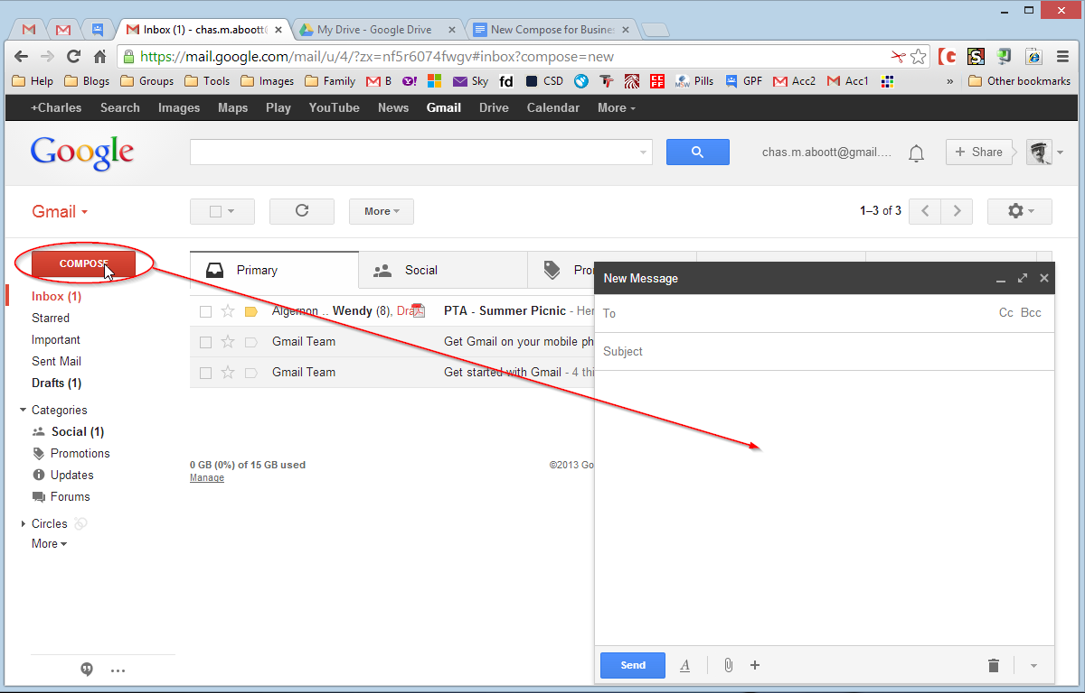
Figure 16: Gmail dashboard [16]


4.1.2 Zoom
Zoom is a video conferencing application that allows people to communicate and work together online without needing to be in the same physical location. Users can communicate through video and voice calls, send messages using the chat function, and share their screens with other participants. Zoom is widely used by students, teachers, businesses, and organisations for different purposes, including online classes, business meetings, interviews, webinars, training sessions, and team discussions. The application can be used on computers, tablets, and smartphones, which makes it convenient for people to join meetings from different locations.
One of the main benefits of Zoom is that it allows people to communicate face-to-face online. During a meeting, participants can use their cameras and microphones to see and speak to each other. This can make online communication more personal and effective than communicating only through email or text messages. For example, a business team working from different locations can arrange a Zoom meeting to discuss a project, share updates, and make decisions without everyone having to travel to the same office.
Zoom also provides a screen-sharing feature, which is particularly useful for education and business. A user can share their computer screen with other participants so that everyone can see the same information. For example, a teacher can share a presentation during an online lesson, while an employee can share a document, spreadsheet, presentation, or software application during a business meeting. This makes it easier to explain information and demonstrate how something works.
Another useful feature of Zoom is meeting recording. When a meeting is recorded, the participants can watch it again later, depending on the meeting settings and permissions. This can be useful for online lessons, training sessions, or business meetings because people who were unable to attend can refer to the recording. It can also help participants review important information that was discussed during the meeting.
Zoom also includes breakout rooms, which allow participants to be divided into smaller groups during a meeting. This can be useful when students need to work on group activities or when employees need to discuss different parts of a project separately. After the smaller discussions are finished, participants can return to the main meeting and share their ideas with everyone.
Other features, such as virtual backgrounds and file sharing, provide additional flexibility when communicating online. Virtual backgrounds can be used to change what appears behind a participant during a video call, while file sharing allows information and documents to be shared with other participants. These features can make online meetings more organised and useful.
Overall, Zoom is a reliable and easy-to-use communication and collaboration application that supports remote learning, online meetings, teamwork, and professional communication. It allows people to stay connected even when they are working or studying in different locations. Features such as video and audio communication, screen sharing, recording, breakout rooms, and file sharing make Zoom useful in both educational and professional environments. Therefore, Zoom can help organisations improve communication, support teamwork, and reduce the need for people to travel for meetings [17].
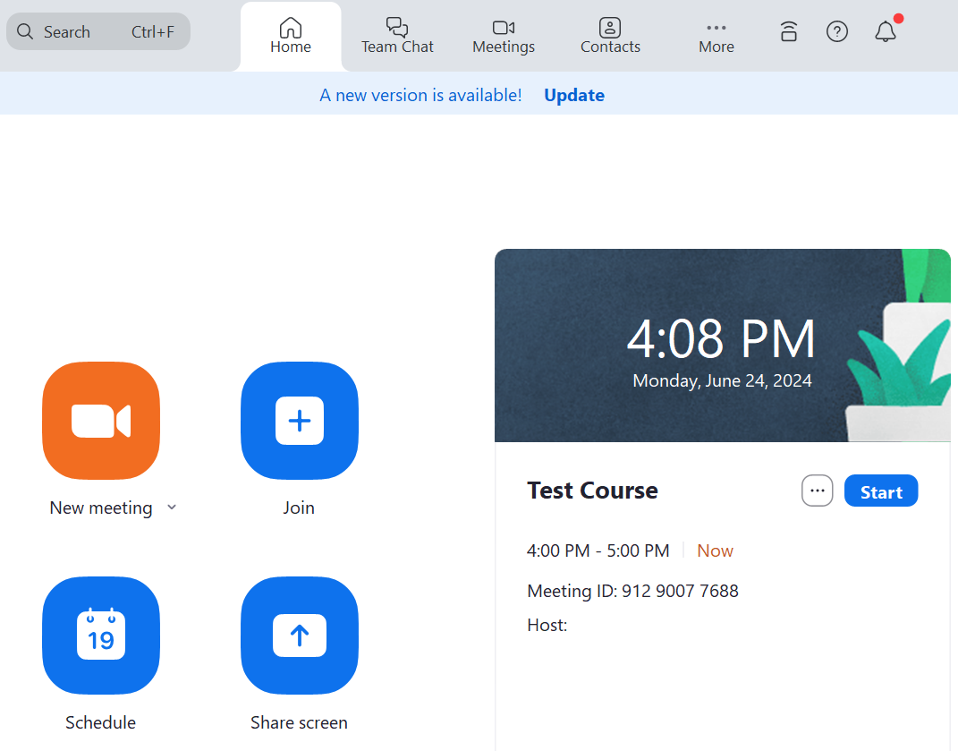
Figure 17: Zoom Dashboard [18]

4.2.1 Gmail
I tested the email feature in Gmail by composing and sending an email. The message was successfully delivered to the recipient, demonstrating that Gmail can be used for reliable communication and file sharing.

The figure 18 shows opening of the Gmail account to access the Inbox, where received emails are displayed and options such as Compose, Sent, Drafts, and Spam are available for email management.

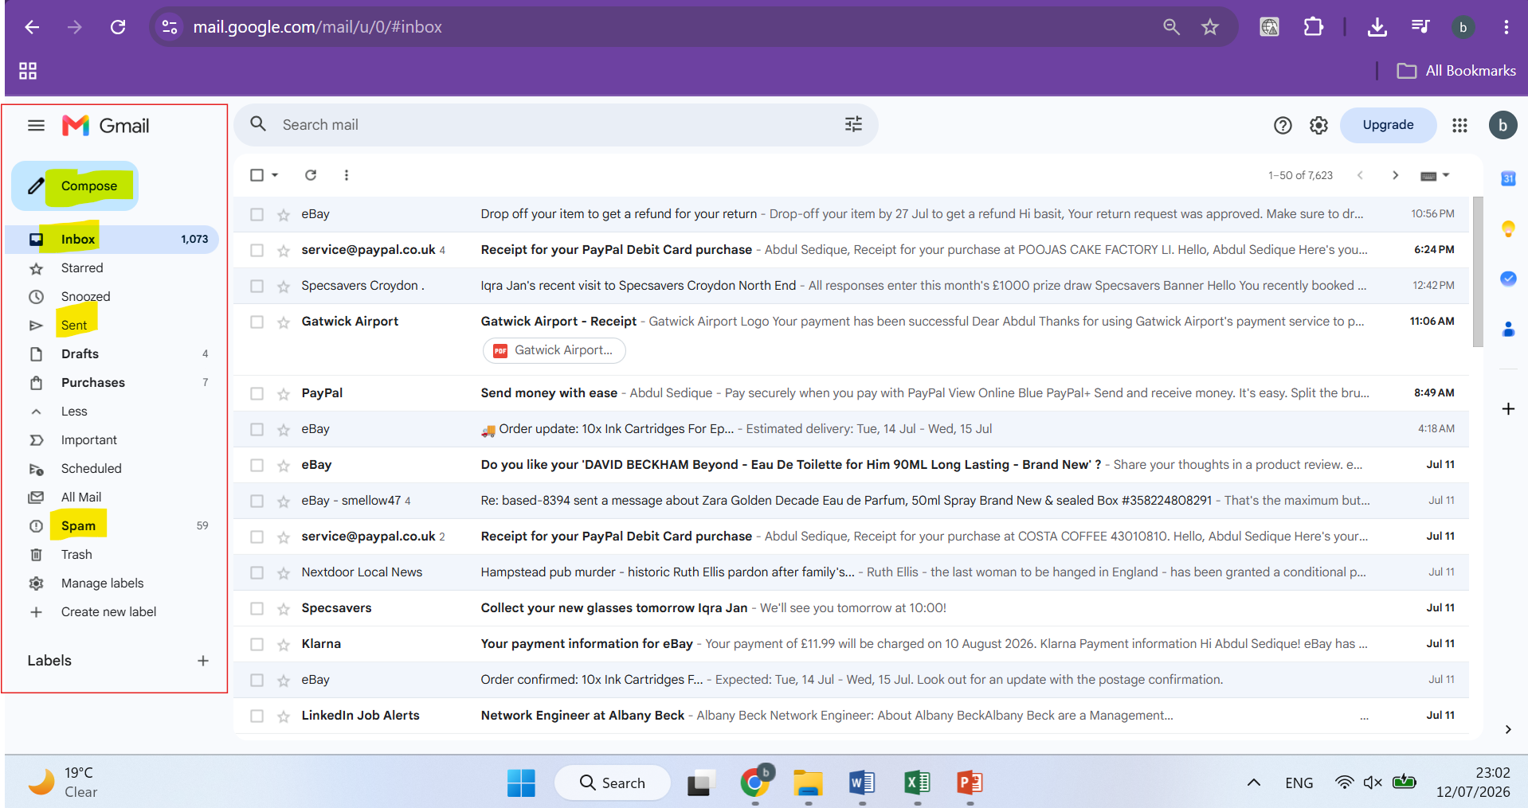
Figure 18 Main Page

The figure 19 shows to process we create email and add the recipient. So the figure shows Clicking the Compose button to create a new email. Entered the recipient’s email address, added a subject line, wrote the email message, and prepared it to be sent.
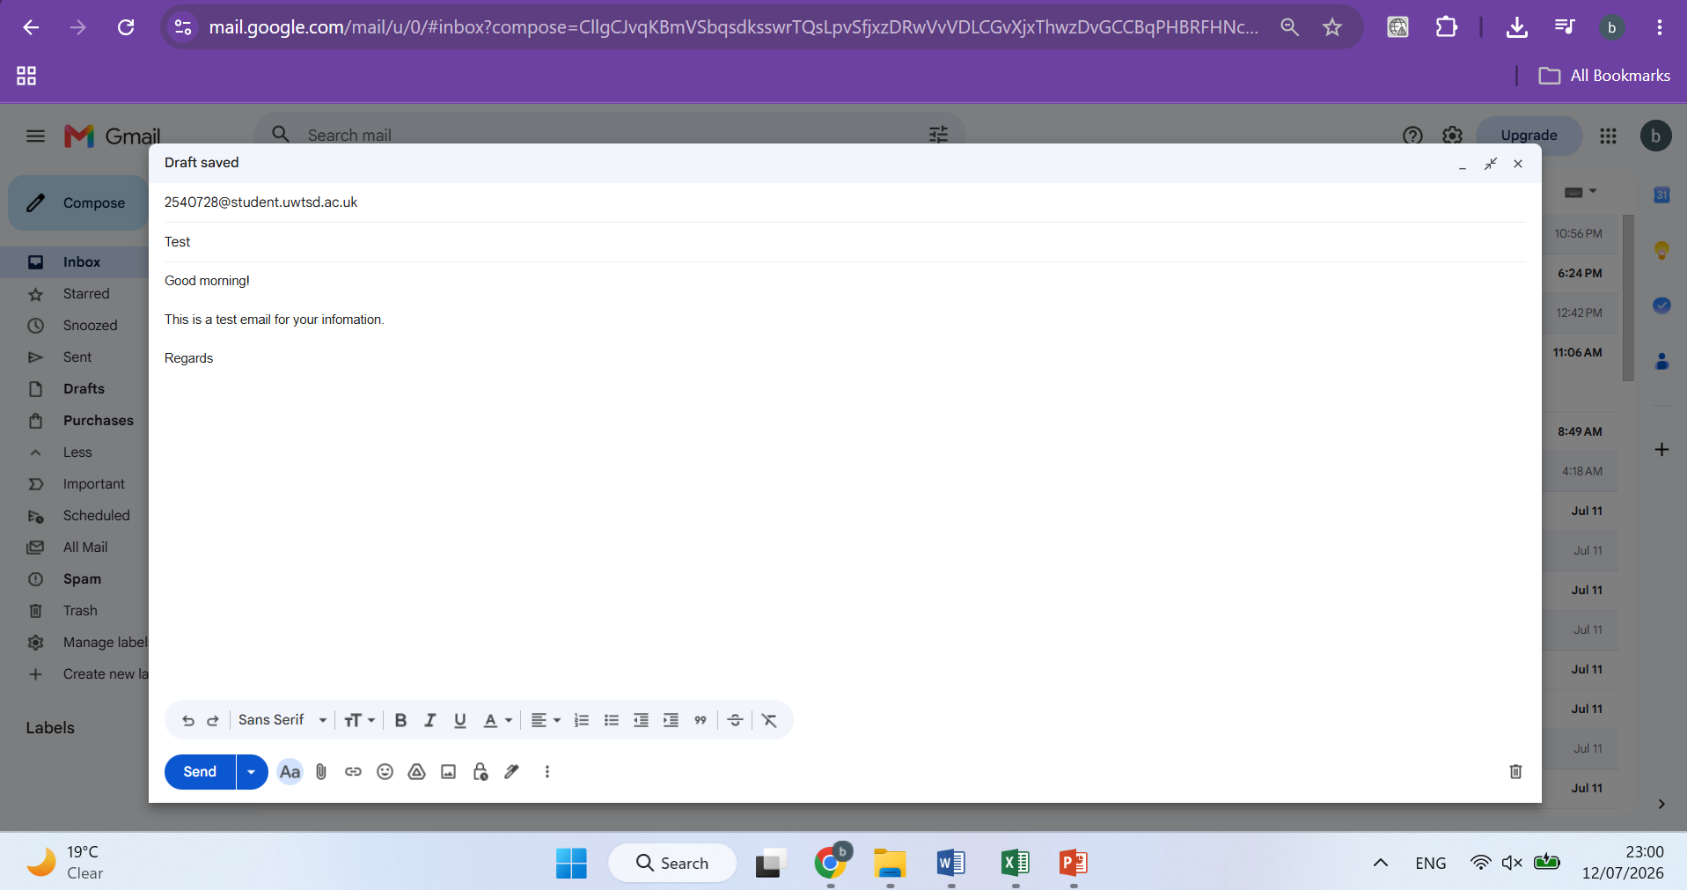
Figure 19 Compose Email Page

4.2.2 Zoom
I tested the meeting scheduling feature in Zoom by creating a new online meeting. The meeting was successfully scheduled, allowing participants to join using the meeting link and ID.
The figure 20 show how we can Opened the Zoom sign-up page and create a new account. Entered the birth year as the first step in the registration process before proceeding to create a free Zoom account.
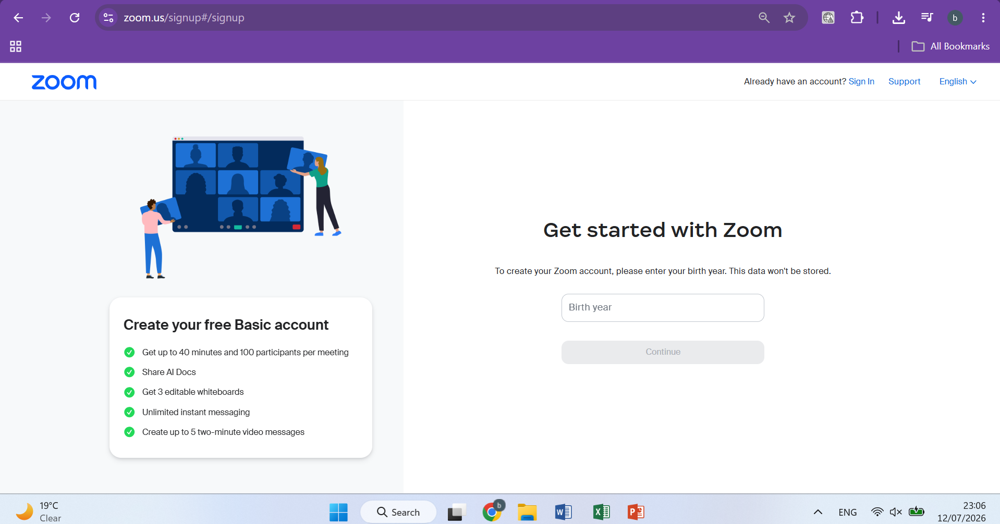
Figure 20 Login Page

The figure 21 shows Entered an email address on the Zoom sign-up page and clicked Continue to begin creating a free Zoom account.
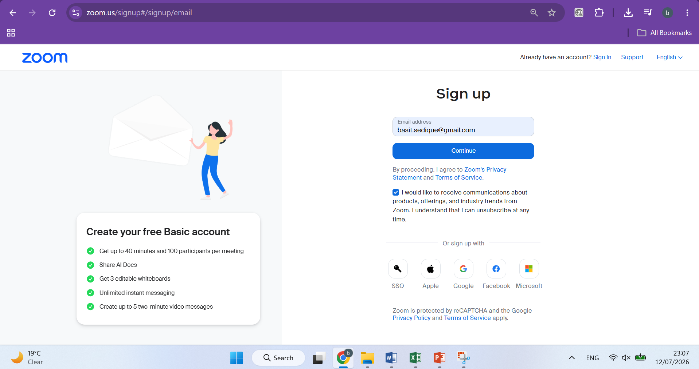
Figure 21 Signup Page
The figure 22 shows Successfully logged in to Zoom and accessed the Home dashboard, where meeting options such as New Meeting, Join, Schedule, and account management features are available.
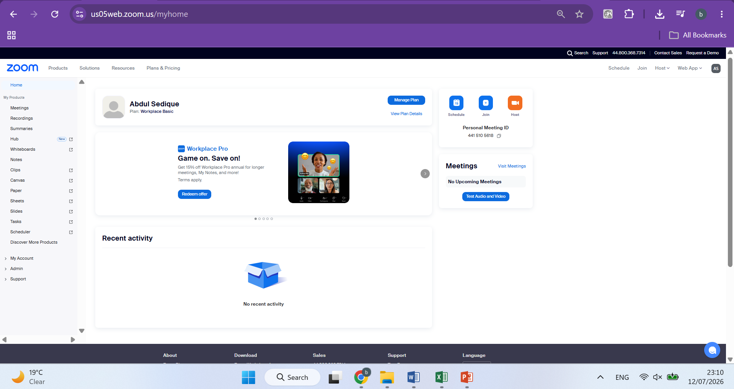
Figure 22 Dashboard

The figure 23 shows Opened the Schedule Meeting page in Zoom and entered the meeting details, including the meeting topic, date, time, duration, and time zone. This allows the meeting to be scheduled and shared with participants.
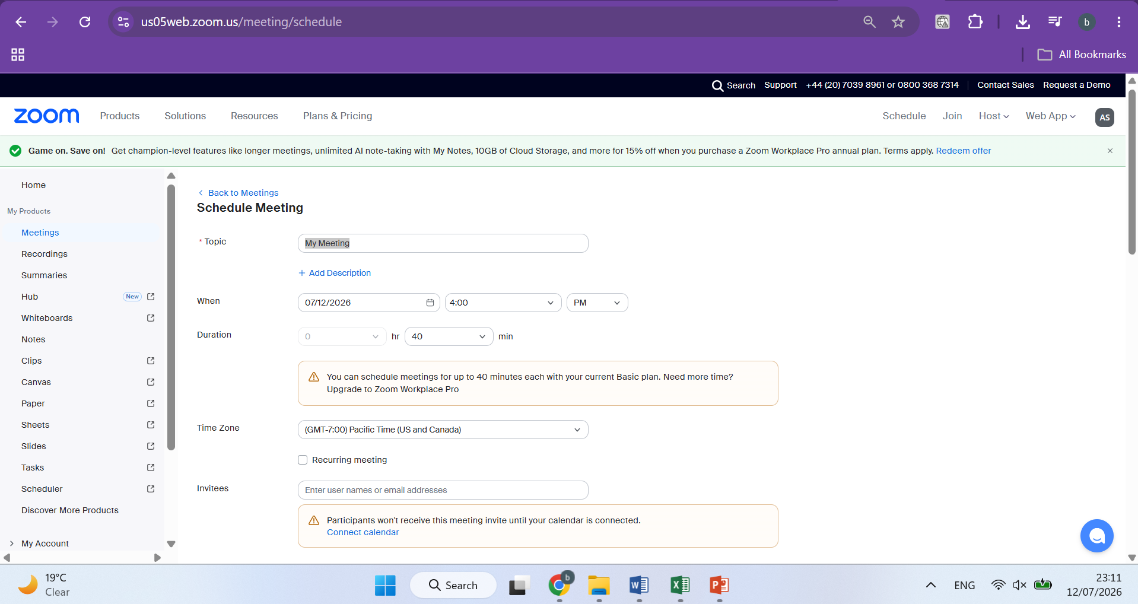Figure 23 Schedule Meeting Page

Conclusion
This assignment has given me a better understanding of the different software applications that are widely used in today's digital business environment. Through my research and practical activities, I explored e-commerce platforms such as Wix and Shopify and learned how they enable individuals and businesses to create and manage professional websites and online stores without requiring advanced technical skills. I also gained an understanding of mind mapping and how it can be used to organise ideas, improve planning, support decision-making, and encourage creativity in business operations.
In addition, I explored a range of Microsoft Office applications and learned how they help improve productivity and efficiency in the workplace. By using Microsoft Word, Excel, Access, Gmail, and Zoom, I developed practical skills in creating professional documents, managing data, communicating through email, and organising online meetings. These activities helped me understand how software applications support collaboration, communication, information management, and everyday business tasks.
Overall, this assignment has strengthened both my theoretical knowledge and practical skills in using contemporary software solutions. It has shown me the important role these technologies play in improving productivity, supporting effective communication, and helping businesses operate more efficiently. The knowledge and experience I have gained will be valuable in my future studies and professional career, as digital skills are essential in almost every modern workplace.

References
[1] J. Holland, "Learn how to create a wix website: Current best practices," vol. 8, no. 2, pp.50–58, 2020, [Online]. Available: https://nssascholars.org/wp-content/uploads/2023/09/NSS_Tech_8-2.pdf#page=50
[2] S. L. S. PÉREZ, "USE OF A WEB PAGE IN WIX TO STRENGTHEN THE COMMUNICATIVE," vol. 1, pp.31, [Online]. Available: https://repositorio.uwiener.edu.pe/items/4e6ccbb2-005a-49b1-aa74-cccc2de2573c
[3] S. Bang, "Top E-Commerce CMS platforms (Shopify/WordPress/BigCommerce)," 2023, [Online]. Available: https://www.theseus.fi/handle/10024/797028
[4] G. Dushnitsky and B. K. Stroube, "Low-code entrepreneurship: Shopify and the alternative path to growth," vol. 16, pp.e00251, 2021, [Online]. Available: https://www.sciencedirect.com/science/article/pii/S2352673421000299
[5] D. Astriani, H. Susilo, H. Suwono, B. Lukiati and A. Purnomo, "Mind mapping in learning models: A tool to improve student metacognitive skills," vol. 15, no. 6, pp.4–17, 2020, [Online]. Available: https://www.learntechlib.org/p/217193/
[6] Y. Shi, H. Yang, Y. Dou and Y. Zeng, "Effects of mind mapping-based instruction on student cognitive learning outcomes: a meta-analysis," vol. 24, no. 3, pp.303–317, 2023, [Online]. Available: https://link.springer.com/article/10.1007/s12564-022-09746-9
[7] O. Kruse and C. Rapp, "Word processing software: The rise of MS Word," in Digital Writing Technologies in Higher Education: Theory, Research, and Practice, Springer, 2023. pp. 15–32. [Online]. Available: https://link.springer.com/chapter/10.1007/978-3-031-36033-6_2
[8] "Introduction of Word." Accessed: 29/07 2026. [Online]. Available: https://wtcs.pressbooks.pub/digitalliteracy/chapter/introduction-to-word/
[9] M. S. Excel, "Microsoft Excel," 2007, [Online]. Available: https://bobanispirovic.wordpress.com/wp-content/uploads/2013/10/iv-modul.pdf
[10] "Overview of excel." Accessed: 29/07 2026. [Online]. Available: https://ecampusontario.pressbooks.pub/beginningexcel/chapter/1-1-overview-of-microsoft-excel/
[11] Y. San Ng and A. T. Ranti, "The effects of ms powerpoint on students at a Malaysian university in the English for professionals (EFP) classrooms," vol. 13, no. 4, pp.32–43, 2022, [Online]. Available: https://www.researchgate.net/profile/Yim-San-Ng/publication/362639196_The_Effects_of_MS_PowerPoint_on_Students_at_a_Malaysian_University_in_the_English_for_Professionals_EFP_Classrooms/links/633e2d889cb4fe44f305d182/The-Effects-of-MS-PowerPoint-on-Students-at-a-Malaysian-University-in-the-English-for-Professionals-EFP-Classrooms.pdf?origin=journalDetail&_tp=eyJwYWdlIjoiam91cm5hbERldGFpbCJ9
[12] "Overview of Powerpoint." Accessed: 29/07 2026. [Online]. Available: https://www.thetraininglady.com/powerpoint-window/
[13] P. Beynon-Davies, "Microsoft Access," in Database systems, Springer, 2004. pp. 446–456. [Online]. Available: https://link.springer.com/chapter/10.1007/978-0-230-00107-7_33
[14] "VLOOPUP Functions." Accessed: 29/07 2026. [Online]. Available: https://www.ablebits.com/office-addins-blog/excel-vlookup-tutorial/
[15] P. Darbyshire and A. Darbyshire, "Gmail," in Getting StartED with Google Apps, Springer, 2010. pp. 45–107. [Online]. Available: https://books.google.co.uk/books?hl=en&lr=&id=tkd01HmAnpEC&oi=fnd&pg=PR1&dq=+P.+Darbyshire+and+A.+Darbyshire,+%22Gmail,%22+in+Getting+StartED+with+Google+Apps,+Springer,+2010.+pp.+45%E2%80%93107.+&ots=yWlVusLKFL&sig=VWOs36T5oBkGwWyDqIbtLC8JOnw#v=onepage&q&f=false
[16] "Gmail dashboard." Accessed: 29/07 2026. [Online]. Available: https://gmail-miscellany.blogspot.com/2013/08/new-compose-without-tears-for-serious.html
[17] M. M. Archibald, R. C. Ambagtsheer, M. G. Casey and M. Lawless, "Using zoom videoconferencing for qualitative data collection: perceptions and experiences of researchers and participants," vol. 18, pp.1609406919874596, 2019, [Online]. Available: https://journals.sagepub.com/doi/pdf/10.1177/1609406919874596?src=getftr
[18] "Zoom dashboard." Accessed: 05/08 2026. [Online]. Available: https://helpdesk.tcsedsystem.edu/hc/en-us/articles/4416675393431-What-is-Zoom-and-how-do-I-use-it

Appendices
Appendix A: Wix & Shopify
Appendix B: Mind Map
Appendix C: Microsoft Office & Access
- Microsoft Word dashboard – Corresponds to Figure 5.
- Microsoft Excel dashboard – Corresponds to Figure 6.
- Microsoft PowerPoint dashboard – Corresponds to Figure 7.
- Microsoft Access – Create Table view – Corresponds to Figure 8.
- Microsoft Access – Order table – Corresponds to Figure 9.
- Microsoft Access – Sample records – Corresponds to Figure 10.
- Microsoft Access – Query Design – Corresponds to Figure 11.

Appendix D: Excel VLOOKUP & IF Testing
- VLOOKUP search – Corresponds to Figure 12.
- VLOOKUP formula and result – Corresponds to Figure 13 and demonstrates =VLOOKUP(E1,A2:B11,2,FALSE).
Appendix E: Gmail
- Gmail main page – Corresponds to Figure 18.
- Compose Email page – Corresponds to Figure 19.
Appendix F: Zoom
- Zoom sign-up page – Corresponds to Figure 20.
- Zoom signup page with email – Corresponds to Figure 21.
- Zoom dashboard – Corresponds to Figure 22.
- Zoom Schedule Meeting page – Corresponds to Figure 23.

