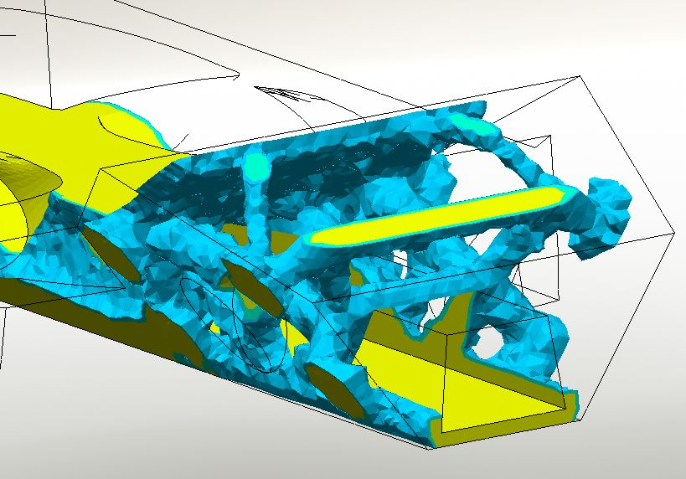

FEA and topographical optimisation of a vehicle chassis

  - Oliver Duane
  - Motion simulation and FEA
  - University of Wales Trinity St. David’s
  - 2020

Contents
1. Abstract 1
2. Introduction 1
3. Background 1
4. Aims 2
5. The motion simulation 2
The car 2
The parts 3
The results 4
Tyre loads 4
Body loads 5
Wishbone loads 5
Battery load 7
6. The Finite Element Analysis 7
7. Topographical optimisation 8
The new chassis 10
Testing the new chassis 10
Re-designing the new chassis 12
Re-testing the new chassis 13
8. Conclusion 14
9. Further work 14
FEA fixtures 14
Mesh size 14
Wheel torque 15
More track tests, more data 15
Asymmetric loads 15
Bodywork 15
10. Bibliography 15

Figure 1. Car model 2
Figure 2. Initial chassis structure 3
Figure 3. Assembled test car 3
Figure 4. Car on test track 4
Figure 5. Tyre loads 5
Figure 6. Bodywork mass loads, front and rear 5
Figure 7. Wishbone loads FL 6
Figure 8. Wishbone loads FR 6
Figure 9. Wishbone loads RL 6
Figure 10. Wishbone loads RR 7
Figure 11. Battery load 7
Figure 12. Computer generated optimisation 8
Figure 13. Computer generated optimisation - Rear detail 9
Figure 14. Computer generated optimisation - Stresses 9
Figure 15. New chassis 10
Figure 16. Assembled new rolling chassis 10
Figure 17. Meshed chassis 11
Figure 18. Stress in new chassis 11
Figure 19. Stress in new chassis, bottom view 12
Figure 20. Modified new chassis 12
Figure 21. Stress in modified new chassis 13
Figure 22. Stress in modified new chassis – Detail 13
Figure 23. Assembled modified new chassis 14
Figure 24. Asymmetrical load 15

Table 1. Masses and quantities of parts 4
Table 2. Measured forces 7

Abstract
‘Like a sculptor building a statue, not by adding, but by hacking away the unessential so that the truth will be revealed unobstructed – artlessness’ (Lee, 1997).

The modern chassis designer has the challenge of increasing strength while decreasing weight and cost. There are the questions, “How strong? How light? How much cost?” etc. Compromises must be made, and the optimum solution found.
Computer Aided Design provides tools that suggest solutions to given problems, simplifying the task of optimisation. The recent addition of the Topographical Optimisation feature to SolidWorks shows that this technology is becoming widely available and may soon replace many traditional design methods.

Introduction
The common monocoque chassis is a rigid shell often made of steel, with suspension components mounted directly to the shell. The perimeter surface has a large surface area, and when made from steel, is very heavy. It also has a high rotational inertia and large radius of gyration. Suspension forces act directly on this mass, causing the entire shell to be jarred by sudden wheel movement (Reimpell, et al., 2001).
Using Finite Element Analysis, a car design was tested to see the level of force that the suspension pick-up points were subject to.
The data was then used to do a topographical optimisation of the vehicle, resulting in a sub-frame with mounting points for suspension and the original vehicle shape bodywork. The bodywork and cabin of the car could then be made of a different material, with the rolling chassis as a sub-frame, thereby, reducing the ferocity of jolts felt by the occupants. Mass would be reduced, and structural rigidity between the four corners maintained.
SolidWorks software was used throughout this investigation.

Background
People have been calculating stress and strain in designs for hundreds of years, but with the advent of computers, this has become increasingly common. There are three main numerical methods used to calculate the stress and strain in an object, these being:
- The finite element method
- The finite difference method
- The boundary element method
The Finite Element Method has become the most commonly used. A complex shape is split into many simple shapes, or cells, and the stresses and strains calculated through each individual cell. Assuming the object is in equilibrium, a picture can be built up of how the forces are acting on it (Mottram & Shaw, 1996).

Aims
The aims of this report are to:
- Perform a motion simulation on a car chassis driving over bumps to measure the forces it is subjected to
- Perform a Finite Element Analysis on the bulk chassis
- …resulting in a topographical optimisation of the chassis
- Create a new chassis based on the results, made from ABS plastic, with a target weight of 100Kg

The motion simulation

The car
Firstly, a model of a car was designed. All structural parts must fit within this exterior shape. This will sit upon the structural chassis and will have different requirements and properties.

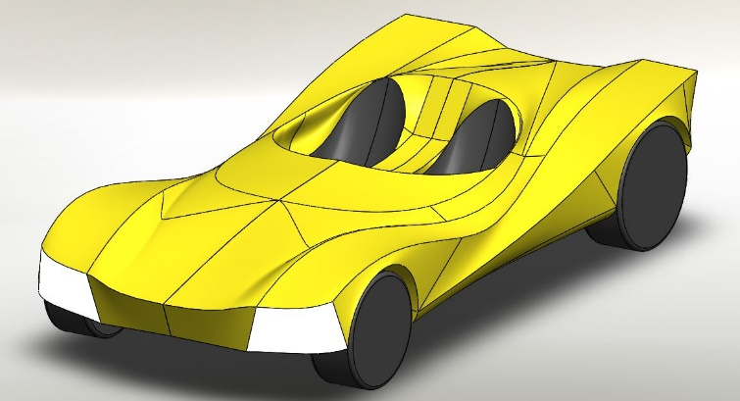
Figure 1. Car model
A copy was used as the initial rolling-chassis structure. Areas required for suspension components were removed and wishbone mounting points added (coloured yellow). A battery compartment was created along the centre, and vertical circular surfaces (coloured red) for in-board motors cut into the slanted surface containing the wishbone mounts. The upper part of the car was removed to provide space for the main body to sit on. The mounts on the chassis for the bodywork are coloured blue. The material was assigned as balsa wood due to its weight of 114.25Kg, around the target of 100Kg for the new chassis. This was done so that the loads in the (motion simulation test) bulk chassis and in the optimised plastic chassis would be similar due to them both having a similar mass.
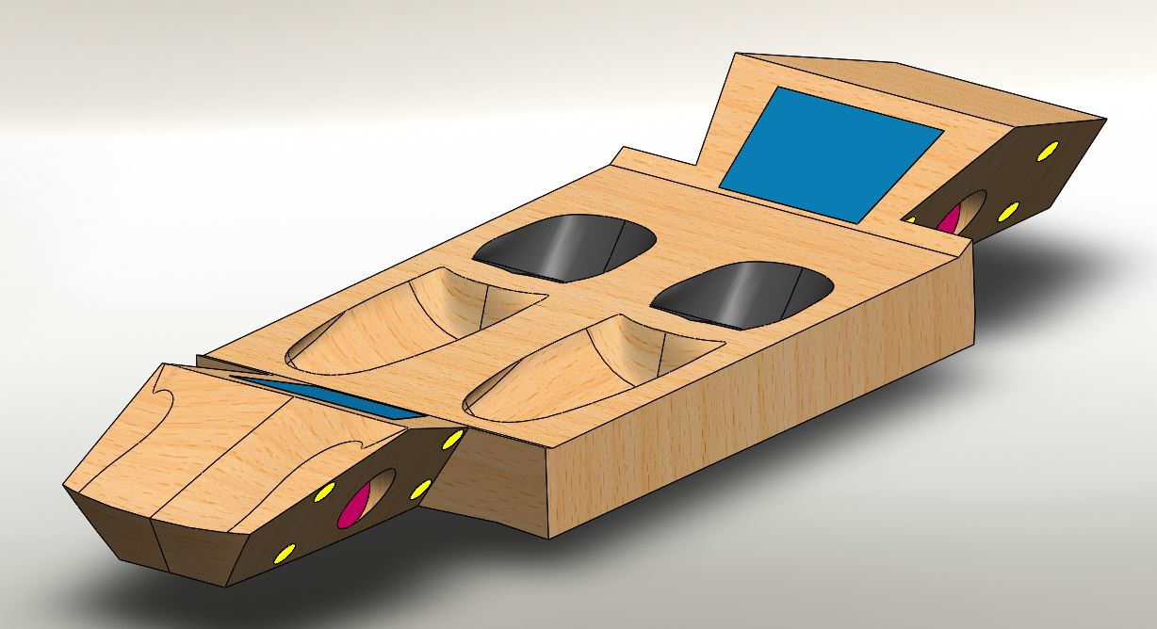
Figure 2. Initial chassis structure

The parts
The chassis was assembled with suspension components, battery and weights (to simulate the bodywork) and a portion of track with bumps.
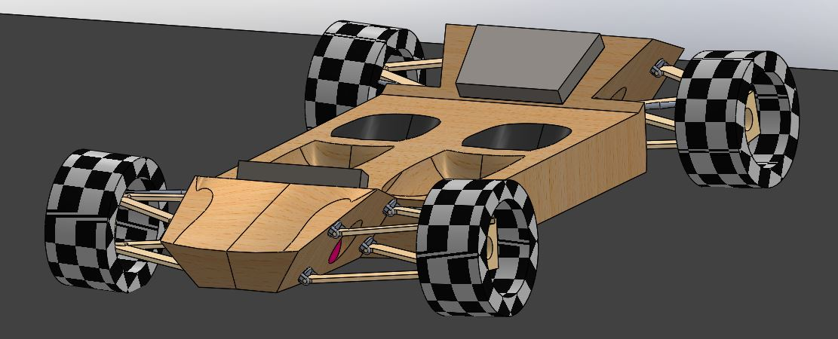
Figure 3. Assembled test car
Materials were assigned to each part and their masses recorded
Table 1. Masses and quantities of parts
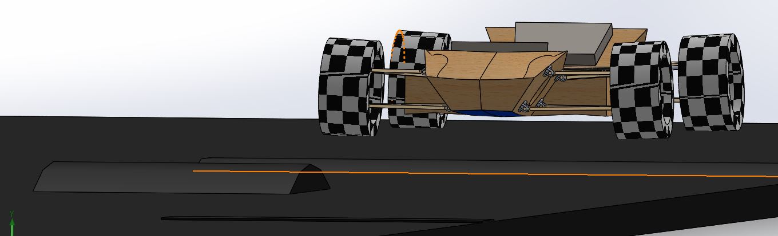
Figure 4. Car on test track

The results
A motion study was used to find the reaction forces acting on the suspension pick-up points. The highest value recorded was used as the required strength for that pick-up point for both sides of the car.
Springs, dampers and torque were added, and through trial and error, a six-second test drive was performed, and the data from it used for the FEA and topographical optimisation.

Tyre loads
Tyre loads were measured and are shown in Figure 5. Strangely, there appears to be a lack of correspondence between the measured tyre load and the vehicle mass. At 1.8s, on a flat portion of track, the tyre loads totalled 616Kg, while the vehicle mass is 510Kg.
FL 875 + RL 2335 + RR 1686 + FR 1148
= 6044N
/ 9.81m/s^2
=616kg
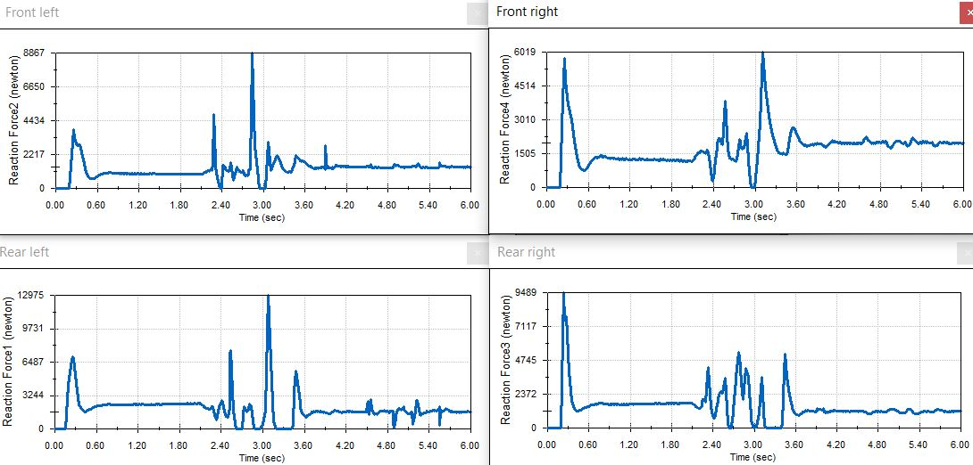
Figure 5. Tyre loads

Body loads
Forces on the body mounts, wishbone mounts and battery compartment floor were measured.
Body loads front and rear
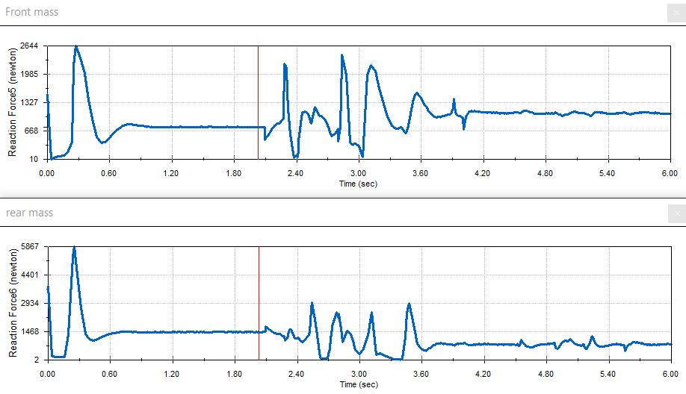
Figure 6. Bodywork mass loads, front and rear

Wishbone loads
Front left
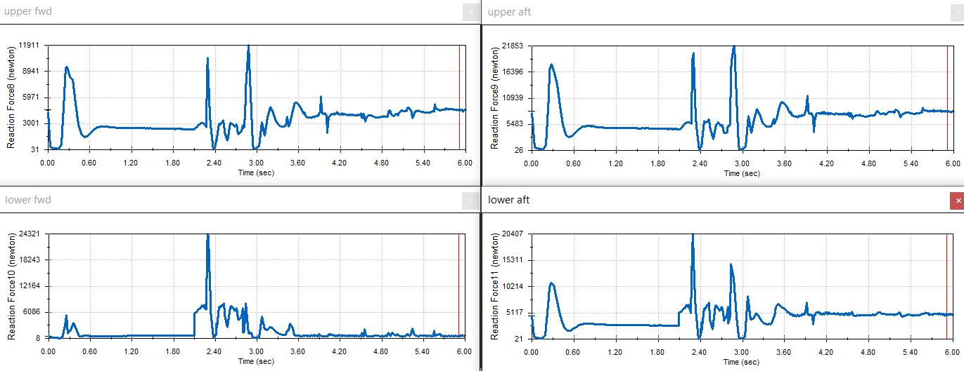
Figure 7. Wishbone loads FL
Front right
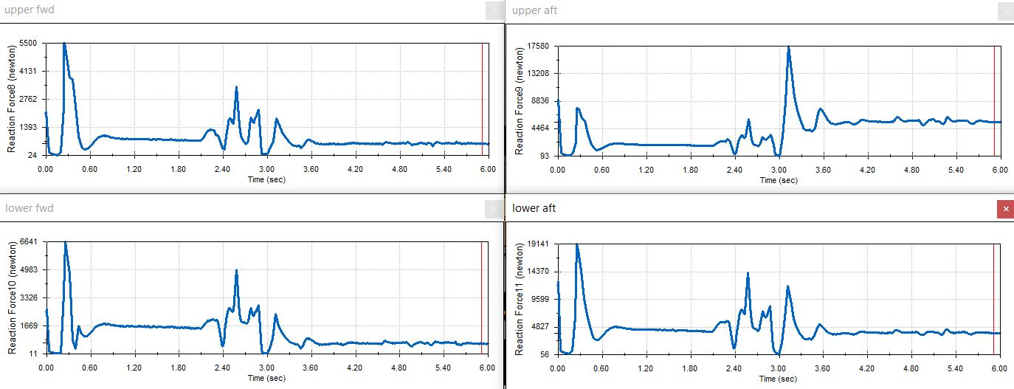
Figure 8. Wishbone loads FR
Rear left
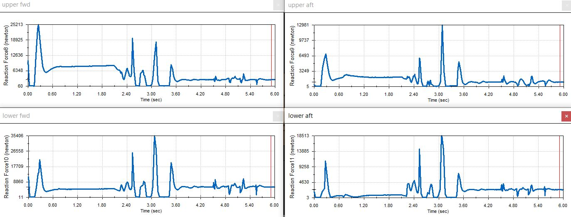
Figure 9. Wishbone loads RL
Rear right
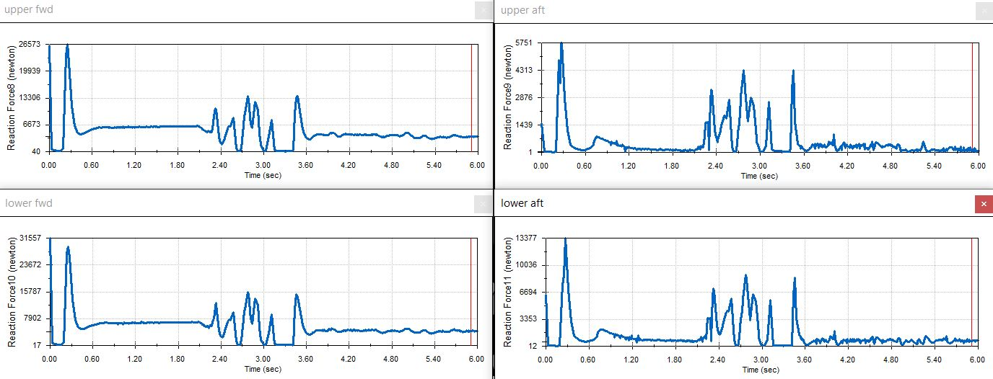
Figure 10. Wishbone loads RR

Battery load
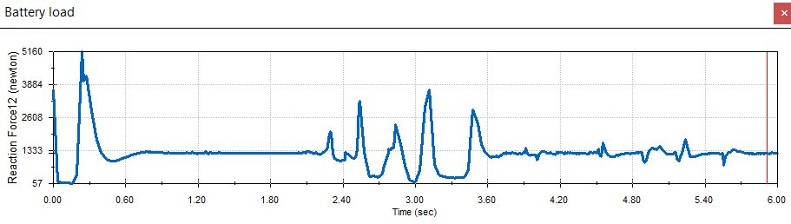
Figure 11. Battery load
The maximum for each load was recorded, shown in Table 1.
Table 2. Measured forces

The Finite Element Analysis
The load results from the motion study were then used to do a FEA of the chassis. The assigned material was changed from balsa wood to ABS plastic, a commonly used material that is recyclable.
Average strengths for ABS
UTS = 39MPa
Yield = 45MPa
(Matweb - Material Property Data, 2020)
The weight of the bulk chassis made from ABS was 728Kg. The aim was to reduce the weight by 80% while maintaining the structural rigidity necessary to withstand the applied forces. After extensive trials the following procedure was used for the topographical optimisation study:
- A 200mm circle in the middle of the lower surface of the car was used as a fixture
- The forces from Table 1. were applied to the suspension pick-up points, the bodywork mounts and the battery compartment floor
- The best stiffness-to-weight was opted for, with a target weight saving of 80%.
- A symmetry plane was added down the middle as the model and forces are symmetrical.
- A standard mesh was used, with a maximum cell size of 30mm, and a minimum of 3mm.

Topographical optimisation
Using the data from the FEA, a topology study was performed on the chassis to take away the unnecessary material.
When the study had completed, the excess mass was adjusted and the results in Figures 12. and 13. were reached.

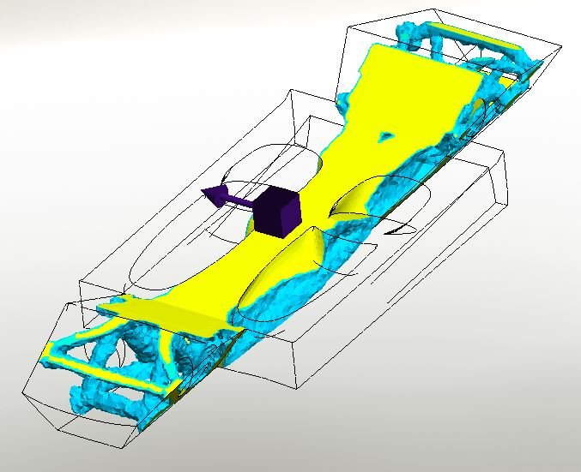
Figure 12. Computer generated optimisation
Figure 13. Computer generated optimisation - Rear detail
Figures 12. and 13. shows the optimised structure. Just 18% of the material remained, weighing 136Kg.
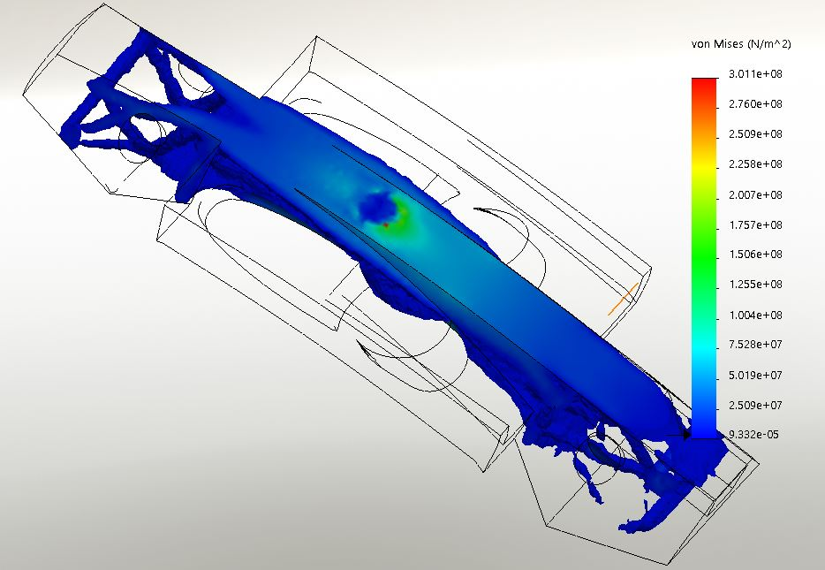
Figure 14. Computer generated optimisation - Stresses
Examining the stress in the computer generated, “generative” design Figure 14., it is visible that the floor around the fixing is the weakest area. It shows a stress concentration of around 300MPa, far beyond the strength of ABS.
The next step was to smooth the mesh and create a new part from it and do a static load simulation. Unfortunately, for some reason the smoothing function would not work, and a new part could not be produced directly from the computer-generated solution.
To get around this problem, the generated part was instead used as a template to create a new chassis, shown in Figure 15. It weighed 121Kg.

The new chassis
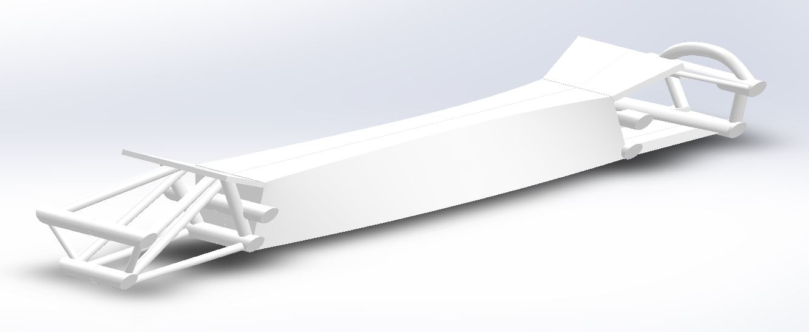
Figure 15. New chassis
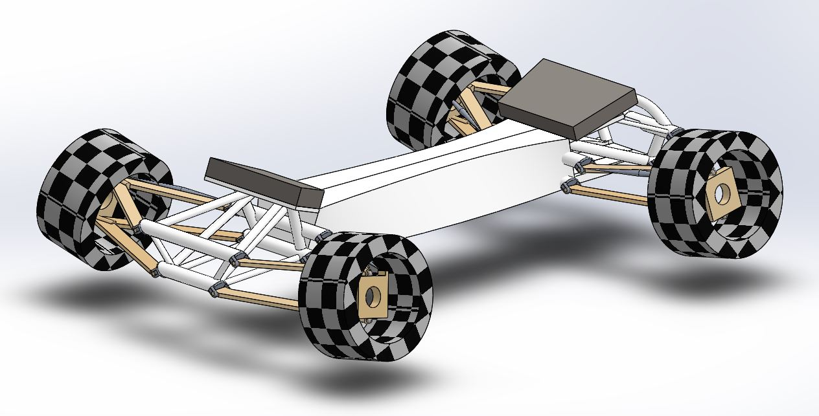
Figure 16. Assembled new rolling chassis

Testing the new chassis
A FEA of the new chassis was performed with the same loads as used previously. A mesh was created, using a cell size of between 3 and 30mm. This was fast to compute, and appeared perfectly adequate under close inspection, with cells capturing all details.
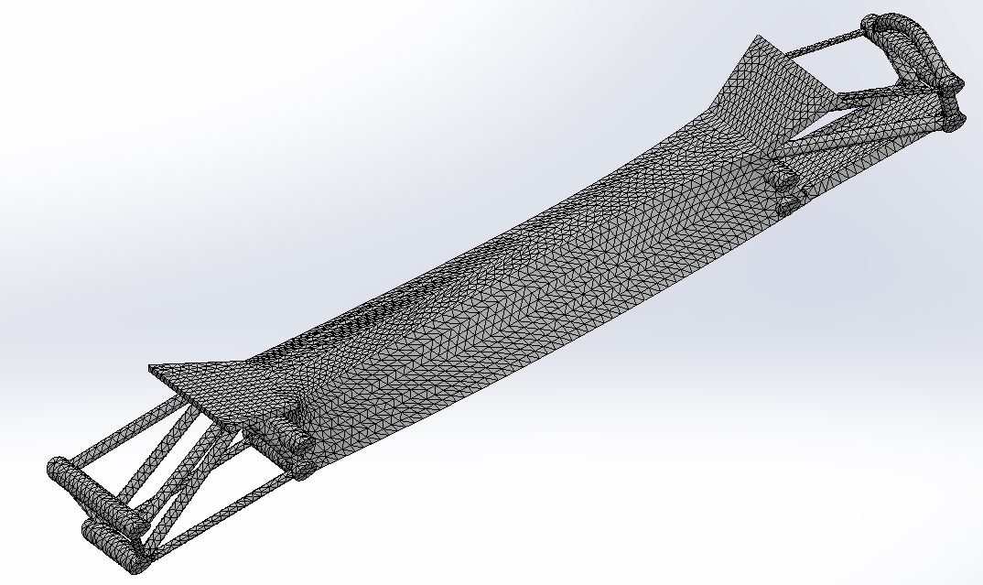
Figure 17. Meshed chassis
The maximum stresses shown in Figure 18. and 19. are just over half that of those predicted for the computer-generated optimisation, while the weight is 9% less.
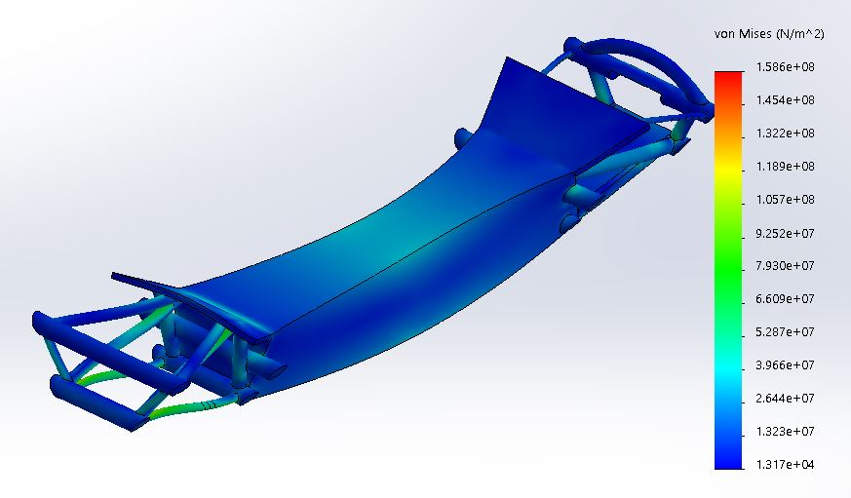
Figure 18. Stress in new chassis
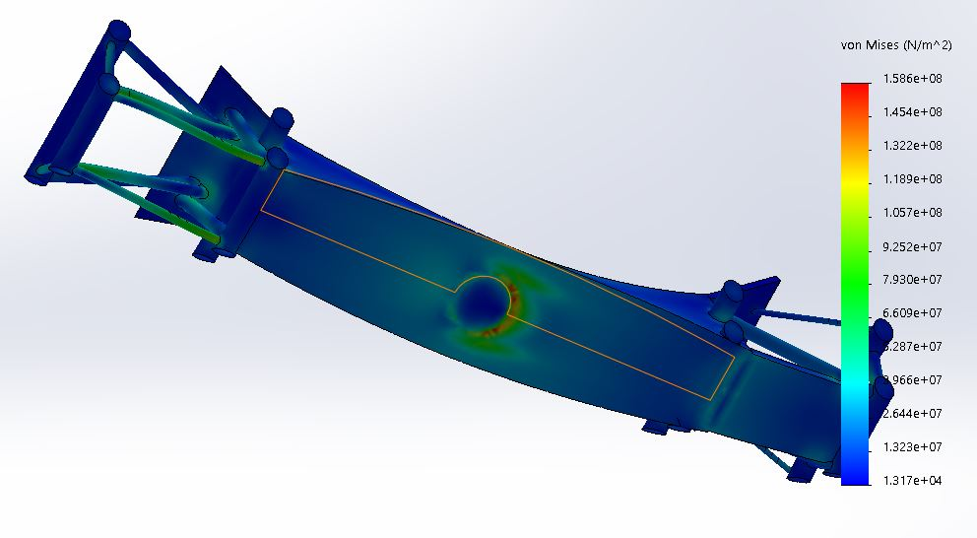
Figure 19. Stress in new chassis, bottom view
The stress concentration shown in Figure 19. reveals the fixture to be the weak spot, with some strengthening of the rods also required.

Re-designing the new chassis
The model was adjusted to spread the stress distribution over a larger portion of the mass. The fixture was enlarged, and parts of the chassis were thickened. These modifications increased the mass by 2Kg, to 123Kg.
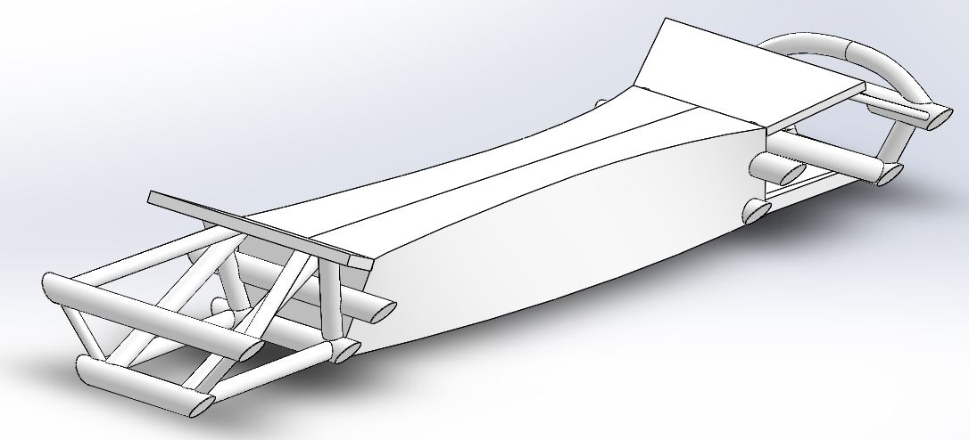
Figure 20. Modified new chassis

Re-testing the new chassis
The FEA using a static load simulation was repeated, but the mesh failed. A new mesh was created, this time with cells sized between 1.5mm and 30mm. The stress for the modified new chassis is shown in Figure 21.
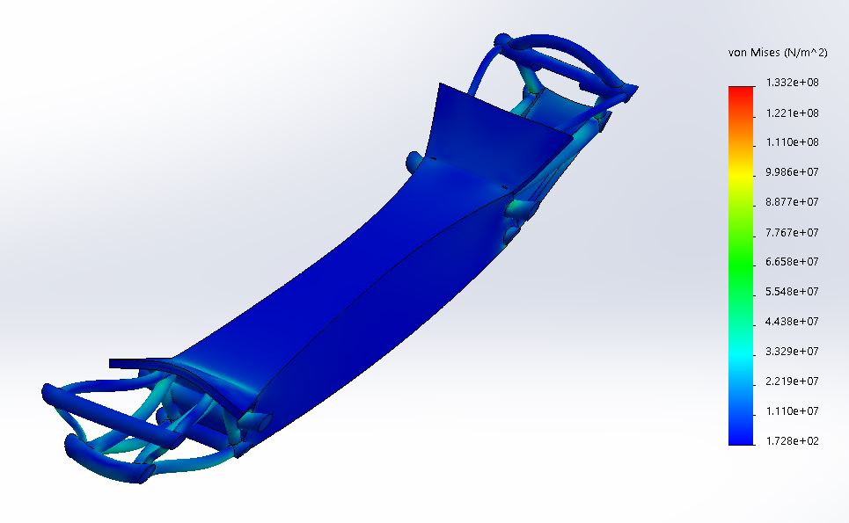
Figure 21. Stress in modified new chassis
The maximum stress in the modified new chassis, 133MPa, was found to be over a very small area, caused by surface imperfections (Figure 22.). Apart from that one small area, the stress did not appear to go beyond around 30MPa, within the yield limit of ABS.
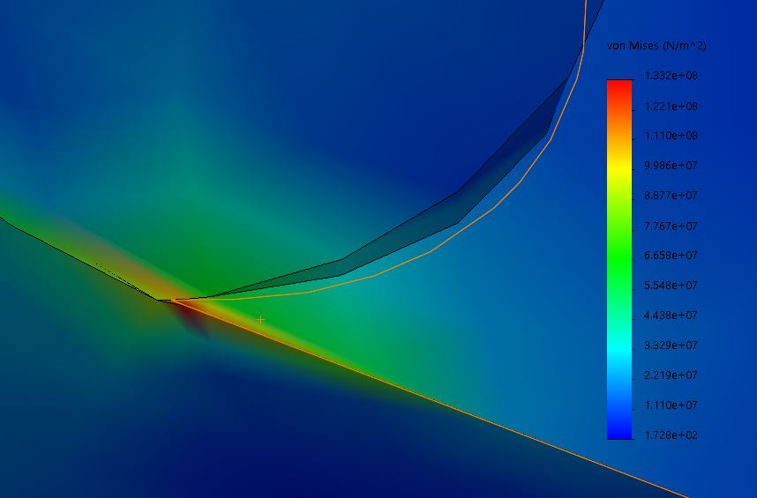
Figure 22. Stress in modified new chassis – Detail

Conclusion
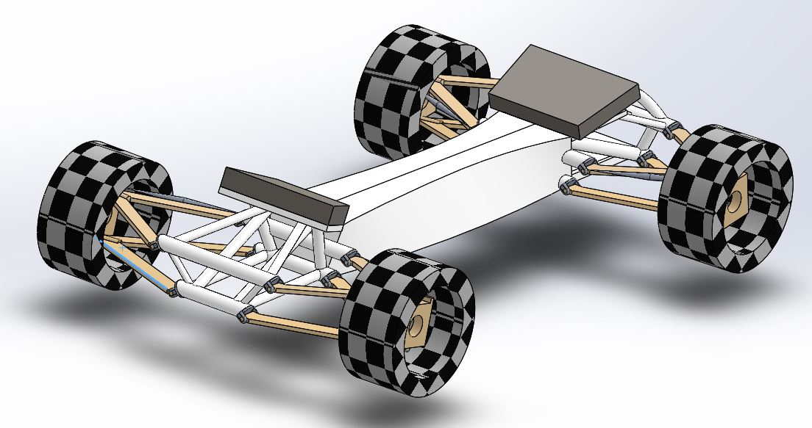
Figure 23. Assembled modified new chassis
The results appear to show that CAD, FEA and Topographical optimisation when used together, offer an incredibly powerful tool to the designer. Any results would of course have to be validated with real-life tests, and any anomalies investigated, such as the tyre loads not corresponding to the vehicle mass, but even at its most basic, can present simple, effective solutions.
Full familiarisation with the software would of course be of benefit to the user, and, no doubt, updates will regularly be included in future versions of SolidWorks.
Generative design it seems is set to dominate the future of design. Along with advancements in materials and production techniques, huge potential for an increased rate of technological development exists.

Further work

FEA fixtures
The correct fixture for the FEA is a difficult factor to determine. A soft spring fixture was initially attempted on the lower side of the chassis, as it was thought that this would not interfere with the wishbone forces. Problems arose, and as time was pressing on, a simple surface was created to use as the fixture. This is not a satisfactory solution and further effort should be made to find a better fixture, as it is an unrealistic representation of the problem. The floor of the battery compartment could have been used, but the battery should not be relied on for rigidity.

Mesh size
Not enough testing was done on the effects of the mesh cell sizes. It was assumed that cells between 1.5mm and 30mm would produce reasonable results, but since the mesh takes very little time to solve, it would be easy to try more detailed meshes.

Wheel torque
The test plan initially involved the inboard motor-mounts (shown in red in Figure 2.) to react to the wheel torque, but due to time constraints, this was abandoned.

More track tests, more data
The test was only six seconds long, over very limited bumps; more data should be acquired initially so that any unusual loads are recorded.

Asymmetric loads
It was apparent that asymmetrical loads had not been accounted for when force was applied to just one pick-up point. Stress and deformation are shown in Figure 24. More testing is required with different load combinations, and solutions found that satisfy every combination.
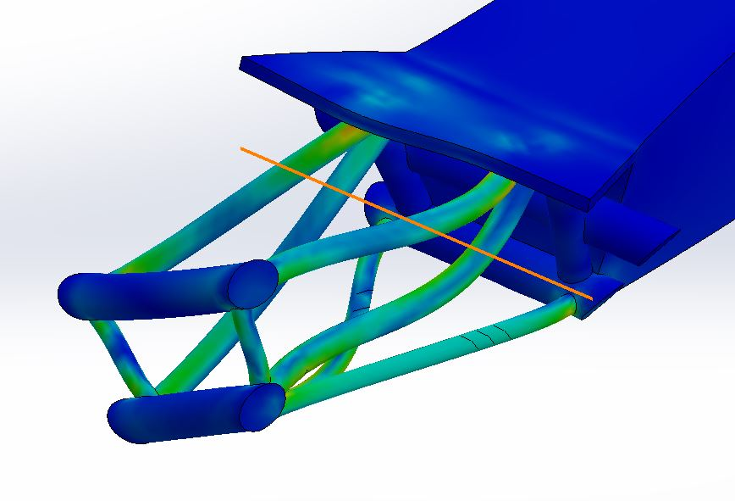
Figure 24. Asymmetrical load

Bodywork
The bodywork needs to be adapted to sit on the mounts.

Bibliography
Ashby, M. F., 2017. Materials Selection In Mechanical Design. Fifth ed. Oxford: Elsevier.
Lee, B., 1997. Jeet Kune Do. Hong Kong: Tuttle.
Matweb - Material Property Data, 2020. Overview of materials for Acrylonitrile Butadiene Styrene (ABS), Molded. [Online]
Available at: http://www.matweb.com/search/QuickText.aspx?SearchText=abs
[Accessed 19th January 2020].
Mottram, J. T. & Shaw, C. T., 1996. Using Finite Elements in Mechanical Design. Maidenhead: McGraw-Hill Book Company Europe.
Reimpell, J., Stoll, H. & Betzler, J. W., 2001. The Automotive Chassis. Fourth ed. Oxford: Butterworth-Heinemann.

Appendix
CAD files:
https://uowtsd-my.sharepoint.com/:f:/g/personal/oduane_151457_student_uwtsd_ac_uk/EpNt6Ul3KkpIoIenGreUFaEBBBpaLhwmmmvDOolsJvWTtQ?e=xQYBMV

