Interns
Internship Appraisal
Honorata Sieczych
Student No. 1708007

Internship and Volunteerism
BMSP6003
Tutor: Jessica Shore
Submission Date: 30/03/2020

Contents
Content of pages 1
Executive Summary 3
1.0 Introduction 3
1.0 Main Findings 4
1.1 Benefits and Limitations of the Internship 4
2.2 Application Process and Internship Documents 5
2.3 Placement Skills Audit and Feedback 6
2.4 Advantages and Disadvantages of Gantt Chart 8
2.5 Government Employability Skills 9
2.6 General Experiences 11
3.0 Conclusion 12
4.0 Recommendations 13
References 15
Appendices: 16
Appendices 1 Gantt Chart for my Internship 16
Appendices 2 Screenshot of Internship Advertisement 16
Appendices 3 Pre-placement Skills Audit 17
Appendices 4 Post- placement Skills Audit 20
Appendices 5 Post Placement Review and Feedback 22

Executive Summary
The critical appraisal suggests that internship is vital for its students because it helps individuals to acquire practical skills which are significant for future employment. The UWTSD sustainable marketing placement, which author of its study obtained, was successful. Hence, it resulted in a high number of applicants for the Business Management course in the academic year of 2019/2020. Furthermore, the participant enhanced personal development in some skills, but in other skills, there is still room for improvement.
- Introduction
The research aims to provide a critical appraisal of the student internship concerning personal experiences and personal future livelihood of the researcher. The student was interested and applied for the internship at the University of Wales Trinity Saint David (UWTSD) in Carmarthen. The proposal for placement came from Carmarthen Business School, and the internship offer was on sustainable marketing of undergraduate programme of Business Management course.
Furthermore, the internship emphasised on sustainable and ethical thinking of its participant as the Business Management course attract forward-thinking and proactive individuals that desire to change the nature of the organisation. UWTSD internship aimed to sell business courses to potential students for the academic year 2019/2020.
In addition, the purpose of the internship was to improve and implement a sustainable marketing plan for the undergraduate programme of Business Management course. The expectation of the placement was the development and implementation of social media strategies targeted at specific groups.
Moreover, the other expectation was to develop and implement local strategies for the recruitment of prospective students (Appendices 1).

  - Main Findings
  - Benefits and Limitations of the Internship
One of the requirements at UWTSD of undergraduate students of Business Management course is to undertake twenty days of internship during the third year of its study. In order to provide a smooth transition from university into a professional setting, the internship experience is entrenched in an academic programme.
Thus, individuals increase their ability to work within organisational settings. The students are expected to complete their work experience before attaining a diploma from the university. Therefore, the programme of Business Management course is intended to expose its student to the practical aspect of their gained knowledge and acquired skills over three years of its study (UWTSD, 2020). An internship is a period of time of work experience obtainable by the company. It may be defined as a period of practical work experience of between one week and one year. This work experience is carried out by students or graduates in order to fulfil its needs of development its skills. During the internship, employers assess individuals’ capabilities and their performance which can be promising for a future job if a student performs well, and there is a job position available (Smith, 2019). Throughout the internship, a student can determine if the field that placement occurs is satisfying its needs and if that can be the prospect of its career field (Hashamuddin, Kamaruizam, & Noor , 2018).
The purpose of the internship is to prepare graduates for the work environment through acquired experiences (AIE, 2020) and this is associated with objectives of Business Management course programme to generate skilled, knowledgeable and experienced graduates as this is usually a requirement of future employers (UWTSD, 2020). One of the main advantages of the placement is that it expands the professional knowledge and skills of its individuals. Furthermore, it enhances the opportunities for future employment; thus, students might get a job offer at the end of its placement (Pinto L & Pereira, 2019).
Moreover, the internship provides students with a transfer from academic knowledge and skills to ‘hands-on’ real-life scenarios at the workplace (Hebert, Wood, Jenkins, & Robison, 2017; Adebakin, 2015). Hence, students utilise their potential and adapt to the work environment.
Also, an internship enables its participant to develop their portfolio of work and build a network of relationships in the professional settings, which can be beneficial in future. Lastly, a placement can boost the confidence of its student, which is vital for the future of its individual (AIE, 2020).
However, it can be argued that the internship has disadvantages as well as provides benefits of its participants. One of the typical limitations is that most of the internship is unpaid. Therefore, the participants do not gain any financial rewards in order to complete their placement. Furthermore, the student of its training must consist of high intrinsic motivation if the extrinsic factors do not take place in order for successful completion (Bukaliya, 2012). In the case of the author of this investigation, the internship was unpaid, which generate additional costs for its participant during its placement. Other barriers of internship can occur in the form of patronising its participant as it is still a student without qualification (AIE, 2020). However, that did not exist in sustainable marketing placement of the author of its research.

2.2 Application Process and Internship Documents
From the perspective of the participant, the application process for the internship was challenging and complicated. In order to gain access to the National Union of Students (NUS) and have the ability to research advertisements for future placement, the NUS requested to create a profile on their website. The formation of the student portfolio was time-consuming, and some questions were irrelevant for the purpose of the placement.
Furthermore, after a long process of creating a student portfolio, the researcher was able to search and examine potential future internships. The student had an impression that would be able to access the NUS website at home and apply for attractive internship offer, which was sustainable marketing at UWSTD (Appendices 2). However, access to the website was denied, and the student was unable to proceed with an application for their own placement. Therefore, the student made an appointment with the Director of Carmarthen Business School and explained all the situation. That resulted in having an interview and being offered this desired internship. Those actions show an ability for critical thinking, being proactive and the ability to address issues creatively in order to obtain wanted placement (Appendices 3).
Moreover, the NUS invited our students for internship training at Bristol University. The training consisted half-day of sustainability training which was inadequate for the author of the assignment because our course encompasses sustainability in every aspect of our learning and sustainability aligns with all modules across my course. The researcher and the rest of the students are privileged to learn about sustainability at any angle of the course as we are pioneers. However, the second part of the training was useful in order to gain knowledge for the internship’ assignments. It allowed the researcher to understand the meaning of SMART aimed methods and helped to improve their skills actively (Bjerke & Renger, 2017).
In order to comply with health and safety policies and procedures, a student must complete all risk assessments, induction checklist and documentation for protection of UWTSD as well as a participant in their internship. Nonetheless, the student was not aware of this until the end of September 2019, whereas the student started their internship in June 2019. The lecturer at the time of that module gave it all forms for completion. Therefore, all forms were backdated, and students were requested to do it.

  - Placement Skills Audit and Feedback
The skills audit provides individuals with the knowledge of gap in their skills or room for improvement (Reach Volunteering, 2019). In order to assess the development of student personal skills. Pre-placement must be compared with the Post- Placement Skill Audit.
The author of this study enhanced the skill that considers the whole system when thinking about resolving and improve methods of doing things. The example of this is that student must think in advance when some issue occurs such as cancellation of venue or refusing the events in Lampeter university as their marketing team conclude that there was a conflict of interest (Appendices 3&4). Moreover, another skill that enriched student was thinking creatively when marketing team requested some activities concerning sustainability for clearing week in order to gain a wider audience. Therefore, a participant in the internship created an activity related to the usage of plastic (Appendices 3&4). During the placement student improved proactivity, adaptability and innovative approach as different venues required different approach or proactive thinking, as well as adaptability for example regarding transport as a student, do not drive (Appendices 3&4). Besides, the student expanded their skill regarding self-reflection and analysis as the student has an awareness of its own substantial assets and their limitations. Therefore, the participant always tried to reflect upon their actions and continuously strive for further progression as the placement helped to gain some valuable skills (Appendices 3&4). Also, a vital skill that student improved is oral and written communication throughout the internship and their events such as flyers distributions, stands and social media engagements. The example of the successful progression of student cooperation with others is participation in some venues with a colleague as she had a similar placement. Also, there is a proof of collaboration with UWTSD marketing team, which gave a student positive feedback (Appendices3&4& 5).
Furthermore, the participant of internship developed efficient time management as it must adjust and adapt itself in order to collaborate with organisations, transport providers or people that were involved in the internship operations (Appendices 3&4). Additionally, the author of this study is committed to lifelong learning which increased their skills by performing placement and resulted in personal achievement as the participant relative decided to continue higher education and to apply to university. This progress came up from observation of the researcher of its study (Appendices 3&4). However, some skills still have room for improvement, such as practical and active listener. In the opinion of the participant of the internship, this is related to self-reflection and analysis. Therefore, the student continuously tries to enhance their skills (Appendices 3&4). Another skill that did not progress well is an effective facilitator. The student-initiated some activities of its placement but most of the venues depended on the third-party individuals. Nonetheless, the student tried their best in order to accomplish the best results.
The student’ self- a reflection on the skills’ audit was based on Gibb’s reflective model which enables individuals to improve and self- actualised their skills and performances as Gibbs implies that people learn through recurrence (Gibbs G. , 2016; Gibbs G. , 1988).
The participant received their post-placement review and feedback. Hence, the student was proud of their achievement regarding its placement and its enhancement of professionalism as well as the development of personal qualities and acquired skills during three years of learning at UWTSD (Appendices 5).

2.4 Advantages and Disadvantages of Gantt Chart
For the purpose of the clear visual representation of the internship tasks and time management, the Gantt chart was created. The visualisation of tasks is one of the advantages of a chart as it is easy to understand and could be a useful tool for communication with others. However, the table was generated after the internship begin. The student had to research and prepare all in advance and did not have all confirmation of the upcoming events, venues and agreements of the participations in these occurrences.
Moreover, the student was synergetic with another colleague as her placement was similar, and cooperation was needed in order to achieve the best outcomes. Therefore, the chart was made during the internship and regularly amended for the purpose of smooth operation during placement. However, that would be not acceptable in the workplace as a Gantt chart consists of a rigid structure rather than flexible and the student would not have an opportunity of adjusting or correction of some tasks or dates. In the researcher opinion, this is one of the disadvantages of the Gantt chart as minor changes in data could cause significant changes in the chart. Another barrier of the chart is the lack of visualisation of interdependencies of the activities (Marchington & Wilkinson, 2016). Also, the table does not illustrate an early or late start in tasks and does not show uncertainty involved in performing the activity.
Furthermore, in a student case, the Gantt chart was the primary indicator of time management, and it was helpful in this regard to some extent. Effective time management would occur if the student would not be dependent on different people concerning transport as the author of this appraisal does not drive. Nonetheless, the author of this report improved their time management during an internship as it was vital for the completion of the placement tasks.
Moreover, each bar on the chart did not indicate the time consumed on each task and preparation beforehand that were required in order to achieve the desired outcome (Saunders, Lewis, & Thornhill, 2015; Taylor & Woodhams, 2015; Wren, 2015; Geraldi & Lechter, 2012) (Appendices 1).

2.5 Government Employability Skills
The Government requires the academic institution to teach their students in the way that they will be ready for imminent employment. Therefore, future employers expect from their graduates to be ready, prepare for the work environment. Different organisations have a different specification of desired graduates and potential future employees.
At UWTSD mission statement declares “change people, change lives” (UWTSD, 2019) which suggests that throughout education at university students will be prepared for future employment because UWTSD subliminal curriculum is embedded into the teaching of its students. Hence, the university focuses on a holistic approach and sustainable development of its teaching to its students (UWTSD, 2019).
Graduate employability underlines the importance of obtaining by a student variety of skills, abilities, knowledge, competencies and capabilities in order to start work and to become successful as well as progress up in the desired individuals’ career field (Nirmala & Kumar , 2018). Furthermore, employability equals work readiness which refers to required personal skills, knowledge, understanding and attitude that will shape productive, efficient and vital member of the workforce (Nirmala & Kumar , 2018).
Moreover, employability can be described as the capability to get into the job, sustain it and be able to find another work in future (Suleman, 2017). However, employability can be classified as a cognitive and non- cognitive accomplishments thus, the individuals’ soft skills, their intelligence, their qualities and peculiar potential that will enable to get into a job and promise success in the place of work (Knapton, 2019).
Employability skills are fundamental in order to be desirable for future employers. Those skills can be divided into two categories as technical skills and soft skills.
Generally, the organisations want individuals that have basic technical knowledge such as the ability to work within Microsoft Office programs like Excel or Word document. However, anyone can learn these technical skills, that is why soft skills are the most important traits within the potential future employee.
Soft skills are most essential aptitudes as these abilities empower human to work well with co-workers, utilise their knowledge and play a part in any workplace. Furthermore, these talents can be perceived as a professional ability which leads to success in a work environment and transferable skills as can be conveyed to any occupation. The soft skills include communication, ability to work within a team, critical thinking and ethics. Every form of professional communication is vital for the organisation. However, listening skill and paying attention is as much important as communication (Arredondo, 2000).
Moreover, teamworking is another significant aspect of any business as team members must collaborate, manage conflict and being reliable. Critical thinking allows people to be creative and resolve an issue that can occur during work operations. Lastly, every boss would like to hire a person that is honest and trustworthy. The organisations want their staff to comply with policies and procedures of their business as well as they require their employees to behave professionally and responsibly (Dotdash, 2020; Marchington & Wilkinson, 2016; Taylor & Woodhams, 2015).
The researcher believes that it developed their own employability skills and improved their communications skills. As the author of this study is firmly committed to lifelong learning, it is essential for a student that it can progress at every time and improve their skills and knowledge as well as abilities to work better at every aspect of any job(Appendices 3 & 4).

2.6 General Experiences
The author of this study is satisfied with the results of its internship operations. Furthermore, the marketing was the new subject for its participant as the student choose different module in the second year of its course. Thus, it was challenging for its individual at the beginning of the placement. However, the student learnt lots of new things, acquired new skills and met many kind and professional people during its placement. The student tried to manage all issues when they occurred and tried their best to achieve the best outcome for themself and UWTSD. Although, the student itself did not sell the business course to anyone, throughout active advertisement on private social media, in different towns and areas the highest number of individuals signed up for the Business Management course this year as the placement provider states in the feedback.
Moreover, from the perspective of its participant, the only downfall of its placement is that there is no vacancy for its student after the finished internship.
At last, the student would like to thank everyone for their participation and help during its internship and is looking forward to gaining experience in ‘real-life’ work environment.
- Conclusion
In conclusion, sustainable marketing placement was the best choice, and the student is fulfilled with the outcome of its internship. However, there is always room for improvement, and as the student experienced sustainable marketing at UWTSD therefore, at the end of this research, it will place recommendation for further improvement.
The internship is a compulsory module at UWTSD consequently, throughout the placement, individuals practically utilise their knowledge. Their knowledge is applied in every aspect of its work experience. Therefore, the students acquire transferable skills which are crucial in any workforce. Furthermore, the internship prepares students for being ready to start the desired job and maintain it. At present, the employers are looking for people who are adaptable, innovative, creative and possess’ soft skills which are vital for any organisation. Hence, a skills audit highlights the importance of the skill gap or these abilities that need to be improved. Moreover, the placement helped the author of this research to meet professionals from various work field and learned from them, which, created a new experience for its student.

4.0 Recommendations
For the further success of the next internship, the student proposes recommendations as follow:
Ensure that all placement documentation such as Placement Provider Agreement, Health and Safety Questionnaire, Student Placement Agreement, Risk Assessments and Induction Checklist are completed in advance of the internship. It will protect the placement provider and its participants in case of possible emergencies or different issues that might occur in future.
- As the advertisement of sustainable management internship suggested that the placement provider expects to “develop and implement social media strategies” (Appendices 2). Therefore, it would be useful to have access to the university or business management website as this was a crucial aspect of the UWTSD requirements of its internship, and it would make more manageable for the student to promote its course.
- Ensure that participant the placement have frequent supervision and through those observations and meeting the individual receive up to date feedback on their performance and guidelines to their placement operations and expectations of the UWTSD.
- Strongly recommended making job descriptions with defined tasks for future internships and their participants.
- As mention in second assessments hence, blogs some of the organisations were reluctant to take big posters of Carmarthen Business School. Therefore, the student suggestion is to reduce the size of those posters in order for the successful promotion of the course.
- Ensure that efficient communication exists between departments of UWTSD. It was prominent for a student as a marketing team in some situation was hesitant to cooperate with the Business Management department. The communication is crucial for the further success of the placements and their participants.
- Make sure that all marketing materials and equipment of Business Management are available for the internship as the participant on their placement must ask student union for some equipment.
- Lastly, paid placement would encourage further field and different approaches to the advertising of its course.

References
Adebakin, A. (2015). DOES INTERNSHIP EXPERIENCE BEGET ACADEMIC RELEVANCE AND EMPLOYMENT PROSPECTS: AN ASSESSMENT OF GRADUATE INTERNS FROM A NIGERIAN UNIVERSITY. Bulgarian Journal of Science & Education Policy, 302-316.
AIE. (2020, n.d. n.d.). www.aie.org. Retrieved from www.aie.org: https://www.aie.org/life-after-college/continue-your-education/considering-an-internship/benefits-of-an-internship/
Arredondo, L. (2000). Communicating Effectively. New York: Mc Graw-Hill.
Bjerke, M., & Renger, R. (2017). Being smart about writing SMART objectives. Evaluation and Program Planning, 125-127.
Bukaliya, R. (2012). THE POTENTIAL BENEFITS AND CHALLENGES OF INTERNSHIP PROGRAMMES IN AN ODL INSTITUTION: A CASE FOR THE ZIMBABWE OPEN UNIVERSITY. International Journal on New Trends in Education and Their Implications, Vol.3 Issue1.
Dotdash. (2020, n.d. n.d.). https://www.thebalancecareers.com/. Retrieved from https://www.thebalancecareers.com/: https://www.thebalancecareers.com/
Geraldi , J., & Lechter, T. (2012). Gantt Charts revisited. International Journal of Managing Projects in Business, 578-594.
Gibbs, G. (1988). Learning by Doing. A Guide to Teaching Methods. Oxford: Oxford Polytechnic.
Gibbs, G. (2016). Teacher Engagement. Uniped, 184-187.
Hashamuddin, Y., Kamaruizam, M., & Noor , F. (2018). The Effect of Internship on Job Performance: An Assessment of Students’ Perception. International Journal of Scientific & Engineering Research, Vol 9.
Hebert, E., Wood, R., Jenkins, J., & Robison, C. (2017). Internship Management, Placement, and On-Site Visits in Kinesiology. Kinesiology Review, 394- 398.
Knapton, H. (2019). EMPLOYABILITY - WHAT DOES IT REALLY MEAN? Teaching Business & Economics, 14-16.
Marchington, M., & Wilkinson, A. (2016). Human Resource Management at Work. London: CIPD.
Nirmala, K., & Kumar , S. (2018). The Impact of Basic, Higher-Order Thinking and Affective Skills on Graduate Employability. Journal of Soft Skills, 7-28.
Pinto L, & Pereira, P. (2019). ‘I wish to do an internship (abroad)’: investigating the perceived employability of domestic and international business internships. Higher Education, 443-461.
Reach Volunteering. (2019, n.d. n.d.). https://reachvolunteering.org.uk/guide/how-complete-skills-audit. Retrieved from https://reachvolunteering.org.uk/guide/how-complete-skills-audit: https://reachvolunteering.org.uk/guide/how-complete-skills-audit
Saunders, M., Lewis, P., & Thornhill, A. (2015). Research Methods for Business Students. Harlow: Pearson.
Smith, J. (2019, August n.d.). https://www.prospects.ac.uk/. Retrieved from https://www.prospects.ac.uk/: https://www.prospects.ac.uk/jobs-and-work-experience/work-experience-and-internships/internships
Suleman, F. (2017). The employability skills of higher education graduates: insights into conceptual frameworks and methodological options. Higher Education, 263-278.
Taylor, S., & Woodhams, C. (2015). Studying Human Resources Management. London: CIPD.
UWTSD. (2019, n.d. n.d.). www.uwtsd.ac.uk. Retrieved from www.uwtsd.ac.uk: https://www.uwtsd.ac.uk/
UWTSD. (2020, n.d. n.d.). www.uwtsd.ac.uk. Retrieved from https://www.uwtsd.ac.uk/ba-business-and-management/: https://www.uwtsd.ac.uk/ba-business-and-management/
Wren, D. (2015). Implementing the gantt chart in Europe and Britain: The contributions of Wallace Clark. Journal of Management History, 309-327.

Appendices:

Appendices 1 Gantt Chart for my Internship
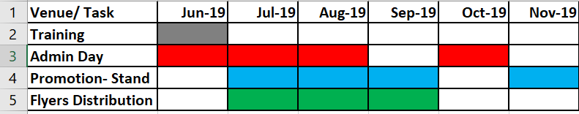

Appendices 2 Screenshot of Internship Advertisement
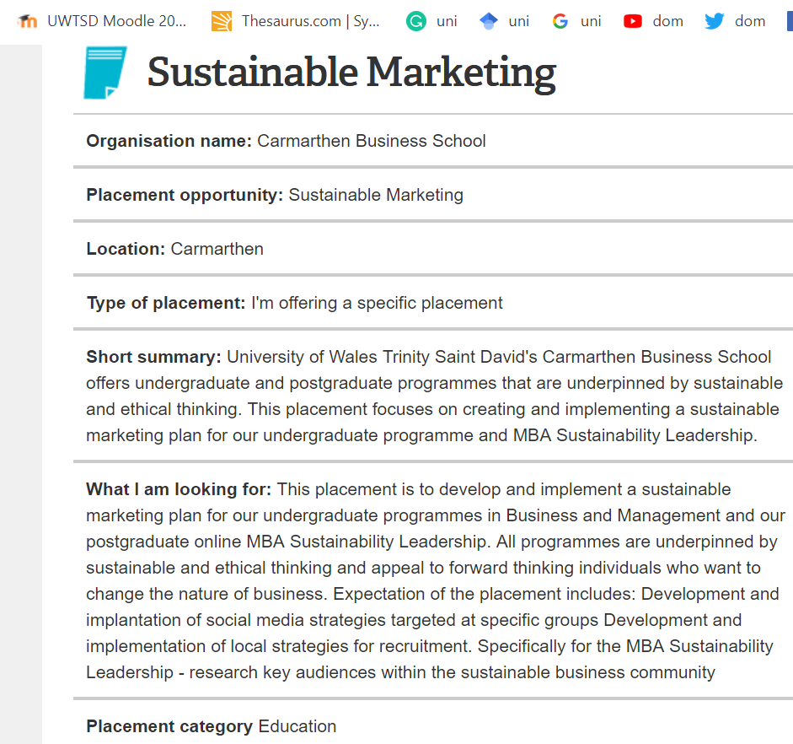

Appendices 3 Pre-placement Skills Audit
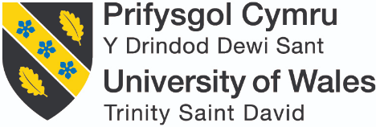
INTERNSHIP & VOLUNTEERISM
Assessment 1 – Pre-Placement Skills Audit
Name: Honorata Sieczych

Placement Provider: UWTSD

Date: 06/06/2019
The purpose of this skills audit is to assess your skills set prior to you undertaking your placement to establish what skills you need to improve on during your placement. Please be honest, take some time for self-reflection and when responding to each skill try to think of an example of when you may have done this.
Skill | Already there | Well on the way | Gathering speed | Not currently
I think about the whole system when working to solve problems and developing ways of doing things |  | x
Example: I try my best to resolve a problem if a problem occurs by looking at solutions or alternatives in order to reach a goal. I have fixed an issue that occurred when applied for placement.

I have the ability to ability to address current and future problems creatively |  | x
Example: I was proactive when I have applied for the placement, and the NUS website did not work. Therefore, I went to the director of our Business Management course for a meeting and gained an interview for a placement, then after I have gained a placement at UWTSD.

I am confident in assessing and critiquing a range of information sources |  |  | x
Example: I am trying to look at both sides of the information and find my own objective answer.

I have a critical understanding of connections between environment, social and economic factors |  |  | x
Example: I have performed a PESTEL analysis and SWOT analysis for NHS for the purpose of one of my assignment in the second year of my course.

I am capable of engaging in self-reflection and analysis |  | x
Example: I am aware of my strength and weaknesses and I try continuously to progress my values throughout reflection, for example when I look at my feedback from my lectures.

I have a commitment to life-long |  | x
Example: I would like to think that I am progressing well at present and will continue in future.

I am committed to supporting and encouraging others with life-long learning |  | x
Example: I have encouraged my son to do A levels and applied for university, and he was successful with his application. Also, I am supporting my other son to learn as much as he can about his interests. Besides, I will help others to learn and apply for university as this is my aim at my placement.

I am innovative and adaptable, proactive rather than reactive |  | x
Example: I like working with people and can adapt well to different scenarios. I am positive and enthusiastic person.

I am an engaging and dynamic communicator (written) |  | x
Example: I would like to think that I will improve my writing. Therefore, I will be more engaging and dynamic communicator. However, within university group I am engaging well.

I am an engaging and dynamic communicator (oral) |  | x
Example: I am well known within the university for being good and dynamic oral communicator. I have always updated my colleagues with any information regarding university. Also, I like to do presentations.

I am an effective networker |  | x
Example: Within the university, I try to engage between lectures, departments and classmates if need be. Also, I am Student Representative.

I am an effective facilitator |  | x
Example: I was a PASS leader last year and tried to help others as much as I could.

I work well in cooperation with others |  | x
Example: I would like to think that I work well; an example would be participating in debates.

I am a well-practised and effective active listener |  | x
Example: I like to listen to others.

I can organise myself and manage my time effectively |  | x
Example: For the purpose of my placement, I must organise the whole process of events and stands or any other activities and manage my time.

I understand how to act as a responsible citizen |  | x
Example: I am trying to think before my actions. I think before responding while difficult situation and try to be sustainable and promote as an example.

I have a clear vision of forthcoming change and how to act to realise a sustainable future |  |  | x
Example: Since I am studying, I have reduced my plastic usage as much as I could, but there is always room for improvement.

I feel competent in leading on change for social, environmental and/or economic benefit |  |  | x
Example: I must improve because I do not feel fully competent.

I feel comfortable speaking openly about my values |  | x
Example: I would like to think that I will improve to speak openly.
I can lead with integrity driven by my own values |  | x
Example: I would like to think that.

Appendices 4 Post- placement Skills Audit

INTERNSHIP & VOLUNTEERISM
Assessment 3 – Post-Placement Skills Audit
Name: Honorata Sieczych

Placement Provider: UWTSD Carmarthen

Date: February 2020
The purpose of this skills audit is to assess your skills set prior to you undertaking your placement to establish what skills you need to improve on during your placement. Please be honest, take some time for self-reflection and when responding to each skill try to think of an example of when you may have done this.
Skill | Already there | Well on the way | Gathering speed | Not currently
I think about the whole system when working to solve problems and developing ways of doing things | x
Example: Generally, as in life problems always occur that is why I have been proactive when some of my potential venues were canceled or refused. For example: when I have asked UWTSD Lampeter to attend their open day and they have refused due to ‘conflict of interest’ in their opinion.

I have the ability to ability to address current and future problems creatively | x
Example:
During clearing week, I had to create an activity related to my course in order to promote Carmarthen Business School. Therefore, one of the activities was to answer a question ‘How many tons of plastic did the UK produce in 2014?
I am confident in assessing and critiquing a range of information sources |  | x
Example: I am trying to be objective and look at an information from both sides.

I have a critical understanding of connections between environment, social and economic factors |  | x
Example: PESTEL and SWOT analysis helps me to get to understand connections between social, environmental and economic factors as I must think about this while I am doing every assignment.

I am capable of engaging in self-reflection and analysis | x
Example: I am aware of my strength and my weaknesses therefore I am always trying to reflect upon my actions and continuously strive for further progression as my placement helped me gain some valuable skills.

I have a commitment to life-long | x
Example: Definitely, I have progressed my skills during my placement.

I am committed to supporting and encouraging others with life-long learning | x
Example: I have encouraged my son to stay in education and as a result of that he will start university in September this year! Personally, I strive for constant progression in my professional work environment. I am open and engage in any new trainings that can boost up my abilities to work effectively, productively and efficiency.

I am innovative and adaptable, proactive rather than reactive | x
Example: During my placement I have improved my proactivity, adaptability and innovative approach as different venues required different approach or proactive thinking for example regarding transport as I don’t drive.

I am an engaging and dynamic communicator (written) | x
Example: While on placement I have progress my written communication skills.

I am an engaging and dynamic communicator (oral) | x
Example: I am excellent oral communicator! Although sometimes this is my downfall.

I am an effective networker | x
Example: I would like to think that I have polished my networking skills. However, sometimes it was hard to be effective as for example someone was unavailable to answer an email or to contact with.

I am an effective facilitator |  | x
Example: I was a PASS leader and tried to help people as much as I can, but I think there is still room of improvement.

I work well in cooperation with others | x
Example: I like to work with people and my evidence of cooperation on placement would be to have joined venues with another classmate as it has similar placement.

I am a well-practiced and effective active listener |  | x
Example: I like to listen to others however I think there is still room for improvement.

I can organize myself and manage my time effectively | x
Example: My placement thought me how to improve my time management and organisational skills.

I understand how to act as a responsible citizen | x
Example: Although I think that I act as a responsible citizen I think there is always room for improvement.

I have a clear vision of forthcoming change and how to act to realise a sustainable future |  | x
Example: I have improved my sustainability in every aspects of my life, but I still think there is room for improvement in order to change habits or eat less meat.

I feel competent in leading on change for social, environmental and/or economic benefit |  | x
Example: I think there is still room for progression.

I feel comfortable speaking openly about my values | x
Example: I would like to think that I have made progression. For example: During clearing week I took participation in making short video for marketing purposes in order to promote business course.
I can lead with integrity driven by my own values | x
Example: I think I have progressed.

Appendices 5 Post Placement Review and Feedback

POST-PLACEMENT REVIEW AND FEEDBACK

Dear Participant

Many thanks for your involvement in the work placement. I hope that the experience was a valuable and rewarding one, whether you were a Placement Provider, Student or Placement Tutor. The University of Wales Trinity Saint David reviews the provision annually for enhancement purposes and so we would be pleased to hear your feedback on any aspect of the placement.

If you wish to participate, please use this form to record your views. I’d be grateful if you would return the form either in person, by postal mail or email to the contact details below.

Yours sincerely

Jessica Shore

Placement Coordinator

UWTSD Carmarthen

Name of provider’s organisation: |  | UWTSD
Name of student: |  | Honorata Sieczych
What were the positive aspects?
Having Honi assist us with our marketing was invaluable. Honi was able to attend events in the community promoting the course, which created a lot of interest. As a result we achieved the highest number of applicants received in recent times.
Honi attended an event organised by the central marketing team who attended the event with her and they sent very positive feedback about her professionalism and ability to complete the tasks.

Were there any problems?
The only problems experienced from our end was the lack of time for supervision. We are a small team and therefore time was an issue. However, the time that Honi saved the team was far more valuable than any lack of supervisory time.

Do you have any recommendations for enhancement for the future?
Perhaps, a role description and the creation of a list of specific tasks.

Signed: | J.Shore
Name in block capitals: | Jessica Shore
Position (please tick one): | ☒ Placement Provider  ☐ Student  ☐ Placement Tutor |  | Date: | 14/02/2020
Thank you for completing this questionnaire. Please return it as soon as possible to the Placement Coordinator.

