Name: Dilruba Khatun
Student Number: 1709434
Module Code: BMHP5003_BIRM
Module Title: Introduction to Physiology
Lecturer’s Name: Mumtaz Golam
Assignment Title: Task 1 – Individual Academic Poster
Task 2 – Individual Poster Presentation

Understanding of the relationship between body functioning and relevant detailed anatomy and physiology of one body system, within a health and social care context
The digestive system

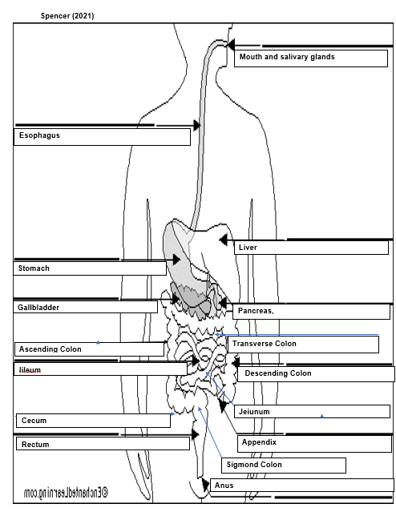
Mouth and salivary glands
This organ is the first in the digestive tract, is when you take bit from any food. This digestive process starts from your salivary glands that is active because of the smell of the food. Which You need to chew your food for it to break into pieces which make it easy to digest. This is because your salivary in your mouth mixes with your food and it absorb and easy to swallow through your tongue and through your throat and into your Esophagus. Cleveland Clinic (2021)

The process of the organs in the digestive system.
Liver

This organ has different function but its main role in the digestive system is to process nutrients aborted from small intestines. So, the bail from this organ secreted into the small intestine which role is very important in the digestive system by digesting fat and vitamins. This organ is called the chemical factory because this organ takes raw materials and obsessed in the intestine that make chemical which the human body needs to function. This organ also detoxifies which is potentially harmful chemicals which break and secrets other drugs that is toxic to the body. Cleveland Clinic (2021)

Rectum

This organ is chamber connecting to the colon and the auns. The rectum role in the human body is to receive stool from the colon to let you know that it is time for the bathroom. This process is when the rectum sense by sending message to the brain that it time to go to the bathroom. The human brain rectal contract to release or not. Also, the sphincters can relax and then the rectum contract to dispose any contents. But if an individual cant disposes their stool the sphincter contracts and the rectum both acceded and sensation of going to the bathroom temporality goes away. Cleveland Clinic (2021)

Esophagus

This organ is close to the trachea which are windpipe. Also, this organ receives food from the mouth for you to swallow. There is a small flap which is called epiglottis which cover toy windpipe to prevents you from choking when the food goes through your windpipe. Muscles which are connects to this organ is called peristalsis which is there to deliver food to the stomach. There is a ring muscle under this organ which is called the Esophagus sphincter which let food through which connect to the stomach that flows back into this organ. And if the food dose not flow through this organ you will suffer from acid reflex or heartburn. Cleveland Clinic (2021)

Ascending Colon

This organ is part of the large intestine which has different part like the ascending, transverse descending and the sigmoid. This organ first section in the digestive tract is from the end of the small intestine and the second part of a colon which is the transvers colon which known as the right colon. This organ function to absorb water and electrolyte from the stool. This is because most of the vitamin minerals are absorbed in the small intestine. Which the water absorbed bad wasted material passes through the right the colon turning liquid into solid stool. Tressa A, J (2021)

Recommendation

How to adapt to this disease called diverticular disease.
The bottom line is that this disease can be preventable if the individual diet is high in fibre, it will help them in their life without and future flare up. Also diet in low fibre or clear liquid will reduce future symptoms regarding this disease. Coppola (2020)
If this disease has a high affected inside the individual body. The first thing is to visit the doctor they can help with pain and discomfort in their body. Coppola (2020)
Medical treatment for diverticular disease.
Diet is one treatment for this diseases. Eating high fibre food ease, the symptoms and helps reduce the diseases from developing into diverticulitis. You should take 30g fibre in your diet every day. This includes fresh fruit, dried fruits also different vegetable, nuts and cereals and finally starchy food. Finally, you can get supplements in powder form from the pharmacy and health food stores. NHS (2020)
Other recommendation for treating this disease is different form of medicine tablets and surgery treatment to reduce this disease. Both treatments have effects and severe outcome. So, you should investigate before taking any major step towards preventing any major complication regarding this disease called diverticular. NHS (2020)

A Disease that affects the digestive system
A disease that affects the digestive system organ is called. Diverticular disease. This disease is in form of small pounces of mucosa that protrude which is herniate. This effects the potential gravity which circular through muscle fibres of the colon between the taenia coli. The wall in the mucous embrace which covers with visceral peritoneum. Which occurs in the weakest point of the intestinal wall. Then the blood vessels entre mostly commonly in the sigmoid colon. (Waugh and Grant, 2018, P. 357)
The cause of this diseases is called diverticulosis in presence known as the diverticular. It is also associated with deficiency of an individual dietary fibre. This happens in western countries; this disease diverticulosis is common in middle age by asymptomatic symptom. (Waugh and Grant, 2018, P. 357)
This disease is also known as diverticulitis arises because of the actual form of the disease diverticulosis that the faeces in the intestines become trapped in the diverticula which is the wall of the intestines that become inflamed and oedematous is a secondary infection develops in the intestines wall. And importantly this disease reduced blood supply that cause ischaemic abdominal pain. Which occasionally occurs and that result in peritonitis. (Waugh and Grant, 2018, P. 357)

Cecum

This organ is known as cecum, which is a pouch tube, reaching to the lower abdominal crave that receive undigested food material from the small intestines. It is considered like the large intestines. This organ is not connected with the ileum organ which is the last part of the small intestines. And the limit of food that passes into this organism help because it does not reach the small intestines again. Britannica (2021)

This is a diagram showing the disease cross -section of bowel showing diverticular disease.

(Waugh and Grant, 2018, P. 357)
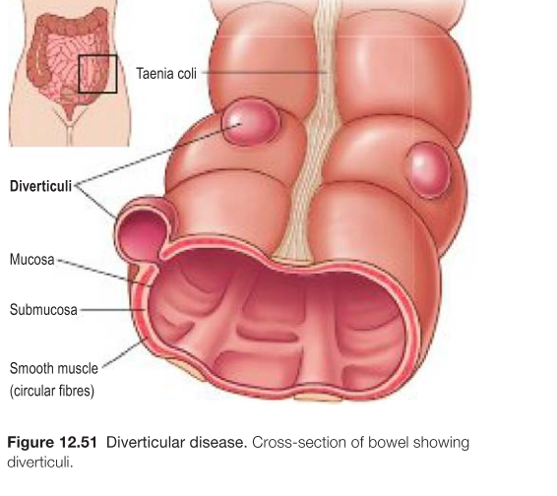

Ileum

This organ is the final section of the small intestines which is at the distal end. It is separated from the large intestines which opens by the ileocecal valve. This organ has the richest lymphoid follicles which is attached to the abdominal wall by the mesentery. The vascular appearance supplies the ileal arteries innervation via which the coeliac and the superior mesenteric plexi. The main function of this organ is enzymatic cleavage of nutrients also absorption of vitamin B12 from intrinsic factor from stomach fat and fatty acid and glycerol and bile salts. Also, the immunological function which is access transfer of antigens. Karunahararamoorthy, A Mytilinaios, D (2021)

Appendix

This organ is found under the abdomen, which it is called the McBurney point which you can feel pain or tenderness, which can be shown that you have appendicitis. It is a finger shaped organ which is attached on the large intestine which is called the cecum which is a small pouch which is found in the beginning of the large intestine. This orgnanis function when the muscle is lining in the GI tract alongside your hormones and your enzyme which this system produces. Also, the GI tract help minimize your food because the appendix does not help you all the time in digesting your food. Castro, J, B, Jasmer, R (2018)

Gall bladder
This organ stirs and concentrate bile from the liver which they release into the duodenum and in the small intestine which helps absorb and digest fats. Cleveland Clinic (2021)

Anus

This organ is the last part of the digestive tract. This organ is 2 inches long canal consisting of the pelvis floor muscles and two anal sphincters which are internal and external. The lining of this organ is detected rectal contents that let the body content like liquid gas, or solid. This organ is surrounded by sphincter muscle which allows control of human stool from soiling from the eternal sphincters which is tight because of stool entering the rectum. This keeps the human poo from involuntary spilling out of the body when sleeping the human poo is not presence in the stool. The human poo is kept hold on when the external sphincter holds the human poo in when the body is ready to release it in the bathroom. Cleveland Clinic (2021)

Sigmond Colon

This organ is found in the section of the bowel. which is attached to the rectum. Which is around 40 centimetres and shape like an S. The role of this organ is building feces until our body what to go to the bathroom. This organ contains a lot of tissue. The muscle is arranged in two ways which some muscle tissue run the Sigmond tube, and the other bundles of muscles are circular shape around the tube. It contains four layers of tissue. Which in the tissues is a layer called mucous membrane Which keep the body from bacteria in the fecal matter and the feces glide along through the tube. Stanbourough, R, J, Chavoustie, C, T (2019)

Jejunum

This organ is part of the small intestine. Which is between the duodenum first art of the small intestine and the ileum which is the last part of the small intestine. This organ helps for further digesting food from the stomach. It absorbs nutrients or vitamins, minerals, and carbohydrate and fat and lastly proteins. and water from the food that help the body function properly. National Cancer Institute (2021)

Stomach

This organ is a hollow organ which contains and holds foods which are mixed in the stomach enzymes. The enzymes process and break down food to a usable form. Also, the cell of the staunch lining is string and secretes. This is because strong acid and powerful enzymes, they are responsible for the breakdown of process of contents in the stomach which processed enough so they can release into the small intestine. Cleveland Clinic (2021)

Descending Colon

There are different colons in the digestive system and one of these is the descending colon which is a retroperitoneal structure that ascended superiorly from the cecum. It also meets the right lobe which is lower and is 90 degrees horizontally. This term is called the right colic flexure or the hepatic flexure which is the start of this organ called descending colon. Also, this organ moves left colic flexure which moves inferiorly to the pelvis which is called the descend in colon. Which its retroperitoneal gas a majority individual that located anteriorly to the left kidney, which Pass over the lateral border. Jones, D, A (2018)

Transverse Colon

This organ is part of the large intestines that cross the upper abdomen from right to left. It dawns on the large intestines. It transverse around the abdomen that why it called the transvers colon. This organ proformas critical function like moving waste materials forwards and absorption from key compounds for the body to function properly. Study. Com (2021)

Pancreas

This organ secretes digestive enzymes into duodenum then breaks all protein and carbohydrate. Also. this organ helps make insulin which is passed through the bloodstream. The insulin is a chief hormone in the human body, this organ also metabolises sugar which is very vital for this organ to process in this digestive system. Cleveland Clinic (2021)

Reference:
Britannica (2021) Cecum Anatomy. Available at: https://www.britannica.com/science/cecum (Accessed: date 3 July 2021).
Castro, J, B, Jasper, R (2018) What Is the Appendix? A Vestigial Organ, or One with a Purpose. Available at: https://www.everydayhealth.com/appendicitis/guide/appendix/ (Accessed: date 3 July 2021).
Cleveland Clinic (2021) The Structure and Function of the Digestive System. Available at: https://my.clevelandclinic.org/health/articles/7041-the-structure-and-function-of-the-digestive-system (Accessed: date 2 July 2021).
Coppola, S (2020) Healthline. Available at: https://www.healthline.com/health/diverticulitis-diet-list-of-foods-to-avoid (Accessed: date 10 June 20201).
National Cancer Institute (2021) Jejunum. Available at: https://www.cancer.gov/publications/dictionaries/cancer-terms/def/jejunum(Acessed :date 3 July 2021).
NHS (2020) Diverticular disease and diverticulitis. Available at: https://www.nhs.uk/conditions/diverticular-disease-and-diverticulitis/ (Accessed: date 11 June 2021).
Scarborough, R, J, Chamosite, C, T (2019) What is sigmoid colon. Available at: https://www.healthline.com/health/digestive-health/sigmoid-colon#location (Accessed: date 3 July 2021).
Spencer, A (2012) Diagram of digestive system. Available at: https://slideplayer.com/slide/9853744/ Accessed: date 9 June 2021).
Study. Com (2021) Transverse Colon: Definition & Function. Available at: https://study.com/academy/lesson/transverse-colon-definition-function.html (Accessed: date 3 July 2021).
Jones, D, A (2018) The Colon. Available at: https://teachmeanatomy.info/abdomen/gi-tract/colon/(Acessed :date 3 July 2021).
Karunahararamoorthy, A, Mytilidae’s, D (2021) Ileum: Want to learn more about it. Available at: https://www.kenhub.com/en/library/anatomy/the-ileum (Accessed: date 3 July 2021).
Tressa A, J (2021) The Anatomy of the Ascending Colon. Available at: https://www.verywellhealth.com/ascending-colon-anatomy-5184808. (Accessed: date 3 July 2021).
Waugh, A and Grant, A. (2018) The digestive system chapter 12 Diverticular disease. Education 13. Available at: Edinburgh, New York, Oxford, Philadelphia, St Louses Sydney, Toronto: Elsevier (Accessed: date 9 June 2021).

