

Assignment Title:
Critiquing and creating data visualisations

Module:
Data Analysis and Visualisation

Module code: ACCB4002

Student: Irina Tupca (2112902)

Lecturer: Koushik Modak

Date of submitted: 04 March 2022

Table of contents:

Introduction 3
Brief analysis of Task 1 4
Task I 5
I. Identifying the message 5
II. Assess the way colour is used. 5
III. Assess the way text is used. 6
IV. Assess the suitability of the graph 6
V. Assess the way graphics are incorporated 7
VI. Cognition (is it suitable for the user) 8
VII. Improving the infographic 8
Conclusion and Recommendation: 12
References: 13
Appendices: 14

Introduction

Based on the infographic “Physical activity for adults and older adults”, we need to write a short discussion about how effective it is as a means of presenting the information it contains. This infographic is a type of image that combines data with design, helping healthcare organizations to concisely communicate messages to adults and older adults.
We should include all the great poster features, any problems we have identified, and our ideas for improving the design (colours, text, graphics, etc).

Brief analysis of Task 1

Given infographic presents the health benefits of physical activity for adults and older adults. The infographic shows the physical activities that are useful to them and that are harmful. And a few quotes that can change your mood for the better. All this information is presented with the help of graphics, icons, and images.

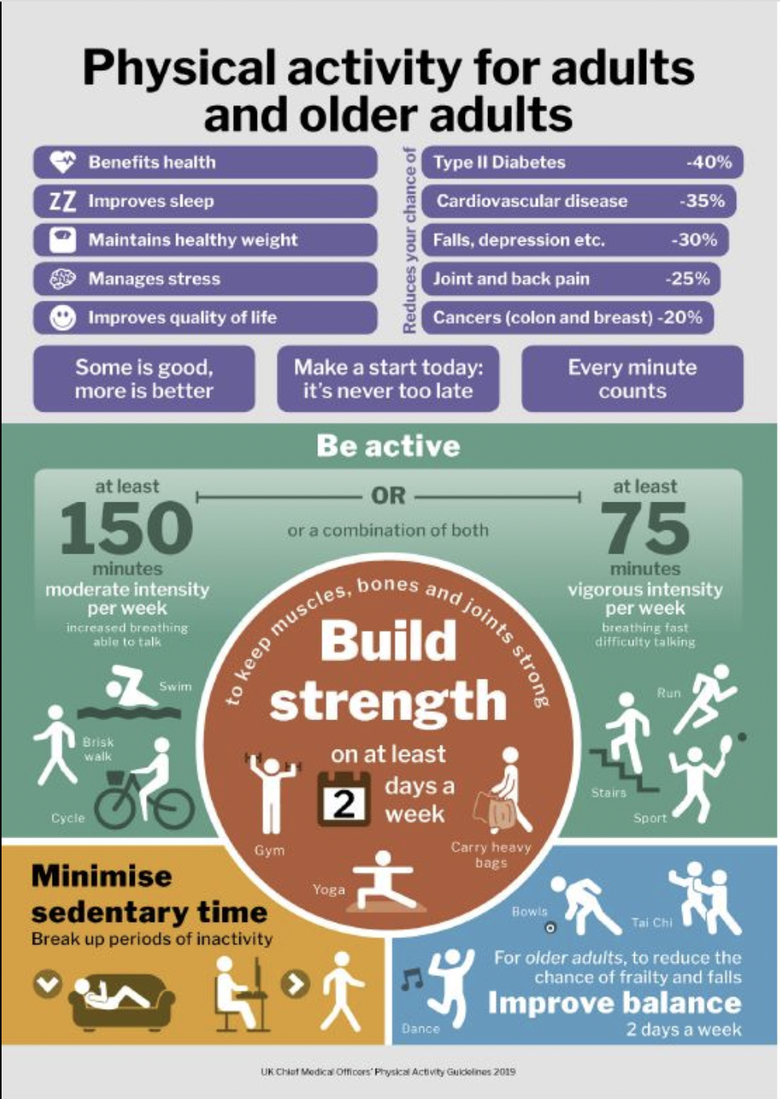

Task I

The evaluation of infographic is based on the following seven points:

Identifying the message

The poster tries to provide the importance of physical activities among adults and older adults.
At the beginning of the poster, the information highlighted in purple specifies the benefits of physical activity, both on the person's physique and mentality.
In the middle of the poster, the information highlighted in green lists the recommended physical activities for adults and older adults to be active and how much time to devote to those activities.
In the middle of the poster, the information in the circle highlighted in red are stipulated activities that help increase strength.
At the end of the poster, the information highlighted in orange and light blue specifies which activities are useful but also fun at the same time and which activity should be minimized.

Assess the way colour is used.

The information presents in the poster is well visible, but the white colour of the text on a dark background affects readability (details in Appendices 2.1).
The colours are chosen according to the content topics (details in Appendices 2.2). [1]
Given infographic contains five colours, but it is perfect to use two, three colours or the same colour with different shades.
One of the fundamental principles of the use of colour in design, namely the 60-30-10 Rule, was not observed when making this infographic (details in Appendices 2.3).[5]

Assess the way text is used.

The chosen font type has a huge impact on the infographic. It's important because it provides information, and the fonts are part of the visual experience.[3]
Only one simple and clear style of text is used in our infographic, but different sizes. (details in Appendices 3.1)
And the large text is not used much compared to the small text. Larger fonts are used to indicate importance and are used only for headings in each graphic. (details in Appendices 3.2)
The infographic contains a lot of small text and is used for ancillary information. Small text is used to describe the icons and for a more detailed description of the headings. Here, the small text is not easy to read and browse compared to the large text.
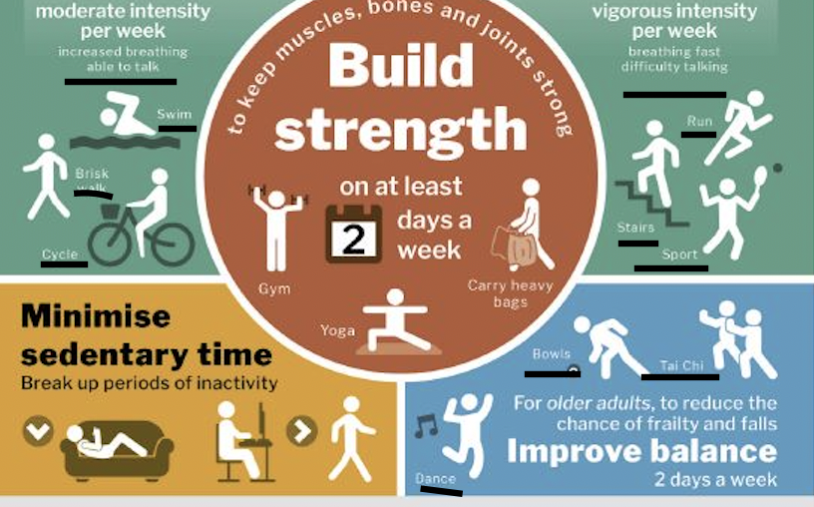
More lowercase letters are used in our infographic compared to uppercase letters. Capital letters are used only at the beginning of the sentence. [6]

Assess the suitability of the graph

The “Physical activity for adults UK” infographic contains mixture of graphs, images, and icons.[6]
In my opinion, the first graph "Reduces the chances of" will be perfect to be changed in the chart bar, which makes the data easy to understand (examples below).

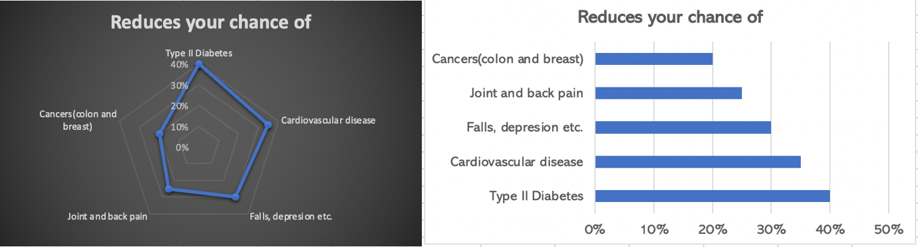
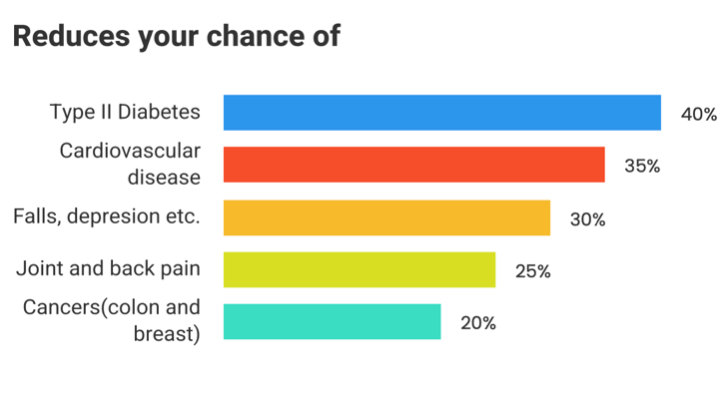
The “Build strength” graph shows its importance through its content (eye-catching font, text) and its location (centre of infographic). Other graphs support content and theme of the infographic. They are arranged around the graph “Build strength”, which are like secondary graphs.
The graphic type is suitable for the data presented, but all the graphics are arranged very close to each other and the space between them is very small. In this case all the content inside the graphic is cluttered. Thus, it is very difficult for the reader to focus and identify the order of the graphics in the infographic.
In my opinion, these graphics should be modified so that the white space between them will be larger, arranged one after the other, with a different colour palette and graphic shapes. (example below)

Assess the way graphics are incorporated

I think the graphic communication in this infographic is respected.
It is impossible to say that infographic design is good or bad without understanding the principles of design [8] (details in Appendices 5.1).
The main design principles are largely followed in the given infographic.
The following graphics do not provide any information.

They are harmless and do not prevent you from seeing the information that is presented. They are rather quotes.
This infographic does not raise moral conflict or ethical issues.

Cognition (is it suitable for the user)

Cognition is a term for the mental processes that take place in the brain, including thinking, attention, language, learning, memory, and perception. All these skills are useful for adults and older adults to understand, interpret, and perceive our infographic. [5] (details in Appendices 6.1)
I don't think the age-related cognitive changes were taken into account, namely slower processing of things and poor eyesight.

Improving the infographic

To improve our infographic, I consider we need to make the following changes [2],[6]:
- Changing the colour from orange to red because "the sedentary lifestyle is too dangerous for adults and the elderly".
- Changing the colour of the small text (from white to black) or the colour of the graphic (darker shades of colour), because small text is hard to see, especially from light green and light blue graphics.
- Text” Reduce your chance of” is hard to read and uncomfortable, need to change it vertically and change the shape of the graph.
- Leaving empty space around the text and graphical images, for keeping the design clean and uncluttered. This will also enhance readability.
- Selecting a font for body copy and another for headlines.
- Removing any unnecessary words and phrases to cut down the word count. Using only key phrases and include only essential information.
- In this infographic are used five colours and this can distract from the data they are trying to explain. Respectively, the colour palette should be changed for all graphs.
- Deleting graphics that do not provide any information.
- Respecting the fundamental principles of the use of colour in design.

Modified infographic

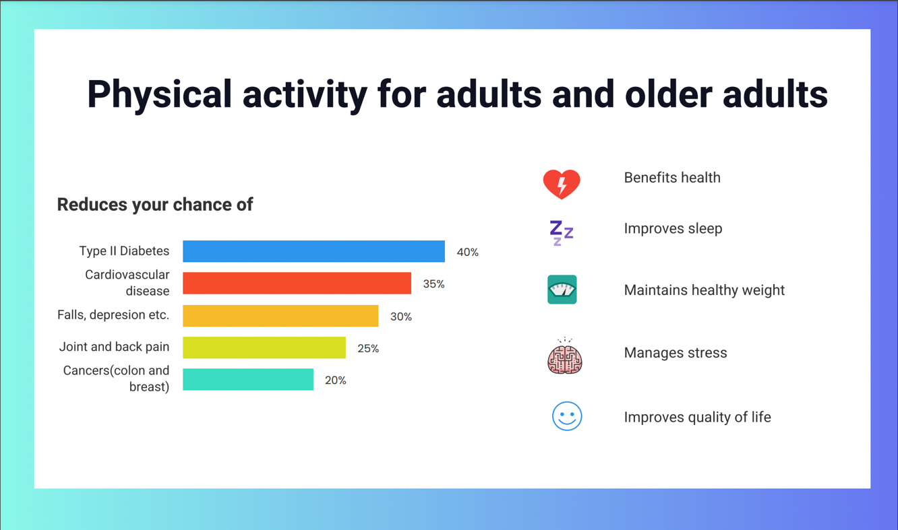
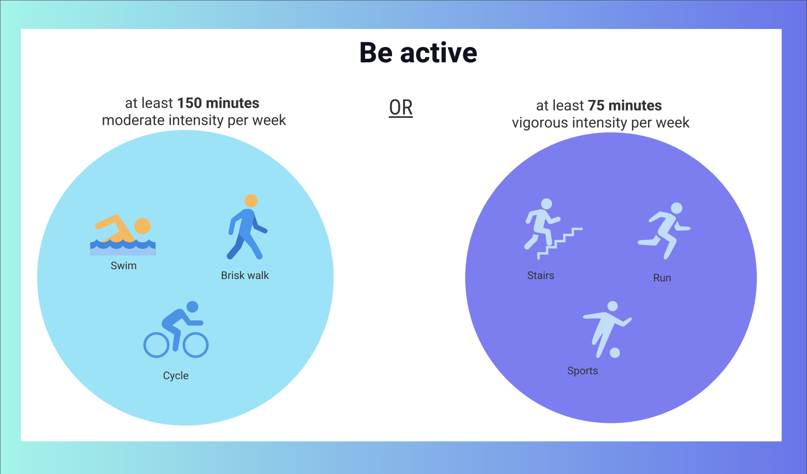

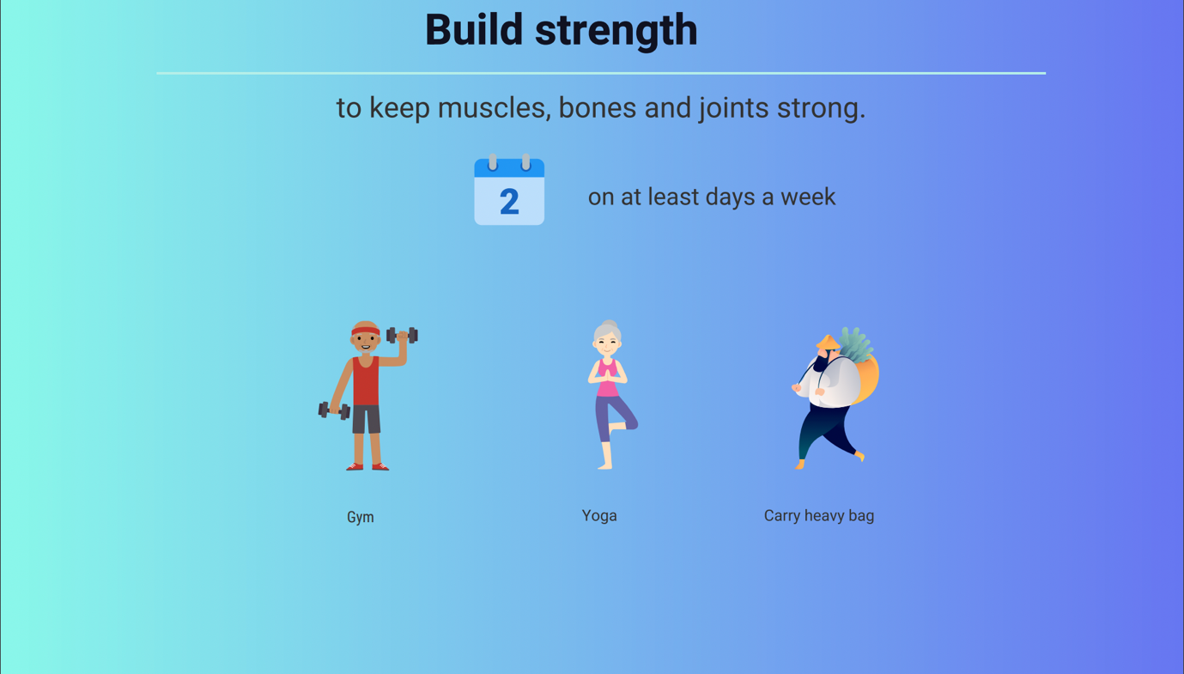

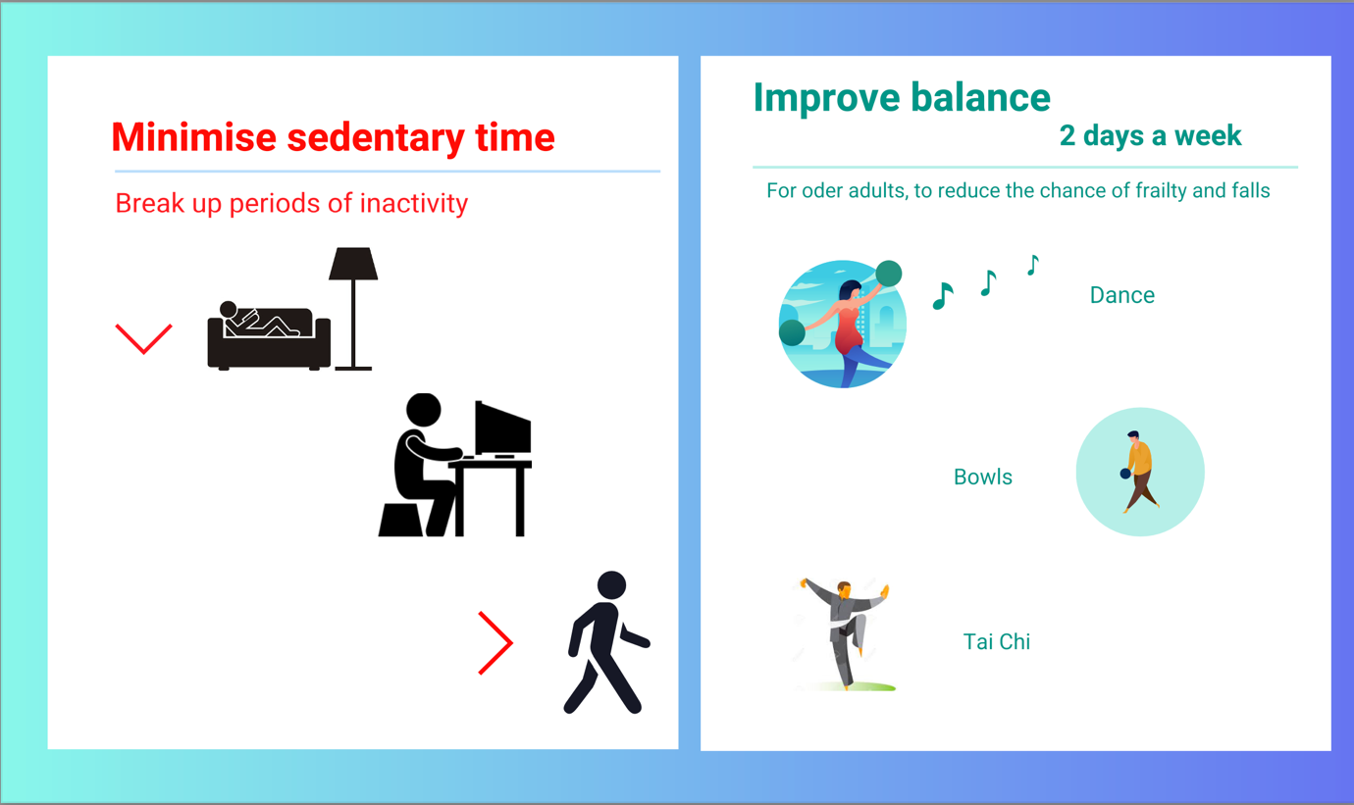

Conclusion and Recommendation:

Visualizations should make data easier to understand and not confuse the reader. The given infographic presented both quantitative and qualitative content, but only the design needs to make some changes. In conclusion, to perfect a best infographic, need to be taken into account many factors specified previously.
For the most pleasing design, follow these tips:
- Keep an eye on the alignment.
- Less text is better.
- Using icons instead of stock photos will give you a more modern and fresher look for your infographic.
- Pre-select readable fonts.
- Get your dimensions right.
- Don’t be afraid of negative space.
- Use an eye-catching title.
- Highlight your main points.
- Select a careful colour scheme.

References:
[1] BlackBearDesign (2018). The Meaning of Colour in Graphic Design from Black Bear Design. [online] Black Bear Design. Available at: https://www.blackbeardesign.com/blog/graphic-designers/understanding-color-the-meaning-of-color/.
[2] Camps, L. (2021). 10 Tips to Improve Your Infographics Right Now | Design Cloud. [online] DesignCloud. Available at: https://designcloud.app/10-tips-to-improve-your-infographics-right-now/.
[3] Breuninger, J. (2020). Legibility: how to make text convenient to read. [online] Medium. Available at: https://uxdesign.cc/legibility-how-to-make-text-convenient-to-read-7f96b84bd8af.
[4] Laurence, A. (2017). Sara Lynn Brennan. [online] Sara Lynn Brennan. Available at: https://www.saralynnbrennan.com/blog/the-60-30-10-design-rule.
[5] Mind Tools Content Team (2009). Cognitive Load Theory: Making Learning More Effective. [online] Mindtools.com. Available at: https://www.mindtools.com/pages/article/cognitive-load-theory.htm.
[6] Siricharoen, W.V. and Siricharoen, N. (2015). How Infographic should be evaluated? The 7th International Conference on Information Technology, 7(7).
[7] Visual Perception-Cognitive Ability. (n.d.). CogniFit. [online] Available at: https://www.cognifit.com/science/cognitive-skills/visual-perception.
[8] Keung, L. (2019). The Principles of Design. [online] Design & Illustration Envato Tuts+. Available at: https://design.tutsplus.com/articles/the-principles-of-design--cms-33962.

Appendices:

2.1

The contrast between the white text and the dark backgrounds leaves much to be desired, unnecessarily worsening legibility. Because the words and letters in the text are compact and close, when the white text reflects light, the reflected light scatters and reaches the neighbouring words and letters. This makes the shape of words and letters more difficult to perceive, which is stressful for the eyes. On the other side, they choose dark background on white text for most of their headings (red, purple, orange), which offer excellent contrast.
A better choice for displaying text is black text on a light background or grey text on a dark background. This will not put as much stress on the user's eyes, as the grey text is not as bright as the white text. It reflects less light, making it easier to read.
2.2
Each colour bears different emotional symbols and send different messages, such as:
- Purple can give a sense of wealth, luxury, or creativity. The message is: “Health is a luxury, and we have to work hard to maintain it.”
- Light green — often connected to growth and ambition. Another association is to move forward, giving it an association with the action. The message is: “Set goals and reach them.”
- Red is associated with power, passion, and energy. The message is: "Your physical and mental health is very important, and it is your strength."
- Orange is for creativity, youth, and enthusiasm. The message is: “This activity is not recommended.”
- Light blue provides a feeling of peace, trust, and friendliness. The message is: “Enjoy life and be healthy.”
The meaning of colours in our infographic:
- the red colour shows what is the power for adults and older adults - “Build strength”.
- the green colour symbolizes - “Be active”.
- the orange colour shows which activity is dangerous -” Minimise sedentary time”.
- the colour blue looks like freedom, and calm is important for adults and older adults - “Improve balance”.
- the colour purple shows what is the greatest wealth for adults and older adults - “Their Health”.
Unfavourable colour combinations between text and background were avoided in our infographic (as red and blue, blue, and yellow, red and blue/purple).
2.3
The 60-30-10 Rule can be broken down into the following steps:
- primary colour should dominate in proportion of 60 percent of the infographic area (red, yellow, blue).
- secondary colour should cover in proportion of 30 percent of the infographic (green, purple, orange).
- accent colour should cover the remaining 10 percent of the design. It’s the pop of colour that helps tie the whole graphic together.
In our infographic: primary colours dominate in proportion to 30 % and secondary colours cover in proportion 70%.

3.1

Similar style fonts with appropriate sizes made graphs be organized and easy to read and to follow. A set pixel margin is well set, and the guidelines for our infographic are set correctly. The pieces of text are all aligned in the same way, even if they are used in different parts of the infographic.

3.2

The headings are used to grab the user’s attention, to be more interesting and eye-catching. So, users will stop and read, instead of simply scrolling and searching for a relevant title or image. In our case, there are used bold and large headlines that offer the best readability and leave little room for artistic freedom. And no style variations were used which worsens the legibility of the text.

5.1

- Our infographic is an excellent example of medium contrast design.
- Balance - used symmetrical designs with elements of equal weight on each side of the infographic centre. But all the elements are clump.
- Emphasis - the most important information is the headlines of each graphic.
- Proportional differences between the tiny type, icons and texts clearly delineate the most important elements.
- Hierarchy using layout (the most important part is at the centre), size (more important content is larger), and typography (headlines are larger than body text). But it is hard to comprehend the order of the graphs and to follow it.
- White space is not used much.
- Here ordinary rhythms are used which follow the same distance between each element without variations.
- The images at the top of the infographic are a great example of repetition in design.
- The slanted images and bold headlines contribute to the movement principle.
- In our infographic, variety is created in a variety of ways, through colour, images, and shapes to create interest, while emphasizing the content of the main text.
- Unity - all visual elements have clear relationships with each other.

6.1
The information presented in this infographic does not affect the working memory of the users and does not overload it. Because explanatory information has a lesser impact on working memory if it is narrated (like images, icons, and text).
Another cognitive function that helps the user to interpret the information in our infographic is visual perception. Visual perception could be defined as the ability to interpret the information that our eyes receive. The main features that play a role in visual perception are lighting, contrast, shape, position (too close to each other), colour (white text), size (small text), and name. If we combine all these features, it is too difficult for older users to percept this infographic.[7]
This infographic is a mental model that helps older people understand how physical activity works. This mental model is a thinking tool used by the healthcare organizations to help older people understand the importance of physical activity in their lives, make decisions, and solve problems.[3]

