What recommendations can be implemented to reduce Obesity in Children in the UK? Obesity in Children.
Name: Isaac Alake
Student Number: 2132943
Module Code: BMHP5005
Name of lecturer: Hamdi Hussain

Abstract
Obesity in children is a serious medical concern globally as the impact of this issue can be seen in the form of heart issues, bone and joint weakness and pain, diabetes and high blood pressure. Number of cases of obesity in children are rising due to wide range of causes which must be addressed well on time. These causes include dietary habits, increase in screen time, limited physical activity, imbalanced sleep cycles and family history of obesity and unhealthy food choices of parents. There is less focus on diet and physical activity of children due to which obesity in children is rising. In the last two decades, this issue has worsened due to which quality of life of children is getting compromised.
Thus, it is important to take steps to overcome this issue and ensure a healthy life for children. Recommendations to minimise the cases of obesity in children are discussed in this research. These recommendations include offering free meals to the children in school which are prepared by taking the nutritional requirement of the children into account, introduction of mandatory guidelines for the amount of nutrition, physical activity level and sleep period children need and implementation of strict guidelines for food industry by the government.
Table of Contents
Introduction 3
Background information 4
Methodology and methods 6
Consideration of ethical practice in research 9
Results 10
Findings and discussion 12
Conclusion and recommendations 15
References 16

Introduction
Obesity in children is a serious medical condition which is affecting the quality of life of children at large. Obesity can be defined as the collection of excessive or abnormal fat that may result in impairment of health of a person. Poor psychological and emotional health are the implications of obesity in children. Bullying is faced by children because of obesity (Government UK, 2022). According to the report of WHO, Obesity has around tripled since the year 1975 all around the globe. In the year 2020, around 39 million children who were under the age of 5 years were obese or overweight. In 2016, the number of obese or overweight children and adolescents between the age of 5 to 19 years was 340 million (WHO, 2021).
Focus of this literature review will be on providing background information of the topic – Obesity in Children. Discussion will cover methods and approaches that are applied to collect data along with consideration of ethical practice. Findings will be presented which will be based on the review of the published secondary sources of literature. Recommendations will also be discussed to deal with obesity in children and improve their quality of life.

Background information
Obesity in children is causing extreme harm to them including emotional and behavioural, social absence, increased chances of obesity in later stages of life, increased chances of disability and premature mortality during adulthood, high cholesterol, high blood pressure, pre-diabetes, problems related to bones and joints and breathing difficulties (Government UK, 2022). In the United Kingdom, one in three children is obese or overweight by the time they are leaving primary school. In the United Kingdom, food insecurity is severely affecting the low-income household which is affecting the health of children in those households (Kingdon, 2023).
It is seen that children are consuming more than the recommended daily limit of sugar, not consuming sufficient nutrition and are not physically active which have contributed in excess weight gain. Physical activity is important for children to accomplish and maintain a healthy weight. In UK and internationally, obesity in children is a crucial public health problem and COVID19 has aggregated this health problem among children as schools were closed and social gatherings were not allowed (Baker, 2023).
Government of the UK has published “Tackling obesity: empowering adults and children to live healthier lives” in the July month of 2020 which defined the policies for supporting healthy eating and expansion of the weight management services of NHS. Another initiative taken by the government of UK is in the form of a release in September 2022. Government released “An implementation plan on the restriction of food and drinks high in fat, salt or sugar” with a motive to deal with the increasing prevalence of obesity (Nuffield Trust, 2020).
There has been increase in the number of hospital admissions due to obesity in children in England. Obesity in children has increased at large all around the globe in the fast few decades. Around 41 million children who were under the age of 5 years were obese worldwide in the year 2014. Obesity in children is seen as a major public health issue which is at rise and resulting severe health conditions among the children during their adulthood. Children with obesity suffer from social isolation and depression according to the UK Millennium Cohort Study. In the year 2015, £4.2 billion of expenses in the UK alone were attributable to obesity in direct way (Triggle, 2021).
Diet of adults is unhealthy consisting of high sugar, fast food and cold drinks which are harmful for the body. Adults are role models for children they are influencing the diets of children badly with their unhealthy diet. Impact of obesity in children can be seen in the form of adverse consequences on general wellbeing and mobility of children. Eating habits of parents determines the eating habits of the children and unhealthy eating habits of parents or family member may influence the eating habits of children. Positive or direct relation has been seen in the maternal obesity and weight gain in children (Tilenius, 2018).
This research topic has been selected as obesity in children is a serious medical condition and the number of children struggling with this medical condition is at rise. It is important to address this issue to ensure a better and healthy life for children. Obesity in children can result in long term consequences including physical, mental and psychological. By conducting research on this topic, focus has been placed on understanding this condition and the causes or reasons for this medical condition. Focus has been on identifying the ways through which number of cases of obesity in children can be reduced. This research is an initiative to gain understanding of the causes of this condition so that possible solutions can be explored.

Methodology and methods
Research theory
Research theory selected for this research work is research onion theory. With the help of this theory, research methodology can be designed by following a series of steps. Different layers are defined by this theory which are crucial for developing a sound research methodology to collect quality data for the research (Abdelhakim & Badr, 2021). This theory has helped in providing direction to the method selection process for this research.
Research method
Qualitative and quantitative research method has been selected in this research to meet the objective of the research. Quantitative research method is used for the purpose of finding patterns and averages, for observing situations and events which affect people and identification of trends and averages (Rahman, 2016). Qualitative research method provides non-numerical data including video, audio and text for understanding the opinion, issue or event better. By applying qualitative method, researchers can collect in-depth insights into the issue and new ideas can be generated for the research (Aspers & Corte, 2019). Secondary data has been collected with the help of both methods to accumulate the required data for the research.
Research design
Explanatory qualitative research design has been put to use to answer the objectives of the research. In this research design, focus is placed on gaining better understanding of a particular topic for predicting future occurrences. Focus of this design is placed on collecting information related to “why” and “how” questions so that the issue or problem can be understood and pattern can be identified ((Ansari, et. al., 2022). Existing data has been studied in this research for the purpose of investigating the patterns and trends. Main motive behind selection of this method is that this method is time and cost effective.

Research approach
Action research approach is the selected approach for this research. By using this approach, real-world problem can be solved. Issues and problems are the key focus of this approach so that proper diagnosis can be done (Doğanay & Öztürk, 2017). Obesity in children is a real-world problem which is affecting the lives of children all around the globe. This approach has been used to come up with solutions to deal with this issue.
Data collection method
Method selected for collecting data for this research work is secondary method. In the case of secondary method of data collection, researcher focuses on using the second hand data which was collected by other researchers for their work. This method is considered more reliable in comparison with primary method (Lowry, 2015). Secondary sources issued or published after 2014 have been used in this research and these sources include journals, articles available on websites such as Forbes, Wall Street journal and government websites.
Flow chart

Research limitations
Limitations identified in this research include use of secondary method only, lack of collection of first-hand data and shortage of time and resources. Authentic and reliable secondary sources have been used to over the limitation of use of secondary method and lack of collection of first-hand data. Research time frame was followed to complete the work well on time and allocation of resources properly.

Consideration of ethical practice in research
Ethical practice is essential aspect in a research work as it guides the actions of the researcher in ethical manner. Focus of the ethical practices is on not harming the interest of the stakeholders and ensuring that the research work gets completed by complying with the selected ethical values (Yip, et. al., 2016). Ethical values followed in this research include unbiasedness, secrecy and confidentiality and independent review of the secondary sources. Secondary sources have been reviewed independently to ensure that the personal opinion is not affecting the quality of the work and data collection and analysis process. Misconduct has been avoided by complying with the ethical values. Principle of fairness has been followed to ensure that the secondary data is presented in a fair manner. Proper citations have been done to ensure that the sources are properly cited and credit is given to the secondary sources from where data has been collected.

Results
Obesity in children is a social issue not only in UK, but all around the globe. Estimates have been made that around 91 million children might be suffering with obesity by the end of 2025 worldwide (Tilenius, 2018). In the year 2021-2022, around 10.1% of the children between the age 4-5 were obese in England. Obesity in children in more common among the children living in the most deprived parts of the UK. After the pandemic, obesity rates in children in England has increased drastically. As per the new data released on 16-11-2021, two out of 5 children who were between the age 10 to 11 were overweight and obese in England. Boys are more likely to be obese in comparison to girls. Another important factor which has shown direct link to body weight and obesity is ethnicity (Diabetes UK, 2021).
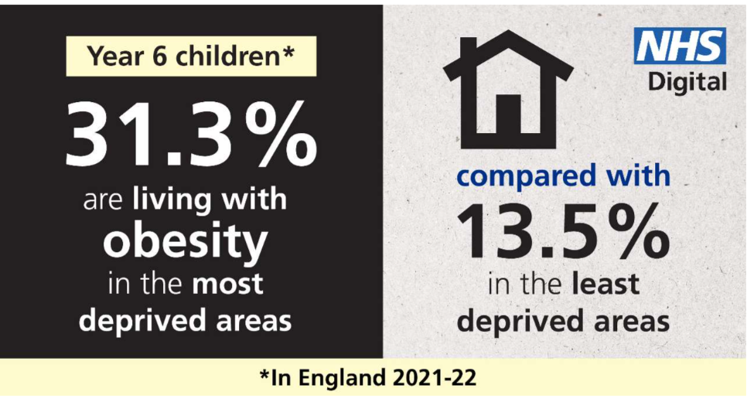
Figure 1: Percentage of children of 6 years suffering with obesity in England in 2021-2022
Source: (NHS, 2022)
Number of cases of type 2 diabetes, asthma and high blood pressure is at rise among children due to the increase in obesity in children. Cases of overweight and obesity were higher among the children who were between 1- to 11 years of age in 2018-2019 in the UK. It is seen that the rate of obesity is higher in children belonging to some of the ethnic minority groups. Obesity in children has resulted in weak immunity which makes them prone to infections and severe illness. Children living in the areas where low-income families live are more likely to suffer with obesity (Nuffield Trust, 2020).
Pandemic has resulted in substantial increase in the number of children with obesity in England. Around 14% of children were suffering with obesity at the start of primary school in 2020-2021 which was higher than the number of children with obesity at the start of primary school in 2019-2020 (BBC, 2021).
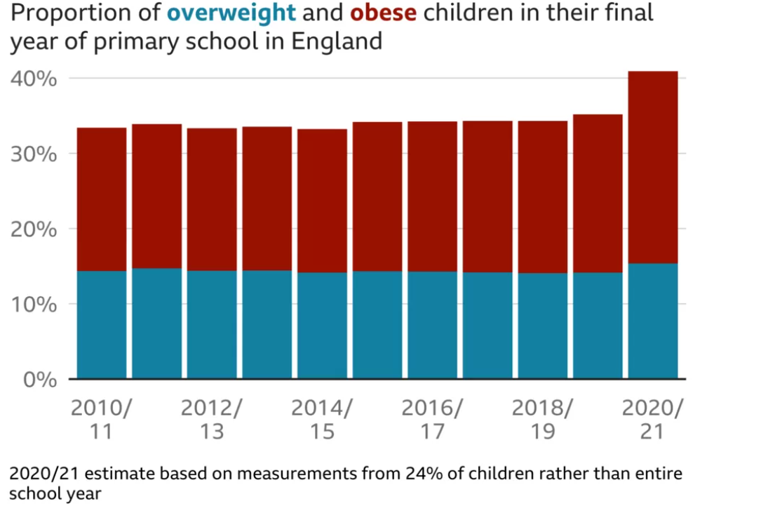
Figure 2: Estimates of jump in the number of children with obesity during COVID-19
Source: (BBC, 2021)
Several factors have been considered responsible for the significant rise in the number of children suffering with obesity in the UK. These factors include household income, diet of parents and family members, health condition of parents, gender of child, stress level, low income neighbourhoods, prescribed drugs which have weight gain as side effect, level of physical activity, increase in screen time of children and lifestyle issues (Government UK, 2020).

Findings and discussion
It has been found that several reasons are responsible for the significant increase in the number of cases of children suffering with obesity. COVID-19 has severe impact on excess weight gain in children in the UK as the schools were closed and social gatherings such as public parks and playing outside was restricted. This resulted in low physical activity among the children (). According to Jebeile, et. al. (2022), widening gap in inequality is a concerning factor which is contributing to poor nutrition and diet among children. In comparison to the children living in least deprived areas, number of children with obesity was higher in the most deprived areas. Children lost access to breakfast clubs and free school meals due to closure of schools due to COVID-19 resulted in low nutrition in the diet of children.
In the last decade, there has been fall in the level of physical activity due to screen time and lockdowns which have affected the health of the children. It is important to engage children in physical activity as by being physically active, physical and mental health benefits can be gained by the children which can help in maintaining a healthy weight. But diet has been seen as the most important factor which is responsible for weight gain and obesity in children in the UK. Record growth was experienced by food delivery companies (Kansra, et. al., 2021). In the year 2020, extra £160.8 million was spent on biscuits. This shows the increase in consumption of biscuits, cakes and other packed and processed food items (OHA, 2022).
According to Busam & Soloman-Moore (2021), dietary habits are crucial to ensure that the child is not obese. Junk foods are high in fat and fast carbohydrates which result in obesity in children. Sugared energy drinks are also being consumed by children which is directly linked to obesity in children. Low physical activity and increasing screen time are causing disturbance in hormones. Sleeping patterns have changed at large and children are deprived of sleep which is also contributing towards obesity. Genetic contribution is also a leading factor in the cases of obesity in children. When the parents are obese or have unhealthy lifestyle, then this affects the health of the children. Low income household are not capable offering food which fulfils the nutritional requirements of the children. Education about the health and nutritional values for children is also essential as it helps in ensuring that the parents are taking care of the nutritional needs of the children (Shaban Mohamed, et. al., 2022).
As per Salm, et. al. (2023), there are few health conditions such as hypothyroidism, cushing’s syndrome and growth hormone deficiency which result in obesity in children. Author also stated that there are certain medications used for children lead to weight gain such as antidepressants, anticonvulsants, corticosteroids and lithium. As per the reports published by BDA, in the year 2018-2019, 9.7% of children aged 4 to 5 years and 20.2% of children aged 10 to 11 years were classified as obese or severely obese. Health condition during the early life phase determines the health in adult life of a person. It is important to maintain healthy weight to eliminate the chances of suffering from hypertension, type 2 diabetes, poor mental health, body shaming, musculoskeletal pain and hyperlipidaemia (Atwal, 2020).
According to Safaei, et. al. (2021), engaging children in sports activities can be helpful in ensuring better health for children. Poor health literacy can be a contributing factor to obesity. Advertising campaigns must be fair so that the parents are well aware of the nutritional values in the food products. Health and social inequalities have created a well-recognised gap which has resulted in increase in number of cases of obesity in children in more deprived areas. Obesity in children are resulting in early puberty among girls and increase in the cases of children suffering with fatty liver diseases and cartilage damage.
According to government report, it is seen that the cases of severe obesity are at all-time high among children in England during the last year of primary school. Children are drowning in unhealthy food options in the UK due to which health issues have increased among children (Yeung, 2019). Health inequalities in the UK have been highlighted by the jump in childhood obesity. Poor children are at higher risk of suffering with obesity (Government UK, 2020). As per the report of NHS digital, it is found that children between the age of 4 to 5 years and 10 to 11 years increased by approximately 4.5 % in the year 2020. In the year 2021, there was increase to 14.4% in the cases of obesity among the children aged between four to five years of age. In the year 2021, obesity rate among the children aged between 10 to 11 increased to 25.5% in comparison to 21% in the year 2021 (Askew, 2021).
Obesity in Wales has been described as “national scandal” and there is absence of any sign of improvement. It has been revealed by the figures updated by Childhood Measurement Programme for Wales that 1/4th of the children who started primary school between the age of 4 to 5 years were obese and overweight in the year 2017-2018. More than 1000 children were classified as severely obese between 4 to 5 years of age in Wales which is worst in the UK. Main reasons listed as the case of obesity in children in Wales are low level of exercise, availability of cheap convenience food options and deprivation. Serious concerns have been raised over the increase in the rate of obese children in the UK. It is important to ensure control over the exposure of children to fast food which is a leading cause of obesity in children (Smith, 2019).
According to Geraghty (2019), focus of the parents should be on ensuring that the child is eating all meals well on time and avoid giving fast foods. Rising obesity in the UK among children is seen as an epidemic problem which can cause serious health problems for children in future. It is important to spread awareness among the people regarding this problem so that better initiatives can be taken to control the cases of obesity in children.

Conclusion and recommendations
Thus, it is summarised on the basis of the above discussion that obesity in children is a major health concern which has affecting the overall health and wellbeing of the children and their later journey. Obesity in children is at rise because of low physical activity, increased screen time and parental eating habits. It is important to deal with this health concern which is resulting in compromise in the health and life quality of children. Recommendations that can help in minimising the cases of obesity in children are discussed below:
Free school means for every child in school: It is important to offer free school means to every child in the school so that the required nutrition can be offered to the children which is needed for their proper growth. Meals should be designed as per the nutritional requirements of the children as per their age and body requirement. The gap between the children belonging to most deprived and least deprived is widening and offering free meals can help in minimising this gap to address these groups (Triggle, 2021).
Introduction of mandatory guidelines for the amount of food intake, nutrition related, physical activity related and sleep cycle: Recommendations must be made to make adjustment in the diets of children to the parents and schools so that better food options can be offered. Guidelines must be issued in respect to the time period for which children should exercise and sleep so that the chances of obesity in children can be minimised. It is important to break the low physical activity cycle and junk-food cycle to improve the health and wellbeing of children.
Strict guidelines for food industry to be designed by the government: It is important to reduce the sugar and calories in the packed food items offered by food industry. By forming strict guidelines, better control can be offered on what children are consuming in the form of packed items. Nutritional value of the packed food items can be improved.

References
Abdelhakim, A. S. & Badr, R. M., 2021. Adopted Research Designs By Tourism And Hospitality Postgraduates In The Light Of Research Onion. International Journal of Tourism and Hospitality Management, 4(2), 109.
Ansari, M. R., Rahim, K., Bhoje, R. & Bhosale, S., 2022. A Study On Research Design And Its Types. International Research Journal of Engineering and Technology (IRJET), 99(7), 1134-1135.
Askew, K., 2021. Jump in childhood obesity highlights UK health inequalities: ‘Childhood obesity is strongly associated with low incomes’. Available at https://www.foodnavigator.com/Article/2021/11/18/Jump-in-childhood-obesity-highlights-UK-health-inequalities-Childhood-obesity-is-strongly-associated-with-low-incomes#
Aspers, P. & Corte, U., 2019. What is Qualitative in Qualitative Research. Qual Sociol., 42(2):139-160.
Atwal, K., 2020. The childhood obesity pandemic: now more important than ever?. Available at https://www.bda.uk.com/resource/the-childhood-obesity-pandemic-now-more-important-than-ever.html
Baker, C., 2023. Obesity statistics. Available at https://commonslibrary.parliament.uk/research-briefings/sn03336/#:~:text=10.1%25%20of%20reception%20age%20children,and%20published%20by%20NHS%20Digital.
Busam, B. & Soloman-Moore, E., 2021. Public Understanding of Childhood Obesity: Qualitative Analysis of News Articles and Comments on Facebook. Health Communication, 38(5).
Diabetes UK, 2021. New figures show record increase in childhood obesity since pandemic. Available at https://www.diabetes.org.uk/about_us/news/new-figures-show-record-increase-childhood-obesity-pandemic#:~:text=Two%2Dfifths%20of%20children%20aged,and%20address%20the%20socioeconomic%20factors.
Doğanay, A. & Öztürk, A., 2017. Developing Attitudes towards Human Rights through Socioscientific Issues in Science Courses: An Action Research. Multidisciplinary Journal of Educational Research, 7, 253.
Geraghty, L., 2019. Fact/Fiction: Are working mums to blame for Britain’s child obesity crisis?. Available at https://www.bigissue.com/news/fact-fiction-are-working-mums-to-blame-for-britains-child-obesity-crisis/
Government UK, 2020. Tackling obesity: empowering adults and children to live healthier lives. Available at https://www.gov.uk/government/publications/tackling-obesity-government-strategy/tackling-obesity-empowering-adults-and-children-to-live-healthier-lives
Government UK, 2022. Childhood obesity: applying All Our Health. Available at https://www.gov.uk/government/publications/childhood-obesity-applying-all-our-health/childhood-obesity-applying-all-our-health#:~:text=In%20addition%3A-,children%20living%20with%20obesity%20are%20more%20likely%20to%20become%20adults,causal%20factors%20of%20excess%20weight
Jebeile, H., Kelly, A.S., O'Malley, G. & Baur, L. A., 2022. Obesity in children and adolescents: epidemiology, causes, assessment, and management. Lancet Diabetes Endocrinol. 10(5):351-365.
Kansra, A. R., Lakkunarajah, S. & Jay, M. S., 2021. Childhood and Adolescent Obesity: A Review. Front Pediatr.
Kingdon, C., 2023. The primary cause of Britain’s childhood obesity emergency is clear: poverty. Available at: https://www.theguardian.com/commentisfree/2023/apr/17/britain-childhood-obesity-emergency-is-poverty-type-2-diabetes
Lowry, L. D., 2015. Bridging the Business Data Divide: Insights into Primary and Secondary Data Use by Business Researchers. IASSIST Quarterly.
NHS, 2022. Latest obesity figures for England show a strong link between children living with obesity and deprivation: statistical press. Available at https://digital.nhs.uk/news/2022/national-child-measurement-programme-21-22
Nuffield Trust, 2020. Obesity. Available at: https://www.nuffieldtrust.org.uk/resource/obesity
OHA, 2022. Making a bad situation worse: Covid-19 and the impact on childhood obesity. Available at https://obesityhealthalliance.org.uk/2022/01/13/making-a-bad-situation-worse-covid-19-and-the-impact-on-childhood-obesity/
Rahman, M. S., 2016. The Advantages and Disadvantages of Using Qualitative and Quantitative Approaches and Methods in Language “Testing and Assessment” Research: A Literature Review. Journal of Education and Learning, 6(1), 103-104.
Safaei, M., Sundararajan, E. A., Driss, M., Boulila, W. & Shapi’I, A., 2021. A systematic literature review on obesity: Understanding the causes & consequences of obesity and reviewing various machine learning approaches used to predict obesity. Computers in Biology and Medicine, 136.
Salm, L., Nisbett, N., Cuming, K., Hrynick, T., Lulache, A. & MacGregor, H., 2023. A whole system approach to childhood obesity: how a supportive environment was created in the city of Brighton and Hove, United Kingdom. Food Sec., 15, 919–935.
Shaban Mohamed, M.A., AbouKhatwa, M.M., Saifullah, A.A., Hareez Syahmi, M., Mosaad, M., Elrggal, M.E., Dehele, I.S. and Elnaem, M.H., 2022. Risk Factors, Clinical Consequences, Prevention, and Treatment of Childhood Obesity. Children, 9(12), p.1975.
Smith, M., 2019. Wales has the UK’s biggest childhood obesity problem - and here are the worst areas. Available at https://www.walesonline.co.uk/news/health/childhood-obesity-wales-worst-uk-15934926
Tilenius, H., 2018. Childhood obesity: a challenge for primary care teams. BJGP, 68(667): 90-91.
Triggle, N., 2021. Pandemic sees big rise in obese children in England. Available at https://www.bbc.com/news/health-59308878
WHO, 2021. Obesity and Overweight. Available at https://www.who.int/news-room/fact-sheets/detail/obesity-and-overweight
Yeung, J., 2019. Severe obesity among 10 and 11-year-olds hits all-time high in UK. Available at https://edition.cnn.com/2019/10/11/health/uk-child-obesity-intl-hnk-scli/index.html
Yip, C., Han, N. R. & Sng, B. L., 2016. Legal and ethical issues in research. Indian J Anaesth., 60(9), 684-688.

