Name:_____Daniel Jones____________________________

Student Number: ___2404095_____________________
__________________________________________________________

WORKSHEET 3 – TESTING (Lap Times)

- Original code:
lapTime = []

print("Welcome to the Racing Stats program:\n")

# User Input Lap Time
for counter in range(0, 5, 1) :
i = 0
lapTime.append(input(f"Please input the time for lap {counter + 1} (seconds): \n"))

# Input Validation
while i == 0 :
if lapTime[counter].isalpha() :
print("Invalid input (No special characters or letters allowed)")
lapTime[counter] = input(f"Please input the time for lap {counter + 1} (seconds): \n")
elif lapTime[counter] == "" :
print("Invalid input (Missing Input)")
lapTime[counter] = input(f"Please input the time for lap {counter + 1} (seconds): \n")
else :
lapTime[counter] = float(lapTime[counter])
i = 1

# User Input Target Time
i = 0
while i == 0 :
targetLapTime = input("Now please enter your target lap time: \n")

# Input Validation
if targetLapTime.isalpha() :
print("Invalid input (No special characters or letters allowed)")
elif targetLapTime == "" :
print("Invalid input (Missing Input)")
else :
i = 1

targetLapTime = float(targetLapTime)

# Variable Declaration
totalTime = sum(lapTime)
avgLapTime = round(totalTime/5, 2)
maxLapTime = max(lapTime)
minLapTime = min(lapTime)

successLaps = 0

lapSpeed = []

# Number of laps that matched or beat the target time
for counter in range(0, len(lapTime), 1) :
if lapTime[counter] <= targetLapTime :
successLaps = successLaps + 1

# Lap comparison from previous lap speed
for counter in range(1, len(lapTime), 1) :
if lapTime[counter-1] == lapTime[counter] :
lapSpeed.append("Same Speed")
elif lapTime[counter-1] > lapTime[counter] :
lapSpeed.append("Faster")
else :
lapSpeed.append("Slower")

# Statistic output
print("\nYour statistics...\n")
print(f"1. Overall time for 5 laps was: {totalTime} seconds")
print(f"2. Average lap time was: {avgLapTime} seconds")
print(f"3. The fastest lap was lap {lapTime.index(minLapTime)+1} in {minLapTime} seconds")
print(f"4. The slowest lap was lap {lapTime.index(maxLapTime)+1} in {maxLapTime} seconds")

# Statistic output - successful laps
if successLaps > 0 :
print(f"5. {successLaps} of your laps were better than or equal to your target time")
else :
print("5. None of your laps were better than or equal to your target time")

print("6.")

# Statistic Output - laps time and speed list
for counter in range(0, len(lapTime), 1) :
if counter < 1 :
print(f"Lap 1 was {lapTime[counter]} seconds")
else :
print(f"Lap {counter + 1} was {lapTime[counter]} seconds which was {lapSpeed[counter-1]} than the previous lap")

- Code Testing
For each test below, run your code and show the results of the scenarios below. Present a screenshot of what happened when the programme ran. Did the programme behave correctly or did it do something unexpected, and if so, why?

- Test a lap time for your programme:
- 42 seconds
- 2 seconds
- -4 seconds
- 53444 seconds
- Test the target lap time – show that the values entered are reasonable

- Using the same five lap times as the sample output ie

Lap 1: 42.3
Lap 2: 42.1
Lap 3: 44
Lap 4: 44
Lap 5: 39.4

Examine each statistic (1-6) and comment on whether the correct answer(s) are displayed or not. (If any statistics were incomplete after Phase 1 (code completed in class) simply write “Unfinished”)

- Test two further sets of lap times of your own choice.

Template for tests:
Test i:
Input i. - Enter lap time: 42 Seconds

Screenshot(s) of output:
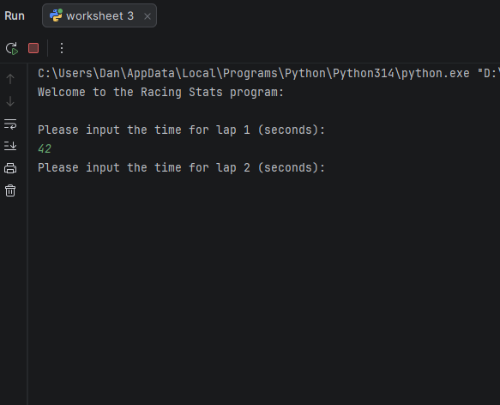
Result: Did the programme behave as expected ie syntactically and logically correct?
Yes, entering the lap time 42 seconds behaved as expected as it did not throw up any errors and allows the user to now enter the second lap time.

Test ii:
Input ii. - Enter lap time: 2 Seconds

Screenshot(s) of output:
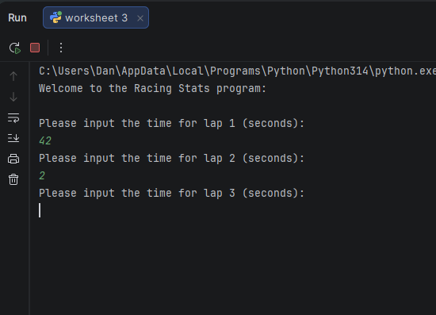
Result: Did the programme behave as expected ie syntactically and logically correct?
Yes, entering 2 seconds for a lap time is also successful as no validation errors have come up. However, this does make me think that logically there should be a minimum lap time as it is very unlikely for a lap to be completed in 2 seconds.

Test iii:
Input iii. - Enter lap time: -4 Seconds

Screenshot(s) of output:
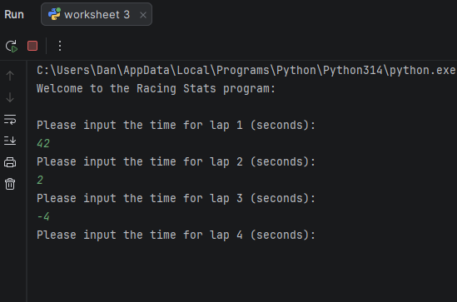
Result: Did the programme behave as expected ie syntactically and logically correct?
No, this did not work as expected. The validation should have picked up on the special character “-” and denied it but instead it seems there was no validation in place to detect special characters and instead only to detect letters and or blank spaces.

Test iv:
Input iv. - Enter lap time: 53444 Seconds

Screenshot(s) of output:
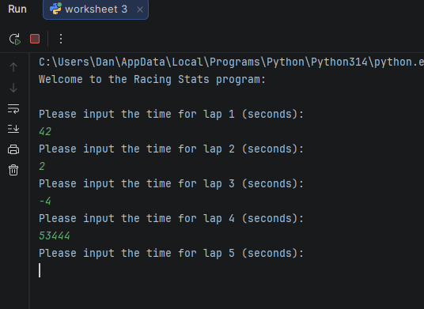
Result: Did the programme behave as expected ie syntactically and logically correct?
Yes, this value worked as expected. However, again this raises the question of if the code should include a maximum lap time to ensure only realistic values are used.

Test v:
Input v. - Enter target lap time (show that the values entered are reasonable)

Screenshot(s) of output:
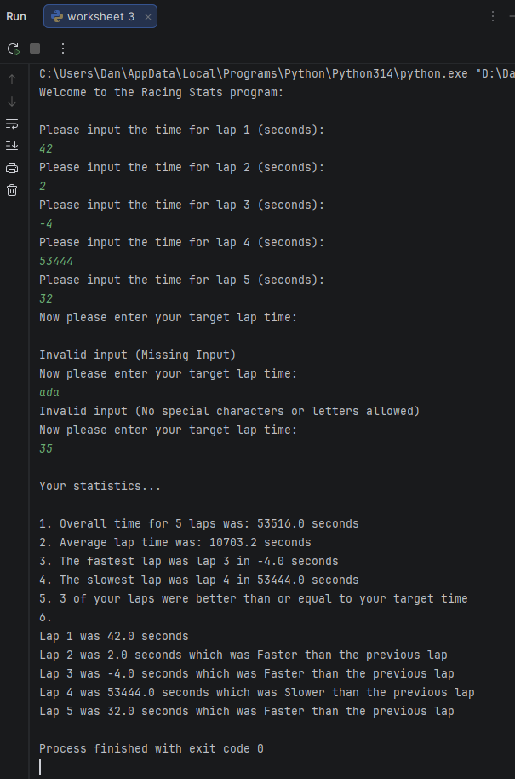
Result: Did the programme behave as expected ie syntactically and logically correct?
Yes, the code worked as behaved as the target lap time not only picked up on the blank input but also the invalid input of characters. When submitted with an accurate number “35” the code then allowed the user to proceed with the statistics as intended.

Test vi:
Output i. - Lap 1: 42.3 | Lap 2: 42.1 | Lap 3: 44 | Lap 4: 44 | Lap 5: 39.4

Screenshot(s) of output:
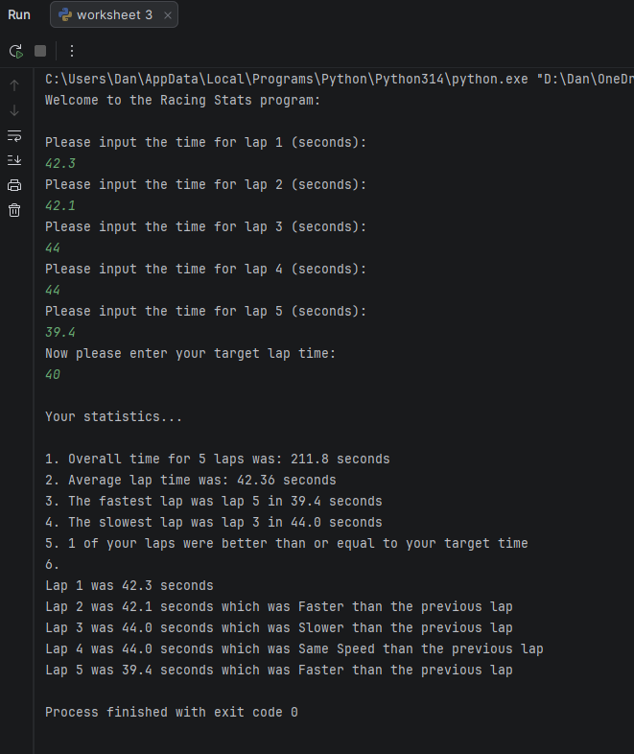
Result: Did the programme behave as expected ie syntactically and logically correct?
Yes, the code worked as expected. The statistics seems to all have been outputted correctly with accurate values for the input given.

Test vii:
Output ii. – Negative Values

Screenshot(s) of output:
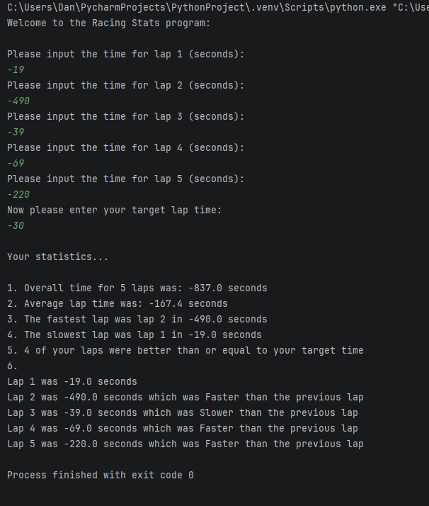
Result: Did the programme behave as expected ie syntactically and logically correct?
No, as previously found the code is allowing results in the which logically shouldn’t make sense in relation to racing times.

Test viii:
Output iii. – Large Values

Screenshot(s) of output: 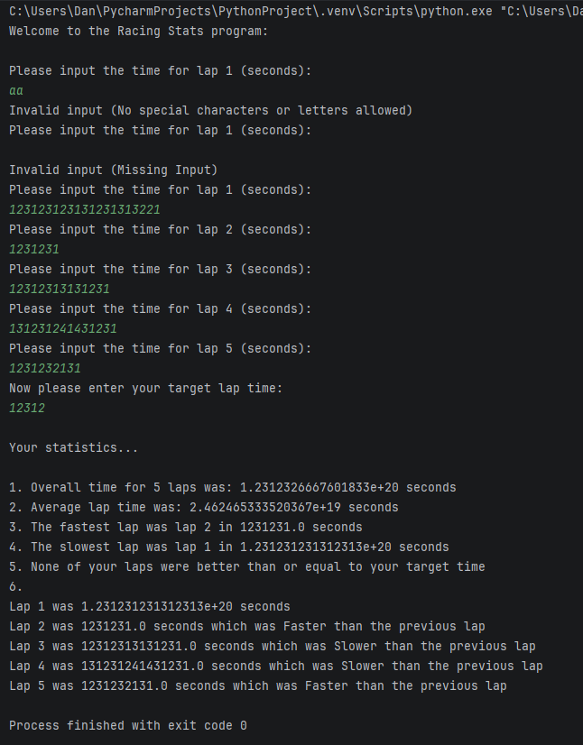

Result: Did the programme behave as expected ie syntactically and logically correct?
No, the code did indeed catch that invalid letters and or blank inputs that were used and correctly asked the user to re-enter which was great but it seems there is nothing in the code that prevents a user from entering a massive numerical input which should be out of the scope of this program. Limits should be made to the input that prevent the user from entering values that are too high.

- Consider the results of the above tests and revisit your original code in order to address any tests that failed and/or improve code efficiency.

(Note: you may not be able to solve all of the problems that were encountered, but solve as many as you can.)

Paste your full revised code here :

lapTime = []
print("Welcome to the Racing Stats program:\n")
# User Input Lap Time
for counter in range(0, 5, 1) :
i = 0
lapTime.append(input(f"Please input the time for lap {counter + 1} (seconds): \n"))
# Input Validation
while i == 0 :
if lapTime[counter].isalpha() :
print("Invalid input (No special characters or letters allowed)")
lapTime[counter] = input(f"Please input the time for lap {counter + 1} (seconds): \n")
elif lapTime[counter] == "" or lapTime[counter].isspace() :
print("Invalid input (Missing Input)")
lapTime[counter] = input(f"Please input the time for lap {counter + 1} (seconds): \n")
elif float(lapTime[counter]) > 9999 :
print("Invalid input (Time Cannot Exceed 9999 Seconds)")
lapTime[counter] = input(f"Please input the time for lap {counter + 1} (seconds): \n")
elif float(lapTime[counter]) < 5 :
print("Invalid input (Time Cannot Be Less Then 5 Seconds)")
lapTime[counter] = input(f"Please input the time for lap {counter + 1} (seconds): \n")
else :
lapTime[counter] = float(lapTime[counter])
i = 1
# User Input Target Time
i = 0
while i == 0 :
targetLapTime = input("Now please enter your target lap time: \n")
# Input Validation
if targetLapTime.isalpha() :
print("Invalid input (No special characters or letters allowed)")
elif targetLapTime == "" or targetLapTime.isspace() :
print("Invalid input (Missing Input)")
elif float(targetLapTime) > 9999 :
print("Invalid input (Time Cannot Exceed 9999 Seconds)")
elif float(targetLapTime) < 5 :
print("Invalid input (Time Cannot Be Less Then 5 Seconds)")
else :
i = 1
targetLapTime = float(targetLapTime)
# Variable Declaration
totalTime = sum(lapTime)
avgLapTime = round(totalTime/5, 2)
maxLapTime = max(lapTime)
minLapTime = min(lapTime)
successLaps = 0
lapSpeed = []
# Number of laps that matched or beat the target time
for counter in range(0, len(lapTime), 1) :
if lapTime[counter] <= targetLapTime :
successLaps = successLaps + 1
# Lap comparison from previous lap speed
for counter in range(1, len(lapTime), 1) :
if lapTime[counter-1] == lapTime[counter] :
lapSpeed.append("Same Speed")
elif lapTime[counter-1] > lapTime[counter] :
lapSpeed.append("Faster")
else :
lapSpeed.append("Slower")
# Statistic output
print("\nYour statistics...\n")
print(f"1. Overall time for 5 laps was: {totalTime} seconds")
print(f"2. Average lap time was: {avgLapTime} seconds")
print(f"3. The fastest lap was lap {lapTime.index(minLapTime)+1} in {minLapTime} seconds")
print(f"4. The slowest lap was lap {lapTime.index(maxLapTime)+1} in {maxLapTime} seconds")
# Statistic output - successful laps
if successLaps > 0 :
print(f"5. {successLaps} of your laps were better than or equal to your target time")
else :
print("5. None of your laps were better than or equal to your target time")
print("6.")
# Statistic Output - laps time and speed list
for counter in range(0, len(lapTime), 1) :
if counter < 1 :
print(f"Lap 1 was {lapTime[counter]} seconds")
else :
print(f"Lap {counter + 1} was {lapTime[counter]} seconds which was {lapSpeed[counter-1]} than the previous lap")

