AHHI5017 Contesting Conflict: Representations of War, 1789–Present
Weeks 9: The Holocaust
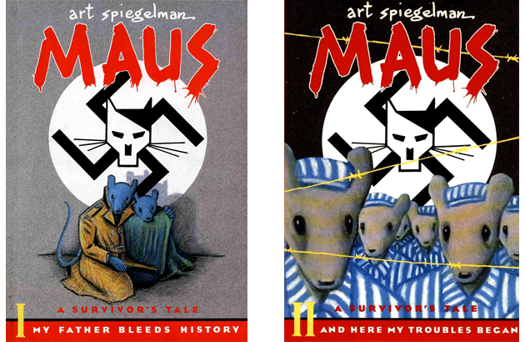

Lectures summary:
This lecture examines the challenges of commemorating the Holocaust. It gravitates around Theodor Adorno’s dictum about the impossibility of “poetry after Auschwitz,” as explored through an examination Art Spiegelmann’s celebrated comic Maus. We shall also consider instances in which Holocaust memory is given material form at former concentration camps and museums respectively. Thought is given to the built and natural landscapes of the camps as they exist today; to the different commemorative practices enacted at them; and to how the camps can be interpreted as expressing political sentiments.

Required reading:
- Michael Rothberg, introduction, Traumatic Realism: The Demands of Holocaust Representation (University of Minnesota: Minneapolis, 2000), pp. 1–15.
- Art Spiegelman, Maus: A Survivor's Tale (London: Penguin 2003 [original serialisation 1980–1991]), pp. 5–25, 164–167, 199–234, 261–277.

Lecture preparation:
When preparing for the seminar, it may be advisable to first read the chapter from Michael Rothberg’s Traumatic Realism: The Demands of Holocaust Representation as it offers a very general introduction to Holocaust literature and scholarship, and brings attention to a number of themes relevant to the other assigned texts. Then read the extracts from Maus, paying attention to Spiegelman’s text and his images. The latter extracts are not as much reading as they might appear: they combine illustrations as well as text.
Note: The amount of literature and scholarship that has been written about the Holocaust can make it an intimidating topic to approach, so students should not be unduly concerned if they feel as though they do not have a clear grasp on this vast subject area. They should concentrate instead on getting a clear handle on the writings by Rothberg and Spiegelman.
An overview of Holocaust literature is available here: http://www.oxfordreference.com/view/10.1093/acref/9780192806871.001.0001/acref-9780192806871-e-3682?rskey=HaKuJS&result=6.

Questions to consider
General
Interpret the below quotations:
“We know that we will have difficulty being understood, and this is as it should be. But consider what value, what meaning is enclosed even in the smallest of our daily habits, in the hundred possessions even the poorest beggar owns: a handkerchief, an old letter, the photo of a cherished person. These things are part of us, almost like limbs in our body; nor is it conceivable that we can be deprived of them in our world, for we immediately find others to substitute old ones, other objects that our ours in their personification and evocation of our memories.
“Imagine now a man who is deprived of everyone he loves, and at the same time of his house, his habits, his clothes, in short, of everything he possess: he will be a hollow man, reduced to suffering and needs, forgetful of dignity and restraint … he will be a man whose life or death can be lightly decided with no sense of human affinity.”
- Primo Levi, ‘On the Bottom,’ If This is a Man and The Truce (London: Abacus, 1979), p. 33

“In 1944, the Nazis blew up the gas chambers and crematoria at Auschwitz, but the ruins remain … the Warsaw ghetto, after the famous insurrection in the spring of 1943, was razed to the ground, but thanks to the superhuman efforts of a number of fight-historians who made certain in that rubble, often many metres deeps, or smuggled beyond the wall, testimony survived, other historians could rediscover, how day by day, the ghetto lived and dies. All the archives in the Lagers were burned during the last days of the war, and that was truly an irremediable loss, so that even today there is discussion as to whether the victims were four, six, or eight million.”
- Primo Levi, The Drowned and the Saved (London: Abacus, 1988), p.2

Rothberg, The Demands of Holocaust Representation
- What two key approaches does Rothberg claim have “dominated” (p. 3) writing and thinking about the Holocaust?

- What three key demands does Rothberg claim that the Holocaust makes on “attempts at comprehension and representation” (p.7)?

- How do interpret Theodor Adorno’s comment that “to write poetry after Auschwitz is barbaric?” Why might it be deemed “barbaric” to write poetry after Auschwitz?
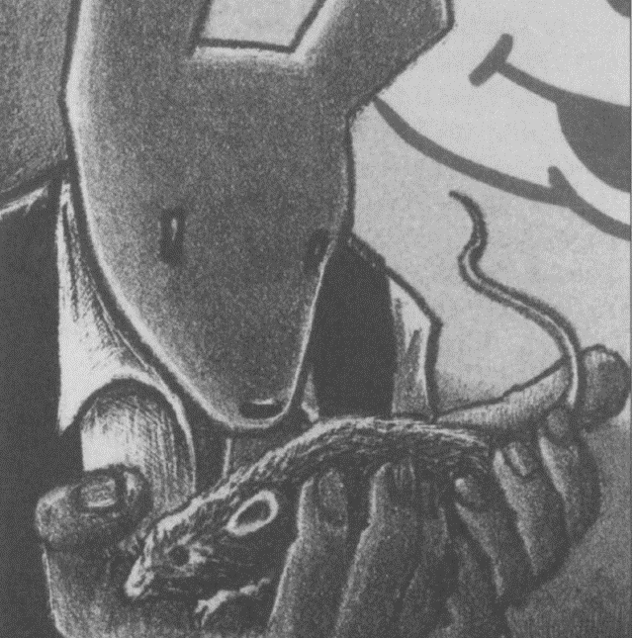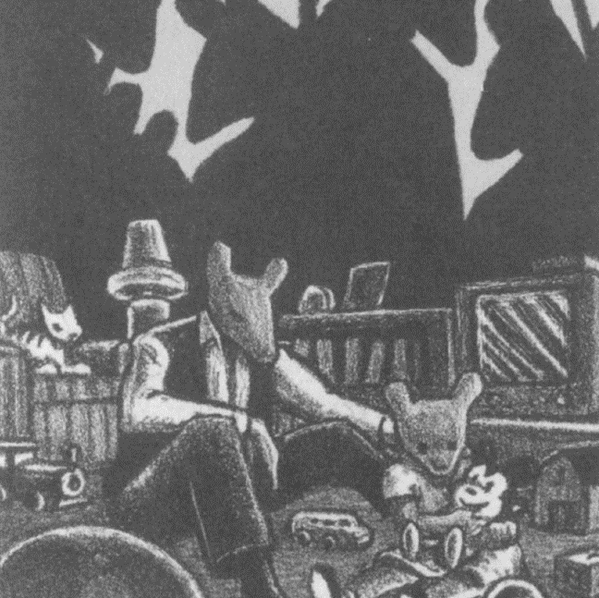
- Why does Rothberg choose to begin by writing about illustrations by Art Spiegelman (see above)? What insights does he suggest these offer about Holocaust representation? What interpretations of Maus does he offer?
Spiegelman, Maus
- Can you summarise the following features of Maus:
- Its plot
- Its key characters
- Its setting
- Its literary genre?

- What do you think were Spiegelman’s motivations for writing about the Holocaust in the manner in which he did? Why do you think he chose to use animals as a narrative/pictorial device?

- Do you think the way Spiegelman represents the Holocaust is effective?

- How does Maus relate to Adorno’s comments about “poetry after Auschwitz?”

