

Student name: | Manav Patel | Student ID number: | 2437942
Programme: | MSc Data and Artificial Intelligence
Module: | L7 - Artificial Intelligence
Module code: | ACCA7026 | Contribution to Overall Module Assessment (%): | 50%
Lecturer: | Malik Mehmoud | Internal Verifier: | Dr Seena Joseph
Assignment Title: | Assignment – ML Model | Word count (or equivalent): | 3000

Abstract
The sentiment analysis is among the primary applications of the natural language processing and the artificial intelligence (NLP) which is aimed at identifying the opinion and emotion in the textual information automatically. With the quantity of online platforms increasing at a quick rate, organisations must have sentiment analysis increasingly to acquire insights into customer remarks, monitor brand perception, and ground information-oriented choices. The paper will discuss the applications of machine learning and models based on transformers in sentiment categorization on IMDB movie reviews dataset. The data will be comprised of labeled reviews with positive or negative sentiments towards the movies. Two models of sentiment analysis were performed and compared, a classical machine learning model based on Term FrequencyInverse Document Frequency (TF-IDF) and Logistic Regression, and one based on deep learning transformers and BERT. Lemmatisation, removing stopwords, and tokenisation of text data were done before the models were trained. The models were all tested based on the popular measures of classification that included the accuracy, accuracy, recall, F1-score and confusion matrix. The results indicate that, BERT model possesses superior contextual understanding and superior classification performance compared to the conventional TF-IDF based technique.

Table of Contents
Abstract 2
1. Introduction 5
2. Related Work 5
2.1 Sentiment Analysis in Natural Language Processing 5
2.2 Traditional Machine Learning Approaches 6
2.3 Deep Learning and Transformer Models 6
3. Methodology 6
3.1 Dataset Description 6
3.2 Data Preprocessing 6
3.2.1 Text Cleaning 6
3.2.2 Tokenisation 7
3.2.3 Stopword Removal 7
3.2.4 Lemmatization or Stemming 8
3.3 Exploratory Data Analysis 8
3.3.1 Class Distribution Analysis 8
3.3.2 Word Frequency Analysis 9
3.3.3 Text Length Distribution 10
3.4 Traditional Machine Learning Model (TF-IDF + Logistic Regression) 10
3.4.1 Feature Extraction using TF-IDF 10
3.4.2 Logistic Regression Classifier 11
3.4.3 Hyperparameter Optimisation 11
3.5 Transformer-based Model (BERT) 12
3.5.1 BERT Tokenisation 12
3.5.2 Model Architecture 12
3.5.3 Model Training Procedure 12
3.6 Evaluation Metrics 13
4. Results and Discussion 13
4.1 Model Performance Comparison 13
4.2 Confusion Matrix Analysis 16
4.3 Computational Efficiency and Model Complexity 17
4.4 Comparison with Previous Studies 18
4.5 Model Interpretability and Feature Importance 18
5. Conclusion and Recommendations 19
5.1 Summary of Key Findings 19
References 20

1. Introduction
Sentiment analysis is a new type of artificial intelligence and natural language processing (NLP) to examine opinions and feelings in text data. Organisations have access to a lot of user-generated content because of the accelerating online presence of social media, review websites and discussion forums. This cannot be easily analysed manually and hence automated sentiment analysis is an essential tool to understand the opinion of the people, their normalisation, and market trends. By establishing the existence of positive or negative sentiment in textual material, the organisations make effective observations that will translate to decision-making and improved products and services.
NLP is also significant towards understanding the human language by machines. The classical machine learning techniques such as Bag-of-Words and TF-IDF have been widely used to carry out text classification tasks.
This research will strive to develop and experiment with the sentiment analysis models on both traditional machine learning and transformer-based models. Specifically, the paper in question will preprocess and analyse the data of IMDB reviews, run TF-IDF and BERT-based models and compare the findings using the prevalent assessment criteria.

2. Related Work

2.1 Sentiment Analysis in Natural Language Processing
Sentiment analysis or opinion mining is one of the central studies of Natural Language Processing (NLP) research which seeks to extract opinions, emotions, and attitudes in textual data. Sentiment analysis has acquired significance over the recent years as the use of web platforms such as social media, blogs, websites that evaluate products and services rapidly gains impetus, as the sentiment analysis offers an opportunity to examine large volumes of information that is generated by users (Ahmed et al., 2025). The sentiment analysis is widely applied in organisations to measure customer satisfaction, brand reputation, and opinion analysis of the people. Early sentiment analysis techniques were lexicon-based techniques which- to determine sentiment polarity- used pre-existing lists of positive and negative words.

2.2 Traditional Machine Learning Approaches
Traditional machine learning algorithms have been applied in sentiment classification to a great extent; these algorithms include: naive bayes, support and logistic regression algorithms. These methods typically involve text convolution engines such as Bag-of-Words and TF-IDF to give text a numerical representation.

2.3 Deep Learning and Transformer Models
Deep learning models like CNN, RNN, and LSTM help to improve sentiment analysis with the help of sequence models of text. In more recent times, transformer-based models such as BERT, DistilBERT and RoBERTa, have used attention mechanisms to extract contextual meaning in sentences (Ahmed et al., 2024). Other methods of interpretability such as SHAP and attention visualisation are the ways of explaining model predictions and making NLP systems become more transparent.

3. Methodology

3.1 Dataset Description
The data set to assume in this experiment is the IMDB Large Movie Review Dataset a popular benchmark data set which have been applied in sentiment analysis research. It has 50,000 tagged movie review, and they are collected at the Internet Movie Database (IMDB). The data will be divided into 25,000 training reviews and 25,000 testing reviews (above reviews will belong to a specific category based on their sentiment polarity either positive or negative). The primary advantage of this data set is that it has a balanced format as the number of positive and negative reviews is equal, and this fact reduces the classification bias during a model training (Arora, Gupta and Pathak, 2023). It organizes the data into two distinct train and test folders that have positives (pos) and negatives (neg) subfolders in which single reviews are accessed in the form of text files.

3.2 Data Preprocessing
The information retrieved on the Internet in written format is likely to have noises and inconsistency and other irrelevant aspects that could compromise the machine learning models.

3.2.1 Text Cleaning
The raw textual data was first cleaned to remove unwanted characters and formatting items. The presence of HTML tags, punctuations, numbers, and other characters when reviewing movies are not necessarily applicable in sentiment classification. These elements were removed with regular expressions to ensure that only valuable text-based information would be left behind (Boparai, Aggarwal and Rani, 2025).
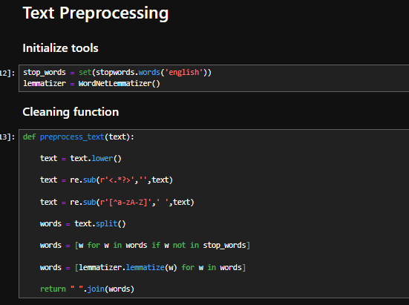
Figure 1: Preprocessing
(Source: Obtained from Jupyter Notebook)

3.2.2 Tokenisation
Division of text into smaller units which are typically single words is referred to as tokenisation. This is because machine learning algorithms do not operate with raw sentences. The model can be used to analyse individual words within each review and construct significant linguistic patterns by tokenising (Danyal et al., 2025). By converting sentences to tokenised words the model can learn about the relationship between terms and sentiment categories.

3.2.3 Stopword Removal
Stopwords usually contain as that are present in a text, such as the, is, and, and in; these are words that are very frequent, but do not generally have much semantic information to be employed in sentiment classification. These words were eliminated by using predefined stopword lists as part of natural language processing libraries (Danyal et al., 2024). Stopwords removal will help reduce the dimensions of the dataset and allow the model to focus on words that contribute to the manifestation of sentiment with more significant weight.

3.2.4 Lemmatization or Stemming
Lemmatization, which is the shortening of words to base or root words, brought about shortening of words. One of them is that the words, such as running, runs, and ran are replaced by the basic variant run. The process also ensures that the dissimilarities of the same word are treated as a single feature during the analysis. Lemmatization increases consistency in features and vocabulary reduction that improves the performance and efficiency of the model (Domadula and Sayyaparaju, 2023).

3.3 Exploratory Data Analysis
Exploratory Data Analysis (EDA) was conducted to study the discourse of the dataset and their properties that would be used in constructing the classification models.

3.3.1 Class Distribution Analysis
The first was to examine the ratio of the good and bad reviews in the dataset. The IMDB data is balanced with the equal number of reviews of each kind of sentiment. The visualisation of the distribution revealed that the dataset has quite an equal number of positive and negative reactions (Duru and Sunar, 2025). This symmetrical shape is important in the education of category types since the unequal distribution of data can lead to a prejudiced forecast.
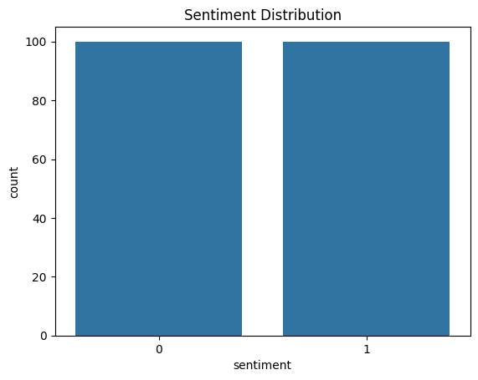
Figure 2: sentiment Distribution
(Source: Obtained from Jupyter Notebook)

3.3.2 Word Frequency Analysis
The frequency analysis of words was done to find out the most recurring words in the dataset. It is possible to analyse the frequency of the words in both positive and negative reviews, which can be understood with the help of the analysis. Datasets of sentiments usually contain words of high emotional expressions (Hegde et al., 2024). Word frequency analysis provides data on the frequency of words usage within the text and also serves to ensure that the preprocessing phase has been successful and that it has removed irrelevant words.
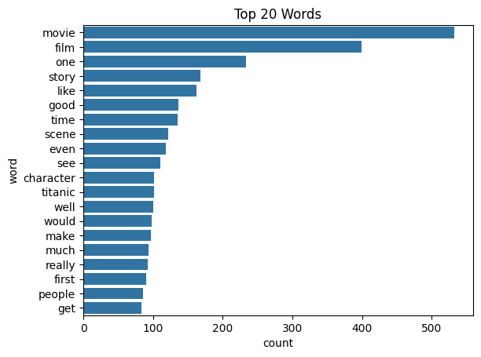
Figure 3: Word Frequency Plot
(Source: Obtained from Jupyter Notebook)

3.3.3 Text Length Distribution
Another important aspect of the dataset is the distribution of the length of the review. The form of reviews can be varied and may comprise of the brief notes or elaborate descriptive reviews. The analysis of text length helps to determine the existence of extreme variations of the dataset that can affect the model performance (Ipadeola, Ojo and Adebayo, 2025).

3.4 Traditional Machine Learning Model (TF-IDF + Logistic Regression)

3.4.1 Feature Extraction using TF-IDF
To have machine learning models analyze texts, the processed text must be represented as numbers. The technique used in this paper to encode the text as feature vectors was Term Frequency-Inverse Document Frequency (TF-IDF). The TF-IDF is utilized to calculate which word is important in a document relative to the whole data set. The importance degree of common words in a given document, which are not common in others, is greater (Khan and Alharbi, 2024). Such an approach will highlight important words and neutralize the occurrence of very frequent words. TF-IDF vectorisation algorithm converts the individual reviews of the movies into numerical vectors that can be inputted into classification algorithms.
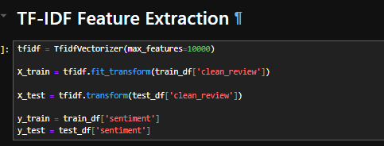
Figure 4: TF-IDF
(Source: Obtained from Jupyter Notebook)

3.4.2 Logistic Regression Classifier
The model of machine learning used in sentiment classification was the Logistic Regression. Logistic Regression is highly sought after in the binary classification tasks because it approximates the probability of an occurrence of a particular value based on an input. In this paper, the model was trained using the TF-IDF feature vectors obtained on the basis of the preprocessed reviews. It is an algorithm that learns a decision boundary between positive and negative sentiment classes based on the input features (Kokab, Asghar and Naz, 2022). Logistic Regression is relatively computationally efficient and has a high-quality baseline performance in text classification.

3.4.3 Hyperparameter Optimisation
Tuning of the hyperparameters was done to improve the performance of Logistic Regression model. Regularisation strength is a parameter, which defines the tradeoff between the capability of a given model to fit the training data and the capability of a model to overfit. The different parameter values were tested using the grid search methods and the one which produced the best performance in terms of classification was identified (Malavika, Murali and Vimina, 2025). Optimal hyperparameter can be used to ensure the model is generalised on unseen data.
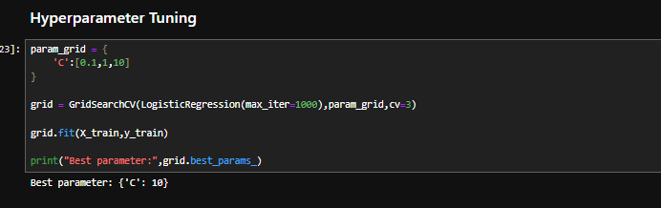
Figure 5: Hyperparameter
(Source: Obtained from Jupyter Notebook)

3.5 Transformer-based Model (BERT)

3.5.1 BERT Tokenisation
Text preprocessing was done in the case of the transformer-based model through the BERT tokenizer that is specifically designed to operate with transformer architectures. BERT tokeniser uses subword tokenisation as opposed to other more classical tokenisation systems that use text as individual words. The strategy allows this model to work more efficiently with rare words or less familiar ones (Pradhananga and Sah, 2023).

3.5.2 Model Architecture
The model used in this study is the BERT (Bidirectional Encoder Representations from Transformers). A trained deep learning system is called BERT, which is trained on large textual corpora. It deploys a self-attention transformer architecture in order to extract the contextual relationship among the words in a sentence. The pretrained BERT model was walled in the sentiment analysis exercise, which has a classification layer that predicted whether the review has positive or negative sentiment (Putra and Sunyoto, 2026).

3.5.3 Model Training Procedure
The tokenised reviews were trained using the BERT model to generate contextual embeddings. Such embeddings represent the semantic meaning of the text but consider the context of each word. The model was trained on the labelled IMDB reviews to learn the relationship between the text patterns and sentiment labels (Shettar and Ramya, 2025). Fine-tuning allows the pretrained BERT model to tune the model to the sentiment classification problem.

3.6 Evaluation Metrics
Both models were evaluated by means of certain conventional measures of classification. Measuring correctly predicted cases is accomplished by using accuracy. Precision refers to the count of the accurate positive cases which it predicted versus the genuine positive cases, and recall measures the extent of the accurate global cases differentiated (Sinha, Ponnusamy and Subramaniam, 2025). F1-score provides an artificial assessment of recall and accuracy.

4. Results and Discussion
This section presents experimental results of the implementation of the two models of sentiment analysis and provides the description of the performance. The results show that the traditional machine learning and transformer-based techniques can be helpful in categorizing the reviews of movies in terms of the sentiment polarity (Souza and Filho, 2023).

4.1 Model Performance Comparison
As it was discovered, the performance of the two models produced within the frames of the given study was evaluated using common classification metrics like accuracy, precision, recall, and F1-score. The models that were compared were the old TF-IDF model with the use of the Logistic Regression classifier and the BERT transformer-based model.
The Logistic Regression model considers the use of TF-IDF, which transforms the text into numeric vectors and the algorithm is trained to learn the relationship between words and sentiment classes (Vaish, Goel and Gupta, 2025). It is computationally efficient and used in the classification of texts but does not use contextual connections among words which is why this approach is not used.
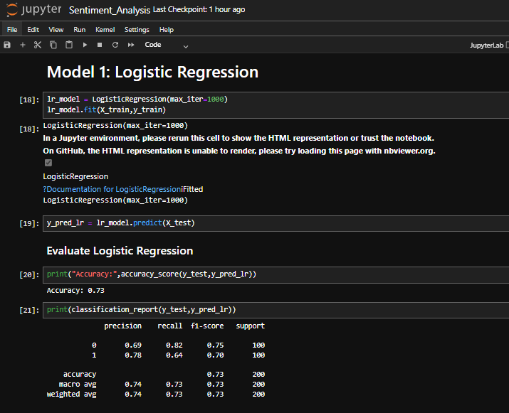
Figure 6: Logistic Regression With TF-IDF
(Source: Obtained from Jupyter Notebook)
BERT model, however, utilizes the benefits of transformer-based architecture and contextual embeddings to learn words in the context they are used. This allows the model to learn the language pattern in a superior way and become more accurate in making predictions.
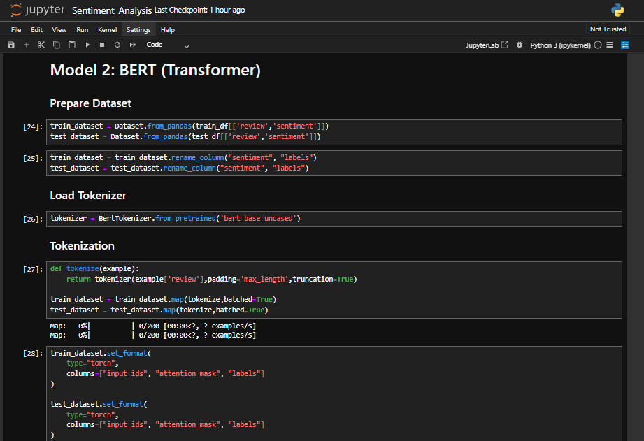
Figure 7: BERT Model
(Source: Obtained from Jupyter Notebook)
As this experiment shows, BERT model proves to be much more efficient as compared to the classical machine learning methodology. The Logistic Regression had the accuracy of 0.73, and the accuracy of the BERT model was 0.80. This improvement of the performance of BERT can be attributed to its ability to detect semantic relationship and contextual meaning of sentences.
Model | Accuracy
TF-IDF + Logistic Regression | 0.73
BERT Transformer Model | 0.80
Table 1: Model Performance Comparison
This evidence indicates that the transformer-based models have a better sentiment classification approach than the traditional machine learning algorithms.

4.2 Confusion Matrix Analysis
The confusion matrix presents the breakdown of the model predictions in the form of an elaborate comparison of the predicted labels and the actual sentiment classes. It helps to identify the true positives, true negatives, false positives and false negatives which can be used to measure the accuracy of the classification model.
True positives are the reviews, which are correctly expected to be positive, and true negatives are those, which are correctly expected to be negative. False positives are false identifications of a negative review as a positive review and false negatives are false identifications of a positive review as a negative review.
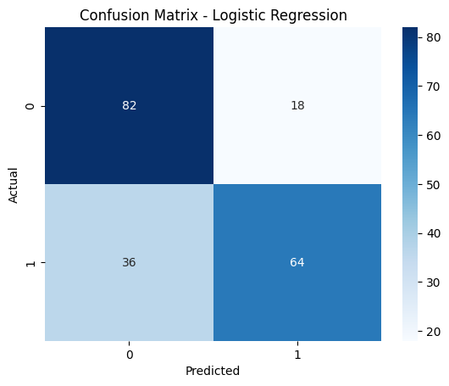
Figure 8: Logistic Regression Confusion matrix
(Source: Obtained from Jupyter Notebook)
In Logistic Regression model, the confusion matrix indicates that despite the fact that the model can be used to classify several of the reviews, it at times fails to differentiate subtle patterns in language. This is one of the reasons that lead to some kind of a misclassification of reviews that have mixed or complex sentiment expression.
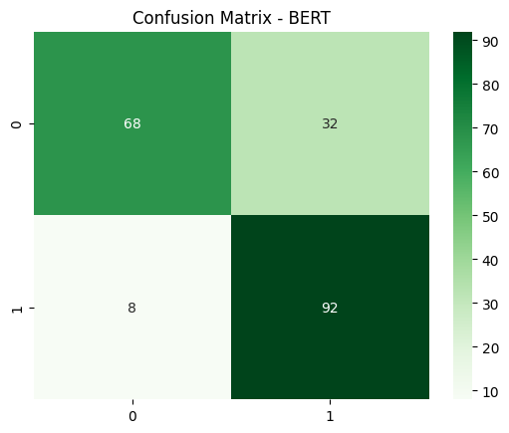
Figure 9: BERT Model Confusion matrix
(Source: Obtained from Jupyter Notebook)
The BERT model achieves improved classification behaviour on the confusion matrix. The language contextual interpretation of the language makes the model better placed to comprehend sentence-word associations. Therefore, BERT reduces the errors in classification when compared to the conventional model. This improvement is the reason why more useful transformer-based models are to be used when it comes to imitating more profound semantic meaning in the text.

4.3 Computational Efficiency and Model Complexity
Although the BERT model is more accurate in classification, it is also far computationally intensive compared to the Logistic Regression model. The classic machine learning algorithm consists of TF-IDF vectorisation and a simple linear classifier, which allows the algorithm to be trained fast and executed well with standard computing devices.
Transformer-based models such as BERT, in their turn, have millions of parameters and are more likely to require more computing resources, memory, and training time. Fine-tuning the BERT model may involve using more than a single transformer layer, bringing complexity and resources to the model.

4.4 Comparison with Previous Studies
The results of this paper are comparable to the results of the previous studies in sentiment analysis. Past studies show that the traditional machine learning models such as Logistic Regression and Support Vector Machines can work with reasonable rates when trained with feature extraction models such as TF-IDF.

4.5 Model Interpretability and Feature Importance
The manner in which machine learning models yield predictions to increase the visibility and reliability of AI systems is also relevant to learn. The methods of interpretability (SHAP, SHapley Additive exPlanations or attention visualisation) are applied to understand which words or phrases play the most important role in making a sentiment prediction.
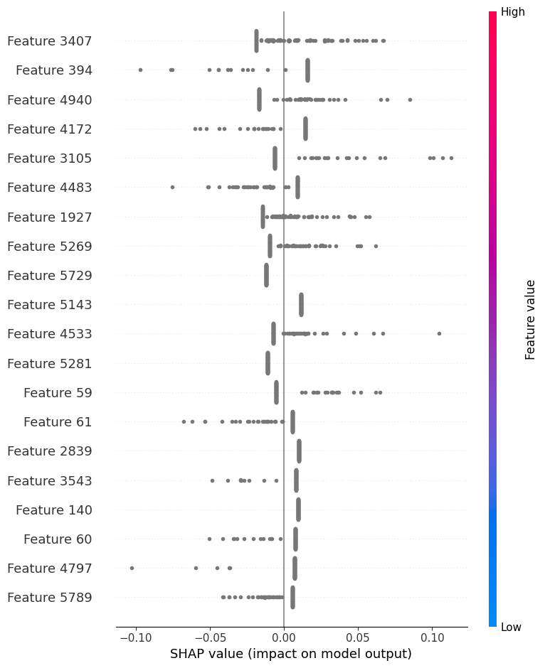
Figure 10: SHAP Analysis
(Source: Obtained from Jupyter Notebook)
With the traditional models, SHAP values may indicate the influential features of the TF-IDF vectors, that is, those words that significantly influence the classification outcome. To understand the sentiment of a sentence that is being formed by a transformer-based model, one can pay attention to visualisation of what the model is paying attention to at any one point of the sentence. These interpretability tools can help the researchers to understand the behaviour of a model, potential biases, and to increase the credibility of the sentiment analysis frameworks (Yadav, Garg and Jain, 2025).

5. Conclusion and Recommendations

5.1 Summary of Key Findings
The two methods of sentiment analysis discussed in this paper are a classical machine learning system using TF-IDF and Logistic Regression and a deep learning system using transformers and BERT. IMDB movie review dataset was used in the training and evaluation of both models. The practical results show that the Logistic Regression model was good with an accuracy of 0.73 as compared to BERT which had a superior accuracy of 0.80. The ability to create the contextual relationship among words based on transformer-like structure has made BERT superior to others. The traditional models are founded on frequency of words and thus lack the capability of expressing better semantics.
Sentiment analysis systems can also be of advantage to organisations since they can handle large volumes of customer response, product reviews and social media posts to give useful information. Such insights can guide the businesses to have an understanding of customer satisfaction, brand reputation, and enhance the trends. Proper sentiment classification models enable informational decision-making and help organisations to improve products, services, and customer experience.
Future research could explore the possibility of better exploiting large and more diverse data sets to improve generalisation of models. In addition to that, one can develop multilingual sentiment analysis models to analyse text in other languages. Transparency and belief of AI-based sentiment analysis systems can also be improved by conducting further studies on the methods of model interpretability.

References
Ahmed, A., Ahmed, N., Ghafoor, U., Rizwan, S.M., Qureshi, R., Khan, H. and Hussain, M.Z., 2025. An Enhanced Textual Review Classification and Sentiment Analysis Approach based on Machine Learning: A Comprehensive Analysis for Text Categorization Approaches. The Asian Bulletin of Big Data Management, 5(4), pp.259-291.
Ahmed, S., Samia, M.M., Sayma, M.H., Kabir, M.M. and Mridha, M.F., 2024. tRF-BERT: A transformative approach to aspect-based sentiment analysis in the bengali language. Plos one, 19(9), p.e0308050.
Arora, K., Gupta, N. and Pathak, S., 2023, July. Sentimental analysis on imdb movies review using bert. In 2023 4th International Conference on Electronics and Sustainable Communication Systems (ICESC) (pp. 866-871). IEEE.
Boparai, N., Aggarwal, H. and Rani, R., 2025, June. Comparative Analysis of BERT-based Classifiers using Semantics of Hotel Reviews. In 2025 International Conference on Electronics, AI and Computing (EAIC) (pp. 1-8). IEEE.
Danyal, M.M., Khalid, A., Khan, S.S.K. and Shah, J., 2025. Citation Sentiment Classification using XLNet & Transformer Models on a Comprehensive Corpus. Journal of Independent Studies and Research Computing, 23(2), pp.1-11.
Danyal, M.M., Khan, S.S., Khan, M., Ullah, S., Mehmood, F. and Ali, I., 2024. Proposing sentiment analysis model based on BERT and XLNet for movie reviews. Multimedia tools and applications, 83(24), pp.64315-64339.
Domadula, P.S.S.V. and Sayyaparaju, S.S., 2023. Sentiment analysis of IMDB movie reviews: a comparative study of Lexicon based approach and BERT Neural Network model.
Duru, I. and Sunar, A.S., 2025. Transformer and Pre-Transformer Model-Based Sentiment Prediction with Various Embeddings: A Case Study on Amazon Reviews. Entropy, 27(12), p.1202.
Hegde, N.P., Vikkurty, S., Kumar, S.V., Devineni, A. and Cherukuri, S., 2024, February. Comparative Study of Models in Sentiment Analysis. In International Conference on Communications and Cyber Physical Engineering 2018 (pp. 1545-1552). Singapore: Springer Nature Singapore.
Ipadeola, I.O., Ojo, J.A. and Adebayo, I.G., 2025. Sentiment Analysis of Movie Reviews using Word Embeddings and Machine Learning Techniques. LAUTECH Journal of Engineering and Technology, 19(3), pp.155-160.
Jamshidian, M., 2023. Evaluation of text transformers for classifying sentiment of reviews by using tf-idf, bert (word embedding), sbert (sentence embedding) with support vector machine evaluation.
Khan, S.S. and Alharbi, Y., 2024. Sentiment analysis of movie review classifications using deep learning approaches. International Journal of Advanced and Applied Sciences, 11(8), pp.146-157.
Kokab, S.T., Asghar, S. and Naz, S., 2022. Transformer-based deep learning models for the sentiment analysis of social media data. Array, 14, p.100157.
Malavika, N.S., Murali, G. and Vimina, E.R., 2025, May. Sentiment Analysis of Movie Reviews with Transformer Models: A Deep Learning Approach to Text Classification. In 2025 5th International Conference on Pervasive Computing and Social Networking (ICPCSN) (pp. 1384-1388). IEEE.
Pradhananga, A. and Sah, A.K., 2023. Transformer-based deep learning models for sentiment analysis in Romanized Nepali: a comparative investigation of BERT and RoBERTa. In Proceedings of 14th IOE graduate conference (Vol. 14).
Putra, R.D. and Sunyoto, A., 2026. The Application of BERT in Sentiment Analysis of IMDB Movie Reviews. Journal of Social Research, 5(2), pp.614-622.
Shettar, R. and Ramya, V., 2025, November. Sentiment Analysis Using Natural Language Processing. In 2025 9th International Conference on Computational System and Information Technology for Sustainable Solutions (CSITSS) (pp. 1-6). IEEE.
Sinha, A., Ponnusamy, R.R. and Subramaniam, P., 2025, April. Movie Recommendation System using Posters and Overview through Convolutional Neural Network and BERT Transformer. In 2025 International Conference on Metaverse and Current Trends in Computing (ICMCTC) (pp. 1-5). IEEE.
Souza, F.D. and Filho, J.B.D.O.E.S., 2023. Embedding generation for text classification of Brazilian Portuguese user reviews: from bag-of-words to transformers. Neural Computing and Applications, 35(13), pp.9393-9406.
Vaish, N., Goel, N. and Gupta, G., 2025. Sentiment analysis using AdBERT model. International Journal of Data Science and Analytics, 19(3), pp.419-433.
Yadav, A., Garg, P. and Jain, T., 2025, February. Sentiment Analysis of Movie Reviews Using Machine Learning. In 2025 International Conference on Pervasive Computational Technologies (ICPCT) (pp. 41-45). IEEE.

