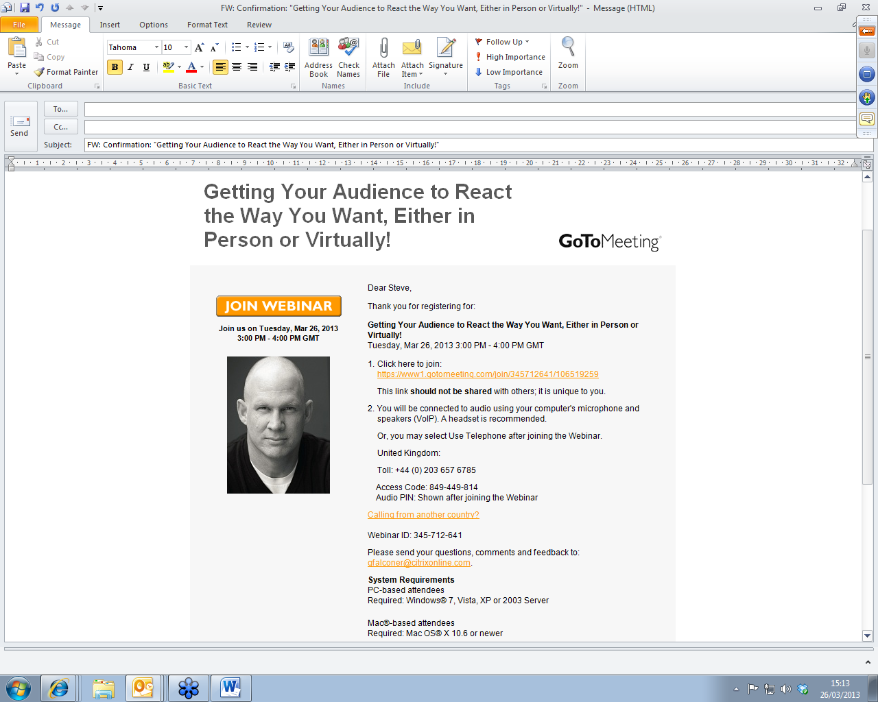
26 March 2013 Webinar notes
Based on training actors
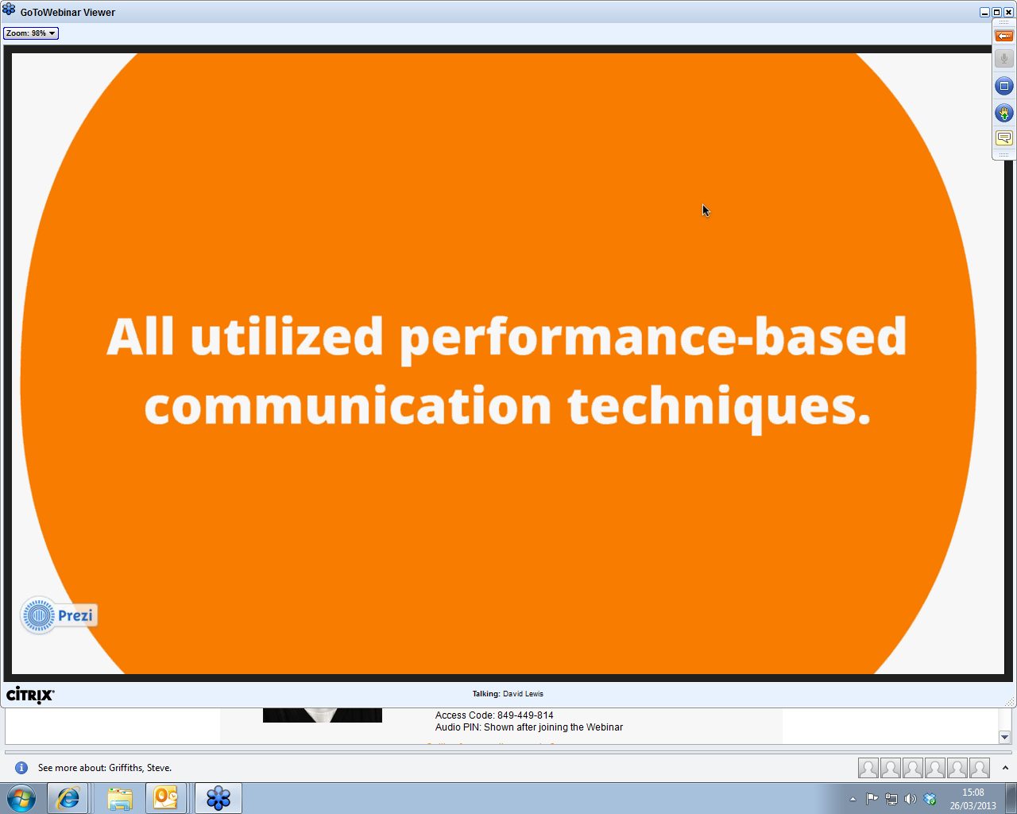

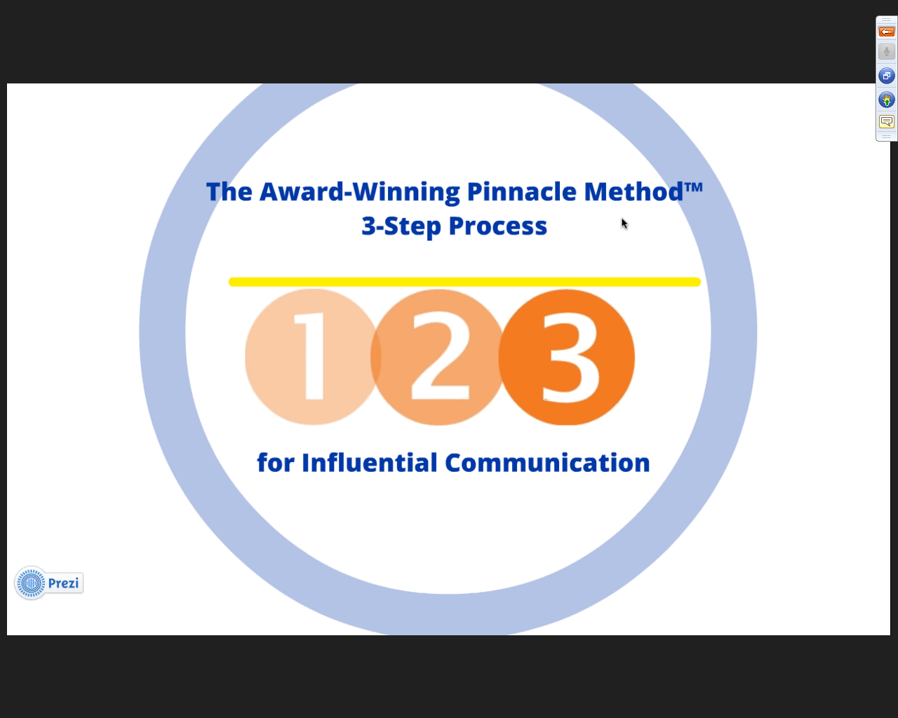

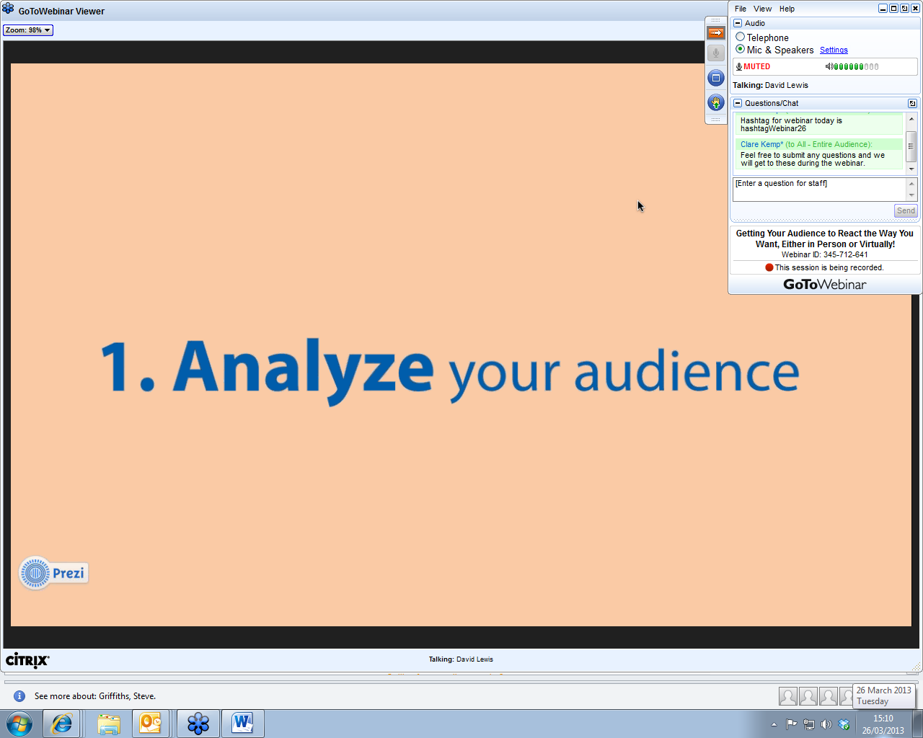
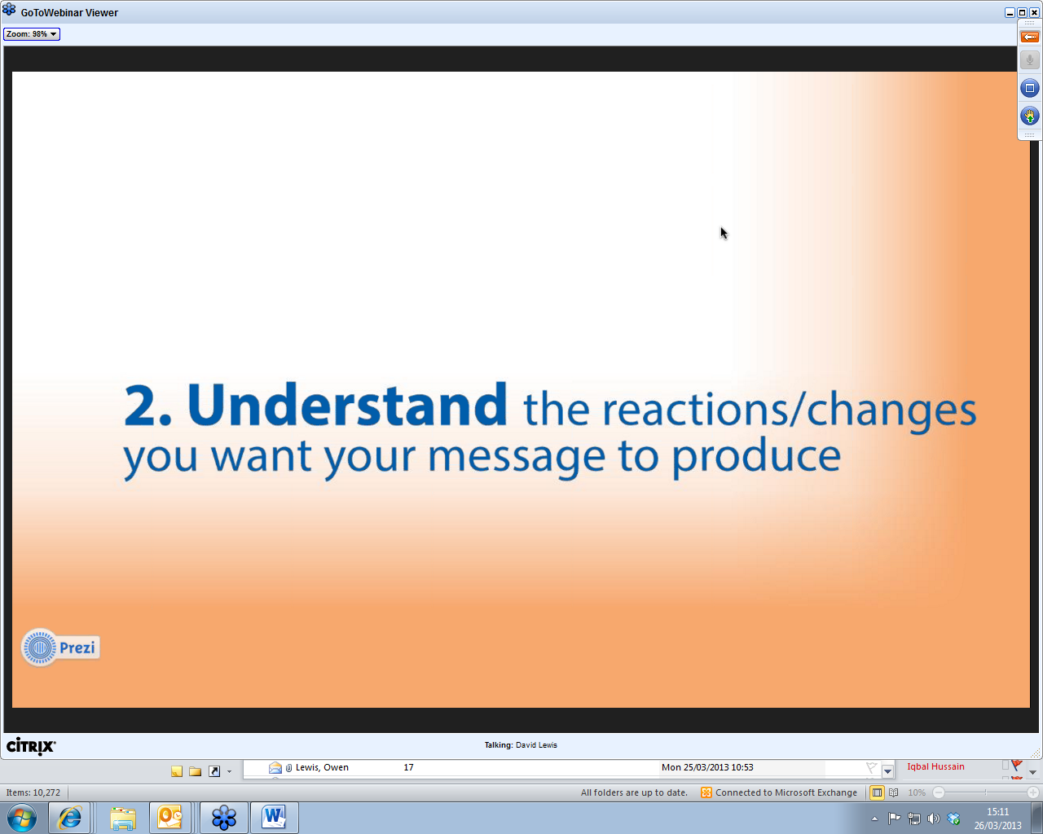
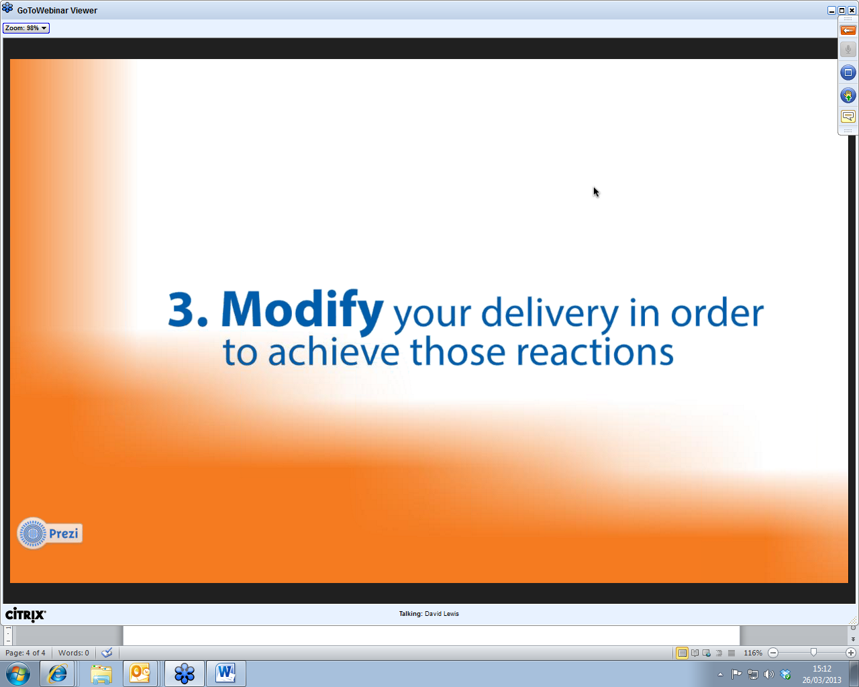

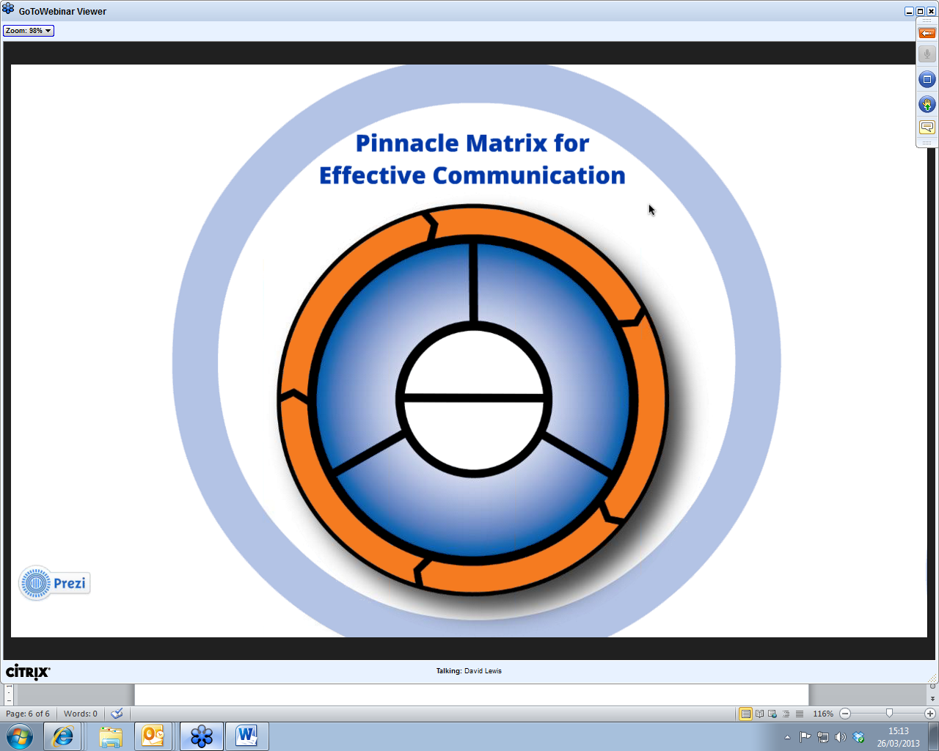
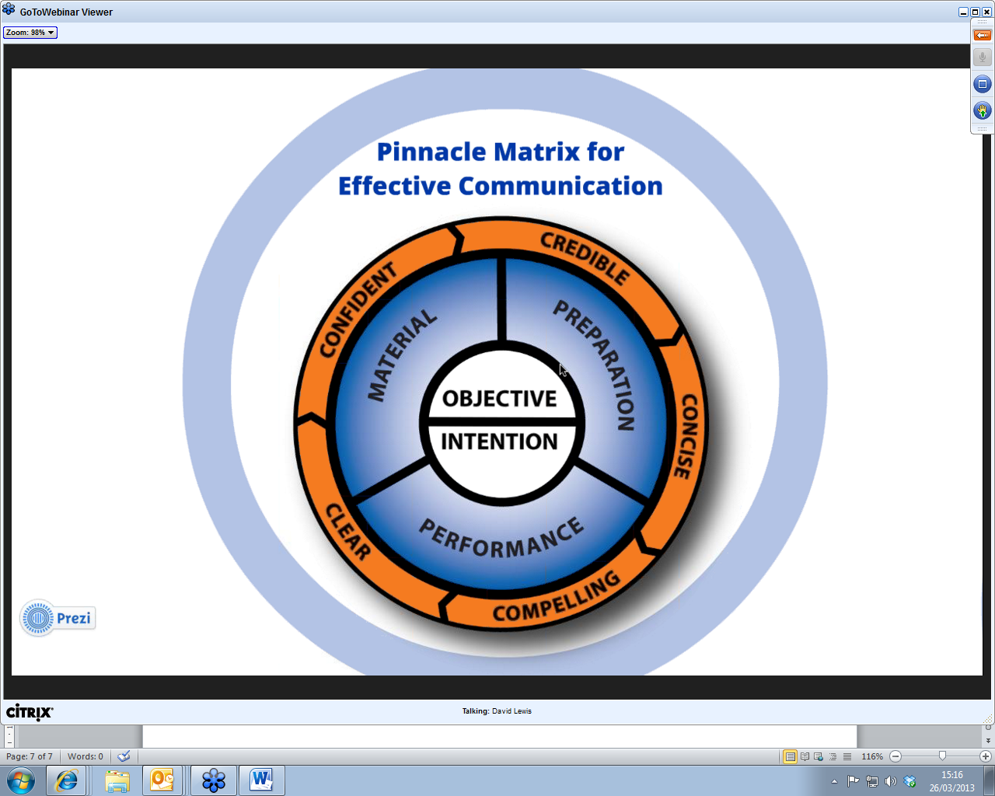
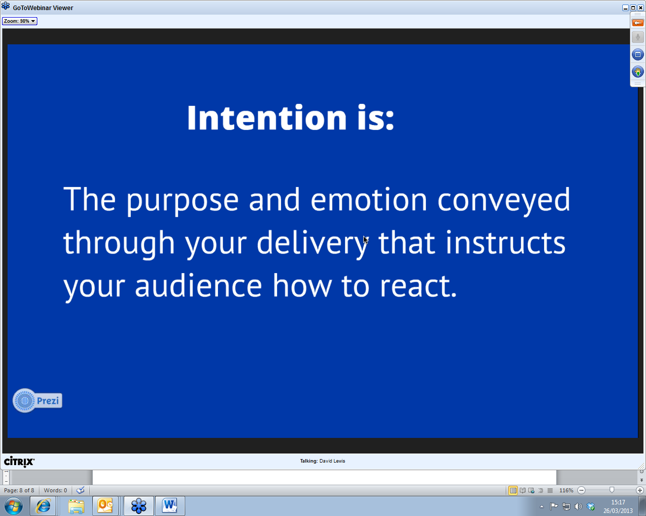
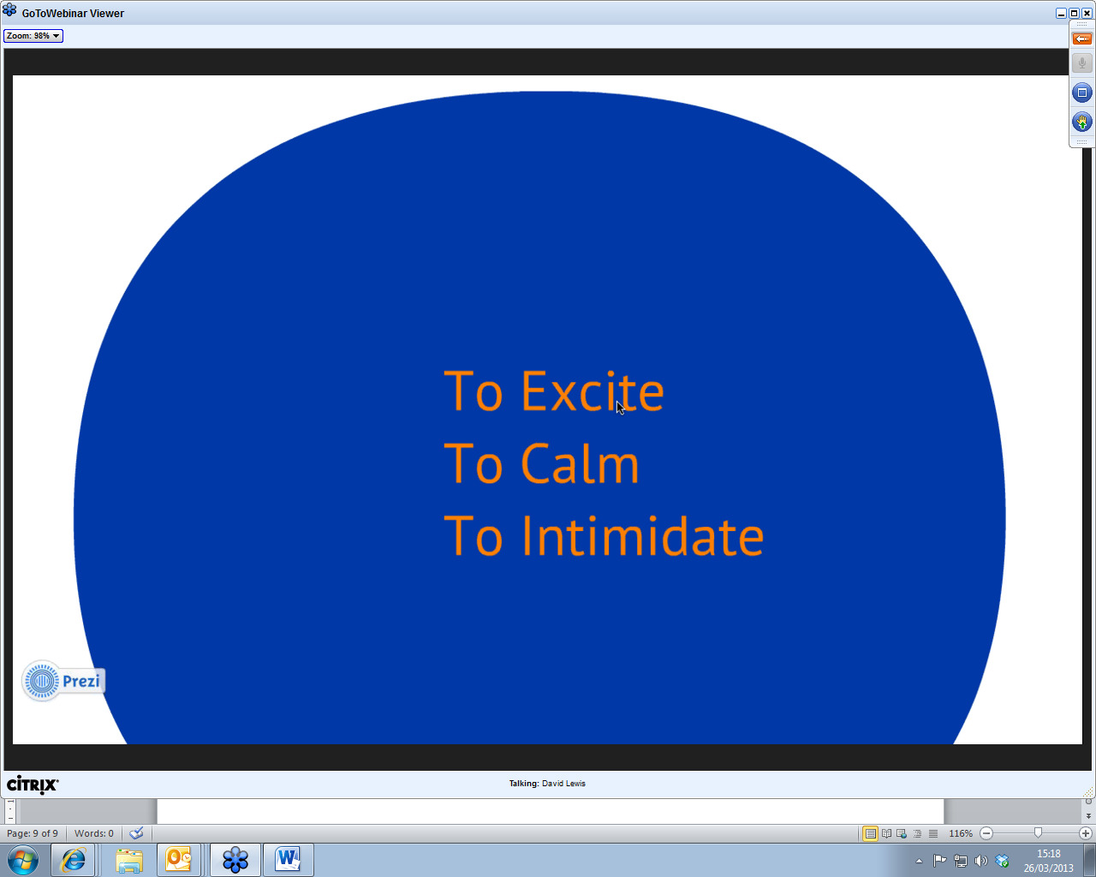
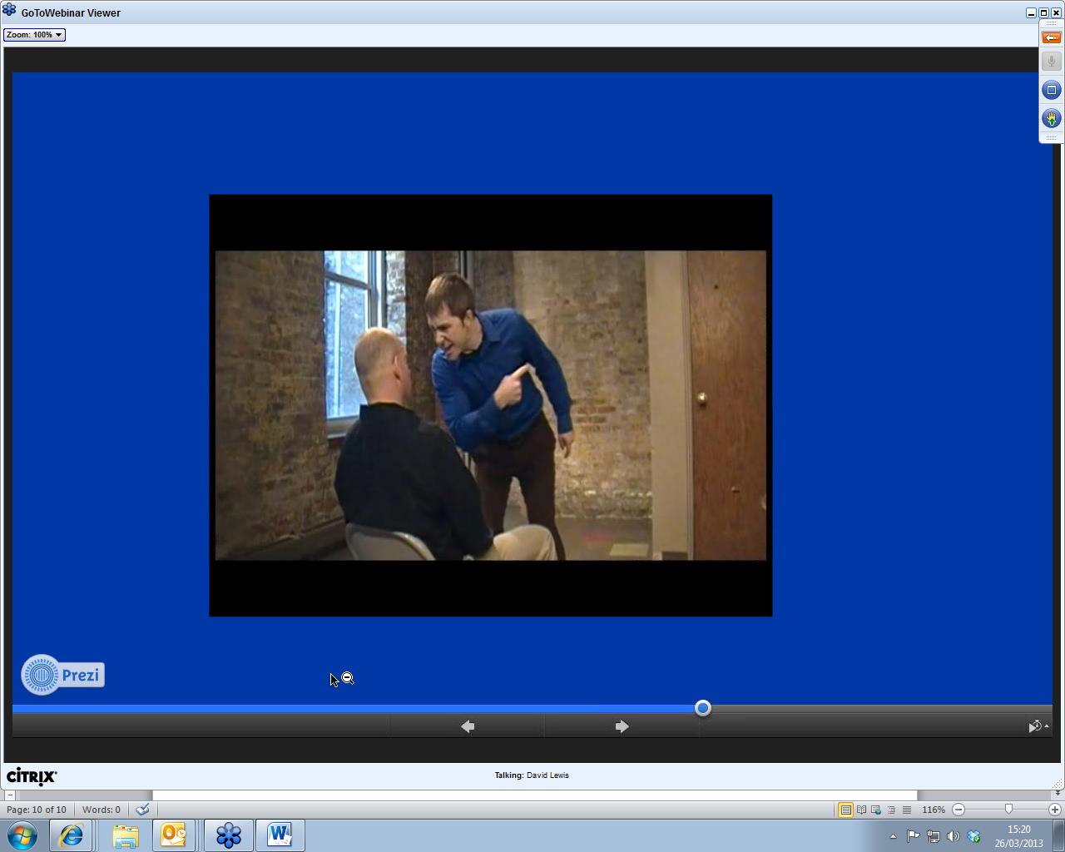
3 ways to say the same thing, but different intonation
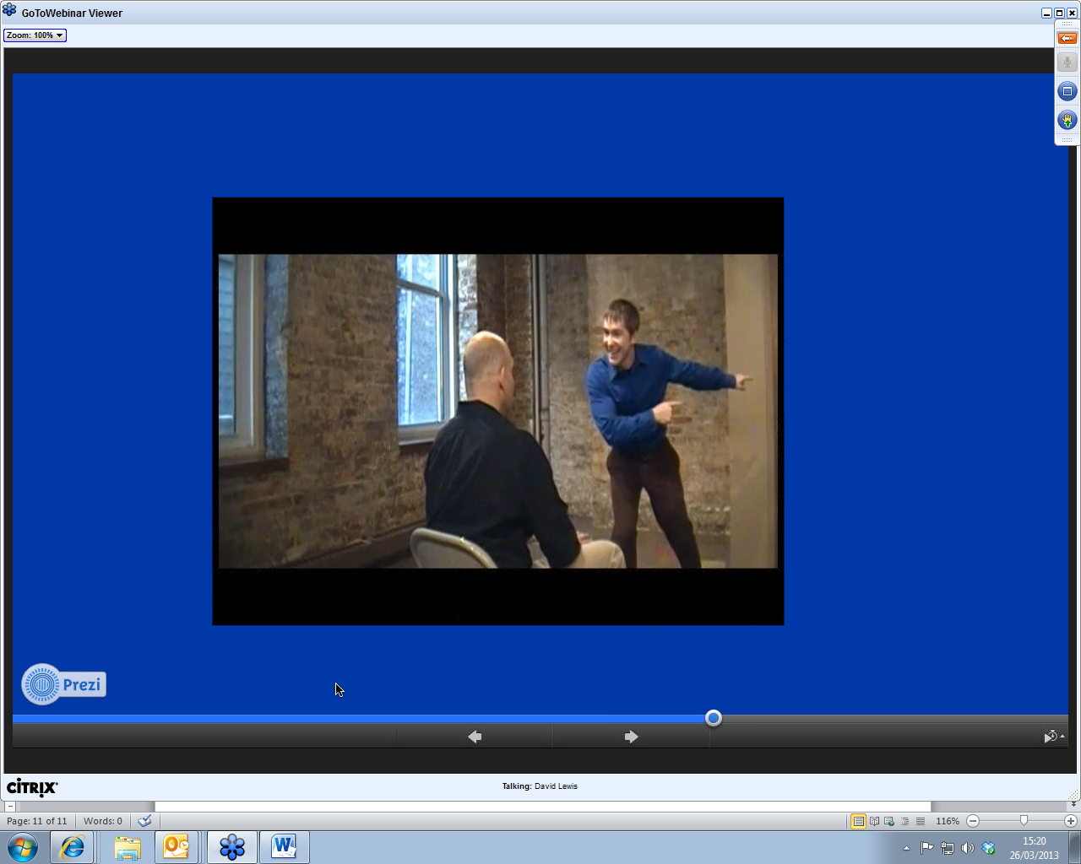
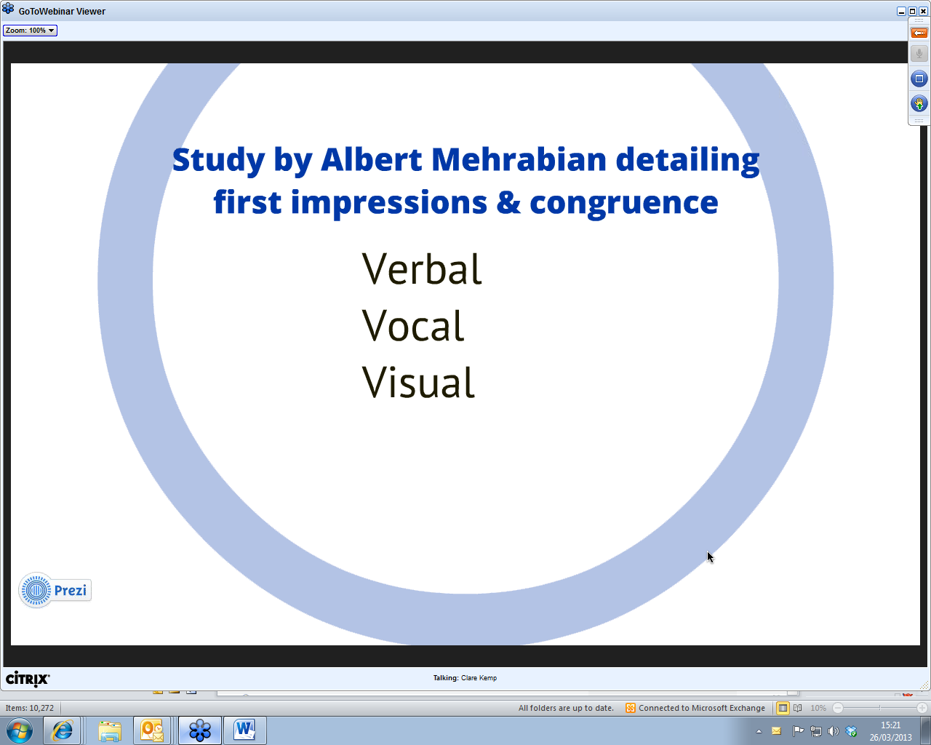
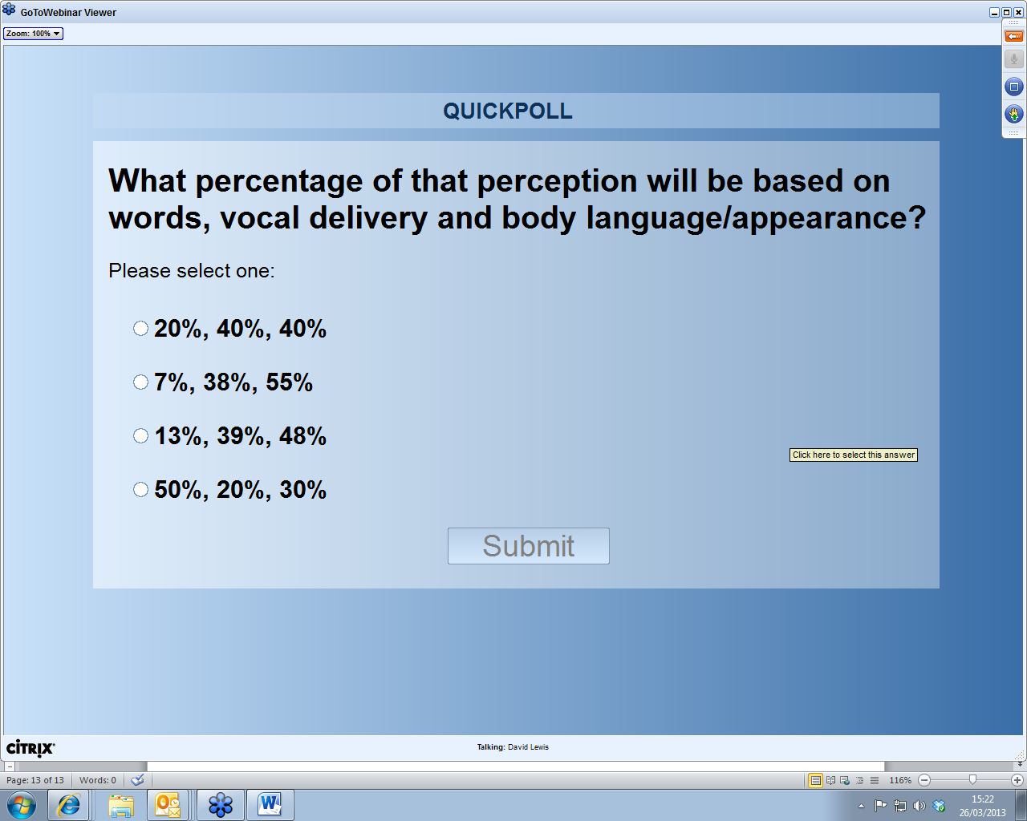
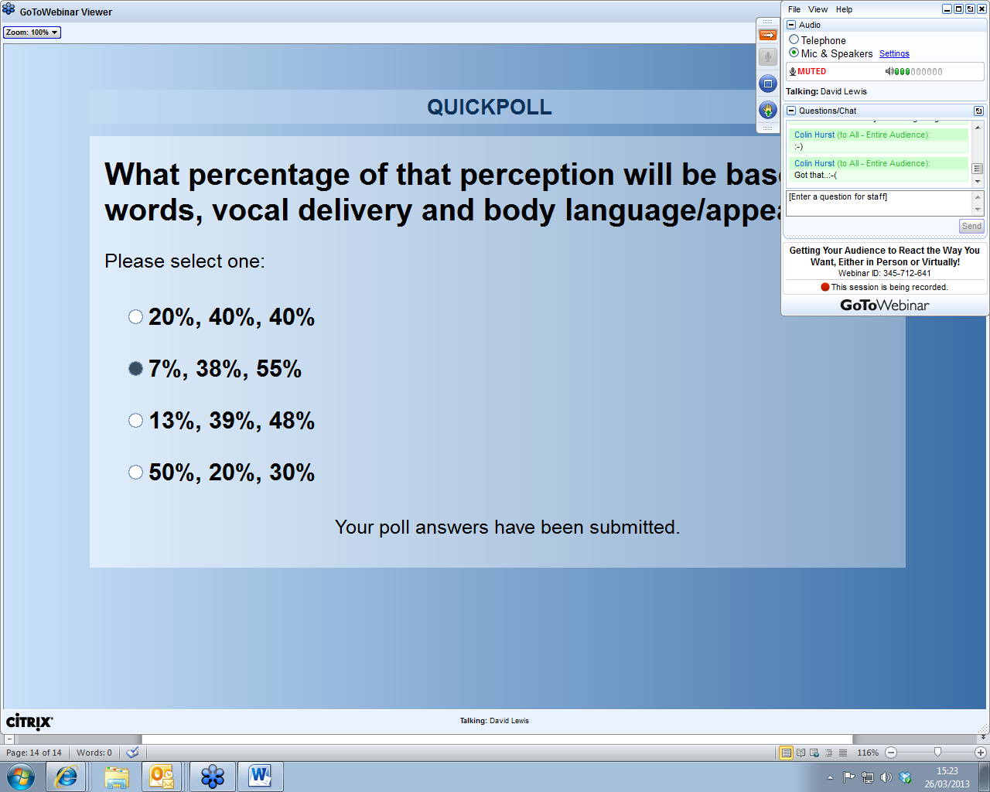
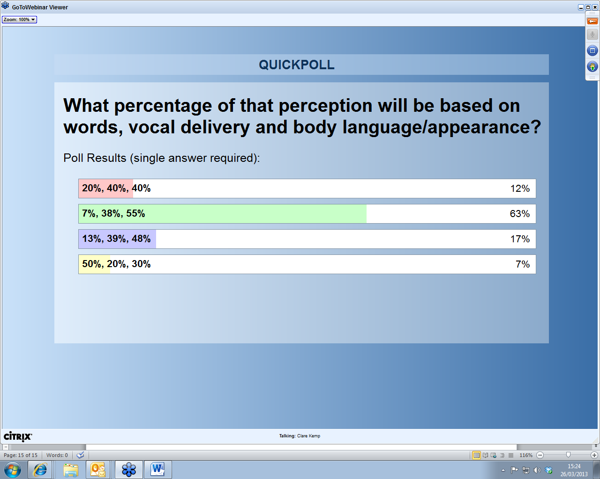
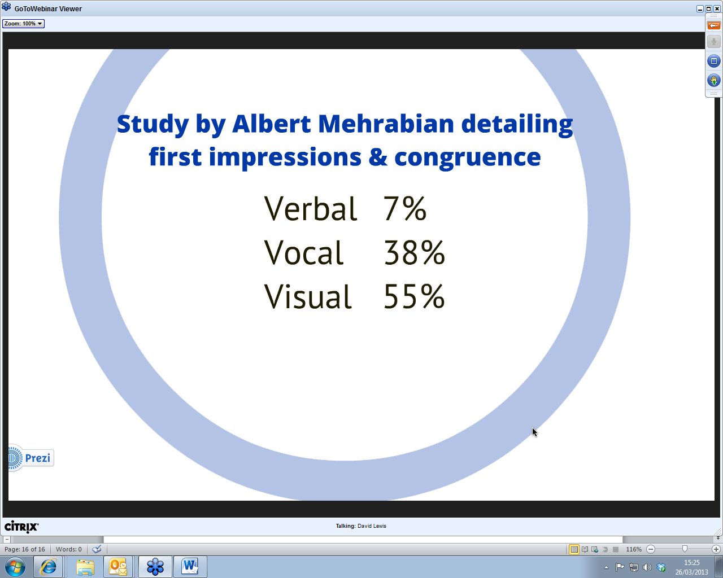
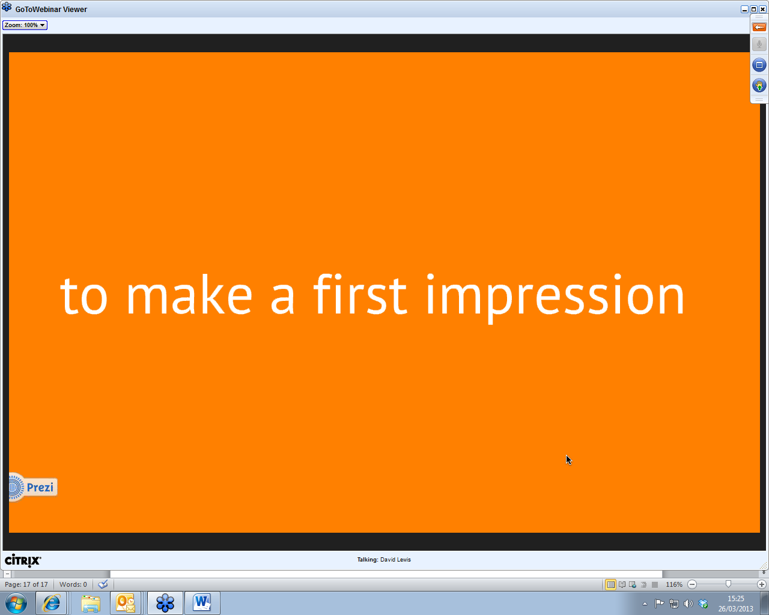
1st 60 seconds
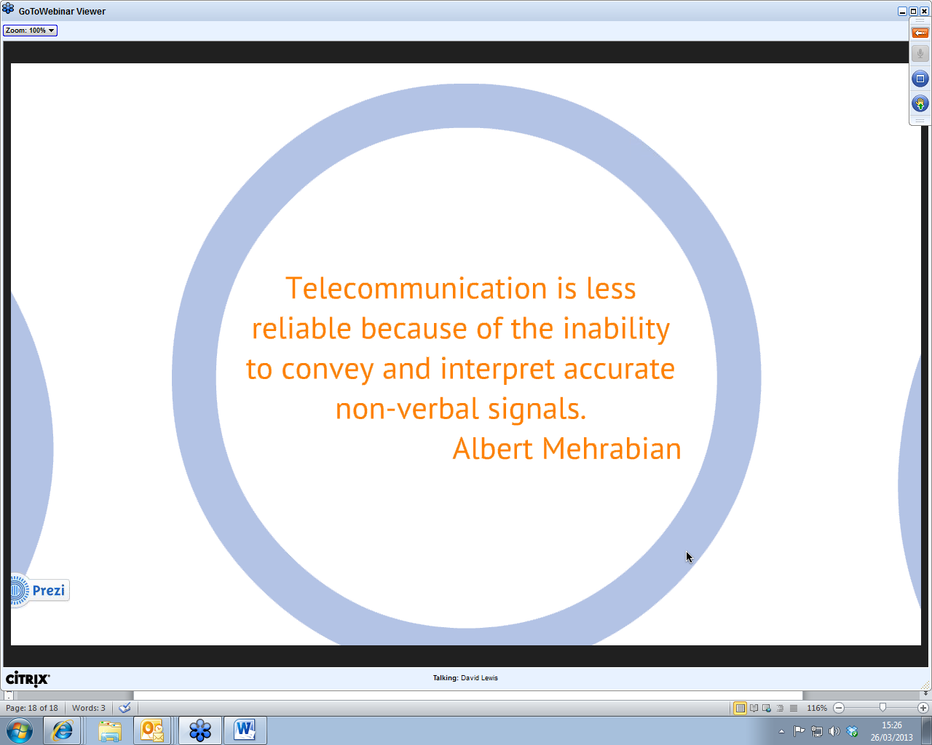
Telephone and email no “presence” need to think about replicating face to face
If the body language and “performance” are so crucial ( >50%)
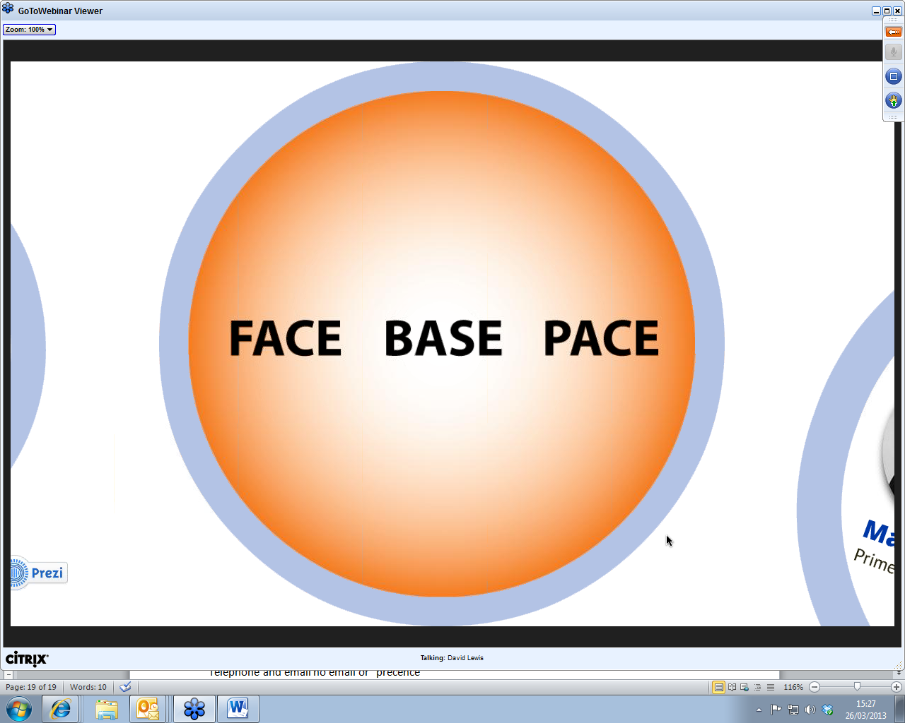
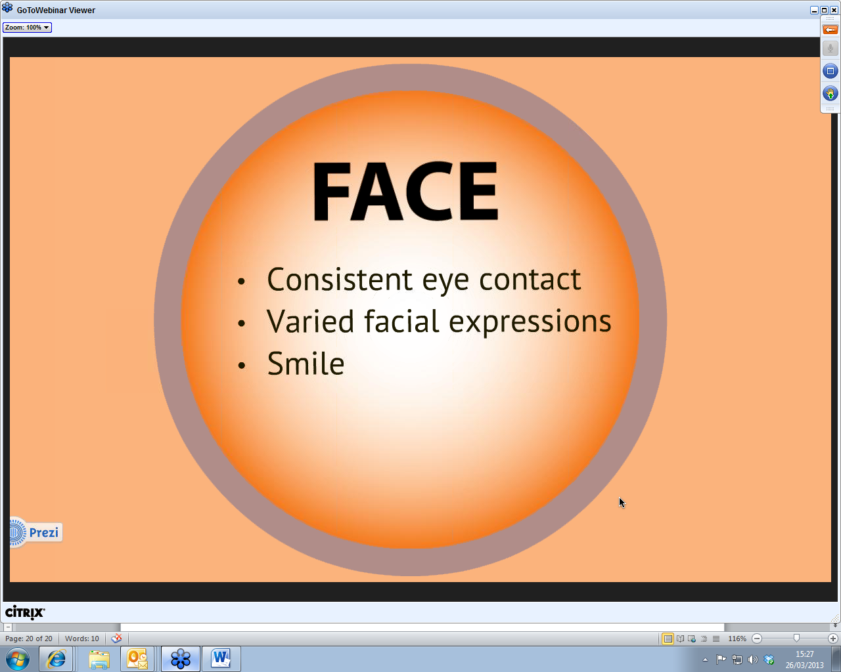
Smile unless you are delivering bad news
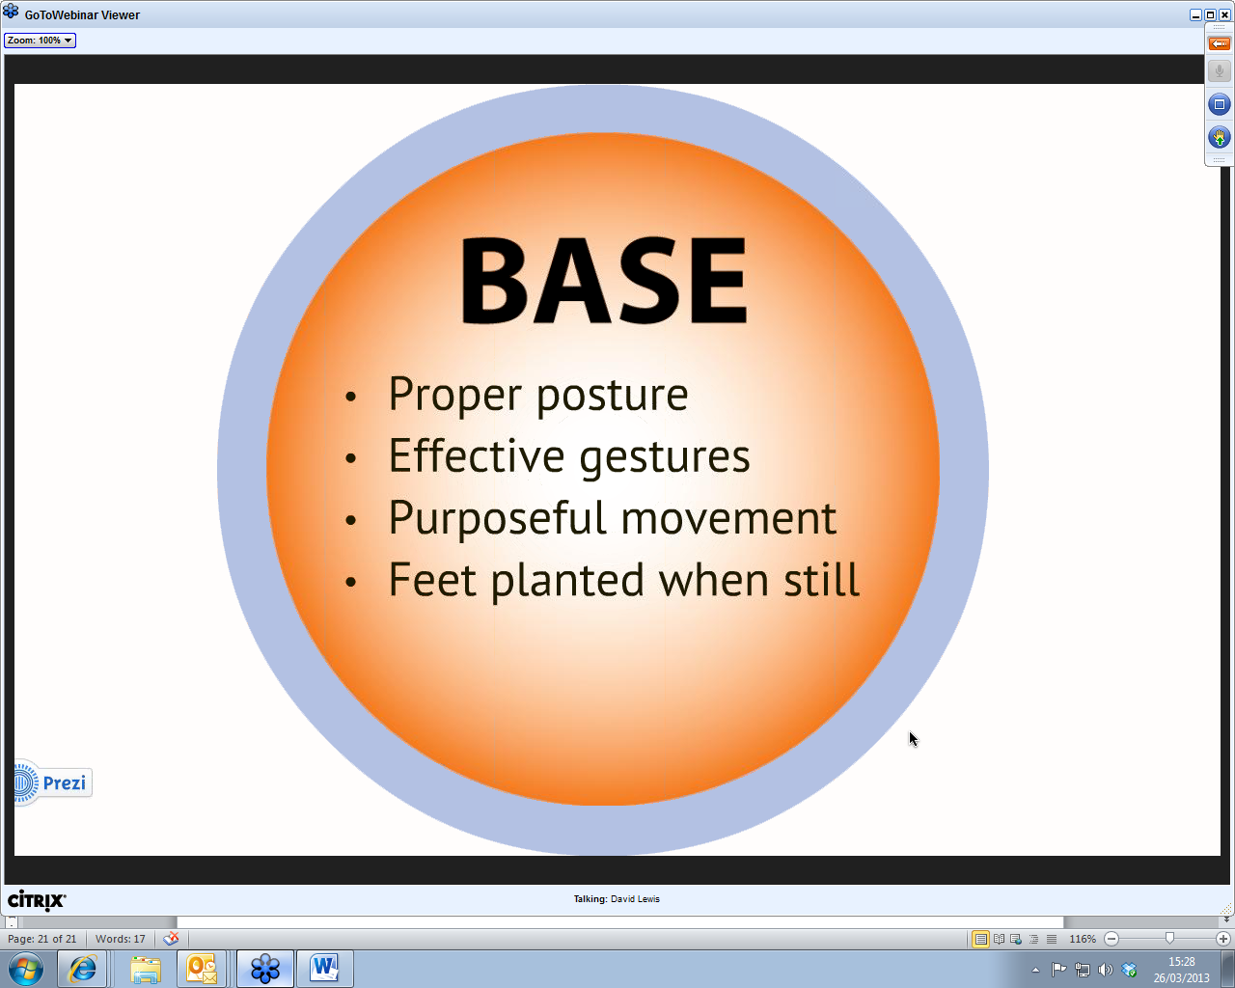
Could be sitting properly at a webcam
Wandering around ..could be conveying that you are less than competent
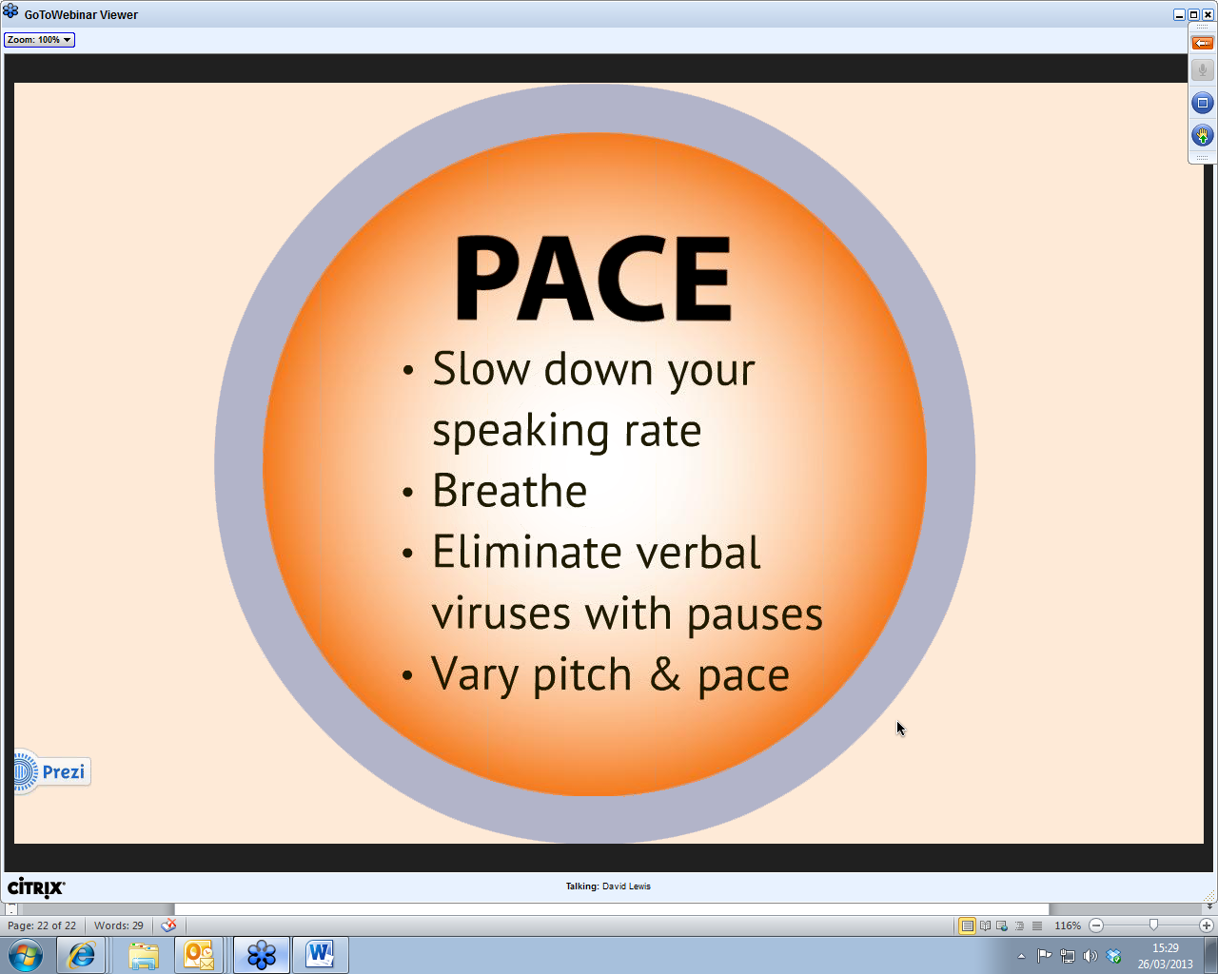
Critical when on the web.since cant see the audience 100-150 words per minute Verbal viruses speaking too fast…. Keep breathing
Put in pauses…let the audience think..you don’t have to be always talking…modulate up and down pitch of voice and other delivery features

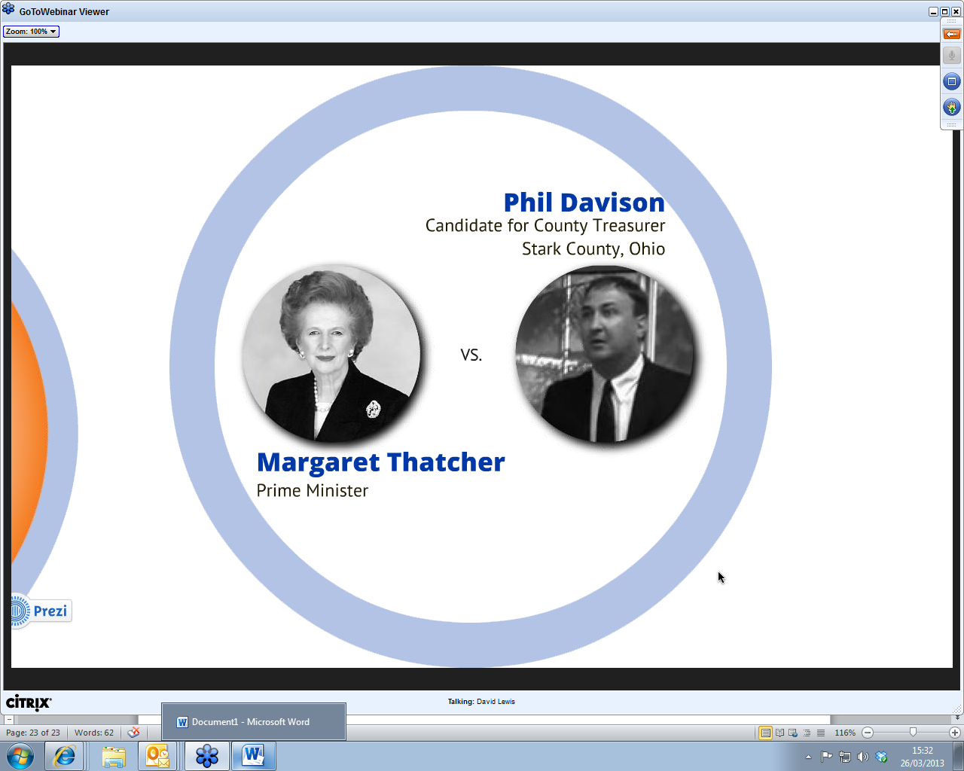
Video clips Intent to convey by the message
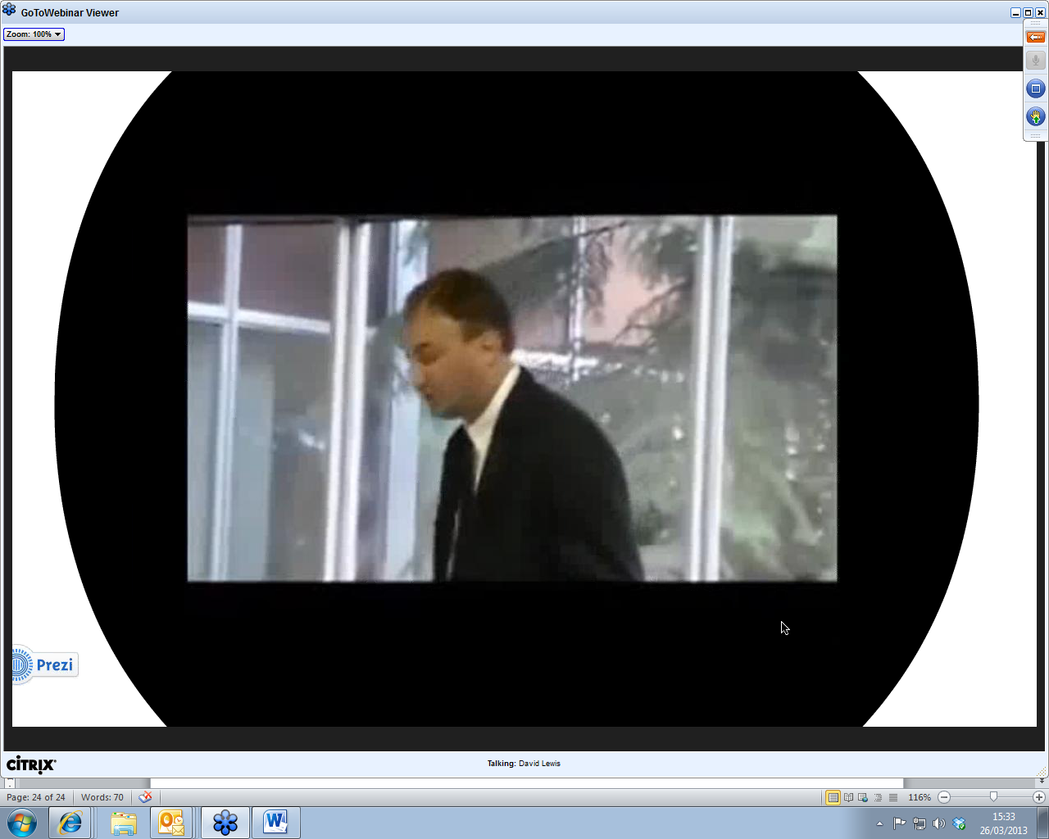
Hectoring and aggressive

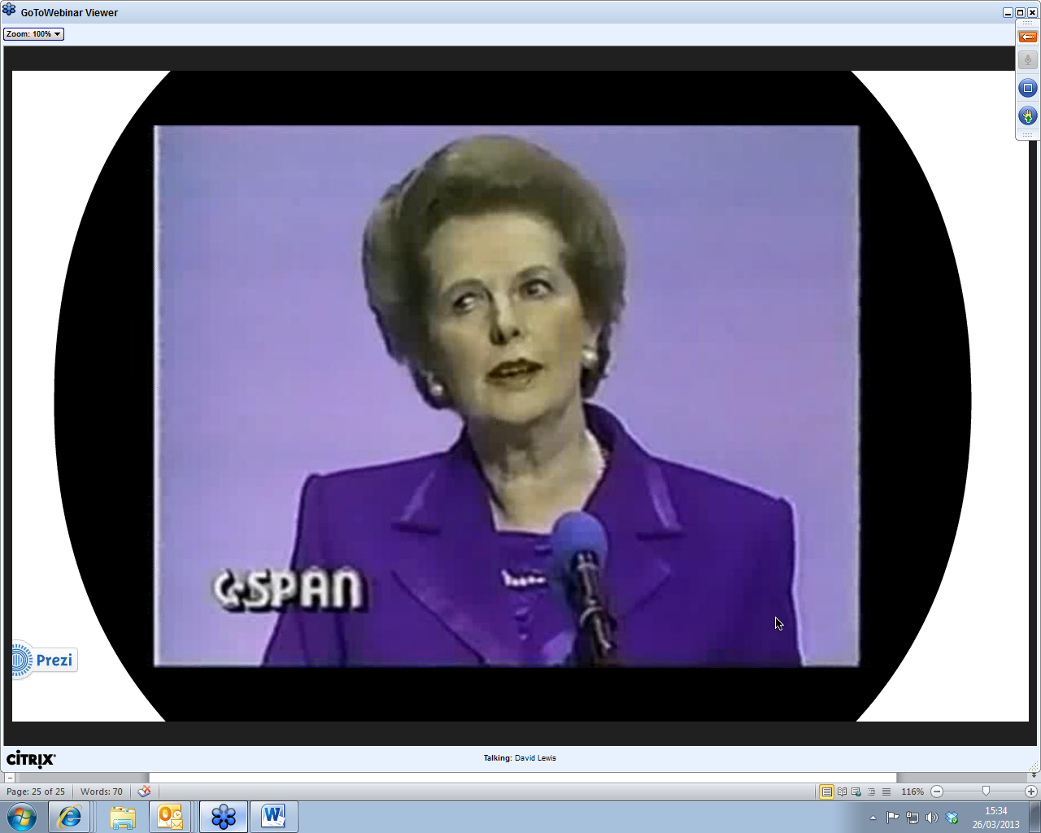
Communicated competence and control………..with sense of humour
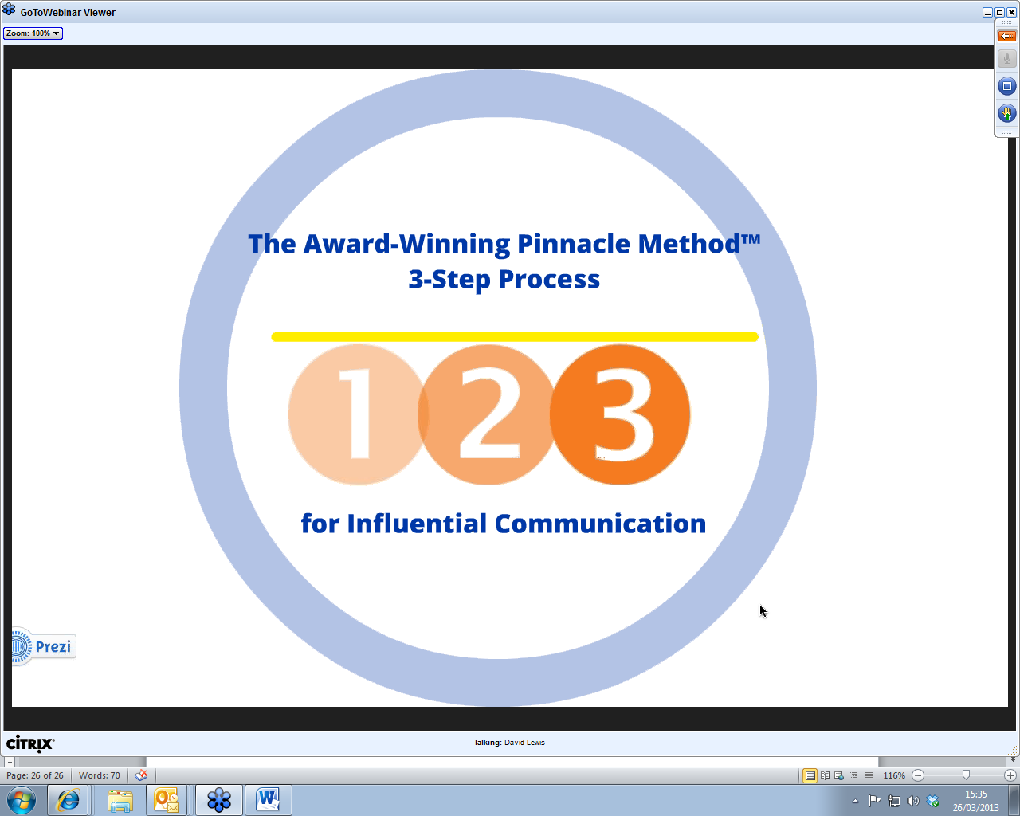
Go for …………..Good use of pause………. humour not hectoring or aggressive
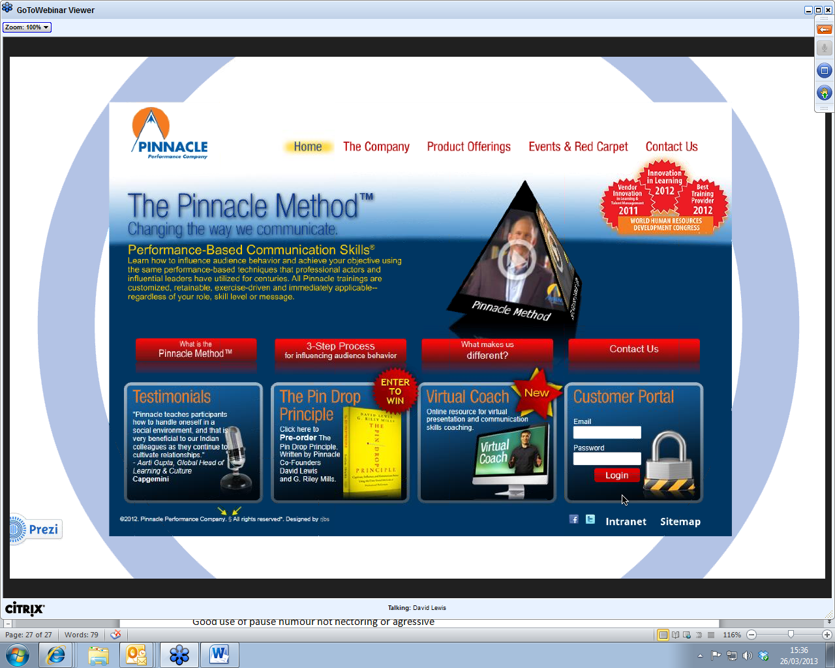
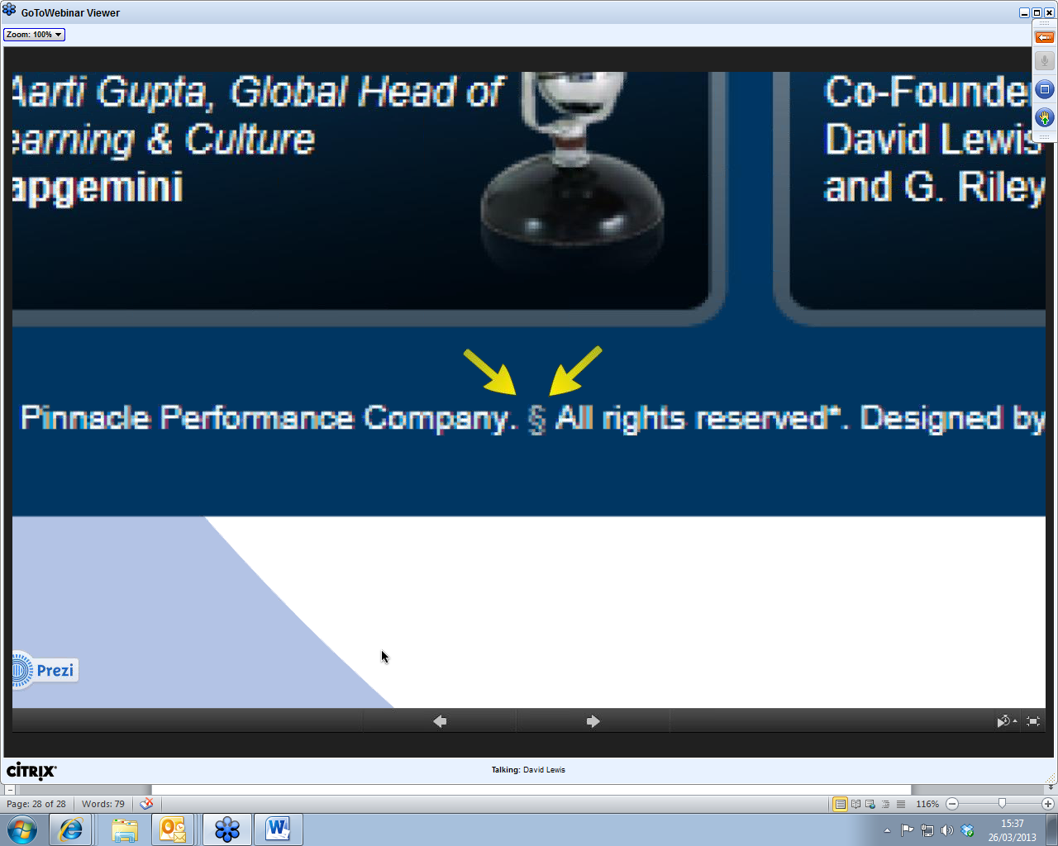
Look for free video clips

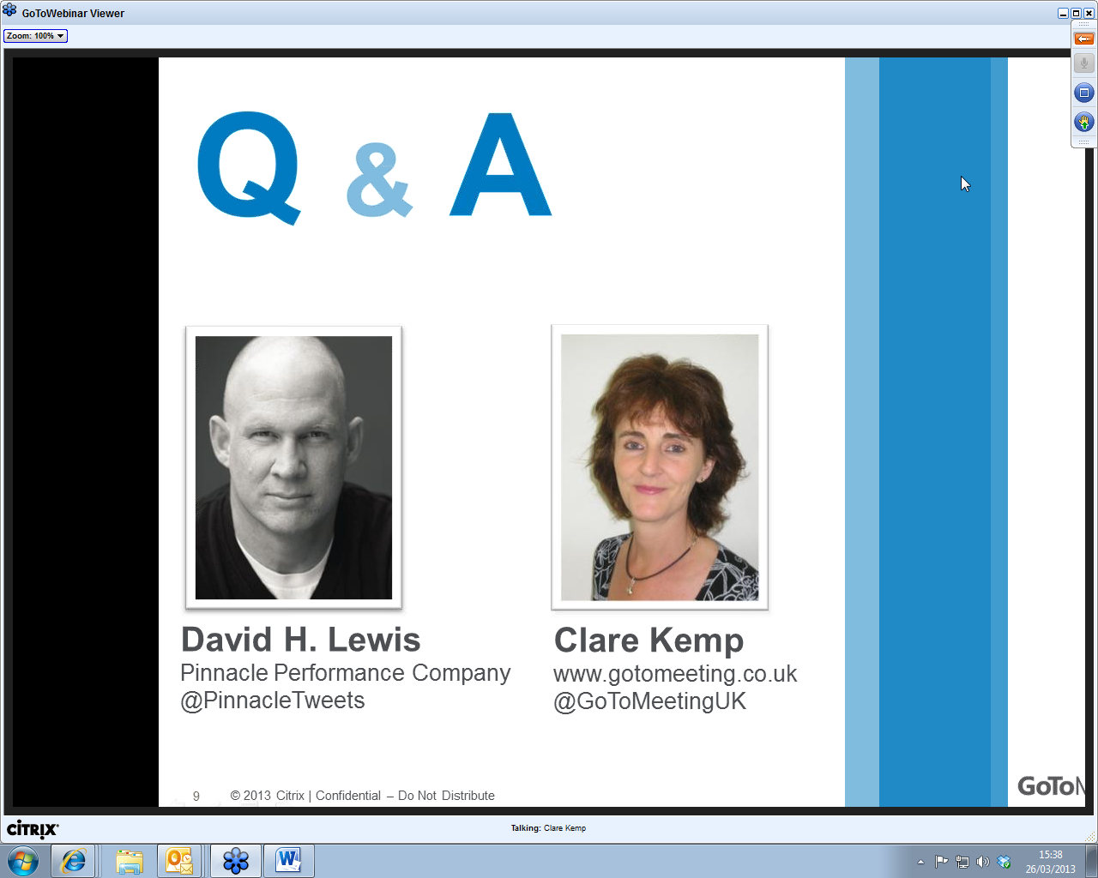
Need to deflect questions that you are not ready or prepared for
Like actors or athletes, warm up and rehearse
Standing or sitting………gestures…if they support the message its ok, but if they divert no
Starting tactics…hostile audiences..may want to disagree with you or let you know who is more powerful but stay in control. Take the heat away from the current performance
Take the debate off line
Cultural influences in gestures, vocabulary etc Need to be globally accepted. For example in Japan he does not teach how to communicate in Japan but for global audience…eg in Japan avoid eye contact but in many western countries this conveys trustworthiness
You’re the expert on what you are prepared to deliver, if you are not prepared…….doomed…Surprise presentations ? Keep it short…….I’ll look it up and get back to you…prep the first 60 seconds…..what do you want your audience to take away with them?
Rule of 3
More likely to remember things in groups of 3



