

TITLE PAGE:

Engineering Academic Discipline
Motorsport Engineering HND
----------------------------------------------------------
TITLE OF REPORT: MODULE NAME AND CODE:
ANALYTICAL METHODS ANALYTICAL METHODS
COURSEWORK ACHA 4000
----------------------------------------------------------STUDENT NAME: RYAN WILLIAMS
STUDENT NUMBER: 2409909
DATE: 12/01/2025
----------------------------------------------------------

Content Page:

TITLE PAGE: 1
Content Page: 2
Task One: 3
Task Two: 5
Task Three: 6
Task Four: 6
Task Five: 9
Task Six: 11
Task Seven: 12

Task One:
  - Task One A:
  - $$\left(x+6\right)\left(x+6\right)+2x=x^{2}-5 \\ x^{2}+6x+6x+36+2x=x^{2}-5 \\ x^{2}+12x+36+2x=x^{2}-5 \\ x^{2}+14x+36=x^{2}-5 \\ x^{2}+x^{2}+14x=-5-36 \\ 14x=-41 \\ x=-\frac{14}{41}$$

  - Task One B:
  - $${log2}^{x+5}=log6^{x}$$
$$\left(x+5\right)log2=x\log^{6}$$
$$\left(x+5\right) × 0.3010=0.7782$$
$$0.3101x+1.505=0.7782x$$
$$0.3010-0.7782=-1.505$$
  - $$-0.4772= -1.505 \\ x=\frac{-1.505}{-0.4772}=3.1538$$

  - Task One C:
  - $log⁡(x+3)^{2}=log⁡(x+5)(x+8)$
$$\left(x+3\right)\left(x+3\right)=(x+5)(x+8)$$
$$x^{2}+3x+3x+9= x^{2}+8x+5x+40$$
$$3x+3x-8x-5x=40-9$$
$$-7x=31$$
$$\frac{-31}{7}=-4.428571$$

  - Task One D:
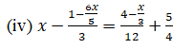
$$x-\frac{1}{3}+\frac{6x}{15}=\frac{1}{3}+\frac{x}{36}+\frac{5}{4} \\ x-\frac{2}{3}+\frac{6x}{15}=\frac{x}{36}+\frac{5}{4}$$
$$x-120+72x= -5x+255$$
$$180x+72x+5x= +120+225$$
$$257x=345$$
$$\frac{345}{257}=1.3424$$

Task Two:
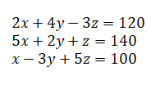
$Z=140-2y-5x$
$$2x+4y-3\left(140-2y-5x\right)=120$$
$$x-3y+5(140-2y-5x)=100$$

$$2x+4y+420-6y-15x=120 \\ x-3y+5+700-10y-25x=100$$

$17x+10y=540$ (1)$-24x-13y=600$ (2)

$$17x+10y=540 \\ 221x+130=7020$$

$$-24x-13y=600 \\ -240x-130=6000$$

$$-221x+130=7020 \\ -240x-130=6000$$$19x =-1020$

$$\frac{-1020}{19} \\ x=-53.68$$

$$17x-53.68+10y=540 \\ 10y=-17x-53.68+540 \\ 1452.56÷10 \\ y=145.256$$
$$140-2x145.256-5x-53.68 \\ z=117.888$$

Task Three:
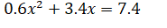
$$0.6x^{2}+3.4x=7.4 \\ 0.6x^{2}+3.4x-7.4=0 \\ ∆=3.4^{2}-4×0.6×-7.4=29.32 \\ \sqrt{29.32}=5.41$$
$$x1=\frac{-3.4^{2}+\sqrt{5.41}}{1.2}=-7.695$$
$$x2=\frac{-3.4^{2}-\sqrt{5.41}}{1.2}=-11.571$$

Task Four:
Task Four A:
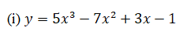
$$\frac{dy}{dx }=5\left(3x^{2}\right)-7\left(3x^{1}\right)+3x-0 \\ \frac{dy}{dx }=15x^{2}-14x+3$$
Task Four B:
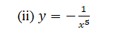
$$y=x^{-5} \\ \frac{dy}{dx }=5x^{-6}$$
Task Four C:
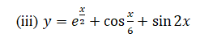
$$e^{\frac{x}{2}}→\frac{d}{dx}\left(e^{\frac{x}{2}}\right)=1x\frac{1}{2}e^{\frac{1}{2}} \\ \cos\left(\frac{x}{6}\right)→\frac{d}{dx}\left(cos\frac{x}{6}\right)=-\frac{1}{6}\sin\left(\frac{x}{6}\right) \\ \sin\left(2x\right)→\frac{d}{dx}\left(sin2x\right)=1x2\cos\left(2x\right) \\ \frac{dy}{dx}=\frac{1}{2}e^{\frac{1}{2}}=-\frac{1}{6}\sin\left(\frac{x}{6}\right)+2\cos\left(2x\right)$$

Task Four D:
$$\frac{du}{dx}=5(7x^{6}+0)(x^{7}+4)^{4}=35x^{6}(x^{7}+4)^{4} \\ \frac{dv}{dx}=4(6x-0)(3x^{2}-1)^{3}=24x(3x^{2}-1)^{4} \\ \frac{dy}{dx}=35x^{6}(x^{7}+4)^{4}×(3x^{2}-1)^{4}+(x^{7}+4)^{5}×(3x^{2}-1)^{3}$$
Task Four E:
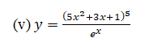
$$U=(5x^{2}+3x+1)^{5} \\ V=e^{x} \\ \frac{du}{dx}=5(10x+3)(5x^{2}+3x+1)^{4} \\ \frac{dv}{dx}=1x1e^{x}=e^{x} \\ \frac{dy}{dx}=\frac{5(10x+3)(5x^{2}+3x+1)^{4}e^{x}-e^{x}×(5x^{2}+3x+1)^{5}}{e^{2x}}$$
Task Four F:
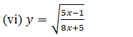
$$w=(\frac{5x-1}{8x+5})^{\frac{1}{2}} \\ \frac{dw}{dx}=\frac{5\left(8x+5\right)-8\left(5x-1\right)}{(8x+5)^{2}} \\ \frac{dy}{dx}=\frac{1}{2}\frac{5\left(8x+5\right)-8\left(5x-1\right)}{(8x+5)^{2}}×(\frac{5x-1}{8x+5})^{-\frac{1}{2}}$$

Task Four G:
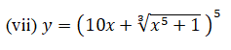

$$(10x+(x^{5}+1)\frac{1}{3})^{5} \\ (10x+w)^{5} \\ \frac{du}{dx}=5(10+\frac{dw}{dx})(10x+w)^{4} \\ w=\left(x^{5}+1\right)\frac{1}{3}=\frac{dw}{dx}=\frac{1}{3}(5x^{4}+0)(x^{5}+1)^{\frac{1}{3}-1} \\ \frac{dw}{dx}=\frac{5}{3}x^{4}(x^{5}+1)^{\frac{-2}{3}} \\ \frac{dy}{dx}=(5(10+\frac{5}{3}x^{4}(x^{5}+1)^{\frac{-2}{3}})(10x+x^{5}+1)^{\frac{1}{3}})$$

Task Five:
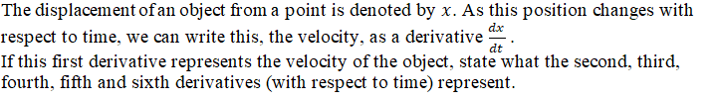

$$\frac{dx}{dt}$$

$$\frac{d^{2}x}{dt^{2}}$$

$$\frac{d^{3}x}{dt^{3}}$$

$$\frac{d^{4}x}{dt^{4}}$$

$$\frac{d^{5}x}{dt^{5}}$$

$$\frac{d^{6}x}{dt^{6}}$$

Task Six:

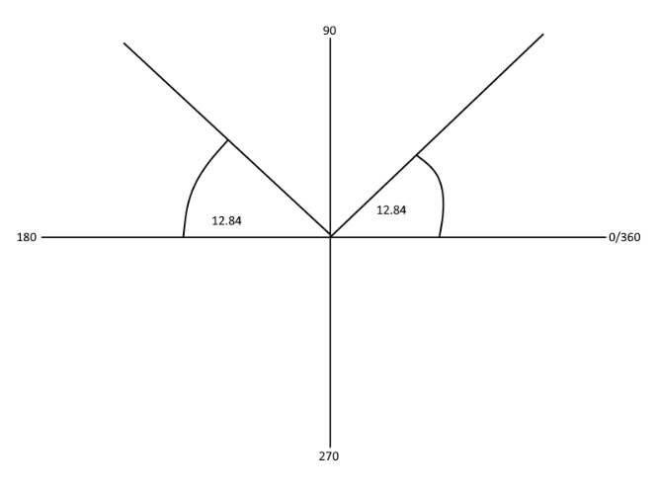
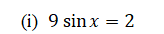
$$9sinx=2 \\ sinx=\frac{2}{9} \\ x=sin^{-1}\left(\frac{2}{9}\right) \\ x=12.84$$

$$180-12.84=167.16 \\ x=167.16 \\ x=12.84$$

$$5sin^{2}-0.3cosx=2 \\ 5\left(1-cos^{2}x\right)-0.3cosx=2 \\ 5-5\left(1-cos^{2}x\right)-0.3cosx-2=0 \\ -5cos^{2}x-0.3cosx-2=0 \\ -5cos^{2}x-0.3cosx-3=0 \\ 0=5cos^{2}x+0.3cosx+3 \\ 0=\left(5cosx-1\right)\left(cosx-3\right) \\ \left(5cosx-1\right)\left(cosx-3\right)=0 \\ 5cosx-1=0 cosx-3=0 \\ 5cosx=1 cosx=3 \\ cosx=\frac{1}{5} \\ x=78.46 \\ x=360-78.46=281.54 \\ x=281.54 \\ x=78.46$$
Task Seven:

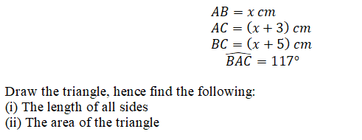

$$(x+5)^{2}=x2+(x+3)^{2}-2x\left(x^{2}+3x\right)cos117 \\ x^{2}+10x+25=x^{2}+x2+9+6x-2\left(x^{2}+3x\right)cos117 \\ x^{2}+10x+25=x^{2}+x2+9+6x+0.9\left(x^{2}+3x\right) \\ x^{2}+10x+25=2x^{2}+9+6x+0.9x^{2}+2.7x \\ x^{2}+10x+25=2.9x^{2}+9+8.7x \\ x^{2}+10x+25-2.9x^{2}-9-8.7x=0 \\ a=-1.9x^{2} b=1.3 c=16$$

$$x=\frac{-1.3±\sqrt{{1.3}^{2}-4×\left(-1.9\right)×\left(16\right)}}{2×\left(-1.9\right)}=-2.5$$
$$x=\frac{-1.3±\sqrt{{1.3}^{2}-4×\left(-1.9\right)×\left(16\right)}}{2×\left(-1.9\right)}=3.2$$

$$x=3.2cm \\ \left(x+3\right)=6.2cm \\ \left(x+5\right)=8.2cm \\ \frac{1}{2}×3.2×6.2×\sin\left(117\right)8.82cm^{2}$$

