

Assignment 1

Module code: LCLM4005
Student: Mauricio Henrique da Luz Alves ID 2509312
Lecturer: Lizeta Demetriou

Submitted on: 15/07/2026

Job Description
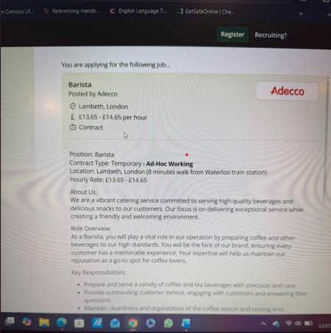

CV
Mauricio Henrique da Luz Alves
07907907533 / Hendon, London
Mauriciohenrique3@gmail.com
Professional Profile
Friendly, customer-focused and reliable professional with extensive experience in customer service and delivery operations, now building a career in specialty coffee. Currently working part-time as Barista at Another Cup, where I prepare high-quality drinks, deliver excellent customer service and thrive in a fast-paced café environment. Passionate about coffee, eager to learn, and committed to creating a welcoming experience for every customer.
Key Skills
- Customer Service
- Coffee Preparation
- Cash Handling & POS
- Teamwork
- Communication
- Attention to Detail
- Time management
- Problem Solving
- Adaptable & Eager to Learn
Work Experience
Barista (Part-time) – Another Cup
January 2026 – Present
- Prepare espresso-based drinks and other beverages.
- Deliver friendly and efficient customer service.
- Maintain cleanliness and food safety standards.
- Support the team during busy service periods.
Delivery Driver (Part-time) Online platforms
November 2022 – Present
- Deliver food and small parcels for Uber Eats, Deliveroo and Gophr.
- Provide reliable and professional customer service.
Noor Sideways Ltd
July 2020 – November 2022
- Delivery Driver for FedEx and DPD.
Plus Delivery
August 2018 – July 2020
- Delivery Driver for FedEx, DX, DHL, APC and Hermes.
Education
- CERTHE Business Skill for the Workplace – University of Wales Trinity Saint David, October 2025 – Present
- High School Education – Educandario Alfredo Nascer – Goiania/Brazil, February 1992 – November 1998.
Languages
- Portuguese (Native)
- English (Fluent)
- Spanish (Fluent)
References
References available upon request

Cover Letter
Dear Hiring Manager,
I am writing to express my interest in the Barista position at your café as advertised on adecco.com. With a strong background in customer service and my current part-time role as a Barista at Another Cup, I have developed a genuine passion for coffee and for creating a welcoming experience for every customer.
Working in a busy café has taught me the importance of teamwork, attention to detail and staying calm under pressure. I enjoy preparing high-quality coffee, maintaining high standards of cleanliness and ensuring that every customer leaves with a smile. Alongside my barista role, I also work part-time in delivery services, which has strengthened my reliability, time management and commitment to providing excellent service.
I take pride in being friendly, hardworking and eager to learn. I enjoy meeting new people and believe that a positive attitude can make a real difference to a customer's day. I am always keen to improve my skills and would welcome the opportunity to contribute to your team while continuing to develop my knowledge of coffee and hospitality.
Thank you for taking the time to consider my application. I would be delighted to discuss how my experience, enthusiasm and work ethic would make me a valuable member of your team. I look forward to hearing from you.
Yours faithfully,
Mauricio Henrique Da Luz Alves

