Circuit Build Assignment

Fundamentals of Electrical and Electronic Systems
ACDA4018



Submission Deadline – 22/July/2024
Theodore Dunning – 2317700
Contents
Table of Figures 2
1 Circuit Description and operation 3
2 Miltivibrator Analysis 4
3 What is a bread board? 4
4 Proteus Simulation 5
5 Testing of 555 timer circuit on bread board 7
6 Conclusion 8
7 References 10

Table of Figures

Figure Number | Description of Figure | Page Number
1 | Internals of a 555 IC Chip | 3
2 | Internals of a Bread board | 4
3 | Circuit made on Proteus | 5
4 | Results of oscilloscope on Proteus | 6
5 | 555 Circuit made on Bread board | 7
6 | Oscilloscope results from bread board | 8
7 | Bread board circuit attached to power supply | 8
8 | Ideal oscilloscope wave forms | 8

1 Circuit Description and operation

1.1 This project investigates the uses and simulation of a 555 IC chip. “The 555 chip is a highly stable integrated circuit that can produce accurate time delays and oscillations, it has three operating modes, bistable, monostable and astable.” [1]. It will be used to create an oscillating current that will alternatively flash two LEDs. This is possible as the LEDs are omnidirectional, they will only light up when the current is flowing in the correct direction. In the circuit, resistors are used to control the voltage passing through the components and capacitors are used to alter the rate of flashing.

1.2 It is important to understand electronics when working within the OME field. For example, artillery rounds use fuses that contain electrical components for a reliable detonation. Electronic timer fuses allow for artillery rounds to detonate after a certain period after being fired, this allows the shell to detonate above ground to cause more damage. Or when using pyrotechnics, when the shell detonates above ground it spreads the material with a greater surface area which works more effectively when providing cover. Furthermore, “wire-guided weapons use electrical signals send through a bundle of wires connected between the missile and guidance mechanism” [3], being able to direct an explosive after firing allows for a very accurate strike. The safety of the users of these weapons rely on the electronic systems working as intended.
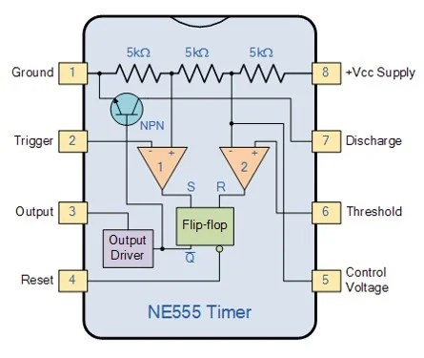

Figure 1, Internals of the 555 IC Chip [7]
1.3 The 555 IC has 8 connections; Ground, Trigger, Output, Reset, Vcc, Discharge, Threshold and Control Voltage. The ground connects the negative side. Output, the output voltage of the chip is 1.5V lower than the Vcc when high and 0V when low. Pin 4 resets the wheel circuit, when the pins voltage goes low the chip resets. This means the voltage needs to be high normally so the chip doesn’t reset. Pin 5, control voltage, is used to control the threshold voltage. This can be used to change the frequency of the circuit without changing any of the resistors or capacitors values. Pin 6, threshold, isn’t connected when the output is high and it’s connected to ground when the output is low. Pin 8 is the positive power supply, it can take voltages between 5 and 15 [2].

1.4 The capacitors in the circuit work by storing and releasing electrical energy, they are made of two conductive plates with a dielectric material in-between. The capacitors need to charge full of energy before they can disperse it through the circuit, in the flashing LED circuit the capacitors take turns charging and dispersing which is why the LEDs flash alternating instead of at the same time [4].

2 Miltivibrator Analysis
2.1 A multivibrator circuit oscillates between “HIGH” and a “LOW” state producing a continuous output [5]. Each of the three modes it can be in have unique outputs. Astable multivibrators create a continuous oscillating signal which is useful for timing signals. Monostable multivibrators produce single output pulses as a result of an external trigger, like timers. Bistable multivibrators act as a flip-flop, it maintains one of the stable states until it is triggered to swap, used for storing binary data and memory devices [6].

3 What is a bread board?
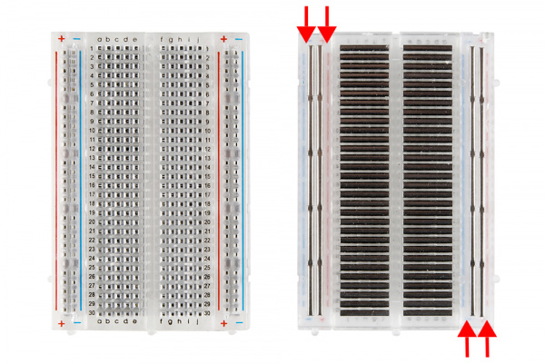
3.1 Bread boards are platforms used to connect circuits without needing to solder connections, this makes it extremely useful when learning how to put circuits together as connections can be moved endlessly without making a mess. The board relies on clips that hold on to the components and create fixed power rails between connections, this allows for the whole circuit being simulated to be directly copied onto the board for real life testing. When using the board it is really easy to make adjustments and test if components are working while building the circuit, components can be swapped within seconds and with no safety risk of being burnt by solder.
Figure 2, Internals of a bread board [8]

4 Proteus Simulation
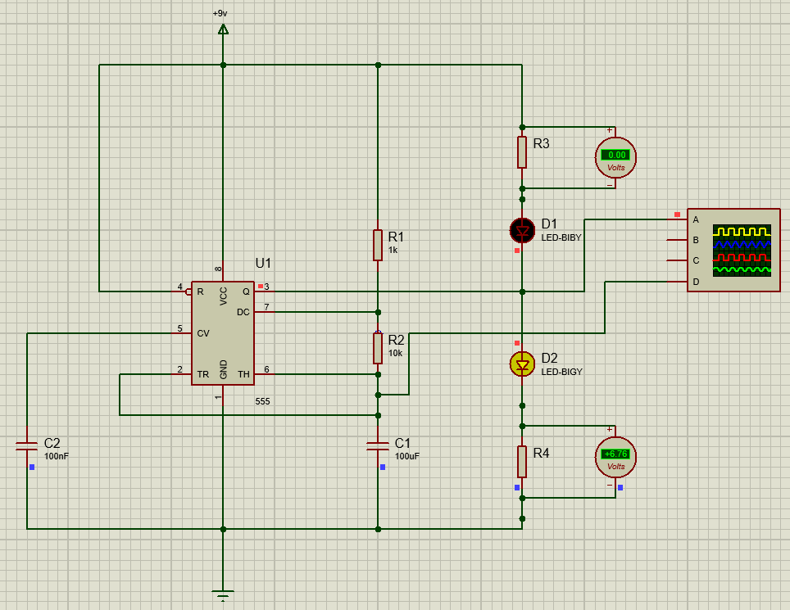

Figure 3, Circuit made on Proteus

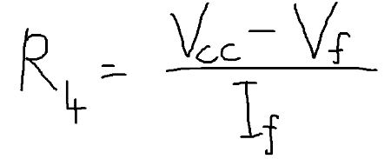
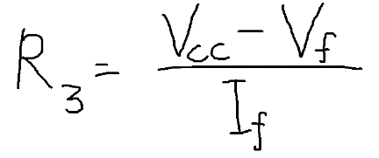
4.1 Firstly, the circuit was drawn out in Proteus so it could be simulated and data can be collected about the unknown resistors. All the values apart from R3 and R4 were provided. Working out these values are important as if the voltage is too high it could blow the bulbs and damage other components in the circuit. After the screen shot the volt meters were moved to be parallel to the LEDs instead of the resisters. All equations were found from the website Circuit Digest [9].

4.2 In the circuit, the Vcc (voltage input) was 9V, the LEDs have a Vf (forwards voltage) of 2.2V and an If (forward current) of 20mA. Implementing these values put into the formulas gives R3 and R4 values of 340 Ohms. The frequency and period can be calculated using the following formula. As the capacitors are in series, the capacitance is calculated using the in series rule shown below, the result is 9.99x10^-10 F.
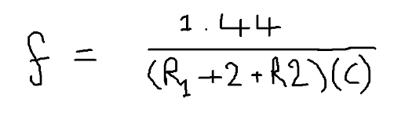
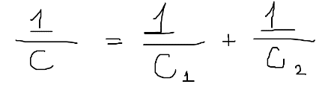

4.3 The frequency of the circuit is 14.161 KHz. From this we can work out the period as the formula is 1 divided by frequency. The period of the circuit is 70.615 milliseconds. The on / high time is 47.077 milliseconds and off / low time 23.538 milliseconds.

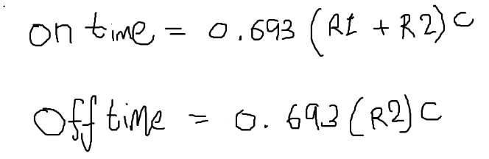

4.4 While running simulations, voltmeters were placed in parallel with the LEDs to measure the voltages passing through. After starting the simulation, the voltmeters alternated between 2.26V and 0V.

4.5 As both bulbs were reading the same while being perfectly out of period it proved that the current was oscillating as expected. After this, a virtual oscilloscope was added to see what waveform had formed, the yellow line shows the output voltage and the green line shows the C1 voltage. Each box represents 2V and 200mS.

4.6 From the oscilloscope the values for the waveforms peaks and troughs can be measured. The output voltage wave shows the highest at 5.80V and the lowest being -6.10V, the C1 voltage is much weaker with a peak of 1.3V and dip of -1.40V. While both values are two very different sizes, they still oscillate in the same frequency of 1200 mS.

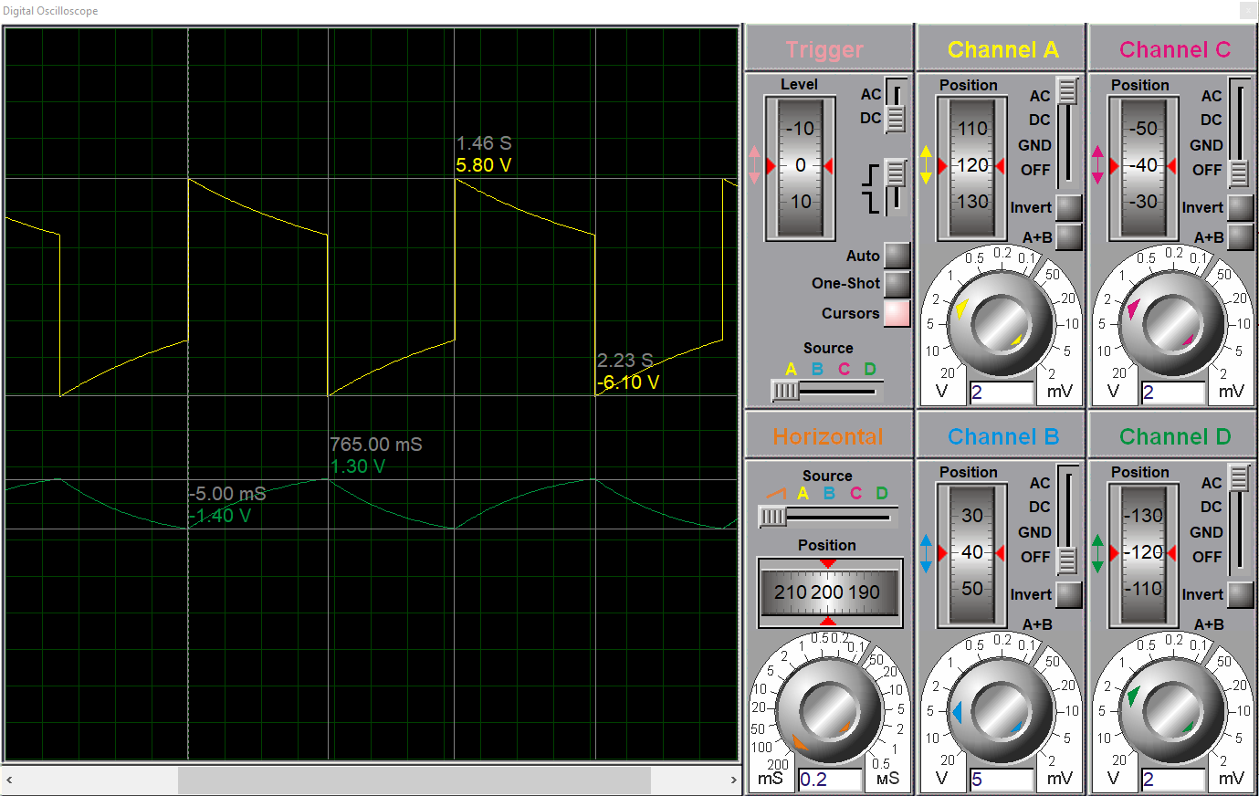
Figure 4, Results of oscilloscope on Proteus

5 Testing of 555 timer circuit on bread board

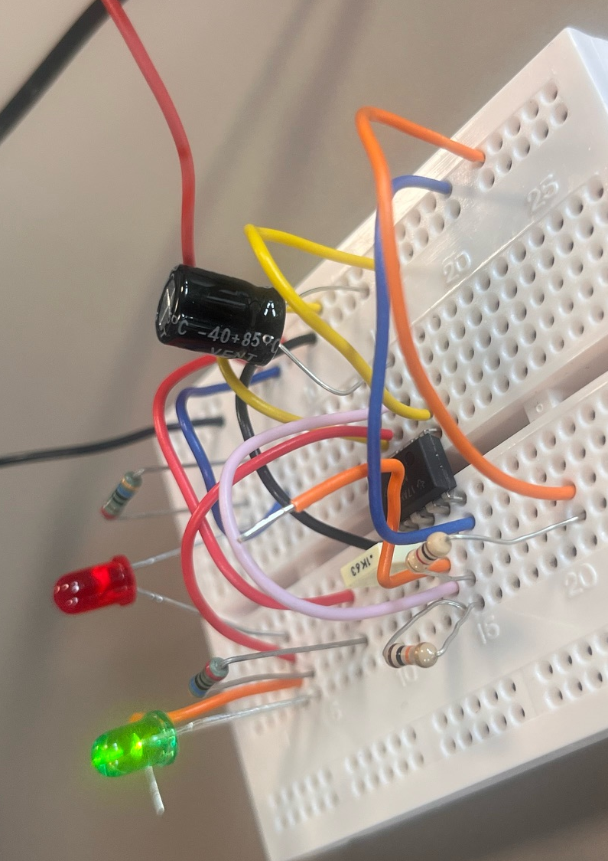
5.1 After running lots of simulations it’s vital to follow out the same experiments in the real world to see if the same results are given. To test the Proteus circuit, a bread board was used. This is a cheap, easy and reusable type of circuitry that even beginners can learn on. Once the circuit was constructed exactly the same as the Proteus simulation, the positive and negative terminals were connected to a 9V power supply. Before turning it on, the capacitors and LEDs had to be checked that they were facing the right way so that no damage to components would happen.

Figure 5, 555 Circuit made on a bread board

5.2 Once the power was turned on the lights immediately started flashing, this meant the circuit was wired correctly and working as intended. However, when looking at the oscilloscope readings it shows the output voltage has a much different shape when compared to the simulated readings. This could be because of the equipment we used being old and worn making resistance higher, the outcome is that the LEDs aren’t as bright for as long. On the other hand, the C1 voltage shows a more similar shape to the simulated results, but, opposite to the previous, the real world results show a different result throughout. The peak and trough voltage are present for much longer while on the simulations it shows a much smoother line.

5.3 From the simulations, a peak of 5.80V and a trough of -6.10V is shown on the yellow line, this is different to the 7.5 and -7.5V results from the bread board test. Similarly, the Proteus simulation showed 1.3V and -1.4V for the C1 voltage while the bread board circuit provided a C1 output of less than 1V each way alternating.

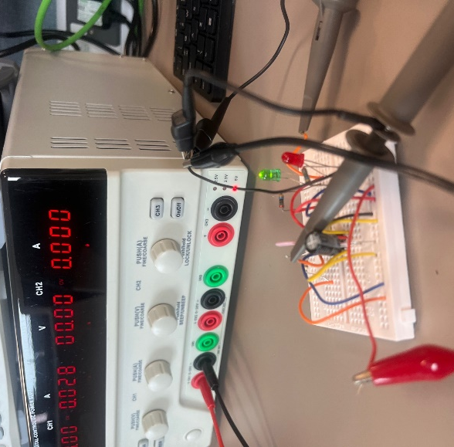
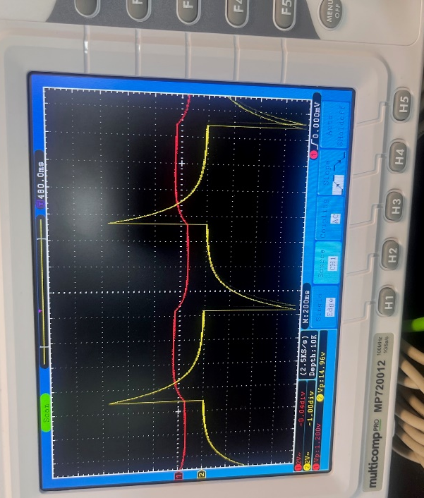
Figure 7, Bread board circuit attached to power supply
Figure 6, Oscilloscope results of bread board circuit v

6 Conclusion
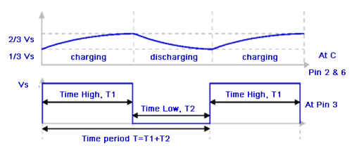
6.1 The results of this experiment highlight the importance to double check results to make sure the correct values are found. As both results were different it would be best to repeat both to check if they give different results again. Even though there was a mistake and the results didn’t match up, the experiment helped to demonstrate the principles of electronic systems and how precise they need to be to be accurate. Understanding electronics is essential within the OME field as lots of fuses and explosives rely on electrical signals to begin the explosive train. This means the integrity of the circuits placed on explosives can affect the safety of the people handling them.

Figure 8, Ideal oscilloscope wave forms [9]

6.2 From this figure, the correct wave forms are shown. This is what the simulations and bread board experiment should have shown, a clear stable high and low voltage. The charging and discharging wave is similar and showing a consistent voltage change, it appears to be charging and discharging too quickly. This may be what has effected the high and low points making them not last long enough.

Total words - 1551

7 References

[1] Dejan, “555 Timer IC - Working Principle, Block Diagram, Circuit Schematics,” How to Mechatronics. https://howtomechatronics.com/how-it-works/555-timer-ic-working-principle-block-diagram-circuit-schematics/
[2] Øyvind Nydal Dahl “555 Timer Tutorial and Circuits,” Build Electronic Circuits, Jun. 04, 2021. https://www.build-electronic-circuits.com/555-timer/
[3] EFY Bureau,“Precision-Guided Munitions: Guidance Techniques (Part 1 of 4),” Apr. 28, 2015. Precision-Guided Munitions: Guidance Techniques (Part 1 of 4) (electronicsforu.com).
[4] Øyvind Nydal Dahl, https://www.facebook.com/BuildElectronicCircuits, “Blinking LED Circuit with Schematics and Explanation,” Build Electronic Circuits, Feb. 26, 2017. https://www.build-electronic-circuits.com/blinking-led-circuit/
[5] “Multivibrators including Monostable, Astable and Bistable,” Basic Electronics Tutorials, Aug. 29, 2013. https://www.electronics-tutorials.ws/sequential/seq_3.html
[6] “Bistable Multivibrators | How it works, Application & Advantages,” Electricity - Magnetism, Oct. 26, 2023. https://www.electricity-magnetism.org/bistable-multivibrators/
[7] “In-Depth 555 timer IC complete guide,” Microcontrollers Lab, Feb. 15, 2020. https://microcontrollerslab.com/555-timer-modes-circuit-diagram/ (accessed Jul. 22, 2024).
[8] M-Short, JOEL_E_B. “How to Use a Breadboard -learn.sparkfun.com,” Sparkfun.com, 2020. https://learn.sparkfun.com/tutorials/how-to-use-a-breadboard/all
[9] “555 Timer Astable Circuit Calculator,” circuitdigest.com. https://circuitdigest.com/calculators/555-timer-astable-circuit-calculator#:~:text=The%20frequency%20can%20be%20calculated%20as%20Frequency%20%28F%29 (accessed Jul. 22, 2024).

