

Online Retail Customer Churn Prediction and Segmentation
A WEKA-based data mining report using classification and clustering

Student | Abubarkar Dembele
Programme | BSc Applied Computing
Module | ACCA6026 Data Warehousing & Data Mining
Assessment | Component 2: Data Mining
Submission deadline | 31 July 2026, 14:00 • DSA one-week extension applies
Target length: 2,500 words

Contents

Executive Summary
This report analyses the Online Retail Customer Churn Dataset in WEKA in order to support two related business aims: predicting whether a customer is likely to churn and identifying meaningful behavioural customer segments. The dataset contains 1,000 customer records and 15 original attributes covering demographic, financial, transactional, service and marketing behaviour. Because Customer_ID is a unique identifier rather than a true behavioural variable, it was removed before modelling. The final modelling dataset therefore contained 14 useful attributes with Target_Churn selected as the class variable for supervised learning. The practical investigation combines classification and clustering because the assignment requires both predictive and exploratory data mining. Five classification models were compared: ZeroR, J48, Random Forest, Logistic Regression and Naive Bayes. Their performance was evaluated mainly through 10-fold cross-validation, accuracy, weighted precision, weighted recall, weighted F-measure, ROC area and confusion matrices. In addition, SimpleKMeans clustering was tested at k=3, k=4 and k=5 to investigate whether stable customer segments could be created from the same data without using the churn label. The results show that the strongest predictive model among the learning algorithms was Random Forest with 51.3% accuracy, but this still did not outperform the ZeroR baseline of 52.6%. This means the present variables and default WEKA settings do not provide a strong churn-prediction model. However, the clustering analysis was more useful in managerial terms, especially the k=5 solution, which created five interpretable customer groups with different value, engagement and service characteristics. The overall conclusion is therefore balanced: the dataset is currently more useful for segmentation and managerial targeting than for accurate automated churn prediction. The report recommends cautious use of the classification output, stronger future feature engineering, and immediate use of the customer segments for differentiated retention, service recovery and marketing campaigns.

1.1 Purpose and Practice of Data Mining
Data mining refers to the process of discovering valid, useful and understandable patterns in data so that organisations can make better decisions. In an online retail setting, large volumes of customer behaviour data are routinely collected through transactions, service interactions, promotions and account activity. On their own, these raw records do not automatically create business value. Data mining adds value by identifying patterns that may help managers predict behaviour, target resources more effectively and reduce avoidable losses. In this assignment, the main business problem is customer churn, which means a customer stops buying or becomes inactive. Churn matters because acquiring a new customer usually costs more than retaining an existing one, so even modest improvements in retention can produce financial benefits. The practical importance of churn analysis is that managers rarely want a purely technical answer. They need to know which customers are most at risk, what kinds of customers behave similarly, and what type of action should be taken. For this reason, a single algorithm rarely gives the full answer. Supervised learning is suitable when a historical target label already exists and the business wants prediction. Unsupervised learning is suitable when the aim is exploration, grouping and pattern discovery. A good data mining report therefore combines technical output with business interpretation, rather than simply listing model scores. This report follows that logic by combining classification and clustering. Classification was used to compare predictive approaches to Target_Churn, while clustering was used to create interpretable segments from customer profile and behaviour variables. The two approaches complement each other. A predictive model may be used to flag possible churners, while clustering may reveal that some groups need service recovery, others need loyalty reinforcement, and others respond mainly to promotions. Even if predictive performance is weak, segmentation can still be valuable. This is an important principle in data mining practice: models should be judged according to how well they support a business decision, not only by whether they produce a complex technical output.

1.2 Dataset Description and Exploration
The dataset used for the analysis is the Online Retail Customer Churn Dataset. It contains 1,000 instances and 15 original attributes. These attributes describe customer age, gender, annual income, total spend, years as a customer, number of purchases, average transaction amount, number of returns, number of support contacts, satisfaction score, last purchase days ago, email opt-in status, promotion response and the churn target. As a whole, the dataset is appropriate for the problem because it contains a mixture of demographic data, value measures, service measures and engagement measures. These are all plausible drivers or indicators of churn in an online retail context. In WEKA, the dataset initially displayed Customer_ID as the first attribute. This field had 1,000 distinct and unique values, confirming that it was simply an identifier. Keeping a unique identifier in a predictive model is poor practice because it does not describe general behaviour and may encourage meaningless row-level memorisation. For this reason, Customer_ID was removed, leaving a final modelling relation with 14 attributes. The class attribute was set to Target_Churn, which is nominal. The WEKA Preprocess screen also indicated 0% missing values for the selected attribute Age, along with a minimum of 18, a maximum of 69, a mean of 43.267 and a standard deviation of 15.242. These values show a broad customer age spread and confirm that the dataset can support variation-based analysis. Another important exploratory observation concerns the balance of the churn target. ZeroR predicted the majority class and achieved 52.6% accuracy, which implies that the class distribution is close to balanced, although slightly weighted toward churn=True. This is useful because it means the data does not suffer from an extreme imbalance problem. However, it also makes the modelling challenge harder, because a useful classifier must do more than simply identify a heavily dominant class. A near-balanced class means accuracy alone must be interpreted carefully, and this justifies using additional metrics such as precision, recall, F-measure and ROC area. From a business point of view, the attributes appear sensible. Total_Spend and Annual_Income may indicate customer value. Years_as_Customer and Num_of_Purchases may indicate loyalty and activity. Num_of_Returns, Num_of_Support_Contacts and Satisfaction_Score may capture quality issues, dissatisfaction or post-purchase friction. Last_Purchase_Days_Ago is especially important because inactivity is often closely related to churn. Email_Opt_In and Promotion_Response may indicate whether customers are still responsive to engagement efforts. Together, these fields provide a reasonable starting point for both predictive and exploratory data mining.
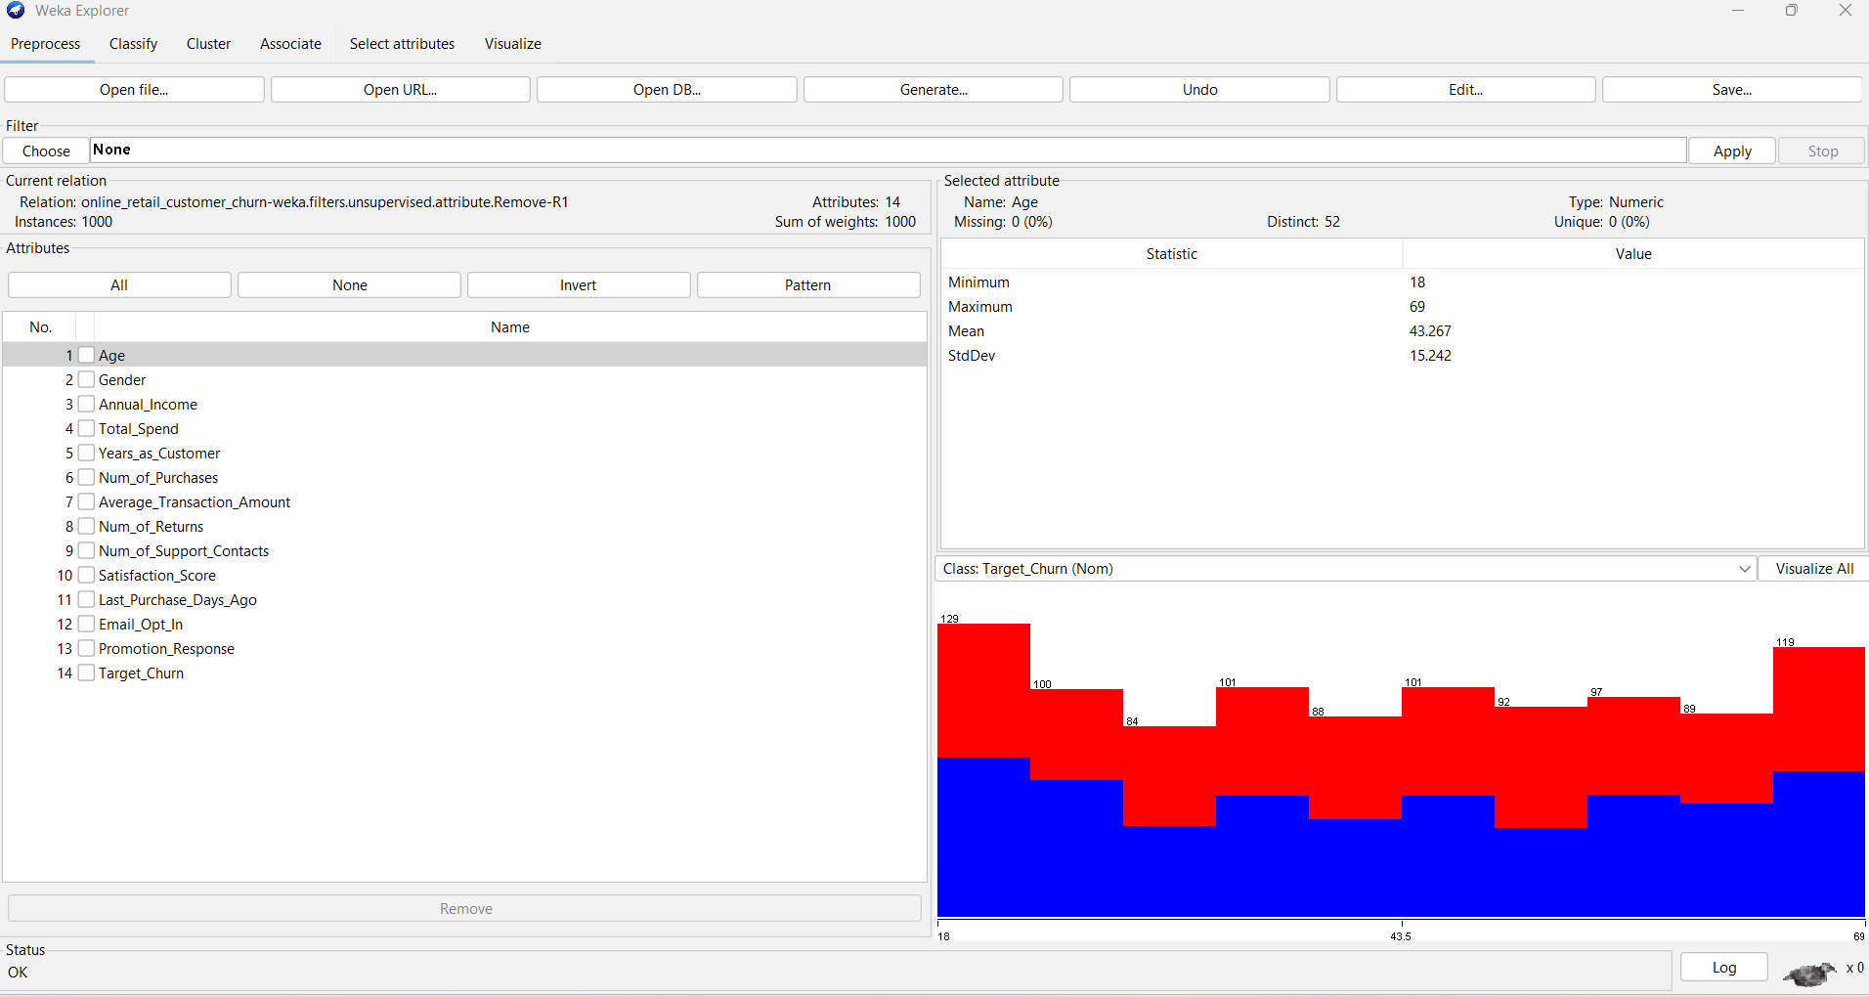
Figure 1. WEKA Preprocess view after Customer_ID was removed and Target_Churn was selected as the class.
Figure description: The screenshot confirms that the final modelling relation contains 1,000 instances and 14 attributes. The Age attribute is selected and shows no missing values, while Target_Churn is selected as the class attribute for supervised classification.

Table 1. Dataset attributes used for churn prediction and segmentation.
Attribute | Type | Use in analysis
Age | Numeric | Customer demographic profile
Gender | Nominal | Customer group comparison
Annual_Income | Numeric | Spending capacity indicator
Total_Spend | Numeric | Customer value indicator
Years_as_Customer | Numeric | Loyalty and tenure
Num_of_Purchases | Numeric | Purchase frequency
Average_Transaction_Amount | Numeric | Typical basket value
Num_of_Returns | Numeric | Possible dissatisfaction or buying pattern
Num_of_Support_Contacts | Numeric | Service friction indicator
Satisfaction_Score | Numeric | Customer experience measure
Last_Purchase_Days_Ago | Numeric | Inactivity indicator
Email_Opt_In | Nominal | Marketing engagement
Promotion_Response | Nominal | Campaign response behaviour
Target_Churn | Nominal | Prediction class

1.3 Data Pre-processing and Post-processing
The first and most important pre-processing action was the removal of Customer_ID. This step is essential because a unique identifier does not generalise and has no real predictive meaning. The second preparation step was to set Target_Churn as the class variable for the classification experiments. This allowed WEKA to evaluate each classifier consistently against the same business target. No rows were removed during this process, so the modelling dataset remained at 1,000 instances. The dataset contains both numeric and nominal variables, and the chosen WEKA classifiers can work with this mixture. Numeric fields such as Total_Spend, Annual_Income, Last_Purchase_Days_Ago and Num_of_Purchases were retained because they express magnitude and intensity of behaviour. Nominal fields such as Gender, Email_Opt_In and Promotion_Response were retained because they capture category-based behavioural differences that could matter in retention analysis. For clustering, Target_Churn was explicitly ignored so that customer segments would be formed from the behavioural profile itself rather than from the outcome label. This is important because meaningful segmentation should reveal hidden structure, not simply reproduce the known class. The clustering output indicated that missing values were globally replaced with mean or mode during SimpleKMeans. Since the Preprocess evidence showed no missing values for the selected variables and no missing-data issue emerged in the modelling process, missing values were not a major limitation here. However, it remains useful to note how WEKA handles this, because in real business settings missing-data treatment can change the interpretation of clusters and models. Post-processing in this report was not limited to reading the raw WEKA output. The results were interpreted in business terms by comparing models to the ZeroR baseline, examining confusion matrices, summarising model metrics in a comparison table, and turning cluster centroids into customer segment labels. This stage is important because data mining does not end when the software finishes running. The output must be translated into a form that can support a managerial decision. In other words, post-processing turns technical scores into business knowledge. If the analysis were repeated in a second development cycle, useful additional preparation would include feature engineering. Examples include spend per purchase, return rate, support contacts per year, and inactivity bands. Such transformations could create variables that better express behavioural intensity and may improve predictive performance. For this first assignment run, however, keeping the variables close to the original dataset helps preserve clarity, reproducibility and transparency.

1.4 Sample Runs and Analysis Methods
All five classification models were evaluated using 10-fold cross-validation. This evaluation method repeatedly trains on nine folds of the data and tests on the remaining fold, rotating until each fold has been used as test data. This is generally more reliable than evaluating on the full training set because it provides a stronger indication of likely generalisation. The first model run was ZeroR, which predicts only the majority class. ZeroR achieved 52.6% accuracy by predicting Target_Churn=True. This result is important because it establishes the minimum baseline that a useful churn model should beat. If a more advanced model fails to improve on ZeroR, then the data or the modelling choices may not yet support a practically strong predictor. J48 was selected because decision trees are easy to interpret and can often be turned into rules managers understand. In this run, however, J48 achieved only 50.3% accuracy, a weighted precision of 0.502, a weighted recall of 0.503, a weighted F-measure of 0.502 and a weighted ROC area of 0.494. The tree contained 148 leaves and a total tree size of 285, indicating that it became relatively complex without achieving a strong predictive payoff. This suggests that the relationships in the data may be weak, noisy or not easily separable by the current variables. Random Forest was then tested because ensemble tree methods often perform better than a single tree when relationships are more complex or nonlinear. Random Forest produced the best learning-model result with 51.3% accuracy, weighted precision 0.508, weighted recall 0.513, weighted F-measure 0.506 and weighted ROC area 0.505. Although it still failed to beat ZeroR, it gave the most balanced overall performance among the real learning models and therefore represents the strongest candidate if a cautious churn-scoring approach were required. Its confusion matrix showed 331 correctly classified churn=True cases and 182 correctly classified churn=False cases, but also substantial misclassification. This means it captures some useful signal, yet not enough for confident automated deployment. Logistic Regression was included because it is a standard binary classification approach and can sometimes provide useful interpretability. It achieved 46.9% accuracy and a weighted ROC area of 0.448, making it weaker than both Random Forest and J48 in this setting. Naive Bayes was included as a fast probabilistic benchmark and achieved 48.8% accuracy with a weighted ROC area of 0.463. Taken together, the classification results indicate that the present dataset and default settings do not yield a strong churn-prediction model. This is not a failure of the analysis; rather, it is a valid finding that should be stated honestly. The clustering analysis used SimpleKMeans with k=3, k=4 and k=5. Here the class label Target_Churn was ignored so that natural customer groups could be discovered from the remaining fields. The k=3 solution provided a broad overview, the k=4 solution gave a somewhat more detailed split, and the k=5 solution produced the richest and most actionable segmentation. At k=5, cluster sizes were 253, 215, 135, 200 and 197 customers respectively. These are reasonably distributed cluster sizes rather than one dominant group and several trivial groups. The cluster centroids also showed real differences in average age, income, total spend, tenure, support contacts, satisfaction and promotion response. This makes k=5 the most useful segmentation solution for business interpretation. A critical evaluation judgement is that the project produced stronger evidence for segmentation than for prediction. This does not mean the assignment failed. Instead, it shows that the current data is more suitable for exploratory customer grouping than for accurate automatic churn scoring. This distinction is important because it demonstrates evaluation rather than overclaiming. In practice, the retailer could use the segmentation results immediately, while treating the predictive results as a first-stage diagnostic that indicates the need for richer data or better feature design.
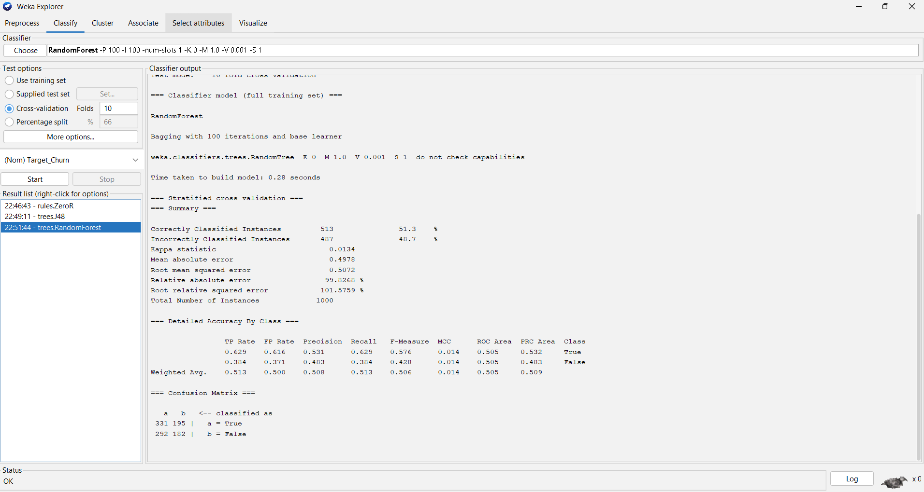
Figure 2. WEKA Random Forest classification output using 10-fold cross-validation.
Figure description: The screenshot shows Random Forest correctly classifying 513 out of 1,000 instances. It achieved the strongest balance among the tested learning models, although its accuracy remained below the ZeroR baseline.

Table 2. WEKA classification model comparison.
Model | Accuracy | Weighted precision | Weighted recall | Weighted F1 | Weighted ROC
ZeroR | 52.6% | - | - | - | -
J48 | 50.3% | 0.502 | 0.503 | 0.502 | 0.494
Random Forest | 51.3% | 0.508 | 0.513 | 0.506 | 0.505
Logistic Regression | 46.9% | 0.455 | 0.469 | 0.449 | 0.448
Naive Bayes | 48.8% | 0.475 | 0.488 | 0.467 | 0.463

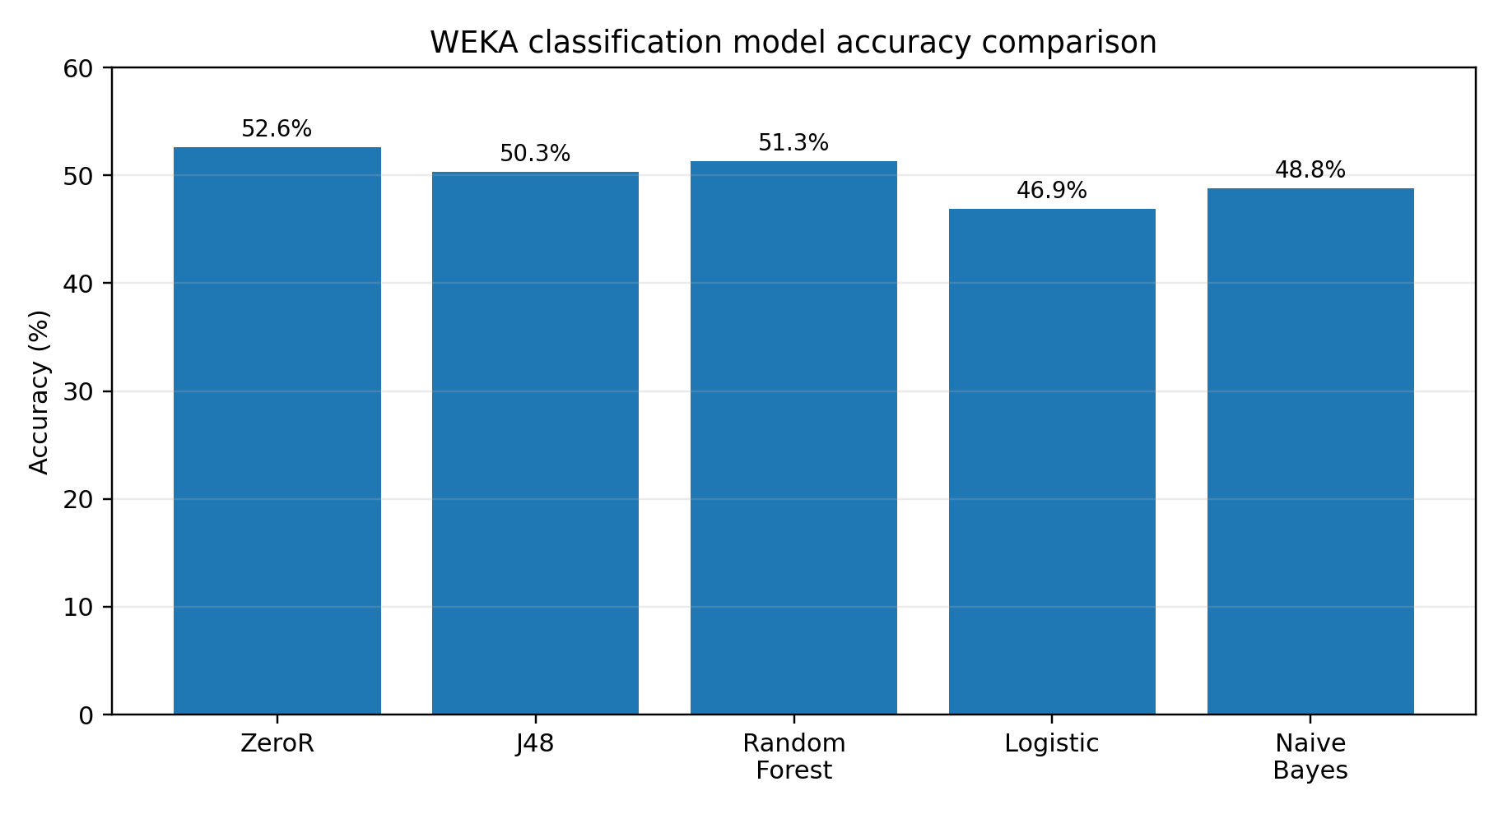
Figure 3. Classification accuracy comparison across the WEKA models.
Figure description: The bar chart shows that ZeroR achieved the highest accuracy because it predicted the majority class. Among real learning models, Random Forest achieved the best overall accuracy.

Another reason for looking beyond accuracy is that different business errors have different costs. A false negative means a real churner is missed and may leave without intervention. A false positive means the company spends time or incentives on a customer who may not have left anyway. Because the present models produce both types of error in notable quantities, managers should be cautious and should not treat the model scores as if they represent high-confidence risk labels. Instead, the prediction output should be combined with business rules and human review if used at all.
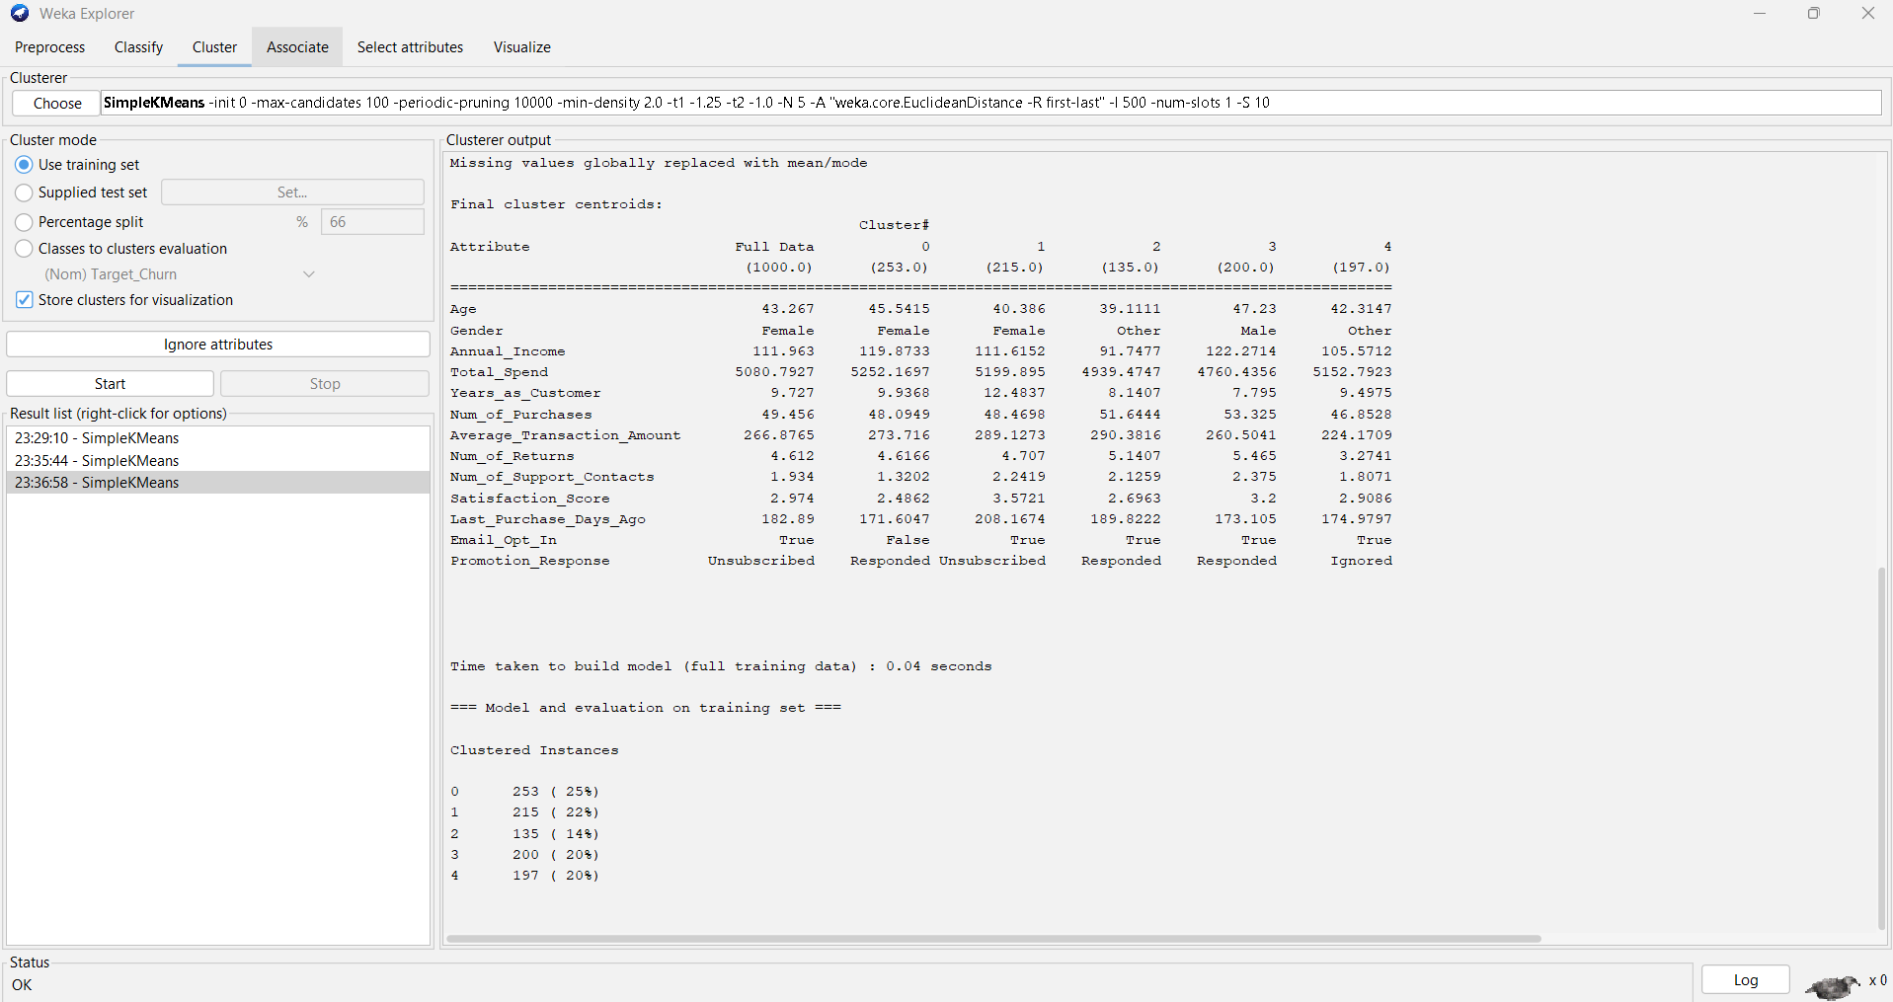
Figure 4. WEKA SimpleKMeans k=5 clustering output with Target_Churn ignored.
Figure description: The screenshot shows five customer clusters created from demographic, spending and engagement variables. Target_Churn was not used to form the clusters, making the segmentation suitable for behavioural interpretation.

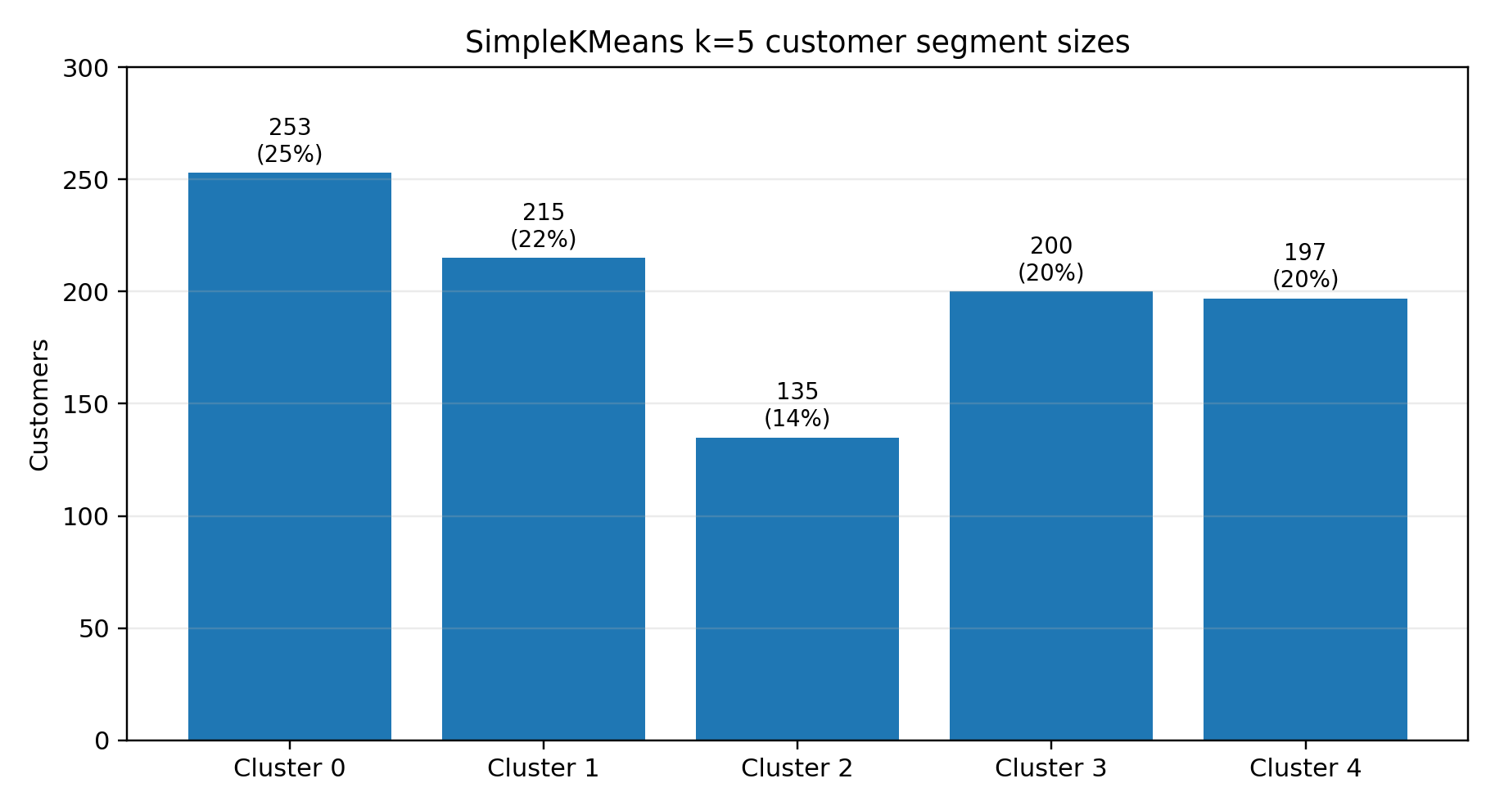
Figure 5. SimpleKMeans k=5 customer segment distribution.
Figure description: The chart summarises the five segment sizes. The clusters are reasonably distributed, with the smallest group still representing 135 customers and the largest group representing 253 customers.

Table 3. SimpleKMeans k=5 customer segment interpretation.
Cluster | Size | Centroid pattern | Business label
0 | 253 (25%) | Female, older, high income, good spend, lower satisfaction, not email-opted in | High-value low-engagement customers
1 | 215 (22%) | Female, longest relationship, highest satisfaction, high average transaction, unsubscribed | Loyal high-satisfaction customers
2 | 135 (14%) | Other gender, lowest income, high purchases, promotion responded | Budget but active customers
3 | 200 (20%) | Male, high income, high returns, more support contacts, promotion responded | High-value support-risk customers
4 | 197 (20%) | Other gender, lower average transaction, low returns, promotion ignored | Low-response stable customers

1.5 Business Recommendations
The first recommendation is that the retailer should not deploy the current WEKA classification models as a fully automated churn decision tool. None of the learning models beat the ZeroR majority-class baseline, so the evidence does not justify treating the current scores as a high-quality predictive engine. However, Random Forest can still be used carefully as an exploratory indicator of risk if it is combined with business rules such as long inactivity, low satisfaction, repeated support contacts or unusual decline in purchase activity. The second recommendation is to make immediate use of the segmentation results, because this is where the analysis adds clearer business value. High-value low-engagement customers should receive personalised re-engagement, service follow-up and non-generic retention messaging. Loyal high-satisfaction customers should receive recognition and loyalty reinforcement rather than aggressive discounting. Budget but active customers may respond well to value-based promotions and low-cost incentive campaigns. High-value support-risk customers need operational attention because their high service contact and return patterns may indicate friction, dissatisfaction or unmet expectations. Low-response stable customers should not be over-targeted, but should instead receive occasional low-cost communication to preserve awareness without creating fatigue. The third recommendation is to improve the input data before attempting a stronger predictive deployment. Additional variables such as product category, basket diversity, browsing behaviour, complaint type, coupon history, delivery issues, refund timing and previous campaign outcomes would likely provide richer predictive signal. It would also be useful to engineer derived variables such as return rate, spend per purchase, time since customer registration, or support contacts per year. These measures may reflect behaviour more clearly than raw counts alone. Finally, the business should evaluate future models using cost-sensitive logic rather than accuracy alone. In many real situations, losing one genuinely high-value customer costs far more than the cost of sending a retention message to a false alarm. Therefore, a future churn programme should compare not only technical performance but also business payoff. This would create a more realistic connection between data mining results and managerial decision making.

1.6 Reflective Commentary
This practical work showed that WEKA is useful for quickly exploring data mining techniques, comparing algorithms and producing evidence for academic reporting. The software made it easy to move between pre-processing, classification and clustering, and it provided clear outputs such as confusion matrices, ROC statistics and cluster centroids. The assignment also reinforced an important analytical lesson: not every dataset will produce a strong predictive model simply because several algorithms are tested. Honest evaluation is therefore a strength, not a weakness. From a personal learning perspective, the classification results were initially disappointing because more advanced models did not outperform the ZeroR baseline. However, this became a useful insight rather than a problem. It highlighted the importance of baselines, feature quality and critical interpretation. The best learning model, Random Forest, still produced many errors, showing that a technically sophisticated method cannot compensate fully for limited or weak signal in the input variables. The clustering analysis felt more successful because it translated naturally into business language. Segmenting customers into groups such as loyal high-satisfaction customers or high-value support-risk customers creates immediate managerial meaning, even when precise churn prediction remains weak. If I repeated the project, I would spend more time on feature engineering, parameter tuning, and possibly cost-sensitive evaluation. I would also test whether time-based validation or a richer transactional history improved the realism of the model. Overall, the assignment improved my confidence in using WEKA and in interpreting data mining results critically rather than just reporting them mechanically.

Conclusion
This report used WEKA to investigate customer churn and customer segmentation for an online retail dataset. The analysis fulfilled the assignment aim by applying both classification and clustering methods, documenting sample runs, and interpreting the output in business terms. The classification models showed limited predictive strength, with Random Forest performing best among the true learning algorithms but still failing to beat the ZeroR baseline. This means the current data and default settings do not justify confident automated churn prediction. In contrast, the clustering analysis produced more useful managerial insight, especially the k=5 solution. The five segments provide a practical basis for targeted marketing, service recovery and retention planning. The strongest overall conclusion is therefore that the dataset is presently more suitable for customer segmentation than for accurate churn prediction. Future work should improve data richness, create stronger behavioural features and evaluate models using business cost as well as technical metrics.

References
[1] H. Eskikri, “Online Retail Customer Churn Dataset,” Kaggle. [Online]. Available: https://www.kaggle.com/datasets/hassaneskikri/online-retail-customer-churn-dataset. [Accessed: Jul. 2026].
[2] P. Chapman et al., CRISP-DM 1.0: Step-by-Step Data Mining Guide. SPSS, 2000.
[3] I. H. Witten, E. Frank, M. A. Hall and C. J. Pal, Data Mining: Practical Machine Learning Tools and Techniques, 4th ed. Cambridge, MA, USA: Morgan Kaufmann, 2016.
[4] University of Waikato, “Weka 3: Data Mining with Open Source Machine Learning Software in Java.” [Online]. Available: https://ml.cms.waikato.ac.nz/weka/. [Accessed: Jul. 2026].
[5] University of Waikato, “Attribute-Relation File Format (ARFF),” Weka Wiki. [Online]. Available: https://waikato.github.io/weka-wiki/formats_and_processing/arff/. [Accessed: Jul. 2026].
[6] L. Breiman, “Random forests,” Machine Learning, vol. 45, pp. 5-32, 2001.
[7] J. R. Quinlan, C4.5: Programs for Machine Learning. San Mateo, CA, USA: Morgan Kaufmann, 1993.
[8] C. M. Bishop, Pattern Recognition and Machine Learning. New York, NY, USA: Springer, 2006.
[9] E. Frank, M. A. Hall and I. H. Witten, The WEKA Workbench. Online Appendix for “Data Mining: Practical Machine Learning Tools and Techniques,” 4th ed. Morgan Kaufmann, 2016.
[10] ACCA6026, “Component 2: Data Mining Assessment Specification,” UWTSD course material, 2026.
[11] ACCA6026, “Lecture 8: Cluster Analysis,” UWTSD course material, 2026.
[12] ACCA6026, “Lecture 9: Classification Analysis,” UWTSD course material, 2026.

Appendices
Appendix A: WEKA screenshots and output evidence
The appendix records representative screenshots from the WEKA practical work and supports the interpretation discussed in the main body of the report.
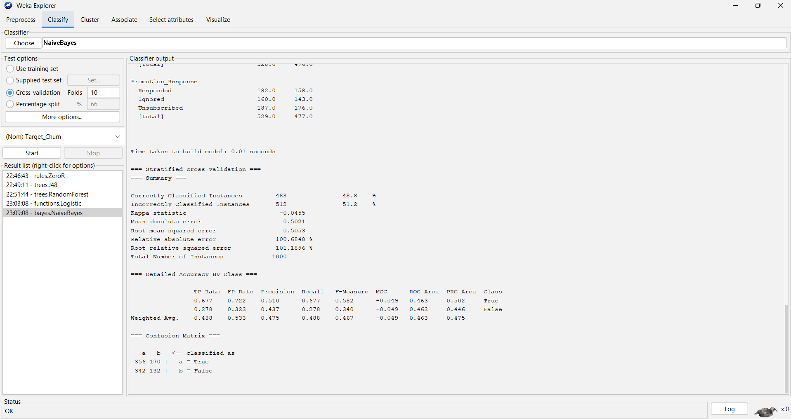
Appendix Figure A1. Naive Bayes WEKA output.
Figure description: This screenshot provides additional evidence of the Naive Bayes classifier results, including accuracy, class-level metrics and the confusion matrix.

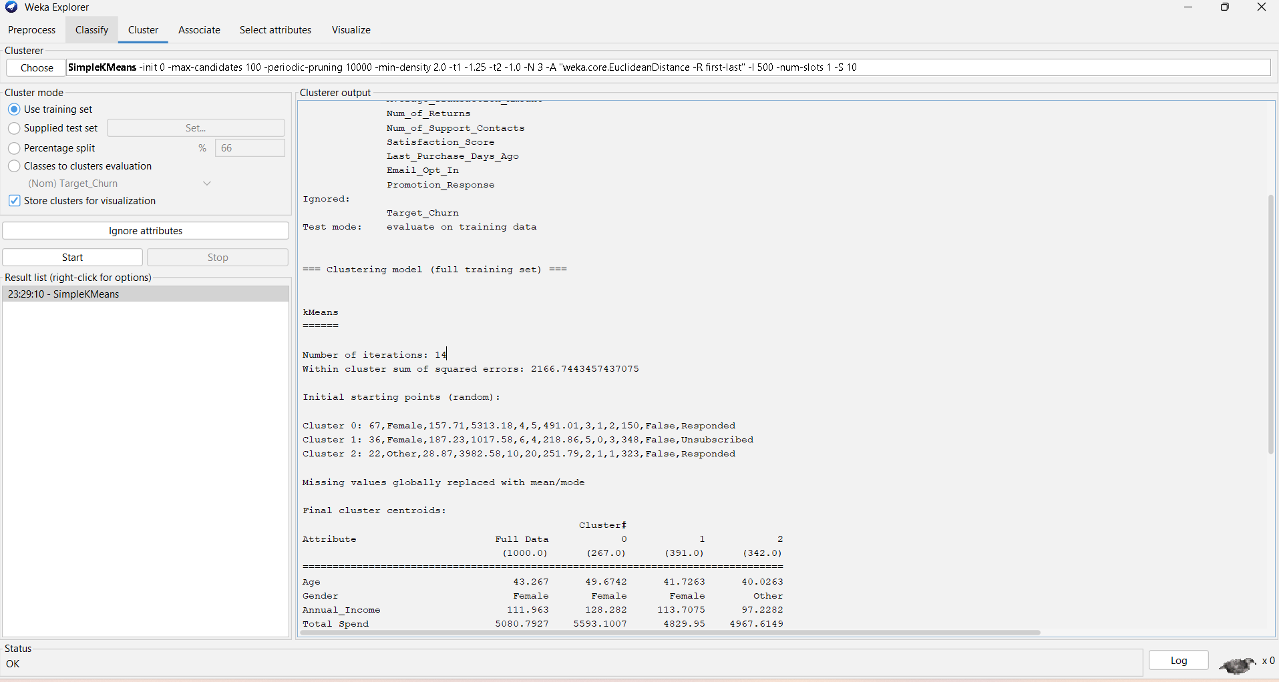
Appendix Figure A2. SimpleKMeans k=3 output.
Figure description: This screenshot shows the k=3 clustering run used as an earlier comparison before the more detailed k=5 solution was selected for the main segmentation discussion.

Main report word count: 2938

