Assignment 1 – Thomas Dilley 1550329

Index

Page 1 Introduction
Page 1 Foundation
Page 1 Frame
Page 2 Wind
Page 2 Enclosure System
Page 3 Conclusion
Page 4 Diagram 1
Page 5 Diagram 2
Page 6 Diagram 3
Page 7 Diagram 4
Page 8 Conclusion

Introduction

This Project is designed to look at the recommendations of the primary structure along with the façade of the systems; along with this diagrams are provided to showing specific recommendations. The building is a two-storey office building which erected in the SA1 area in the dock. The building is to be a large office space for the use year round which means it must deal with the issue of the extreme heat generated in the summer which is currently increasing every year, as well as dealing with the high levels of rainfall we experience in the winter months. Due to this, the building needs to be flexible in terms of use. As this is to be an office space, the area must be kept at comfortable temperatures for the occupants whilst working, this will need to battle the highs and lows the British climate.

The diagrams shown will be annotated to reflect the recommendations made regarding the building, as the build has not yet been constructed these are things which can be discussed and worked on and developed through the construction process, the recommendations made are to be used in association with the development team to minimalise issue over the lifespan of the building whilst ensuring that the building is a future adaptive structure.

Foundation
Foundation used for the displayed building (As Diagrams below).
I would recommend the use of a pad foundation system due to the large expansive structure, the building would be able to sit on selective foundation points, which run deep and brace from pad to pad. This system means that that cost and time can be saved on excavating for a complete foundation to be filled with concrete to which it may not be used.

From the foundation used, I would then recommend using steel as the main construction material to be used to allow for an expansive steel frame to constructed for the building, this will allow for large open areas along with. Due to the great lengths steel be fabricated at while still achieving great strength. This will allow for the open layout with minimal bracing inside the building. Steel framed structures can span 406×178×54 is stated to be able to span 10m. (https://civilsir.com/rsj-beam-size-for-3m-4m-5m-6m-7m-8m-9m-and-10m-span/)

Frame
Due to the use of the building being for open office, it is best to minimalise the reliance on supports on the internal supports, as this will enable the office to maximise on airflow throughout the building to ensure for better controls of temperature, with global warming increasing temperatures. It is beneficial to maximise on the use of natural airflow through the use of windows being opened with uninterrupted pathways. However as this is constantly increasing, minimal disruption internally allows for adaptation for the space as time progresses. The ability to adapt a space is no only beneficial to ensure that spaces are adaptable for aesthetic purposes for business as this ensures that the office space is not pigeon holed for a particular fashion on purpose, (Change of use). This also allows the space to be fitted with ventilation, with the ability to retrofit different systems, as the more efficient, effective systems are required.

Large steel columns are used to brace steel beams to manage the weight of the structure; this column bracing will spread the weight to the columns to place upon the pad foundation. This large steel frame bracing onto pad foundation means that the weight can be spread down through the columns down through the frame. The large frame structure would need to construct off site, however the benefit of this means that they can ensure that the structure is constructed to precise sizing, with the ability to eliminate contaminants in a warehouse environment. Ensuring the steel frame is heavily treated against rust is important due to the high salt content in the SA1 dock area that is planned for the construction.

The area that the building is being planned for construction is has to deal with heavy wind loads due to its exposure out into the water from the original land, these heavy winds come a cost to the buildings face if not correctly maintained. When the building is constructed, it will be important to anchor the building heavily into the foundation to ensure that the building does not affect with the wind. These figures will be calculated to allow for the increase gusts in this area. Along with this it will be advised to keep the weight of the building as low as possible with wind deterrents to ensure wind does not affect the building with a brunt force.

Wind
Along with the high winds in this area, there are rising temperatures in the UK; this means that it is likely to be beneficial to introduce screens to break heavy sun into the windows to minimalise overheating in the office space. It is clear from the drawings provided that the building is designed to harness heating from the sun through the use of a sun screen to the roof of the building. This form of heat harness can be a good use of the natural resource, which can enable the reduction of energy costs, If this screen is being used for energy production, this system will allow building to maximise on benefits with the large increases occurring with energy prices.

The window system used will be critical due to the location in relation to the off shore wind that will affect the structure, introduction of the plant life will be a good step to reducing heavy impacts caused by offshore gusts, unfortunately this along will not be a suitable solution. The introduction of dampeners to the primary structure, which in tune can be used to offset forces acting against the structure. This dampening affect can counter the issues caused which helps to eliviate the damage caused by the forces. (Structural Improvements for Tall Buildings under Wind Loads: Comparative Study (hindawi.com))

Enclosure System
The system of enclosure that will be required should tie in with the local architecture while being well designed to accommodate the climate changes, as things are moving. As the building will need to be designed in a way that it future proofs the structure as this is an increasing issue which will be affecting the modern infrastructure. I would recommend that the structure is predominately a brick façade to the steel frame, onto this I believe it is important to use sun canopies or recessed windows to break up the sun that is shining into the building to ensure that overheating does not occur for the occupants. On the Ocean facing elevation (west) there are benefits to the use of cladding screens due to the high winds that come off the ocean, it can be an excellent way to break up high impact of water caused by these forces. This likely to reduce water penetration from these areas.

Next, it is important to include a heating and air condition system, this will be used to maintain comfortable temperatures throughout the year. As the building is designed to be an open area split into smaller offices, due to this being an office with multiple different staffing numbers, which can potentially shift over time, I would recommend that windows are able to be manual opened and closed.

The concept provided indicates that the building is designed to have a small parapet wall; I believe that this roof behind the wall should maximise the fall behind to ensure that drainage issues are minimal including reducing pooling water. This is something, which can be a common issue in our wet climate, which can if anticipated in advance this can drastically reduce the issues that may occur. On the roof space, I would advise adding an access hatch to the roof, this will allow for minimal disturbance when maintenance works are required as this can allow access through the building to access the roof space. This will mean the costs are reduced for access, solar system on the roof maintaining access for a cheap cost will make these systems much more affordable.

The large scale windows that are being introduced should be tinted to help to reduce UV impact whilst maintaining light into the building, these large windows will need to be regularly cleaned to ensure that light is maintained as uninterrupted light is important for the occupant’s mental health along with ensure that the building does not look as if it is being neglected.

The building is designed to be an office space with large atriums to the ground, first and second floors. These spaces will be perfect for ensure that the uniform temperature is achieved throughout the building, when smaller areas are used it possible to create temperature zones which can lead to certain areas maintaining a much greater temperature that desired. This may be that the heating system is detected a temperature from one side of the building whilst the bottom floor is not releasing heat quick enough meaning that the system is turning off prior to heat being removed effectively. Therefore, it is imperative that a suitable monitoring system for the heat is included to help ensure that all areas are effectively controlled to a suitably comfortable temperature all year round.

Tree planning is an excellent way to block excessive direct sunlight with a natural source; however, this planting is a good choice as the use of these trees means that it can help to reduce the risk of flooring due to the extra drainage that it provides to the area. Where possible this should be introduce as this helps to break up direct wind to the structure itself without the need for mechanical intervention for the building. This will need minimal maintenance through pruning to keep tidying and from becoming overgrown whilst also potentially watering in the hotter months.

The building is designed for office space however as the world is evolving therefore it is important in all aspects of construction to ensure that a building can be adapted to the future that is required. I believe by keeping a steel framed structure that stud walls can be used internally therefore in the future if the internal space needs to be adapted it means that the need to adapt the supportive frame of the building.

People have begun changing the way they work with the introduction of ‘Hybrid Working’ becoming a more normal part of the average office. This may mean that staff are only attending office partial throughout they are working week. These changes are important to keep in mind, as smaller offices over time may be adapted to collaborative settings, it is important to ensure that these areas can grow with the building. Therefore, it is recommended that these walls remain adaptable.

Lastly, I have chosen a brick façade for multiple reasons however an advantage of this is if there are damages to bricks, over time you replace individual sections or expose behind without having to cut into the building. As this is a matching aesthetic I believe this is a good choice for the external façade of the building.

Conclusion
Based on what has been discussed the focus of my recommendations have been to ensure that the building does not become outgrown quickly whilst ensuring that the building is fit for its current purpose. The building is designed to occupy and office space, the recommendations I have made align to what is required for an office space if opened today along with allowing the building to be adaptable of the future of working, as people begin to ‘hybrid work’ more the space may end up being adapted, these adaptations allow the building to be used for years to come without having to modify the primary structure itself.

As the modern office, space is changing and businesses grow office, begin to change, if a building is built with its current use in mind without thinking of future use it is easy to end up causing a situation where the building becomes very expensive to adapt.

Diagram 1
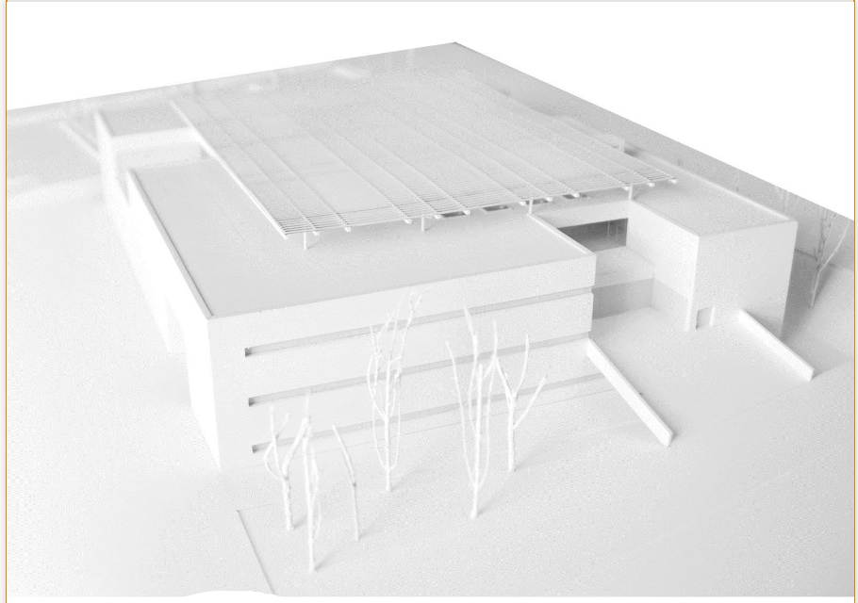

System for maximising the use of heat generate from sun on the roof.

Maximise Fall to Roof.

Brick Cladding to match local architecture.

Sun Shades to reduce direct sunlight / Recessed windows.

Diagram 2
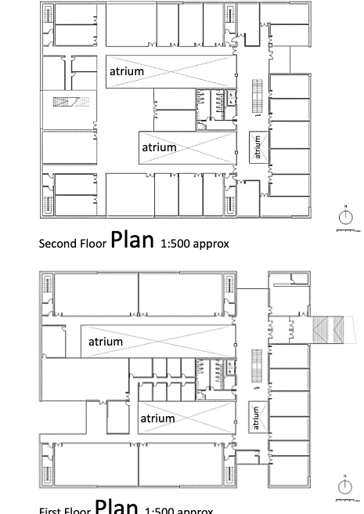

Steel Columns used to displace weight downwards. These points allow the areas to remain open. Indicated by boxes shown on plan.

Diagram 3
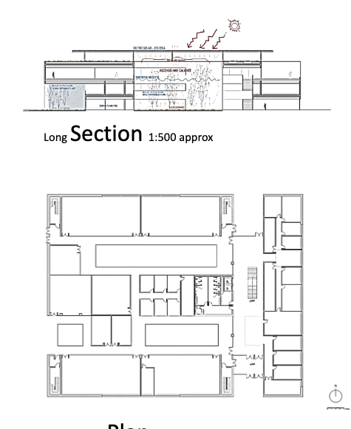
Absorb heat, used to reduce power costs.

Diagram 4

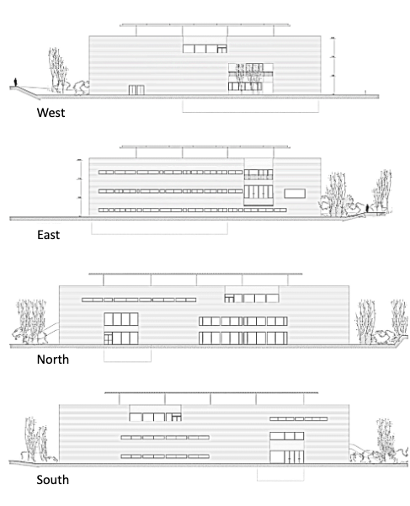
Trees used as a natural light and window barrier for the building.
Large windows to maximise on natural light.

References

- https://civilsir.com/rsj-beam-size-for-3m-4m-5m-6m-7m-8m-9m-and-10m-span/)
- Structural Improvements for Tall Buildings under Wind Loads: Comparative Study (hindawi.com)

