Contemporary Challenges Making A Difference To Health Inequality

Introduction
Firstly, this report will discuss the challenges the population face when trying to achieve a healthy lifestyle.
Secondly the main cause for the current issue facing inequality, further the effects and consequences, moreover potential solutions. In 2004 the World Health Organisation (WHO) Global Strategy on Diet, physical Activity and Health was adopted by the health assembly to take actions to support healthy diets and physical activity [1].
Definition
Differences in health status and the factors that determine it can be experienced by people grouped by a variety of factors, such as socio-economic factors, (income), location (region, urban/rural), characteristics including those protected by law, such as gender, ethnicity, or disability. Health inequality is also used to refer to differences in the care that people receive and the opportunities that they have to lead healthy lives, both of which can contribute to their health status [2].
Different health statuses lead to health inequalities as a result of the social conditions in which people are born, grow, live, work and age, or in the distribution of health resources. For individuals and society, the social and economic cost associated with these inequities are significant. The right combination of government policies can reduce the injustice towards health inequities [3]. WHO made a statement defining health is not the absence of a disease but a state of complete physical mental and social well-being [4].
Health inequalities are preventable. It is not a result of chance or randomness they are socially governed by situations outside of an individuals’ control which could limit people and their chance to live longer and healthier lives [5]
The main cause
There are unfair and avoidable differences in health outcomes due to the systematic differences in the opportunity’s groups have, to achieve optimal health, which is the main cause for health inequalities [6, pp. 167–194].
There is sufficient evidence that social influences comprising of education, employment status, income level, gender, and ethnicity have a clear authority on how healthy a person is. There is a higher risk of poor health the lower an individual’s socio-economic position is [3].
Healthcare professionals have unfavourable sentiments and believe stereotypes about people considered to be overweight or obese, people who are overweight are seen as a comparable group with the same experiences however people have intersectional lives and different lifestyles which can affect an individual’s health and wellbeing, overweight people being categorised as ‘fat’, lazy and unhealthy is also another issue which has led to healthcare inequality [7].
Time is another factor that influences people's actions; however, the way time shapes health has been overlooked, health inequalities are caused by a lack of awareness of the fact that time influences health in the same way that insufficient time complicates health. People need time to work, care for, access health services, play, exercise- all activities are fundamental to health. In the same way that a lack of time is cited as a reason for not exercising or eating well, mental health issues can be directly linked to time pressure [8].
The effects and consequences
A health statistic called maternal mortality highlights the vast disparities between rich and poor, both between and within nations. 99% of maternal deaths worldwide each year occur in developing countries. The vast rate of maternal deaths in various parts of the world reflects unequal access to healthcare services and emphasises the economic inequality [3].
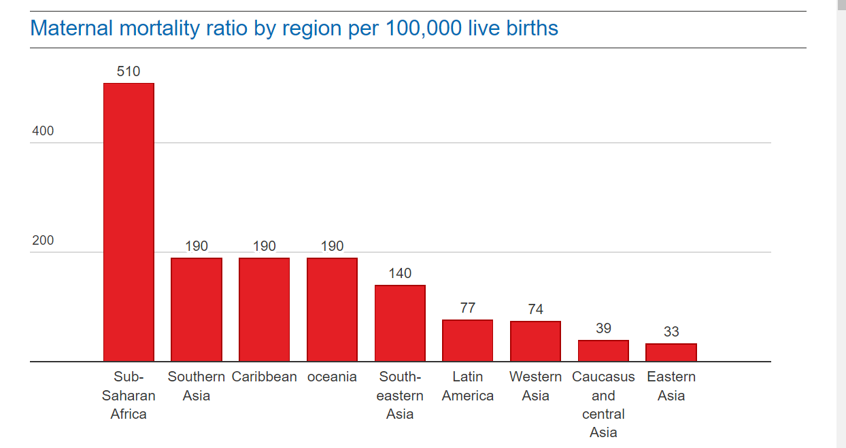

Graph statistics shown here are the maternal mortality ratio by region per 100,00 live births [9].
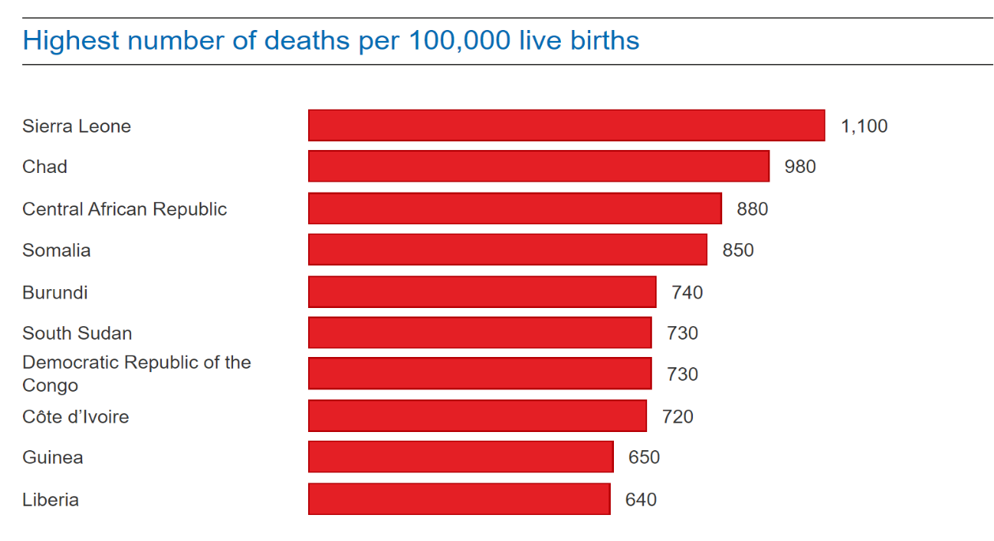

Graph statistics shown here are the ten countries with the highest number of deaths per 100,000 live births [9].
High demands, which perpetuate stress responses and have negative health effects, define exposure to negative environments in work, school, and life. Due to their vulnerability, these exposures are likely to occur more frequently among lower socioeconomic groups. Negative working conditions may also be more common among lower status groups. [10]
Work, education and good quality housing are the fundamental causes which can influence the distribution of influences on the wider environment [5].
Some countries are experiencing an increase in educational inequality; as a result, educational practise and policy should be taken into consideration for equality of opportunity. Since there are still significant educational disparities in the world, a student's background has a significant impact on their prospects for success in school [11, pp. 8].
According to recent data more than one billion people worldwide are obese, WHO indicated obesity also leads to a range of non-communicable diseases which can range from type 2 diabetes, cardiovascular disease, hypertension and stroke, various forms of cancer plus mental health issues [12].
Potential solutions
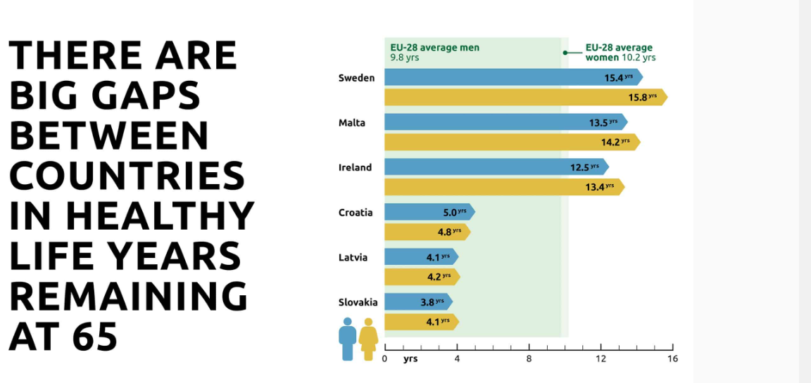
Possible solutions include Utilize taxation, policy, legislation, and regulation to achieve a more equitable distribution of wealth, power, and income. Across European nations and groups of people, health outcomes continue to vary significantly, we must change Europe's fiscal and social policy narrative to one in which issues are approached holistically if we are to reduce inequality and improve health for all; where health care, well-being, and social spending are considered investments; where policies interconnected nature is acknowledged and valued; and in which social sustainability serves as a cornerstone. It makes economic sense because countries would receive monetary benefits ranging from 0.3 to 4.3% of Gross Domestic Product (GDP) for a 50% reduction in life expectancy gaps, improvements are attainable, the EU and its member states have the tools to act in reducing social and health inequalities [13]

[13].

Health inequality could be reduced by establishing public services that are planned and provided in response to demand and ensuring that everyone has equal access to public services like decent housing, health care, and education among other solutions to alleviate the effects of health inequality action is required To address the unfair differences in people's experiences of environmental factors some of these actions could include Training to ensure that public sector employees are sensitive to all social and cultural groups and Integrate welfare advice for low-income families, including vulnerable or high-risk individuals, with healthcare [14].
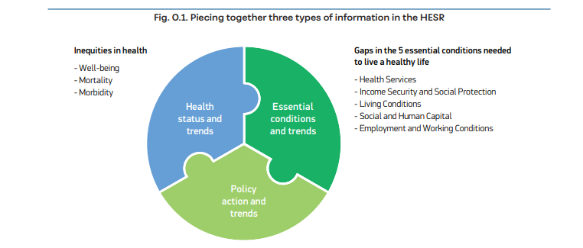

[15].

Conclusion
In conclusion, social conditions that are socially governed by circumstances beyond an individual's control are the root cause of disparities in health outcomes [2]. High demands define exposure to negative environments, which result in unjustified and avoidable differences in health outcomes and perpetuate stress responses [10]. Systematic disparities in the opportunities available to various groups to achieve optimal health are the primary cause of health inequalities [11]. Through taxation, policy, legislation, and regulation, wealth, power, and income can be distributed more fairly [13].

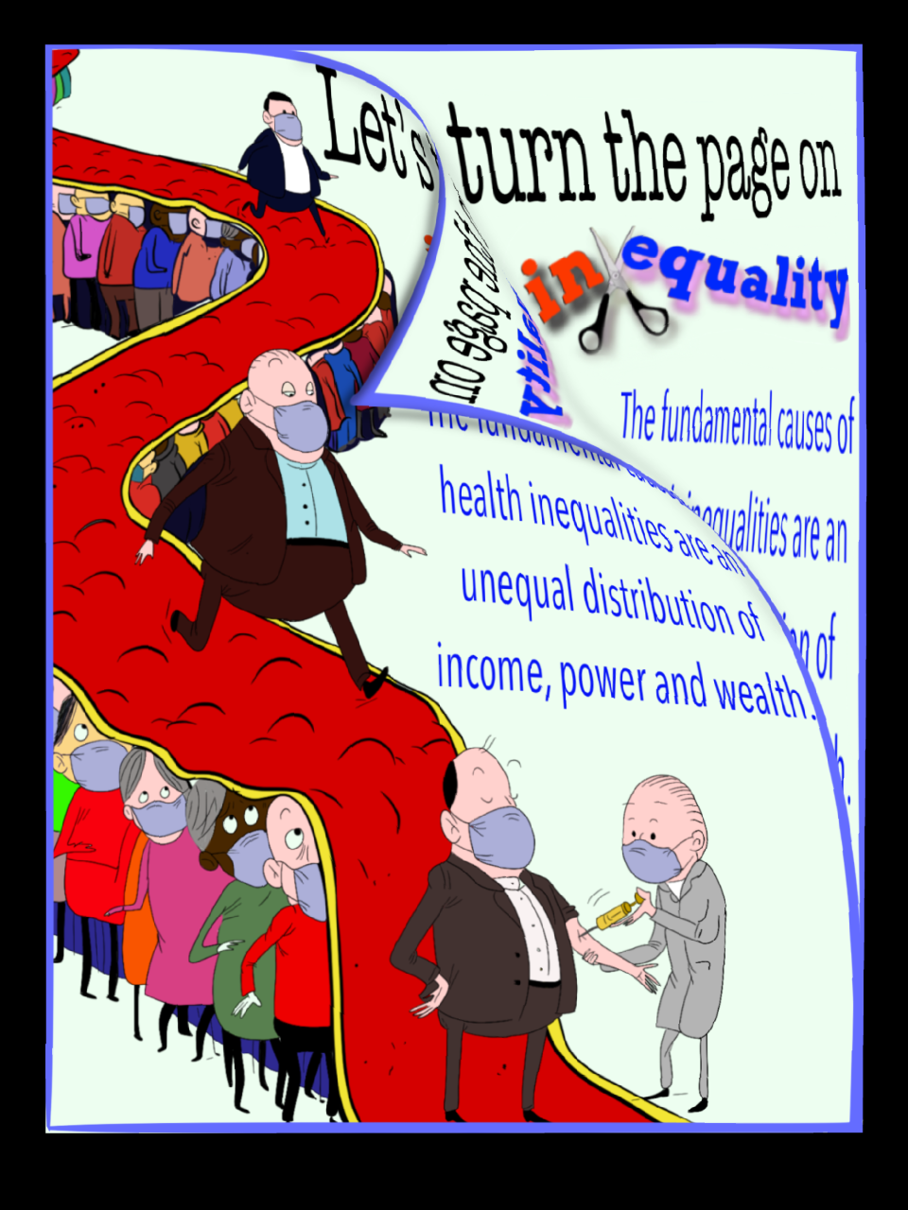

References:
[1] World health Organisation, “Global Strategy On Diet, Physical Activity And Health,” 2004 [Online]. Available: https://www.who.int/publications/i/item/9241592222
[2] GOV.UK, “Health disparities and health inequalities: applying All Our Health,” 2022. [Online]. Available: https://www.gov.uk/government/publications/health-disparities-and-health-inequalities-applying-all-our-health/health-disparities-and-health-inequalities-applying-all-our-health
[3] World Health Organisation, “Health inequities and their causes,” 2018. [Online]. Available: https://www.who.int/news-room/facts-in-pictures/detail/health-inequities-and-their-causes
[4] S. Evans, “What is health? The search for an accurate definition,” 2017 [Online]. Available: https://www.healthpolicypartnership.com/what-is-health-the-search-for-an-accurate-definition/#:~:text=The%20World%20Health%20Organization%20(WHO,But%20how%20accurate%20is%20this%3F
[5] P. H. Scotland, “Improving Health,” 2021. [Online]. Available: https://www.healthscotland.scot/health-inequalities/what-are-health-inequalities#:~:text=As%20shown%20in%20the%20diagram,marginalisation%20of%20individuals%20and%20groups
[6] P. Braveman, “Health disparities and health equity: concepts and measurement,” vol. 27, pp. 167–194, 2006, doi: 10.1146/annurev.publhealth.27.021405.102103. [Online]. Available: https://pubmed.ncbi.nlm.nih.gov/16533114/
[7] C. Dacey, “Weight: The overlooked health inequality,” 2022. [Online]. Available: https://standagency.com/weight-health-inequality/
[8] L. Strazdins et al., “Time Scarcity: Another Health Inequality?,” vol. 43, no. 3, pp. 545–559, 2011, doi: 10.1068/a4360. [Online]. Available: https://doi.org/10.1068/a4360
[9] H. Leila, Maternal mortality down 45% globally, but 33 women an hour are still dying. [Online]. Available: https://www.theguardian.com/news/datablog/2014/may/07/maternal-mortality-rate-drops-half-report-who-childbirth-pregnancy#:~:text=Sub%2DSaharan%20Africa%20is%20the,deaths%20occur%20in%20developing%20countries.
[10] (US) National Research Council and (US) Institute of Medicine, “No title,” 2013. [Online]. Available: https://www.ncbi.nlm.nih.gov/books/NBK154491/
[11] Mennes, H.I. “Inequalities in education for democracy,” 2023. [Online]. Available: https://pure.uva.nl/ws/files/107187043/Thesis.pdf
[12] United Nations, “Over one billion obese people globally, health crisis must be reversed, 2022 [Online]. Available: https://news.un.org/en/story/2022/03/1113312#:~:text=According%20to%20recent%20data%2C%20more,they%20are%20overweight%20or%20obese.
[13] EuroHealthNet, “Factsheet: Health Inequalities in the EU,” 2019 [Online]. Available: https://eurohealthnet.eu/publication/health-inequalities-in-the-eu/?gclid=CjwKCAiA_6yfBhBNEiwAkmXy57QF4aIPBvFOai85xQKJK5CRKv7Xf1i184LaSsuGNDu59zWdE1_ZbxoCzpEQAvD_BwE
[14] Williams.E, Buck. D. Et,al, “What are health inequalities?,” 2022. [Online]. Available: https://www.kingsfund.org.uk/publications/what-are-health-inequalities?gclid=CjwKCAiA_6yfBhBNEiwAkmXy5xeMeij6Do9IPlLGW3pn4rmf1teO2Yi6Wt4L1GP028vpKCuWnXnhoRoCoSIQAvD_BwE
[15] World Health Organization, “Healthy, prosperous lives for all:,” p. 11, 2019 [Online]. Available: https://apps.who.int/iris/bitstream/handle/10665/346044/WHO-EURO-2019-3536-43295-60680-eng.pdf?sequence=1&isAllowed=y

Poster References

[1]
A. Mar Dieye, “Addressing the root cause of inequality,” 2019 [Online]. Available: https://www.undp.org/blog/addressing-root-causes-inequality
[2]

“Health inequality | Cartoon Movement” [Online]. Available: https://cartoonmovement.com/cartoon/health-inequality.

[3]

Public Health Scotland. “Power Inequality,” 2021 [Online]. Available:
https://www.healthscotland.scot/health-inequalities/fundamental-causes/power-inequality

