

Module: Managing Guest Service Operations
Module code: BMIH6003
Assignment Title: Student Learning Log
Student Name: Iuliana-Daniela Giurea
Student ID: 2226406
Table of Contents
Introduction 3
Section 1: Role Reflection 4
Section 2: Management Performance and Guest Service Analysis 6
Section 3: Guest Service Improvement Plan 8
Conclusion 10
References 11

I confirm that I have not used any Al tools in the research and creation of this assignment.
I confirm that I have not presented any Al generated materials as my own work.
I confirm I have copies of my drafts, notes, and other resources l used, which I may be asked to provide in evidence.

Introduction
During the 10 weeks of my placement at Ibis Hotel in London Gatwick, I was allocated to the “Housekeeping Department”, which is an integral aspect of the hotel, as it aims at providing guests satisfaction and helps to maintain the hotel's reputation as well. The housekeeping department in the hotel is charged with ensuring that there are high standards of cleanliness, hygiene and aesthetic presentation, thus in “guest rooms”, “public areas” and “back-of-house facilities”. The team ensures cleaning of rooms properly, replenishing amenities and reporting any case of maintenance as soon as possible.
Learning Objectives
To make my time management and multitasking better during the rush hours through completing room assignments and additional guest requests on a daily shift.
To increase my knowledge on the issue of leadership and delegation in a housekeeping department within the next 7 weeks.
To improve my communication with the fellow team members and guests for becoming more confident and clearer in my conversation with people during the placement.

Section 1: Role Reflection
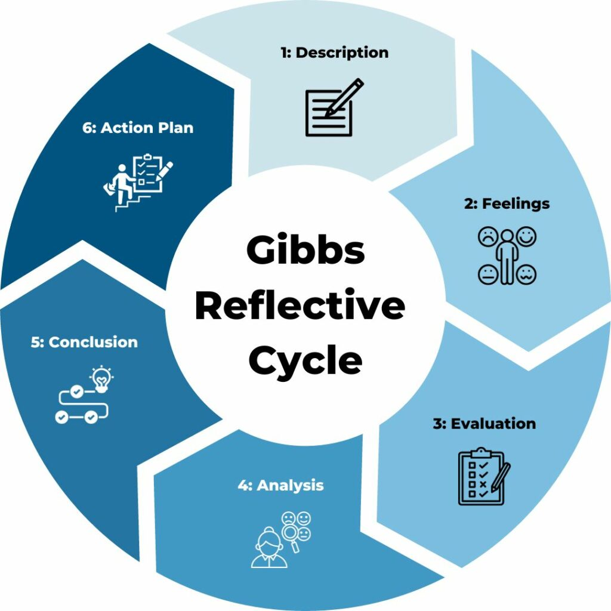
Figure: Reflective cycle model of Gibbs
Source: (McLeod, 2025)
Description
While in my placement at Ibis Hotel in London Gatwick, I was working under the "Housekeeping Department". Some of the duties I was expected to perform were cleaning the guest rooms, changing the used linen and towels, refilling the amenities and reporting the maintenance issues to the supervisor (nicole-brown, 2024). I also assisted in guest requests, for example offering additional pillows, hangers and others.
Feelings
During the beginning of my placement, I was nervous in terms of the pace and quality that I was supposed to meet with the team. I also had doubts on how to communicate effectively with the guests and the senior staff. However, with weeks passing, I felt more comfortable with the roles that I had to play. Getting assistance from the supervisor and support from the team members allowed me to develop confidence.
Evaluation
I understood how significant leadership and delegating were to the efficiency of the housekeeping team. With this one supervisor clearly marking out the rooms with a checklist on a daily basis and explaining the priority rooms for early check-ins, the shift was a success, and all tasks were accomplished within time (Martins, 2025). The team was more organised and I was better placed in planning my day. The second important aspects were teamwork and communication. I observed how communication helped in solving problems within time (Lacalle, 2024). For example, in a situation, a hotel customer complained about a missing thing in their room, the supervisor assigned the employee next at hand to take care of it and after only minutes had passed, the issue was already done with. I believe that one of the aspects I did well in this placement was the attention to detail. I always adhered to the standards and ensured that everything in the room was in perfect order. Thus, one of my weaknesses was reluctance to report problems to the supervisors, delaying corrective measures.
Analysis
All this experience supported me to understand the role that is played by the leadership, delegation, and teamwork in ensuring that housekeeping activities go on smoothly. I also came to know that even though technical skills such as bed-making, cleaning are very important, soft skills such as “problem solving”, “communication skills” and “decision making” are equally relevant.
Conclusion
Having worked in the housekeeping department of the hotel has given me possibilities to acquire practical as well as interpersonal skills. I learned how important these elements of team structure, practice of delegation, and consistent communication are (Forbes, 2023). The positive experiences also helped me to have my ideas about my strong sides and those aspects that I still have to develop.
Action Plan
I intend to start a short online course concerning the basics of communication and leadership in hospitality ensuring that I could realise how to become more confident in a team. I will also start to request weekly feedback from supervisors in the future roles, for me to have a better idea of my progress and adjust to areas of improvement. In order to enhance my “time management” ability, I will have weekly personal goals to be achieved in a given time (Wells, 2024).

Section 2: Management Performance and Guest Service Analysis
Management Styles
The supervisors of housekeeping at Ibis Hotel in London Gatwick applied a combination of democratic and transactional styles of leadership (Cherry, 2023). One of the supervisors fostered team input and he often asked for suggestions in morning briefings thus increasing motivation and establishing a feeling of ownership. This shows the democratic approach I learnt in the course of "Management & Organisational Behaviour”, in which participative management tends to result in high levels of engagement of the team involved.
Health and Safety Compliance
The hotel is bound to COSHH regulations (“Control of Substances Hazardous to Health”) and “Manual Handling Operations Regulations” to maintain safety when working with the chemicals (HSE, 2025). I was trained on the right way of handling cleaning products to ensure safe storage and use of PPE if required. “Health and safety checklists” were done on a daily basis. The concern for safety was essentially responsible for providing the staff and guests with a safe working environment.
Culture and Teamwork
The organisational culture of the housekeeping team was involving and encouraging. Staff was highly diverse, and the concept of mutual respect was very obvious (Casado, 2012). This links up to what I had in level 5 of “Personnel Resourcing & Development” particularly the roles of culture that contribute towards establishing good working environments. Teamwork was promoted by having joint tasks and pairs of assignments.
Marketing and Guest Experience
The expectations of guests were high at Ibis Hotel as it is a well-known modern standardised hotel. The direct role that the housekeeping had in the brand positioning included ensuring that rooms were the same as in marketing materials (Hsieh et al., 2025). I observed that even little things such as towel origami or a customised welcome note made guests feel they were appreciated. This goes with what I have learned in my “Hospitality & Guest Services” module whereby expectations are surpassed hence positive service recovery and rebooking.

Section 3: Guest Service Improvement Plan
Key Issue: Servicing Delays as a Result of Lacking Communication
The most notable problem that I noticed was the delay in services arising from the miscommunications between the housekeeping and the front office. If the guests were checked into rooms, which had not been thoroughly cleaned, issues were raised concerning complaints and rework (Widiastini et al., 2024).
Significance of the Issue
Intiar et al. (2024), interpreted coordination of departments as important in the area of guest satisfaction as in hospitality. Lack of communication not only provokes the guests' dissatisfaction but also decreases the productivity of the workers. According to Selamet et al. (2023), real-time communication between housekeeping and the front desk is valuable in handling the readiness of rooms and complaints from guests. A lot of delays would have been prevented if task status updates were clear and better use of technology.
Three-Step Improvement Plan
Step 1: Installation of Digital Room Management System
Software such as “Opera PMS” or a mobile housekeeping app can be implemented to update the status of the rooms in real-time. This can minimise the delays and enhance the coordination (Seghezzi et al., 2021).
Step 2: Morning Coordination Briefing
Starting a daily briefing for the personnel of the department and the front desk will support them to share check-in lists, room priorities, and any guest requests. This will ensure there is cooperation between the two departments and correct task delegation undertaken.
Step 3: Staff Training on Communication Protocols
Holding a monthly training programme based on interdepartmental communication can also be supportive. This can promote team work thereby enhancing overall guest experience (Avery, 2023).
Expected Impact
These steps would minimise room readiness errors, increase the satisfaction scores of guests, and increase ease of flow in work during the period. With improved communication, there is the development of a culture of shared accountability and improved operational levels of the hotel (Barnhill, 2023).

Conclusion
This placement has been a valuable experience for my personal and professional growth. It gave me knowledge concerning the operation of guest service and the relevance of teamwork, communication, and leadership. Through observation and participating in the housekeeping department at Ibis Hotel in London Gatwick, I attained practical skills that I could not have learned while in a classroom. This reflective learning log has presented the structure of the housekeeping department, and utilised Gibbs' reflective cycle to evaluate me and my personal development. It has also evaluated management performance in respect of various modules. Moreover, a guest service improvement plan has been developed related to the best practices in the industry.

References
Avery, R., (2023). Why Every Employee In Your Company Should Have Communication Training. [Online] Available at: https://www.entrepreneur.com/leadership/why-communication-training-will-transform-your-team/452632 [Accessed 21 May 2025].
Barnhill, A., (2023). Effective Communication: How Leaders Can Inspire, Engage And Succeed. [Online] Available at: https://www.forbes.com/councils/forbescoachescouncil/2023/07/21/effective-communication-how-leaders-can-inspire-engage-and-succeed/ [Accessed 22 May 2025].
Casado, M., (2012). Housekeeping Management. 2nd Ed. London: Wiley.
Cherry, K., (2023). How to Lead: 6 Leadership Styles and Frameworks. [Online] Available at: https://www.verywellmind.com/leadership-styles-2795312 [Accessed 19 May 2025].
Forbes, (2023). How To Delegate Effectively: 8 Ways To Make The Most Of Your Team’s Time And Talent. [Online] Available at: https://www.forbes.com/sites/allbusiness/2023/05/25/how-to-delegate-effectively-8-ways-to-make-the-most-of-your-teams-time-and-talent/ [Accessed 18 May 2025].
HSE, (2025). Control of substances hazardous to health (COSHH). [Online] Available at: https://www.hse.gov.uk/cleaning/topics/coshh.htm [Accessed 19 May 2025].
Hsieh, Y., Hirudayaraj, M. and Hsieh, W.C., (2025). Rethinking housekeeping job quality: insights from hotel housekeepers and managers. Current Issues in Tourism, pp.1-15.
Intiar, S., Rahayu, E., Prabowo, B.A. and Yuliamir, H., (2024). Maximizing Guest Satisfaction and Financial Benefits: An Integrated Approach in Wimarion Hotel Management. Indonesian Journal of Economics and Management, 5(1), pp.30-38.
Lacalle, E., (2024). All things communication in the hospitality industry. [Online] Available at: https://www.mews.com/en/blog/communication-in-hospitality-industry [Accessed 17 May 2025].
Martins, J., (2025). How to delegate effectively: 10 delegation tips for leaders. [Online] Available at: https://asana.com/resources/how-to-delegate [Accessed 18 May 2025].
McLeod, S., (2025). Gibbs Reflective Cycle. [Online] Available at: https://www.simplypsychology.org/gibbs-reflective-cycle.html [Accessed 16 May 2025].
nicole-brown, (2024). Reflective model according to Gibbs. [Online] Available at: https://www.nicole-brown.co.uk/reflective-model-according-to-gibbs/ [Accessed 17 May 2025].
Seghezzi, E., Locatelli, M., Pellegrini, L., Pattini, G., Di Giuda, G.M., Tagliabue, L.C. and Boella, G., (2021). Towards an occupancy-oriented digital twin for facility management: Test campaign and sensors assessment. Applied Sciences, 11(7), p.3108.
Selamet, I.W.A., Wira, S.N.B.S. and Sawokupu, M., (2023). Performance of The Front Office in Providing Services to Tourists Staying at The Kamarkoe Hotel. Jurnal Manajemen Pelayanan Hotel, 7(2), pp.1027-1044.
Wells, R., (2024). How To Improve Your Time Management Skills In 2024. [Online] Available at: https://www.forbes.com/sites/rachelwells/2024/01/18/how-to-improve-your-time-management-skills-in-2024/ [Accessed 18 May 2025].
Widiastini, N.M.A., Santiara, I.M. and Rahmawati, P.I., (2024). Analysis Operational Efficiency Strategy and Improvement of Hotel Housekeeping Communication System. Jurnal Manajemen Pelayanan Hotel, 8(2), pp.338-353.

