Please delete the box below and replace it with an “appropriate” passport style photograph that clearly shows your face. Your photo should be roughly the same size as the box:

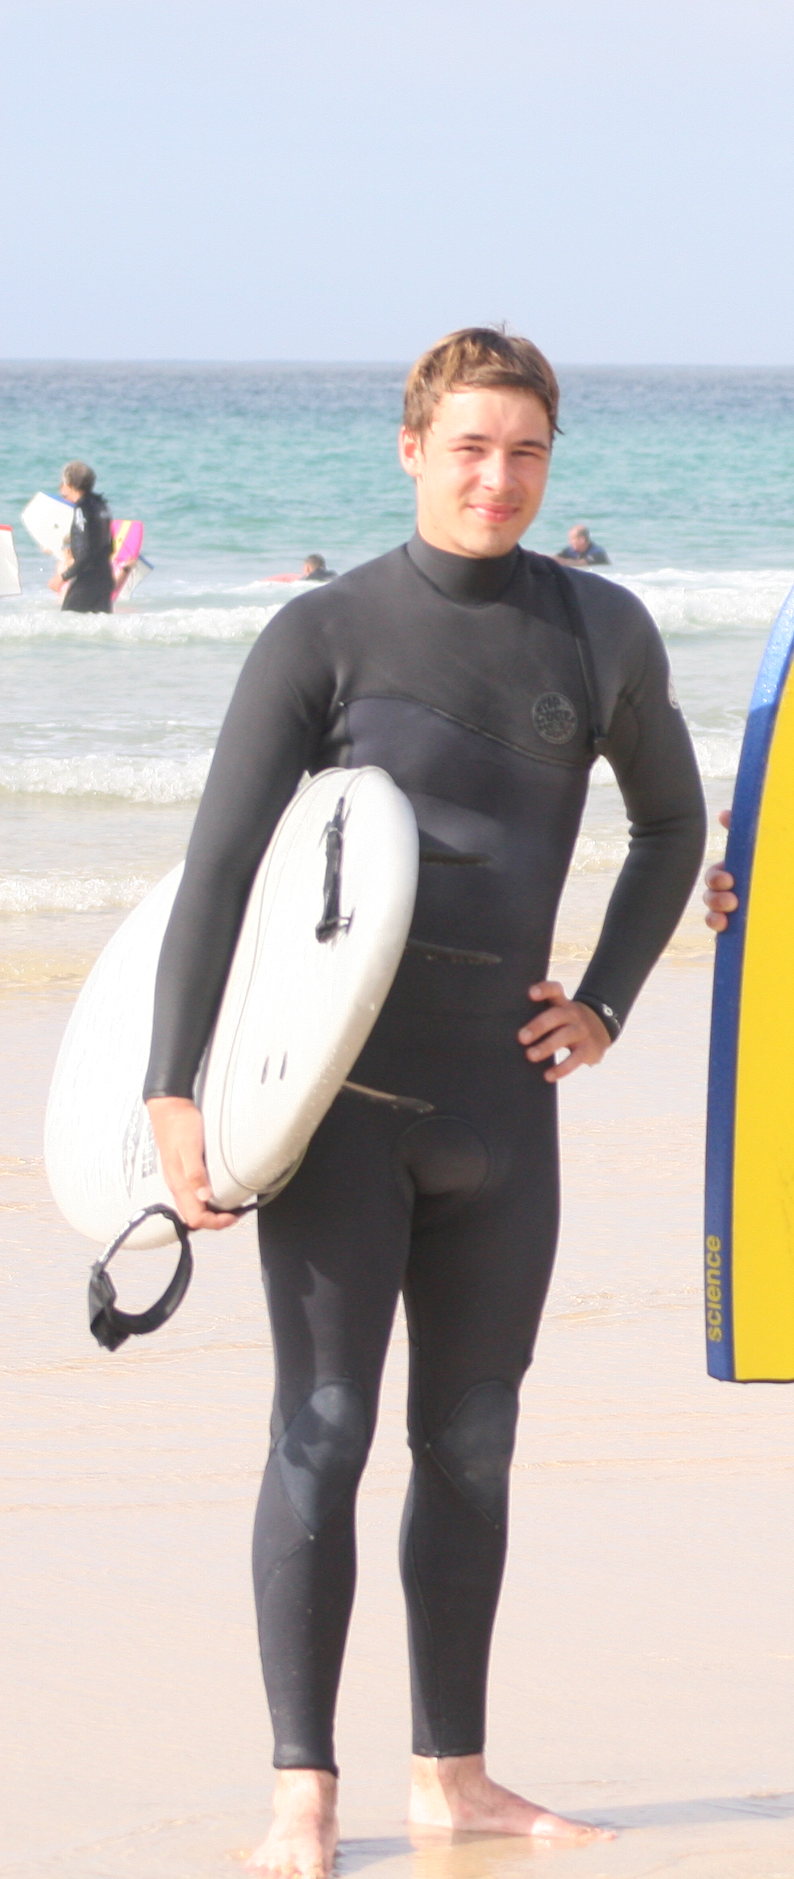

Name: Aaron Reddy

Student number: 1903134

Student email address: 1903134@student.uwtsd.ac.uk

Contact number: 07943100855

Please use the remaining space to give a brief outline of why you have chosen your course of study and any relevant special interests or experiences:

I have chosen to do outdoor adventure education as it will give me the best opportunity to get the job I want in the future.

