Gobbet
Critical analysis of: When will we stop stereotyping people?

The Video talks is part of a series that talks about “isms” and this particular video, titled “When will we stop stereotyping people?” (Alsultany. E. 2018). Talks about the meaning and connotation of the word “orientalism”. The source mainly uses Edward Said and his penmanship of the word orientalism. The source then states, “Orientalism then, is the form of knowledge, in quotation marks, that authorises and justifies the assertion of Western Power over the East.” Alsultany. E. 2018).
The source goes on to make points including “Orientalism acts like a pair of glasses that distort your vision and exaggerate cultural and religious differences. With these glasses, just about everything and everyone seems highly exotic and strange or worse, fanatical and dangerous.” (Alsultany. E. 2018).
Another point the source makes is the imagery of eastern women who are exotic, and this is when they are depicted as belly dancers or worse, as oppressed by their society and religion. The source goes on further and states the same thing about men who have presented in the same light from being lotharios to fanatical terrorists. “Orientalism is about a much broader set of power relations. When the US Government views the Middle East through orientalist glasses, it creates policies with far-reaching consequences. From outright war waged on other countries to imposing a travel ban on the whole group of people.” (Alsultany. E. 2018). The source makes references to wars such as the WWII which saw Palestine being mandated by the British leading to conflict with countries such as Israel as well as making reference to Trump’s Travel Ban on people from Muslim countries in the East.
The significance of the source is to utilise and educate others on the term “orient” and its effects of those who are deemed as “oriental”. The Key words that float around the source are the word “Orient”, “Oriental”, “Western Power” “Exotic” and “Stereotype” with the theme focusing on stereotypes and the problems that people of the “orient” face. The use of words such “Oriental” other people from Asia and the source argues that the term “Middle East” is also orientalist.
The source talks about the knowledge behind Orientalism and how “it is has historically been produced as knowledge” (Alsultany. E. 2018). The source then goes further by giving examples of those in power such as “…government officials, Religious figures, or the media.” And individuals such as Donald Trump who on his Muslim Travel Ban stated that everyone in the Middle East hated America. “Each of these phases and eras produces its own distorted knowledge of the other, each its own reductive images, its own disputatious polemics.” (Said. 1977,11) The “Oriental” view of the East has stopped being romanticised and fetishized but now vilified and nations of people deemed as anti-American due to a western powers perspective which then circles the cycle of stereotyping and leads to a non-violent domination of the East.
The source does not give the viewer time to think or fully digest the topic as for it is only 3 minutes long and relatively fast paced, but the viewer can process after viewing. The source is relatively concise about what it is talking in a matter that does not require too much jargon and simple for someone who is not in academia to understand. The sources use good examples of what is deemed as oriental but fails to mention when orientalism came to be. It lacks to mention the parallels of orientalism and colonialism and how orientalism derived from colonialism. One could argue that the source was created to inform people who had known the word “orient” but didn’t know the meaning but fails to inform how it came to be which is an important assessment. The mentioning of Edward Said and his description of the word orient and penmanship of “orientalism” is ideal as it illustrates his work in the late 20th century. The source does a good at mentioning Said’s prospective on orientalism by describing how the Europeans deemed the orient by stating three points “Inferior, uncivilised, weird” but also highlighting how Europeans defined and deemed Europe as being the opposite of the orient. The source lightly touches on the romanticisation of the “Orient” by talking about women being seen as exotic with certain provocateur of being described as belly dancers and men seen as “exotically romantic” one has to look at the word “exotic” to understand the connotation. It can be perceived in a wide number of ways often meaning foreign, unknown, mysterious and sexuality can be incorporated. The source lacks information about the exploitation of the “orient” and how the East didn’t view itself the way it was viewed by the west. Said in his work talks about the importance of Orientalism to Europeans “…what mattered was not Asia so much as Asia's use to modern Europe.” (1977,115). This reminded me of European importation of Asian goods including tea, dye and opium.
Overall, the source is very educational and gets to the point without explaining too many things and the use of language that the listener might not be able to interrupt. It does not challenge the listener to form critically engage or form their own opinion. The source could have been longer and gone into more depth and detail on Orientalism but sadly it dumbs it down.

Bibliography and references
Alsultany. E., Somethin' Else (2018). When will we stop stereotyping people?. [video] Available at: https://www.bbc.com/ideas/videos/when-will-we-stop-stereotyping-people/p06p97cr?playlist=the-a-z-of-isms [Accessed 8 Mar. 2019].
Said,E. (1977). Orientalism. London: Penguin Books . 11.

BLOGPOST

Political Satire: When Satire Doesn’t need a Comedian to Write It Anymore.

Throughout the years, politics and satire have gone hand in hand with one another. From medieval ages with the Kings and Court Jesters, to the Newspapers making fun of nations and their people for politically charged propaganda in light of war. Political satire in the United States of America mainly focuses on ridiculing both political parties in order to get the point of view across. Presidents such Richard Nixon, Ronald Reagan and Bill Clinton to George W. Bush, Barack Obama and now Donald Trump.
What is Political Satire?
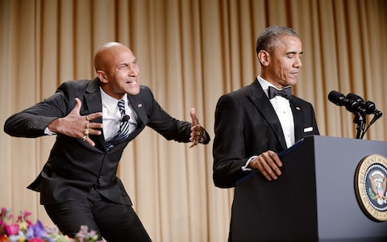
According to Gale Thomson, Political satire is “a satire that specializes in gaining entertainment from politics; it has also been used with subversive intent where political speech and dissent are forbidden by a regime, as a method of advancing political arguments where such arguments are expressly forbidden” (2007). Certain countries such as China, satire is not an everyday thing as it is in America. In the US, political satire is seen as relevant to day to day politics in various ways with even some politicians subjecting themselves to ridicule willingly for example, the annual correspondents’ dinner in Washington which subjugates the President of the United States to a “roast” by various comedians. Presidents such Barack Obama have always attended the dinners and able to laugh at themselves for one night This has been a tradition in the US since 1983 and might be potentially stopped in 2019 due to President Trump’s absences from the 2017 and 2018 correspondent’s dinner.
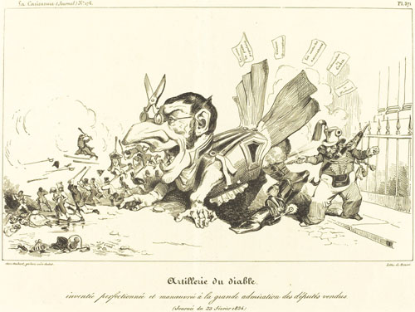
Political Satire has been widely used throughout the years, often being seen in newspapers as pictures for those who were unable to read. It was often cartoons depicting the ruling class in an unfavourable manner for lower classes to poke fun at.
In the age that we are living in, Political Satire is now more than just entertainment but also a news source for example, The Daily Show with John Stewart and Last Week Tonight with John Oliver. These shows rely news to the viewers in an unconventional way that is different from what the BBC or CNN shows to their viewers.
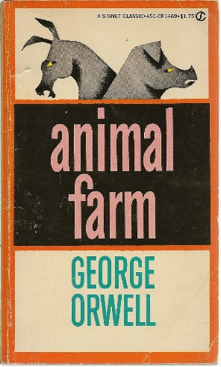
Political Satire in books is often rare but their have been notable books that have nuances of Political Satire such as Animal Farm by George Orwell. The book pokes fun at totalitarian societies with communist and isolationist ideology such as Russia. Various books such as No Billionaire Left Behind: Satirical Activism in America by Angelique Haugerud discuss the role Satirical Activism plays in politics. Protesting and activism doesn’t need to be loud and aggressive but can sarcastic and still the point the point across.
In media and literature alike, political satire is prevalent especially so-called news sites such as The Onion which operates like any news site but with the content being 100% satire. Articles from this media outlet which Trump has named as fake news, have gone viral throughout the years such as “Fall Canceled After 3 Billion Seasons”.
Donald Trump and revitalising Political Satire.
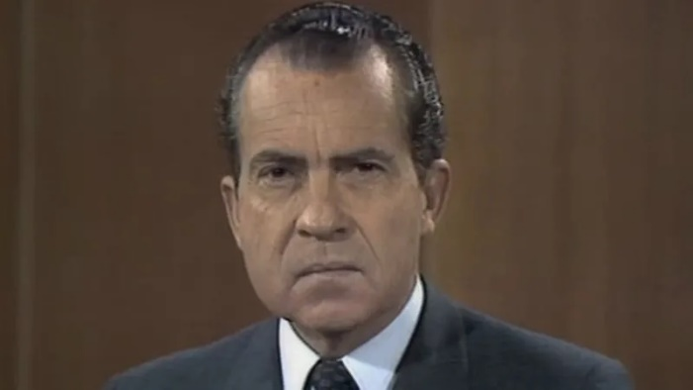
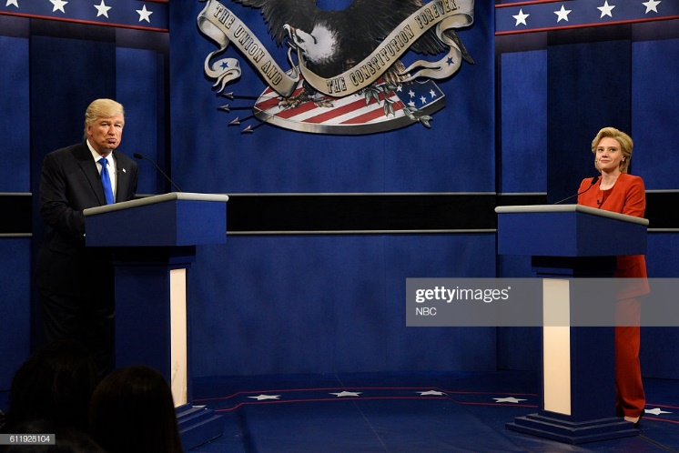
The election of Donald Trump into the U.S office was seen as one of the most shocking presidential results due to his political standings and views on various issues such as sexual harassment as embarrassing scandals involving adult film actors but Donald Trump has done something that his predecessor couldn’t do. He and his administration have saved Political Satire! Controversial I know but hear me out. It had been a long time since satire was on the rise and controversial figures and just general political controversy has always been what drives satire from the infamous “I am not a crook” statement from Richard Nixon to Bill Clinton’s “I did not have sexual relations with that woman.” Comedian throughout the nation used this as a material whether it was through stand-up or through shows such as Saturday Night Live. With the Obama administration, satirical content decreased and that changed with Donald Trump and his statements and actions from making fun of the disabled, laughing at jokes that promoted misogyny and most notoriously labelling the entire Mexican population as rapists and murders. Political Satire was born again, comedians, writers, and commentators could use satire to bring awareness to the statements that Donald Trump had made in order to derail his popularity but that did the opposite. Donald Trump brought life to satire by even hosting Saturday Night Live as he was running for office. Joe Raiola makes the comparison of Nixon and Donald Trump as candidates “Ever since 1968, when Richard Nixon appeared on Rowan and Martin Laugh In, Political satirists have been way too cosy with politicians… Keep in mind that when Nixon made an appearance…. He was Candidate Nixon and he then went on to win the national election. When Saturday Night Live let Donald Trump host…they let him rise to power!” (TEDx Talks.,2017) Raiola’s point of view somewhat stands. Giving a politician a comedic platform is problematic because their sense of humour then masks their policies when the purpose of satire in politics is to bring awareness. It is harder for political satire to serve its purpose when politicians are in on it. Giving both Nixon and Trump the power of appearing on a comedic show, influenced some individuals to vote for them which then leads to the question, can political satire influence individuals to vote for or against an individual? The answer to that is a simple yes and no. I know I know that’s not really an answer, but people did seem to believe that Donald Trump was relatable person due to his sense of humour whilst completely forgetting his vast wealth and his “grab her by the p**sy” comments. And what about no? both Hilary and Donald have been the subject of jokes on SNL and various satire platforms but she has never personally appeared on one herself. If she had appeared on SNL, would she have been able to win? It is hard to say because she was never given the chance.

Political satire gives people a voice to show how they interpret politics and politicians but also does something now that it didn’t do a hundred years ago, it is now a form of news too especially with shows such as Last Week Tonight with John Oliver where the programmers inform the viewers who might have been put off from watching regular news. Individuals who often watch political satire shows also tend to create a relationship with the host thus meaning viewership which translates to the show being renewed for another season. With politicians such as Donald Trump who hate comedy but have benefitted from partaking in satire, satire continues to be influenced by what it is around it and often satirists don’t need to try hard as for the satire writes itself (i.e. covefefe and Tim Apple). They just need to present it a manner that is both humorous and still able to get the point across.

Bibliography and references

Fig. 1
Correspondents Dinner. (2015). [image] Available at: https://www.telegraph.co.uk/content/dam/comedy/2017/04/27/anger-translator_trans_NvBQzQNjv4BqH7ePlBY3E4z00ksx7LiwukDS1xmwfsi7Fogv6zQAuO4.jpg?imwidth=700 [Accessed 7 Mar. 2019].
Fig. 2
Grandville, J. and Forest, E. (1826). Artillerie du Diable. [image] Available at: http://www.oxfordartonline.com/fileasset/images/OAO/Bzt_Satire_Grandville.jpg [Accessed 8 Mar. 2019].
Fig.3
Orwell, G. (1986). Animal Farm. [image] Available at: https://images-na.ssl-images-amazon.com/images/I/51ueAiIF20L._SX299_BO1,204,203,200_.jpg [Accessed 8 Mar. 2019].
Fig. 4
Murray, N. (2012). Nixon gets socked in Laugh-In’s most famous, and influential, five seconds 1968) [image] Available at: https://i.kinja-img.com/gawker-media/image/upload/s--AELR6lX4--/c_scale,f_auto,fl_progressive,q_80,w_800/xlrd5oatbwbnkqekdqim.jpg [Accessed 8 Mar. 2019].
Fig. 5
Heath, W. (2017). SATURDAY NIGHT LIVE -- 'Margot Robbie' Episode 1705 -- Pictured: (l-r) Alec Baldwin as Republican Presidential Candidate Donald Trump and Kate McKinnon as Democratic Presidential Candidate Hillary Clinton during the 'Debate Cold Open' sketch on October 1, 2016. [image] Available at: https://www.gettyimages.co.uk/detail/news-photo/margot-robbie-episode-1705-pictured-alec-baldwin-as-news-photo/611928104 [Accessed 8 Mar. 2019].

Joe Raiola (2019). Does Political Satire matter in the Age of Donald Trump?. [video] Available at: https://www.youtube.com/watch?v=D2ibtfqevUY&t=11s [Accessed 8 Mar. 2019].

