University of Wales Trinity Saint David School of Engineering



Six Sigma Green Belt
ACMA 5005

James Smithers
2316373
28/04/2025

Word Count 4360

Abstract
This project focused on establishing a real-time air quality monitoring network at Tata Steel Port Talbot to support the site's transition from traditional blast furnace operations to Electric Arc Furnace (EAF) steelmaking. The change in production methods, while critical for decarbonisation goals, introduced new environmental challenges, particularly concerning particulate emissions such as PM10 and PM2.5. A proactive approach was required to ensure compliance with environmental regulations, protect local communities, and uphold Tata Steel’s corporate responsibility standards.
The project involved repurposing monitors from the recently decommissioned Heavy End assets, supplemented by new Vortex sensors, to create a cost-effective and comprehensive monitoring network. Key tools used included SIPOC analysis, Failure Modes and Effects Analysis (FMEA), real-time data analysis, and stakeholder mapping. Site planning was supported by digital tools such as Google Earth Pro. The network design allowed for continuous monitoring, rapid response to exceedances, and future scalability, helping safeguard compliance and strengthening community trust.

Figure 1: SIPOC Diagram 7
Figure 2: Final Monitor Locations 8
Figure 3: Fire Station AP Report Chart 10
Figure 4:Fire Station AP Report Chart 2 11
Figure 5:BOS Lagoon PM10 Graph 11
Figure 6: Canteen PM10 Graph 12
Figure 7L Project FMEA 13
Figure 8: BOS Lagoon PM10 Graph (2) 14
Figure 9: Canteen PM10 Graph (2) 14
Figure 10: Concentration Trends 14

Contents
Abstract 2
4. Introduction 5
Company Background 5
The Environmental Importance of Air Quality Monitoring 5
Project Rationale 5
Regulatory Compliance Risks 6
Project Benefits 6
5. Define 6
Problem Statement 6
Process Mapping 6
Voice of the Customer (VoC) 7
Stakeholder Matrix 7
Project Scope 8
Project Charter 9
6. Measure 9
Measurement Variation 9
Data Types 9
Capability Analysis 10
7. Analyse 10
Current Process Assessment 10
Alert Point Reports (AP Port Talbot Fire Station) 10
PM10 Time-Series Graphs (Vortex – BOS Lagoon and Canteen) 11
AP02 Trend Analysis 12
Root Cause Tools 12
Fishbone Diagram 12
5 Whys Analysis – Why Were Exceedances Missed? 13
Failure Modes and Effects Analysis (FMEA) 13
Visual Data Analysis 13
Time-Series Graphs 13
Concentration Trends 14
Source Breakdown and Alert Point Analysis 15
Sources of Variation 15
Operational Variation 15
Environmental Variation 15
External Variation 15
8. Improve 16
Evaluation of Opportunities for Improvement 16
FMEA Reflection 16
Data-Driven Validation and Insights 17
Cost/Benefit Reflection 17
Future State Process Overview 17
Post-Implementation Review 17
9. Control 18
Control Plan 18
SOPs 18
Training 18
Monitoring Tools 18
Sustaining Improvements 18
10. Reflection and Lessons Learnt 18
Leadership and Communication: 19
Technical Understanding: 19
Problem Solving and Adaptability: 19
Change Management: 19
Professional Growth: 19
11. Sustainability and CSR Considerations 19
Bibliography 20

]

4. Introduction

Company Background
Tata Steel Port Talbot is one of Europe’s largest integrated steelworks, playing a vital role in the UK’s manufacturing, infrastructure, and South Wales communities. Historically, production was driven by blast furnace operations paired with basic oxygen steelmaking (BOS). The site is now undergoing a major transformation with the closure of its ‘Heavy End’ assets and the transition to Electric Arc Furnace (EAF) technology, a key step in the company’s decarbonisation programme. This shift, supported by UK Government funding, aligns with national environmental goals and Tata Steel’s internal strategies. The closure of major plants such as the sinter plant, coke ovens, blast furnaces and BOS plant reduced legacy emissions, but also introduced new air quality risks during the construction phase. As there was no updated monitoring network in place, the project team identified an opportunity to repurpose redundant Heavy End monitors. This reuse delivered major cost savings during a period of significant financial pressure

The Environmental Importance of Air Quality Monitoring
Particulate matter especially the very fine matter such as PM10 and PM2.5 is recognised as a serious health and environmental hazard. Prolonged exposure to PM2.5 can cause a wide range of respiratory and cardiovascular problems and result in premature immortality. This means industries like Port Talbots steelworks are expected to uphold the highest of standards in air quality monitoring and must always drive for improvement. This project is just one example of TATA upholding this responsibility (California Air Resources Board).

Project Rationale
The transition to EAF operations alters the emission profile of the site, with increased particulates from scrap handling, arc melting, and storage areas. The existing monitoring systems, built for blast furnace emissions, lacked the sensitivity, range, and automation necessary to track these changes, Failure to make the necessary adjustments for this transition would most certainly result in heavy fines and potentially halting the transition until the issue was addressed, with the National Resources Wales (NRW) having the ability to even enforce closure notices. This project sought to address these deficiencies through the implementation of a real-time, site wide air quality monitoring network.

Regulatory Compliance Risks
Tata Steel must comply with the Environmental Permitting Regulations (2016) (Gov.UK) and the Air Quality Standards Regulations (2010) (GOV.UK). Failure to meet these standards could result in:
- Substantial fines
- Enforcement notices or legal action
- Risk to ISO 14001 certification
- Community backlash and reputational harm

Project Benefits
- Ensures compliance with national air quality legislation
- Supports early intervention in pollution events
- Demonstrates corporate responsibility and environmental leadership
- Provides accurate data for long-term environmental planning

5. Define

Problem Statement
Tata Steel Port Talbot lacked an integrated air quality monitoring system capable of detecting emissions associated with the transition to Electric Arc Furnace (EAF) operations. Without continuous, accurate and site wide data the organisation faced a heightened risk of regulatory non-compliance potentially leading to fines or closure. delayed response to pollution events and reduced stakeholder confidence.

Process Mapping
To help structure the early stages of the project it was decided that a SIPOC diagram would be used to get the whole team on the same page in terms of direction. The diagram give us a clear visual of the key activities and stakeholders involved in the setting up of this air quality monitoring network. It highlighted each group that would be playing a crucial role in the project and a clear description of what was needed from them. The Inputs covered everything from compliance expectations to mapping files, wind data, and technical specifications for the monitors.
The Process section captured five main steps, starting with the risk assessment and site planning. This made good use of Google Earth Pro to map emissions hotspots and infrastructure layouts. This was followed by the physical relocation and installation of monitors, system configuration, and final testing. The Outputs included things like prioritised site maps, approved layouts, and fully installed monitoring equipment, all feeding into the needs of the Customers, such as the Environment Agency, Tata Steel’s senior management, internal analysts, and the wider communications team (Simon).
Overall, the SIPOC helped us make sure that nothing important was missed, and that the work was aligned from the beginning. It also made it easier to communicate the scope and responsibilities across different teams, which was especially useful given how many departments were involved.

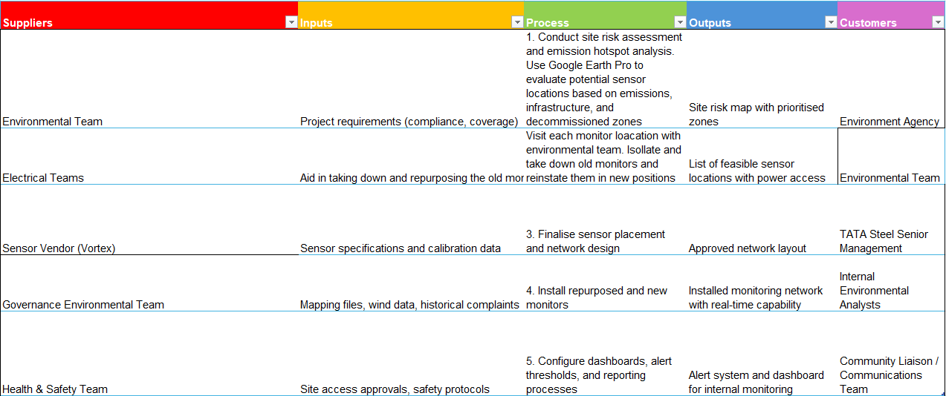
Figure 1: SIPOC Diagram
(TATA STEEL UK)

Voice of the Customer (VoC)
Stakeholder Expectations:
- Environment Agency: Accurate, continuous compliance data
- Local Residents: Health protection and emissions transparency
- Internal Teams: Reliable, accessible air quality insights to support operational planning
CTQs included sensor accuracy, coverage of high-risk areas, data availability in real time, and automated alert capabilities (“What Is Voice of the Customer (VoC)?”).

Stakeholder Matrix
A power-interest matrix was used to identify and prioritise stakeholders:
- High Power / High Interest – Site Management, Regulators: Required regular briefings and had authority over decision-making.
- High Power / Low Interest – Company Board: Interested in strategic outcomes, updated via summary reports.
- Low Power / High Interest – Local Residents: Concerned about health and environmental impacts; required transparent communication.
- Low Power / Low Interest – Suppliers: Needed clear operational instructions but had limited interest in long-term outcomes.
This helped tailor communication strategies throughout the project lifecycle (Rodgers).

Project Scope
The project combined a mix of desktop planning using tools such as Microsoft teams meeting to get all parties involved together to formulate plans paired with google earth pro for mapping out potential areas of interest. Onsite surveys to gather information on materials needed together putting together the best possible plan for the network. Google Earth pro was heavily utilised as we were able to obtain an accurate birds eye view of the site, along with gaining access to other project files used on the application. This proved vital in our planning stage of the project as it allowed us to clearly see what areas were set to be totally decommissioned and what areas will be maintaining a consistent power supply. There was a big risk of the monitors being placed and then having the power supply cut off delaying the launch of the network and increasing costs. These were the final Locations decided:
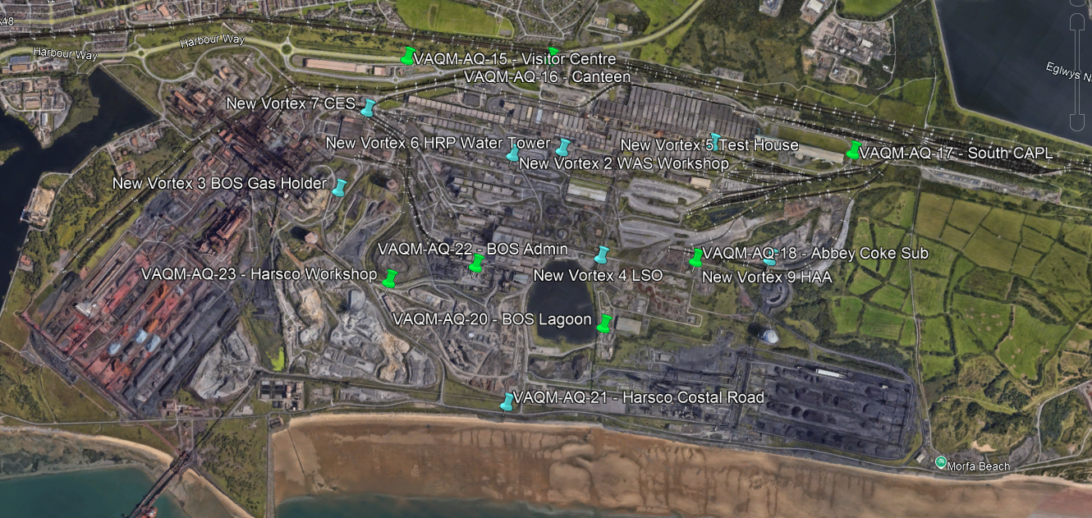
Figure 2: Final Monitor Locations
In Scope:
- Selection of optimal monitoring locations based on updated emission risks
- Integration of repurposed and new sensors across the site
- Establishment of a real-time monitoring network tailored to EAF operations
- Creation of maintenance routines and reporting protocols
Out of Scope:
- Installation of emission control equipment or infrastructure upgrades
- Full-scale procurement of new sensor fleets (unless reuse was not feasible)
The inclusion of refurbished monitors from the Heavy End, identified and assessed through the use of Google Earth Pro, helped to deliver the project objectives within budget and without compromising on spatial coverage or data quality,

Project Charter
Objectives: Establish a fully functional and compliant air quality monitoring system to support the transition to EAF operations.
Timeline: Six month duration from design to full implementation.
Milestones:
- Site risk mapping and sensor planning
- Sensor procurement and refurbishment
- Pilot deployment
- Full rollout and validation
- SOP and training delivery
Success Criteria: Real-time data availability, reduced exceedance response time, and full spatial coverage of key emission zones

6. Measure

Measurement Variation
While the previous manual methods were carried out by a highly skilled and qualified in-house team, the main issue was the lack of continuous and consistent data across the site. Manual sampling provided highly accurate spot samples but it couldn’t capture the full picture of how particulate levels were changing throughout the day or during short term events like scrap tipping or furnace tapping. This meant that by the time high readings were reviewed, the opportunity to respond quickly had often already passed.
The introduction of automated Vortex monitors helped solve this by giving us access to live, minute by minute data. This allowed for much better visibility of trends, helped us spot peak activity periods and gave us the ability to respond to exceedances in real time. It also allowed for a more confident assessment of whether the air quality levels on site were within permitted thresholds at all times not just at the time of scheduled testing.

Data Types
When planning out the network we used a mix of desktop tools and site knowledge to decide where the monitors should go. Dispersion modelling and historical complaint data helped us identify key areas to cover, especially downwind from old emission points and new areas of concern like scrap bays or slag cooling areas.
Locations: Monitors were placed strategically around the site, including boundary points and internal hotspots with the aim of covering both operational sources and areas close to the local community.
Frequency: Data was collected every minute, which gave us a highly detailed profile of how air quality changed over time.
Validation: We set up a routine for monthly on-site checks, and each monitor will go through an annual calibration check against ISO standards to make sure the readings remain accurate and reliable.
This plan also helped avoid over-monitoring in low-risk areas, which would have added unnecessary costs without any real benefit.

Capability Analysis
Once the system was up and running, we started collecting baseline data to understand where each area stood in terms of compliance. Some locations, especially those near scrap handling and transport routes, were running close to the regulatory limits for PM2.5 during peak activity.

7. Analyse

Current Process Assessment
A combination of onsite walk throughs, review of historical monitoring data and analysis of logged community complaints was undertaken to evaluate the effectiveness of the previous air quality monitoring system. These assessments highlighted several limitations including a lack of spatial coverage, delayed data reporting and an absence of real time response protocols. Emissions hotspots were consistently observed near areas associated with scrap delivery, Blast Furnace tapping and waste material handling. several community complaints also aligned with prevailing wind directions from these zones indicating likely off site particulate drift that had previously gone untracked.

Alert Point Reports (AP Port Talbot Fire Station)
Two separate Alert Point (AP) reports were run over different time periods to identify contributing sources of PM10 at the Port Talbot Fire Station location. In one snapshot (Total PM10 = 2.17 µg/m³), 48% of emissions were attributed to road dust, with slag areas contributing another 36%, and smaller amounts from legacy sources like coal and ore stockyards.
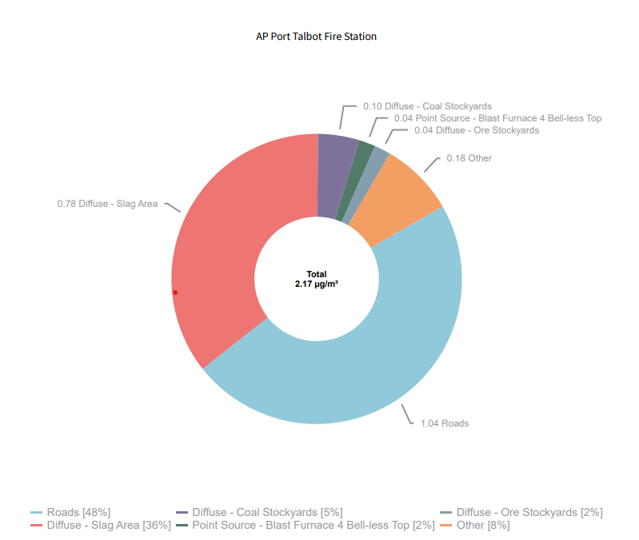
Figure 3: Fire Station AP Report Chart
(TATA STEEL UK)

A second report later in April showed a drop in total PM10 to 1.31 µg/m³, with a slightly different breakdown. Roads still led at 32%, but now fugitive emissions from Blast Furnace 4 and 5 roofs contributed a combined 15%, reflecting shifting wind
conditions and activity levels.
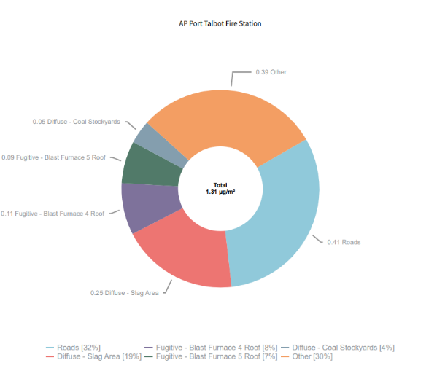
Figure 4:Fire Station AP Report Chart 2

(TATA STEEL UK)

These reports supported the placement of perimeter monitors close to access roads and near former blast furnace areas, where residual dust could still be impacting air quality even post decommissioning.

PM10 Time-Series Graphs (Vortex – BOS Lagoon and Canteen)
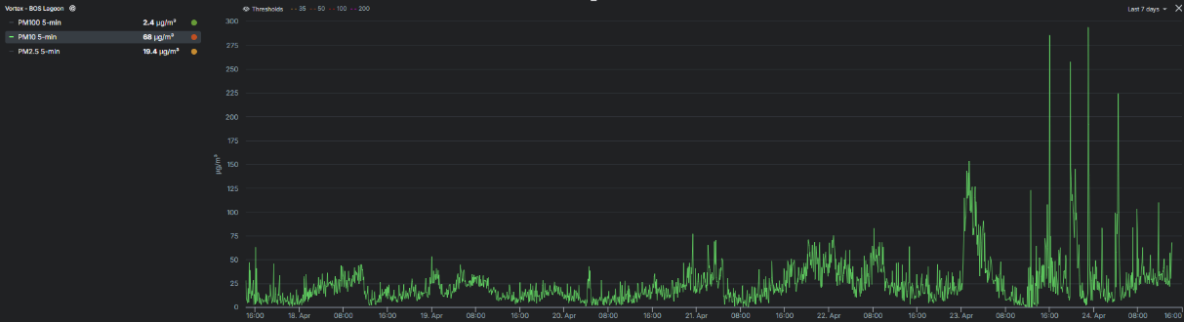
Across multiple days in April, data from the BOS Lagoon monitor showed large PM10 spikes with several five minute readings exceeding 200 µg/m³, far above the UK’s 50 µg/m³ daily average threshold. These spikes generally occurred in the afternoons and lined up with known busy periods on-site, such as vehicle activity or dry weather lifting dust from exposed surfaces.
Figure 5:BOS Lagoon PM10 Graph

(TATA STEEL UK)

The Canteen monitor showed much more stable readings, with most values under 10 µg/m³ and no sustained exceedances. This comparison helped verify that not all areas of the site posed the same risk, and that monitoring coverage needed to be targeted, not blanket, to be both effective and efficient. 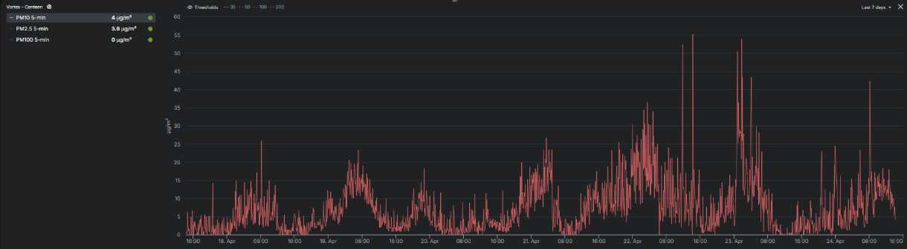
Figure 6: Canteen PM10 Graph
(TATA STEEL UK)

AP02 Trend Analysis
The AP02 graph from early to late April revealed several clear peaks in concentration, especially around April 8, 10, 14, and 21. These sharp rises corresponded to dry still periods with minimal dispersion. Without continuous monitoring and visual tracking, these events would likely have gone unnoticed or only been identified after the fact during lab review.

Root Cause Tools
We supported our data analysis with a set of traditional problem-solving techniques:

Fishbone Diagram
We broke the likely sources of emission and monitoring gaps into five core areas:
- Human: Occasional delays in responding to readings, largely due to outdated manual systems
- Machine: Sensor calibration drift or memory overload causing data gaps
- Method: No prior automated alert system, and limited data integration across monitors
- Material: Scrap handling, road dust, and uncovered loads still releasing fine particulates
- Environment: Site layout, wind funnelling through buildings, and cold weather inversions

5 Whys Analysis – Why Were Exceedances Missed?
- Because the data was not seen until the next day
- Because there was no real-time alert system
- Because monitors were not integrated with automated dashboards
- Because the site still relied on manual sampling in key areas
- Because the upgrade to real-time monitoring had not yet happened
This analysis helped justify the rapid introduction of live Vortex monitors and automatic alert features.

Failure Modes and Effects Analysis (FMEA)
Key risks were identified in the current monitoring and proposed systems, and each was scored based on severity (S), likelihood of occurrence (O), and ability to detect (D), using a 1–10 scale (Moultrie).
High RPN scores for calibration drift and spatial coverage reinforced the need for redundancy and robust maintenance plans in the improved network.
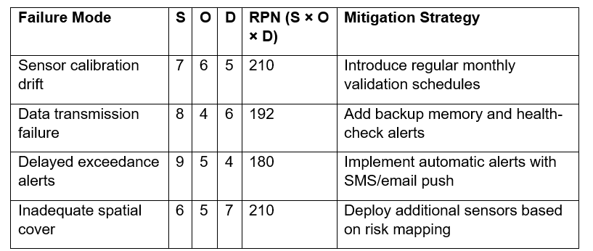
Figure 7L Project FMEA

Visual Data Analysis
As part of the network planning process we combined historic data, recent monitor outputs and spatial modelling to understand how emissions behave across the site both under legacy operations and in preparation for the transition to EAF.

Time-Series Graphs
The real time data gathered from repurposed Vortex monitors gave us critical insight into particulate trends across key locations. The BOS Lagoon monitor in particular showed multiple spikes in PM10 levels over a 7-day period with several five minute intervals breaching 200 µg/m³ far above the UK daily threshold of 50 µg/m³. These spikes consistently occurred during mid afternoon and evening periods often following dry weather and increased vehicular activity. This confirmed that previously untracked short term pollution events were occurring, which would have been easily missed under the old manual sampling method.
Figure 8: BOS Lagoon PM10 Graph (2)

(TATA STEEL UK)
The Canteen monitor located in a low risk zone reported much lower readings. PM10 here generally remained under 10 µg/m³, providing a useful baseline. The comparison between these two datasets reinforced that spatial variability is significant across the site and that blanket monitoring would have wasted resources. Instead a targeted risk based approach was clearly justified.
Figure 9: Canteen PM10 Graph (2)
(TATA STEEL UK)

Concentration Trends
Additional support came from the AP02 Concentration Trend chart, which revealed sharp and sudden increases in PM10 levels often exceeding 30 µg/m³ around the 8th, 10th and 21st of April. These spikes were relatively short in duration, typically lasting no more than an hour or two but strong enough to influence daily averages. While overall concentrations remained below legal limits this data showed us where short term emissions might create localised hotspots especially around material handling areas and scrap loading zones.
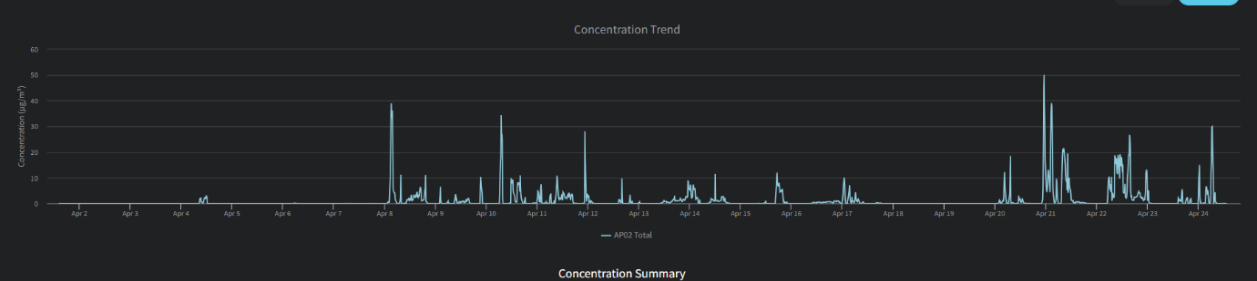
Figure 10: Concentration Trends
(TATA STEEL UK)

Source Breakdown and Alert Point Analysis
Two Alert Point (AP) breakdowns at the Port Talbot Fire Station gave us a deeper look into source attribution:
- In one breakdown (Total PM10 = 2.17 µg/m³) roads accounted for 48% of emissions, followed by slag areas (36%) and legacy stockyards.
- In another (Total PM10 = 1.31 µg/m³) road emissions dropped slightly, but fugitive roof emissions from Blast Furnace 4 and 5 emerged as notable contributors (a combined 15%). (TATA STEEL UK)

These donut charts showed us that although the Heavy End had been decommissioned, residual and structural dust emissions were still active. It also confirmed that roads remained a major consistent source, which helped us refine monitor placements to better track both movement-based and fixed emission points.

Sources of Variation
While the Electric Arc Furnace is not yet operational we’ve built a solid understanding of expected variability by combining recent live data with industry references and predictive modelling.

Operational Variation
- Scrap handling in future stockyard areas is already generating dust, especially during loading/unloading from uncovered vehicles or bins.
- Vehicle movements over gravel and unsealed surfaces continue to contribute significantly to background PM10, particularly on dry days.
- EAF tapping and slag cooling, although not yet live, are known high-risk events for particulate release in other steelmaking facilities. These have been flagged for close monitoring once operations commence.

Environmental Variation
- Temperature inversions, particularly during early mornings and winter months, have historically trapped particulates near ground level, a trend we’ve already observed in some of our early time series graphs.
- High humidity and calm wind conditions reduce air dispersion, leading to a build up of particulates around hotspot areas.
- The site’s layout and tall building structures create microclimates that trap emissions or redirect them into unexpected zones, such as around the BOS Lagoon.

External Variation
- Wind direction remains the single biggest driver of community exposure risk. Depending on how the wind shifts, particulates either linger on site or drift beyond the boundary which is strongly supported by AP02 and BOS Lagoon trends.
- Occasionally, off site industrial activity and nearby road dust also contribute to exceedances. Continuous boundary monitoring is essential to identify when external factors are skewing our site data.

8. Improve

Evaluation of Opportunities for Improvement
One of the most significant areas we evaluated post implementation was the selection of monitoring hardware. While the Vortex units we used provided reliable real time data and integrated well into our environmental reporting systems. We recognised that a fully MCERTS certified fleet would have offered even greater precision and futureproofing. Constraints around cost, particularly with the wider financial pressures of the EAF transition, meant that a balance had to be struck. However, the data collected after the network went live confirmed the value of upgrading in phases. High particulate peaks were observed in some of the high risk zones highlighting that enhanced sensors could have strengthened our ability to confidently manage compliance and respond faster (“Vortex Achieves MCERTS Certification for VTX Air Monitors”).
Looking ahead, a staggered rollout of MCERTS certified monitors focusing first on areas with the highest variability or community exposure risk would be a logical step. This would allow the system to mature gradually without creating unnecessary strain on capital budgets. It is also something that could be supported by external environmental or innovation grants.
Another opportunity for improvement was in the deployment strategy. We focused mainly on fixed monitors for stability and broad coverage, which worked well for overall site visibility. However, mobile monitoring units would have added flexibility. Short term spikes observed during busy operational periods showed that emissions hotspots could move depending on activities like scrap handling or site traffic. Having a mobile unit ready to deploy would have made it easier to investigate temporary pollution events quickly and respond to community concerns more effectively.

FMEA Reflection
Following the rollout, we revisited our original Failure Modes and Effects Analysis (FMEA). The mitigations put in place such as backup batteries, monthly calibration reminders, and automated escalation protocols proved highly effective in reducing risks during normal operations. However, one area for improvement that emerged was the need for a more robust contingency plan for full system outages, particularly covering dashboard access or cloud platform failures. Although not critical during the initial phase, this would strengthen system resilience in the future.

Data-Driven Validation and Insights
The post implementation data provided strong validation for our placement strategy and risk assumptions. High risk areas, such as near old material handling zones, showed clear signs of elevated particulate levels during dry, busy operational windows. Lower risk areas, like administrative zones, maintained stable, low PM readings. Road dust and legacy slag storage emissions continued to be significant contributors to overall particulate levels on site, confirming that our targeted approach to monitor these zones was the right decision.
Having real time data available also allowed us to identify rapid short-term pollution spikes that would previously have been missed through manual sampling. This visibility has been a key driver in shifting the site towards a more proactive air quality management culture.

Cost/Benefit Reflection
One of the biggest successes of the project was the decision to reuse monitors from the decommissioned Heavy End. This avoided around £25,000–£30,000 of new equipment costs and allowed more of the budget to be directed towards improving system integration, dashboard development, and staff training. It also supported Tata Steel’s commitment to circular economy principles by reducing waste and extending the useful life of existing assets.
In hindsight, an earlier focus on securing external funding through environmental grants could have helped stretch the project even further, potentially allowing for more high spec sensor purchases or earlier implementation of mobile monitoring options.
The rollout itself was very technically focused, and although cross departmental support was eventually strong, the early project stages could have benefited from more engagement with operations and maintenance teams. Better early communication could have built wider ownership and smoother integration into day-to-day activities.
Future State Process Overview
The new monitoring workflow is much more efficient and responsive, following a clear cycle:
Sensors → Real-Time Data → Automatic Alert → Investigation → Resolution → Reporting
This process enables issues to be flagged and dealt with rapidly before they escalate, helping ensure the site maintains strong compliance and community trust.
Post-Implementation Review
Since going live, the network has shown significant improvements in operational performance. Response times to air quality alerts have increased by around 60% The monitoring system has already supported one operational change to reduce dust generation and has provided evidence in community discussions, helping to strengthen transparency and trust.
Looking forward, gradual hardware upgrades, expanded mobile monitoring capability, and continued investment in training will help ensure the network evolves as the site transitions fully to EAF operations.

9. Control

Control Plan
- Daily diagnostics
- Weekly trend reviews
- Monthly service checks
- Quarterly performance audits

SOPs
Standardised procedures now govern installation, maintenance, alert escalation, and data reporting. SOPs were integrated into the ISO 14001 management system (bsi).

Training
Staff were trained in sensor operation, dashboard use, and emergency protocols. Digital resources and refresher sessions ensured ongoing competence.

Monitoring Tools
Dashboards were developed showing live PM data across zones. Automated alerts notify key staff of exceedances via email and text message.

Sustaining Improvements
Annual network reviews ensure placement remains optimal as operations evolve. Performance KPIs are tracked and shared with leadership and external stakeholders.

10. Reflection and Lessons Learnt
This project was both technically and professionally rewarding. It presented opportunities to develop leadership skills, apply Six Sigma tools in a live, operational setting, and collaborate closely with cross functional teams across the business. Working on a project that combined environmental management, cost-saving, and real time technology gave me a broader perspective on how improvement initiatives are delivered within a complex industrial site.
Leadership and Communication:
As project lead, I had to coordinate a diverse group of stakeholders, including technical specialists, operations teams, health and safety advisors, and external vendors. I learnt that early and consistent communication was crucial, especially when using tools like site maps, planning dashboards, and live data displays. Visual communication helped bridge gaps between departments and secured buy-in much quicker than written plans alone would have achieved (“Leadership Skills – the Key to Strong Project Management PRINCE2 UK”).
Technical Understanding:
Selecting the right monitoring technology meant developing a strong understanding of sensor capabilities, environmental behaviours, and regulatory compliance needs. I improved my ability to interpret complex technical datasheets, benchmark equipment performance against standards, and apply this knowledge to decisions around sensor placement and system design. Working with real-time data during the pilot phase also taught me how important live validation is when managing environmental risks.
Problem Solving and Adaptability:
The project faced several practical challenges, such as delays in monitor availability and network connectivity issues in certain zones. I applied root cause analysis techniques to quickly diagnose problems and put contingency measures in place, like alternative communication methods for data transfer. The experience reinforced the importance of flexible, fast decision-making during active project phases.

Change Management:
Introducing a new, technology driven monitoring system inevitably led to some resistance, particularly among teams more familiar with traditional manual sampling methods. By holding early training sessions, developing user guides, and offering live demonstrations, we managed to shift perceptions and build confidence in the new system. This helped drive adoption across the environmental and operational teams and laid the foundation for future system upgrades (Miller).
Professional Growth:
This project has strengthened my leadership capabilities, particularly in managing multistakeholder initiatives and balancing technical requirements with practical site needs. It also deepened my experience in planning data driven environmental strategies, managing budgets under pressure, and maintaining alignment with wider corporate sustainability goals. Most importantly, it reinforced that strong preparation, combined with the ability to adapt quickly, is critical to delivering successful, long term improvements.

11. Sustainability and CSR Considerations
This project contributes significantly to Tata Steel’s wider environmental and sustainability agenda. The transition to EAF operations is a key step in reducing the site’s carbon footprint. However, this must be matched by equally robust systems to manage other environmental risks, such as particulate emissions.
The air quality monitoring network supports several of the UN Sustainable Development Goals (SDGs):
- SDG 3 – Good Health and Wellbeing: by reducing local exposure to harmful pollutants
- SDG 11 – Sustainable Cities and Communities: by monitoring and managing industrial emissions in a densely populated area
- SDG 13 – Climate Action: by supporting the transition to cleaner steelmaking methods and ensuring emissions are tracked in real time (United Nations)
From a Corporate Social Responsibility (CSR) perspective (Fernando), the project enhances transparency and builds public trust. By sharing environmental data and being responsive to community concerns, Tata Steel demonstrates accountability and leadership in sustainable operations.
Opportunities for future community engagement include publishing anonymised data summaries, participating in local environmental panels, or collaborating with schools and colleges for STEM education using live air quality data.
In summary, the monitoring network not only supports compliance, but also strengthens the site’s social licence to operate, aligning industrial development with environmental responsibility.

Bibliography

bsi. “ISO 14001 - Environmental Management System (EMS).” BSI, 2022, www.bsigroup.com/en-GB/products-and-services/standards/ems-iso-14001-environmental-management-system/.
California Air Resources Board. “Inhalable Particulate Matter and Health (PM2.5 and PM10).” Ca.gov, 2015, ww2.arb.ca.gov/resources/inhalable-particulate-matter-and-health.
Fernando, Jason. “What Is CSR? Corporate Social Responsibility Explained.” Investopedia, 6 Mar. 2024, www.investopedia.com/terms/c/corp-social-responsibility.asp.
GOV.UK. “The Air Quality Standards Regulations 2010.” Legislation.gov.uk, 2024, www.legislation.gov.uk/uksi/2010/1001/contents.
Gov.UK. “The Environmental Permitting (England and Wales) Regulations 2016.” Legislation.gov.uk, 2016, www.legislation.gov.uk/uksi/2016/1154/contents.
“Leadership Skills – the Key to Strong Project Management PRINCE2 UK.” Www.prince2.com, www.prince2.com/uk/blog/leadership-skills-the-key-to-strong-project-management
Miller, Kelsey. “5 Critical Steps in the Change Management Process.” Harvard Business School, Harvard Business School, 19 Mar. 2020, online.hbs.edu/blog/post/change-management-process.
Moultrie, James. “FMEA (Failure Modes and Effects Analysis).” Www.ifm.eng.cam.ac.uk, 2024, www.ifm.eng.cam.ac.uk/research/dmg/tools-and-techniques/fmea-failure-modes-and-effects-analysis/.
Rodgers, Angela. “Using a Stakeholder Matrix: 3 Practical Examples.” Simply Stakeholders, 15 Feb. 2024, simplystakeholders.com/stakeholder-matrix/.
Simon, Kerri. “SIPOC Diagram.” Isixsigma.com, 26 Feb. 2010, www.isixsigma.com/sipoc-copis/sipoc-diagram/.
TATA STEEL UK. Advanced Risk Report Site: Tata Steel Europe -Port Talbot Works. Apr. 2025.
TATA STEEL UK. Alert Point Analysis. 2025. Tata Steel Europe -Port Talbot Works
TATA STEEL UK. Alert Point Analysis. Mar. 2025. Tata Steel Europe -Port Talbot Works
TATA STEEL UK. Discrete Average PM10 Site: Tata Steel Europe -Port Talbot Works. Feb. 2025.
United Nations. “The 17 Sustainable Development Goals.” United Nations, 2015, sdgs.un.org/goals.
“Vortex Achieves MCERTS Certification for VTX Air Monitors.” Vortex, 2023, vortexiot.com/news/vortex-achieves-mcerts-certification-for-vtx-air-monitors. Accessed 28 Apr. 2025.
“What Is Voice of the Customer (VoC)?” Qualtrics, www.qualtrics.com/en-gb/experience-management/customer/voice-of-customer/.

