INTERNATIONAL MARKETING

Name: Farhan Patel
Student ID: 1706368
Subject Code: SBMA7108_LON
Lecturer name: Richard Small

Executive summery
In this report the luxury automobile manufacturer Audi is analysed through international marketing models and frameworks. Audi is owned by the German automaker Volkswagen group. The company is present in the UK as well in the Indian market. both the market is different inters of environmental factors. The similarity in the political system provides different scenario for the global trade where the protectionism is gaining in UK and India is asking for more global tread. The better economic scenario of India providing better prospect in the market whereas the mature Uk luxury car market is impacting by new choices in the alternative fuel segment. The buyer’s power and the competitive rivalry are at high level in the market. Audi has advantage there but needs to constantly evaluate that. It can use its better brand value, market perception and quality product. The electric and hybrid market of UK and fast growing Indian car market provides the opportunity to the business improve its position in the market further. Considering this situation Audi took the assembling approach in India. The products then marketed through selected dealerships. In UK it manufactures the models and the market it thorough selected dealers. This is two distinct approach of market entry. In the business strategy the lack of diversification can be managed through entering in the super luxury or the below the luxury category. The product development approach also needs to be followed keep the advantage in the fast changing car market. The persuasion of the demographic, geographic and psychological segment in both the market get sufficient customer to target. The excellent design, luxury, comfort and precision engineering are the factors in the product positioning process. The luxury segment oriented product, premium pricing and selective distribution policy is useful for both markets to gain advantage. The promotion of Audi is limited compared to the competitors but an integrated approach helps to send the message to the prospective buyers.

Table of Contents
Executive summery 2
Introduction: 4
Background to the company: 4
Business environment analysis 5
Macro environment 5
Micro environment 10
Internal environment analysis 13
Strategic analysis for Audi in UK and India: 15
Strategy for market entry: 15
Ansoff Matrix: 16
Segmentation, Targeting and Positioning of Audi in UK and India: 17
Marketing Mix for Audi in UK and India: 19
Conclusion 21
Reference 22

Introduction:
When the marketing principles are applied for a business in more than one country, it is known as international marketing and in order to sell the products in diverse range of countries that the business operates in, there is requirement for the business to emphasize upon diverse range of marketing mix strategies as well as enter the country with different marketing planning in order to cater the demand that is different in nature (Jobber et al., 2012). Moreover, there are differences in attitudes of the customers as well as cultural barriers and also the environmental differences which force the businesses to follow different kinds of strategies in two different markets for continuing the operations. Furthermore, the globalization of the technologies and innovation has caused the companies to reach the customers in overseas market and that has helped in establishing some of the businesses all over the world (Czinkota et al., 2013).
In order to achieve the criteria of the assignment, there are two distinct countries that have been chosen for the assignment and they are United Kingdom and India. The niche market brand that has been chosen for the assignment is Audi, which caters their cars among the luxurious segment market. Thus, for the purpose of analyzing the marketing strategies, Pestle analysis, swot analysis as well as porters’ five forces will be constructed in respect to the company for two diverse countries. Moreover, the strategic analysis of the company will be constructed in respect to two diverse markets.

Background to the company:
Audi is an automobile manufacturer that is based in Germany and was found exactly 108 years before in the year 1910. There are a total number of 11 factories of production of the car brand that is based in 9 countries across the world (www.audi.com, 2018). Moreover, Audi is owned by Volkswagen and have headquartered of the company located in Ingolstadt in Bavaria. August Horch founded the company in 1910 and as of May, 2015, Audi employed a few more than 84,000 employees in the country. Moreover, the revenue for the company in the year 2017 amounted to € 60,128 million, while the operating tax for the company in the market has accounted to € 4783 million (www.audi.com, 2018). BMW is the first and foremost competitors of Audi while there are many other competitors that are present in the world for this particular car brand and they are Mercedes, Jaguar, Aston martin, Porsche, Bentley and so on.
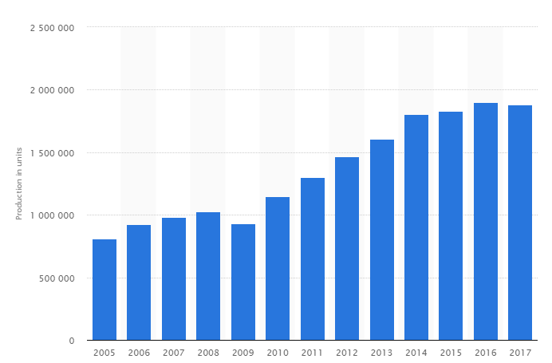
Audi A4 is the highest selling car model for the company that is followed by Audi A6 as of 2017 and there are many other models that are sold in the diverse range of countries where they operate (www.volkswagenag.com, 2018). Moreover, in Aurangabad that is situated in India there are a lot of models of the brand that is manufactured and they include A3, A4 as well as Audi A6 models, while in UK, the car models of Audi are imported from Germany and they have produced a total number of 18, 79,840 models in the year 2017 of all the models (www.statista.com, 2018).

Business environment analysis
The business environment plays a significant role in the business decisions. In case of marketing the external environment in the same manner would influences the strategy and planning related decisions. In the following section of the report the business micro and the macro environment is discussed to underhand the automobile market situation of UK and Indian for further analysis of business decision of Audi.

Macro environment
In the macro environmental analysis of the luxury car industry in the UK and India market the PESTLE analysis is used in the following section.
Political factor- in the international marketing complete homogeneity of the markets is rare but similarity helps the marketers in the strategic decision making. The political factor of UK and India provides some similarity in term functional liberal democratic system. India being the former colony of Britain, had adopted much of the similar political system after the independence (Armour and Lele, 2009). But the political compulsion and situation are not similar. UK being a developed country was highly in favour of the globalisation and expansion of international trade but in recent time the situation of Brexit is shifting the direction to more of protectionism. The political negotiation of Brexit is not going smooth though in recent time the initial breakthrough in the talks has provided much hope for a favourable trade negotiation (euronews, 2017). Because of this reason the businesses are in confusing mode and holding their investments. In case of automobile industry especially like Audi which is part of the German automobile industry, the disruption in the supply chain because of the loss of single market status would create negative impact (reuters, 2018). On the other hand the situation of India is totally different. After the liberalisation process of early 90’s the country has seen some rapid growth in recent time and benefited from the international trade. The aspiring young population is demanding faster growth with more prosperity. India is showing more favourable situation to the globalisation and international through there are many obstacle in the system for the businesses to grow (Bansal, 2018). The political leadership in India is showing reform orientation to improve the business situation in the country to have a faster growth.
Legal factor- in the car industry the legal factors are very important because of the environmental impact, safety and security related issues of the product. The UK brexit situation is not providing any clear direction how the new law would be in UK and how similar that would be to EU legislations. The manufacturing policies till now were as per the EU policies and may continue as per that. But in recent time the vehicle approval models that used to be EU types, has be overhauled and the UK government from now would control the process (GORDON, 2017). On the other hand in India the business related legislations and the roadblocks are changing fast. Better policy and business legislation changes has improved the ‘ease of doing business’ ranking of India and got into top hundred which is a 30 point jump (worldbank, 2018). One of the significant reforms in recent times is in the taxation system where the country has successfully implemented the GST or the ‘goods and services tax’. As per this new taxation system the luxury item would attract highest tax salve of 28% in the Indian market (economictimes.indiatimes, 2016). One of the needs reform is the labour law of the country which makes it difficult for the business to get into the manufacturing process. Still the direction is positive and much more favourable legal and policy situation is expected in the Indian market.
Social factor- the social factor in the macro environment influences the consumer taste and preference and the purchases related decisions. The luxury car market needs not only the favourable market sentiment but also a better infrastructure in the transport sector. Greater urbanisation helps in the creation of demand higher disposable income in the society. In the UK around 81% of the population are having urbanised infrastructure and being a developed nation the luxury car market is in its mature stage (worldometers.info, 2017). In UK the disposable mean household income in at £32,700. The £17k to £18k is the bracket where highest number of household falls (ons.gov.uk, 2018). This favourable position is god for the product at the higher end of any market especially car market. The population is aging in UK as the median age has touched 40 years level. The change in demographic is also changing taste and preference of the market. One of the significant aspects of aging population is the greater achievement level in the individual’s carrier and that provides better proposition for the luxury car market (Teece, 2010). On the other hand India is a young country. Here around 356m people are below 25years of age group but more than 10 years in age (thehindu, 2016). The country has the largest young people population in the world. This aspiring situation and this generation is looking for greater prosperity and willing to spend to showcase their success. In recent time the rise in the disposable income in India that is sown in the below figure is proving much more promising situation for the luxury brand especially car brands in this Indian market (tradingeconomics, 2018). The rising aspiration and growing income is appropriate for the better future prospect in the Indian luxury car market.
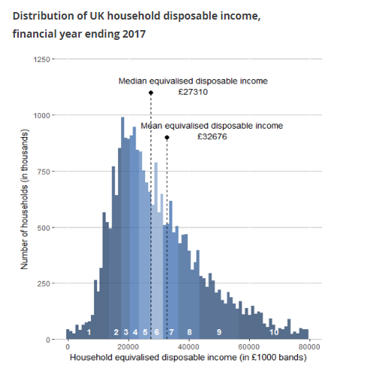
[Source: ons.gov.uk, 2018]

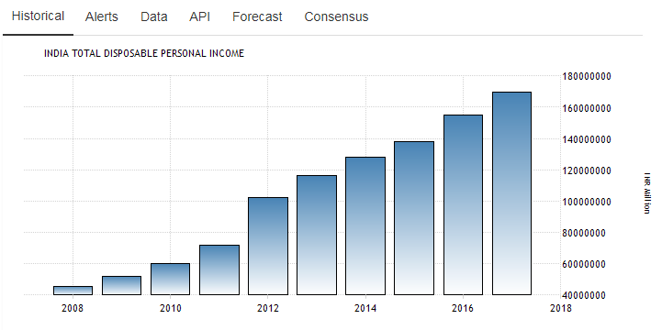
[Source: tradingeconomics, 2018]
Economical factor- the economic situation of both the market is different. One is a developed nation and other one is the developing nation. India through economically needs lots more improvement, is now the fastest growing economy in the term of larger size. In term of total size of the economy in 2018 India would overtake UK and become the fifth largest in the world (McRae, 2018). The rate of inflation is at 4.7% and is under control in term of its faster growing status. The national incomes are also showing a steady rising aspect and currently are at $3793 level (data.oecd, 2018). The projected GDP growth of the country is at 7.4%.the interest level is at around 6% level and that has come down a lot in recent years. All of those indicators are showing positive economic and consumer sentiment scenario for the Indian market of luxury car. Low inflation would improve the saving and the low interest rate would fuel demand for the luxury products. On the other hand the UK economy is at 1% growth rate level (Jackson et al., 2017). The Brexit like situation has depreciated the value of Pound and that has made the eternal supply cost for the manufacturing processes. The rate of inflation is at around 3% level and that is increasing the cost of the products though it is showing a drop in recent times (BBC News. (2018). the positive situation is on the unemployment rate which is at historic low of last few decades and the rate of interest which is near zero (Jackson et al., 2017). All of those situations are providing some mixed situation for the UK market.
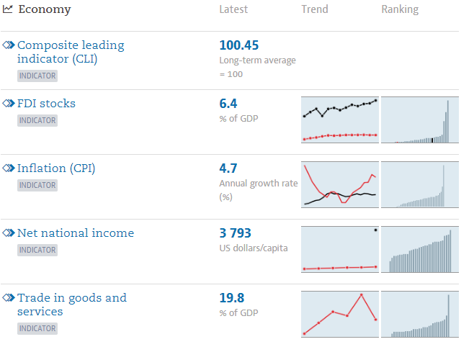
[Source: data.oecd, 2018]
Environmental factor- the environmental factors are important for the car or automobile industry as it is one of the largest source of greenhouse gas. In recent climate deal many country has decided to cut their current level of emission and there UK had pledged to cut the current level with respect to 1990’s level by a 57% reduction within the 2030 and would go zero emission level by 2050 (Vaughan, 2016). In case of India not only commitment to climate change treaty but also higher level of pollution in the cities are to be considered in the environmental factors. India committed to reduce around 25% from the 2005’s level of emission by the same 2030 (Suryaprakash, 2017). Here also the clean technology and reduced emission level would be important.
Technological factor- the improvement in the plug-in and hybrid technology is changing the course of the industry. There are many automobile manufacturers who are making luxury and high performance car through the all electric technological innovation. In recent time the support and subsidy from the government has provided huge growth in this types of vehicle purchase in Uk (Murray, 2017). On the other hand the electric and the hybrid car market are not so developed in the Indian market. In India the government is not heavily promoting the new technology and the required infrastructure for these types of car are not developed (Ganguly, 2018).

Micro environment
The micro environment of the luxury car industry would be analysed through the Porters five forces analysis in the following approach.
Threat from new entrant (low)- this segment of the automobile industry is driven by large cost for R&D and advertisement. The R&D cost produces innovative, better designed and high performance car for the niche segment of the market. On the other hand the large advertising cost is required to showcase product differentiation and also for the demand creation. This large cost and investment makes it difficult for the new entrant in the market (Dälken, 2014).
Threat from substitution (moderate to low)- the substitution product in the car market is the other mobility options for the public. Generally the luxury car owners are not only satisfied with the mobility service provided by the product but needs other qualities like comfort, luxury, performance, status and so on. Considering this the alternative transports would not be attractive for the customers (Dälken, 2014). But this threat would be dependent on the technology and economic factors. During economic hardship people would look for greater value than luxury. Current better economic situation in India would reduce that threat but the uncertain condition of UK needs to consider that. The first technology evolution is fast changing the concept of luxury. Few features that used to be luxurious couple of years ago may be present in the non luxurious segment. Therefore in overall this threat is moderate to lower side. To counter this moderate threat Audi in its innovation research is specially researching the changing scenario of the society and how Audi can contribute in that to minimise this threat (audi, 2018).
Suppliers bargaining power (moderate to highly)- the supplies in this segment of market needs to be high quality and technologically much more advanced. This situation makes the number of suppliers limited to meet the higher standard. This would make the power of the suppliers moderate but on the higher side (E. Dobbs, 2014). Here the Audi which is part of the Volkswagen group takes the sustainability approach seriously. The organisation maintains better relationship with the suppliers, provides training and development support to the suppliers, better human right and labour right issues and so on (audi, 2018). All of these approach helps to minimise this threat.
Buyers bargaining power (high)- one of the reason of this higher threat proposition is the number of option, more access to the information and the economic up and down cycle. There are greater numbers of option for the customers in the form of other luxurious car brand in the market. The growth of internet and more information available there are helping the customer to make their choice (E. Dobbs, 2014). In both the UK and Indian markets these two factors holds. The economic difficult time would see customers are looking for more value than luxury.
Competitive rivalry (high)- this is one of the attractive segment of the market where the margins are high. In the UK market the Volkswagen group is at the top which owns the Audi brand (Cain, 2017). On the other hand the in the Indian market the Audi is having greater make share that its nearest competitors like Mercedes Benzes and BMW (financialexpress, 2016). In both the market Audi has strong position but the other companies are not far behind. In the Indian market the Mercedes Benzes has developed compact luxury car to counter Audi as this compact luxury segment would rise from current 25% to 50% level by the year 2022 (financialexpress, 2016). The better market scenario in India would attract more competitors and the existing ones are fighting even harder. In the UK market the competition is tight because of the mature industry type. In the luxury segment of the market the higher initial cost of manufacturing would need higher loss figures to take an exist decision for the companies. Because of this reason little loss would not discard the competitors and that makes this segment more competitive.
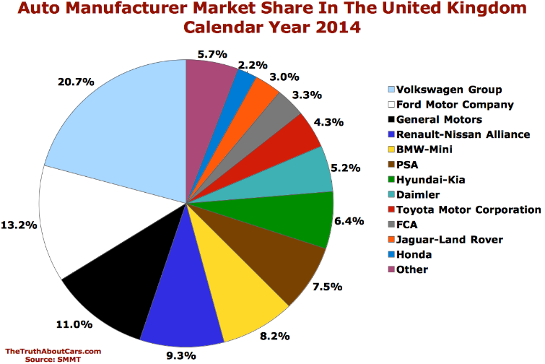
[Source: Cain, 2017]

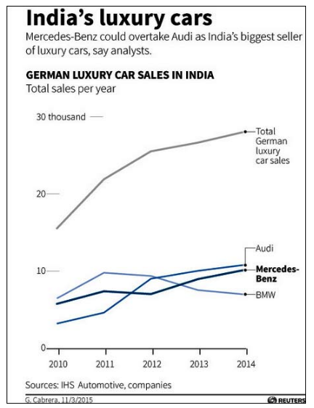
[Source: financialexpress, 2016]

Internal environment analysis
The SWOT framework would be applied for the internal analysis of Audi. This would provide greater knowledge about the internal business position to exploit or counter the external opportunity and threat respectively.
Strength
The application of advance technology, making best design and approach facility for manufacturing high quality car is one of the strength of the Audi. High end automobile engineering, large capacity engine, great look, precision level of their engineering are some if the attractive position to attract high end customers. The brand value is one of the significant strength as Audi currently stand at 37 in the Forbs list with $14.1 bn valuation of brand (forbes, 2017). The product portfolio is also large to attract different types of customer as the brand produces the diesel, petrol and hybrid variation for the luxury market. The safety and security features are of highest quality. The large sales figure is also an import strength as in the 2017 the company achieved $57.6b in revenue from sales (forbes, 2017).
Weakness
Audi is the brand that is highly focused in the luxury segment of the market. This approach has limited the process of business diversification and the company does not have the option to cater the segment just below the luxury segment. During the difficult economic time in the market the business has the chance to suffer more (Wheelen et al., 2017). On the other hand the brand does not have sufficient position to cater to the super luxury segment of the market. Another weakness is the higher maintenance cost of the products as shows in the figure below.
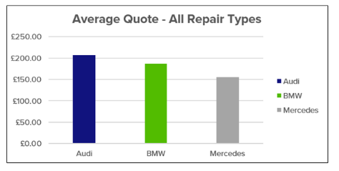
[Source: am-online, 2017]
Opportunity
The demand of all electric and the hybrid is increasing in the market especially in the UK market (Murray, 2017). Audi with its huge resource and capability based can invest in this segment more provide luxury solution through these technologies. On the other hand in the Indian market the better economic prospect and hope is influencing the rising demand of the Luxury car (Kishore et al., 2014). There Audi as already a known and respected brand have the change to grow faster. The brand has the opportunity to get into super luxury or the just below the luxury segment car market in both the country. Audi spent less in the marketing promotion compared to the competitors. An investment in this aspect would improve the sales of the business further. Innovation is the key and that would decide the future course in the market and Audi can capitalise on that through its existing capability.
Threat
Being only in the luxury segment the brand occupies only limited market segment where the competition is high as discussed earlier. The government subsidy and support is making the all electric like renewable energy vehicle popular and there are players who provide luxury solution in that segment (Lévay et al., 2017). In UK special the mature luxury segment would move in this direction quickly.

Strategic analysis for Audi in UK and India:
Every company has some strategy in order to enter the foreign markets where they operates and also they attracts the customers of the organization by offering various kinds of products which helps them to earn competitive advantage in the market over their rival brands (Hill et al., 2014).

Strategy for market entry:
For entering diverse markets of the countries that they operate in, Audi follows different kinds of strategy for entering the market and entering the market in India differs from the market entry strategy that is followed by the company while entering in UK. In India, Audi have entered the market assembling strategy and the parts of the cars are first made in Germany in their production unit and them they are shipped to India as distinct body parts (Ramita Verma, 2013). Audi factory in India is located in Aurangabad and when the parts of the car reach this factory they are assembled and then are sent to Bangalore in India. There are a maximum number of 4 Audi cars that are sent with the help of the trucks in Bangalore and then distributed with to the distributors of the car in the whole country from where the customers are able to buy the products. Thus, Audi cars are made available to Indian customers with the help of first manufactured in Germany and then shipped to Aurangabad in India for assembling. Then it reaches the distributors of the brand in various showrooms and thus reaches to the customers of the brand in the market.
In UK, a distinct process is follow by the car manufacturer in order to cater their car models to the customers. The cars of the brand are directly exported from Germany to UK due to the distance of these two countries (Abjoca, 2013). The cars are exported to the dealers of UK with the help of huge trucks from Bavaria in Germany and there are some of the huge dealers of Audi that are present in UK. Some of the greatest dealers of Audi cars in UK are Inchcape, Milton Keynes, and Marshall Audi and so on. Moreover, due to the implementation of Brexit, the car sales in UK has decreased and Audi wants to stick to their plans of exporting their cars in UK till the situations of the country is under control and the car sales increase.

Ansoff Matrix:
This is a tool for making the strategic decision of the company that are related to the development of growth of the business (Eden et al., 2013). There are four areas under the Ansoff Matrix which are described below:
Market penetration:
The market penetration is the strategy that is used when the products of the company are present in a particular market and within the existing market with the existing products; the business has to cater their products (Wheelen et al., 2017). Moreover, in order to cater the products in these kinds of market, the business has to update or upgrade their cars with technological advancements. Audi market is congested in UK due to high number of Audi cars running in the UK streets and thus in order to penetrate in the market, Audi should update their car features so that they can attract new customers in the market of UK.
Market Development:
This is another area under Ansoff matrix where the company looks forward to develop new markets with the help of selling their existing products. In order to sell the existing products in the market, the company should find new markets that are not congested in nature and for that reason; they should bring in new models of the cars where they have never sold their products before (Rothaermel, 2015). Indian market is ideal for Audi as there are many untapped demands that have not been answered and for that reason, it is ideal for the company to follow the market development strategy. There are many potential customers who still do not know about the brand due to the fact that most of Indian economy is rural and thus there are areas for the brand to develop in the Indian market.
Product Development:
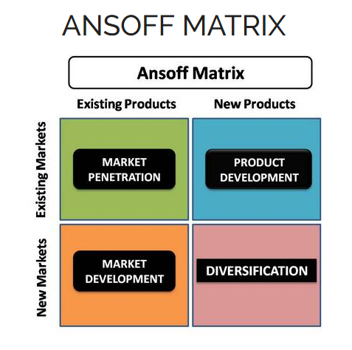
This is the third area of Ansoff matrix is product development and in this area the company should be able to cater the new demands in the market with the help of developing new products of the company to serve to the customers (Lasserre, 2017). Due to the fact that Audi market in UK is congested and there is more number of Audi cars in UK, the company should bring in new car models to capture the demand of the customers in the country. Audi should invest in their research and development facilities and develop new cars that can satisfy the customers of UK in order to help the company gain more sales that can help the company to make more revenue.
Diversification:
This is totally a new strategy and is one of the most risky strategies for the businesses that exist in the present world (Chen et al., 2014). With the help of this strategy the companies looks for a new market with an altogether diverse range of products to serve the customers, if Audi has to follow this strategy, they will have to supply their new car models to completely diverse country where their cars are still not available. In order to diversify their market, Audi should be able to cater their products in the different country where their presence has still not been felt but as Audi cars are available in India and UK both, it is not possible to follow this strategy in any of the countries.

Segmentation, Targeting and Positioning of Audi in UK and India:
The segmentation, targeting and positioning of the brand is a strategy in marketing in order to divide the customers into various segments and to target the most profitable segment in the market with the help of positioning the brand (Hassan et al., 2012). Moreover, in diverse range of countries Audi follows different kinds of segmentation, targeting and positioning strategy to increase the sale of their brand.
Segmentation:
The segmentation is the process with the help of which Audi divides their base of customers into various halves and there are four types of segmentation that exist for the business to divide their customers among which Audi follow only three types of segmentation process as mentioned below:
Geographic segmentation:
The geographic segmentation of the company helps in dividing the customers of the world based on their areas of location (Wedel et al., 2012). There are borders which separate the countries worldwide due to this, the geographic segmentation has come to use. In UK, people are most likely to drive the cars that are smaller in nature and they mostly prefer sedan or hatchback model, while in India, people mostly prefer SUV cars. This is the reason, in India; Audi Q3 and Audi Q5 is the highest selling car while in UK Audi A3 is the highest selling.
Demographic segmentation:
The demographic segmentation helps the brand to divide their market as per the ability of the person and also their age group. While in UK and India, the age segment that is targeted by the company is 20-70 years of people and also both the genders are targeted, but in UK, due to the income level of the people is different to that in India, the income group targeted is diverse in these two countries (Kapferer, 2012). In India, the income level of people and GDP is lower than that of UK and thus in India the people of who have high paying jobs in the country can afford an Audi while in UK, the people with medium income can also afford an Audi.
Psychographic segmentation:
This is the third category of Audi segmentation and in this segment the lifestyle or an individual and the characteristics of the personality is used to segment the market. An Audi is targeted toward the rich customers who have high buying power in the market in India, while in UK; the upper middle segment is also included in the target market of the company.
Targeting:
The targeting is the process with the help of which the company identifies the most profitable segment from the segmentation of the organization and thus that segment becomes the target market of the company (Friedman, 2012). There are two basis upon which the targeting is done for the company and they are based upon country wise and type of driving. With the help of their targeting strategy, most of the world countries are included in the target market of Audi and the cars are imported from 11of their factories which are located in 9 countries around the world. Moreover, the car range of Audi is used for the purpose of luxury as well as for driving purpose.
Positioning:
In both UK and India, Audi has differentiated their products from their rival car brands like BMW and Mercedes in order to position their products. In order to increase their sales in the market, the brand use their unique selling proposition which states that they sale comfortable and luxurious cars in the market that delivers excellent performance with the help of the German made engines (Riezebos et al., 2012). Moreover, the cars have a sporty look compared to that of the other rival brands. In 2013, Audi was the top manufacturer in terms of profit and they have increased their revenue by 10.1% the same year which states that the positioning of the brand in the market is very good.
Moreover, Audi was the 2nd best business brand in Germany and also in luxury products customer satisfaction index, they were ranked the same. Furthermore, in performance of the automotive, they have earned the 3rd position in the world and auto pacific satisfaction of vehicles; they are ranked in the 5th position in the market.

Marketing Mix for Audi in UK and India:
Marketing mix of a company is referred to as a combination of various factors that can be changed by the company so that the purchase decisions of the customers in the market can be influenced (Armstrong et al., 2015). Audi is German based luxurious car manufacturer that uses their marketing mix in order to attract the customers towards their brand and this helps them to gain more sales of their product to the customers that increase the revenue of the company.
Products:
There are a number of product that are sold by the company in the UK and Indian market and Audi focus upon mainly in four categories in both the markets and they produce mini cars, Sedan, sports cars as well as SUVs. But in India, the SUVs are the most focussed products of Audi as Indians likes driving big cars due to the fact that they are more family oriented people and in India there is tradition of joint families that still exists (Mayrhofer, 2012). While in UK, Audi focus upon marketing more mini cars and sports oriented cars due to the reason that UK people are more focussed upon cars that occupy small areas and also like to stay single. UK people do not like the concept of joint families much and thus, UK market is targeted by Audi for selling mini car models of the brand and also sedan cars. That is the reason, in UK, the highest selling model of the brand is Audi A3 while in India, Audi Q3 and Q5 are the highest selling cars of the brand. Moreover, the production plant set up in Aurangabad in India in the year 2007 has boosted up the sales of the company and Audi sales has boosted its growth of sales in India more than 400% in 2017 than that was the condition in 2012.
Price:
Audi has always marketed them as a luxurious brand and the prices of the cars are high in both the market of UK and India (Ruhnau et al., 2014). But due to the fact that there are economical differences between the people of UK and India and UK being a rich economy in the market, there are differences in the category that can afford the car in the market in both the countries. While in India, the Audi cars are only affordable by the individuals who are have huge buying power and the upper class people, in UK, apart from the rich people and upper class, Audi can also be bought by the upper middle segment. This is due to the economical differences in these two countries that the premium range can be availed by two different segments in UK, while it can be afforded by only one in India. But in India, the buying power of youth people are increasing day by day and thus India is considered as a good market for marketing the cars of the brand (Belokar et al., 2012).
Place:
Audi has made entry in the Indian market in the year 2004 and it is due to the fact that there were large amount of disposable income of the people in the country. Audi cars are available in the showrooms of 21 chief cities across India and they are sold through the dealers of the brand (Bothra, 2014). Due to the fact that Audi has located and set up their plant near Aurangabad in India, they are able to assemble their cars quickly and also distribute their products in a fast pace in Bangalore from where the cars are catered to the entire major cities across the country. This helps in fulfilling the demand of the customers of all over India and thus the places plays a major role in marketing decision making of the company.
While in UK, the cars are sent through road with the help of export procedure from Germany. The cars are carried in trucks from Germany to Britain and there, they are dispatched to the dealers of the company. But due to coming up of Brexit, the cars sales are down in the country and thus the supply of cars are less at this point of time in the UK market.
Promotion:
Promotion is the strategy with the help of which the company keeps informing their potential customers about the products of their brand and this helps in raising the sales of the company in the market (Fill et al., 2016). There are diverse amount of strategy followed by Audi in order to market their products and car models to the customer of two different countries and mostly Audi uses technological power in order to market their products in India and UK. Audi makes use of social media in order to promote their new products in the market through pay per click and pay per view advertisements in both the countries. Moreover, they also make use of malls and various hotels throughout India in order to launch their new products. Apart from this, in UK, they promote their car models in the country with the help of motor shows as well as with the help of sporting events sponsor. Lastly, in UK, they also feature their cars in movies in order to promote their brand to the potential customers of the organization.

Conclusion
In the international marketing the different condition of the markets makes the strategy and decision making important for different markets. The marketing condition analysis in that context becomes important and in the current report the Indian and UK market analysis provides the insights that have the implication on the marketing strategy and decision making process. The more mature UK market and fast growing Indian market provides the contrast in this analysis.

Reference
Abjoca, D., 2013. Foreign Investments-Forms of Market Entry. Metalurgia International, 18(3), p.146.
am-online. (2017). Insight: BMW vs Audi vs Mercedes: which costs most to maintain? (2017 update). [online] Available at: https://www.am-online.com/news/aftersales/2017/01/04/insight-bmw-vs-audi-vs-mercedes-which-costs-most-to-maintain-2017-update [Accessed 30 Apr. 2018].
Armour, J., and Lele, P. (2009). Law, finance, and politics: the case of India. Law & Society Review, 43(3), 491-526.
Armstrong, G., Kotler, P., Harker, M. and Brennan, R., 2015. Marketing: an introduction. Pearson Education.
audi. (2018). Innovation . [online] Available at: https://www.audi.com/en/innovation.html [Accessed 30 Apr. 2018].
audi. (2018). Supplier management. [online] Available at: https://www.audi.com/corporate/en/sustainability/topics-and-facts/value-creation-and-production/supplier-management.html [Accessed 30 Apr. 2018].
Bansal, P. (2018). Indian PM Modi defends globalization at Davos summit. [online] U.S. Available at: https://www.reuters.com/article/us-davos-meeting-modi/indian-pm-modi-defends-globalization-at-davos-summit-idUSKBN1FC1AL [Accessed 30 Apr. 2018].
BBC News. (2018). UK inflation rate drops back to 3%. [online] Available at: http://www.bbc.com/news/business-42702752 [Accessed 30 Apr. 2018].
Belokar, R.M., Kumar, V. and Kharb, S.S., 2012. An application of value stream mapping in automotive industry: a case study. International Journal of Innovative Technology and Exploring Engineering, 1(2), pp.152-157.
Bothra, N., 2014. Louis Vuitton, Gucci, and Audi: The Luxury Retail Sector in India-Will it Grow or Go?. Indian Journal of Marketing, 44(6), pp.51-61.
Chen, Y., Jiang, Y., Wang, C. and Chung Hsu, W., 2014. How do resources and diversification strategy explain the performance consequences of internationalization?. Management Decision, 52(5), pp.897-915.
Czinkota, M.R. and Ronkainen, I.A., 2013. International marketing. Cengage Learning.
Dälken, F. (2014). Are porter’s five competitive forces still applicable? a critical examination concerning the relevance for today’s business (Bachelor's thesis, University of Twente).
data.oecd. (2018). Selected indicators for India . [online]. Available at https://data.oecd.org/india.htm [Accessed 30 Apr. 2018].
E. Dobbs, M. (2014). Guidelines for applying Porter's five forces framework: a set of industry analysis templates. Competitiveness Review, 24(1), 32-45.
economictimes.indiatimes. (2016). GST Rates: Items that will continue to be expensive. [online] economictimes.indiatimes. Available at: https://economictimes.indiatimes.com/news/economy/policy/gst-rates-items-that-will-continue-to-be-expensive/articleshow/61598211.cms [Accessed 30 Apr. 2018].
Eden, C. and Ackermann, F., 2013. Making strategy: The journey of strategic management. Sage.
euronews. (2017). Brexit talks breakthrough: What we know about the deal. [online] Available at: http://www.euronews.com/2017/12/08/brexit-breakthrough-what-we-know-about-the-deal [Accessed 30 Apr. 2018].
Fill, C. and Turnbull, S.L., 2016. Marketing communications: brands, experiences and participation. Pearson.
financialexpress. (2016). Mercedes seen overtaking Audi to top India’s luxury car market . [online] Available at: https://www.financialexpress.com/auto/news/mercedes-seen-overtaking-audi-to-top-indias-luxury-car-market/223359/ [Accessed 30 Apr. 2018].
forbes. (2017). #37 Audi. [online] Available at: https://www.forbes.com/companies/audi/ [Accessed 30 Apr. 2018].
Friedman, L., 2012. Go to market strategy. Routledge.
Ganguly, A . (2018). The Indian government isn’t ready to walk the talk on electric vehicles. [online] Available at: https://qz.com/1211191/the-indian-government-isnt-ready-to-walk-the-talk-on-electric-vehicles/ [Accessed 30 Apr. 2018].
GORDON, S. (2017). There is a silver lining for business in UK political upheaval. [online] Ft.com. Available at: https://www.ft.com/content/def25988-4d3e-11e7-919a-1e14ce4af89b [Accessed 30 Apr. 2018].
Hassan, S.S. and Craft, S., 2012. Examining world market segmentation and brand positioning strategies. Journal of Consumer marketing, 29(5), pp.344-356.
Hill, C.W., Jones, G.R. and Schilling, M.A., 2014. Strategic management: theory: an integrated approach. Cengage Learning.
Jobber, D. and Ellis-Chadwick, F., 2012. Principles and practice of marketing (No. 7th). McGraw-Hill Higher Education.
Kapferer, J.N., 2012. The new strategic brand management: Advanced insights and strategic thinking. Kogan page publishers.
Kishore, J., Sharma, N., and Singh, V. (2014). Influence of Pricing on Sales: An Insight into Indian Car Market with Reference to Chevrolet, Ford, Hyundai and Maruti Suzuki.
Lasserre, P., 2017. Global strategic management. Palgrave.
Lévay, P. Z., Drossinos, Y., and Thiel, C. (2017). The effect of fiscal incentives on market penetration of electric vehicles: A pairwise comparison of total cost of ownership. Energy Policy, 105, 524-533.
Mayrhofer, U., 2012. Marketing international (No. halshs-00739267).
McRae, H. (2018). This year, India will surpass the UK to be the fifth largest economy – but we shouldn’t worry too much. [online]. Available at https://www.independent.co.uk/voices/uk-economy-india-china-g7-g20-industrial-revolution-western-technology-a8248341.html [Accessed 30 Apr. 2018].
Murray , J. (2017). UK demand soars for electric and hybrid vehicles. [online] Ft.com. Available at: https://www.theguardian.com/environment/2016/jan/07/uk-demand-soars-for-electric-and-hybrid-vehicles [Accessed 30 Apr. 2018].
ons.gov.uk. (2017). Internet users in the UK: 2017. [online] Available at: https://www.ons.gov.uk/businessindustryandtrade/itandinternetindustry/bulletins/internetusers/2017 [Accessed 30 Apr. 2018].
ons.gov.uk. (2018). Household disposable income and inequality in the UK: financial year ending 2017. [online]. Available at https://www.ons.gov.uk/peoplepopulationandcommunity/personalandhouseholdfinances/incomeandwealth/bulletins/householddisposableincomeandinequality/financialyearending2017 [Accessed 30 Apr. 2018].
Ramita Verma, M.B.A., 2013. PEST Analysis for Indian Luxurious Car Market.
reuters. (2018). German car suppliers could lose thousands of jobs over hard Brexit - study. [online] U.S. Available at: https://www.reuters.com/article/uk-germany-autos-britain/german-car-suppliers-could-lose-thousands-of-jobs-over-hard-brexit-study-idUSKBN1F0138 [Accessed 30 Apr. 2018].
Riezebos, R. and Van der Grinten, J., 2012. Positioning the brand: an inside-out approach. Routledge.
Rothaermel, F.T., 2015. Strategic management. McGraw-Hill Education.
Ruhnau, T. and Bunzel, W.M., 2014. Sustainability in automotive pricing. In Sustainable Automotive Technologies 2013 (pp. 143-150). Springer, Cham.
Suryaprakash, R. (2017). How to make India's climate commitments a reality. [online] dailyo. Available at: https://www.dailyo.in/politics/india-climate-change-goals-paris-agreement-indc-carbon-budget/story/1/17323.html [Accessed 30 Apr. 2018].
Teece, D. J. (2010). Business models, business strategy and innovation. Long range planning, 43(2), 172-194.
thehindu. (2016). India has world’s largest youth population: UN report. [online] the hindu. Available at: http://www.thehindu.com/todays-paper/tp-in-school/india-has-worlds-largest-youth-population-un-report/article6612615.ece [Accessed 30 Apr. 2018].
tradingeconomics. (2018). India Total Disposable Personal Income . [online]. Available at https://tradingeconomics.com/india/disposable-personal-income [Accessed 30 Apr. 2018].
Vaughan, A. (2016). UK sets ambitious new 2030s carbon target. [online] the Guardian. Available at: https://www.theguardian.com/environment/2016/jun/30/uk-sets-ambitious-new-2030s-carbon-target [Accessed 30 Apr. 2018].
Wedel, M. and Kamakura, W.A., 2012. Market segmentation: Conceptual and methodological foundations (Vol. 8). Springer Science & Business Media.
Wheelen, T. L., Hunger, J. D., Hoffman, A. N., and Bamford, C. E. (2017). Strategic management and business policy. pearson.
Wheelen, T.L., Hunger, J.D., Hoffman, A.N. and Bamford, C.E., 2017. Strategic management and business policy. pearson.
worldbank. (2018). India Jumps Doing Business Rankings with Sustained Reform Focus. [online]. Available at http://www.worldbank.org/en/news/press-release/2017/10/31/india-jumps-doing-business-rankings-with-sustained-reform-focus [Accessed 30 Apr. 2018].
worldometers.info. (2017). U.K. Population. [online] Available at: http://www.worldometers.info/world-population/uk-population/ [Accessed 30 Apr. 2018].
www.audi.com. (2018). 2017 Annual Report. [online] Available at: https://www.audi.com/content/dam/com/investor-relations/financial-events/jpk18/AR_2017.pdf [Accessed 30 Apr. 2018].
www.audi.com. (2018). Audi at a glance. [online] Available at: https://www.audi.com/corporate/en/company/audi-at-a-glance.html [Accessed 30 Apr. 2018].
www.statista.com. (2018). Number of cars produced worldwide by Audi from FY 2005 to FY 2017. [online] Available at: https://www.statista.com/statistics/267234/worldwide-car-production-of-audi/ [Accessed 30 Apr. 2018].
www.volkswagenag.com. (2018). 1,878,100 automobiles sold: Audi closes 2017 with new record-breaking sales. [online] Available at: https://www.volkswagenag.com/en/news/2018/01/Audi_sales_17.html [Accessed 30 Apr. 2018].

