Assessment Component 2
Coursework: Essay
Student Name: Mariana Acris
Student Number: 2239619
Lecturer Name: David Oyebisi
Module Name: LCBB5005
Project Management

Table of Contents
1. Introduction 3
1.1. Importance of Contracting in Project Management 4
1.2. What are the Benefits of an Effective Contract Management Process? 4
2. Methods of Contracting in Project Management 5
2.1. Turnkey Contracting: Advantages and Disadvantages 5
2.2. Multicontract: Advantages and Disadvantages 7
2.2.1. The Benefits and Challenges of Multi-Contracting 8
2.3. Do-It-Yourself (DIY) Contracting: Advantages and Disadvantages 8
2.3.1. Relative Economic Benefits of DIY Contracting: 10
2.4 Multicontract + DIY: Advantages and Disadvantages 10
2.4.1. Benefits of multiple people contracting under the same limited company. 12
3. Conclusion 12
References 13

1. Introduction
Project Management (PM) includes the application of knowledge, skills, tools, and techniques to project actions to meet project necessities. It involves planning, executing, monitoring, controlling, and concluding projects effectively and efficiently (Kerzner, 2017). One critical aspect of successful project delivery is the choice of the appropriate contracting method, which influences the allocation of responsibilities, risks, and rewards among project stakeholders.
The essay goals to investigate the four primary methods of contracting in project management—Turnkey, Multicontract, Do-It-Yourself (DIY), and Multicontract + DIY. It explores their advantages, disadvantages, and contextual suitability for different types of projects. Understanding these methods allows project managers to make informed decisions that align with project goals and stakeholder expectations.
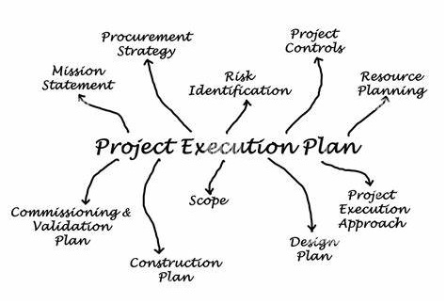
Contracting is essential in project management because it defines the legal and operational framework within which project activities are performed. The choice of contracting method affects cost control, risk allocation, schedule management, and overall project quality (Bajari, 2001).
Therefore, selecting the most suitable contracting approach is a strategic decision that can significantly impact project success.

Fig. 1. Source of: https://www.vmsconsultants.com/construction-project-execution-list-of-major-activities-and-their-timelines/

Importance of Contracting in Project Management
Contracting in project management is essential for ensuring clarity, accountability, and successful project execution. It defines the legal and operational framework for the relationship between the client and contractors, outlining the scope, deliverables, timelines, costs, and quality expectations. Clear contracts help prevent misunderstandings by establishing roles and responsibilities, reducing the risk of disputes and legal conflicts (Turner, 2017).
Effective contracting enhances risk management by specifying how risks are allocated between parties, ensuring that potential issues such as delays, cost overruns, or quality failures are addressed and mitigated. It also improves cost control by fixing payment terms, tracking expenses, and preventing unauthorized changes. Additionally, contracting ensures compliance with legal regulations, industry standards, and organizational policies, safeguarding the project against legal and financial liabilities (Mosey, 2009).
In project management, contracting also promotes efficiency and performance by defining key milestones and deliverables, providing a basis for monitoring progress and enforcing accountability. It supports stakeholder collaboration by aligning expectations and fostering transparent communication. Ultimately, contracting is crucial for maintaining project structure, reducing risks, ensuring quality, and delivering successful outcomes on time and within budget (Mosey, 2009).

What are the Benefits of an Effective Contract Management Process?
An effective contract management process can significantly enhance your company’s productivity and efficiency. It speeds up negotiation cycles by 50%, allowing you to focus on core business activities. Implementing contract management software streamlines the entire contract lifecycle-from preparation and negotiation to execution. With improved visibility, it reduces erroneous payments by 75-90% and lowers operating and processing costs by 10-30%, providing a clear competitive advantage (Cunanan, 2024).
Efficient contract management also fosters better collaboration across the organization. Traditionally, 90% of records management falls on the legal team, with only 1.2% of administrative staff involved. By adopting a contract management platform, this workload is reduced, facilitating faster contract creation and enabling broader team participation throughout the contract’s lifecycle. This holistic approach improves accuracy, reduces administrative burdens, and empowers various departments to engage actively in managing contracts (Cunanan, 2024).

2. Methods of Contracting in Project Management

2.1. Turnkey Contracting: Advantages and Disadvantages
Definition and Explanation: Turnkey contracting is a project delivery method where a single contractor assumes full responsibility for the design, construction, and delivery of a fully operational facility. The contractor manages all project phases, and the client is only required to "turn the key" to start operations. 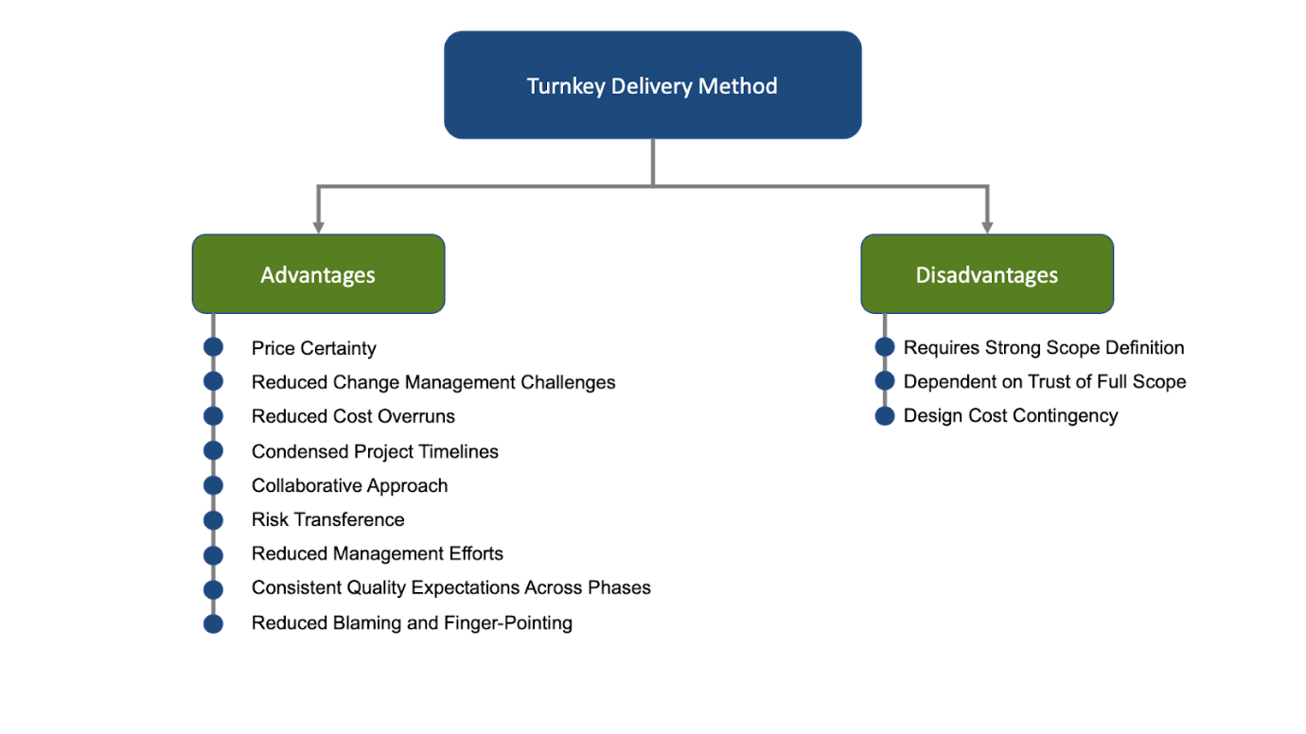
Fig. 2. Source of: https://www.hm-ec.com/blog-posts/turnkey-project-advantages-and-disadvantages-what-to-know-before-signing-a-contract-hm

Advantages of Turnkey Contracting:
- Price Certainty:
Different than the traditional Design-Bid-Build (DBB) approach, turnkey methods decrease financial unknowns and offer project possessors the ability to accurately calculate return on investment (ROI). This predictability allows better budgeting and minimizes the risk of unforeseen costs during the project lifecycle (H+M, 2023).

- Reduced Change Management Challenges:
With the DBB approach, disconnections between the design and construction teams can lead to inconsistencies and change orders, causing price increases. Turnkey methods mitigate this by integrating the design and construction processes, ensuring that everything in the "Issued for Design" package is included in the price.
- Reduced Cost Overruns:
If the turnkey contract is fixed-cost, the project owner is only responsible for the agreed-upon lump sum. This means any cost increases, such as rising material costs, are absorbed by the contractor. Additionally, involving the construction team during the design phase helps prevent delays and cost overruns.
- Condensed Project Timelines:
With a single entity managing design and construction, stages of the project can overlap, reducing timelines. For instance, procurement can occur while designs are being finalized, accelerating the overall delivery process.
- Collaborative Approach:
The turnkey model fosters collaboration between the designer and builder, reducing adversarial relationships and blame-shifting that may occur in DBB models.
- Risk Transference:
The contractor assumes much of the project risk, including responsibility for the schedule, cost, and performance, relieving the project owner of these burdens.
- Reduced Management Efforts:
Turnkey projects minimize the need for project owners to manage and supervise multiple contractors, allowing greater focus on strategic project outcomes.
- Consistent Quality:
Quality standards are established from the outset and are consistently applied across design, fabrication, and construction teams, enhancing project outcomes.
Disadvantages of Turnkey Contracting:
- Limited client control over design and construction phases.
- Higher risk premiums result in increased contractor fees.
- Potential for disputes if project requirements are not clearly defined.
Suitable Project Types for Turnkey Contracting:
- Large-scale infrastructure projects (e.g., power plants, airports).
- Industrial facilities requiring specialized technical expertise.

2.2. Multicontract: Advantages and Disadvantages
Definition and Explanation: Multicontracting involves the client directly managing and awarding separate contracts for various project components (e.g., design, construction, equipment supply). The client coordinates between multiple contractors.
Advantages of Multicontract:
- Greater control over project design and execution.
- Potential cost savings by eliminating contractor mark-ups.
- Flexibility to select specialized contractors for specific tasks.
Disadvantages of Multicontract:
- Increased client responsibility for project coordination.
- Higher administrative burden and potential for interface issues.
- Greater risk exposure due to fragmented accountability.
Additionally, while multicontracting provides better cost control and enhanced visibility across different project components, it also introduces challenges in managing the interfaces between multiple contractors. Each aspect of the project, from wind turbine generators (WTG) to cables and foundations, requires careful oversight to prevent conflicts. The need to coordinate multiple contractors demands an experienced team focused on managing commercial and program aspects, which can be difficult given the competitive recruitment landscape, especially post-COVID when infrastructure projects are booming globally.

Suitable Project Types for Multicontract:
- Complex, large-scale projects requiring specialized expertise.
- Projects where the client has strong project management capabilities.

2.2.1. The Benefits and Challenges of Multi-Contracting
Recently, several U.K. developers have chosen to adopt a multi-contracting strategy for offshore wind farm construction. This approach offers greater transparency and control over risks and costs compared to the traditional Engineering, Procurement, Construction, and Installation (EPCI) model, which often involves paying a premium for a single entity to manage most project risks.
While multi-contracting provides better oversight of costs, local content, and individual installation packages, it also introduces additional complexities (Clarksons, 2023). Managing the various interfaces and associated risks requires careful coordination, often necessitating the transfer of these risks to specialized subcontractors or insurers.
Overseeing multiple contractors demands a dedicated and experienced team to manage both the commercial aspects and the delivery of various project scopes—such as Wind Turbine Generators (WTG), cables, foundations, offshore substations (OSS), and export cables. Assembling such a team is especially challenging in the post-COVID landscape, where competition for skilled professionals is fierce due to increased global infrastructure projects, the resurgence of the Oil & Gas sector, and the rapid growth of offshore wind.

2.3. Do-It-Yourself (DIY) Contracting: Advantages and Disadvantages
A specific form of presumption is Do-It-Yourself (DIY), which involves individuals using raw or semi-raw materials and components to create, modify, or reconstruct physical items, including projects involving natural resources like landscaping. In the home improvement industry, DIY products are usually unfinished and adaptable (e.g., lumber), allowing DIYers to play multiple roles - designer, builder, and inspector. Unlike other self-service activities that prioritize convenience (e.g., ATMs, fast food, gasoline), DIY projects require significant time, effort, and expertise, making them more labour-intensive and complex (Bateson, 1985; Dabholkar, 1996).
DIY also differs from Arts & Crafts in several key ways, including the types of projects, tools, materials, labour intensity, and cost. DIY projects generally demand more resources and effort. This distinction is reflected in the retail landscape—home improvement stores (e.g., Home Depot) focus on building materials and garden products, while Arts & Crafts stores (e.g., Michaels) offer home décor and craft supplies. There is minimal overlap between these retail segments (Wolf & McQuitty, 2011).

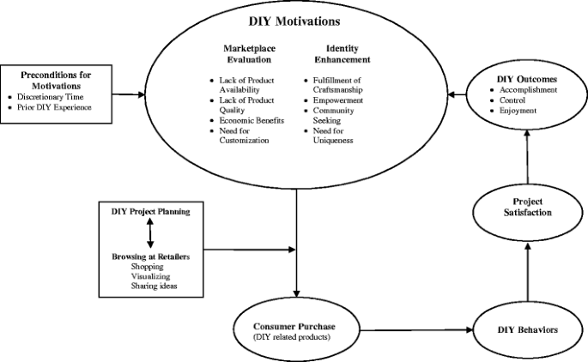
Fig. 3: Source of https://link.springer.com/article/10.1007/s13162-011-0021-2
Definition and Explanation: DIY contracting involves the client directly managing all project activities, from design to execution, without relying on external contractors for major project components.
Advantages of DIY Contracting:
- Full control over project processes and outcomes.
- Potential for significant cost savings.
- Flexibility to adapt project scope and design.

Disadvantages of DIY Contracting:
- Requires extensive in-house expertise and resources.
- Greater exposure to project risks and liabilities.
- Time-intensive and demands strong managerial commitment.
Suitable Project Types for DIY Contracting:
- Small-scale projects where the client has specialized knowledge.
- Research and development projects with evolving requirements.

2.3.1. Relative Economic Benefits of DIY Contracting:
One of the primary motivations for DIY contracting is the potential for significant cost savings (Wolf & McQuitty, 2011). By managing projects, themselves, clients can save on labour costs and use the savings to invest in upgraded materials or future projects. This approach is not limited to individuals with lower incomes; people across various economic backgrounds value spending money wisely. Although DIY activities do not directly increase household income, the savings from avoiding professional services allow clients to allocate funds to other priorities, improving their overall standard of living.

2.4 Multicontract + DIY: Advantages and Disadvantages
Combining contractor work with DIY (Do-It-Yourself) projects can save money, offer customization, and provide personal satisfaction, but it requires careful planning and coordination. Start by dividing tasks—assign complex, technical jobs like electrical or plumbing to contractors while handling simpler tasks such as painting or landscaping yourself. “Create a timeline” that schedules contractor works first and allows DIY projects to follow without causing delays. Clear communication with contractors is essential-define the scope of work, set expectations, and ensure your DIY efforts align with their schedule.
It’s also important to manage materials effectively by coordinating with contractors to ensure compatibility and to source necessary supplies. Safety and compliance should be a priority—leave hazardous work to licensed professionals and ensure proper permits are in place. Regularly track progress by checking in with contractors and inspecting their work to maintain quality.
By staying organized, communicating clearly, and understanding your limits, you can successfully integrate contractor work with DIY projects, ensuring a smooth process while maximizing cost savings and personal involvement.
Definition and Explanation: This hybrid approach combines multicontracting with in-house management of specific project components. Clients outsource specialized tasks while managing core activities internally.
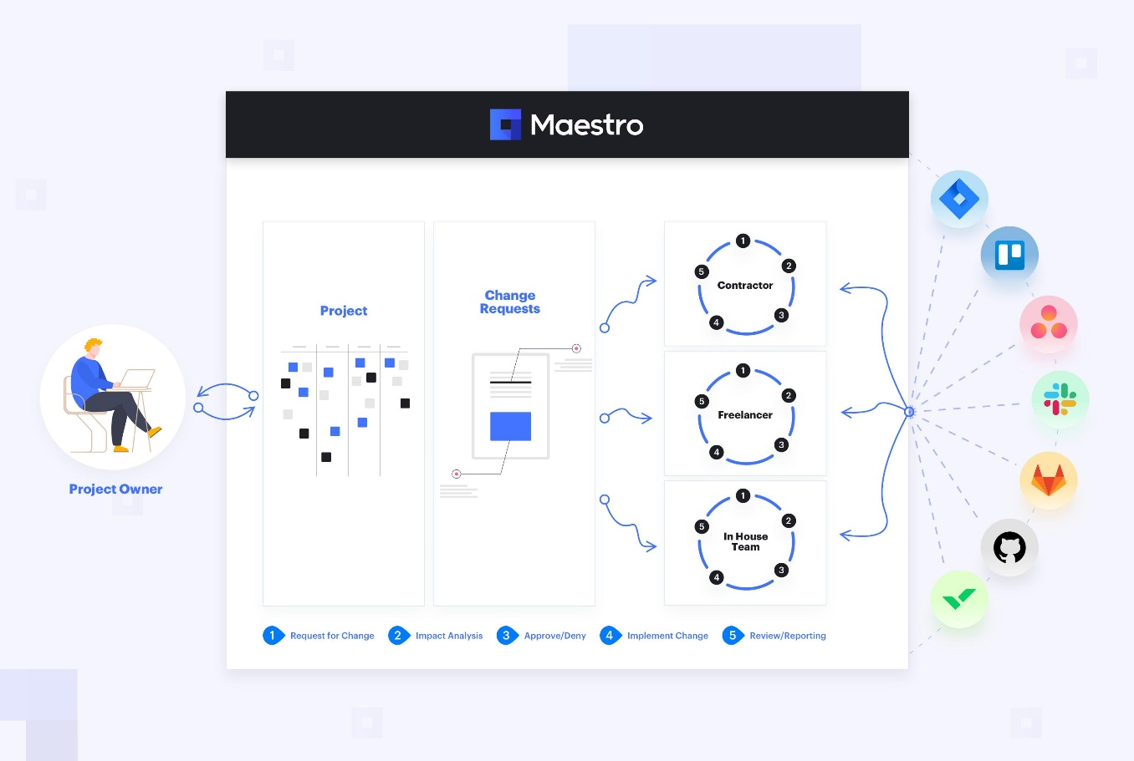
Fig. 4. Source of: https://maestrocr.com/blog/managing-change-requests-with-multiple-contractors

Advantages of Multicontract + DIY:
- Balanced control and flexibility over project phases.
- Cost optimization by leveraging internal capabilities.
- Access to external expertise for specialized tasks.
Disadvantages of Multicontract + DIY:
- Complex coordination between internal and external teams.
- Requires strong project management capabilities.
- Potential for scope and responsibility conflicts.
Suitable Project Types for Multicontract + DIY:
- Medium to large-scale projects with diverse technical needs.
- Projects where the client has core competencies but needs external expertise.

2.4.1. Benefits of multiple people contracting under the same limited company.
Contracting under the same limited company offers several benefits, including tax efficiency, as contractors can share business expenses, pay themselves through a tax-efficient mix of salary and dividends, and split income to reduce individual tax burdens. It also leads to cost savings by sharing administrative expenses, accounting fees, and resources like office space and professional services. Legal protection is another advantage, as the limited company structure shields personal assets from business liabilities while allowing for simplified contracting with clients (PMI, 2021).
Additionally, working under one entity enables business growth opportunities by allowing the team to take on larger projects and present a more comprehensive range of skills. Operational flexibility improves as contractors can divide work based on their expertise, provide backup support, and maintain consistent project delivery. This structure also enhances the company’s professional image, offering greater credibility and brand-building potential.
Moreover, a shared limited company facilitates exit and succession planning, as equity shares allow contractors to benefit from business growth and simplify ownership transfers or exits. However, it is crucial to have clear agreements outlining roles, profit-sharing, and decision-making processes while ensuring compliance with legal frameworks (e.g., IR35 in the UK). This collaborative approach can lead to greater efficiency, reduced costs, and improved business opportunities when managed effectively.

3. Conclusion
In conclusion, the choice of contracting method in project management significantly influences project success. Each method: Turnkey, Multicontract, DIY, and Multicontract + DIY offers distinct advantages and disadvantages, making them suitable for different project types. Turnkey contracting is ideal for large-scale projects requiring minimal client involvement, while multicontracting suits complex projects with specialized needs. DIY contracting is best for small-scale projects with available in-house expertise, and the hybrid Multicontract + DIY approach balances internal control with external specialization.
The Turnkey approach aims to deliver a fully completed, ready-to-use project with minimal client involvement. The contractor manages all phases—design, procurement, construction, and commissioning-providing a finished product while reducing client risk and ensuring a faster, more predictable delivery. In contrast, the Multicontract approach divides a project into multiple specialized contracts, offering better cost control, transparency, and flexibility. This method allows the client to oversee each contractor directly, select the best providers for specific tasks, and avoid the premium costs associated with a single-source contractor.
The Do-It-Yourself (DIY) approach focuses on enabling the client to manage and execute portions of the project independently, reducing costs and providing greater customization. It is often chosen to save on contractor fees while maintaining direct control over quality and project outcomes. Multicontract + DIY combines the benefits of both approaches, allowing clients to outsource complex technical work while handling simpler tasks themselves. This hybrid model enhances cost efficiency, flexibility, and customization while ensuring professional expertise is applied to specialized areas, offering greater control and reducing reliance on external contractors.
Understanding these contracting methods enables project managers to align their strategies with project objectives, optimizing cost, time, and quality outcomes.

References
Bajari, P. &. T. S., 2001. Incentives versus Transaction Costs: A Theory of Procurement Contracts. RAND Journal of Economics, 3(32), pp. 387-407.
Clarksons, 2023. clarksons: The opportunities of multi-contracting but the challenges it presents. [Online]
Available at: https://www.clarksons.com/home/news-and-insights/2023/the-opportunities-and-challenges-of-multi-contracting-in-offshore-wind/
[Accessed 13 March 2023].
Cunanan, J., 2024. What are the Benefits of an Effective Contract Management Process?. This infographic discusses the benefits of an effective contract management and the impacts it has on businesses., 22 May.
H+M, 2023. H+M Industrial Team: Turnkey Project Advantages and Disadvantages: What To Know Before Signing a Contract. [Online]
Available at: https://www.hm-ec.com/blog-posts/turnkey-project-advantages-and-disadvantages-what-to-know-before-signing-a-contract-hm
[Accessed 5 May 2023].
Kerzner, H., 2017. Project Management: A Systems Approach to Planning, Scheduling, and Controlling. 12th ed. Wiley: s.n.
Mosey, D., 2009. Early Contractor Involvement in Building Procurement: Contracts, Partnering and Project Management. s.l.:John Wiley & Sons.
PMI, 2021. A Guide to the Project Management Body of Knowledge (PMBOK Guide). 7th ed. s.l.:s.n.
Turner, J. R., 2017. Contracting for Project Management. s.l.:Taylor & Francis.
Wolf, M. & McQuitty, S., 2011. Understanding the do-it-yourself consumer: DIY motivations and outcomes. Springer Nature Link, Volume 1, pp. 154–170,.

