

MSc Public Health and Social Care in Practice

Health Care System, Organisation and Leadership (LCHS7002)

Case Study Analysis Report: Comparative report on COVID19 leadership Responses

Student Name- Monalikumari Ishwarbhai Tandel

Student ID- 2505012

Lecturer Name- Shepherd Ziko

Word Count - 4600

Submission Date- 16 December 2025

Executive Summary
This report provides a comparative study of how health-care systems are organized and how the leadership addresses the COVID-19 pandemic in Spain, South Korea, and Canada. The research question that the study addresses is the role of different levels of centralization and decentralization on preparing to deal with pandemic emergencies, decision-making, coordination, and the overall health of the population within these jurisdictions. The report is a critical evaluation of the governance frameworks of national and sub-national responses through the lens of a systems-thinking approach and specifically in the context of testing, contact tracing, health-system capacity, and vaccination policies.
The report also discusses the leadership approaches taken by some of the political and public-health leaders involved in the crisis based on the existing leadership theories, such as crisis leadership, adaptive leadership, and transformational leadership. Through the comparison of these methods, the report identifies the advantages and disadvantages of centralized and decentralized systems of governance in times of large-scale public-health crises. The results show that the effective management of the pandemic is not only determined by the structure of governance, but also on the leadership capacity, institutional coordination, transparency, and the trust of the people.

Table of Contents
Executive Summary 2
1. Introduction 4
2. Critical Analysis- Centralized and Decentralized Health- Care System Reactions to COVID- 19. 5
2.1 Introduction: Health Systems, Governance and Response to pandemics 5
2.2 Spain — decentralised structure, emergency recentralisation and mixed outcomes 6
2.3 South Korea – centralised technocracy, rapid digital public-health response and trade-offs 7
2.4 Canada - Federalism, lack of intergovernmental coordination and heterogeneous outcomes 8
2.5 Comparative synthesis: hybrid, adaptive governance is better 9
3. Critical Analysis of Leadership Styles During the COVID-19 Pandemic 12
3.1 Leadership Theories Relevant to Public Health Crises 12
3.2 Spain Leadership: Fragmentation, Crisis Recentralisation and Adaptive Learning 13
3.3 South Korean leadership: Technocratic Crisis Leadership, Transparency and Trust. 14
3.4 Leadership in Canada: An Empathic approach, Federal Constrains and Coordination Problems 16
3.5 Comparative Leadership Analysis: Structure, Style and Effectiveness 17
4. Conclusion 19
References 20

1. Introduction
The COVID -19 crisis posed a challenge to health-care systems and political leadership in all countries of the world that has never been experienced before, and it challenged the national capacity to coordinate, make decisions, and respond to a crisis. In addition to clinical and epidemiological reactions, the pandemic demonstrated the way in which the governance systems and leadership styles are inherently defining the outcomes of the interaction between the population and the health during the complicated emergencies. Different countries with varying centralization and decentralization took different approaches to the management of surveillance, restrictions, health-system capacity and vaccination programmes leading to different outcomes.
The present report is a comparative case-study analysis of Spain, South Korea and Canada, three countries with different structures of health-care systems and arrangements of governance. Spain has a highly decentralized health-care system, which gives great independence to its autonomous communities. South Korea on the other hand has a more centralized and technocratic model of public-health governance, which is supported by institutional reforms in response to past outbreaks of infectious disease. Canada is a federal system where provinces and territories are not only the major actors in the delivery of health-care services, but the federal government performs the role of coordination and funding.
Centralization is the power and control of authority and decision making at the national level which may allow the homogeneity of the policy, quick mobilization of resources and the uniformity of communication. Decentralization, in its turn, transfers power to the regional or local authorities, permitting policies to be adapted to local conditions and, in effect, creating disunity and coordination difficulties. The success of either strategy is determined by the quality of mechanisms of intergovernmental coordination and leadership ability in the face of a public-health crisis like COVID-19.
At a time when health systems are operating under crisis, leadership is very important on how these systems should be shaped. The leadership styles that are particularly relevant in the situation of a pandemic are crisis leadership, adaptive leadership, and transformational leadership because leaders have to manage the uncertainty, balance expert advice and political factors, earn the trust of the population and ensure compliance during extended periods of time. In line with this, this report looks at not only structural governance arrangements but also the role of leadership styles on the organization and performance of health systems in Spain, South Korea, and Canada during the COVID-19 pandemic.

2. Critical Analysis- Centralized and Decentralized Health- Care System Reactions to COVID- 19.
Note: This part is in the form of an assignment that is needed in the brief. The report provides comparisons between system organization and pandemic governance in Spain, South Korea, and Canada and critically assesses the benefits, drawbacks, and consequences of a centralized or decentralized policy. (The structure of the assignment and word division is according to the module instruction).

2.1 Introduction: Health Systems, Governance and Response to pandemics
The pandemic governance is placed in the core of the health-system design, legal authority, institutional capacity, and political leadership. Governments had a common set of operational choices in response to COVID-19 including testing and surveillance, contact tracing, isolation/quarantine, clinical surge management, non-pharmaceutical interventions (NPIs), and vaccination programmes, but the locus of decision-making (national versus sub-national) had a significant material impact on the pace, coordination, and equity of response (Capano and Howlett, 2021; Haldane et al., 2021). Centralized systems may lead to consistent policies, common procurement, as well as quick national communication, thus lessening inter-jurisdictional variation; decentralized systems may provide more local responses, as well as build on local knowledge, however, they may become fragmented, inconsistent in their messaging, and unequal in access to resources where intergovernmental coordination is weak (OECD, 2021; WHO, 2021).
The performance of centralization or decentralization during a pandemic is determined by three interacting capacities: (1) institutional capacity (testing laboratories, public-health workforce, logistics); (2) coordination mechanisms (legal emergency powers, data-sharing protocols, intergovernmental forums); and (3) legitimacy and trust (transparent communication, scientific credibility) that perpetuate public compliance (Ansell et al., 2021; Sanders et al., 2021). Those countries that had experience of previous epidemics, had interoperable digital infrastructure and pre-existing emergency channels were more placed to combine national strategy with local implementation. The comparison below is empirical and studies the manifestation of these dynamics in Spain, South Korea and Canada, as well as the connection between institutional design and measurable outcomes and policy trade-offs.

2.2 Spain — decentralised structure, emergency recentralisation and mixed outcomes
The National Health System (Sistema Nacional de Salud) of Spain is organized into 17 autonomous communities which are granted significant power in service provision, distribution of the workforce and local public-health services. This traditionally decentralised structure provided local responsiveness in the normal state of affairs but showed coordination failures in the initial stage of the pandemic, especially when it comes to harmonising surveillance and acquiring personal protective equipment and redistributing hospital capacity in time (Royo, 2020; Garcia-Basteiro et al., 2020). The central government declared a state of alarm in March 2020, which temporarily concentrated the powers, such as mobility restrictions, central procurement, and nationwide lockdown operations, thus recentralising the authorities to handle the highly spreading crisis. Such a drastic transition resulted in both benefits, including the implementation of national lockdowns in the shortest possible time and cohesive purchasing, and at the same time, it caused a political confrontation and confusion among people, who felt deprived of autonomy by the regions (Erekoreka, 2022; European Commission, 2021).
The major advantage of the response of Spain that followed was its centralised strategy in purchasing and distribution of the vaccines and decentralised distribution of the vaccine to local health services. The presence of centralised procurement reduced the bargaining fragmentation and provided economies of scale and the operational flexibility required by mass vaccination clinics and targeted outreach was supplied by the regional health services. This model was a hybrid one, which included national strategic command and local tactical implementation that allowed Spain to reach a high level of vaccination by mid-2021 and this was quite a success in contrast to the failure in the past (European Commission, 2021). However, the initial inability to combine real-time surveillance and unified reporting between the areas slowed down situational awareness and probably led to high early mortality in some autonomous communities (Garcia-Basteiro et al., 2020).
The case of Spain highlights the political and practical drawbacks of sudden recentralisation. Legitimacy is essential: in case the central instructions seem politically inclined or intergovernmental conflicts are at the center of the conversation, people lose their trust and adherence, thus compromising health outcomes (Sanders et al., 2021). Regularly, the regional differences in ICU capacity and workforce magnified equity differences, which demonstrates the weakness of a pure decentralised model with no effective redistribution processes. At the system level, the best performance by Spain was observed with national procurement and coherent messages combined with the regional service delivery; meanwhile, the fragmented information and politicised intergovernmental relationships produced mixed policies and timing variance which returned sub-optimal results. This means that decentralisation requires prior, legally defined coordination structures and interoperable data systems to be operational when there is a crisis; otherwise, temporary centralisation can both correct supply coordination but can lead to political opposition and misunderstanding (Royo, 2020; OECD, 2021).

2.3 South Korea – centralised technocracy, rapid digital public-health response and trade-offs
The reaction of South Korea is generally viewed as a model of centralised, technocratic governance of the pandemic that capitalised on the lessons of institutional learning acquired during MERS (2015). The reforms of the law, the enhancement of the disease-control agencies (KDCA), and the investments in the laboratory networks and digital surveillance provided the infrastructure that would allow the rapid growth of the testing, the implementation of new modalities, including drive-through testing, and the mass contact tracing within days of detection (Kim‛& Lee, 2021; Jeong et al., 2020). Integrated laboratory reporting, mobile location logs, and transaction data centralised into a single data system made near real-time situational awareness possible, and provided targeted containment actions, minimising the need to lock down entire areas and playing down the level of overall economic impact. The legal powers of the KDCA to gain access to the data in times of a public-health emergency, combined with its authority, further helped to map the cases and control the clusters quickly.
There were quantifiable epidemiological dividends in the initial stages of the pandemic in terms of faster case identification, isolation targeting, and reduced initial death rates than comparable countries that did not scale-up testing (Ryu, 2021). Ethically and politically, there are trade-offs; the application of digital surveillance brought up concerns regarding privacy and triggered the discussion of proportionality and the possible long-term effects on civil liberties (Lim & Sohn, 2023). The case of South Korea shows that centralised regimes, supported by the large institutional capacity and solid popular adherence, can enforce intrusive but efficient surveillance systems, a strategy that is feasible when the law is clear, people agree or even have a perceived gain.
Coherence in governance was another strength: national agencies were providing clear day-to-day communication, evidence-based guidance, and a uniform testing policy, which continued to keep the people at ease and willing to comply without the use of a lot of coercion (Moon, 2020). Streamlined regulatory pathways facilitated the process of public-private cooperation, namely, the quick approval of test kits and supply alliances. However, centralisation may concentrate risk: any errors by the policies in their initial stages or the excessive surveillance of people will affect the whole nation and hence requires strong checks and balances to safeguard the rights of the individuals. Overall, the case of South Korea shows that centralised, technically qualified governance is capable of being fast and precise in controlling the outbreak, though it requires institutional protection in order to maintain transparency, accountability and privacy, and thus legitimacy.

2.4 Canada - Federalism, lack of intergovernmental coordination and heterogeneous outcomes
Canada has a federal system which places the primary health-service delivery in the provinces and territories with the federal government taking the role of financing, regulation and coordination at the national level. Such a structure created a pluralistic pandemic terrain: provincial governments proceeded with different non-pharmaceutical intervention (NPIs), school policies, and long-term-care policies with different epidemiological results across the federation (Allin and Marchildon, 2020; Bubela and Atkinson-Grosjean, 2022). Federal involvement in centralised procurement of vaccines was a successful policy, with the ability to concentrate buying power, ensuring a supply throughout the country. Nevertheless, logistics of distribution and provincial rollout were different, which created the perception of unequal access and varying wait times in people.
The advantage of local tailoring presented by federalism was that those provinces which had favourable geography or demography could adopt early strategies of the Atlantic bubble, which produced low transmission levels without uniformity across the nation. However, the lack of binding national data standards and reporting interoperability did hamper national situational awareness and federal coordination (Public Health Agency of Canada, 2023). The intergovernmental cooperation was episodic as it was based on voluntary agreement and not an obligatory requirement, which also restricted the ability of the federal government to enforce national uniformity in policies quickly (Bubela et al., 2023). Though it maintained the provincial independence, it created confusion and contradictory messages that undermined the obedience of people at times.
The long-term-care crisis of the early waves in Canada revealed structural weaknesses: long-term-care environments were underfunded, privatized, and lacked uniformity in infection-control measures, as well as uneven coverage of the whole situation across the provinces, which led to the high death rate among older adults (Haldane et al., 2021). The limits of a decentralised delivery model were highlighted in the policy response in the scenario where national standards and surge support are not pre-determined. On the other hand, to ensure compliance with NPIs, federal economic supports (income replacement) served to address the economic cost of isolation, which is a valuable lesson in coordination where federal fiscal capacity is supplemented by provincial health action (Allin, 2021).
Canada illustrates that federal decentralisation can help to generate policy experimentation and contextual sensitivity, but when tasked critically by strong vertical mechanisms of coordination, which include data standards, surge-capacity sharing agreements and pre-negotiated legal frameworks of emergencies in place to prevent unequal results. In areas where such mechanisms were either feeble or lacking, decentralisation increased inequity; in areas where federal fiscal and procurement capacity was practised it increased equity and mobilization of resources. So, the Canadian case shows that the distribution of authority and collaboration is not structural labels that define the performance in minor health emergency cases but rather big-scale emergencies.

2.5 Comparative synthesis: hybrid, adaptive governance is better
There is evidence that neither of the two extremes of centralisation and decentralisation is universally better in the three cases. The centralised technocratic model of South Korea was able to contain itself early with the capacity of the institution and the digital surveillance but required strict legal protection of privacy; the decentralised delivery of Spain worked when coupled with national procurement and the existence of clear emergency channels but failed when coordination and data interoperability was lacking; the federalism of Canada allowed local customisation but failed to produce equal results.
The unchanging rule is that the most robust pandemic response can be found in adaptive hybrid governance having national strategic powers of procurement, surveillance, and equity; sub-national operational powers of local execution; pre-existing coordination protocols; interoperable data systems; and transparent and evidence-based leadership (OECD, ⁻ ? 2021; WHO, �� register. Successful crisis leadership that maintains legitimacy and effective communication as the cohesive factor enables hybrid systems to work under the pressure.

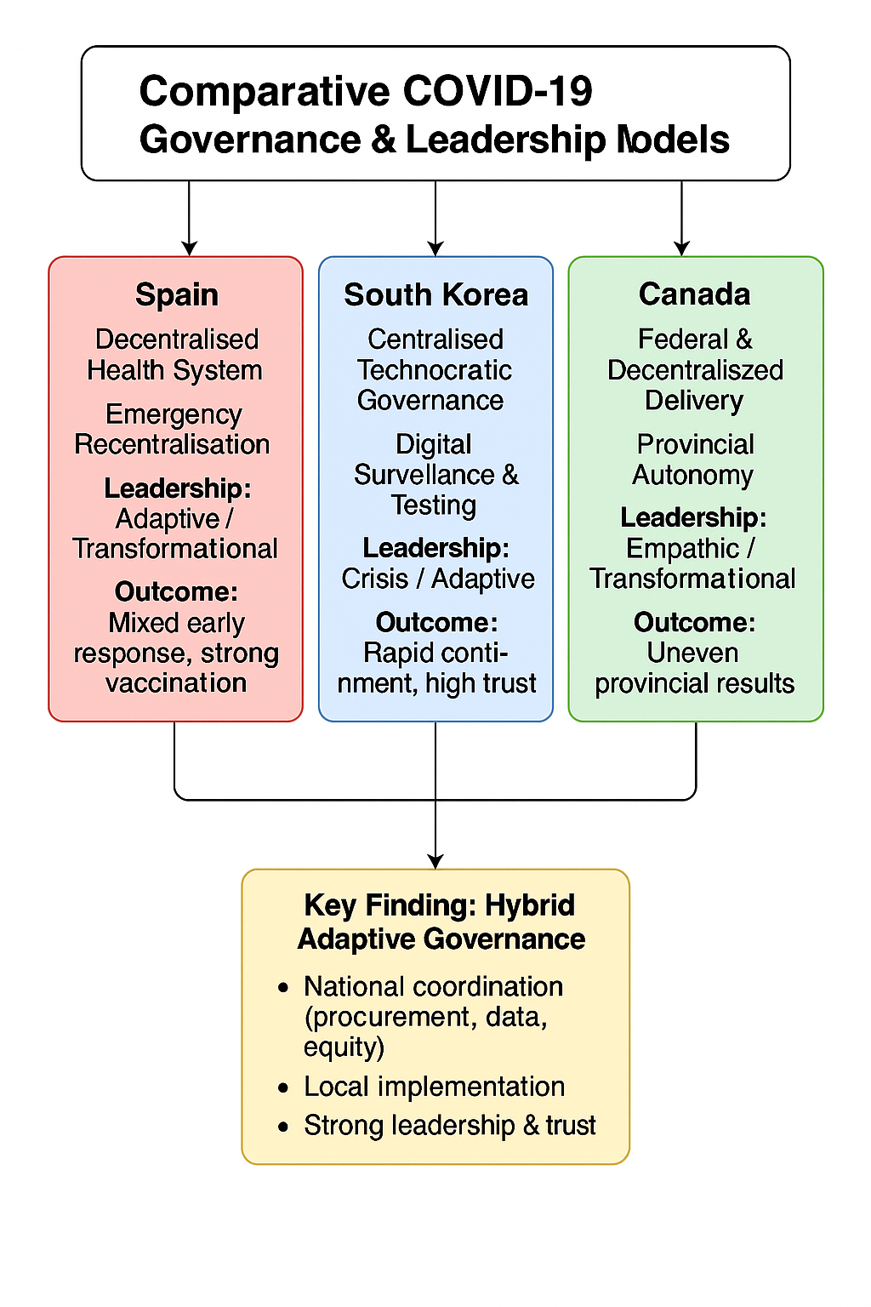
Figure 1: Comparative COVID-19 Governance and Leadership Models in Spain, South Korea and Canada

3. Critical Analysis of Leadership Styles During the COVID-19 Pandemic

3.1 Leadership Theories Relevant to Public Health Crises
Public health emergencies, including the COVID-19 pandemic, are complex, long-term crises that are characterised by uncertainty, emerging evidence, high political salience, and massive social and economic disruptiveness. In this case, the traditional forms of management leadership are ineffective, and, therefore, the crisis-specific theories of leadership become especially relevant. The key characteristics of crisis leadership include speed of sense-making, decisive action, institutional coordination, and communication in a crisis.
Leaders are required to act using partial information and stay legitimate and trusted by the people in the long term
Transformational leadership is also central to the pandemic conditions because it aims to inspire the group of people to act together based on the common vision, moral purpose, and trust-building. Transformational leaders can increase voluntary compliance and social cohesion by re-framing the idea of collective responsibilities instead of coercive impositions on social control through public health initiatives. This is particularly important because the restrictions have to last longer durations to alleviate fatigue and resistance of the people.
Adaptive leadership deals with the wicked problems like pandemics where the solution is not a technical one and requires constant learning, adaptation, and involving stakeholders. Adaptive leaders embrace trial and error, embrace uncertainty, and make corrections to the strategies as facts change.
Situational leadership is closely associated with it, as it acknowledges that the leadership approaches should change with time, that is, when the acute surges occur, directive leadership should be adopted, whereas when the situation is in the recovery and vaccination stages, participative and consultative leadership are more appropriate.
These theories of leadership provide a rich analytical perspective in which the leaders of Spain, South Korea, and Canada were compared in terms of navigating the COVID-19 crisis. The subsequent paragraphs critically analyse the interaction between leadership styles and governance structures in each nation, thus influencing the compliance of the people, institutional coordination and finally the performance of the health-system.
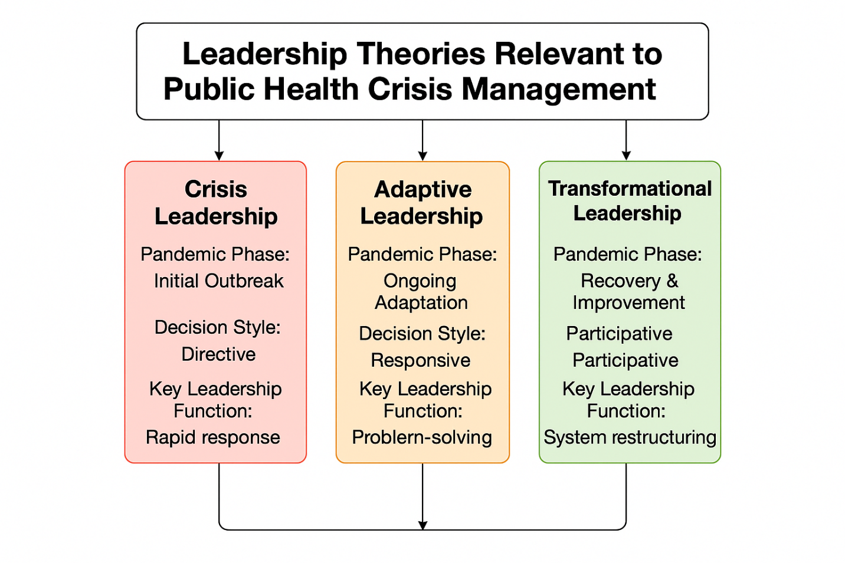
Figure 2: Leadership Theories Relevant to Public Health Crisis Management

3.2 Spain Leadership: Fragmentation, Crisis Recentralisation and Adaptive Learning
The political and health-care structure of Spain, which is highly decentralised, and political polarisation as it existed before the Covid-19 pandemic had a profound influence on the leadership that guided the country through the crisis. During the initial stages of the outbreak, national and regional governments underestimated the possible seriousness of the arising threat which led to the late interventions and ineffective communication. As a result, leadership reactions were more of a normal administrative governance than crisis leadership, which is characterised by little sense-making and inadequate foresight of the continuous case growth.
When the number of cases was growing and hospital systems were getting towards collapse, Spanish leadership was rapidly changing to a more centralised model of the crisis. The declaration of the national state of alarm allowed the central government to introduce the same lockdown measures, manage mobility, and centralise the acquisition of vital medical equipment. In the perspective of the crisis leadership theory, this shift has been decisive and able to mobilise authority quickly. However, this new centralisation was challenged by a number of autonomous communities, and thus this led to political conflict and gave rise to ambivalent views of the public.
The lack of communication also weakened leadership performance at the onset of the crisis. Conflicting messages by the leaders of the country and the regions, as well as the changing scientific recommendations, created confusion and a lack of trust in people. Crisis leadership theory highlights the significance of a continuous and open line of communication, especially in high uncertain situations. Fragile leadership narratives in Spain served as a challenge to compliance and facilitated the disparity in restrictions implementation between jurisdictions.
Even though these weaknesses were present at the beginning, Spanish leadership demonstrated adaptive learning as time passed, particularly at the vaccination stage. The leaders of the countries were more transformational in their framing, describing the process of vaccination as a communal civic duty and mobilising the acquisition at both European and national levels. The delivery was under the operational authority of the regional health authorities allowing a flexible implementation to be made depending on local circumstances. This combined model of strategic centre-led and decentralised implementation turned out to be effective and led to a high vaccination coverage and a rise in public confidence.
The Spanish case shows the two-sided risks and opportunities of leadership in the case of decentralised systems. In the absence of early coordination and shared accounts, decentralisation may actually make things worse, holding back decisive action. On the other hand, structural weaknesses can be partly offset by adaptive leadership which recognizes previous failures, re-establishes authority and restores trust. The experience of Spain has shown that crisis leadership in a decentralised setting will require coalition-building, role definition and initial coordination to reduce the necessity of disruptive recentralisation of the crisis in the future.

3.3 South Korean leadership: Technocratic Crisis Leadership, Transparency and Trust.
The reaction of South Korea to COVID-19 has been extensively referred to as a model of successful crisis management based on the expertise of technocrats, institutional readiness, and citizen confidence. The political leaders and senior public-health officials directly used the experience of the past infectious disease outbreaks, especially MERS, which revealed the lack of transparency and coordination. On that note, the leadership in the pandemic was focused on quick decision-making, evidence-based policy, and delegating the power to the experts in the field of public-health clearly.
The primary element of the leadership strategy in South Korea was the promotion of the public-health agencies to be authoritative voices. Technical experts were conducting daily briefings, which provided consistent and detailed information on the number of cases, the pathways of transmission, and policy justifications. This openness was similar to the transformational leadership philosophy, which involved the citizens as knowledgeable stakeholders and not subjects of instructions. A large degree of social trust made voluntary adherence to testing, isolation, and contact-tracing methods easier, thus minimizing the need to use force.
Adaptive leadership was also seen in the fact that South Korea is innovative and able to make changes to the policies within a short period. Instead of locking down the entire country, the leaders supported trial of new testing models, the use of digital contact tracing and targeted interventions. Flexibility in regulations allowed fast acceptance of diagnostic instruments and partnership with partners in the private sector. Such ability to adapt to uncertainty by having to solve problems quickly and recalibrate indicates adaptive leadership of focusing on constant problem solving.
The leadership style of South Korea was however not devoid of controversy. The widespread application of digital surveillance brought up moral issues of privacy and data security. The theory of crisis leadership recognizes that the emergency action usually consists of trade-offs between efficiency and civil liberties. Transparency, law predictability, and the feeling that surveillance was reasonable and short-lived assisted in publicizing these measures in South Korea. However, the impact of the long-term in the democratic governance is contentious.
In general, South Korea proves that centralised leadership can be highly effective in case it is technocratic, transparent, and has strong institutional capacity. Instead of coercive authority, legitimacy and leadership continued to be the major source of compliance. As demonstrated in this case, crisis leadership is successful when expertise is valued, communication is regular and adaptive learning is institutionalised.

3.4 Leadership in Canada: An Empathic approach, Federal Constrains and Coordination Problems
The federal structure of governance in Canada had a significant impact on the response to the COVID -19 pandemic as it significantly restricted the extent to which the country could exercise national control over intervention in the field of public health. On the federal level, the leaders preferred rather transformational and empathetic leadership style that emphasised solidarity, reassurance, and shared responsibility. Opposite to the situation, regularly planned public speeches placed the measures of social health as a social enterprise in protecting the vulnerable groups, which strengthens the social unity during uncertainties.
This kind of understanding attitude strengthened the trust people had on a national scale, particularly at the very beginning of the pandemic. Scientific advisors were consulted extensively by federal leaders and they were not afraid to express uncertainty thus complying with the principles of transparent crisis leadership. Public health restrictions were further augmented with economic support mechanisms, including income replacement schemes, to reduce the individual costs of compliance, which indirectly increased the effectiveness of leadership.
However, the decentralised federal structure limited the ability of the federal government to impose equal measures of public health. The provincial governments maintained high levels of autonomy and produced unequal lockdowns, school shutdowns and long-term care plans. On the leadership level, this disintegration made it more difficult to spread national messages and watered down the sense of a concerted action. Although federal transformational leadership might be able to create cooperation, it was not able to force compliance.
Interjurisdictional adaptive leadership was difficult. The forums of intergovernmental interaction did provide an information exchange, but they lacked binding authority to make the coordinated action of action at the critical juncture. Therefore, the leadership performance depended on the voluntary cooperation and political orientation between provinces. Different provincial leadership styles and priorities on politics at times weakened national targets thus helping to create disparate health results.
The case of Canada highlights the limitation of leadership without a structural authority. When coordination mechanisms are weak, empathy, transparency and trust-building is obligatory but inadequate. Successful leadership in times of crisis in federal systems requires the existence of pre-existing structures on joint decision-making, data standards, and clearly defined emergency powers. Without these provisions, even the best leadership that has good intentions will not easily translate vision into consistent action.

3.5 Comparative Leadership Analysis: Structure, Style and Effectiveness
Comparative analysis of Spain, South Korea and Canada shows that the effectiveness of leadership in the context of COVID-19 pandemic depended on the leadership style, as well as the congruence between leadership styles and the governance framework. South Korea is a good example of high alignment, whereby the centralised institutions supported a technocratic, adaptive mode that allowed the quick, consistent action. Misalignment on the other hand was evident in Spain during her formative years; decentralised organisation and fragmented leadership hindered action swiftly and finally led to disruptive recentralisation. Canada depicts the limitations of empathetic transformational leadership working in a highly decentralised federal system.
In all the cases, transparency, trust, and adaptability become the important leadership qualities. The improvement of compliance and system performance is associated with clear communication, the use of expertise, and changes in strategies with time. On the other hand, lack of consistency in communication and politicised leadership undermine legitimacy and reduce effectiveness.
The comparative analysis suggests that effective leadership during a pandemic requires not just effective personalities but also governmental structures that enable coordination, learning, and accountability. Structural design and leadership go hand in hand and when they are not aligned, even strong styles of leadership might not perform to the best.

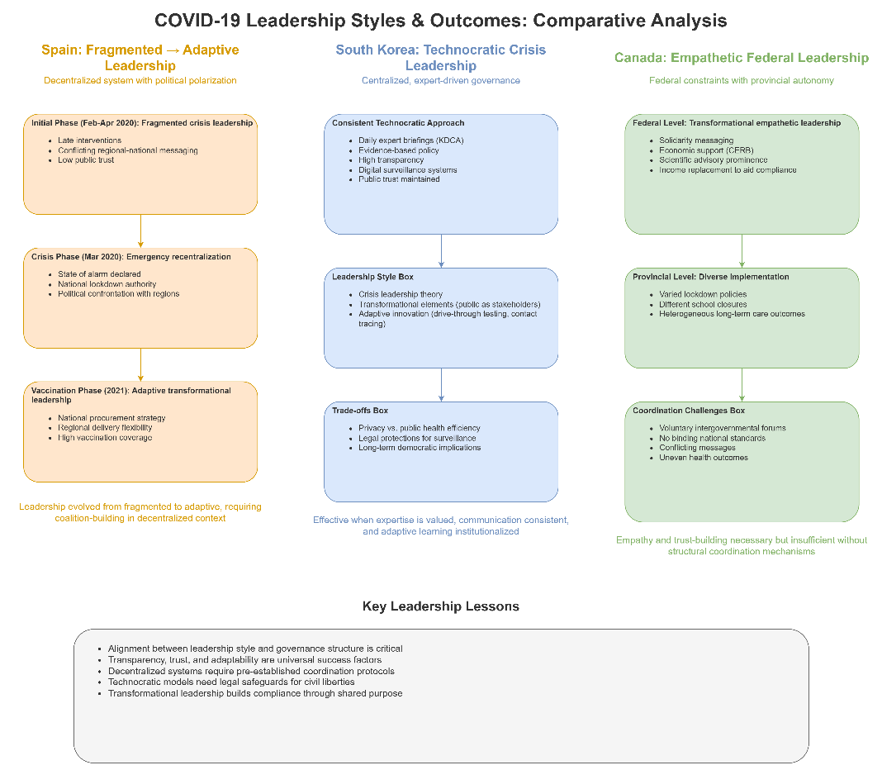
Figure 3: Comparative Leadership Styles and Their Evolution During COVID-19 in Spain, South Korea, and Canada

4. Conclusion
The COVID-19 pandemic demonstrated the existence of underlying strengths and weaknesses in the organisation and leadership of the health-care system in Spain, South Korea, and Canada. This comparative study reveals that neither centralisation nor decentralisation alone is a precursor of a pandemic success. Rather, the success of outcomes depends on the interaction of governance structures, leadership capacity, institutional preparedness and confidence of the populace. The centralised and technocratic system of South Korea enabled quick testing, proper contact tracing, and massive adherence to it, highlighting the value of institutional learning and open crisis leadership. Co-ordination and data-integration issues plagued the decentralised system of Spain, but, later on, it enjoyed the fruits of adaptive leadership and hybrid governance as the vaccination process commenced. The federal model in Canada provided local freedom and strong social-protection policies, but unequal provincial reactions and weak cohesive coordination mechanisms had unequal results. In each of the cases, good leadership of crises was exhibited through transparency, dependence on expert knowledge, flexibility to the changing evidence, and the capacity to maintain legitimacy in the long periods of disruption. The styles of transformational and adaptive leadership were especially relevant to ensuring compliance with people and dealing with uncertainty. These results indicate that sustainable pandemic preparedness requires mixed governance systems that combine national strategic capacity with decentralised operational delivery, supported by explicit coordination mechanisms and interoperable data systems. The additions of these factors will be necessary to equip health systems and leaders to respond to future outbreaks of disease between the population and the health sector more efficiently.

References
Allin, S., 2021. The federal government and Canada's COVID-19 responses. PubMed Central. Available at: https://pmc.ncbi.nlm.nih.gov/articles/PMC8326669/ (Accessed: 15 December 2025).
Ayuso-Mateos, J.L., 2021. Informing the response to COVID-19 in Spain. PubMed Central. Available at: https://www.ncbi.nlm.nih.gov/pmc/articles/PMC8193968/ (Accessed: 15 December 2025).
BMJ / Haldane commentary., 2021. From response to transformation: how countries can build back better after COVID-19 (BMJ). Available at: https://www.bmj.com/content/375/bmj-2021-067507 (Accessed: 15 December 2025).
Boin, A. and Lodge, M., 2016 (widely used for crisis leadership theory). Designing resilient institutions for transboundary crisis management: A time for public administration (LSE eprint / full PDF). Available at: https://eprints.lse.ac.uk/67652/1/Designing%20resilient%20institutions_author.pdf (Accessed: 15 December 2025).
Bozorgmehr, K., 2022. Resilience of health systems: understanding uncertainty and complexity after COVID-19. PubMed Central. Available at: https://pmc.ncbi.nlm.nih.gov/articles/PMC9808231/ (Accessed: 15 December 2025). PMC
Chung, J. / contact-tracing evidence., 2020. Contact transmission & use of credit-card / mobile logs in South Korea (case studies). PubMed Central. Available at: https://pmc.ncbi.nlm.nih.gov/articles/PMC7045882/ (Accessed: 15 December 2025).
Debie, A., 2024. Building a resilient health system for universal health coverage: a systematic review. PubMed Central. Available at: https://pmc.ncbi.nlm.nih.gov/articles/PMC10765832/ (Accessed: 15 December 2025).
European Observatory on Health Systems & Policies., 2022. COVID-19 Health System Response Monitor (full country pages & downloadable reports). Available at: https://pmc.ncbi.nlm.nih.gov/articles/PMC10765832/ (Accessed: 15 December 2025).
García-Basteiro, A.L., Alvarez-Dardet, C. and Montalvo, J.G., 2020. Evaluation of the COVID-19 response in Spain: principles and requirements. European PMC (Lancet Public Health commentary). Available at: https://www.thelancet.com/journals/lanpub/article/PIIS2468-2667(20)30208-5/fulltext (Accessed: 15 December 2025).
Garcia-Carretero, R., 2023. Hospitalization burden and epidemiology of the COVID-19 pandemic in Spain. PubMed Central. Available at: https://pmc.ncbi.nlm.nih.gov/articles/PMC10353154/ (Accessed: 15 December 2025).
Guisado-Clavero, M., 2023. Open data for monitoring COVID-19 in Spain: descriptive study. PubMed Central. Available at: https://pmc.ncbi.nlm.nih.gov/articles/PMC10073586/ (Accessed: 15 December 2025).
Haldane, V. et al., 2021. Health systems resilience in managing the COVID-19 pandemic: lessons from 28 countries. Nature Medicine / PubMed Central summary & commentary. Available at: https://www.nature.com/articles/s41591-021-01381-y (Accessed: 15 December 2025).
Hansen, G., 2020. Canada’s decentralized “human-driven” approach during the first 100 cases. PubMed Central. Available at: https://pmc.ncbi.nlm.nih.gov/articles/PMC7759506/ (Accessed: 15 December 2025).
ICNL / Korea pandemic report., 2024. The collaboration dynamics of government and civil society during Korea’s pandemic response (full PDF). Available at: https://www.icnl.org/wp-content/uploads/2024-Korea-Pandemic-Report-vf.pdf (Accessed: 15 December 2025).
Juneau, C.-E. et al., 2023. Effective contact tracing for COVID-19: a systematic review (includes Korea examples). PubMed Central. Available at: https://pmc.ncbi.nlm.nih.gov/articles/PMC9442269/ (Accessed: 15 December 2025).
Juneau, C.-E., et al., 2021. Governance, trust and leadership in pandemic responses — review & evidence synthesis (open access review). PubMed Central. Available at: https://pmc.ncbi.nlm.nih.gov/articles/PMC9997056/ (Accessed: 15 December 2025).
Lee, S., 2021. COVID-19 responses of South Korea as hybrids of different governance modes. PubMed Central. Available at: https://pmc.ncbi.nlm.nih.gov/articles/PMC8484902/ (Accessed: 15 December 2025).
Lim, S., 2022. Lessons from South Korea’s strategy for COVID-19 and implications for future pandemic preparedness. PubMed Central. Available at: https://www.ncbi.nlm.nih.gov/articles/PMC9442269/ (Accessed: 15 December 2025). PMC
Migone, A.R., 2021. Federalism’s impact on the Canadian COVID-19 response. PubMed Central. Available at: https://pmc.ncbi.nlm.nih.gov/articles/PMC8754695/ (Accessed: 15 December 2025).
Moon, M.J., 2020. Fighting COVID-19 with agility, transparency and participation: wicked policy problems and new governance challenges. Public Administration Review (full text at PMC). Available at: https://pmc.ncbi.nlm.nih.gov/articles/PMC7267241/ (Accessed: 15 December 2025). PMC
OECD., 2023. Ready for the next crisis? Investing in health system resilience (full PDF). Paris: OECD Publishing. Available at: https://www.oecd.org/content/dam/oecd/en/publications/reports/2023/02/ready-for-the-next-crisis-investing-in-health-system-resilience_a8424ec8/1e53cf80-en.pdf (Accessed: 15 December 2025).
PHAC / Asia Pacific / Digital innovations review., 2021. Digital innovations for pandemic response in Korea and other Asia-Pacific jurisdictions (full report / PDF). Available at: https://www.asiapacific.ca/sites/default/files/inline-files/PHAC-Paper2_MARCH.pdf (Accessed: 15 December 2025).
Public Health Agency of Canada (PHAC)., 2023. COVID-19 epidemiology update / data (full reports and archived PDF dashboards). Available at: https://health-infobase.canada.ca/covid-19/ (Accessed: 15 December 2025).
Public Health Agency of Canada., 2024. Public Health Agency of Canada – COVID-19 response: lessons learned (summary / reports). Government of Canada. Available at: https://www.canada.ca/en/public-health/corporate/transparency/corporate-management-reporting/evaluation/covid-19-response-lessons-learned-summary.html (Accessed: 15 December 2025).
Royo, S., 2020. Responding to COVID-19: The case of Spain. International Journal of Public Administration. Available at: https://www.ncbi.nlm.nih.gov/pmc/articles/PMC7753436/ (Accessed: 15 December 2025).
Ryu, S., 2021. Korea’s early COVID-19 response: findings and implications. PubMed Central. Available at: https://pmc.ncbi.nlm.nih.gov/articles/PMC8394839/ (Accessed: 15 December 2025).
Sachs, J.D. et al. (Lancet COVID-19 Commission)., 2022. The Lancet Commission on lessons for the future from the COVID-19 pandemic (full Commission report / article). The Lancet. Available at: https://www.thelancet.com/journals/lancet/article/PIIS0140-6736(22)01585-9/fulltext (Accessed: 15 December 2025).
WHO., 2021. Building health systems resilience for universal health coverage and health security (WHO position paper). Available at: https://www.who.int/publications/i/item/WHO-UHL-PHC-SP-2021.01 (Accessed: 15 December 2025).
WHO., 2023. Strengthening health emergency prevention, preparedness, response and resilience (WHA report / PDF). Available at: https://cdn.who.int/media/docs/default-source/emergency-preparedness/who_hepr_wha2023-21051248b.pdf (Accessed: 15 December 2025).
World Bank., 2024. Hospitals in health systems: lessons from COVID-era and health system resilience (full PDF / World Bank study). Available at: https://documents1.worldbank.org/curated/en/099052424144516229/pdf/P178777-c10d8b81-1b92-44e4-b9f9-6191e741fd65.pdf (Accessed: 15 December 2025).

