
Having Your Voice Heard.  It is important that your views, wishes, needs and wants are considered by all adults who represent you. From your social worker to your foster carers, you have the right to be heard and to be involved in decisions being made about you.  Advocacy can help! Your advocate is there to listen, to believe and support you, and most importantly help you be heard by those who it may seem are not listening.  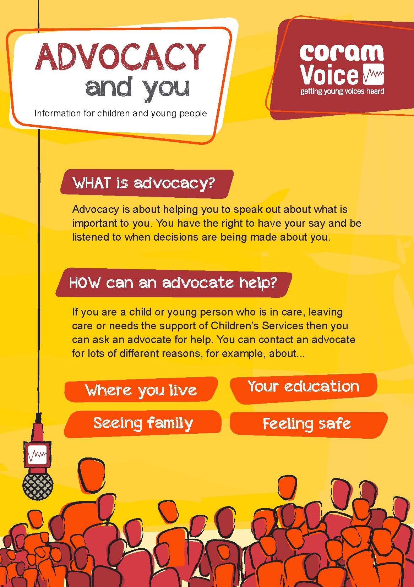 | Who Can Help?  Mind: www.mind.org.uk  0300 123 3393  ___  Advocacy Services: www.coramvoice.org.uk  0808 800 5792  ___  Samaritans: www.samaritans.org  116 123  ___  Your Social Worker  ……………………………………………….  Your Advocate:  …………………………………………………. |   Being Looked After……. What can YOU Do?  Who Can I Trust?  Why am I Here?  Why am I Here?
(Image two)  ‘You Have the Right to Give Your Opinion and For Adults to Listen and Take It Seriously.’ (UNCRC Article 12)  . |  | Make Sure You Are Heard! (Image one)

Your Mental Health.  Mental health can be affected by many different things and cause a variety of different thoughts and feelings.  Feeling anxious or depressed, overwhelmed, nervous and not listened to can all effect your mental health. But you are not alone, and these feelings are very common.  In a new environment it is easy for these feelings and thoughts to take over and feel like you are alone.  Looking after your mental health and wellbeing is incredibly important, try the steps below to help take care of your mental health and wellbeing.  (Image three)  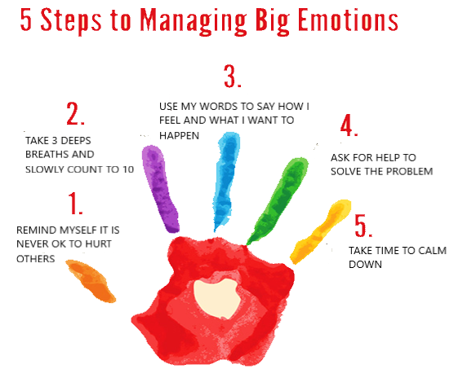 | Looking After YOU!  Connect  - Speak to someone new  - Ask how someone’s weekend was and really listen when they tell you  - Put five minutes aside to find out how someone really is  Be active  - Go for a walk  - Get off the bus one stop earlier than usual and walk the final part of your journey to home  - Have a kick-about in a local park  - Do some easy exercise  Take notice  - Have a ‘clear the clutter’ day  - Take notice of how people are feeling or acting  Learn  - Find out something about those around you  - Read the news or a book  - Research something you’ve always wondered about  - Learn a new word.  Give  Promoting happiness has shown that committing an act of kindness once a week can increase in wellbeing. (CPSL Mind, 2017) | Wellbeing explained  One of the most important steps in having good wellbeing is to accept yourself. If you value yourself, you are more likely to have good relationships with other people and find it easier to cope with difficult times in your life.  • Try not to compare yourself to others.  • Realise your positive qualities and things you are good at.  • Learn to identify and challenge unhelpful thinking patterns.  • Spend time with supportive people.  • Listen to others, and make sure you are listened to. ( CPSL Mind, 2017)  • Take part in hobbies that you enjoy. (Mind, N.D)  (image four)

