Community Engagement
Report- You are required to produce a needs analysis or community profile on an identified group or geographical location. You will need to outline and identify potential issues or gaps in current service provision that may be detrimental to the group/location identified. You should make use or relevant data and statistics as well as other means of information gathering within your report. Reflections on personal experiences gained within community settings may also be used as a foundation for your analyses.
P141917

This needs analysis report will look at a major current societal issue which face people in Wales, in particular children and young people will be focussed upon. Mental health problems in people of all ages are increasing and more people are needing treatment and support. Wales currently has the second highest suicide rate in the UK for both men and women, despite of the increasing amount of funding which is used on it each year (Samaritans, 2017).
Welsh demographic
The Welsh population is estimated at around 3 million, this has remained consistent over many years. The population here is considerably lower than neighbouring England, which in 2016 reached its peak with 55,268,100 people on estimate (ONS, 2016).
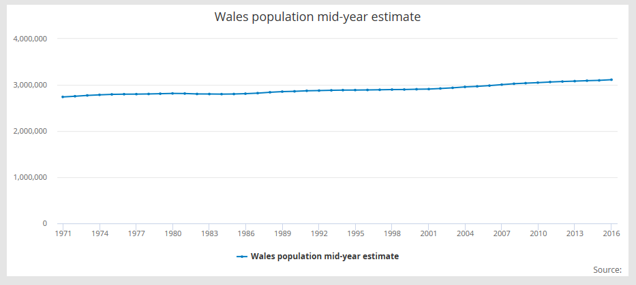
Chart 1: Wales Population mid-year estimate 2016 (ONS, 2016)

Although the population has remained fairly similar in Wales, we see a large difference when we look at age ranges across the country as seen in the graph below.
Chart 2: Wales Population by age (StatsWales, 2016)
Of the population of people who are aged between 0-15 years, the majority are educated in Local Authority maintained schools. Just over 72,000 children aged under 5 years are educated in schools as of 2017. As well as this, the number of children educated in schools between the ages of 5-10 years has increased to 210,437. Another increase seen is in the age range of 11-15, or comprehensive school range. This age range increased by over 1000 pupils in one year (2016 to 2017), to see 158,212 young adults being educated in schools across Wales (Welsh Government, 2017).
As can be seen in Chart 2, the largest age group of people in Wales is 16-64 years which is estimated at almost 2 million people. According to the Welsh Government (2017), the rate of which people in the group are employed stood at 72.8% in 2017, which is lower than the UK average of 75.1%. This resulted in a 23.6% economic inactivity rate and 4.7% unemployment rate in Wales, as of October 2017.
Mental Health Issues
According to the Welsh Government (2015) there have been many positive trends noted over the last 10 years in regard to children and young people’s well-being. These included infant mortality rates dropping, teenage conception rate decreasing by 21 per 100,000, as well as the number of children living in relative poverty reduced. Also, engagement in learning and education has shown positive outcomes, which may have resulted in the decrease in amount of school days missed by primary and secondary students. Despite of these positive trends, there has been one trend in particular which has caused concern. This is that hospital admission rates for young people aged 10 to 17, as a result of self-harm has almost doubled in the last few years (Welsh Government, 2015).
It’s not just the children and young adults of Wales who are showing more signs of mental health issues, there has been a rise in people of all ages experiencing mental health issues across the UK. These charts (Chart 3,4 &5) show the extent of the increasing problem which faces 1 in 4 people in the UK (Counselling Directory, 2016).
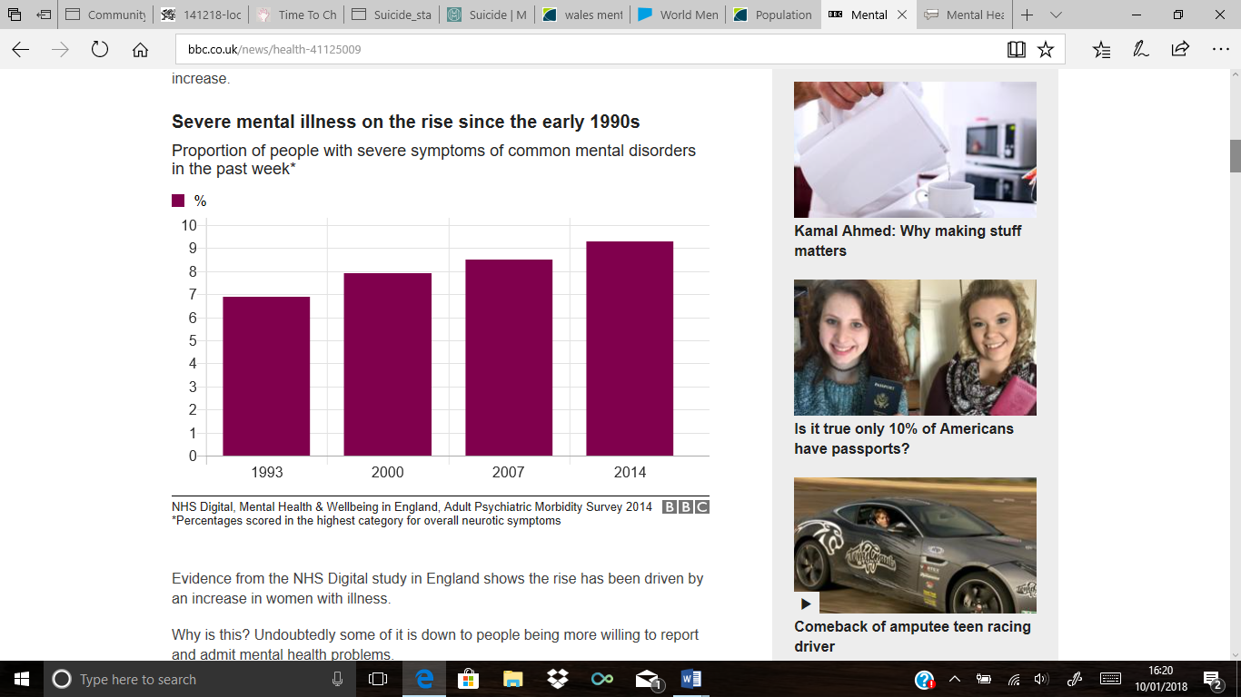
Severe Mental illness on the rise since the early 1990’s
Chart 3: Rising percentage of people with mental illness in the UK (BBC, 2017)

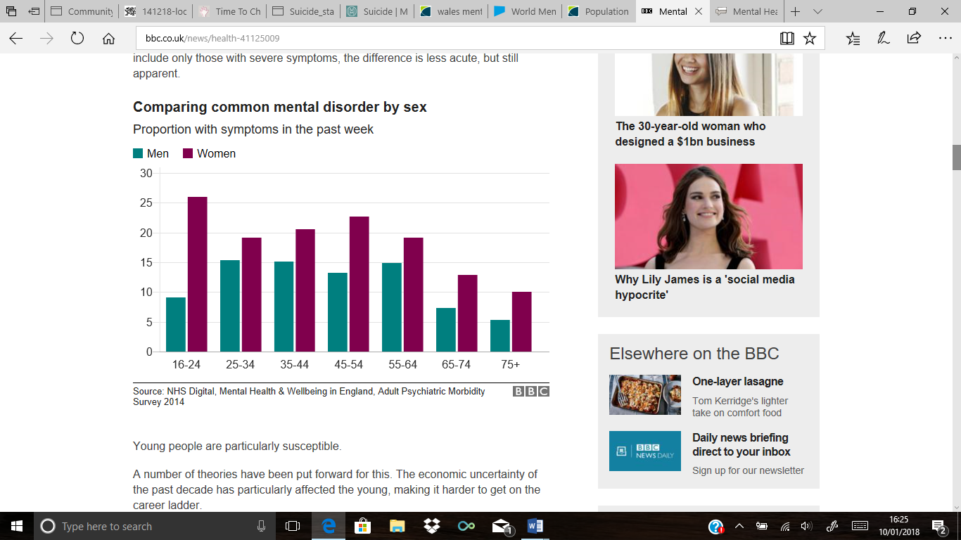
Comparing common mental disorder by sex
Chart 4: Comparisons between men and women with common mental disorder (BBC, 2017)
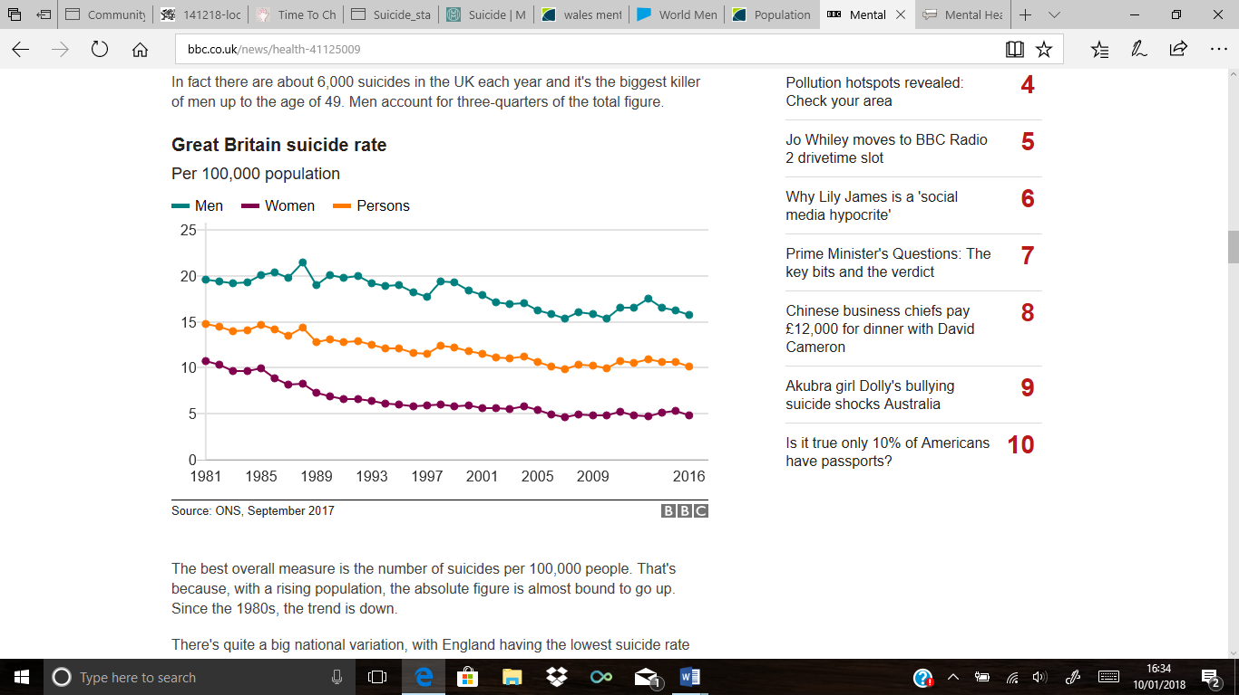
Great Britain suicide rate
Chart 5: Suicide rate since 1981 (BBC, 2017)

From Chart 3 we are able to see the increase in mental illness since 1993 to 2014, but this did not stop there. Kirk (2017) states that the issue is continually getting worse as millions of anti-depressants were prescribed, an increasing number of patients claim they are having suicidal thoughts, and more people are battling with Post Traumatic Stress Disorder (PTSD) and phobias than ever before.
In Chart 4, it is clear to see that more women of every age range are admitting they struggle with common mental illnesses, but from Chart 5 we can see that more men commit suicide every year. This is said to be because typically women feel more able to speak to someone, or see a doctor (BBC, 2017). According to Brown (2017) males account for three-quarters of the overall UK suicide rate, and the main reason for this is the stigma which is attached to mental health and being a man.
Similar results to the charts above were found when looking specifically at Wales. As can be seen in Chart 6, women at all age rangers were more likely than men to admit being treated for any mental health issue.
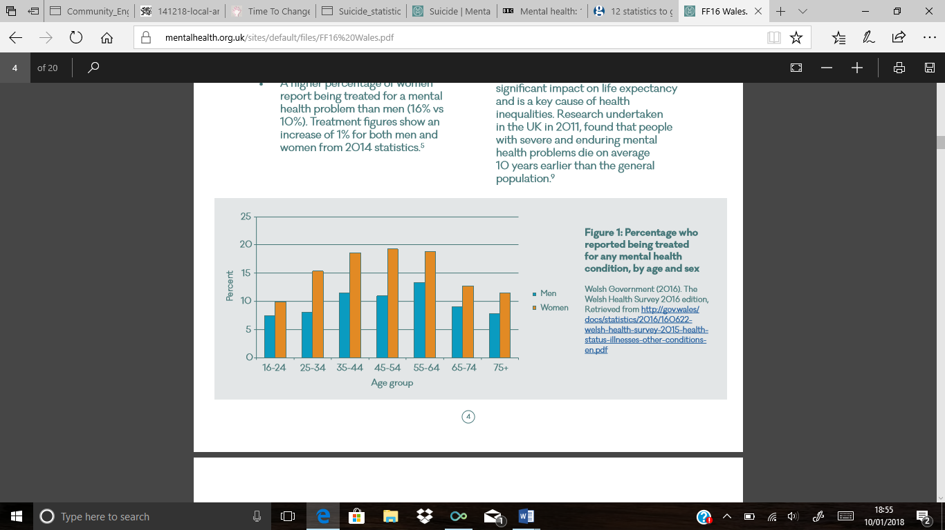
Chart 6: Reports of treatment for mental health conditions in Wales.
(Mental Health Foundation, 2016)

According to Mental Health Foundation (2016) in Wales 13% of people have experienced some sort of mental health condition, this has raised 1% from the previous year. Despite of the amount of people battling mental health issues, only a quarter are receiving on going treatment or support even though £600m is invested in these services a year in Wales.
Despite of how common mental health conditions are in Wales, many people still are unaware of what they include or how they work. A recent survey of public attitudes on mental health in Wales found that:
- 1 in 10 people in Wales believe that if you have mental illness, then you are never able to recover.
- 1 in 12 people believe that if a person shows any signs of mental illness then they should be hospitalized immediately.
- 1 in 20 people believe that if a person has mental health issues then they should not be allowed to consider having children.
- 1 in 10 Welsh people state that people with mental health issues are less trustworthy than those without.
- 1 in 20 people believe that an individual with mental health conditions should not be given any responsibility.
- 10% of people admitted that they would feel uncomfortable around a person who was a mental illness.
(Time to Change Wales, 2017)
The points provided give evidence to the statement that the biggest issue facing people with mental health conditions in Wales is the stigma attached to it. The stigma stems from people’s negative attitudes towards those with mental health conditions, which often lead to a wide range of other issues for the person. Time to Change Wales (2017) states that this can affect people by making them feel discriminated against and isolated, people find it harder to get or stay in a job, stops people feeling able to seek help, as well as also affecting a person’s physical health.

Mental health issues in young people
As a result of the increasing number of young people experiencing mental health conditions, there is an urge for action in Wales. Welsh Police have put forward their views on the matter in a recent article by the BBC (2018), they state that there is a need for children and young people to be educated on their own and other mental health, teachers and adults who work with these young people should also be aware of the signs in order to protect those they work with (BBC, 2018). Educating about mental health from a young age is vitally important as Chart 7 shows how prominent these issues are in children as young as five.
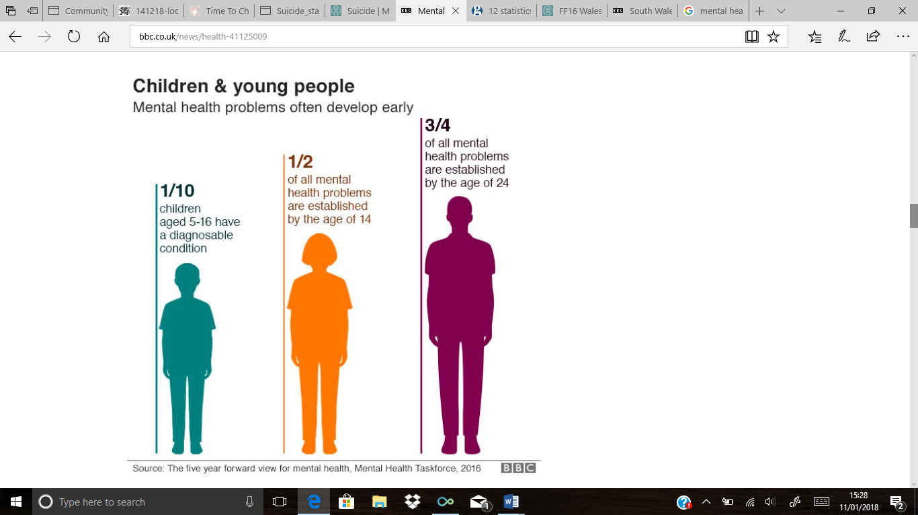

Chart 7: Mental Health problems in children and young people (BBC,2017)

Although, Chart 7 mentions that 1 in 10 children and young people have a diagnosable mental health condition, Children in Wales (2017) states that 70% of these children will not receive the appropriate interventions and care that is needed. The most common forms of mental health conditions which effect children and young adults is depression, anxiety and conduct disorder (Children in Wales, 2017). In 2015, Wales saw 350 per 100,000 people commit suicide, the suicide rate in Wales is the second highest in the UK, despite of the population differences (Samaritans, 2017). This figure is almost guaranteed to increase by the end of 2018, as we see an increasing number of children receiving suicide counselling according to Deacon (2016). A total of 614 calls and messages were received by Childline in 2016, from children in Wales who are concerned about their mental health, this amounts to 12 attempts of contact a week (Deacon, 2016).

Mental health issues links to poverty
According to the Mental Health Foundation (2016) in Wales there is poorer mental health in areas which are deprived. A survey found that in the least deprived areas of Wales 8% of people reported being treated for mental health conditions, where as in the most deprived areas there was just over 20% of people being treated for mental ill health. Another study suggests that when looking at people from Wales, England and Scotland if they had debt then they were more likely to suffer with some form of mental health condition than those without (Mental Health Foundation, 2016).
Current Provision for mental health in Wales
The NHS and social services currently hold the most power when delivering mental health services to the people of Wales, but more recently we are seeing charities and organisations setting up their own strategies to support the people with mental health issues in Wales (Mental Health Wales, 2016). Policies have been introduced by the Welsh Government in order to improve mental health provision. The most well-known government policy is ‘Together for Mental Health’, which aims to ensure that treatment and support is provided for all who are experiencing mental health problems and their families. This policy has three sections, which set out actions for the providers in Wales to aim to meet (Welsh Government, 2016).
Another type of provision comes from ‘Mind’, an organisation with over 20 bases in Wales, who work alongside policy makers to make changes to how mental health support is provided. Mind (2013. Para 1) state that they are ‘an unstoppable community of people in Wales who won’t give up until everyone experiencing a mental health problem gets the support and respect they deserve’. Mind provide support to individuals via internet, phone and support networks. They also provide help for people in regard to legal action if it is linked to mental health, as well as campaigning and protesting for the rights of the people with mental health problems (Mind, 2013). Despite of these and many more types of provision that are in place in Wales, from this report we can see that the mental health rate is still increasing which suggests that more is needed.
Summary
To summarise, this needs analysis has provided the reader with an overview of the demographics of Wales, as well as giving evidence to suggest that there is a major societal issue when looking at mental health, not just in Wales but the UK. Comparisons between men and women who have experienced mental health issues, and suicide rate were shown. Also, mental health issues in children and young people was also discussed and facts given, along with the link between mental health issues and poverty being noted. Lastly, examples of the current provision in Wales regarding mental health were talked about, along with their aims and what they do. I believe this needs analysis has proved that mental health is one of the biggest issues facing Welsh society today, despite of the attempts to provide, the issue is increasing.

Reference List
BBC (2017) Mental Health: 10 Charts on the scale of the problem. http://www.bbc.co.uk/news/health-41125009 Date Accessed: 12th December 2017
BBC (2018) South Wales Police want mental health lessons for young people. http://www.bbc.co.uk/news/uk-wales-42622297 Date Accessed: 10th January 2018
Children in Wales (2017) Mental Health and Well Being in children and young people. http://www.childreninwales.org.uk/item/mental-health-wellbeing-children-young-people/ Date Accessed: 22nd December 2017
Counselling Directory (2016) Facts & Figures. http://www.counselling-directory.org.uk/stats.html Date Accessed: 12th December 2017
Deacon, T (2016) More than 600 children in Wales received suicide counselling sessions. http://www.walesonline.co.uk/news/wales-news/more-600-children-wales-received-11857466 Date Accessed: 12th
Kirk, A (2017) The charts that show the UK is in the midst of a mental health awakening. http://www.telegraph.co.uk/health-fitness/mind/world-mental-health-day-charts-show-uk-midst-mental-health-awakening/ Date Accessed: 12th December 2017
Mental Health Foundation (2016) Mental Health in Wales: Fundamental Facts 2016. https://www.mentalhealth.org.uk/sites/default/files/FF16%20Wales.pdf Date Accessed: 12th December 2017
Mental Health Foundation (2016) Poverty and Mental Health. file:///C:/Users/Owner/AppData/Local/Packages/Microsoft.MicrosoftEdge_8wekyb3d8bbwe/TempState/Downloads/Poverty%20and%20Mental%20Health%20(1).pdf Date Accessed: 22nd December 2017
Mental Health Wales (2016) The NHS and Social Services in Wales. http://www.mentalhealthwales.net/the-nhs-and-social-services-in-wales/ Date Accessed: 2nd January 2018
Mind (2013) Mind Cymru. https://www.mind.org.uk/about-us/mind-cymru/ Date Accessed: 22nd December 2017
Office for National Statistics (2016) Wales population mid-year estimate. https://www.ons.gov.uk/peoplepopulationandcommunity/populationandmigration/populationestimates Date Accessed: 8th January 2018
Samaritans (2017) Suicide statistics report 2017. https://www.samaritans.org/sites/default/files/kcfinder/files/Suicide_statistics_report_2017_Final.pdf Date Accessed: 12th December 2017
StatsWales (2016) National level population estimates by year, age and UK country. https://statswales.gov.wales/Catalogue/Population-and-Migration/Population/Estimates/nationallevelpopulationestimates-by-year-age-ukcountry Date Accessed: 8th January 2018
Time to Change Wales (2017) Mental Health & Stigma. http://www.timetochangewales.org.uk/en/mental-health-stigma/intro/ Date Accessed: 22nd December 2017
Welsh Governement (2016) Together for Mental Health. http://gov.wales/topics/health/nhswales/plans/mental-health/?lang=en Date Accessed: 22nd December 2017
Welsh Government (2015) Children and Young people well-being monitor for Wales 2015. http://gov.wales/docs/caecd/research/2015/151211-children-young-people-wellbeing-monitor-2015-summary-en.pdf Date Accessed: 2nd January 2018
Welsh Government (2017) Key economic statistics. http://gov.wales/statistics-and-research/key-economic-statistics/?lang=en Date Accessed: 8th January 2018
Welsh Government (2017) Schools’ census results. http://gov.wales/statistics-and-research/schools-census/?lang=en Date Accessed 8th January 2018

