Apply the principles and practices of Data security, Governance and Compliance based on a given scenario

Yohannes Zerzghi, Computer Networks and Cyber Security; Module: Data security, Governance, and compliance
Lecturer: Dr Carlene Campbell
Abstract— Today, information data is an essential asset to many businesses around the world. However, its impact can be disastrous if it is not secured and protected from threats appropriately. Therefore, it is important to practice or follow some information security standards to provide confidentiality, integrity, and availability of the data. This paper compares and analyse the most common infosec standards namely ITIL, COBIT, and ISO. Also, it studies the most popular security models such as Biba, Bell-LaPadulla, and Clark-Wilson. Besides, a complete information security system was designed and developed based on the ISO 27001 standard, with a Caribbean shop company’s scenario.
Keywords: ISO 27000; ITIL; COBIT; NIST; CSI; MAC; DAC; BLP; CW

Introduction
At present, Information technology (IT) is becoming a daily part of many individuals and business companies. However, those businesses and organisations dependent on IT can be vulnerable to security and privacy threats due to weak IT governance policies and a lack of robust security controls. Security issues can emerge from inside or outside an organisation. But enterprises can practice following infosec security frameworks and standards to provide and secure data protection.
The security framework is a collection of policies, methods, processes, techniques, and documents used to identify and manage information in a company. It can be applied to minimise risks and vulnerabilities and to strengthen trust between customers and businesses. According to survey paper in [1] , 84% of US organisations have practised security frameworks to combat cyber-related attacks.
This paper intends to provide detailed research on the most common and prominent security frameworks and models. It explains the fundamental concepts of ITIL, ISO 27001, and COBIT standards, and it evaluates and examines those frameworks. Also, it discusses the most popular security models, including Bell-LaPadula, Biba, and Clark-Wilson. Besides, it provides the implementation of information system security employing ISO 27001 standard, with a Caribbean coffee shop company’s scenario. Finally, it contains the conclusion of the work.

LITERATURE REVIEW

Infosec security frameworks and models [1] [2]
In today’s world, many organisations and business companies depend on IT to provide and facilitate services. Therefore, IT services is important for the success of the businesses. However, information security is the main concern in today’s fast-growing technology, particularly in a technically vulnerable working environment. Hence, a secure communication platform is required to provide data integrity, confidentiality and availability for both individuals and companies across the internet. But how can organisations provide and assure data protection? To achieve this, organisations can follow and practice various information security frameworks and models such as IT Infrastructure Library (ITIL), ISO 27000 series, National Institute of Standards and Technology (NIST) and so forth. Also, there are several standard security models such as Bell-LaPadula, Biba, and Clark-Wilson [3] [4].
This section discusses the most common infosec security frameworks and models.

ITIL
ITIL is a framework which was first released in 1980 by the British government’s Central Computer Telecommunication Agency (CCTA) [1]. It is a library of books that describes a structure of implementing the best procedure to develop and manage IT infrastructure. Thus, the ITIL collection has been revised and printed several times in its history. Its current version is ITIL v4 which was developed based on the ITIL v3 concepts [5].
ITIL is a collection of guidelines which helps organisations to deliver the best service. It comprises various elements including people, processes, products and use of partners. This architecture is designed to be a versatile guide in accordance to the organisations needs and infrastructure. Thus, it enables IT practitioners to select the right components and customise them appropriately. The ITIL v3 which was released in 2007 contains five books. This version adopts five phase of service lifecycle containing service strategy, service design, service transition, service operations and continual service improvement [6] [7]. Figure 1 illustrates the service lifecycle of ITIL architecture.
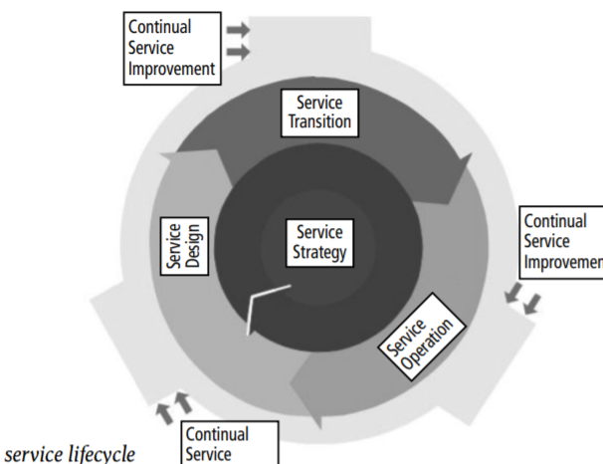
Figure 1: ITIL v3 service lifecycle [6].
- Service strategy [8]- is the main component in the ITIL framework, and it focuses on delivering a policy or plan for the service lifecycle in a manner that is applicable to the organisation structure and business needs. Also, it includes several key processes, namely financial management, service portfolio management, demand management and strategy operations.
- Service Design – the objective of this phase is to design a suitable IT services that includes processes, people, products, and partners [9].
- Service Transition- is the transitional stage where IT service packages are deployed into production use. At this stage, design packages from the service design phase are tested and rolled out into operation. It also defines change management, configuration items and documentation [9].
- Service Operations [5]- monitors and manages the services and ensures the requirements that are expected by the customers. It constantly supervises the overall conditions of the services which are provided to clients and business partners. This involves fixing and finding the cause of problems, help desk and incident management. It also monitors the health and performance of the various services such as applications, infrastructure and technology that are helpful to the successful delivery of the services.
- Continual Service Improvement (CSI) [7]- it deals on the improvement of services by identifying and applying methods to adapt to the changing business environments.
In a nutshell, ITIL is a public framework which can be used as a guideline to many organisations. Its main purpose is to help IT practitioners and business managers to provide services to clients in efficient way. Thus, it improves client confidence and satisfaction. This framework is developed to be vendor-neutral and non-prescriptive [10].
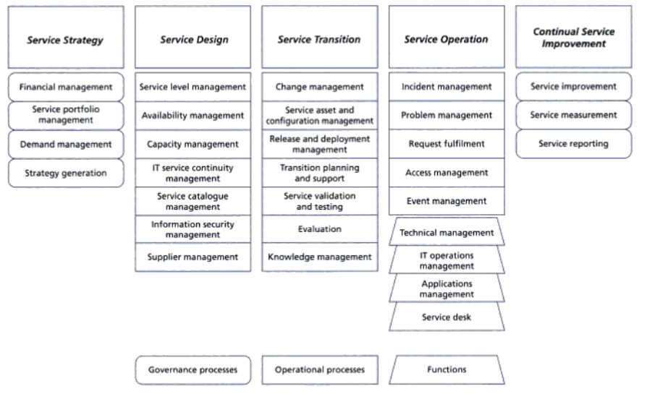
Figure 2: ITIL processes and functions [7].

ISO 27000
ISO is a well-recognised framework that can be used to deploy the best approach security management system. It covers a range of security information guidance that helps organisations to construct an extensive information security management system (ISMS). This model is made up of series ISO family standards that are helpful to implement the best methods of information security based on the requirements [11, 12].
ISO framework provides a detailed method to mitigate risks which covers people, processes, and technology. It is organised in a collection of 46 individual standards. Thus, organisations can choose to apply any of these ISO series standards that are relevant to their infrastructure. For example, figure 3 below shows the various elements of ISO 27001 framework. However, some of them are indispensable such as ISO 27001 [13].
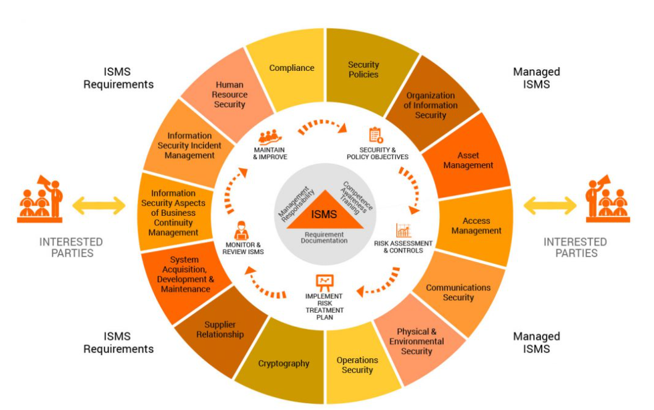
Figure 3: ISO/SEC 27001 framework [14].
The ISO 27001 is designed to be suitable for all types of organisation sizes. It is an essential element in the ISO family. Also, it is the only ISO standard that includes certification. However, it is not a mandatory certification process [15]. This framework contains a list of requirements for implementing an organisation’s ISMS. It enables organisations to provide evidence that they comply with the requirements of protecting valuable and confidential information. Hence, it can be used, as a blueprint to implement a security-related system that satisfies data confidentiality, integrity, and availability. This can be achieved by using different technologies, tests, and auditing processes. Also, it identifies the possible difficulties that could occur to the information using risk assessment, and it provides techniques on how to prevent such challenges using various risk remediation approaches such as staff awareness [16, 17]. Figure 3 below shows risk assessment methodology using ISO 27001 standard.
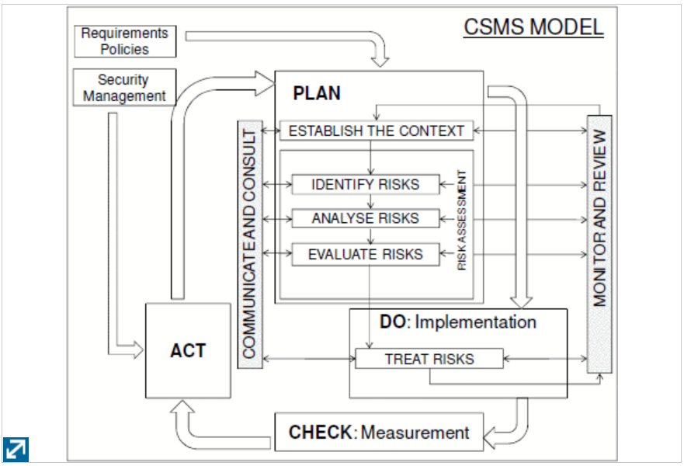
Figure 4: Risk assessment approach using ISO 27001 [18].
In summary, the ensuing of ISO 27000 family standards can be a boon for businesses. The ISO certification can bring confidence and trust to customers that their personal information is protected. In addition, it provides flexibility for companies to work across international borders. Consequently, companies can maximise their profit and sales. Furthermore, implementing ISO standard can provide many benefits for businesses such as reliability, improve performance, better quality service, reduce risks, sustainability and innovation [19, 20].

COBIT Framework
Control Objective for Information and related Technology (COBIT), is a framework that contains a collection of guidelines for applying information technology governance. It is a tool developed by the ISACA (Information Systems Audit and Control Association) to support IT management and leadership. COBIT focuses on IT management that is designed to assist and control companies demands. It enables IT experts, corporate executives, and auditors to communicate with each other to close the gap between business goals, objectives and IT controls [21]. COBIT model has been in periodic updates since its first release in 1996 to achieve the current IT governance. Its latest version is COBIT 5 which was released in 2012. This tool integrates standards from various frameworks including ISO and ITIL. It provides a detailed instruction that helps business companies to organise and manage of the enterprise IT. In other words, it enables organisations to benefit from IT by providing various techniques such as maximising utilization of resources and reducing risks. COBIT 5 is a public tool that can be applicable for businesses of all sizes [22].
COBIT 5 is a blueprint that is based on five essential principles for managing and administrating of an organisation IT. The five key principles can be shown in figure 5 below. The framework also includes seven key areas to create a complete system for the management and administration of IT to assist the five principles. The image in figure 6 illustrates the seven key areas of COBIT 5 framework [23, 24].
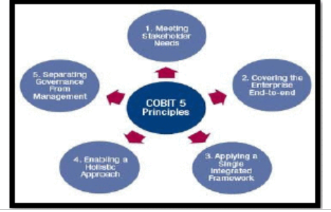
Figure 5: Five key principles of COBIT 5 [23].
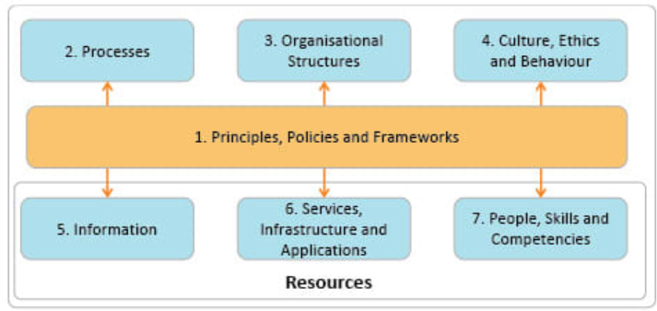
Figure 6: The seven enablers of COBIT 5 [24].
In conclusion, COBIT can be applied for companies of all sizes. It can be used to improve business performance and services. Also, it enables organisations to utilise IT efficiently in order to accomplish business objectives. In addition, it can be used as a reliable process to mitigate risks. Furthermore, it helps business companies to comply with industry standards [25].

Comparison between ITIL, ISO 27001 and COBIT 5
From the above research, all the three frameworks provide different approaches in guidance, recommendations, and practices. Each framework has its own emphasis; however, they can be used in jointly. For example, ISO 27001 focuses on information security standards, while COBIT 5 concentrates on audit, assurance, and governance of an organisation’s IT systems. Also, all the three standards are designed to cover on specific areas of fields and aims. Therefore, it is a good practice to choose standards that are applicable to your organisation needs and infrastructures. It is also an advantage to utilise the latest or updated version of a framework that includes the current technology such as cloud computing. This can improve the production and services of an enterprise. Besides, a combination of any these frameworks can be useful for a company’s objectives. Table 1 below shows the comparisons between the three frameworks.
Table 1: comparison between the three standards [26].
 | ITIL | ISO 27001 | COBIT 5
Focus | Concentrates on service delivery | Provides security standards | IT governance audit
Publisher | Axelos | ISO | ISACA
Area cover | Internal IT operation | External IT services | IT audit and compliance
Definition | Tool for IT services management | Best practice to provide security implementation | Used for IT governance and audit.
Strengths | Provides certification and easy to implement. | Provides international recognition through certification. | Provides support from ISACA and an in-depth illustration.
Weaknesses | Not easy to use. | Difficult to be implemented. Also, requires more budget | It is difficult to implement.

Access control models
Access control (AC) is security tool that is built to secure information or data from unauthorised users. It is an important security mechanism in IT. Access control policies can be implemented based on a user access level. Also, they can be applied at various IT levels such as operating systems, network, and databases. The main aim of ACs is to control and protect information from unauthorised users (subjects). AC methods are established based on three main entities: subjects, objects, and access rights. The subjects are related to a user or application; objects are related to file or class; and access rights are related to permission (read, write, and execute). There are several access control mechanisms such as Bell-LaPadula, Biba, and many others. The most common models are discussed in the following sections [27, 28, 29].

Bell-LaPadula Model
Bell-LaPadula (BLP) is a security model that concentrates on the confidentiality of information. It was first designed for military purposes in 1976. This model aims to provide multi-level security system using mandatory access control (MAC) and discretionary access control (DAC). In MAC, polices are defined in a hierarchical structure to control access of resources, whereas DAC sets permission to access a system resources by the operating system. BLP model is a state machine that processes information flow based on certain conditions of the subject and object. Such property that relates subject and object is called access class. A subject can be a user, an application, a computer, or an organisation; an object can be a file, database, computer memory etc. Both subject and object are assigned with security clearance where each access class comprises of two essential parts: simple security and the * (star property) [30, 31, 32].
The simple security is a no read up policy that prevents the subject from obtaining access to an object of a higher level of protection. It means a user with a low-security level must not be permitted to read information labelled as the most secret. The * (star property) indicates the no write down policy. It is defined where a subject at a certain security level is not allowed to write down at a lower security level. In summary, BLP concept is defined as “no write down” and “no read up” respectively [33]. Figure 7 shows the properties of BLP model.
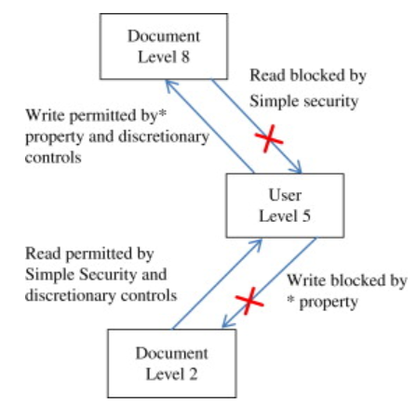
Figure 7: BLP model properties [37].
Generally, BLP core is on confidentiality of information only. Hence, it is applicable in areas where confidentiality is important such as military, governments, health, and pharma. However, it is too difficult to implement in the real world.

Biba Model
Biba is an access control model that focuses on the integrity of data. It follows the opposite of BLP model. Biba ensures that subjects and objects cannot read from a low level and write to a higher level. In Biba, objects and subjects are designated according to their integrity of groups. For example, the integrity level of a subject and an object can be denoted as l(u) and l(o) respectively [33, 34].
Biba model follows two main principles to protect data integrity: the simple integrity and the * integrity property. The simple integrity principle is known as “no read down”. This means, a subject (user) cannot read an object (file) if l(u) <= l(o). Thus, data integrity is protected from any alter or change when moving up from the lower level. On the other hand, the * integrity principle allows a subject to change or modify the content of an object if l(u) >=l(o). Such property shown in figure 7, can be summed up as “no write up” policy [35, 36].
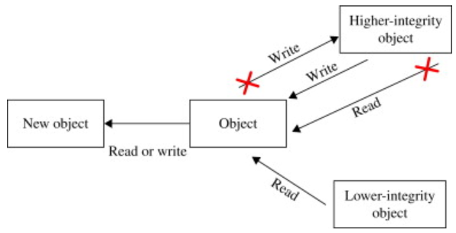
Figure 8: Biba model principles [37].
In general, for business companies, data integrity is more significant than confidentiality. Hence, the Biba model can be suitable to apply for business applications. It is also easy to use and can be practised with BLP to create a system that offers confidentiality and integrity. However, it lacks security perception.

Clark-Wilson Model
Clark-Wilson (CW) is an access control model designed to maintain the integrity of the information system. Like the Biba model, its primary focus is on data integrity, but it follows an entirely different approach. It uses change control principles and programs to provide data integrity rather than using integrity levels. In the CW model, a user can read, write, or modify to an object which belongs to a constrained data through a transformation and integrity verification procedure. This model involves a subject, a program, and an object. The objects are classified into two main groups: constrained and unconstrained data items. The constrained group represents the most valuable data, and the unconstrained group belongs to less critical data. To access an object that belongs to the constrained group, a user needs to go through a negotiator or transformation procedure. But in unconstrained groups, a user can access an object directly without using transformation procedure [38, 39].
The CW model ensures data integrity, especially in a business application environment. It operates upon three principles to achieve the integrity of data [34].
- Protect data modification from unlicensed users.
- Prevent improper use of altering data by the entitled users.
- Preserve the integrity of the data.
In general, CW is used in a business environment such as banking systems to provide data integrity. However, it is difficult to utilise and lacks security understanding (confidentiality).

Implementing Security Information: case study
This section provides the implementation of the information security system of the Caribbean Coffee company. The company uses IT to provide and expand their services across the globe. The author assumes to build the ISMS for the company based on the following lists:
- The company uses cloud computing services.
- 95% of the network is based on wireless technology.
- Contains database, proxy, DNS, DHCP and FTP server.
- It uses private clouding system.

Problem formulation
At present, many organisations are facing security issues. Some of the main security challenges can be data breaches or attacks from inside and outside an organisation, lack of understanding of data security and stealing of valuable information. These problems can be prevented or minimised by implementing an overarching ISMS that includes all the possible security solutions. Security issues can affect an enterprise success and the performance of IT. Therefore, it is a good practice to utilise and develop an ISMS standard to manage all IT components of an organisation. Now, Caribbean Coffee does not have a standard ISMS to overcome security issues.

Scope
The aim of this section is to establish an ISMS policy using ISO 27001 framework for the Caribbean Coffee company that applies to all employees and clients of the company. It involves cloud security, local network, physical, portable devices, and digital information.

ISMS Methodology
The author uses a Plan-Do-Check-Act strategy (figure 4) to develop and implement an ISMS for the Caribbean Coffee company. This will be used to determine the processes and requirements of the company as well as to control, implement, operate, and enhance its information security policy. Figure 9 shows the methodology approach used to develop the ISMS of the company. It is designed to outline the link between risk assessment and risk mitigation.
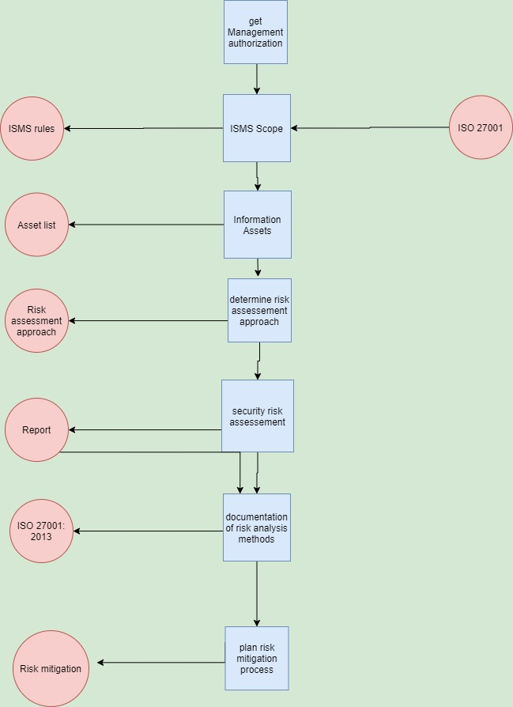
Figure 9: methodology approach designed on draw.io.
The company can be vulnerable to internal and external threats, and this can affect its operational continuity. Therefore, identifying and evaluating the risks is essential to develop a robust ISMS. Figure 4 from the above research was used as a method to identify, analyse, and evaluate the main risks of the company.

Risk Assessment
Risk assessment is a critical process to establish an ISMS of an organisation. It involves identifying, evaluating, and analysing risks. Therefore, understanding the main threats and vulnerabilities of the information security challenges that could happen is an essential process. The steps used to develop a risk assessment process are described below.
- Risk identification-Identifying the potential threats is the first step in the process of developing risk assessment for the company. A threat can be from internal and external attackers.
- Risk analysis-Once the main threats have been found, a vulnerability scan needs to run on each assets of the company. This helps to identify the security holes in the devices or physical of an asset in the company that could enable an attacker to jeopardise or perform an attack on the company’s assets. Then, the vulnerabilities found can be assessed to estimate their level of severity on the information security of the company and individual devices. The vulnerabilities can be rated as of high, low, or medium grading. Also, the probability of the vulnerabilities can be estimated to calculate in the risk assessment. Therefore, risk can be calculated using the following formula:
Risk = impact * likelihood
Impact
Medium
High
Low
H/L | H/M | H/H
M/L | M/M | M/H
L/L | L/M | L/H
Likelihood
High
Medium
Low

Table 2: risk matrix.
Table 2 can be used to evaluate and determine risks based on their priority. This will help in the process of risk treatment of the company.

Risk Response
Risk mitigation is a procedure of applying an appropriate technique to protect the identified weakness. It involves modifying risks, implementing new techniques, establishing priorities, and suggesting risk mitigation plan. Caribbean Coffee shop allows employees to bring and use their own devices. This implies, there is a high chance of utilisation of various vendors and technologies. Hence, it is more likely that the company will face some security challenges. For example, some users may still use obsolete products such as windows XP. Figure 10 below shows the risk treatment plan for some of the potential vulnerabilities of the company.

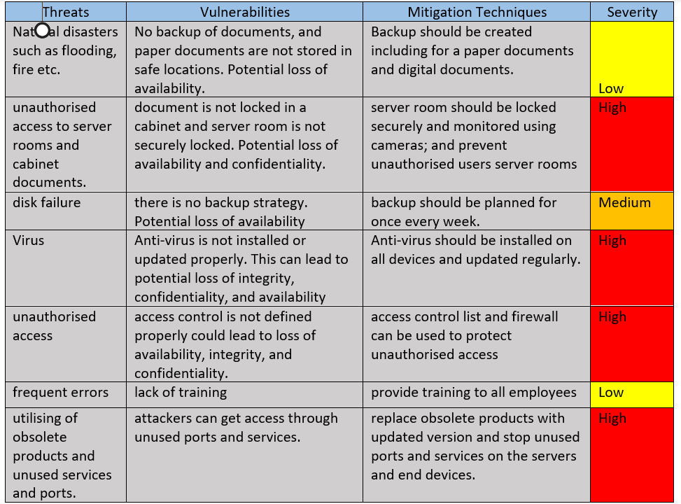
Figure 10: risk mitigation.
Vulnerabilities can be mitigated using various techniques including reconfiguration on the devices or applying security controls. The lists below are the methods used to mitigate the potential vulnerabilities of the systems.
- Disable unused user.
- Disable unused services and ports on the servers and other network devices.
- Implement firewall to filter unwanted traffics.
- Provide training to all employees regarding cyber-attacks.
- Remove obsolete products such as windows XP.
- Monitor traffics using IDS and IPS.
- Apply encryption techniques, especially to a valuable information.

Monitoring Risks
Security controls such as firewalls are used to prevent, detect, or block attackers from gaining access to an organisation system. But there is a possibility for a sophisticated and a well-coordinated attacker to bypass these security controls easily. Therefore, it is essential to monitor for unusual activities on the security checkpoints in order to detect and respond to an attack immediately. Security monitors can be implemented to operate using automated tools to track and notify any security threats. Caribbean coffee shop provides its service based on cloud-based technology. Thus, implementing an automated tool such as SolarWinds can be used to detect malicious activity on the company’s systems. Table 3 provides a security monitoring policy for the Caribbean Coffee shop company.
Table 3: Risk monitoring policies.
Security policy | Reasons | Severity
Evaluate and monitor the capability of security controls | To check the strength and performance of the security controls to mitigate risks. | Low
Create a team from internal and external for threat and vulnerability information; and prioritise risks. | Creates better understanding of the risks and vulnerabilities and speeds the risk respond process. | Low
Examine and update risk response mechanism periodically | Aims to ensure the company’s threat framework to be pertinent. | Low
Conduct regular risk assessment. | Improves mitigation techniques for new and existing threats of the company. | Low

Security policies
This section provides the security policies that are applicable to the Caribbean coffee shop based on ISO 270001 framework.

Strategic planning for information security
- An expert of information security should be appointed to lead and implement an ISMS.
- Specify and classify system services including assets, ownership, and technologies.
- Identify the main risks to the assets of the company including vulnerabilities and threats to the company.

Information security policy
This section includes all the security policies that are applicable to the Caribbean coffee shop. Also, it should be revised and updated as needed. The lists below are the statement policy of the company.
- Information security should satisfy confidentiality, integrity, and availability of the data. Also, business continuity plan should be preserved.
- Identify the risks that are acceptable.

Risk management policy
This section contains the policies that should be followed to control the vulnerabilities and threats of the company.
- A risk assessment should be taken every two years on all services of the company.
- Threats should be monitored, and alleviation methods should be tested and updated regularly.

Staff Training and Awareness policy
Providing training to employees is essential to develop and implement a vigorous ISMS. Also, it helps to minimise threats and protect system assets of an organisation from attackers. Hence, Caribbean coffee shop should provide training to all staff members.
- All employees of the company should get a proper training and education concerning cyber-attacks and information security. Also, they should be aware of the legal consequences if they misuse or abuse the information security of the company.

Asset management policy
Asset management is an important step to develop ISMS. This can be used to identify all the assets of a company including hardware, software, systems, and data. Asset management should be examined and updated regularly. Its main purpose is to keep records of all the assets and assign ownership including hardware and software. Asset management policy for the company is listed as follows:
- Asset inventory of all systems connected to the company’s network including network devices and software’s should be recorded. At a minimum, it should contain network address, devices names, its function, ownership, device label and tag. Also, portable devices such as smart phones, laptops and other electronic devices should be identified.
- Any lost or damaged assets should be forwarded to the responsible team.
- All software’s used in the company should be maintained and updated regularly. Also, all unnecessary or outdated software’s should be removed, replaced, or updated.
- Ensure that owners have the responsibility to the asset they own. Also, owners should have the right skills and adequate tools to protect the company’s assets.

Security controls
The main objective of security controls is to reduce or alleviate the risks to an organisation asset from internal and external threats. Security controls includes technical, physical, policies, procedures, and many others. Firewalls, surveillance cameras and anti-virus software are some examples of security controls. For the Caribbean shop, the security controls are classified according to the asset functions and type. Thus, the security controls comprise of access control, basis configuration security, communication security, cryptography, human resources, and physical security.

Access control
Access control is aimed to prevent a user or a system from accessing information or service of the company without a permission. Figure 11 shows a sample of access control security controls that are applicable to the Caribbean shop company. A detailed description of the content can be found on the other submission platform.
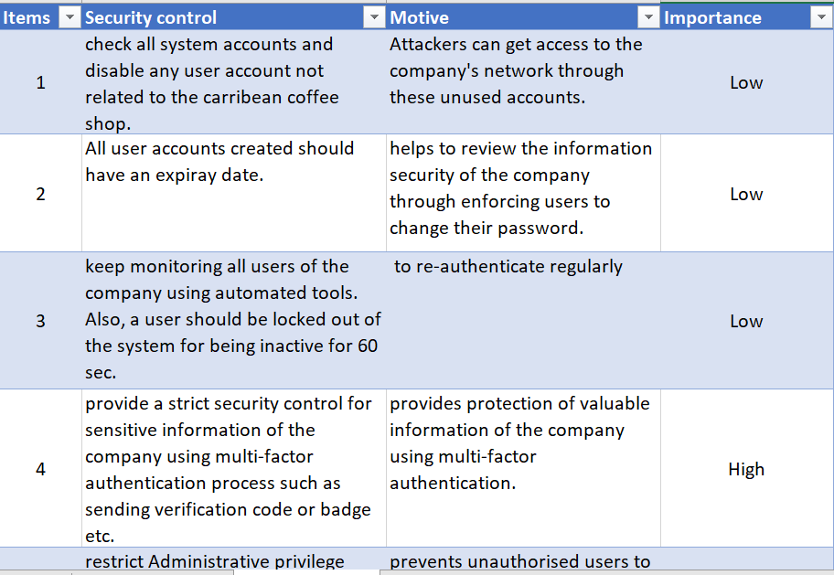
Figure 11: Access controls.

Basis configuration
It is a good practice to implement a configuration that applies to all systems of the company. Simply put, defining the minimum required of a configuration on all systems is essential to implement an ISMS. The basis configuration can be on hardware, software etc. The lists below are the security controls pertinent to the basis configuration of the company.
- Auto-run services must be disabled on all systems of the company including laptops, desktops, servers, pen-drives, and many other devices. Thus, prevents unwanted programs.
- Disable unused user accounts and services.
- Close unused ports on network devices.
- Implement firewall, IDS and IPS on the edges to detect or stop unwanted traffics.
- Install anti-malware on all devices, especially on the devices that are critical to the business.
- Update all operating systems to the latest version.
- Change default configuration on all systems of the company.
- Setup a backup plan on weekly basis.
- All systems should be configured to use an encrypted channel over the network.
- Disable wireless on devices that are not used to use wireless technology.
- Disable Bluetooth technology on all devices of the company.

Communication security controls
Communication security controls are designed to provide protection of information in networks. Communications can be through wireless, LAN, WAN, Bluetooth and many other. Caribbean shop network is mainly based on wireless technology. Hence, it is important to implement communication security controls that are pertinent to wireless networks. The lists below are security controls of the company related to wireless networks.
- Disable broadcast of SSID.
- Default login and password of the wireless access points (WAP) should be changed.
- Default SSID name should be changed.
- At a minimum WPA2 should be implemented on all wireless devices.
- Setup a separate VLAN to connect untrusted and privately owned devices. This helps to separate and filter unwanted traffics.
- Configure WAP on client devices to allow access to authorised wireless network.
- Enable WPA2-PSK authentication on all wireless routers and WAP; and configure shared key at least to 15 characters length.
- Configure firewall on wireless routers to filter traffics.

Network security controls
Figure 12 shows a sample of network security controls that are applicable to the Caribbean internal and external communication systems.
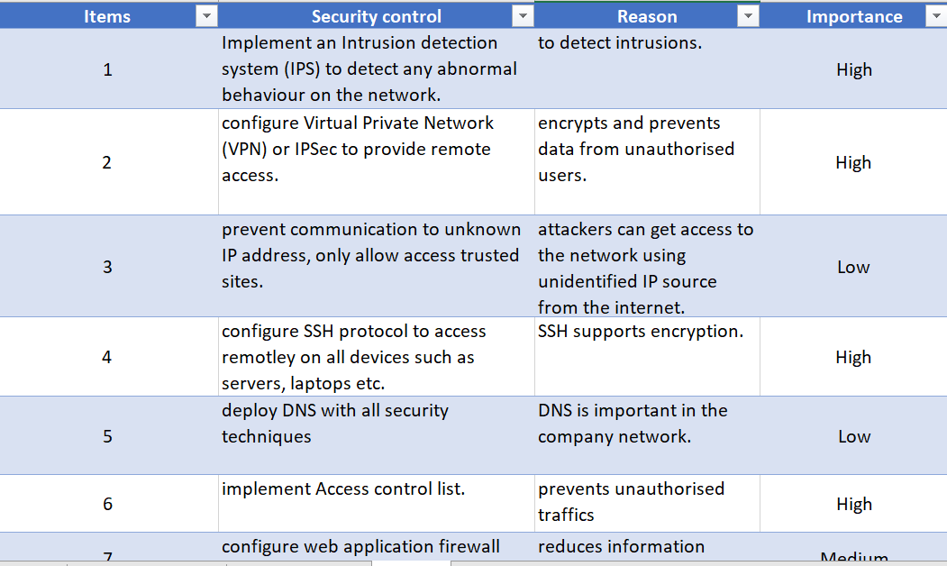
Figure 12: Sample network security controls.

Encryption
Encryption or cryptography is used to provide a secure communication channel. It secures data in transit using various encryption techniques or algorithms such as TLS and Public Key infrastructure (PKI). The lists below provide security controls for encryption techniques that are suitable for the Caribbean company.
- Provide TLS and SSL encryption methods for communication over untrusted networks, especially for sensitive information of the company.
- Implement multi-factor authentication and encryption.
- Apply encryption method on portable devices that holds valuable information of the company.
- Passwords should be hashed using MD5.

Contingency planning
Contingency planning is used to recover services and operations of the company after disruptions of services. It contains various methods, plans, procedures, and technical measures. Service disruptions can occur due to natural disaster, cyber-attacks, or failure of critical devices. The contingency plan for the Caribbean shop is as follows:
- Implement a business continuity planning including methods, techniques, and plans.
- Configure a secondary DNS in the case the primary DNS fails to provide availability. Also, setup a failover redundancy on the critical devices.
- Perform test on the disaster recovery plans before it is applied in real life.

Conclusion
Nowadays, security violations related to digital information is becoming a concern for many governments and organisations. As a result, its impact is significantly creating a trust gap between users and business companies and affecting their income revenue and services. This is mainly due to weak security policies and lack of awareness. However, exercising security frameworks and models can substantially reduce the number of attacks, vulnerabilities, and risks. In this paper, comprehensive research was carried out on the most prominent security frameworks, including ISO 27001, COBIT 5 and ITL, and presented a comparison. Based on the research, ISO 27001 is the best framework to utilise for designing and developing an information security for all types of organisations. It is also examined and discussed various information security models namely Biba, Bell-LaPadulla, and Clark-Wilson. In addition, an information security system was designed and developed based on ISO 27001 security framework, with a Caribbean coffee shop company’s scenario.
A risk assessment approach was applied to implement the company’s information security system. It was used to identify and evaluate the main security threats and vulnerabilities of the company. The risks were classified according to their level of severity on the company’s information security and services. Also, several security controls were implemented to mitigate the threats and the vulnerabilities. The security controls include access control, baseline configuration, communication, and network security policies. Furthermore, a business contingency plan was presented to ensure the company’s servicers are restored after disruptions of services. In conclusion, this paper presented the main information security frameworks and models used in the industry.

References

[1] | T. R. Eikebrokk and J. Iden, “ITIL Implementation: The Role of ITIL Software and Project Quality,” in IEEE, Vienna, 2012.
[2] | M. Tvrdikova, “Information system integrated security,” in IEEE, Ostrava, 2008.
[3] | N. Modiri and Y. M. Sobhanzadeh, “Information Security Management,” in IEEE, Gwalior, 2011.
[4] | M. Cristia and G. Rossi, “Automated Proof of Bell-LaPadula Security Properties,” Journal of Automated Reasoning, 2020.
[5] | axelos, “Axelos Golbal Best Practice,” Axelos, 10 Decemeber 2020. [Online]. Available: https://www.axelos.com/best-practice-solutions/itil. [Accessed 10 December 2020].
[6] | itSMF, “An Introductory Overview of ITIL V3,” 20 December 2011. [Online]. Available: http://www.itsmf.org.rs/sites/default/files/itSMF%20ITIL%20V3%20Introduction%20Overview.pdf. [Accessed 10 December 2020].
[7] | M. Fry, ITIL Lite: a road map to full or partial ITIL implementation, London: The Stationary Office, 2010.
[8] | simplilearn, “An Overview of ITIL Concepts and Summary Process,” simplilearn, 6 October 2020. [Online]. Available: https://www.simplilearn.com/itil-key-concepts-and-summary-article. [Accessed 11 December 2020].
[9] | P. Bernard, IT Service Management based on ITIL, Van Haren, 2011.
[10] | M. Marrone, F. Gacenga, A. Cater-Steel and et.al, “IT Service Management: A Cross-national Study of ITIL Adoption,” Communications of the Association for Information Systems, vol. 34, no. 49, pp. 1-30, 2014.
[11] | V. Arora, “Comparing different information security standards:,” Carnegie Mellon University, pp. 1-9, 2010.
[12] | I. Meriah and L. A. Rabai, “Comparative Study of Ontologies Based ISO 27000 Series Security Standards,” Procedia Computer Science, vol. 160, pp. 85-92, 2019.
[13] | D. Drljaca and B. Latinovic, “FRAMEWORKS FOR AUDIT OF AN INFORMATION SYSTEM IN PRACTICE,” Journal of Information Technology and Applications, vol. 12, no. 2, pp. 78-85, 2016.
[14] | CCQM, “ISO/IEC 27001 Information Security Management System,” CCQM, 17 December 2020. [Online]. Available: https://ccqm.ch/certification-process/iso-iec-27001-information-security-management-system/. [Accessed 17 December 2020].
[15] | ISO, “ISO/SEC 27001 Information Security Management,” ISO, 13 December 2020. [Online]. Available: https://www.iso.org/isoiec-27001-information-security.html. [Accessed 13 December 2020].
[16] | A. Alwi and K. A. Ariffin, “Information Security Risk Assessment for the Malaysian Aeronautical Information Management System,” in IEEE, Putrajaya, 2018.
[17] | C. Wang and D. Tsai, “Integrated installing ISO 9000 and ISO 27000 management systems on an organization,” in IEEE, Zurich, 2009.
[18] | K. Pecina, R. Estremera, A. Bilbao and et.al, “Physical and Logical Security management organization model based on ISO 31000 and ISO 27001,” in IEEE, Barcelona, 2011.
[19] | A. Tanovic and I. Marjanovic, “Development of a new improved model of ISO 20000 standard based on recommendations from ISO 27001 standard,” in IEEE, Opatija, 2019.
[20] | R. Almeida, R. Lourinho and et.al, “A Model for Assessing COBIT 5 and ISO 27001 Simultaneously,” in IEEE, Vienna, 2018.
[21] | G. Krisanthi, I. Sukarsa and et.al, “GOVERNANCE AUDIT OF APPLICATION PROCUREMENT,” Journal of Theoretical and Applied Information Technology, vol. 59, no. 2, pp. 342-351, 2014.
[22] | H. Nugroho, “CONCEPTUAL MODEL OF IT GOVERNANCE FOR HIGHER EDUCATION BASED ON COBIT 5 FRAMEWORK,” Journal of Theoretical and Applied Information Technology, vol. 60, no. 2, 2014.
[23] | K. R. P. Harefa and N. Legowo, “The governance measurement of information system using framework COBIT 5 in Automotive Company,” in IEEE, Jakarta, 2017.
[24] | simplilearn, “COBITÂ® 5 Overview of Enabler 1 Tutorial,” simplilearn, 18 December 2020. [Online]. Available: https://www.simplilearn.com/overview-of-cobit-5-enabler-1-tutorial-video. [Accessed 18 December 2020].
[25] | itgovernance, “what is COBIT?,” itgovernance, 18 December 2020. [Online]. Available: https://www.itgovernance.co.uk/cobit. [Accessed 18 December 2020].
[26] | P. Nastase, F. Nastase and et.al, “Challenges generated by the implementation of the IT standards CobiT 4.1, ITIL v3 and ISO/IEC 27002 in enterprises,” Economic computation & economic cybernetics studies & research, vol. 43, no. 3, pp. 1-16, 2009.
[27] | V. C. Hu, D. R. Kuhn and et.al, “Attribute-based access control,” Computer, vol. 48, no. 2, pp. 85-88, 2015.
[28] | A. V. D. M. Kayem, S. G. Akl and P. Martin, “A Presentation of Access Control Methods.,” in Adaptive Cryptographic Access Control, vol. 48, Boston, Springer, 2010, pp. 11-40.
[29] | R. Sandhu, E. Coyne, H. Feinstein and et.al, “Access Control Models,” IEEE computer, vol. 29, no. 2, pp. 38-47, 2013.
[30] | E. Sahafizadeh and S. Parsa, “Survey on access control models,” in IEEE, Wuha, 2010.
[31] | M. Yang, L. Yuan and Z. Yang, “A discuss of computer security strategy models,” in IEEE, Qingdao, 2010.
[32] | T. Mudarri and S. AL-RABEEI, “Security fundamentals: Access control models,” Interdisciplinarity in theory and practice, vol. 8, pp. 259-262, 2015.
[33] | E. Conrad, S. Misenar and JFeldman, Eleventh Hour CISSP, Elsevier, 2017.
[34] | M. Toapanta and et.al, “Analysis of the Appropriate Security Models to Apply in a Distributed,” IOP Conference Series: Materials Science and Engineering, vol. 423, no. 1, p. 012165, 2018.
[35] | G. Liu, C. Wang and et.al, “BTG-BIBA: A Flexibility-Enhanced Biba Model Using BTG Strategies for Operating System,” International Journal of Computer and Information Engineering, vol. 11, no. 6, pp. 765-771, 2017.
[36] | E. Борисенко, Л. Галата and Б. Корниенко, “Research and analysis of the information security mathematical models,” Pridneprovskiy scientific bulletin, vol. 12, no. 572, 2018.
[37] | T. J. Shimeall and J. M. Spring, “Frustration Strategies: Formal Verification,” in Introduction to Information Security, Syngress, 2014, pp. 107-121.
[38] | F. Avorgbedor and J. Liu, “Enhancing User Privacy Protection by Enforcing Clark-Wilson Security Model on Facebook,” in IEEE, Chicago, 2020.
[39] | F. Jeannot, “Clark-Wilson Security Integrity Model,” Montreal, 2019.

