University of Wales Trinity Saint David
School of Engineering
Motorsport Engineering BEng

Material Selection Report & GD&T Drawings
Engineering Design and Materials (ACHA4001)

Priveshnan Soemani Segaran
2204879
February 2023

Contents
1. Introduction 3
2. Material Properties 4
3. Material Selection 5
4. Manufacturing Processes 11
5. Conclusion 13
6. References 14

Introduction
The automotive piston is a fundamental part of the internal combustion engine, playing a vital role in powering vehicles and allowing them to achieve exceptional performance. Since its invention, the automotive piston has undergone several innovative improvements which have shaped its history, design, and manufacturing processes. The piston that will be featured briefly in this report is the piston from a BMW F30 3 Series, engine model B48 which has been in production from 2015 – 2019. The specifications of this piston are of the following, 82mm bore with a stock stroke 9.5:1 compression ratio. This report will discuss the material properties, material selection and manufacturing process required in developing a fully functioning piston. The piston system enables the piston to transmit force to the crankshaft via the connecting rod, which subsequently activates the wheels of the vehicle. (verifiedmarketresearch, 2021). Automotive pistons are essential in providing the power, efficiency, and temperature regulation necessary for a vehicle to achieve optimal performance. As such, it is important that the right material is chosen to further improve the efficiency and performance of the engine. The correct piston size and material are crucial for producing the best compression ratio in the engine.
: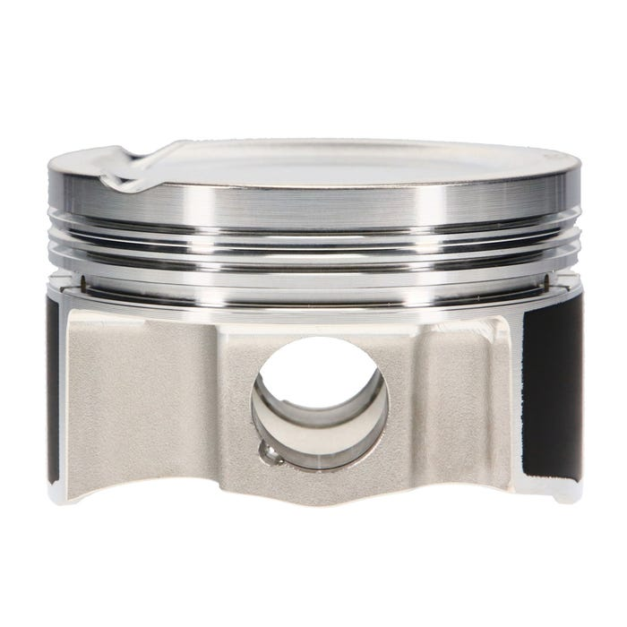
Figure 1: BMW B48 Piston (Pro-RaceEngineering, 2023)
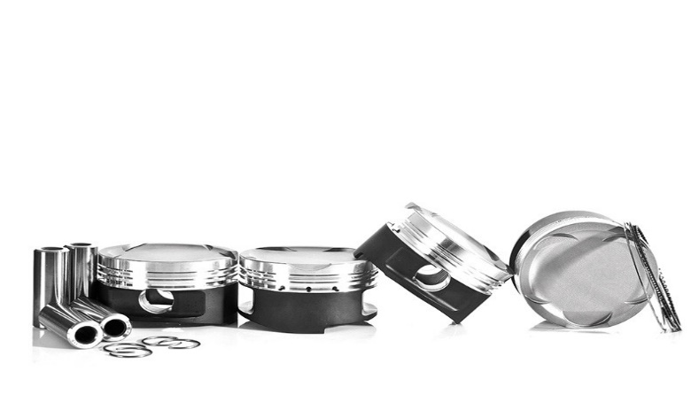
Figure 2: BMW B48 Piston (Pro-RaceEngineering, 2023)

Material Properties
Material properties is a vital part of any designing process. Before selecting a material, the properties must be studied. Material properties refer to the mechanical, physical, and chemical characteristics of materials that determine their behaviour under different conditions. These properties are essential in determining the suitability of a material for a particular application. The material properties are classified into three broad categories which are mechanical properties, physical properties, and chemical properties. Physical properties can be described as measurable or the behaviour of materials under non-mechanical forces. For example, density and conductivity. Mechanical properties on the other hand can be evaluated by observing its reaction when different forces are applied to it. For example, tension and compression. Finally chemical properties can be simply defined as the material properties that become evident during a chemical reaction. For example, flammability and oxidation state.
Product performance is determined by material properties. We require in depth knowledge to choose systematic techniques for well optimised engineering design. This involves evaluating the full profile of features that will maximise performance, not merely rating materials according to a single material property (Ashby, 2015 ). When performance is discussed, this is not only describing the technical excellence of the material but also the cost behind it as well as the environmental intrusion it might produce and how sustainable it is for the future.
The material used in the manufacturing of a piston must have specific characteristics to withstand the harsh conditions of an engine environment. Firstly, it must have high strength and durability to withstand the high forces and temperatures generated during the combustion process. A piston made with weak properties may fail, leading to engine failure, which could be catastrophic. Strength is one of the most important material properties in a piston. The material definition of strength is the mechanical properties that enables a material to resist deformation under the actions of an external load. Durability holds a high value in piston construction. The piston is subjected to extreme temperatures and pressures, which can cause it to crack, deform, or fail altogether. Therefore, it is essential to use materials that are not only strong and stiff but also resistant to wear and fatigue. The piston's durability is directly related to the material's ability to withstand these extreme conditions and continue to function properly over time. Durability can be defined as the ability of a material to remain serviceable in the surrounding environment during the useful life without damage or unexpected maintenance. The material used in a piston must also have excellent thermal conductivity to dissipate heat generated during the combustion process. Pistons are subjected to high temperatures during operation, and the ability of the material to dissipate heat can affect engine performance. A material with high thermal conductivity can help manage heat dissipation in the engine, which can improve performance and reliability. The material definition of thermal conductivity is the rate at which heat passes through a specified material.

Material Selection
Material selection can be defined as the process in which materials can be systematically and rapidly eliminated, used by engineers to best select the most suitable material. Before a material can be selected to produce the writer’s piston, the function of a piston must fully be understood. A gasoline engine piston experiences roughly 10 tonnes of force every 0.02 seconds at full speed and 6000 rpm while frequent explosions heat the metal to more than 316 degrees Celsius (Tingwall, 2014). It is known that a piston must be able to withstand gas pressure, heat, and inertia forces. The piston needs to be extremely strong and durable. Moreover, it should be as light as possible to reduce inertia forces and have a robust construction to withstand heat and mechanical deformation and have enough surface area to prevent excessive wear. After taking into consideration the environment the piston is in as well as the force it is subjected to, we can begin the material selection process.
The basic material selection method consists of translation, screening, ranking and finally having supporting information to make the best selection. Translation can be broken down to parts. The first, is function which is finding out what the component does. In this case the piston. Secondly, is objective. Deciphering what the essential conditions the piston is place under. Thirdly, is understanding constraints. Identifying which parts must be maximized and minimized. Lastly, accounting for the free variables. The second method, screening allows the engineers involved to eliminate unsuitable material rapidly, so no time or cost is wasted. The third method, ranking allows for the materials selected after screening to be evaluated by their individual pros and cons. The last method involves gathering as much supporting information. By doing so, this will reduce the room for error since all aspects are studied and taken into consideration. One of the examples of supporting information is using a material chart.
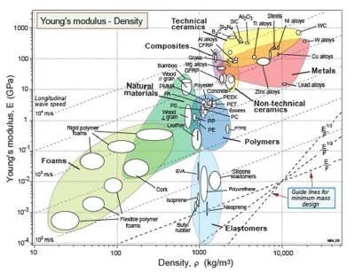
Figure 3: Material chart (GrantaDesign, 2020)
As discussed in the paragraph above there are several methods that can be applicable when performing material selection. In addition to that, there are further simplified step that can be taken in the material selecting process. Step one is identifying the design requirements, step two is identifying the materials selection criteria, step three is identifying candidate materials, step four is evaluating candidate materials and step five is select the materials. (Metallurgists, 2017).
In step one, identifying the design requirements. Design requirements can be listed as performance requirements, reliability requirements, cost requirements, manufacturing and assembly requirements and environmental sustainability requirements. The piston the writer is producing will be used in a high-performance daily driving car such as the BMW M5 CS and Porsche 911. This piston will fall under the category of a motorsport or high-performance engine with can produce high speed and large amount of horsepower.
Step two is identifying material selection criteria. Mechanical properties of the material must be considered when selecting the material. The material of the piston must be able to withstand the high forces and pressures generated during the combustion process. Since this piston is for an engine that will be used daily, it is important that the material selected longevity, for example five to seven years minimum. This means the material selected must be of strong endurance and high durability able to withstand the repeated stresses and impacts that occur during daily driving and high-speed driving. In the case of this piston, it is designed to be lightweight but able to withstand constant load without cracking or deforming. This design element can be described as designing for strength. Other examples of design elements used are designing for stiffness to maximise rigidity and designing for fatigue to avoid cracking which can occur when the piston is subjected to repeated cycles of compression and expansion.
Additional factor to consider when selecting materials for motorsport pistons is the temperature at which the engine will be operating. The engine can reach temperatures up to 350-400 degrees Celsius (DieselNet, 2017). As the piston moves up and down within the cylinder, it is subjected to extreme temperatures and high pressure particularly during the combustion process. This heat can cause the piston to expand, which can lead to issues with clearances and tolerances. When selecting a material, is should be adjusted for the suitable clearances and tolerances. To elaborate, the material selected must be able to expand and contract to the specific tolerances to enable slight movement when it is in the fitting and installing process or different weather types around the world. Therefore, the material used for the piston must be able to withstand high temperatures without allowing exponential expanding or deforming.

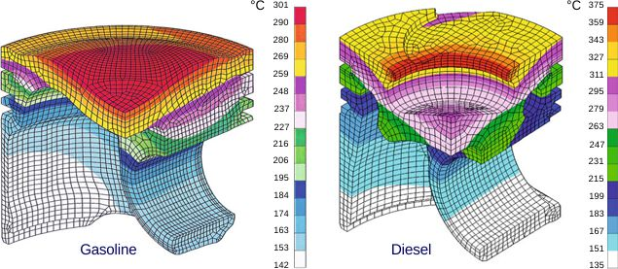
Figure 4: Average Temperature Distribution in a Piston (DieselNet, 2017)

Step three in the material selection process is establishing candidate materials. The writer has narrowed down the material selection using the screening method to three potential materials which are steel, aluminium and titanium.
Aluminium is the most widely used material for the manufacturing of pistons due to its low weight and high strength. Its lightweight characteristics makes it ideal for high performance pistons. Being lightweight this helps reduce reciprocating mass of engine allowing higher revs and quicker throttle response. Aluminium pistons offer excellent thermal conductivity, which helps to dissipate heat quickly. However, aluminium pistons tend to expand more than other materials, which can cause problems in high-performance engines. Aluminium alloy can also be easily machined to specific tolerances. This allows the piston to be made with complex channels and valves. Aluminium is also relatively inexpensive to produce.
Steel is another option for manufacturing pistons. Steel is heavier than aluminium and has slightly lower thermal conductivity. However, it has higher strength and can handle higher temperatures and pressures (ANSI, 2020). Steel pistons are ideal for engines that require high torque and power.
Titanium is the most expensive option for manufacturing pistons, but it is the lightest and strongest. Titanium pistons offer good thermal conductivity and can withstand high temperatures and pressures. Titanium also is highly resistant to corrosion. However, titanium pistons are difficult to manufacture and require specialized equipment.

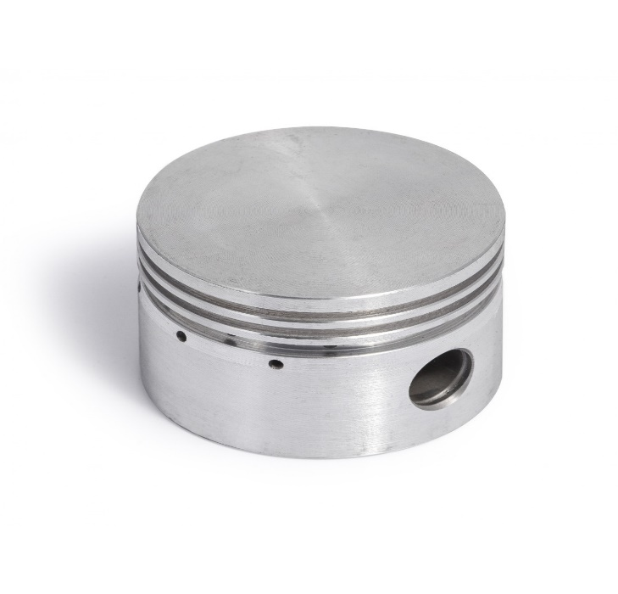
Figure 5: Aluminium Piston (GTair, 2020)

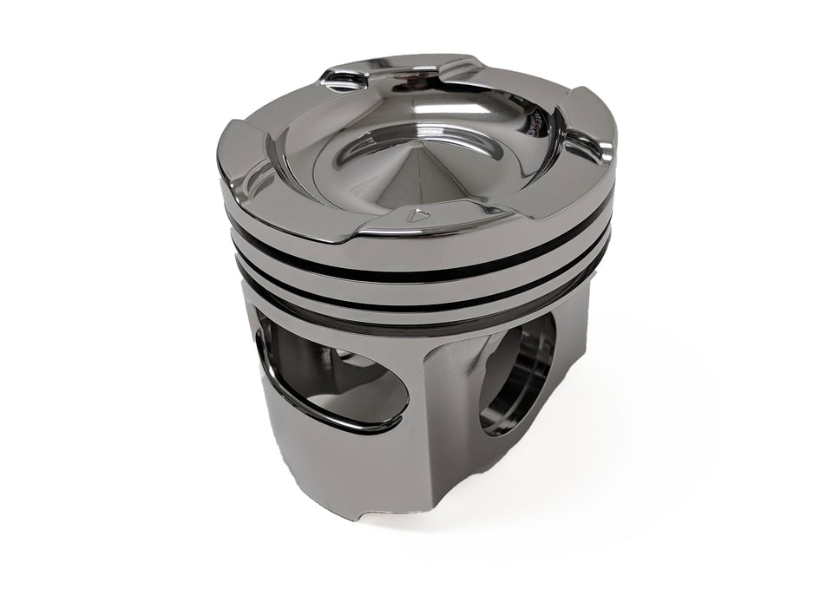
Figure 6: Steel Piston (Baechtel, 2018)

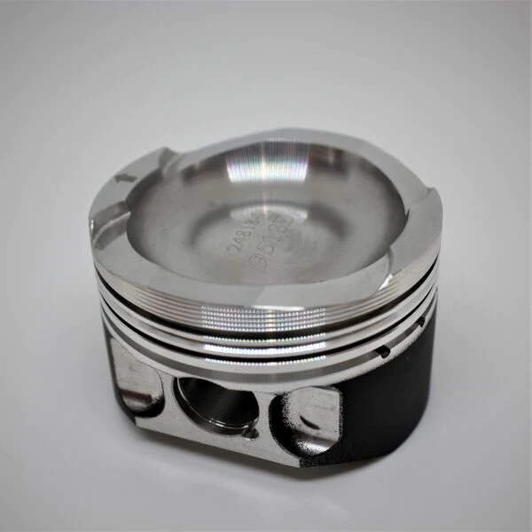
Figure 7: Titanium piston (AbarthTuning, 2023)

Step four in the material selection process involves further evaluating candidate materials.
Table 1: Materials Pros and Cons
Materials | Pros | Cons
Aluminium | Strong  Lightweight  Excellent thermal conductivity  Easily machined  Inexpensive  Outstanding resistance to corrosion  Good stiffness and strength-to-weight ratio | Tends to expand easily
Steel | Stronger than aluminium | Heavier than aluminium and titanium  Lower thermal conductivity compared to aluminium and titanium
Titanium | Stronger than steel and aluminium  Lighter than steel and aluminium  Highly resistance to corrosion  Good thermal conductivity | Very expensive  Not easily machinable  High production cost

The last step is selecting the material. Based on all the table above providing reasons and evidence, the material chosen for the writer’s piston is aluminium. This is because, aluminium is lightweight which allows for lower engine weight and can produce higher revs, unlocking more power. The strength of aluminium will enable it to with stand high pressure and load from the engine. Aluminium also has excellent thermal conductivity allow it to dissipate heat well, cool the engine and prevent overheating. Aluminium is also known to be very machinable to allows for more sophisticated air channels and valve to be built on it enable it to help produce large amount of power and torque. Although it tends to expand slightly, there will be relevant precautions taken to prevent it from deforming or cracking. Finally aluminium is relatively inexpensive, thus allowing for more pistons to be produced with a higher profit margin.

Manufacturing Processes
Manufacturing can be defined as the process of making a product from raw materials, especially as a large-scale operation using machinery. Manufacturing is said to encompass several steps, those being the design of the product, the selection of raw material that will be used to make the product and finally the sequence of processes through which the product will be manufactured. Manufacturing can be discussed in two further sectors which are technological and economical. In a technological standpoint, manufacturing is the use of physical and chemical processes to modify a particular starting material's shape, qualities, appearance in order to create components or products. The manufacturing process can be completed with the combination of machinery, tools, and manual labour. Meanwhile, in the economic sector manufacturing is seen as the process where value is added upon a product by carrying out different processed that alter the products form and usage. There are several manufacturing industries which are split into three parts being the primary industry, secondary industry, and tertiary industry. The writer’s piston falls under the secondary industry in which raw materials are taken from the primary industry and converted into a consumer product. This leads to the type of manufacturing operations which can be broken down to four types. The first is project, this delivers a production rate of 1 to 10 units only. The second type is job shop which produces 10 to 100 units. The third type is production in batch which has 100 to 10000 units. Lastly, the final type of operation is mass production which caters for 10000 units and above. The writer’s piston will be produced in batch as it will be used in cars of low production and limited units. Hence valuing the piston significantly higher than regular pistons.
The two manufacturing processes being looked at for the writer’s piston is casting and forging. Casting involves pouring molten metal or other materials into a mold, where it solidifies and takes on the desired shape. Casting is commonly used in the production of complex shapes and large components, such as engine blocks and turbine blades. The advantages of casting include its ability to produce complex shapes, its cost-effectiveness for large-scale production, and the ability to use a variety of materials. However, casting can be limited by the size and complexity of the mold, and it can result in variations in quality and dimensional accuracy. (Kumar, 2023)
For this piston the writer has selected forging to be primary manufacturing process. 65 percent of the world total forging products are used by the automotive industry (Pradeepmetals, 2016). This justifies the selection of this manufacturing process because it has been successfully carried about for years in this industry hence making it the best pick for the writer. The forging process involves heating metal to a temperature where it can be easily shaped. Once the metal has reached the desired temperature, it is placed on a die or mold and subjected to a high level of pressure. This pressure forces the metal to conform to the shape of the die or mold, resulting in a piece of metal that is the desired shape. There are two main types of forging processes: open die forging and closed die forging. Open die forging involves shaping the metal by hammering it between two flat dies. Closed die forging, on the other hand, involves shaping the metal by placing it in a mold and applying pressure from all sides (Foundry, 2023). The benefit of forging is that it produces parts that are stronger and more durable than those produced through other manufacturing processes. Forged item can overall maintain a higher temperature range due to its structural integrity. This is because the forging process compresses the metal, making it denser and stronger. Forged parts are also less likely to crack or break, which is particularly important in applications where safety is a concern. In the economic standpoint of manufacturing processes, it is important to keep cost down in order to turn a profit. Forging is seen to be highly cost effective because in high volume production, it is less expensive compared to other methods. Forging also allows more accurate dimensioning because it has great design flexibility which is important in perfecting the tolerances of the piston and its supplementary parts. Additionally, the forging process produces parts with a better surface finish than those produced by casting, hence making it more aesthetically pleasing.

Conclusion
To conclude, the steps involved in successfully establishing a product consist of many elements. In this technical report a piston production is discussed thoroughly. It is begun by first analysing material properties. In this element, specification such as the materials mechanical, physical, and chemical characteristics are studied. By doing so, we are able to identify the best material characteristics required by the piston. In this case the piston must be strong, durable and have good thermal conductivity. The next processed in producing a piston is material selection. Before this processed, the piston is studied extensively to ensure the material selected is suitable for the environment where the piston is located. From this report we have identified that the piston is located in a high temperature environment and subjected to high loads and pressure. With this gathered information, aluminium is chosen as the material from this piston because it is strong, lightweight, has excellent thermal conductivity, easily machined and inexpensive. The last step in the piston production is the manufacturing process. In this process we identify that the piston falls in the secondary industry and the writer has selected the piston to be produced in batches which has a production rate of 100 to 10000 units. Finally, the last step in the production of a piston is selection a manufacturing process. Forging has been selected for the piston because it delivers benefits such as being strong, reliable, and highly cost-effective. Overall, these are the step that must be carried out in order to successfully produce an item such as a piston.

References

Abarth Tuning (2023) ABARTH WOSSNER TITANIUM FORGED PISTONS AND PEC RODS [image] available at: https://www.abarthtuning.com/products/forged-pistons-and-rods-72mm (accessed 11 March 2023)

ANSI (2020) Titanium vs. Steel & Aluminum [online] available at: https://blog.ansi.org/2020/03/titanium-vs-steel-aluminum/ (accessed 17 March 2023)

Aqeel Ahmed*, M. S. Wahab, A. A. Raus, K. Kamarudin, Qadir Bakhsh and Danish Ali (2016) ‘Mechanical Properties, Material and Design of the Automobile Piston: An Ample Review’ Indian Journal of Science and Technology, Vol 9(36)

Azo Materials (2010) What is Materials Selection? [image] available at: https://www.azom.com/article.aspx?ArticleID=5134 (accessed 10 March 2023)

Car and Driver (2014) Everything You Ever Wanted to Know About Modern Pistons (and Probably Some Things You Didn't) [online] available at: https://www.caranddriver.com/features/a15109982/everything-you-ever-wanted-to-know-about-pistons-feature/ (accessed 10 March 2023)

CNET (2020) Porsche tests 3D-printed pistons for its 911 GT2 RS [online] available at: https://www.cnet.com/roadshow/news/porsche-tests-3d-printed-pistons-for-911-gt2-rs/ (accessed 11 March 2023)

Diamond Piston (2018) Behind The Scenes: Diamond's STEEL Piston Technology [image] available at: https://blog.diamondracing.net/behind-the-scenes-diamonds-steel-piston-technology- (accessed 11 March 2023)

DieselNet (2017) Piston Cooling [online] available at: https://dieselnet.com/tech/combustion_piston-cool.php#:~:text=Some%20typical%20temperature%20values%20for,injection)%20350%E2%80%93400%C2%B0C (accessed 17 March 2023)

GTair (2023) Piston cast aluminium 64.7mm - BS3800 [image] available at: https://gtair.co.uk/air-compressor-spares/575-piston-cast-aluminium-647mm-bs3800.html (accessed 11 March 2023)

GrantaDesign (2020) Material property charts [online] available at: https://www.grantadesign.com/education/students/charts/ (accessed 17 March 2023)

Industrial Metallurgist (2017) Materials Selection for Great Products: Overview [online] available at: https://www.imetllc.com/materials-selection/ (accessed 10 March 2023)

Metaltek (2020) How To Evaluate Materials – Properties To Consider [online] available at: https://www.metaltek.com/blog/how-to-evaluate-materials-properties-to-consider/ (accessed 7 March 2023)

Motor trend (2003) Buyers Guide To Choosing The Best Piston Parts - Piston Tech [online] available at: https://www.motortrend.com/how-to/mopp-0309-buyers-guide-to-choosing-the-best-piston-parts/ (accessed 22 February 2023)

Pradeep metals (2016) BENEFITS OF FORGING [online] available at: https://www.pradeepmetals.com/benefits-of-forging/#:~:text=Forging%20has%20a%20significant%20cost,secondary%20operations%20in%20most%20cases. (accessed 13 March 2023)

Pro - Race Engineering (2023) BMW B48 82mm Bore Stock Stroke 9.5:1 Compression ratio [image] available at: https://prorace-engineering.co.uk/product/je-bmw-b48-82mm-bore-stock-stroke-9-51-compression-ratio/ (accessed 22 February 2023)

Reliance Foundry (2023) Smithy Secrets: An Intro to Forging Methods [online] available at: https://www.reliance-foundry.com/blog/forging (accessed 12 March 2023)

Science Direct (2015) Materials Property [online] available at: https://www.sciencedirect.com/topics/materials-science/materials-property#:~:text=The%20material%20properties%20are%20size,stress%2C%20fracture%20toughness%2C%20etc. (accessed 7 March 2023)

Science Direct (2012) Material Selection [online] available at: https://www.sciencedirect.com/topics/materials-science/material-selection#:~:text=Materials%20selection%20is%20an%20ordered,which%20are%20the%20most%20suitable. (accessed 10 March 2023)

The mechanical engineering.com (2023) Casting Process: Definition, Working Process, Types in detail, Advantages, Disadvantages, Application [online] available at: https://themechanicalengineering.com/casting-process/ (accessed 12 March 2023)

Thomasnet (2023) Different Types of Casting Processes Used in Manufacturing [online] available at: https://www.thomasnet.com/articles/custom-manufacturing-fabricating/types-of-casting-processes/ (accessed 12 March 2023)

Thomasnet (2023) What is Forging? [online] available at: https://www.thomasnet.com/articles/custom-manufacturing-fabricating/what-is-forging/ (accessed 12 March 2023)
TWI (2023) WHAT IS MANUFACTURING? (DEFINITION, TYPES AND EXAMPLES) [online] available at: https://www.twi-global.com/technical-knowledge/faqs/faq-what-is-manufacturing#:~:text=Manufacturing%20is%20defined%20as%20the,products%2C%20rather%20than%20providing%20services. (accessed 12 March 2023)

Verified Market Research (2021) 5 best automotive piston manufacturers’ success mantra to cheer motorheads [online] available at: https://www.verifiedmarketresearch.com/blog/best-automotive-piston-manufacturers/ (accessed 22 February 2023)

