Feedback on Meetings this week (Ending 1 June 2024) Critical Literature Review Class

There are some common themes in our discussions.

Do look at Moodle there are lots of resources there. In this last phase, you could answer the assignment with the resources that are there for you!

- The deadline is Midnight, 5 June, the Turnitin tile is being updated.

- The submission is for one document. I will try to allow 2 documents so that you can upload separately Part 3 the annotated bibliography as a spreadsheet.
IF NOT.
Do some screen grabs of your Part 3. Add a little analysis of why you inserted the types of comments, related to this exercise and in anticipation of your final thesis delivery.

Then send me your spreadsheet separately by email to my work email s.griffiths@uwtsd.ac.uk so that I can read it. The screen shots are normally too small to read, but the external examiner will wan evidence that you have done the work on the main document.
I WILL CLARIFY IN THE NEXT FEW DAYS.

- Do not go over the word count significantly.

- Do upload by the deadline, even if you are not happy with your quality. You never know how good or bad it is until it is marked.

- Part 1 was quite well done, a rationale for doing a literature review. Some mentioned their own plans, but this was not expected. Part 1 is more a theoretical review of what the review does for you. Do not let your own project take over Part 1. You can leave it out entirely and concentrate on discussing the good and bad things about reviews.

- Varying formats of the literature review. I think it would be good to mention that you realise there are many formats for the review. Without going into depth. I offered this link to most.

Pictures and tables do not count for words, however they must be numbered, given a title and referred to in your text.

CSU library guide, which is itself taken from the source below.
https://libguides.csu.edu.au/review/Types

This one also states the positive and negative implications of the different types….just insert and reference it with a small explanation of your likely type to be adopted?

What's the difference between reviews?
Researchers, academics, and librarians all use various terms to describe different types of literature reviews, and there is often inconsistency in the ways the types are discussed. Here are a couple of simple explanations.
- The image below describes common review types in terms of speed, detail, risk of bias, and comprehensiveness:

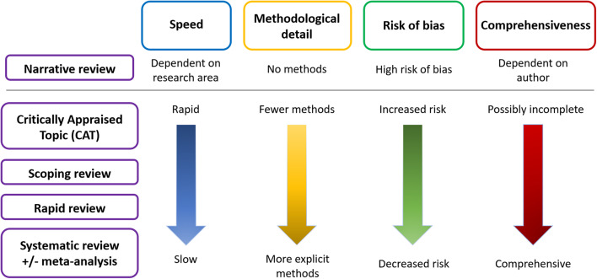
The original source

"Schematic of the main differences between the types of literature review" by Brennan, M. L., Arlt, S. P., Belshaw, Z., Buckley, L., Corah, L., Doit, H., Fajt, V. R., Grindlay, D., Moberly, H. K., Morrow, L. D., Stavisky, J., & White, C. (2020). Critically Appraised Topics (CATs) in veterinary medicine: Applying evidence in clinical practice. Frontiers in Veterinary Science, 7, 314. https://doi.org/10.3389/fvets.2020.00314 is licensed under CC BY 3.0

- The table below lists four of the most common types of review, as adapted from a widely used typology of fourteen types of reviews (Grant & Booth, 2009).
REVIEW TYPE | DESCRIPTION | TIMEFRAME | NO. OF REVIEWERS
Traditional (narrative) literature review | Identifies and reviews published literature on a topic, which may be broad. Typically employs a narrative approach to reporting the review findings. Can include a wide range of related subjects. | 1 - 4 weeks | 1
Rapid review | Assesses what is known about an issue by using a systematic review method to search and appraise research and determine best practice. | 2 - 6 months | 2
Scoping review | Assesses the potential scope of the research literature on a particular topic. Helps determine gaps in the research. (See the page in this guide on Scoping reviews.) | 1 - 4 weeks | 1 - 2
Systematic review | Seeks to systematically search for, appraise, and synthesise research evidence so as to aid decision-making and determine best practice. Can vary in approach, and is often specific to the type of study, which include studies of effectiveness, qualitative research, economic evaluation, prevalence, aetiology, or diagnostic test accuracy. | 8 months to 2 years | 2 or more
Grant, M.J. & Booth, A. (2009). A typology of reviews: An analysis of 14 review types and associated methodologies. Health Information & Libraries Journal, 26(2), 91-108. https://doi.org/10.1111/j.1471-1842.2009.00848.x
See also the Library's Literature Review guide.

My insert to your text would look like this below. Try to change the wording. This is just to show what it might look like.

……………….Other formats can be used depending on the needs of the researcher. Grant & Booth (2009) identify 14 types. De Brun & Pearce-Smith (2009) prioritise search tools linked to formats. Different formats will vary in application depending on the research project, resources available (including time) the planned publication and level of research.

For the reference list
Grant, M.J. & Booth, A. (2009). A typology of reviews: An analysis of 14 review types and associated methodologies. Health Information & Libraries Journal, 26(2), 91-108. https://doi.org/10.1111/j.1471-1842.2009.00848.x

De Brun C. & Pearce-Smith, N. (2009) Searching Skills Toolkit: Finding the Evidence. Oxford, UK: Wiley-Blackwell. ISBN: 9781118463130.

All have positive and negative attributes. Fig. 1 shows five types. On the sliding scale a narrative review is fast and focused but may be too narrow and open to bias due to its restricted coverage. The systematic review is time and resource consuming, but evaluates many methods, comprehensively covers the range of academic perspectives and reduces bias due to the range of sources covered.

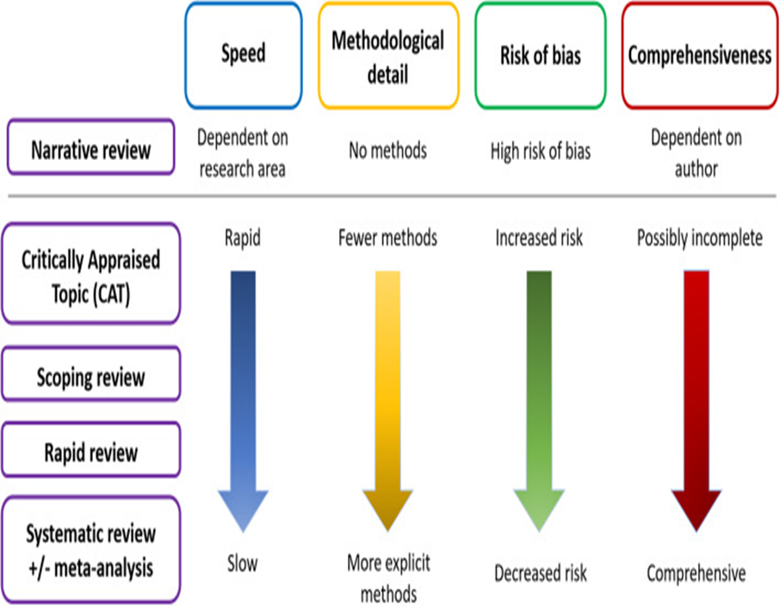
Figure 1. Evaluation of different formats of literature review (Source: Charles Sturt University, 2024)

Put this in the reference list: Charles Sturt University (2024) Literature Review Guide. https://libguides.csu.edu.au/review/Types (Retrieved 30-05-24)
- Bias. In fact most of you are doing a narrative literature review for this exercise. Due to its narrow coverage it is in danger of including bias.
You might try to follow the processes of a systematic review but do not have the time or resources to do a PRISMA, although you could mention it.
A systematic review reduces the risk of bias because it is so comprehensive. The smaller the review the more bias might be a problem. Look at ways to eliminate bias.

Mention BIAS in Part 1 and discuss briefly in Part 2.

A few sources for this:

“Non- Caroline Jawadian” sources, good for checklists.
https://baselinesupport.campuslabs.com/hc/en-us/articles/204305695-Avoiding-bias-in-qualitative-data-analysis

https://www.prolific.com/resources/avoid-bias-research-things-marketers-need-to-know

https://www.cwauthors.com/article/avoiding-biases-at-different-stages-of-research

More university and academic sources
https://network.healthwatch.co.uk/sites/network.healthwatch.co.uk/files/20191101_Managing%20Bias%20Resource%20guidance%20formatted_0.pdf

https://resources.lmu.edu/dei/initiativesprograms/implicitbiasinitiative/whatisimplicitbias/strategiestoreduceimplicitbias/

https://journals.sagepub.com/doi/pdf/10.1177/08943184211051350

One for Olivia! https://builtin.com/articles/remove-bias-from-machine-learning-algorithms

- The Research Gap.
You can mention this whose discovery is an objective of the literature review, in Part 1.
Part 2 is largely devoted to how to find it, or whether there is a gap to be filled by your project.

There are many easy-to-read versions like this….see they quote heavier sources , which you could quote…naughty but effective with the deadline looming.
https://www.tutorsindia.com/blog/what-are-the-different-types-of-research-gaps-in-the-literature-review/
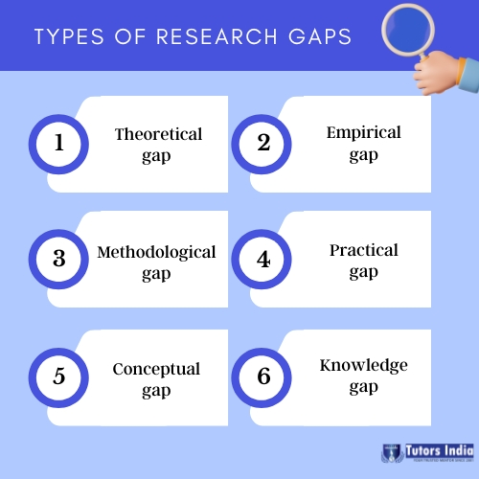

Good to find more heavy academic sources.

https://www.editage.com/insights/dont-know-where-to-start-6-tips-on-identifying-research-gaps

https://resources.nu.edu/researchprocess/literaturegap

https://researcher.life/blog/article/identify-gaps-in-research-tips/

What is a research gap?
Research gaps are areas requiring more studies or research.¹ They can be:
- an unsolved question or problem within your field.
- a case where inconclusive or contradictive results exist.
- a new concept or idea that hasn’t been studied.
- a new/updated research to replace the outdated existing research.
- a specific demographic or location that has not been well studied.

On the research gap
Add this to the reference list and quote him in the text. Cut and paste the diagram to save words.
Miles, D. A. (2017, August). A taxonomy of research gaps: Identifying and defining the seven research gaps. In Doctoral student workshop: finding research gaps-research methods and strategies, Dallas, Texas (pp. 1-15). file:///C:/Users/steve/Downloads/Miles2017.pdf
My screen grab
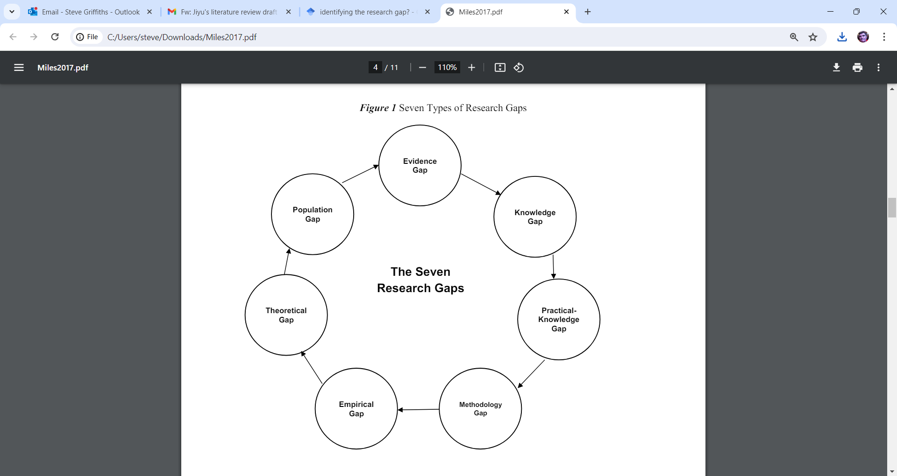
Slightly better version but not great

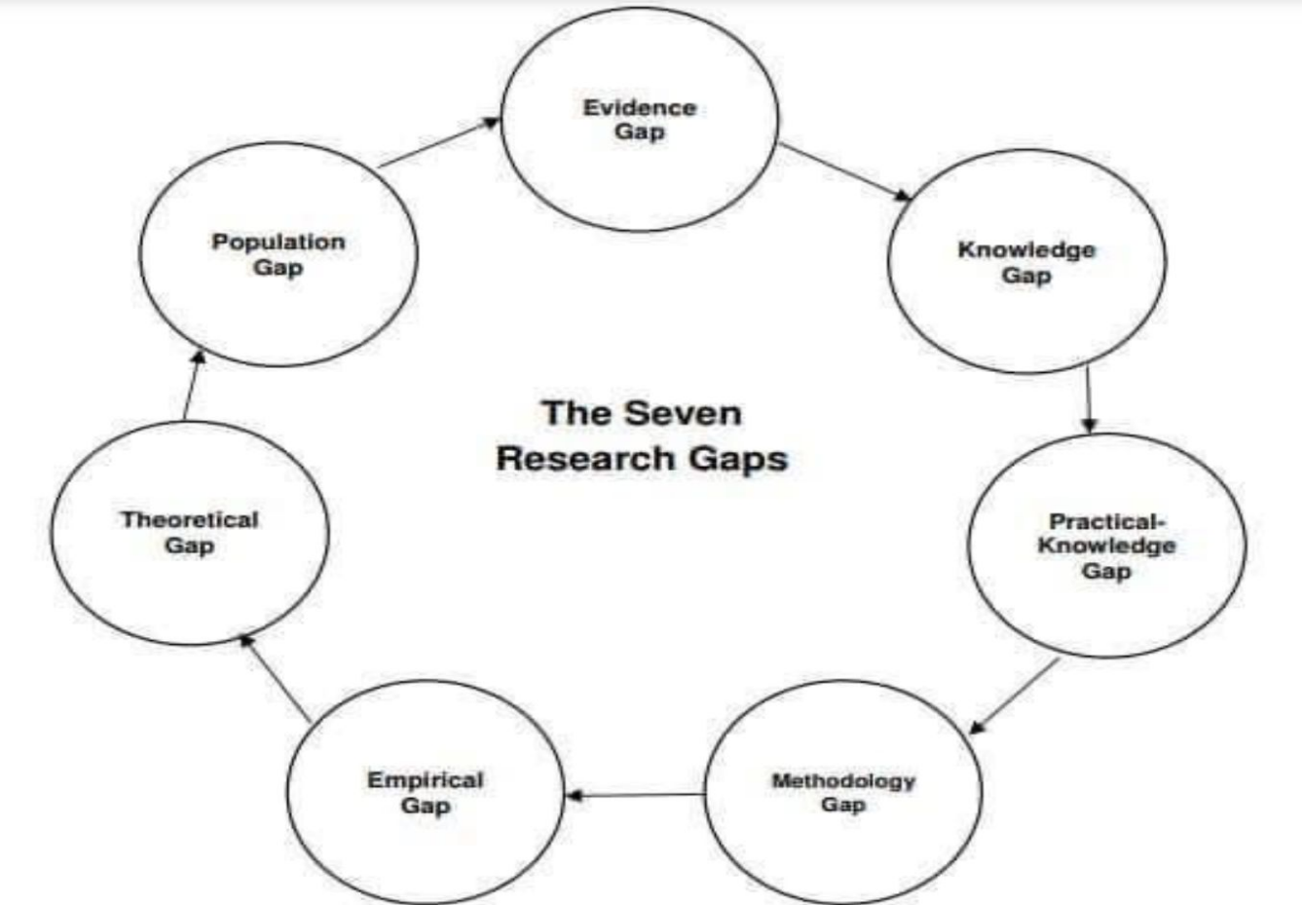

- Part 2.
Basic structure.
Insert the title of your work.
Introduction- definitions, likely variables, plan for the review.
Theoretical background- key theories, main writers, (possibly preferred methodologies) debate, discussion, examples. What is the gap? What are the main controversies?
Conclusions/Recommendations.- the verdict on influential variable, these become your “shopping list” of thing you need to investigate in future modules and your final thesis.
Theoretical recommendations on policies- for researchers, businesses/organisations, government, trainers etc, whatever is relevant.
Reference list- I did say 2 references list for each section. All source to be put into Part 3 bibliography with your commentary.
HOWEVER I have compromised. Some of you have merged the reference lists and have ONE covering parts 1 and 2. If you have done this DO NOT waste time splitting them now.
- Part 3. Do insert some analysis of the criteria for your comments on the sources in your bibliography.

For example:

- Not a reliable academic source.

- Too dated a source for this dynamic contemporary topic.

- Too focused on western cultures when the review seeks to explain Asian applications.

- A classic theory, which is also available in updated forms, but worthy of inclusion in its original format.

- An industry /blog source not refereed however very current . Stringer than even recent academic sources, due to the time lag between research conducted and publication.

- Unreliable media source, but stimulated interest in the topic and referenced academic sources, which will be included.

Best wishes

Steve

