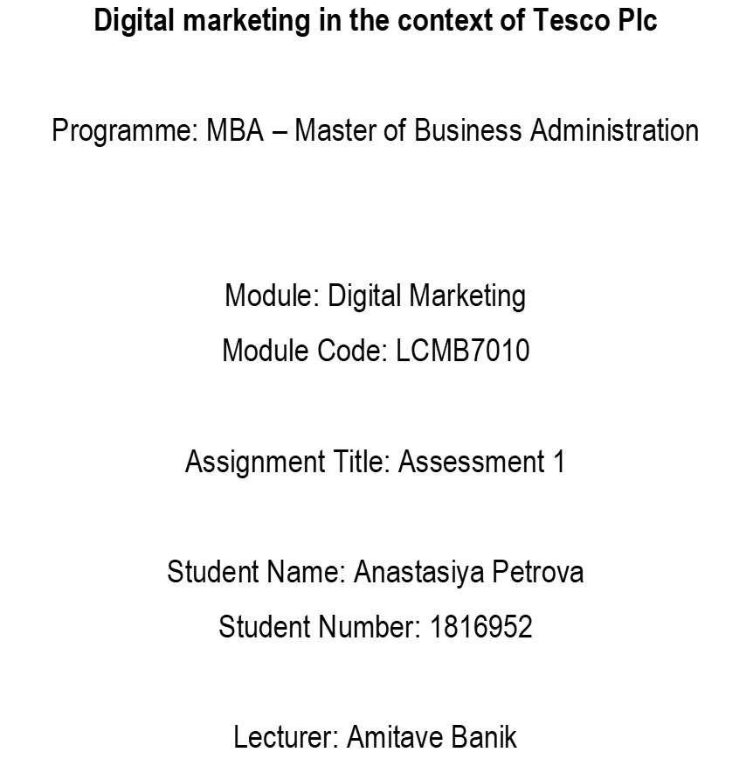

Background
Every business aims to attract as many customers and users as possible, and marketing is the key to attracting them and generating leads. Along with traditional advertising, experienced companies increasingly rely on digital marketing. The COVID-19 pandemic has forced many businesses to enter the digital age quickly by switching to the digital model to survive. Companies realise that digital technologies increase productivity and profitability, and digital marketing provides many innovative solutions.
The report presents the power of digital marketing and how businesses benefit from it to ensure company growth. In the digital marketing context, an analysis of the global retail market where the analysed company operates is presented. In addition, the report analyses the digital assets the company owns, focusing on the website and structural communication flows. Also, it gives the internal and external communication structure flows and the digital marketing strategies implemented in the company's marketing mix. Based on the research, a critical assessment of the effectiveness of digital marketing in the media and social sphere is presented. Furthermore, it shows how Artificial Intelligence is transforming Digital Marketing and customer segmentation, which helps in predictive decision-making and actions, covering the applications of machine learning that increase the return on investment (ROI).
To achieve the report's objectives, the digital marketing strategy of the UK's largest retail organisation, Tesco Plc, was s used. The company is multinational, focusing on digital marketing strategies as part of its strategic planning to achieve sustainable growth in the future.
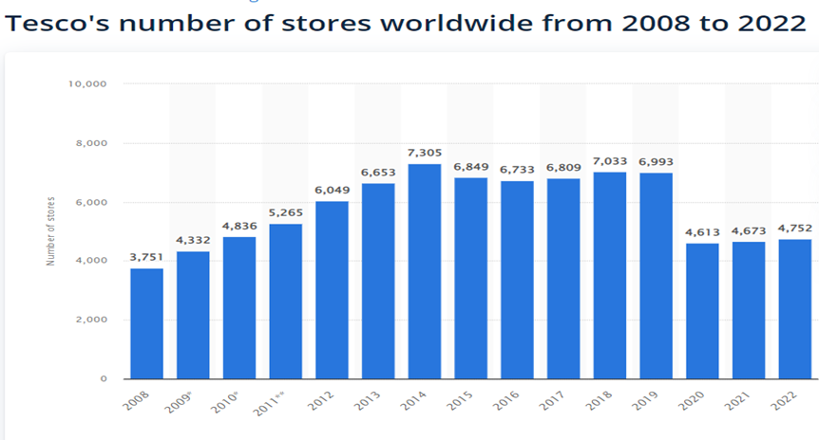
Source: Statista (2022)
The primary industry in which the brand operates is grocery retail, with expansion into retail banking and insurance businesses. The report considers only the retail division, where the retailer offers approximately 40,000 products (Tesco, 2022).

Table of content:
Background...................................................................................................................... p. 2
Part 1
Introduction...................................................................................................................... p. 5
Digital Marketing in the context of Tesco ..................................................................... p. 7
Platforms Involved in digital media ............................................................................... p. 7
The contribution of digital technologies to marketing .................................................... p.10
TESCO applications of digital marketing ....................................................................... p.11
E-business and E-commerce relationship ..................................................................... p.13
Advantages and disadvantages of digital marketing ..................................................... p.16
Tesco Digital Marketing SOSTAC plan ........................................................................... p.17
Objectives ..................................................................................................................... p.18
Strategy ......................................................................................................................... p.18
Tactics - 4Ps .................................................................................................................. p.19
Action and control........................................................................................................... p.20
Tesco's Interactive Marketing Communication flow, strategy and digital assets ...... p.21
Part2
How Artificial Intelligence Is Transforming Digital Marketing ..................................... p.26
Conclusion ....................................................................................................................... p.32
Recommendations ........................................................................................................... p.33
References ........................................................................................................................ p.34

Part 1
Introduction
Strauss (2016) argued that digital marketing is defined as the marketing and publicity of a particular company's products, services and facilities with the help of a digital platform used, and digital technologies are defined as digital marketing methods. Some of the digital technologies are the Internet, display advertising, search engine optimisation, influencer marketing, social media and e-commerce marketing. A digital marketing strategy is a set of planned strategies based on analysing researched information about customer behaviour. According to Armstrong et al. (2015), digital marketing differs from traditional marketing by using all digital modes of communication and technology to reach a wider group of customers. Furthermore, they argue that the digital marketing planning framework consists of several main stages: Opportunity, strategy, action and control. Both definitions imply that digital marketing aims to achieve marketing goals through digital technology.
Digital marketing promotes a product, service or facility through digital technologies to reach customers. According to Chaffey (2019), digital marketing focuses on managing a company's online appearance and performance to achieve marketing objectives. Websites and social media platforms are the channels in which the company is represented, requiring special communication techniques, for example, email marketing, search engine marketing, social media marketing, content marketing and some others, discussed in the following sections of the report. Digital marketing is developing quickly, and the techniques used are also, for this it is necessary to follow the new marketing approaches and trends. A marketing plan is needed for successful marketing activities, clearly defining the communication and promotional strategies that lead to achieving the company's goals (Fomina, N., 2020).
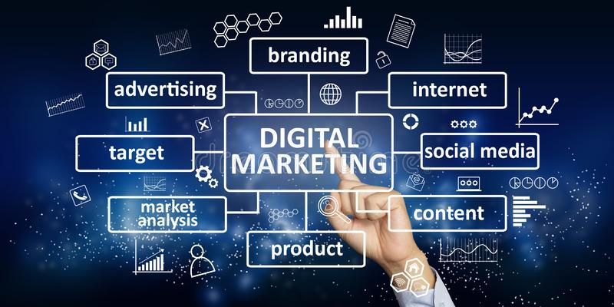
Source: University of Salford Manchester, (2022)
The scope of digital marketing technology has evolved, and businesses are keeping up by integrating online components with their physical storefronts or integrating multiple online marketing tools to build an online following (Mishra, 2020). The key features of digital marketing are that it offers an integrated system customised to meet consumers' needs (Kotane, 2019). In addition, it can track customer behaviour, provide detailed product specifications, create unlimited stock, inventory products, and display them to target audiences at a lower cost than other forms of marketing, such as print media and television promotion.
Mishra (2020) argues that E-marketing refers to promotion types done online using websites, online storefronts, and related software services. E-commerce refers to an online business incorporating financial activity, open communication, and a business transaction network via the Internet. The practice of web-based business procedures on either the Internet, an extranet, or both are referred to as e-business. The critical digital marketing options for growing a business include identifying the target audience; using a mobile-first responsive website; building a social media presence; having a Search Engine Optimisation (SEO) assessment; executing regular SEO maintenance; establishing several marketing channels; providing valuable content (Mishra, 2020). Digital marketing benefits companies by reaching more customers. The University of Salford Manchester (2022) argue that content marketing defines the power of digital marketing. B2B content marketing tactics are social media content, e-newsletters, company website articles, blogs, and in-person events. The importance of digital marketing in terms of SEO (Search Engine Optimization) is invaluable. The goal of search engine optimisation (SEO) is to optimise the content, technical set-up and scope of a company's website so that it appears at the top of searches for a given keyword. Thus, search engine optimisation attracts visitors and potential customers to the business site. It is essential because it helps searchers be directed to the brand more easily and quickly.
As mentioned below, the benefits of the 5 S's of digital marketing offer an essential foundation for reviewing and defining the objectives of digital marketing.
Sell - Increase sales. Direct sales - products can be available on the Internet, and sales via physical stores are included online (Chaffey and Smith, 2017).
Serve - Add quality. It is attained by providing additional advantages to clients online or driving product research and development through digital interaction and insights (Chaffey and Smith, 2017).
Speak - Get acquainted with consumers. It establishes a two-way discussion using dialogue sales promotion, which offers virtual user engagements through blogs and online chat, as well as online consumer analytics (Chaffey and Smith, 2017).
Save - Cut expenditures. It reduces personnel, print, and postal expenses through online email communications, sales, and service transactions (Chaffey and Smith, 2017).
Sizzle - establish an online presence. It is reached by providing innovative solutions, unique offers, and remarkable online concepts, such as creating and sustaining (Chaffey and Smith, 2017).
Digital Marketing in the context of Tesco
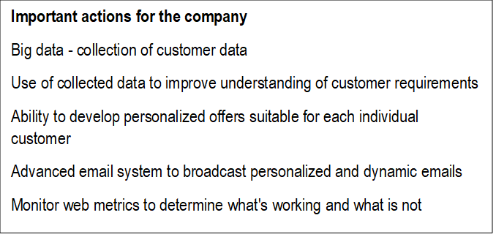
Platforms Involved in digital media
There are various methods for getting to a web page, including utilising the Uniform Resource Locator (URL) and hyperlinks, navigation tools and saved pages, and using search engines like Google, Yahoo, and Ask. Dual screening is an effective marketing strategy that allows advertisers to reach an audience viewing conventional media and getting customised messaging online. These might include incorporating trending online insights and reviews during broadcasts or significant current developments (Madan, 2021).
Desktop apps are software programmes that operate independently on personal computers, cannot be accessed through a browser, and must be installed on the computer (Plantin and Punathambekar 2019). Desktop programmes enable more attention, fewer interruptions, and greater accessibility to critical information. Email marketing (newsletters) is used to improve customer interaction, gain more customers, raise brand recognition, and reinforce repeat business. Email marketing focuses on interaction and visibility for current customers and prospects (Plantin and Punathambekar 2019).
The Programming Interface (API) is a conduit that handles inquiries and enables corporate systems to function correctly (Plantin and Punathambekar 2019). Application API allows the interface of data centres, programs, and endpoints, which is critical to every online business system. Mobile app marketing entails communicating with clients from the moment they learn about a company's app until they become frequent and devoted subscribers. It is accomplished by determining the target audience and marketing content (Plantin and Punathambekar 2019).
Tesco extended out to customers through various platforms, but social media emerged as a crucial frontline, allowing the corporation to reach audiences and expand the message's impact. The company employed social monitoring to determine consumers' desires and then tailored the associated offers accordingly. Tesco, in partnership with dunnhumby, a global leader in Customer Data Science has developed a new Media and Insights platform, the retailer's data analytics arm, to support strategy and drive successful consumer engagement. (Tecko,2021). Brands and agencies can benefit from Tesco's scale through this platform. Furthermore, Clubcard's data connectivity helps gain clear insight and appropriate targeting accordingly. Also, the data from the platform informs the brand's strategy with Tesco and the market.
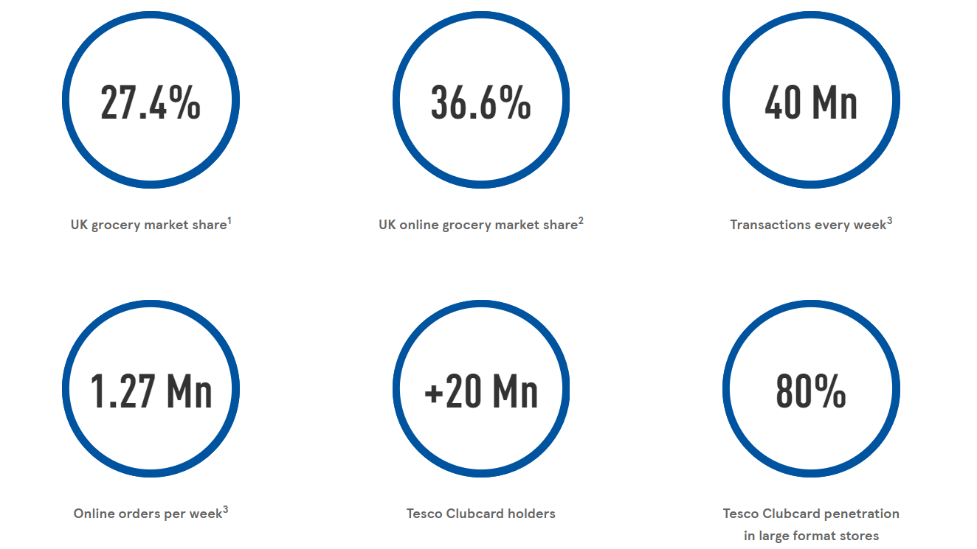
Source: dunnhumby, (2022)
The platform includes a suite of products, such as Media and Insight.

Media
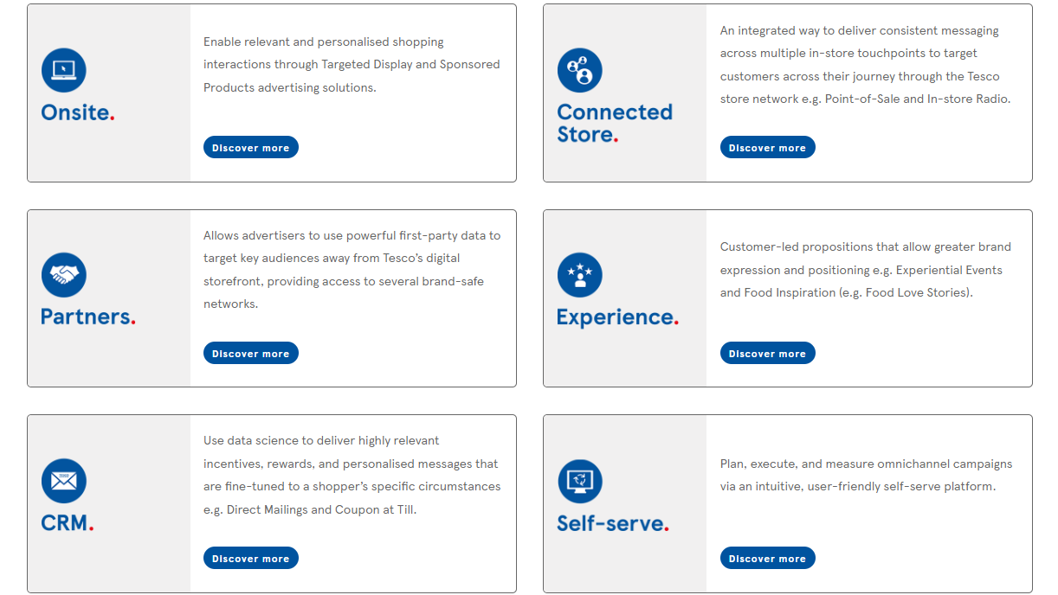
Source: dunnhumby, (2022)
Insight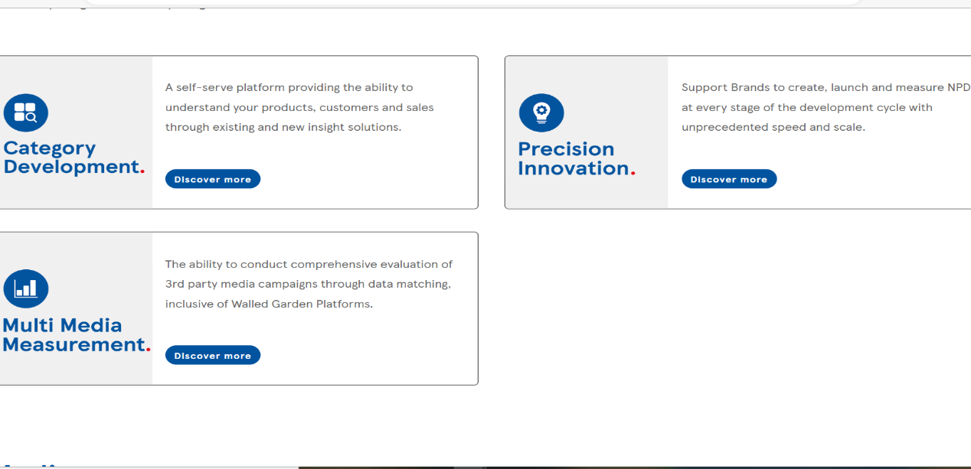
Source: Source: dunnhumby, (2022)
Digital marketing and its societal aspects imply that it generates instantaneous interactions that create massive amounts of data and client purchase behaviour. Tesco is integrating in-store innovations with revolutionary internet services to offer its customers an exceptional retail shopping experience. Foley, J. (2022) states that to implement its multi-channel marketing approach, Tesco employs several Oracle applications (Oracle Retail, Oracle Commerce, and Oracle ATG Web Commerce).
The contribution of digital technologies to marketing: Using consumer-oriented advertising allows marketing to increase product or service exposure, consideration, acquisition or purchase decisions, and customer desire (Classen M. and Friedli T., 2019). Digital transformation helps Tesco identify potential customers by conducting online market research to determine consumer requirements. While marketing anticipates, online technology allows businesses to tailor offers to customers by building a database of their purchase history and propensities. A crucial aspect of performance in e-marketing is ensuring user satisfaction through the online platform by solving issues such as creating a user-friendly website that works properly, establishing satisfactory customer service and the way physical things are delivered (Chaffey, 2018). Engaging with technological innovation in digital marketing enables businesses to accelerate their trajectory (Ponzoa and Erdmann, 2021).
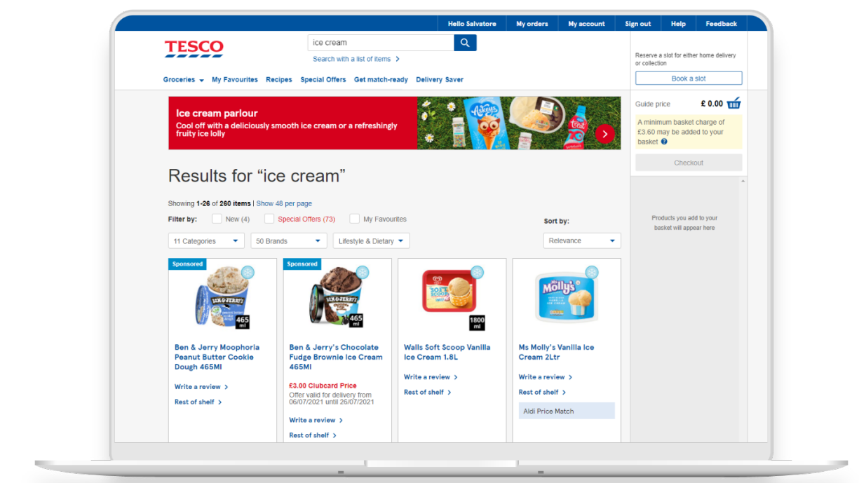
Source: dunnhumby, (2022)
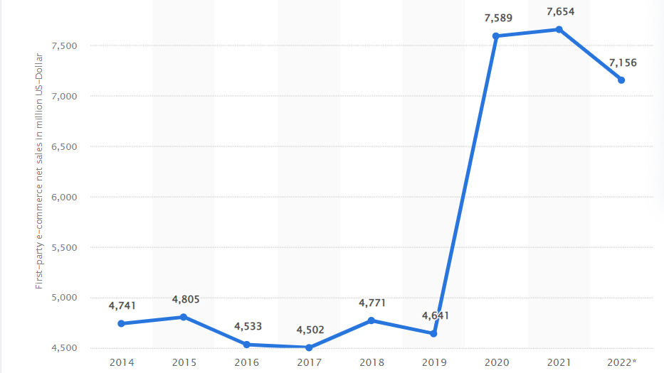
Source: Statista (2022)
Tesco applications of digital marketing Tesco's tailored advertising and featured product promotional solutions on Tesco's digital platforms are delivered through on-site marketing. Tesco's mobile app provides an instant and direct response to customers, allowing them to identify nearby stores, verify their Club card during checkout, create a shopping list to purchase online, and even browse menus. The company's online transactions through the Urban Fulfilment Centre (UFC) have helped the retailer's e-commerce operations. It allows the corporation to serve extra delivery windows for consumers with a faster picking pace, increasing efficiency in meeting continuous online traffic demand (Ponzoa and Erdmann, 2021).
Tesco Direct online website
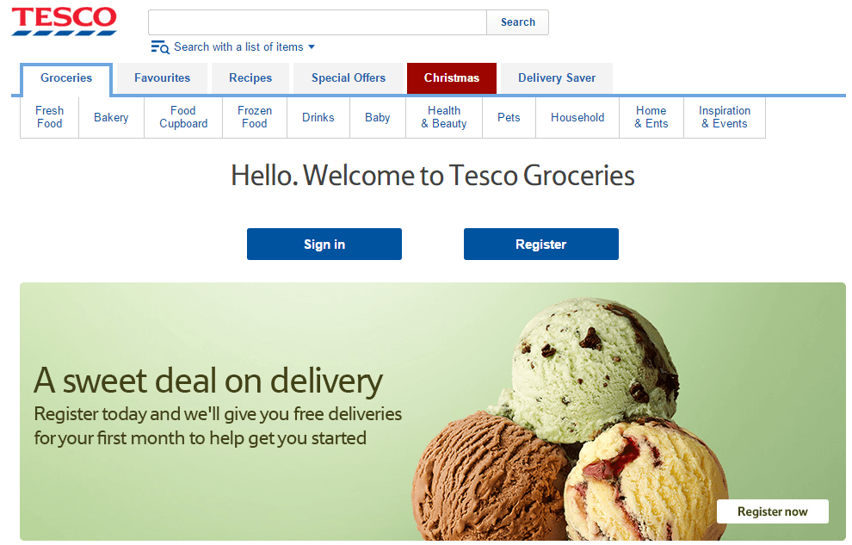
Source: Tesco Direct website
Tesco's online signature of low prices promotional strategy contributes to lead generation, attracting customers, and their creative content on tested channels. Tesco distributes its goods online through its website. To benefit from its delivery services, customers must first sign up for an account (Ponzoa and Erdmann, 2021). The company delivers commodities to consumers' residences once they place an order. Tesco strives to provide the most significant potential value for their clients' budgets by offering exceptional items, good services, appealing outlets, and affordable pricing. Tesco Clubcard broadens customer relationships in new directions by providing: the opportunity to earn Clubcard points through payments; the ability to utilise loyalty points with a variety of recreational and affiliated platforms; and the loyalty component of the strategy, which is accessible via the web (Yawson and Yamoah, 2022).
Tesco Clubcard Tesco "goods to person" picking
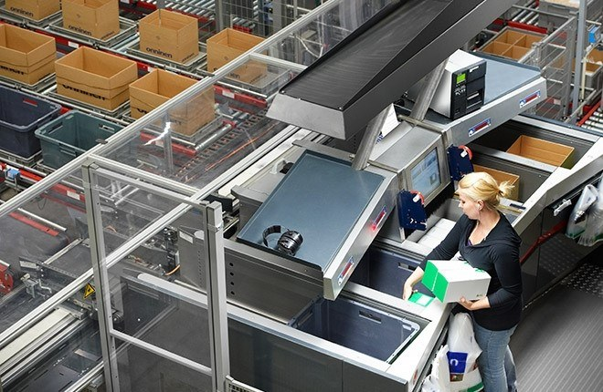
Source: harvard.edu (2016)
In-store:
Scan handheld device
Self Service Checkout
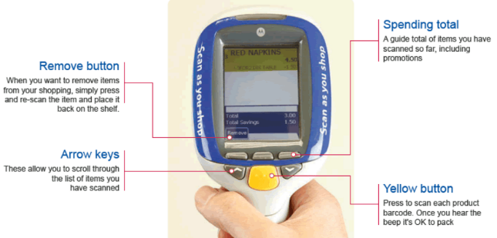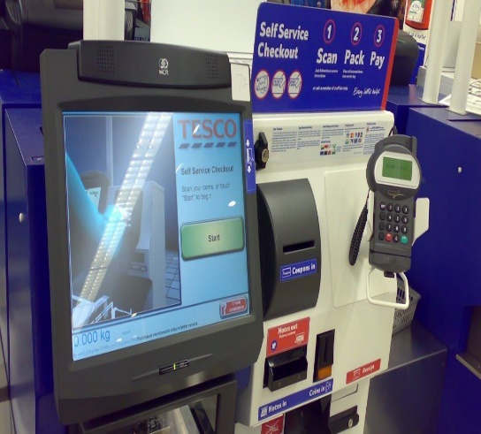
Electronic shelf edge labels
Store 'Broccoli cam'
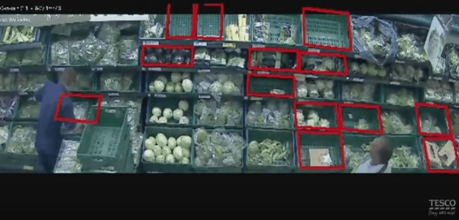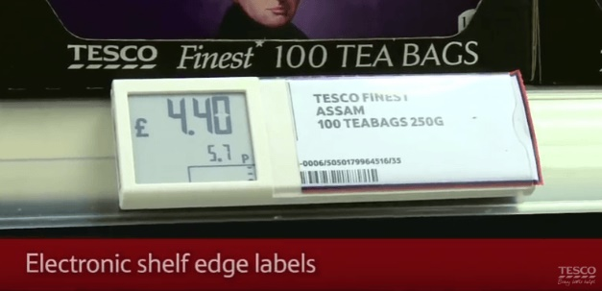
Source: harvard.edu (2016)
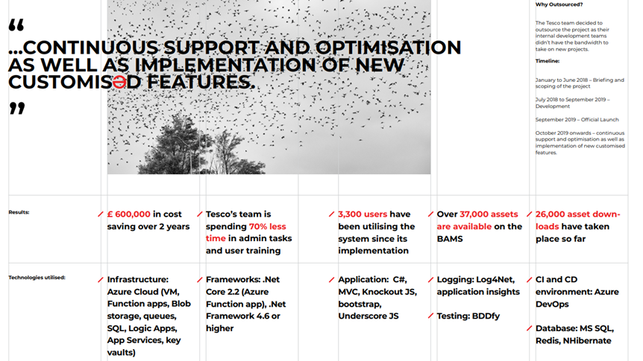
Source: Haefele-software (2020)
E-business and E-commerce relationship
E-commerce is the term used to describe online transactions, including purchasing or selling products or services (Rath, M., 2022). A company can grow by building a corporate strategy based on e-commerce, which allows it to connect with clients in remote places without incurring the costs associated with traditional brick-and-mortar stores (Rath, M., 2022). While e-business includes online transactions such as e-commerce, it also encompasses a variety of tasks besides just purchasing and selling products and services. As a result, e-commerce might be viewed as a component of e-business. E-business covers all aspects of business operations conducted virtually over the Internet (Rath, M., 2022).
Below is a discussion of the five ways in which Tesco conducts digital marketing.
Search Engine Marketing System (SEM)
SEM is the practice of promoting a firm through paid advertisements on search engine results pages (SERPs), allowing the ads to display along with the results for specific web searches (Panchal et al., 2021). Tesco is particularly dominant in keyword search in Google's search engine, with 50% of the e-commerce grocery industry, and has established category-specific algorithms centred on critical vital phrases across the supermarket industry (Panchal et al., 2021). Daily, Google searches for these terms yield URLs that are recorded.
Social Media Marketing System
Social media enables Tesco to engage consumers and expand its marketing content exposure. The company uses social media to determine its users' needs and tailor its offers to meet them. Tesco's sponsored and spontaneous engagement on Facebook, Twitter, Instagram and Snapchat performed exceptionally well, with unique materials created for each channel (StudyCorgi, 2020). For example, the "Prices that give you back" campaign on the company's centenary reached discounters through many channels. Social media enabled Tesco and creative agency BBH to attract and engage customers, driving the message's reach. Tesco uses social networks to tailor its offers based on social listening to customer wishes.

Source: Tesco (2021)
Search Engine Optimisation System (SEO)
SEO is the process of improving a business website to increase its visibility when people search for products or services related to the business on search engines. The types of SEO are Off-page SEO – the focus is on social media presence and presence on any other website; and On-page SEO, where the focus is on the own website. The SEO project that Tesco conducted in 2020 saw a year-on-year increase of 13.91% in terms of average website clicks on Google My Business (Panchal et al., 2021). Tesco can now provide consumers with more direct search results that will engage them on the search page rather than redirecting them to other websites, courtesy of SEO.
Online visibility score of leading grocery delivery websites in the United Kingdom (UK) in 2021
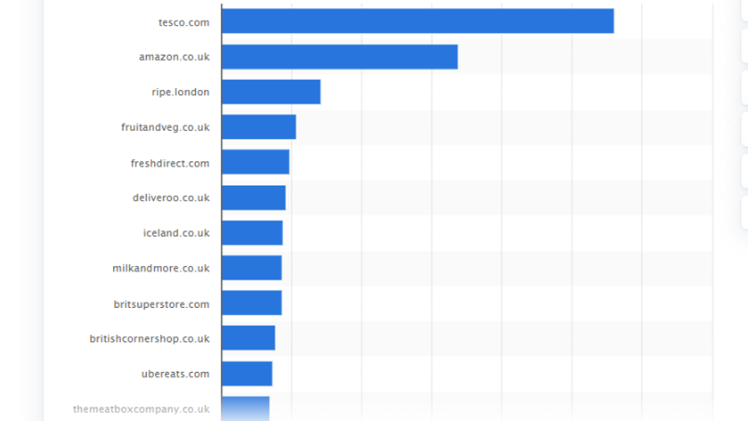
Source: Statista, (2022)
The tools TESCO use to analyse and track websites
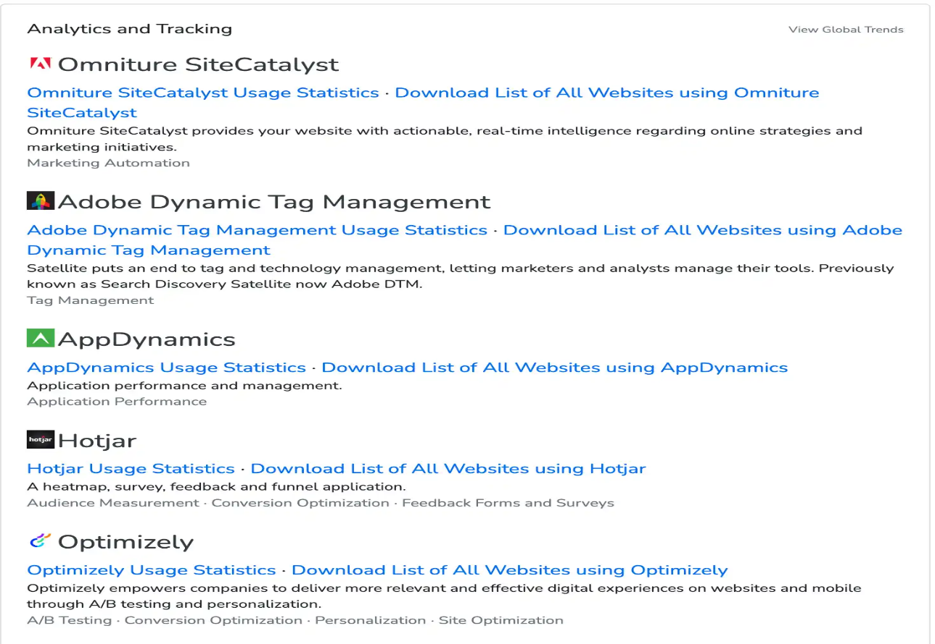
Content Marketing System
Tesco's content marketing is a proactive marketing technique aimed at attracting, retaining, and driving lucrative consumer action through creating and distributing interesting, engaging, high-quality, inspiring content published on its platforms. Tesco's fresh produce information is hosted in a subdirectory accessible by clicking the "recipes" option on the site (Moth, 2020).
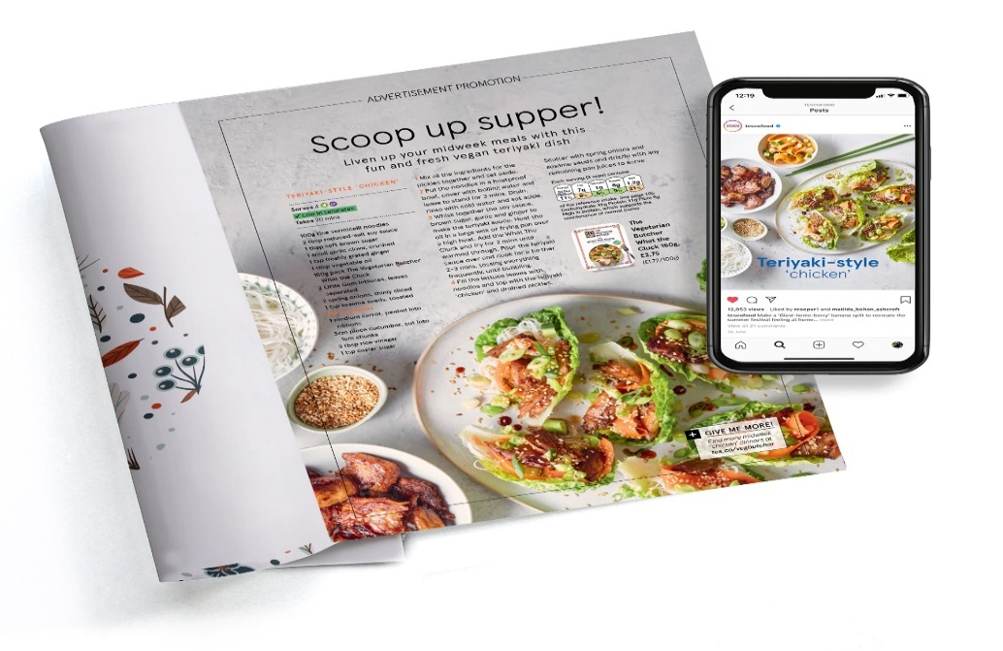
Source: Tesco Real Food (2021)
Email marketing System
According to statistics, Tesco is steamrolling the UK with marketing emails, sending over 25 million emails every month. Tesco considers emails critical to its digital marketing strategy, accounting for around 60% of its online income. In response, Tesco devotes greater attention and resources to emailing (Tesco, 2022). Tesco uses Clubcard data to broadcast personalised emails.
Market share of grocery stores in Great Britain from January 2017 to September 2022
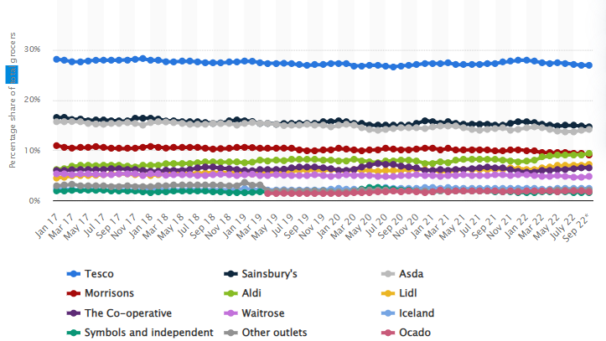
Source: Statista, (2022)
Advantages and disadvantages of digital marketing
The main advantage of digital marketing is that it allows continuous performance optimisation. A company can benefit enormously from digital marketing. It provides local and global reach and visibility. Digital marketing offers firms low-cost alternatives and a wide range of campaigns that are simple to implement. It helps firms reach out to clients more efficiently by employing multiple promotional campaigns. Furthermore, digital marketing aids businesses by increasing engagement through diverse content in blogs, visuals, infographics, and podcasts. Another benefit of online advertising is web tracking, which instantaneously evaluates the results of online marketing efforts (Madan, 2021).
The major disadvantage of digital marketing is that it is purely dependent on technology, considering that the Internet might encounter errors. It is also time-consuming to organise the best strategies to adopt. Digital marketing initiatives are getting increasingly competitive. As a result, businesses must be responsive to their users' requirements and react promptly.
However, digital marketing is transforming, featuring various challenges. Implementing a client-centric strategy is challenging, especially given how rapidly consumer demands and standards change. The need for intriguing and engaging information is growing, and it has lately evolved significantly as video and audio have gained popularity. Marketing professionals are constantly faced with changing privacy legislation and the phase-out of third-party analytics.
Tesco Digital Marketing SOSTAC plan
The SOSTAC is a planning model used in marketing to evaluate processes. It enables the assessment of weaknesses, situational analysis, the feasibility of goals, appropriate strategies selection and implementation, execution of selected strategies and performance control for the company's profitability (Faull, J., 2021). Digital marketing planning refers to a unique and creative style of sales promotion used by many corporate organisations to accelerate their performance (Blakeman, 2018). The digital marketing strategy is a stream of tactics representing a consolidation of studied data concerning consumer behaviour patterns (Zhu and Gao, 2019). They must examine sales and marketing potential, create a structured digital framework, and then take appropriate action by assessing the necessary budget and control systems (Zhu and Gao, 2019).
SOSTAC® marketing planning model
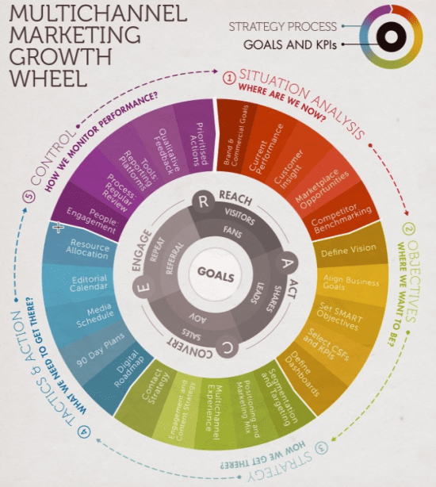
Source: Chaffey D. (2022)
Situational analysis in terms of Tesco Plc is presented in Appendix 1.
With its vast market potential and effective strategic solutions and marketing tools, Tesco has the potential to increase its revenue and maintain its competitive advantage.
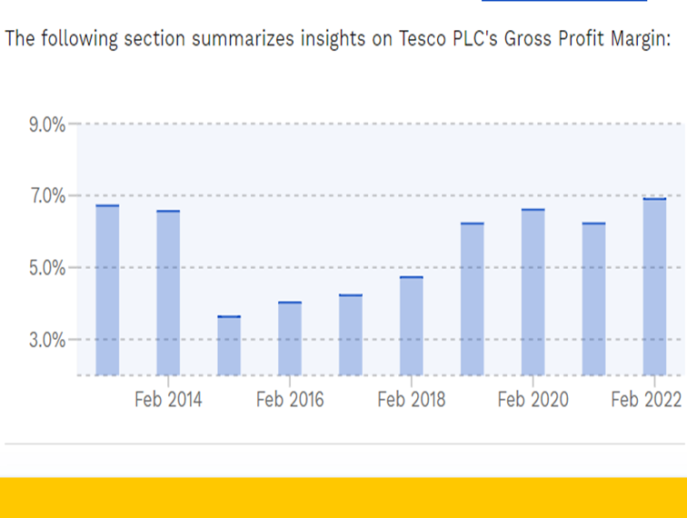
Source: Finbox (2022)
Upgrading online businesses and e-commerce sites can ensure a pleasant shopping experience for customers and their brand loyalty.
Objectives:
- Increase revenue by 30% by expanding online customer interaction for 2022.
- To deliver value to services and goods by developing exceptional online services capable of generating a more comprehensive response while meeting individual requirements.
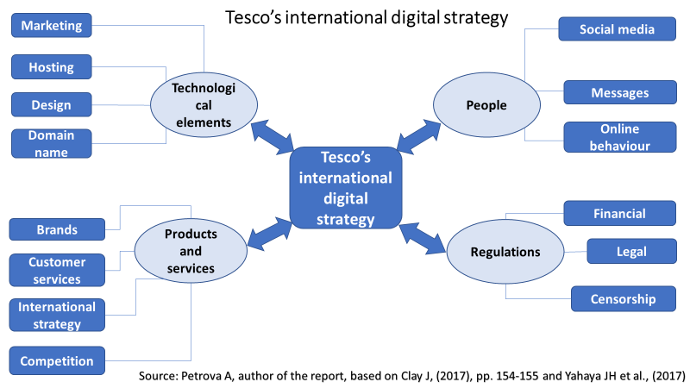
Tesco STP strategy
STP is a strategy assisting organisations in dissolving the customer base into manageable subgroups when pursuing specific client segments with particular products or services (Kozielski et al., 2022).
Tesco STP outlines its target audience with its products by subdividing its marketplace. The practice of organising a market into segments based on geographic, demographic, psychographic, and behavioural criteria is known as segmentation. Tesco has geographic units in the UK and thirteen other countries within urban and rural areas. The company's demographic is all age categories, skilled, working class, lower and middle classes.
Targeting is the process of selecting subgroups obtained through segmentation to offer products. Tesco's target customer segment consists of cost-conscious individuals who are interested in bargains and sales and value various choices.
Positioning comprises identifying the best marketing strategy for the intended audience category. Tesco adopts a multi-segment positioning approach, simultaneously addressing many segments with various products.
Tactics
The implementation of strategies requires competent and differentiated tactics. The adoption and integration of promotional tactical solutions drive the process. The right marketing mix and an effective communication strategy help a company's strategic performance. Tesco considers tactical ventures part of a generally approved marketing mix based on the framework of the 4Ps (product, pricing, placement, and promotion).
Product:
Tesco's many outlets provide a wide variety of products. Food, beverages, electronics and entertainment supplies, household goods, health and beauty products, fashion, and accessories are all examples of product lines offered at Tesco stores. Everyday Value, Tesco Loves Baby, Tesco Lotus, Tesco Bank, and Tesco Value are also brands owned by Tesco (Tesco, 2022). Tesco also markets its goods online through its e-commerce portal and has scrutinised more than 30 food segments and lowered product offerings to centre on essential commodities.
Price: Tesco's pricing scheme is based on a cost leadership approach. Tesco offers the most affordable products while preserving quality. It employs economies of scale and the finest tender documentation to reduce costs. The retailer constantly engages with its suppliers to optimise and consolidate the distribution network to minimise expenses.
Place: Tesco owns over 7,000 outlets throughout the globe, which are featured as store categories based on their size and corresponding traffic. Tesco Metro, Tesco Extra, Tesco Express, and Tesco Superstore are the four categories (Tesco, 2022). Tesco stores are massive warehouses that retail consumables and a limited selection of non-food goods. The UK retailer's official website also serves as a significant e-commerce gateway, allowing people to buy things online and have them delivered.
Promotion: Tesco's marketing initiatives revolve around its cost-cutting approach. The brand promotes itself through signage, television commercials, and charitable activities. It also makes extensive use of special rebates and discounts. Tesco offers a loyalty scheme known as the Tesco Clubcard, which enables the company to define and target its consumers (Yawson and Yamoah, 2022).
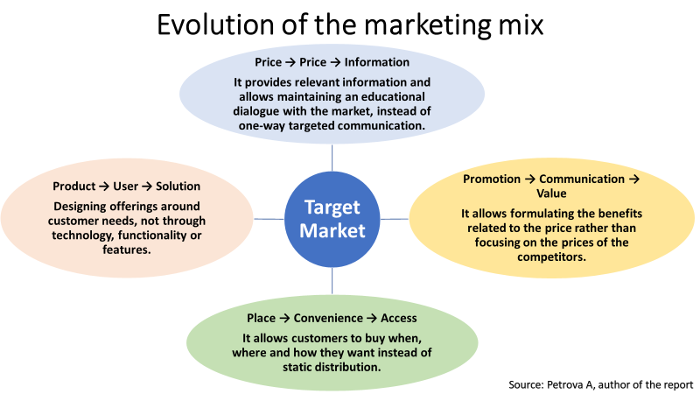

Action & Control
Action is the flawless implementation of the corporation's goals and objectives, and risk management is a pivotal component of the action stage of development (Zhu and Gao, 2019). Tesco's management has placed a high value on carefully preserving its basic plans and is constantly poised for potential risks. Management of processes and systems, competency and human resource management, and guaranteeing the reliability of different entities are all essential parts of Tesco's digital marketing campaign.
Tesco's Interactive Marketing Communication flow, strategy and digital assets
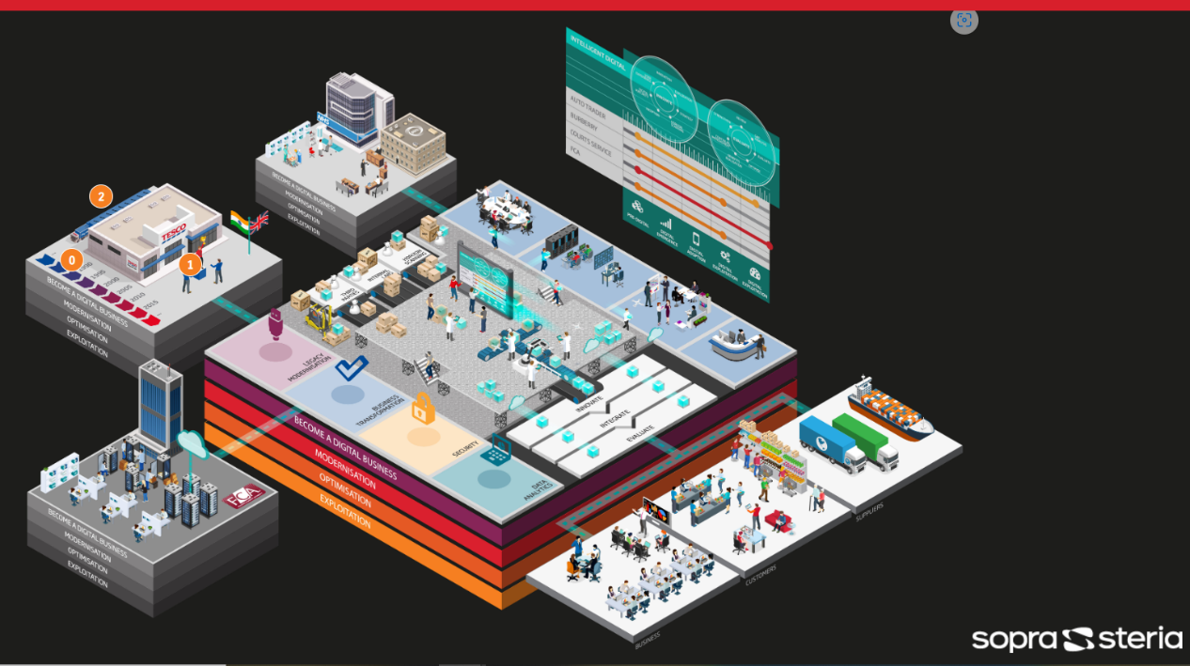
Source: canyouclarify.co.uk/soprasteria/tesco/ (2016)
Interactive marketing is a direct marketing approach that relies on the behaviours of existing and potential customers. It entails promotional endeavours that are prompted by clients' behaviours and demands; as a result, it represents a significant shift from conventional campaign-based marketing efforts to digital marketing (Lim et al., 2022).
The Internet becomes highly beneficial with its connection to the company's marketing efforts. Tesco has several avenues to send coherent and unique content to its potential customers. The following are the fundamental aspects of integrated communications (Lim et al., 2022):
Uniformity: All channels of communication must be interconnected.
Consistency: All messages express the same content.
Continuity: All interactions remain the same throughout.
Complementary: All communication channels should collaborate to create coherence in the promotional strategy.
Tesco data storage
Tesco manages diverse data sets, including client, stock, orders, transactions, and supplier information. Regardless of the data collection methodology used, all critical material is electronically stored in the content management system, which is the central database (Nurwidayat et al. 2019). A Customer Relationship Management (CRM) system is a corporate strategy and software that nurture leads, collect, store, and utilise all data relating to customer interactions to establish customer loyalty. The digitalisation of corporate and consumer data necessitates the electronic storage of all vital information, whose responsibility lies with the company's internal IT department (Nurwidayat et al. 2019).
Tesco's director of data science heads the IT department with other functional units in product engineering, information and business intelligence analysis, technology management and systems engineering, who practice an open interaction but operate independently, reporting to the director of data science (Nurwidayat et al. 2019).
Website
The Digital Design Language is a framework that Tesco teams use to develop sites and applications that are distinctive "Tesco" and attractive to clients. The website has a homepage with an on-site search, product list and filtering, cart and checkout, customer accounts and orders tracking sections, and a product page (Ring et al., 2019). The 4Q Intent-satisfaction service is a survey that tests customer satisfaction through the following questions.
What is your reason for visiting our website?
Were you successful in completing your mission?
Why not if you did not accomplish your mission?
What is your general satisfaction level?
Tesco's dynamic website contains data that may be volatile or variable. A website may produce different content for different visitors from the same source code file, and client-side web pages change based on their web page activity. On the server side, web pages reverse each time a web page is loaded (Yahaya JH et al., 2017).
The architecture of a dynamic website
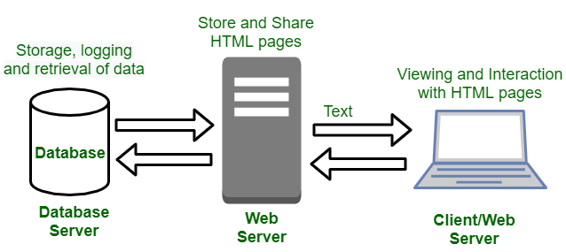
Source: Geeks for Geeks.org, (2022)
Tesco website structure
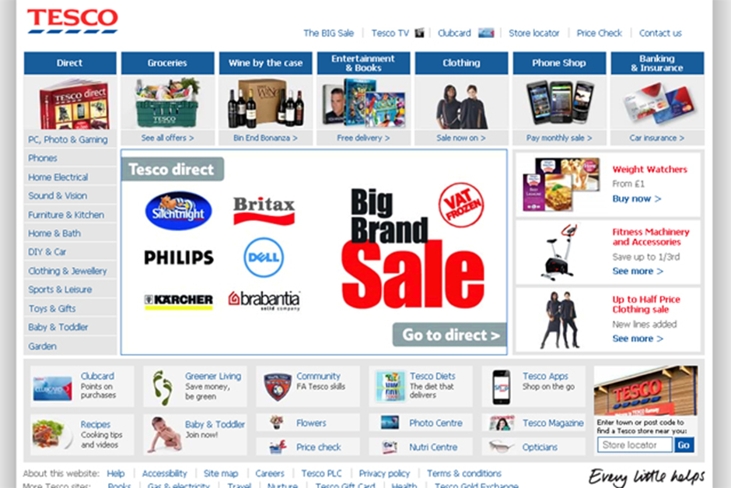
Source: Tesco (2022)
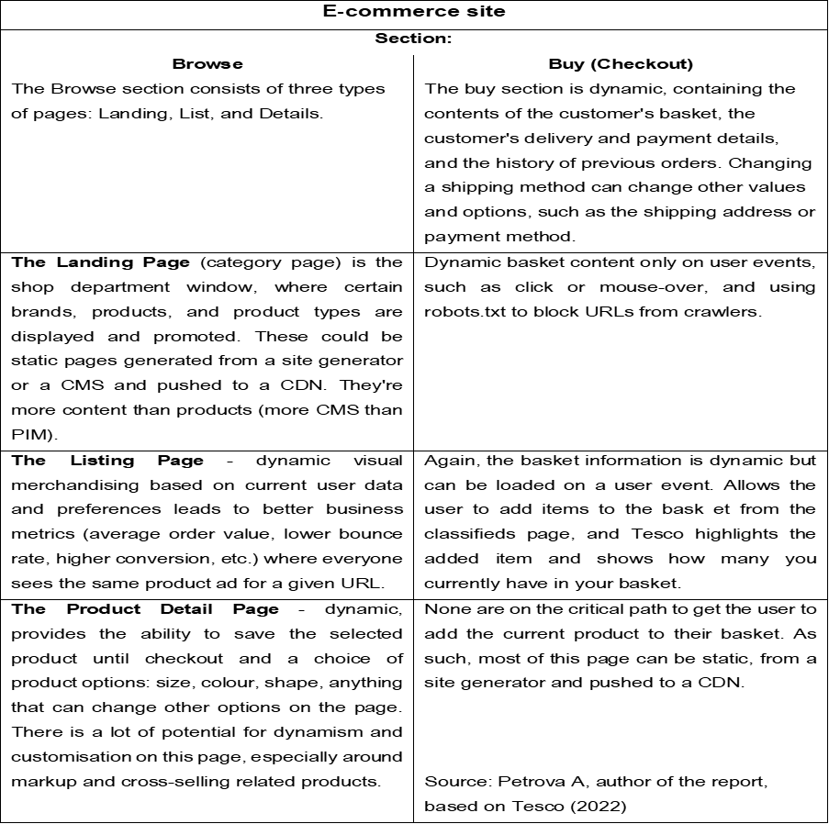
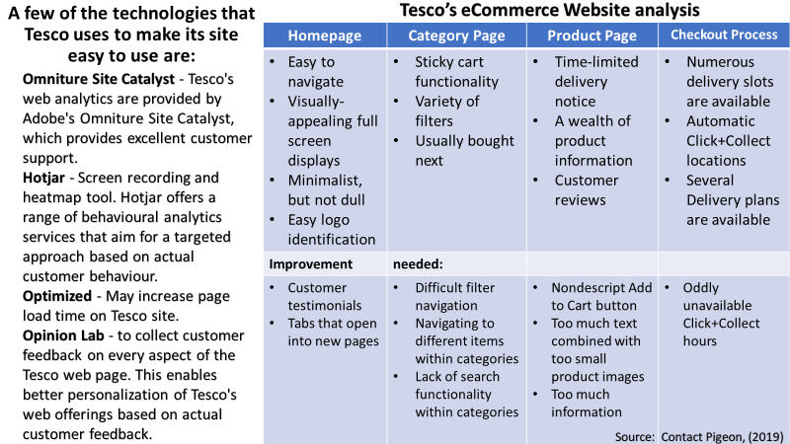
Ratings on Tesco
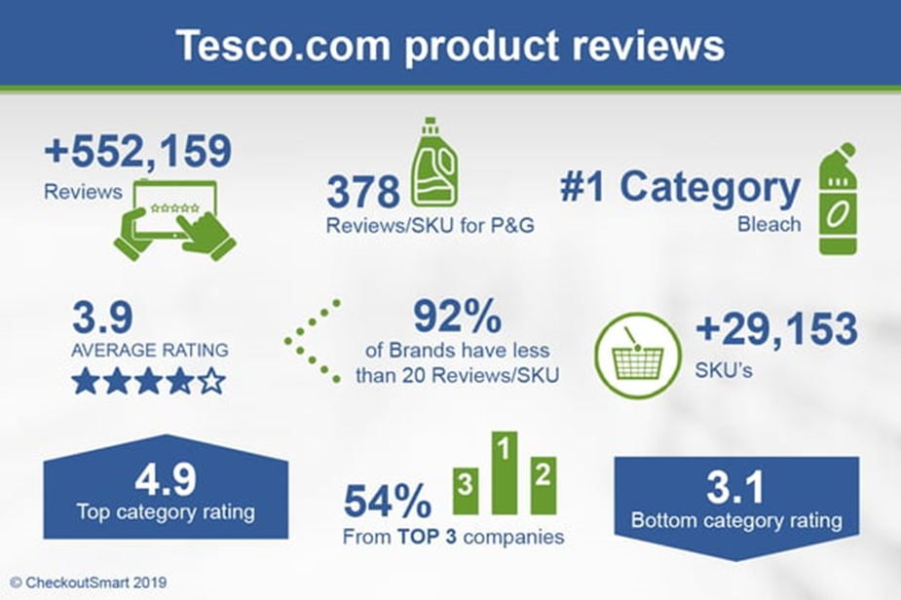
Source: Statista, (2022)
Stages needed for an effective website/social media presence
Identify the target audience: Determine the social media sites the prospective clients frequent, when they are usually engaged, and how they engage with one another.
Goal setting: Set goals which are 'SMART' (specific, measurable, achievable, realistic and time-sensitive (Ring et al., 2019)
Know the success metrics: Determine the critical success indicators, such as organic search, referral traffic, opinions, and engagement.
Selection of the best management tool: Choosing the finest online marketing systems will simplify the numerous chores and save time (Ring et al., 2019).
Creation of curated content: Make sure the information is tailored to the target demographic, and this will increase engagement and brand exposure.
Evaluation and optimisation: Sprout and buffer social analytics can analyse and monitor social media marketing efforts and compare the data to KPIs (Ring et al., 2019).
The key requirement is that an effective website should be well designed and functional, user-friendly, optimised with quality content, indicate contact and location and engage clear calls to action to visitors. Online presence marketing involves the use of websites and other digital tools. Another online presence brings all these resources together in one place, while web design streamlines the whole approach to digital marketing by offering an overall perspective (Odeh A.H., 2019).
Communication mix framework

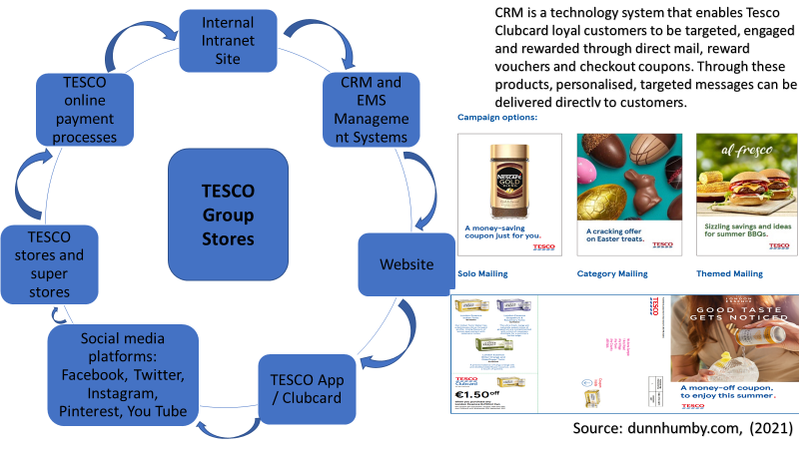
Tesco has developed an SEO strategy that includes content optimisation, a quality page experience, improved dwell time, addressing regional users, and investing in content to produce organic traffic leads. Tesco dominates the grocery business in Google's organic search results. Tesco provides unique deals and promotions to Facebook and Instagram fans, engages consumers, and responds to client support issues. YouTube has also been pivotal in the brand's SEO strategy for video content (Tesco 2022). Tesco's impressive "Better Basket" campaign has been developed with an additional vegetable-packed kitchen to motivate shoppers. Minimising costs as a barrier to healthier choices, most products within the "Better Baskets" offer are featured at the retailer's club prices, everyday low prices or ALDI price match (Tesco 2022).
Part 2
How Artificial Intelligence Is Transforming Digital Marketing
AI is the processing, interpretation and inference of data displayed by machines and the execution of tasks that mimic human intelligence. AI streamlines digital marketing by optimising campaigns, analysing consumer behaviour and delivering personalised services. Additionally, AI can help automate processes such as customer support and documentation. AI can use multiple data sources and fuel better decision-making to develop and execute marketing campaigns targeting a specific sector or target audience (Zhang, C. and Lu, Y., 2021).
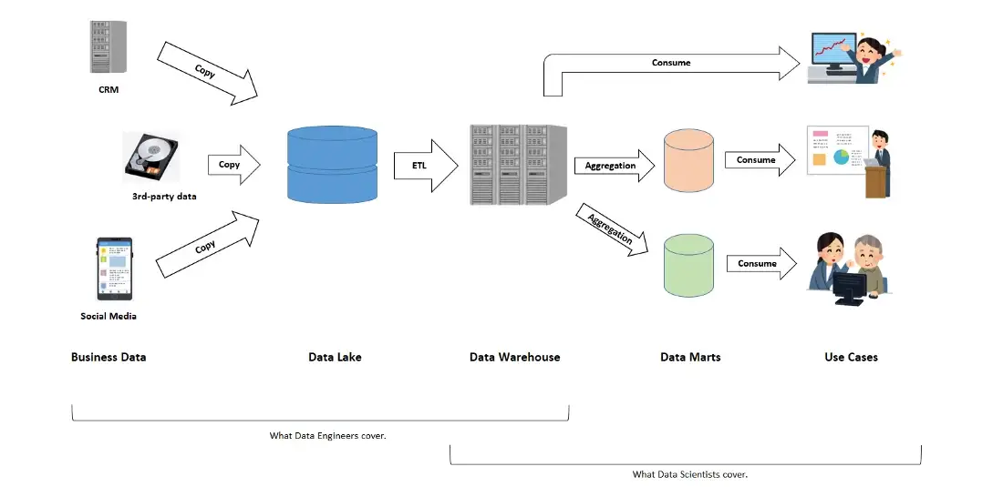
Source: Towards Data Science (2020)
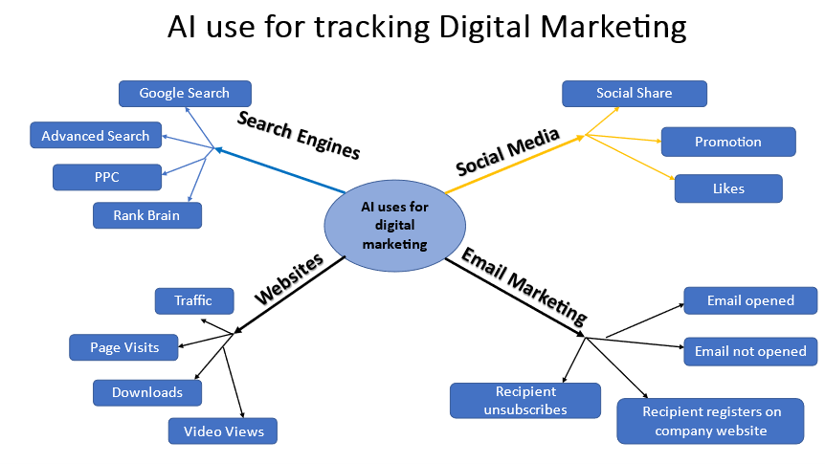
Source: Petrova A. (2022), author of the report (based on Clay J, 2017)
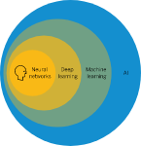
Source: SAP, (2022)
Burns E. (2022) claims that Machine Learning (ML) enables software applications to be more accurate in predicting outcomes, i.e., to discover patterns in structured data without being explicitly programmed to do so. Machine learning algorithms use historical data as input to predict new output values.
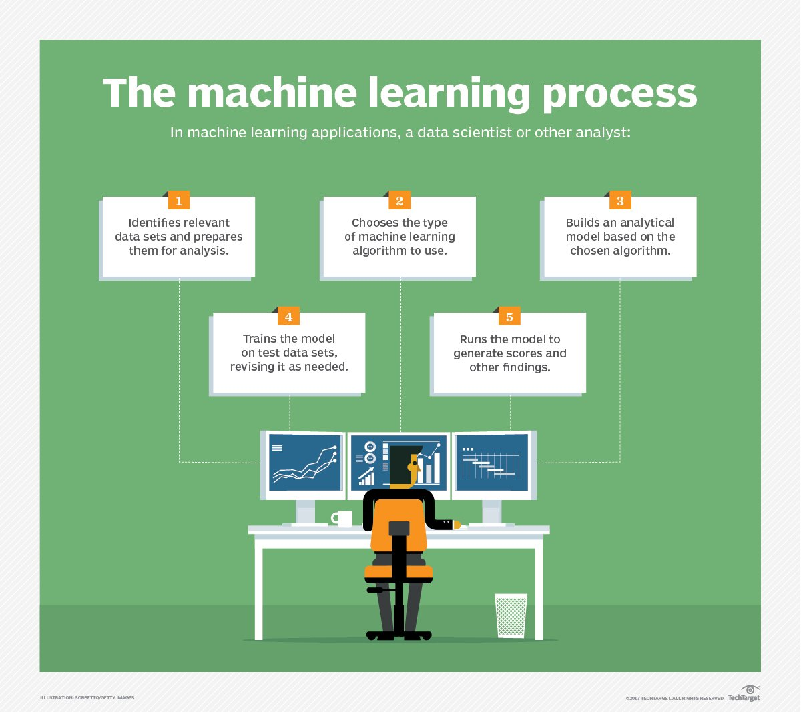
Source: Towards Data Science (2020)
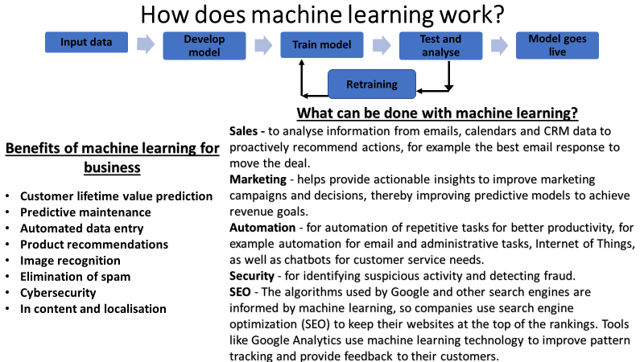
Source: Petrova A, author of the report (based on Towards Data Science, 2020)
A customer service Chatbot is software used to answer basic user inquiries through commercial messages using AI technologies (Chong et al., 2021). AI Chatbots uses existing limited assets, such as FAQs or information mining records, to help answer and resolve user queries. Businesses can identify correlations or trends in existing information using predictive and behavioural analytics strategies such as data mining, visual analytics, algorithmic pooling, and virtual networks (Zhang, C. and Lu, Y., 2021). AI-powered lead generation and marketing solutions can fulfil customer requirements by recommending the cheapest value based on their shopping habits and related information. Since data is a core component of AI technologies, systems can evolve and learn independently (Chong et al., 2021).
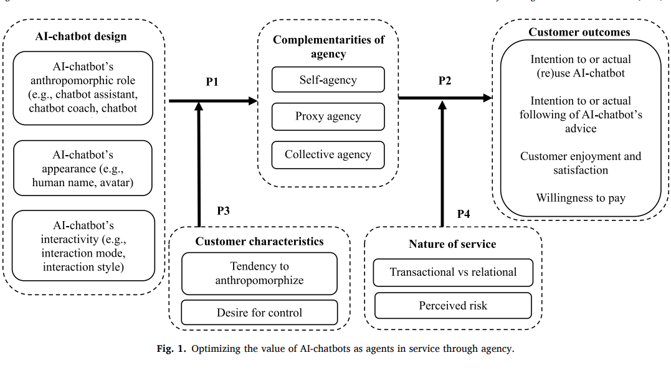
Source: Chong et al., (2021)
AI is applied in Pay-per-click (PPC) optimisation and Search Engine Optimisation. Pay-per-click (PPC) optimisation is monitoring an established ad campaign and adjusting accordingly to the strategy parameters, ad organisational features, searches, and conversion tracking to increase its reach. Its purpose is to boost the visibility of products in sponsored search engine listings (Hua et al., 2022).
An intelligent expert system is presented that provides hardware failure diagnostics for any computing device. Application and hardware errors are widespread in many hardware systems or digital equipment (Gültekin et al., 2022). This software-based formalised reasoning method solves a problem in computing devices. Combining automation in the internet marketing sector with AI can make systems function according to corporate requirements. It is a tool used to generate emails, text messages and personalised conversations with prospects to improve lead generation with minimal involvement. AI-based algorithms can be built to effectively understand promotional channels and implement required strategies (Suleiman et al., 2021).
Computerised planning and scheduling, commonly known as AI planning, has been an area of AI that deals with implementing plans and plot twists by autonomous algorithms, robotic systems, and driverless vehicles. It is hard to believe that AI could generate content like humans, but one must trust that the revolution is inevitable. Because many internet programmes allow writing material, delivering information using AI writing platforms has become a standard business practice (Paul et al., 2022).
AI is a perfect match for the sensor-filled industrial sector, and AI harnesses the significance of the information from devices and monitors, facilitating efficient systems and the mechanisation of practical decision-making. Operations tracking and management systems are indispensable for experimental set-up manufacturing, which allows sophisticated equipment to be manufactured without human interference while increasing profitability and quality (Suleiman et al., 202).
Autonomous mobile robots (AMRs), automated guided vehicles (AGVs), articulated robots, artificial agents, robots, and hybrids are the most frequent forms of robots (Guizzo, 2018). Robotics are employed in various sectors to increase productivity, speed up operations, prevent accidents, and enhance customer interactions. Robots can be configured to function in a repeated sequence if they are appropriately managed and maintain the same performance until they are programmed differently (Guizzo, 2018). It reduces the possibility of RSI occurring. Robotics improves quality control by accurately manufacturing and analysing goods to guarantee that they consistently match the requisite level. Because of the complexity of some jobs, manufacturing positions that demand exceptionally extreme temperatures feature a substantial turnover of workers. Autonomous machines can reduce waste production and eliminate the requirement for people to indulge in risky tasks (Bhbosale et al., 2020).
The impact on jobs is one of the big concerns with the introduction of robotic automation. A robot can work faster and more consistently, leading to job cuts. Investment costs are high, which is a barrier when deciding whether a company should invest in robotic automation (Bhbosale et al., 2020). The introduction of automation requires programming and knowledge of how to operate them, which creates a need for staff qualification (Bhbosale et al., 2020).
Promotional optimisation has been a massive challenge for marketing specialists in digital marketing. It can be managed by AI to offer ads based on the demands of products and the entire company. Through this AI, businesses can monitor and focus on a set of people according to the program's objectives, allowing for more significant optimisation and ROI (Paul et al., 2022). It enables businesses to conserve financial resources and time significantly. AI-powered lead generation and marketing solutions can fulfil customers' demands by recommending the cheapest value based on their shopping habits and related information. Because data is an essential component of AI technologies, systems may develop and learn by themselves (Kotane et al., 2019).
Through advertising on social media, content generation, and marketing optimisation, AI can actively help in many ways. Major corporations like Tesco increasingly use AI to learn consumer preferences and recommend goods to attract more customers. Instances like these abound in digital marketing and remain a trend that will execute quickly (Kotane et al., 2019).
Innovation at TESCO:
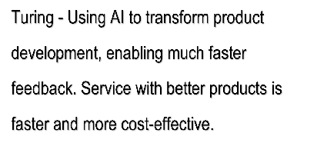
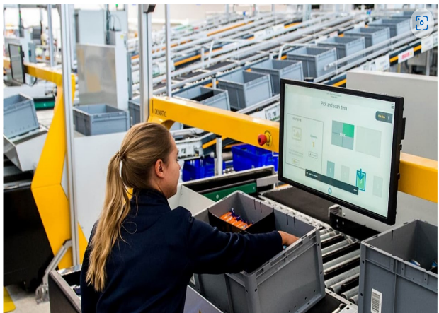
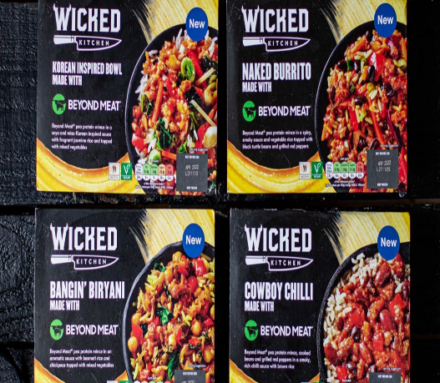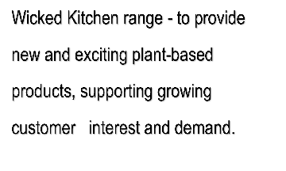
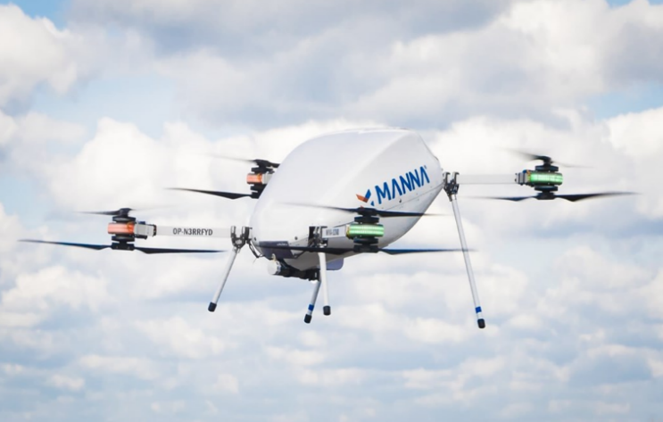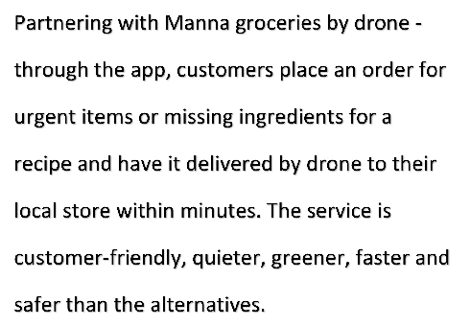
Source: TESCO Plc, (2022)

Conclusion
The report explores the scope and application of digital marketing in the context of Tesco. It offers Tesco's SOSTAC model and effectively assesses the company's objectives which are critical in guiding the digital marketing strategy, as well as the adopted methods to further follow the tactics with opportunities to develop an appropriate action plan and control. Analysing the changing environmental factors helps study the changing consumer needs. Factors influencing purchase behaviour, such as varieties, expectations, preferences, likes, and packaging, help redefine the product range or offer new products based on unique needs and preferences.
Search engine optimisation, pay-per-click, use of social media, affiliate and native marketing, and download and push strategies to ensure sustainable growth and increased market share. Integrating data resources and devices such as mobile phones provide an additional competitive advantage. As search engine algorithms become more robust and user-centric, AI will simplify complex marketing challenges. Tesco has the resources to make its supermarkets the best online shopping destination in the UK and globally with personalised shopping.

Recommendations:
- Preventive security measures
- Anticipating the consequences of the financial crisis, the economic slowdown and intense competition from Walmart and other major competitors
- The creative development of content
- Attention to customer feedback

References:
- Armstrong, G., Kotler, P., Harker, M. and Brennan, R., (2015), Marketing: an introduction, Pearson Education
- Bedford E, (2022), Tesco PLC - Statistics and Facts, Statista, [online]
Available at: https://www.statista.com/topics/3807/tesco-plc/#topicHeader__wrapper
Accessed: 16.11.2022
- Bhbosale, S., Pujari, V. and Multani, Z., (2020), Advantages And Disadvantages Of Artificial Intelligence, Aayushi International Interdisciplinary Research Journal, 77, pp.227-230
Available at: https://www.researchgate.net/profile/Vinayak-Pujari-2/publication/344584269_Advantages_And_Disadvantages_Of_Artificial_Intellegence/links/5f81b70192851c14bcbc1d96/Advantages-And-Disadvantages-Of-Artificial-Intellegence.pdf
Accessed: 02.01.2023
- Blakeman, R., (2018), Integrated marketing communication: creative strategy from idea to implementation, Rowman & Littlefield
- Burns E. (2022), Machine Learning, Tech target, [online]
Available at: https://www.techtarget.com/searchenterpriseai/definition/machine-learning-ML
Accessed: 05.12.2022
- Chaffey, Dave (2019), Digital Marketing, Chaffey
- Chaffey, D. and Smith, P.R. (2017), Digital Marketing Excellence, Planning, Optimising and integrating digital marketing, 5th Ed, Taylor & Francis
- Chaffey D. (2022), SOSTAC® marketing planning model guide and the RACE Growth System, Smart Insights, [online]
Available at: https://www.smartinsights.com/digital-marketing-strategy/sostac-model/
Accessed: 11.11.2022
- Chong, T., Yu, T., Keeling, D.I. and de Ruyter, K., (2021), AI-chatbots on the services frontline addressing the challenges and opportunities of agency, Journal of Retailing and Consumer Services, 63, p.102735
Available at: https://www.sciencedirect.com/science/article/pii/S0969698921003015?casa_token=UH8SRCfXh5MAAAAA:ADm24l2_eHeWPMXaI0bRk5IWKxwsdpXCWSHHiYkdG3r6OeWVJmfXGzCpdPpEq49lkKOuxMnXEnMn
Accessed: 29.12.2022
- Çitilci and Akbalık (2020), The importance of PESTEL analysis for environmental scanning process, In Handbook of Research on Decision-Making Techniques in Financial Marketing (pp. 336-357), IGI Global
Accessed: https://www.researchgate.net/profile/Tugberk-Citilci-2/publication/357836101_The-Importance-of-PESTEL-Analysis-for-Environmental-Scanning-Process/links/61e1df988d338833e36d2673/The-Importance-of-PESTEL-Analysis-for-Environmental-Scanning-Process.pdf
Accessed: 11.11.2022
- Classen, M. and Friedli, T. (2019), Value-Based Marketing and Sales of Industrial Services: A systematic literature review in the age of digital technologies, Procedia Cirp, 83, pp.1-7
- Clay J, (2017), Digital Marketing for Business Growth, Thorogood, p.176
- Contact Pigeon (2019), Tesco Case Study: How an Online Grocery Goliath Was Born, [online]
Available at: https://blog.contactpigeon.com/tesco-case-study/
Accessed: 29.11.2022
- Davey J. (2022), Tesco lowers profit sights as British shoppers face winter crunch, Reuters, [online]
Available at: https://www.reuters.com/business/retail-consumer/britains-tesco-sees-full-year-profit-lower-end-guidance-2022-10-05/
- Department of Health & Social Care (2020), Tackling obesity: empowering adults and children to live healthier lives, Gov.UK, [online]
Available at: https://www.gov.uk/government/publications/tackling-obesity-government-strategy/tackling-obesity-empowering-adults-and-children-to-live-healthier-lives
Accessed: 11.11.2022
- dunnhumby, (2022), Tesco Media and Insight Platform, dunnhumby.com, [online]
Available at: https://www.dunnhumby.com/tesco-media-insight-platform/
Accessed: 23.11.2022
- dunnhumby.com, (2021), Tesco Media and Insight Platform. CRM, [online]
Available at: https://www.dunnhumby.com/wp-content/uploads/2021/11/Tesco-Media-Insight-CRM-OnePager.pdf
Accessed: 29.11.2022
- Faull, J., 2021, Tesco has a major new media offering for advertisers: here's what you need to know. The drum, [online]
Available at: https://www.thedrum.com/news/2021/11/30/tesco-has-major-new-media-offering-advertisers-heres-what-you-need-know
Accessed: 23.11.2022
- Finbox (2022), Gross Profit Margin For Tesco PLC (TSCD.F), [online]
Available at: https://finbox.com/OTCPK:TSCD.F/explorer/gp_margin
Accessed: 12.11.2022
- Foley, J. (2022), Oracle Brand Voice: Tesco Revolutionises Retail And Gears Up For 'Battleground Of The Future', Forbes, [online]
Available at: https://www.forbes.com/sites/oracle/2013/10/21/tesco-revolutionizes-retail-and-gears-up-for-battleground-of-the-future/?sh=50bac97c446d
Accessed: 20.11.2022
- Fomina, N., (2020), Digital Marketing Plan. Case Company, [online]
Available at: https://www.theseus.fi/bitstream/handle/10024/340051/Digital%20Marketing%20Plan.%20Case%20Company.pdf?sequence=2
Accessed: 08.10.2022
- Geeks for Geeks.org, (2022), Dynamic Websites, [online]
- Geeter D. (2019), Here's why Tesco's 'Fresh & Easy' stores failed in the United States, CNBC, [online]
Accessed: 20.11.2022
- Guizzo, E. (2018), Types of Robots - ROBOTS: Your Guide to the World of Robotics, [Online] @robotsapp
Available at: https://robots.ieee.org/learn/types-of-robots/
Accessed: 02.01.2023
- Gültekin, Ö., Cinar, E., Özkan, K. and Yazıcı, A., (2022). Real-time fault detection and condition monitoring for industrial autonomous transfer vehicles utilising edge artificial intelligence. Sensors, 22(9), p.3208
Available at: https://www.mdpi.com/1424-8220/22/9/3208/pdf
Accessed: 29.12.2022
- Haefele-software (2020), Haefele-software-case-study-Tesco-stores-bams, [online]
Available at: https://www.haefelesoftware.com/wp-content/uploads/2020/08/haefele-software-case-study-tesco-stores-bams.pdf
Accessed: 22.11.2022
- harvard.edu (2016), Tesco: A digital transformation, [online]
Available at: https://d3.harvard.edu/platform-rctom/submission/tesco-a-digital-transformation/
Accessed: 22.11.2022
- House of Commons Library, (2013), VAT: the new 20% standard rate, UK Parliament, [online]
Available at: https://commonslibrary.parliament.uk/research-briefings/sn05620/
Accessed: 11.11.2022
- Hua, H., Li, Y., Wang, T., Dong, N., Li, W. and Cao, J., (2022), Edge Computing with Artificial Intelligence: A Machine Learning Perspective, ACM Computing Surveys (CSUR)
Available at: https://dl.acm.org/doi/pdf/10.1145/3555802?casa_token=-mCXmhuiOW8AAAAA:k0Tvz812ZvZT5JmUPhsOiEcKoR-qiEzkumOrA_y-Adh8aKKTdQDOQi2deXpGO3tZOgIpocU5--aWQQ
Accessed: 29.12.2022
- Kotane, I., Znotina, D. and Hushko, S. (2019), assessment of trends in the application of digital marketing, Scientific Journal of Polonia University, 33(2), pp.28-35.
Available at: https://www.researchgate.net/profile/Inta-Kotane/publication/332228157_ASSESSMENT_OF_TRENDS_IN_THE_APPLICATION_OF_DIGITAL_MARKETING/links/5cd2ead992851c4eab8c3120/ASSESSMENT-OF-TRENDS-IN-THE-APPLICATION-OF-DIGITAL-MARKETING.pdf
Accessed: 09.11.2022
- Madan, P. (2021), Digital marketing: a review. V Paradigm shifts in management practices in the era of industry 4.0, Archers & Elevators Publishing House, pp.64-71
- Mishra, C.K. (2020), Digital marketing: Scope opportunities and challenges. Promotion and Marketing Communications, Edited by Umut Ayman and Anıl Kemal Kaya, pp.1-24
Available at: https://www.intechopen.com/chapters/72227
Accessed: 09.11.2022
- Monte, A. (2021), A study of value chain reconfiguration processes under Covid-19 pressures: the case of Tesco PLC in the United Kingdom, LUISS, Department
of Economics and Finance [online]
Available at: http://tesi.luiss.it/31586/1/261361_MONTE_ALESSANDRO.pdf
Accessed: 12.11.2022
- Moth, D. (2020), How do Waitrose and Tesco use on-site content marketing? [Online] Econsultancy
Available at: https://econsultancy.com/how-do-waitrose-and-tesco-use-on-site-content-marketing/
Accessed: 23.11.2022
- Nurwidayat, A., Sudarsono, B., Pratiwi, K. and Havity, M.D., (2019), Implementation of Information System in Submitting Employees’ Annual Leave at PT, Tesco, 3(2), pp.97-103
- Odeh, A.H. (2019), Analytical and Comparison Study of Main Web Programming Languages‒ASP and PHP, TEM Journal, 8(4), pp.1517-1522, [online]
Available at: https://scholar.google.co.uk/scholar?output=instlink&q=info:kO2FTB-hArsJ:scholar.google.com/&hl=en&as_sdt=0,5&scillfp=17488237783429867089&oi=lle
Accessed: 30.11.2022
- Panchal, A., Shah, A. and Kansara, K., (2021), Digital marketing-search engine optimisation (SEO) and search engine marketing (SEM), International Research Journal of Innovations in Engineering and Technology, 5(12), p.17
Available at: https://scholar.google.co.uk/scholar?output=instlink&q=info:z4RKg_WgA5cJ:scholar.google.com/&hl=en&as_sdt=0,5&scillfp=3708915537038502237&oi=lle
Accessed: 22.11.2022
- Paul, S.P., Aggarwal, S. and Jha, S., (2022), A survey on the use of artificial intelligence (AI)-enabled techniques in digital marketing, AIP Conference Proceedings (Vol. 2555, No. 1, p. 050003), AIP Publishing LLC
Available at: https://aip.scitation.org/doi/abs/10.1063/5.0108607
Accessed: 29.12.2022
- Plantin, JC, & Punathambekar, A. (2019), Digital media infrastructures: Pipes, platforms, and politics, Media, Culture & Society, 41(2), 163–174
- Ponzoa, J.M. and Erdmann, A., (2021), E-commerce customer attraction: Digital marketing techniques, evolution and dynamics across firms, Journal of Promotion Management, 27(5), pp.697-715.
Available at: https://scholar.google.co.uk/scholar?output=instlink&q=info:H0Pk3Z7BgDUJ:scholar.google.com/&hl=en&as_sdt=0,5&scillfp=13656681935109304199&oi=lle
Accessed: 20.11.2022
- Rastogi N. and Trivedi M.K., (2016), PESTLE Technique – a tool to identify external risk in construction projects, International Research Journal of Engineering and Technology, [online]
Available at: https://www.irjet.net/archives/V3/i1/IRJET-V3I165.pdf
Accessed: 12.11.2022
- Rath, M., (2022), Machine learning and its use in e-commerce and e-business. In Research Anthology on Machine Learning Techniques, Methods, and Applications, IGI Global, pp. 1193-1209
- Ring, M., Schlör, D., Landes, D. and Hotho, A., (2019), Flow-based network traffic generation using generative adversarial networks, Computers & Security, 82, pp.156-172, [online]
Available at: https://scholar.google.co.uk/scholar?output=instlink&q=info:NGfNMRRPevYJ:scholar.google.com/&hl=en&as_sdt=0,5&scillfp=11904456534888586972&oi=lle
Accessed: 30.11.2022
- Smithers R (2018), Tesco delays Clubcard changes after a customer backlash, The Guardian, [online]
Available at: https://www.theguardian.com/business/2018/jan/17/tesco-delays-clubcard-changes-customer-backlash-reward-loyalty-scheme
Accessed: 20.11.2022
- Statista (2022), Tesco's number of stores worldwide from 2008 to 2022, [online]
Available at: https://www.statista.com/statistics/238667/tesco-plc-number-of-outlets-worldwide/
Accessed: 18.11.2022
- Statista (2022), E-Commerce net sales of tesco.com from 2014 to 2022, [online]
Available at: https://www.statista.com/forecasts/1218318/tesco-revenue-development-ecommercedb
Accessed: 22.11.2022
- Statista, (2022), Market share of grocery stores in Great Britain from January 2017 to September 2022, [online]
Available at: https://www.statista.com/statistics/280208/grocery-market-share-in-the-united-kingdom-uk/
Accessed: 23.11.2022
- Statista (2022), Online visibility score of leading grocery delivery websites in the United Kingdom (UK) in 2021, [online]
Available at: https://www.statista.com/statistics/1320385/grocery-delivery-website-visibility-uk/
Accessed: 29.11.2022
- Strauss, J., (2016), E-marketing, Routledge
- Suleiman, D.A., Awan, T.M. and Javed, M., (2021), Enhancing digital marketing performance through usage intention of AI-powered websites, IAES International Journal of Artificial Intelligence, 10(4), p.810
Available at: https://search.proquest.com/openview/96f3159fe429c424a3bfa39113212669/1?pq-origsite=gscholar&cbl=1686339&casa_token=oiiLlGXv7JkAAAAA:VpUfPDyUovLJlOrJxREodnfyWc37rgkDokztPxtcaxPwTY4fvmhuNfM5B2jvOPf647TBYWOwGjGl
Available at: 29.12.2022
- Towards Data Science, (2020), Fundamentals of Data Architecture to Help Data Scientists Understand Architectural Diagrams Better, towardsdatascience.com, [online]
Available at: https://towardsdatascience.com/fundamentals-of-data-architecture-to-help-data-scientists-understand-architectural-diagrams-better-7bd26de41c66
Accessed: 05.12.2022
- Tesco PLC (2021), Tesco launches the UK's largest closed loop grocery Media and Insight platform, powered by dunnhumby, [online]
Available at: https://www.tescoplc.com/news/2021/tesco-launches-the-uk-s-largest-closed-loop-grocery-media-and-insight-platform-powered-by-dunnhumby/
Accessed: 10.11.2022
- Tesco Plc (2021), Tesco makes ambitious new commitments to support healthy, sustainable diets, [online]
Available at: https://www.tescoplc.com/news/2021/tesco-makes-ambitious-new-commitments-to-support-healthy-sustainable-diets/
Accessed: 11.11.2022
- Tesco PLC (2022), Tesco PLC About, [online]
Available at: https://www.tescoplc.com/about/
Accessed: 08.11.2022
- Tesco Plc, (2022), About innovation at Tesco, [online]
Available at: https://www.tescoplc.com/find-out-more/
Accessed: 02.01.2023
- Tesco (2022), Climate change and energy, Tesco PLC
Available at: https://www.tescoplc.com/media/759054/climate-change-and-energy-factsheet.pdf
Accessed: 12.11.2022
- Tesco PLC (2022), Annual Report and Financial Statements 2021, Tesco Plc, p.112 [online]
Available at: https://www.tescoplc.com/media/757589/tesco_annual_report_2021.pdf
Accessed: 16.11.2022
- Tesco Direct website,
Available at: http://www.tesco.com/groceries/
- Tesco' goods to person' picking image, Available at: http://www.expo21xx.com/material_handling/13440_st3_conveyor_elevator/default.htm
- The University of Salford Manchester, (2022)
Available at: https://www.salford.ac.uk/salford-business-school/sme-digital-marketing-strategies-8-essential-elements-create-fantastic
Accessed: 09.11.2022
- Yahaya JH, Ibrahim AA, Deraman A, (2017), Software process model for dynamic website development towards quality product, Journal of Telecommunication, Electronic and Computer Engineering, [online]
Available at: https://core.ac.uk/download/pdf/235220998.pdf
Accessed: 29.11.2022
- Zhang, C. and Lu, Y., (2021), Study on artificial intelligence: The state of the art and future prospects, Journal of Industrial Information Integration, Elsevier, 23, p.100224.
Available at: https://www.sciencedirect.com/science/article/pii/S2452414X21000248?casa_token=VUnFZtVaJkEAAAAA:daIVnk8BxUKJWx2o21_ABN7GEh42NUpImpIxP30mIYZqt1ZtBZ4OpnOmYHHraNg3yFAY_aFGJgJp
Accessed: 29.12.2022
- Zhu, G. and Gao, X. (2019), Precision retail marketing strategy based on digital marketing model, Science Journal of Business and Management, 7(1), pp.33-37.
Available at: https://www.researchgate.net/profile/Guoan-Zhu/publication/333678454_Precision_Retail_Marketing_Strategy_Based_on_Digital_Marketing_Model/links/5cff05274585157d15a1fda4/Precision-Retail-Marketing-Strategy-Based-on-Digital-Marketing-Model.pdf
Accessed: 08.11.2022

Appendix 1:
PESTLE
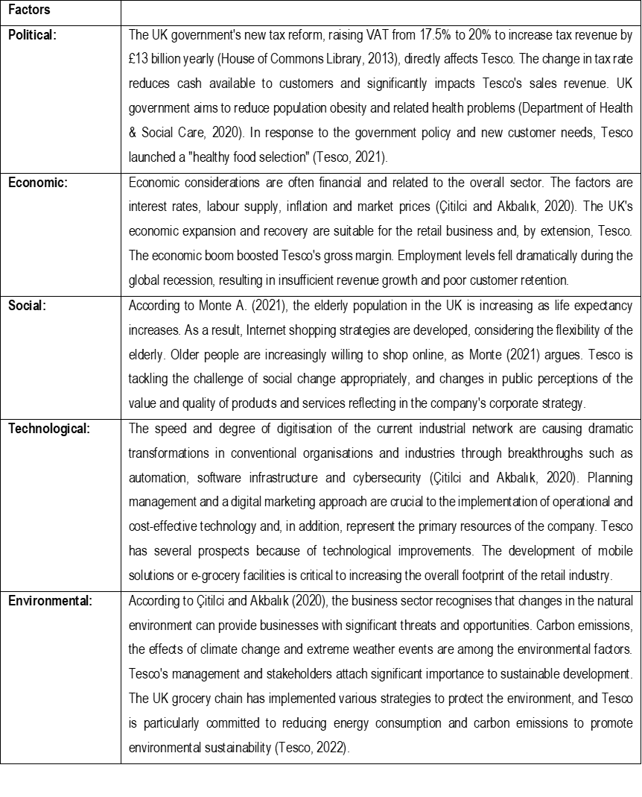

SWOT


