Name: Rebecca Rees
P-Number: P142147
Module: E-Commerce
Assignment: Build a prototype E-Commerce Website
Lecturer: Sue Maw

Table of Contents
1.0 Introduction to the Business 3
2.0 E-Commerce Infrastructures 3
2.1 PHP (Hyper Text Pre Processer) 3
2.2 ASP (Active Server Pages) 4
2.3 JSP (Java Server Pages) 4
3.0 E-Commerce Prototype 4
4.0 Payment Methods 13
4.1 Suggestions for Sol R Energy Payment Methods 14
5.0 Website Performance Measures 14
5.1 Consumption Metrics 14
5.2 Engagement Metrics 15
5.3 Conversion Metrics 15
5.4 E-Commerce Metrics 15
5.5 Sol R Energy Metrics Recommendation 16
References 17

Table of Figures
Figure 1 - Top half of home page 4
Figure 2 - Bottom half of home page 5
Figure 3 - Domestic Case Study 5
Figure 4 - Commercial Case Study 6
Figure 5 - Prototype 'about' page 7
Figure 6 - Prototype 'contact us' page 8
Figure 7 - Prototype shop 9
Figure 8 - Example Invoice 10
Figure 9 - Inventory Tracking Page 11
Figure 10 - Sol R Energy Sitemap 12
Figure 11 - Digital Wallet Statistics UK 13
Figure 12 - Prototype cart and payment gateway 14

1.0 Introduction to the Business
Sol R Energy is a small domestic company that was started three years ago by a woman named Eira Sol. Initially, the business consisted of herself, her son and daughter taking on small solar panel installation jobs. Since then, the business has seen rapid growth therefore the company has not been able to keep up with demand.
A prototype e-commerce website will be built in order to cope with new demands and to also give the opportunity for the business to sell products to a bigger worldwide audience. The website will also give information to both domestic and commercial clients with the opportunity to book a survey on their homes or businesses via the contact information provided.

2.0 E-Commerce Infrastructures
There are many different infrastructures that can be used to build a website. A user can either create a website via a template or by writing their own by code, some example of these will be discussed below.

2.1 PHP (Hyper Text Pre Processer)
“PHP is a widely-used open source general-purpose scripting language that is especially suited for web development and can be embedded into HTML.” (1)
PHP is an open-source technology that lets the user use scripting in their documents, as it is not necessarily a real programming language. The user would firstly have to download PHP software onto their PC to make it function as a server or have a website on a hosted server that supports the use of PHP (2).

2.2 ASP (Active Server Pages)
ASP was created by Microsoft, and as stated by the company, ASP is “a server-side scripting environment that you can use to create and run dynamic, interactive Web server applications.” (3) They go on to say that the user can combine script commands, HTML and COM components to create interactive web pages (3).

2.3 JSP (Java Server Pages)
JSP is a server side technology that was developed by Sun MicroSystems. It has a dynamic scripting capability that works alongside HTML code to help make the HTML more functional (4). JSP is similar to ASP, which is discussed above, but usually runs faster than ASP codes in general. Like ASP, Java Server Pages provide simplified ways to create dynamic web pages. Using JSP is suitable for people who are not Java or Visual Studio experts and for people who have some experience with using HTML or XML code (5).

3.0 E-Commerce Prototype
For the prototype created, it was decided Wix would be used. Wix is a template based website which allows users to drag and drop different features anywhere onto the webpage. This is an advantage as it is very easy to put the website features wherever you want on the webpage. Wix was also used as it has a very user friendly interface and is not difficult to navigate. Wix additionally offers the integration of apps such as Google Analytics, links to social media sites, hit counter, online store etc.
The screenshots below will show each page of the e-commerce prototype that was built for Sol R Energy.
Figures 1 and 2 show the whole of the home page with features including a search bar, page headings in menus on the top of the page and on the left of the page, images, social media links, contact information and statistics.
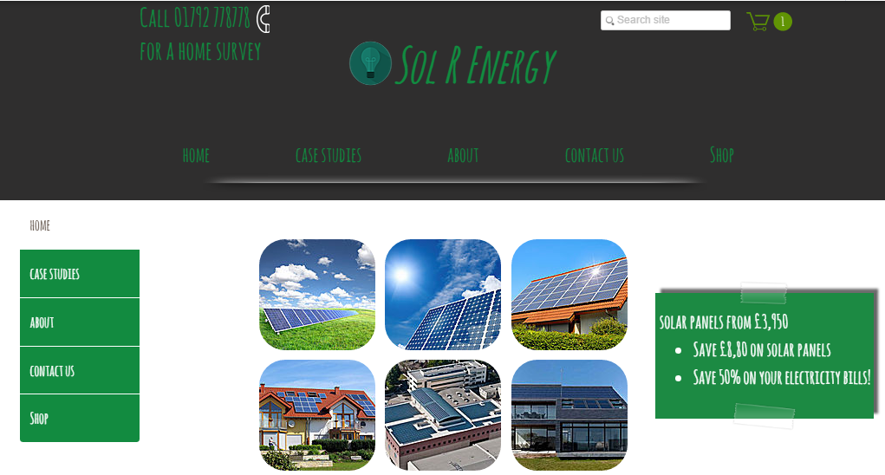
Figure 1 - Top half of home page

The statistics on the home page in figure 2 were obtained from a factsheet by the energy institute (6) who are also based in the UK.
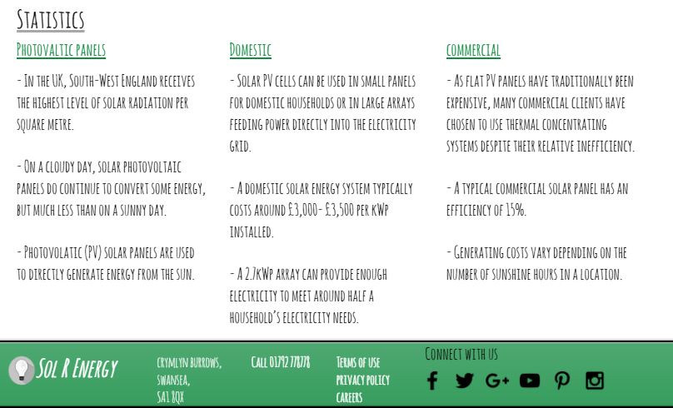
Figure 2 - Bottom half of home page
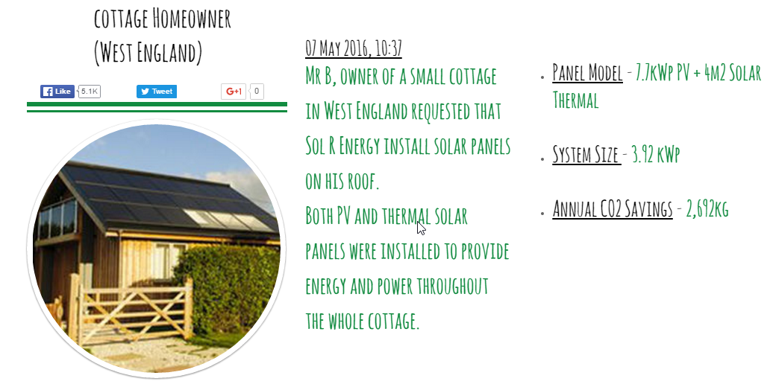
Figures 3 and 4 show example case studies to show customers what sort of solar panels would be used on both homes and businesses. The case studies show pictures of the solar panels on the roof, what type of panels have been installed and what system size is being used. The first case study, shown in figure 3 is an example of a domestic installation in West England, also showing how much CO2 would be saved on an annual basis.
Figure 3 - Domestic Case Study

Figure 4 below is an example of a commercial installation to show other businesses what they could potentially use. Again, this case study also shows the annual CO2 savings a business could make.
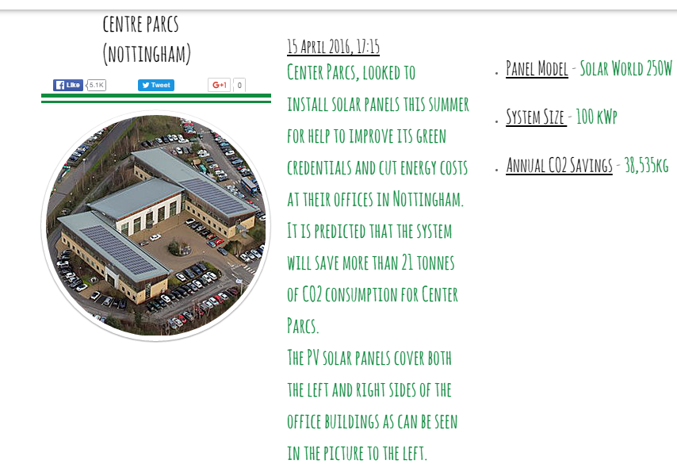
Figure 4 - Commercial Case Study

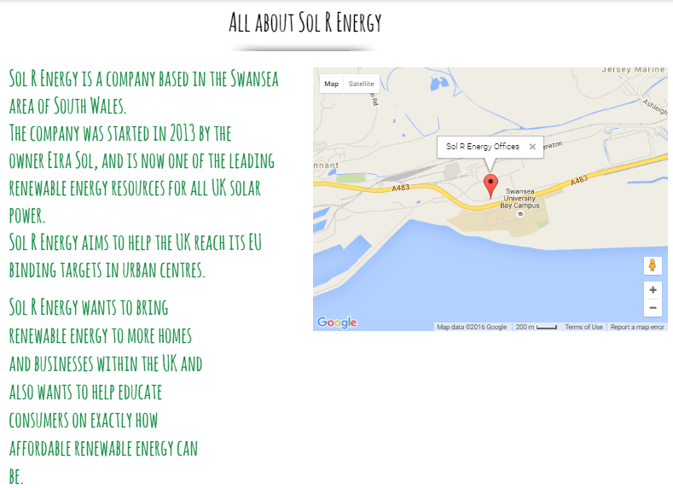
The next page that was created for the prototype was the ‘about’ page, shown in figure 5. This page is used to show the location of the business via Google maps, then to give a brief background on Sol R Energy and when the company was started.
Figure 5 - Prototype 'about' page

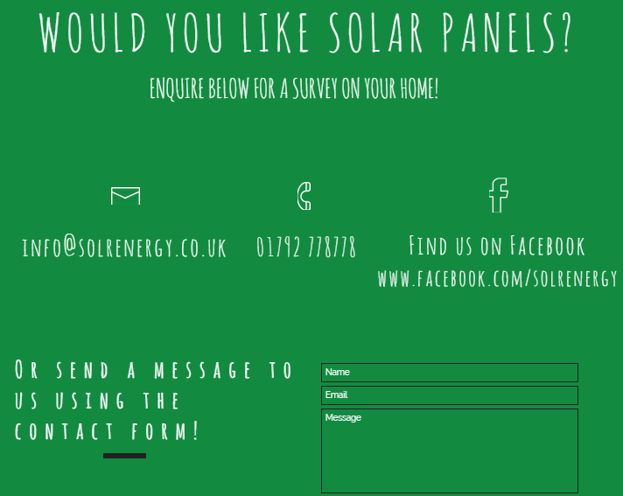
A general ‘contact us’ page, seen in figure 6 was created to allow both domestic and commercial clients to get in touch with the company either for general queries or to set up a survey on their home or business.
Figure 6 - Prototype 'contact us' page

Although this Sol R Energy prototype website is generally an informational website and allows clients to enquire about surveys on their buildings, there is also a shop element to the site. As can be seen in figure 7, an example shop was created showcasing solar kits that can be used by anyone. Included on each product is its details, price and images.
Further on, in figures 9 and 11, product inventory and an example of what the shopping cart looks like can be seen.
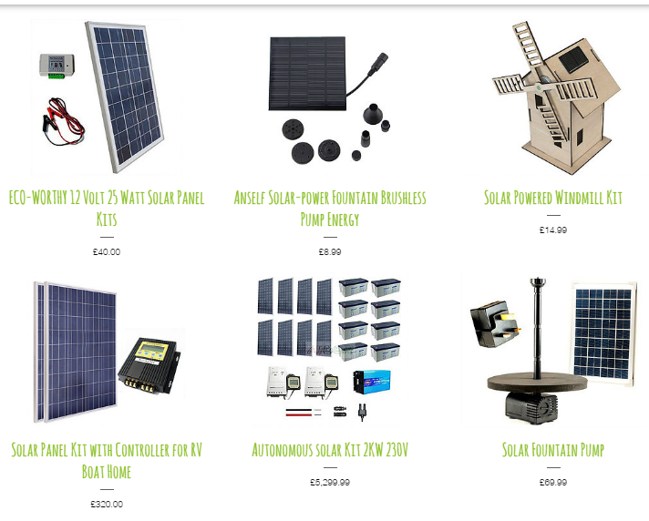
Figure 7 - Prototype shop

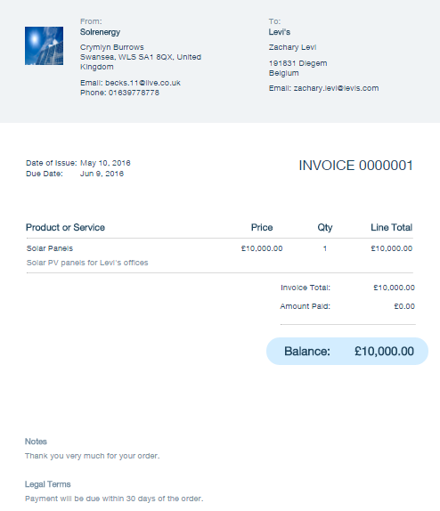
For a business like Sol R Energy, invoicing would be very important to keep track of payments, especially as solar panels would always cost a large amount of money.
An example invoice was created to show what it would look like if the business was to send one out. The invoice was created quickly and easily by filling in each field of the invoice dashboard on Wix.
Figure 8 - Example Invoice

As well as keeping track of payments, it is also incredibly important to keep track of stock levels. Even though the online shop on the Sol R Energy website would be small, keeping an eye on stock levels would still need to be done.
Wix allows the creator of the website to see the amount of each product that is still in stock, seen in the third column in figure 9.
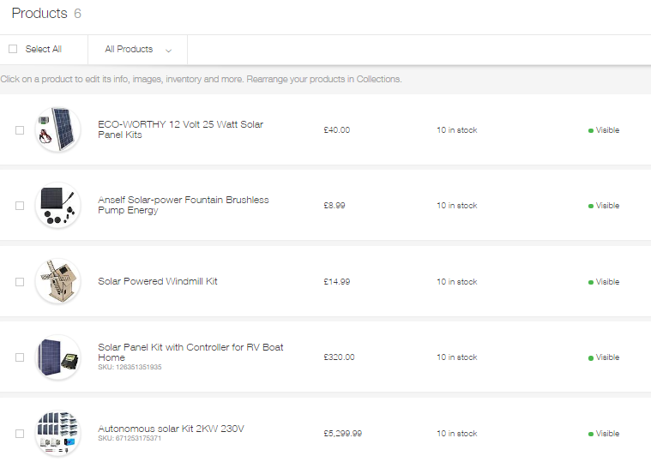
Figure 9 - Inventory Tracking Page

Finally, a sitemap was tried to be obtained by adding ‘sitemap.xml’ after the sites URL, however the error shown in figure 10 came up. As a full sitemap could not be obtained, figure 10 shows the sitemap without any style information.
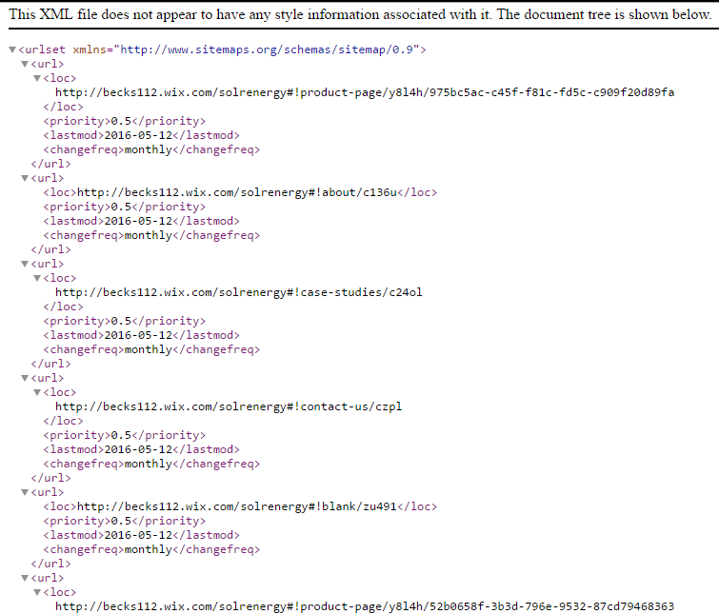
Figure 10 - Sol R Energy Sitemap

4.0 Payment Methods
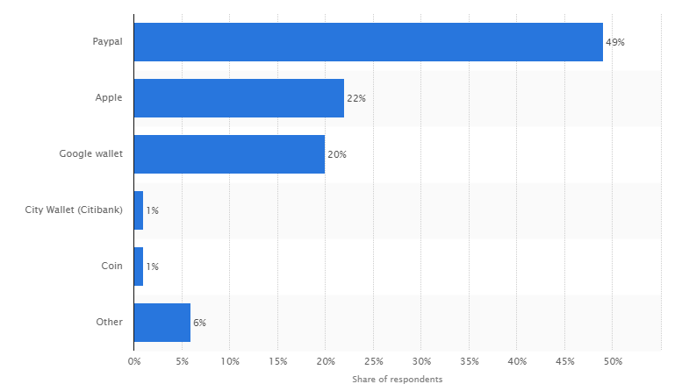
There are a number of electronic payment gateways for e-commerce stores to include on their website. The number one payment option that websites usually offer is allowing users to pay direct via their debit/credit cards. Debit cards transactions will contact your bank to verify the payment before the order is placed, and with a credit card, the user may need a merchant account set up to accept any payments (7).
PayPal is also a very popular gateway payment method for e-commerce websites to include as there are around 179 million active users worldwide (8). PayPal is a type of digital wallet, other digital wallet companies include Apple and Google Wallet. As can be seen in Figure 1, in 2014, PayPal was the most used digital wallet provider in the United Kingdom (9).
Figure 11 - Digital Wallet Statistics UK

Electronic cheques are also sometimes used in place of paper cheques. Botha et al. simply state that an electronic cheque, or e-cheque is “the electronic version of a paper cheque.” (10) Electronic cheques use the same format as a paper cheque, and use the same legal framework as a paper cheque, and also have the benefit of being much cheaper to process if used for a transaction.
Prepaid cards are another form of e-payment, these are cards that are already loaded with money that are activated when someone purchases one. Companies such as iTunes or anywhere that uses gift cards are examples of businesses that use pre-paid cards. People who may benefit from the use of prepaid cards include (11):
- People too young to have debit/credit cards
- Students who do not want to build up debts
- People wanting to build up their credit rating
Security issues are a big problem when it comes to online payments, there are many people who do not feel safe entering their bank details online. Tan writes that the internet is vulnerable to risk of fraud with the extent of the fraud stated below (12):
- 1 in 6 online consumers has been hit with credit card fraud
- Fraud via the internet is 12 times higher than that in-store
- 1 in 12 online consumers has been hit with identity theft

4.1 Suggestions for Sol R Energy Payment Methods
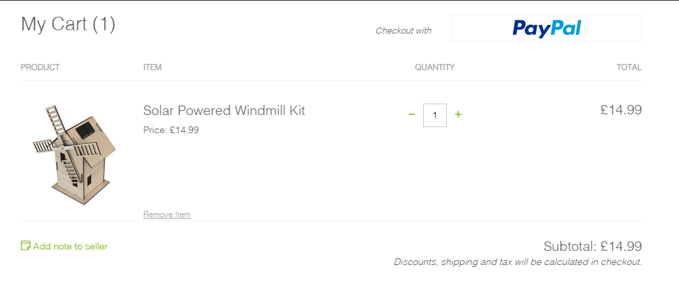
The Sol R Energy prototype website has a small e-commerce store primarily for solar energy kits. As it is only a prototype, only PayPal can be added as a payment option at the moment. However, if the site was to be published, the use of debit/credit cards or prepaid cards would also be included. PayPal is the main suggested payment gateway to include as there are many people worldwide who use PayPal, and also many people who do not like to enter their card details online, therefore PayPal is a safer way for them to pay for any items.
Figure 12 - Prototype cart and payment gateway

5.0 Website Performance Measures
There are many different ways to measure the performance of a website. Honigman says there are three types (13), these being consumption, engagement and conversion metrics, which will be discussed below.

5.1 Consumption Metrics
Consumption metrics include page views which enables the creator of the website to see how many people view any content such as videos, or how many people are visiting the website. It also includes measuring unique visitors which is the amount of people who keep returning to the website. A high number of unique visitors suggests the website is reaching a broader audience. It is important to be able to measure these consumption metrics as you will be able to see whether or not the website is attracting an audience.

5.2 Engagement Metrics
Engagement includes measuring the average time duration of a user’s session, how many webpages a user is clicking on in a session and social sharing which is how many likes, tweets, comments etc. are generated by the website. Having a consumer engaging with the website is a sign of a successful website, especially is the user is sharing the content on their social media pages. On the other hand, if a user is clicking onto many webpages in one session, it is either because they find the content interesting and want to keep looking further into the site, or they are getting lost around the site. Therefore, it is hard to determine whether this type of user engagement is good or bad.

5.3 Conversion Metrics
Honigman goes on to state that there are 3 types of conversion metrics. The first is measuring how many people download any content that is on the website. The next one is measuring how many people sign-up to the website, or a newsletter etc. The last is measuring any sales that take place. As Barker (14) states:
Conversion Rate = Number of Sales / Number of Visits
He says conversion may not always be a great way to measure a website’s performance as the numbers may differ from one day to the next e.g.
Day 1: 5000 visits, 200 sales = 4% conversion
Day 2: 1000 visits, 100 sales = 10% conversion
This shows that a higher conversion rate does not always mean a higher performance (14).

5.4 E-Commerce Metrics
Above, general website metrics were spoken about. Now, metrics pertaining to e-commerce website will be discussed. Wallace (15) claims there are 11 important e-commerce metrics which are as follows:
- Shopping Cart Abandonment
- Cost of Acquiring Customer
- Average Order Value
- Conversion Rate
- Churn
- Cost per Click
- Cost per Impressions
- Cost of Sales
- Revenue per Click
- Customer Lifetime Value
- Cost per Acquisition

5.5 Sol R Energy Metrics Recommendation
After looking at performance metrics for both general websites and e-commerce websites, recommendations are going to be made for Sol R Energy.
The first recommended metric to look at would be page views as this simply allows the creator of the website to view how many people are accessing the website.
Social sharing is the next metric for Sol R Energy to look at as it shows how many people are interested with the content they are sharing via their social media sites.
Webpage clicks would also be recommended to show exactly how many users are clicking through to other webpages on the site.
As the website has a small shop element, it would be recommended that Sol R Energy keep track of the shopping cart abandonment, as if there are a lot of users that have the intent on buying a product but then back out, it must be investigated as to why.

References
1. What is PHP? PHP. [Online] [Cited: April 25, 2016.] http://php.net/manual/en/intro-whatis.php.
2. Spark, Forme. PHP:Basics - Professional. s.l. : Spark Publications, 2014.
3. Microsoft. Active Server Pages. Microsoft. [Online] [Cited: April 25, 2016.] https://msdn.microsoft.com/en-us/library/aa286483.aspx.
4. JSP. Webopedia. [Online] [Cited: April 25, 2016.] http://www.webopedia.com/TERM/J/JSP.html.
5. JSP Opens Dynamic Web Page Design to the Non-Java Experts. Langley, Nick. s.l. : ABI/INFORM Complete, October 4, 2005, Computer Weekly, p. 56. 00104787.
6. Energy Institute. Solar energy factsheet. [Online] April 2012. [Cited: May 11, 2016.] https://www.energyinst.org/_uploads/documents/DSI10.pdf.
7. Choosing payments method. Digital Business. [Online] [Cited: May 7, 2016.] http://digitalbusiness.gov.au/e-commerce/setting-up-an-online-store/choosing-your-payments-method/.
8. PayPal. [Online] https://www.paypal.com/signup/account?country.x=RU&locale.x=en_US.
9. Share of customers who use a digital wallet in the United Kingdom (UK) in 2014, by company. Statista. [Online] [Cited: May 7, 2016.] http://www.statista.com/statistics/493769/united-kingdom-consumers-using-digital-wallet/.
10. Botha, J., Bothma, C. H. and Geldenhuys, Pieter. Managing E-commerce in Business. s.l. : Juta and Company Limited, 2008. 9780702173042.
11. uSwitch. Prepaid debit cards – What are they and how do they work? uSwitch. [Online] [Cited: May 7, 2016.] http://www.uswitch.com/credit-cards/prepaid-credit-cards/.
12. Tan, Margaret. E-Payment: The Digital Exchange. s.l. : NUS Press, 2004. p. 41. 9789971692858.
13. Honigman, Brian. You Are What You Measure: Website Metrics That Matter . DNN. [Online] June 19, 2015. [Cited: May 5, 2016.] http://www.dnnsoftware.com/blog/you-are-what-you-measure-website-metrics-that-matter.
14. Barker, Dan. Why Conversion Rate is a Horrible Metric to Focus On. Smart Insights. [Online] August 14, 2013. [Cited: May 11, 2016.] http://www.smartinsights.com/goal-setting-evaluation/goals-kpis/why-conversion-rate-is-a-horrible-metric-to-focus-on/.
15. Wallace, Tracey. 11 Need to Know Ecommerce Metrics to Scale Like the Big Box Retailers. Big Commerce. [Online] January 22, 2015. [Cited: May 5, 2016.] https://www.bigcommerce.com/blog/6-vital-ecommerce-metrics/.

