Task A

- The room index:
RI = (L x W) / (Hm(L + W))
L = 60m W = 24m Hm = 8m – 1m = 7m
RI = (60 x 24) / (7(60 + 24))
RI = 1440 / 588
RI = 2.45
- The utilisation factors
DLOR = 50%
Celling reflection = 0.5
Wall reflection = 0.3
RI = 2.45
Rounding the RI up to 2.5
Making the UF 0.46

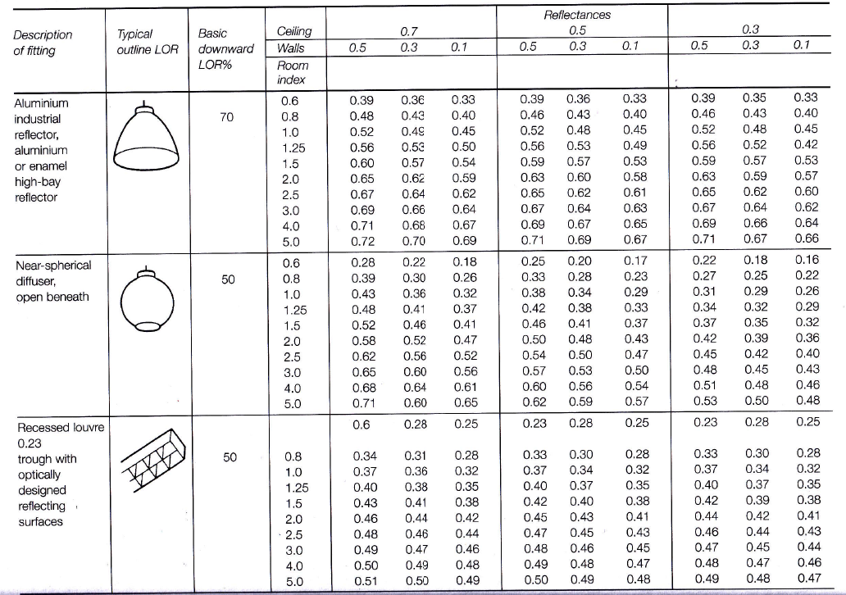

- The number of lamps required
E x A over F x UF x LLF = N

E = 200 lux A = 60m x 24m = 1440m
F = 18000 lm UF = 0.46 LLF = 0.75

200 x 1440 3200
18000 x 0.46 x 0.75 = 69 = 46.377 N = 47
- A suitable layout for the lamp fittings
Hm = 7
1 x 7 = 7m
The maximum distance that the lights can be spaced out is 7m so round 47 up to 48 to make the rows work out better and that leaves you with 4 row of 12 lamps and all the spacings are less than 7 meters.

Drawing have been emailed

Task B

- Brick work = 20 – 4 = 16m2. SRI = 50dB
Window = 4m2 SRI = 10dB
SRI formula = SRI = 10 x (log10(1/T))

Brick=
50 = 10 x (log10(1/T))
5 = log 10 x (1/T1)
1/T1 = 105
T1 = 10-5
= 0.000010

Window=
10 = 10 x (log10(1/T))
1 = log 10 x (1/T2)
1/T2 = 101
T2 = 10-1
= 0.10

(T1 x A1) x (T2 x A2)
A1 + A2

(10-5 x 16) + (10-1 x 4)
16 + 4 = 0.020008 average transition coefficient

SRI = 10 x (log10(1/T))
SRI = 10 x (log10(1/T))
SRI = 10 x (log10(1/0.020008))
SRI = 10 x (log10(49.980007))
SRI = 10 x 1.69
SRI for the composite partition = 17dB

1. Internal Sound Management.

Internal sound management or building acoustics is the science of noise control in buildings, both residential and commercial.
The aim is to reduce noise to the smallest possible level from one space to another, controlling the sound characteristics within the space.
Acoustics are an especially important part/consideration within the design, construction, and cost of most buildings, it also can have an impact on health & wellbeing.
Sound intensity is measured in Decibels (dB), this is a logarithmic scale in which an increase of 10 dB gives an apparent doubling of loudness. Sound pitch is measured in Hertz (Hz), this is the standard unit for measurement for frequency. The audible range for humans is 20 Hz to 20,00 Hz, this diminishes with age.
Sound transmission paths can be disturbed by sound insulation, as well as blocking air paths and the quality of the workmanship when implementing the products.
Purpose built dwelling-houses and flats have an airborne level of 45 dB for walls and floors, with an impact level for floors and stairs of 62 dB.
Sound insulation is governed by its mass, damping and stiffening, e.g., sound insulation between rooms is typically 45 dB Dw, this means that any adjacent room noise is reduced by this figure, e.g., 80 dB becomes 35 dB.
The correct sound management can help control three forms of noise pollution, environmental, neighbours and neighbourhood. This giving a better quality of living.

2. Partition Wall Construction Techniques.

Most internal walls are constructed of wood or steel framing of either 75mm x 50mm or 100mm x 50mm, these partition wall systems are required to be fixed to the floor, walls and ceilings with base/sole plates, header plate and vertical stud supports including horizontal noggins. Forms of fitting are: - mechanical - nailed or screwed and bonded – grab adhesive systems, where areas cannot be drilled etc.
The vertical supports can be set out at 400mm – 600mm centres, depending on their requirements, e.g., springer wall.
Partition walls will be required to meet Part E of the building regulations Resistance to the passage of sound or be constructed in line with Robust Details.
Sole plates can be placed on acoustic matting with headers having acoustic spacing brackets to reduce sound transfer, with an acoustic mastic sealing all voids.
Once one face of the studwork has received 2 layers of acoustic plasterboard cross bonded, the spacing between the vertical studs can be filled with 100mm acoustic wool, fully packed into all areas, the remaining face then receives 2 layers of cross bonded acoustic plasterboard.
All external surfaces can then have all joints taped, sealed and then skimmed of drylined.
Any voids, such as power points must have the correct fitting and be airtight.
Workmanship and the correct implementation of each product is of the utmost importance, assuring the require measures are achieved, thus reducing the transfer of sound by reflecting, absorbing and disturbing the soundwaves, regardless of frequency or wavelength.

3. insulation material choice

The insulation material choice can very but the sole purpose of the insulation is to help soundproof the wall as much as possible. For acoustic insulation to work it’s all about how much mass can be added to the wall this prevents the noise passing through the building so easily. One of the most affective types of insulation is acoustic mineral wool, this is due to it being designed to absorbed wavelengths passing through walls. The wavelengths can pass through a structure at different size depending on the frequency of the noise this means that the insulation has to be able to stop all ranges of noise. This is done by compacting as much martial into as little space as possible to give an extremely dense piece of insulation.

Another way of soundproofing your wall is to use acoustic plasterboard. This is designed in a similar way to acoustic insulation it is made a lot denser with a lot more material packed into it. For example, normal plaster bord is 12.5 mm and so is acoustic plasterboard but normal plasterboard is 6.3kg/m2 where as acoustic is 11kg/m2 this mean there is almost twice the Materia in the same amount of space. With the board being that dense is makes the wavelengths harder to pass through it also reduces the frequency of the sound before is passes through the wall and prevents as many vibrations passing through the wall.

