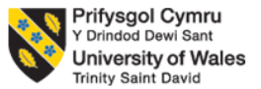

Programme: Master of Business Administration
Module: Human Capital Management
Title: Aether Innovation: Building a Culture of Innovation & Future Work Practices
Lecturer: Dr Eno Maycock
Word Count: 2480
Submission Date:19/02/2026

Student Name : Khushi Rajeshbhai Goraniya
Student ID : 2527497

Table of Contents

Part 1: Option 2: Building a Culture of Innovation & Future Work Practices 4
Introduction 4
1.1 Current Culture and Work Practices in Leading Tech Companies 4
1.1.1 Innovation-Driven Cultures 4
1.1.2 Flexible and Hybrid Work Models 5
1.2 Cultural and Structural Initiatives to Embed Innovation at Aether 6
1.2.1 Establish Cross-Functional Innovation Squads 6
1.2.2 Launch an Intrapreneurship Program 6
1.2.3 Embed Continuous Learning 7
2.4 Redesign Performance Management 8
1.3 Future of Work Model for Collaboration and Creativity 8
1.3.1 Hybrid and Flexible Work Structure 8
1.3.2 Technology-Enabled Collaboration 8
1.3.3 Redefining Leadership for the Future 8
1.4 Impact on Employee Motivation and Performance 9
1.4.1 Enhanced Employee Motivation 9
1.4.2 Improved Retention and Employer Brand 9
1.4.3 Changes in business outcome 9
Conclusion 9
Part 2: Reflection 11
2.1 Learning journey during module 11
2.2 Staying relevant during AI and using AI for work assistance 14
2.2.1 Skillset to be included for being relevant 14
2.2.2 Using AI instead of being replaced 14
Reference 16

Part 1: Option 2: Building a Culture of Innovation & Future Work Practices

Introduction
Aether Innovations, a 300-person fast-growing technology firm, is facing issues with revenue growth, rising employee turnover, and declining customer satisfaction. These issues signal misalignment between people strategy, organisational culture, and business performance. In these industries, people are the primary source of competitive advantage. The World Economic Forum (2020) predicts that 50% of the entire workforce will require reskilling by 2025 because of the changes in technology. Employees who are engaged are more dedicated, facilitate discretionary effort, and have a positive impact on overall organisational performance (Atiku et al., 2024). This report advises on the use of an integrated human capital strategy to restore innovation, engagement, and performance at Aether Innovations. By harmonising culture, structure, and future work practise the organisation is capable of revitalising its workforce and providing higher customer outcomes.

1.1 Current Culture and Work Practices in Leading Tech Companies

1.1.1 Innovation-Driven Cultures
Technology companies with high performance deliberately establish cultures that help employees experiment, achieve independence and psychological security. As an example, Aether would be benefiting by Google. It promotes innovation by using organised experimentation and statistical decision-making. Its “20% time” approach in the past enabled employees to spend time on passion projects and has resulted in the creation of some products like Gmail (Clark, 2021). Likewise, one of the strategies Microsoft employed under Satya Nadella was to replace its organisation with a know-it-all with a learn-it-all culture (Ali and Begum, 2024). Therefore, the focus is on growth mentality and teamwork.
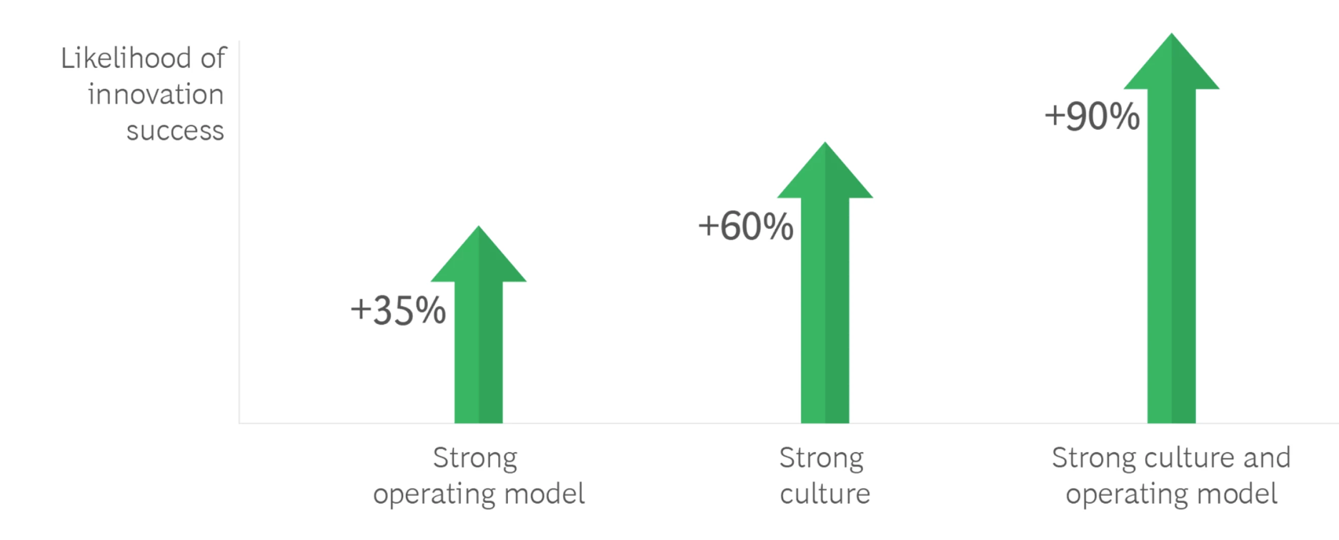
Figure 1: Innovation-Driven Cultures
Source: (Manly et al., 2023)
This is due to the fact that innovation thrives in these companies when the employees have the comfort to be experimental and have the capability and empowerment to produce ideas. The concept of psychological safety, introduced by Amy Edmondson, has a very strong correlation with the performance of the team (Edmondson et al., 2024). Homogeneous teams are more successful in their innovation rates than similar teams, but of low psychological safety.

1.1.2 Flexible and Hybrid Work Models
Flexible methods of work are becoming common in the future of work in tech. GitLab is a company that works with more than 1,000 full-time staff members working in 60+ locations (Choudhury et al., 2020). Technology firms have embraced work-anywhere models, which are flexible. Therefore, allowing employees to work where they are most productive and well.
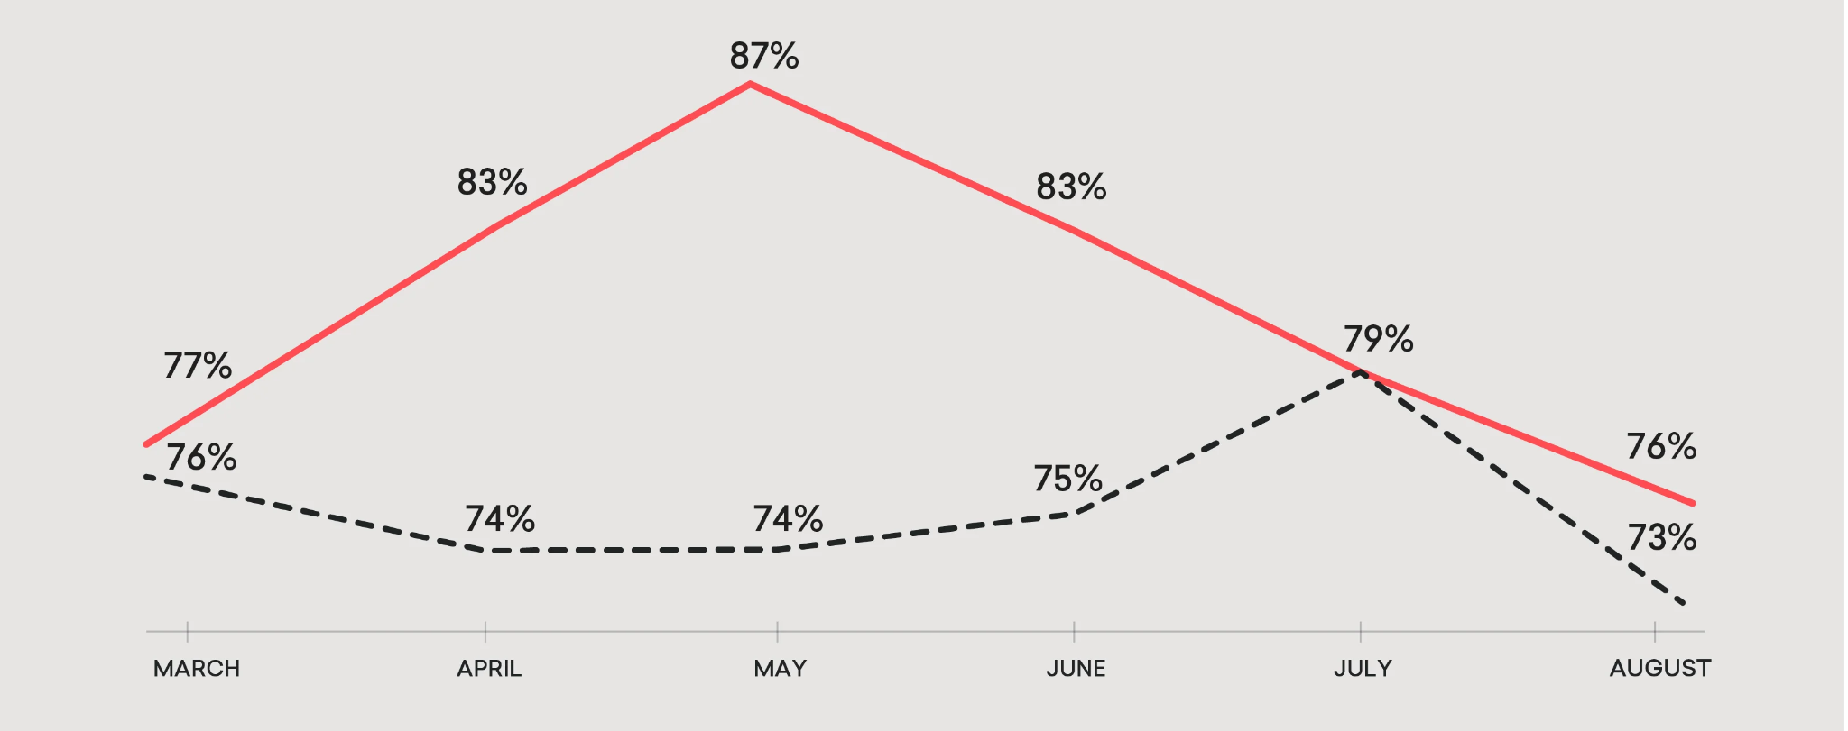
Figure 2: Innovation-Driven Cultures
Source: (Kazi and Hastwell, 2021)
Research by Lufkin (2020) established that remote employees were 13% more productive than those who work in the office. The staff members are shifting towards the flexible models of working more than the office models. The above illustrates the ways in which modern work cultures are being influenced by the concepts of flexibility, autonomy, and digital collaboration.

1.2 Cultural and Structural Initiatives to Embed Innovation at Aether
Aether Innovations needs to consciously recreate its culture and structures to turn around stagnation. Organisations need to create value through innovation and develop an acceptance of cultural relativism, which in future can help achieve cultural competency (Cook, 2023).

1.2.1 Establish Cross-Functional Innovation Squads
Siloed departments restrict creativity. Time-limited sprints of innovation should be solved by cross-functional teams of engineers, designers, marketers, and customer service representatives. These two-week sprints would be based on the inspiration of agile techniques of addressing customer pain points. According to a study conducted by Halliburton (2024), the likelihood of an agile organisation being more financially successful compared to other organisations is 2.5xtimes. The cross-functional collaboration improves speed, learner and customer focus.

1.2.2 Launch an Intrapreneurship Program
An internal innovation incubator would allow employees to pitch and develop new product ideas. The time, mentorship, and seed funds may be given to employees whose ideas are approved. Deloitte (2021) says that firms that push intrapreneurship declare an increased growth in innovation revenue, 20% higher. This effort supports the Human Capital Theory that holds that investments in workforce skills and creativity result in economic profits of organisations (Ullah et al., 2022). It enhances the long run organisation performance by developing a strategic workforce.

1.2.3 Embed Continuous Learning
The process of innovation involves continuous skills. Aether must establish systematic development programmes that are in line with business strategy. Human Resource Planning facilitates the ability to project the workforce and match them to the product and market demands in the future.
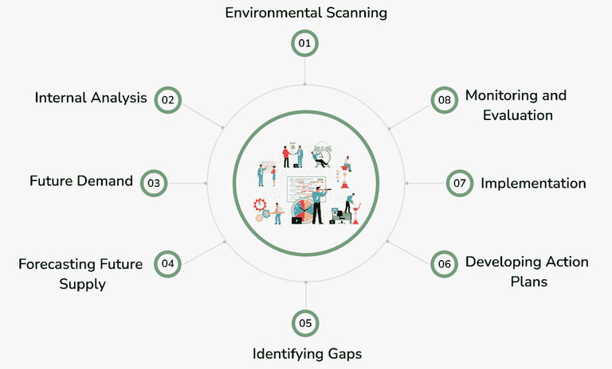
Figure 3: Human Resource Planning
Source: (GeeksforGeeks, 2023)
Training programs should follow Kolb’s Learning Cycle to ensure training includes "Doing" (practice) and "Thinking" (theory) (McLeod, 2025). There would be simulations, hackathons, and actual project assignments and after that, reflections among the employees. It also means that employees tend to stay longer with organisations that invest heavily in the learning and development of their employees. In the case of Aether Innovations, the focus on ongoing skill building might then serve to increase retention and long-term stability of the workforce.

2.4 Redesign Performance Management
Rewards to performance systems should be based on collaboration, testing systems, and customer impact as opposed to merely measuring output. According to Giamos et al. (2023), continuous feedback has been proven to be better in performance and engagement than annual reviews. Such key performance indicators (KPIs) in Aether are innovation contribution, the teamwork rating, and the rating of customer satisfaction.

1.3 Future of Work Model for Collaboration and Creativity

1.3.1 Hybrid and Flexible Work Structure
The Future of Work model motivates staff by offering flexibility and autonomy. It will help enhance engagement, creativity, and collaboration, boosting overall performance at Aether. Aether ought to use a flexible hybrid system where employees have options of either working at home or in their offices on collaboration days. The team brainstorming on the core collaboration days (two days a week) would be centred, whereas individual work can be done remotely.
This strategy reconciles freedom and affiliation. Khan (2024) states that hybrid workers are the most engaged workers in contrast to employees who report working on-site.

1.3.2 Technology-Enabled Collaboration
Digital tools are essential for distributed teams. Aether can utilise the platforms of Microsoft Teams, Zoom, and Zapier to simplify the process of communication and automation of the workflow. The organisation should consider a Remote-First/Fully Distributed approach for certain departments, such as software engineering and customer support. Remote working employees are also happier than their on-site counterparts because happiness is strongly associated with productivity and retention.

1.3.3 Redefining Leadership for the Future
The leaders should abandon the command-and-control approach and use coaching and facilitation (Thomson, 2022). Transparent communication, clear OKRs (Objectives and Key Results), and digital visibility dashboards ensure accountability without micromanagement. Firms that have an effective leadership development system are 2.4xtimes more likely to achieve the performance goals (McKinsey and Company, 2022).

1.4 Impact on Employee Motivation and Performance

1.4.1 Enhanced Employee Motivation
The previously mentioned Future of Work model empowers employees with choice, flexibility, and autonomy. By encouraging employee involvement and innovative thinking, it enables staff to perform at their best. Self-Determination Theory highlights autonomy, competence, and relatedness as key drivers of motivation (Olafsen et al., 2024). Hybrid work enhances autonomy; continuous learning builds competence; cross-functional squads’ foster relatedness. Involved employees have a role to play in enhancing customer loyalty and satisfaction. In Aether, the first way of improving engagement would be the direct benefits on customer experience and retention. Flexibility can be beneficial for employee health and productivity ensuring quality, therefore this can help employees to deliver projected outcome.

1.4.2 Improved Retention and Employer Brand
Low turnover in most cases is attributed to poor growth prospects and inflexible work arrangements. Aether will be an employer of choice because of the innovation and flexibility embedded. Effective learning cultures enhance retention of employees (Muthuswamy and Umarani, 2023). They stimulate loyalty and commitment.

1.4.3 Changes in business outcome
The innovation teams work right on the customer pain points, lower response rates, and enhance the relevance of the products. Deloitte reports that customer-centric companies are 60% more profitable than those that are not customer-centric (Deloitte, 2024). This alignment demonstrates how integrated HR practices strengthen internal engagement levels. This Future of Work model would enable optimal performance by impacting innovation, motivation, and team cohesion. Coordinated people strategies enhance employee commitment, capability, and performance outcomes. Ultimately, this drives superior customer value and sustained organizational excellence.

Conclusion
Aether Innovations’ flat growth, high turnover, and low customer satisfaction reflect misaligned culture and people practices. A competitive advantage can be created out of employees through an integrated human capital strategy. Innovation will be reinforced by cross-functional groups, intra-preneurship and planned HR. Some sort of hybrid model (flexible) will enhance partnership and productivity. The experience of Google and Microsoft tells us that companies with engaged employees are performance-driven. Moving people to be in line with the strategy will bring back growth and customer excellence.

Part 2: Reflection

2.1 Learning journey during module
During this module of Human Capital management, different week based learnings focused on key areas of recruitment, personal management has helped me to design a self-development plan, which is discussed in later part of this reflection. In this part, we will be looking into week-wise learning and adaption. In entire module starting from Week 1 to 7, International team management, strategic HR practices, importance of global culture and need for training has been taught. Brief history of HRM Development has staged and categorised, which has been helpful for me to understand evolution of management practices. I have understood benefits of high performing teams, through PERFORM model. Evolution of modern day teams, where 5-stage model has been defined through Tuckman model (Lecture note: Week 1-7)
In next week’s lecture, definition of team, role of team leader has been taught, which is crucial for organisational positioning. I can utilise this principle in real life situation as a leader, when my team can deliver relatively low output showing a need for team development. Belbin’s team role has helped me learn team roles and leadership perspective. I have also learned importance of working in a globally diverse team or outside home country. Next Week 3 taught me to introduce HR strategy, which can help devise talent acquisition strategy, succession planning. Different sections of strategic reformation and inclusion of data driven decision can help forecast future directions. I have learned dimensions of HRP (Human Resource Planning). Week 5 shows contemporary issues and Week 6 defines meaning of a global culture, and its effectiveness in team building.
Design for appropriate learning and growth mind-set by Gibbs Cycle
During my journey in this course I have come across different subject and topics, which were guided by instructor to improve our day to day routine and assignments. I understand that these modules can help design a learning pathway for my career, which can be explained through Gibb’s Reflective Model consisted of an action plan to implement in real life application (Mukhanova and Seitimova, 2025).
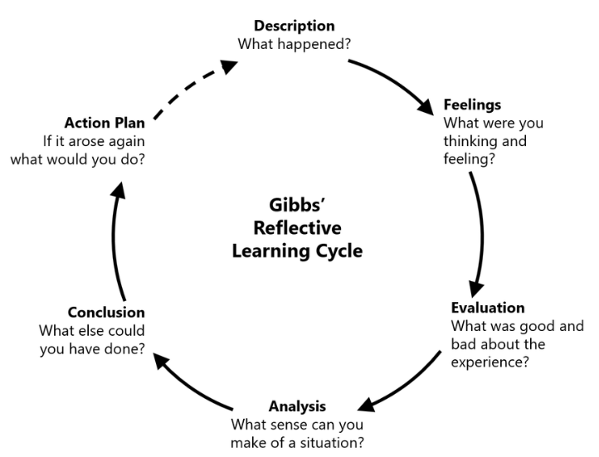
Figure 4: Gibbs Reflective cycle
(Source: Harithuddin, 2021)

Description: Personnel management section discussed in the Week has facilitated me with a clear understanding of HRM as a fundamental new approach within employees to obtain competitive advantage and strategic integration. Week 5 details on the Organisational commitment and control through analysis of contemporary HR issues, long and short term approaches. Theoretical and realistic explanation of workplace practices in HR has been developed to manage and leverage true values from people.
Feelings: At the beginning of this module, I was a bit nervous as I wanted to learn strategic reformations for HRM. However my analytical perspective defined need for a holistic approach rather than a scattered process. Real life training and development focused on surging confidence for considering international as well as local market.
Evaluation: I think this module has done excellent work by blending theoretical aspects with practical application with talent acquisition and HR management strategies. Real world upskilling needed during upcoming AI revolution can be supported through our learning module, where contemporary issues are highlighted with international team management during role of a leader. My evaluation of learning journey completed through this module helps to use practical tools like 360-degree feedback and others.
Analysis: Entire syllabus starting from Week 1 to Week 7 has taught me to turn adaptive strategies into innovative actions, which can help me in workplace in future. My cultural understanding while leading a team for personal growth as a leader has been also nurtured in this module.
Conclusion: As a leader I have developed my skills to comply with disciplinary procedure. Scholarly articles cited in this module also focused on theoretical aspects like Michigan model, Harvard model, Guest model, which has been useful for employee commitment, employee training, and balancing stakeholder interest.

Action Plan:
Steps | Effectiveness | Time
Innovation driven application in simulated situation | Decision making efficiency through creativity development | 0-3 Months
Performance measurement | Online self-assessment for checking readiness in real life scenarios | 3-6 Months
Cultural and strategic reformation in global and national team | Communication and community development through Belbin | 12 months

2.2 Staying relevant during AI and using AI for work assistance

2.2.1 Skillset to be included for being relevant
Artificial Intelligence is currently posing threat to traditional jobs due to its massive support that per. Most effective process to stay relevant during this AI transformation is to shift towards Value creation rather than executor of specific tasks (Edirisinghe and Cheok, 2024). I think AI follows a pre-set approach where inputs can vary type of outcomes. In case of Human intervention, inputs cannot change the way of thinking, rather it is the ideation and exclusive skills such as Emotional Intelligence (EI), Critical thinking, creativity and originality (Akpur, 2024). As far I know, AI works on existing text, information or data, which in case of human is different as it can include multiple other dimensions of critical thinking into the work. I want to enable these exclusive skillset within my work, which requires a strong understanding of problem context and exploration of different views to create or innovate something new as output.

2.2.2 Using AI instead of being replaced
Utilizing AI to train and develop new ideas for myself can be beneficial, as AI can be controlled through measured prompt and collecting new information from different sources. We are standing at the verge of fourth industrial revolution, therefore I need to learn new skills within human development and data analytics through professional courses on communication, creative thinking. Additionally I need to look for business challenges that AI is solving and adaption of this processes within my skillset to deliver equivalent output (Sundquist. and Lubart, 2022). I remember one saying of Donal Hatter, who said best way to stay relevant during this change is to solve problems for influential people. It can help an individual during a situation when AI can replace, that person can get any different job role through that influence. I need to develop strong networking and communication skill for this advantage, which can be created using AI and monitored for daily progress.

Reference
Akpur, U., 2024. Does creativity matter in personality traits and emotional intelligence?. Psychology in the Schools, 61(9), pp.3612-3625.
Ali, M.M. and Begum, S. (2024). Case Study: Satya Nadella’s Leadership at Microsoft. IOSR Journal of Business and Management, [online] 26(12), pp.74–79. doi:https://doi.org/10.9790/487X-2612027479.
Atiku, S.O., Naunyango, K.A.I. and Oladejo, O.M. (2024). Inclusive Leadership and Employee Engagement as Critical Drivers of Sustainability in Telecommunication Companies. Administrative sciences, 14(6), pp.126–126. doi:https://doi.org/10.3390/admsci14060126.
Choudhury, P., Crowston, K., Dahlander, L., Minervini, M.S. and Raghuram, S. (2020). GitLab: work where you want, when you want. Journal of Organization Design, [online] 9(1). doi:https://doi.org/10.1186/s41469-020-00087-8.
Clark, D. (2021). Google’s ’20% rule’ shows exactly how much time you should spend learning new skills—and why it works. [online] CNBC. Available at: https://www.cnbc.com/2021/12/16/google-20-percent-rule-shows-exactly-how-much-time-you-should-spend-learning-new-skills.html.
Cook, J., 2023. Cultural relativism as an ethnocentric notion. In The philosophy of society (pp. 289-315). Routledge.
Deloitte (2021). Innovation Study 2021: Beyond the Buzzword. [online] Deloitte Insights. Available at: https://www.deloitte.com/us/en/insights/topics/innovation/corporate-innovation-program-report-and-key-takeaways.html.
Deloitte (2024). Personalising The Customer Experience. [online] www.deloittedigital.com. Available at: https://www.deloittedigital.com/mt/en/insights/perspective/Personalising-The-Customer-Experience.html.
Edirisinghe, C. and Cheok, A.D., 2024. AI-human collaboration: Redefining roles in the modern workplace. PaKSoM 2024, p.37.
Edmondson, A., Auger-Domínguez, D. and Keswin, E. (2024). Psychological Safety (HBR Emotional Intelligence Series). [online] Google Books. Available at: https://books.google.com/books?hl=en&lr=&id=Kj3wEAAAQBAJ&oi=fnd&pg=PA2000&dq=Psychological+safety
GeeksforGeeks (2023). Human Resource Planning (HRP): Meaning, Process, and Examples. [online] GeeksforGeeks. Available at: https://www.geeksforgeeks.org/hr/human-resource-planning-hrp-meaning-process-and-examples/.
Giamos, D., Doucet, O. and Léger, P.-M. (2023). Continuous performance feedback: investigating the effects of feedback content and feedback sources on performance, motivation to improve performance and task engagement. Journal of Organizational Behavior Management, [online] 44(3), pp.1–20. Available at: https://www.tandfonline.com/doi/full/10.1080/01608061.2023.2238029.
Halliburton, D. (2024). The Role of Business Functions in Shaping a Company’s Strategy. [online] C-Suite Strategy. Available at: https://www.c-suite-strategy.com/blog/the-role-of-business-functions-in-shaping-a-companys-strategy.
Harithuddin, A.S.M., 2021. A first experience of using failure report as a reflective tool in engineering education. International Journal of Emerging Technologies in Learning (Online), 16(18), p.23.
Kazi, C. and Hastwell, C. (2021). Remote work productivity study finds surprising reality: 2-Year analysis. [online] Great Place to Work®. Available at: https://www.greatplacetowork.com/resources/blog/remote-work-productivity-study-finds-surprising-reality-2-year-study.
Khan, Dr.A. (2024). Employee Engagement Strategies in a Hybrid Workforce. Finance & Audit Research Archive Letters, [online] 1(4), pp.176–193. Available at: https://www.farajournal.com/index.php/Journal/article/view/32.
Lufkin, B. (2020). The remote work experiment that upped productivity 13%. [online] www.bbc.com. Available at: https://www.bbc.com/worklife/article/20200710-the-remote-work-experiment-that-made-staff-more-productive.
Manly, J., Harnoss, J., Schmitt, H.L., Werner, R., Blanchard, D. and Lovich, D. (2023). An Innovation Culture That Gets Results. [online] BCG Global. Available at: https://www.bcg.com/publications/2023/innovation-culture-strategy-that-gets-results.
McKinsey & Company (2022). Choosing to grow: The leader’s blueprint | McKinsey. [online] www.mckinsey.com. Available at: https://www.mckinsey.com/capabilities/growth-marketing-and-sales/our-insights/choosing-to-grow-the-leaders-blueprint.
Mcleod, S. (2025). Kolb’s Learning Styles and Experiential Learning Cycle. [online] Simply Psychology. Available at: https://www.simplypsychology.org/learning-kolb.html.
Mukhanova, A. and Seitimova, A., 2025. Reimagining Differentiation: A Reflective Inquiry Using Gibbs’ Model.
Muthuswamy, V.V. and Umarani, M. (2023). Exploring the Role of Learning Culture, Cultural Adaptability and Green Culture to Enhance Employee Retention. Cultura: International Journal of Philosophy of Culture and Axiology, [online] 20(3). Available at: https://culturajournal.com/submissions/index.php/ijpca/article/view/349.
Olafsen, A.H., Baptiste and Kujanpää, M. (2024). Crafting for autonomy, competence, and relatedness: A self‐determination theory model of need crafting at work. Applied Psychology, 74(1). doi:https://doi.org/10.1111/apps.12570.
Thomson, B. (2022). Coaching for Leadership. Springer eBooks, pp.219–234. doi:https://doi.org/10.1007/978-3-030-93486-6_10.
Ullah, A.A. -, Mehmood, W., Amin, S. and Abbas, Y.A. (2022). Human capital and organizational performance: A moderation study through innovative leadership. Journal of Innovation & Knowledge, [online] 7(4), p.100261. doi:https://doi.org/10.1016/j.jik.2022.100261.
World Economic Forum (2020). The Future of Jobs Report 2020. [online] WORLD ECONOMIC FORUM. Available at: https://www.weforum.org/publications/the-future-of-jobs-report-2020/.

