MARKETING ESSENTIALS

MODULE CODE: M4X01916

GEGO EMOKE

1815061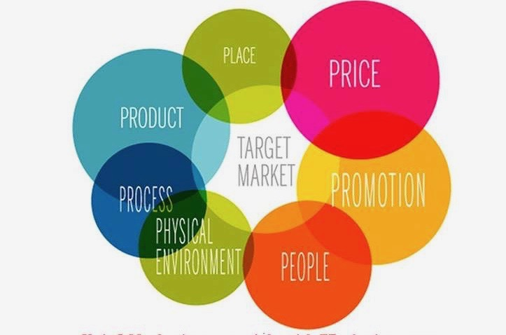

Content Page

Introduction…………………………………………………………………………….....3

MIS for Marketing……………………………………………………………………...…3-4

MIS for Information Gathering in Ritz-Carlton………………………………………4

MIS for Communication in Ritz-Carlton………………………………………………5

Marketing Mix for Ritz-Carlton…………………………………………………………5-7

Conclusion…………………………………………………………………………………7

References………………………………………………………………………………. 7-8

Module subject

Analyse the importance of Marketing Information System, its effectiveness within the hospitality and tourism industry as a tool for marketing, information gathering and communication.

Introduction

Marketing Information System is a permanent setup for systematic collection, analysis, storage, distribution of the market information, from both the internal and external sources on a regular basis. Philip Kotler defines MIS system as “people, equipment, and distribute needed, timely, and accurate information to marketing decision makers.”
The main aim and objectives of this study is to explore the importance of Marketing Information System usage in any business environment, its potency within the hospitality and tourism industry as an essential tool for marketing intelligence.
The review also includes summaries of research topics related to the main subject and data analysis. It has also involved the industry-specific contemporary trends and topics that commands efficient research attention. This research draws a parallel between traditional marketing and E-marketing in hotel industry.
The study will also outline the use of MIS at one of the leading hospitalities chains the Ritz- Carlton.

MIS for Marketing

The development of enterprise information systems can be considered quite rapid if we consider the relatively short period since the beginning of their development. The reason for their call to life is to address the needs of the corporate side, which expected the uncompressed data sets generated by the company’s operation to be manageable and the easiest to extract valuable information from them. It would have been difficult to serve all these needs, of course, if the appropriate tools and resources had not been available for that to be developed at that time without the help of fast developing computing.
Nowadays, globalization is a natural process that has made market competition worldwide. Competitive companies are already crossing national market opportunities and widening competition across the world market. For that reason, it is very important that the information serves the corporate interests as soon as possible, as the information that forms the basis of the knowledge, its application in an efficient way determines the development potential of both the companies and the regions and their competitiveness, too.
For future -thinking and profit oriented companies, market survival, gaining and retaining competitive positions, and long -term survival and long term operation are becoming increasingly difficult, and future -oriented leadership thinking is essential.

Based on my research, in the next piece of writing, I will present the MIS which Ritz-Carlton Hotels is adopting to better serve the customer.

MIS for Information Gathering in Ritz-Carlton

“For Ritz-Carlton, superlative service has long been a competitive advantage.
Ritz-Carltons Hotel’s Strategic Management for Information Systems programme has an outstanding reputation within the hospitality industry and is presented as best practice example in many publications of academic literature. Customer relationship management is a combination of people, processes and technology that seeks to understand a company’s customers. It is an integrated approach to managing relationships by focusing on customer retention and relationship development. Although a large portion of CRM is technology, viewing CRM as a technology -only solution is likely to fail. A successful CRM implementation requires an integrated and balanced approach to technology, process, and people…’ (Ritz Carlton CRM programme, 2009)

At Ritz-Carlton Hotels, exceptional facility has long been a reasonable benefit. To expand the benefit, the company in 1998 has put into action a customer relationship programme called CLASS which is a loyalty and customer satisfaction programme. Each staff member carries a “guest preference pad”, every customer favorites are remarked in the notepads and directed to the guest recognition department.

MIS for Communication in Ritz-Carlton

Today's tendencies of social networking, and freedom have entirely changed customer service expectations. Customers expect quality, personalized service on the web, social media, mobile and phone.
The world of "classical" customer relationship management has changed significantly in recent years. More and more companies are realizing the potential of social networking for their business strategy.

The Ritz-Carlton serves to the wealthy members of society. The average guest is monetarily secure, knows what they want and is unconcerned about the costs of the facilities. A Ritz-Carltonlodger is looking for a personalized experience from the moment they walk in.
Based on my research and on the available, data i can say Ritz Carlton believes that satisfying guests while they are in the property is not enough for future sustainability.
Instead, they focus on finding new customers and keeping the existing ones through loyalty marketing..

Ritz-Carlton Hotel Company is a primary provider of hotel experiences and necessities to do ahead the needs and wishes of thei rvisitors.They have spent a vast volume of assets on how their lodgers get into their hotels before arrival..
The Ritz-Carlton has done an outstanding job in the develpment of their website: ritzcarlton.com

x purchase a new condo or vacation proper
At ritzcarlton.com customers can do research of hotels around the world, make reservations at their preferred hotel, buy goods from the virtual gift shop, make spa appointments, plan and book for social events, enrol into their loyality program the Ritz Carlton Rewards. Guests can even purchase holiday property at the Ritz-Carlton Residences or Club. Once joint with their guest loyalty program, Ritz Carlton Rewards, ritzcarlton.com provides guests with the greatest level of service. As soon as a visitor becomes a member of the reward program, they collect loyalty points for their dwell which points then will gather towards free hotel visits or flights.

The Ritz Carlton has created an application that allowscustomers to create a poster or postcard that preserves the name of the destination by using the photos taken in the hotels, which can also be uploded to any social media platform.
Ritz Carlton, on the basis of photos taken by his guests using the technology described above, sees the most popular photography themes for his guests, which can be used for further development and operation. In addition, the best of the photos are shared on Instagram and on the dedicated ritzcarlton.com/yourmemories website.

Marketing Mix of Ritz-Carlton

We call it ’mix ’ because there are countless sales channels, price strategies, promotions, etc. You have to choose the ones that you can put the most product into the market in the most competitive way and keep it there.
We distinguish marketing tools in many ways. The most common in the literature is the grouping of 4P.

These are the following:

- product, product policy (Product)
- price, price policy (Price)
- place, distribution channels, sales policy (Place - Distribution)
- communication policy, market influencing (Promotion)

In 1981, Booms and Bitner added an additional 3P to the existing mix, and classically, service marketing "requires" this model.

- people (all people involved in the sale on any side: your colleagues and your target group)
- Process (product creation and service)
- Physical Evidence (all that indicates fulfillment: parcel delivered, new hair for hairdresser, download pdf)

But the marketing activity isn't about the marketer only,one doesn't write their website to themself, and even their sub-pages are not about them, but about their customers.
That is why in 1990 Robert Lauterborn wanted to replace the 4P model with 4C, which is a more customer-oriented and modern approach.

- Clients (product helyett)
- Costs (price helyett)
- Convenience (place helyett)
- Communication (promotion helyett)

What justifies this change?

Product is not viable on its own. In modern marketing, we start from the market, demand and customer needs, to which a product means the solution, so we approach from the other side. This is important because product-centricity is really an out-of-date concept: the demand for low supply is extremely high (at the dawn of the industrial revolution).

Product in the Marketing Mix of Ritz-Carlton

Ritz-Carlton Hotels providesspecial treatment to their customers, including personal service, private baths, gourmet cuisine, beach club, golf course etc. Just to mention a few of the superior services they provide to their guests.
The Ritz-Carlton is going to recommend its Yacht Collection for open use from 2020. It will be made of custom-made yacht which will offer a week or even ten days cruise.

Place in the Marketing Mix of Ritz-Carlton

Ritz Carlton started its ventures from the US and over the years has gained the external market in thirty countries. It has one hundred and thirty resorts and luxury hotels to its name that helps it to offer best possible services to its valued guests.
They sensibly select the locations of their hotels, they select prime locations which are either in the city centres or by the airports.

Price in the Marketing Mix of Ritz Carlton

They position themself as a luxury group and their ’ars poetica’ is creating memories and they have implemented a premium pricing strategy.

For the Ritz-Carlton guest the memories and luxurous treatment matters more than money.

Promotions in the Marketing Mix of Ritz-Carlton

They believe in the mouth-of-word strategy. They believe if their guests are satisfied, they will share it with their friend and family.
They advertise themselves in different travel magazines, in their own website and in different social media platforms. They have their own reward program which allows customers to collect loyalty points which will allow them to enjoy complimentary stays in the future.
As part of their promotional program they offer vacation packages as well.

Conclusion

Based on my research I have come to the conclusion that in today's fast-paced world, consistency and digital-mindset are all essential for sustainable growth. Continuous improvement is needed and guests fast changing needs/ behaviours need to be monitored at all times in order to remain a successful in the future.

References

, . () It All Begins with Customer Knowledge [online]. : . Available at http://http://www.destinationcrm.com/Articles/News/Daily-News/forRitz-Carlton [Accessed 10 March 2019].
(, )

(2019) [online] Available at <http://www.slideshare.net> [Accessed 10 March 2019].
(, 2019)

, . (1999) 'Customer loyalty: the future of hospitality marketing'. International Journal of Hospitality Management 18 (4), pp.345-370.
(, 1999)

(2019) Marketing91 [online] Available at <https://www.marketing91.com/about/> [Accessed 12 March 2019].
(, 2019)

Lee, J W. Kwag, M, . (2017) 'Economics and Business '. Journal of Asian Finance 4 (1), pp.79-86.
(Lee, J W. Kwag, M, 2017)

McMurtry, J M., and Hiam, A. (2017) Marketing for dummies /. 408 Seiten.: Illustrationen..
(McMurtry and Hiam, 2017)

Sziva, I. (2016) Traveling in the e-world. 1 edn. Budapest: Foundation for Information Society, INFOTA Research Institute.
(Sziva, 2016)

Tsenden , Travel Service. (2009) Strategic Management for Information Systems, Starwood Hotels & Resorts Worldwide. [Blog] 31 October 2009. Available at http://smp-is.blogspot.com.au [Accessed 10 March 2019].
(Tsenden , 2009)

