BSc Health and Social Care
Changemakers: Creativity and Value Creation

COMPONENT 2: WRITTEN ASSIGNMENT
HeartReach England
A Community and Digital Cardiovascular Disease Prevention Initiative
Student name | Shumaila Naeem
Student number | 2406608
Programme | BSc Health and Social Care
Module | Changemakers: Creativity and Value Creation
Module code | BMHP5014
Assignment title | Component 2: Written Assignment (Poster and Pitch)
Lecturer | Zarah Ahmed
Submission deadline | Sunday 19 July 2026, 14:00

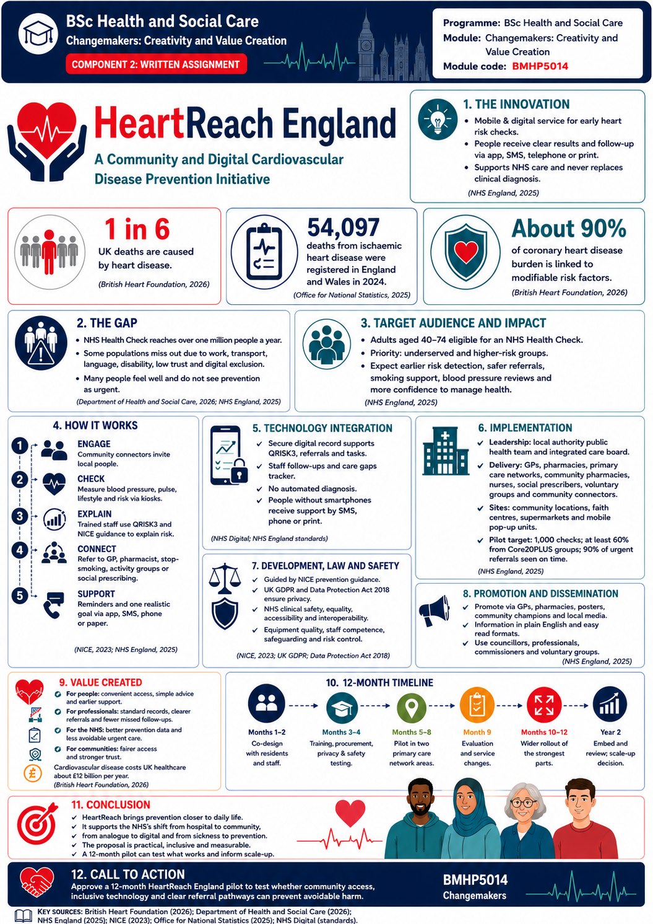

Written Pitch: HeartReach England
A persuasive proposal for a twelve-month community cardiovascular prevention pilot
Pitch in one sentence: Bring short heart checks into trusted community places and connect each person to safe, simple and inclusive follow-up.

1. Introduction
HeartReach England is a proposed cardiovascular disease prevention service. It takes simple heart checks into places that people already know and trust. These include libraries, faith centres, supermarkets, workplaces, and community centres. Each check is linked to follow-up support through an app, text messages or telephone calls (Robson et al., 2016). The main audience is adults aged 40 to 74 who live in underserved areas or find it hard to use normal health services (Brady et al., 2025). The need is urgent. The British Heart Foundation (2026) states that heart disease causes around one in six deaths in the UK. It also reports that about 90 per cent of coronary heart disease burden is linked to risk factors that can often be changed. The Office for National Statistics (2025) recorded 54,097 deaths from ischaemic heart disease in England and Wales in 2024.

2. The gap and the proposed solution
England already has the NHS Health Check programme (NHS England, 2026). The Department of Health and Social Care (2026) explains that it aims to prevent heart disease, stroke, diabetes, and kidney disease among adults aged 40 to 74. It reaches more than one million people each year. Yet some people cannot get time away from work. Others face language, transport, digital or trust barriers. Many feel well and do not see prevention as urgent.
HeartReach moves the first contact from the clinic into the community. A trained nurse, healthcare assistant, or pharmacist will offer a short check. It will include blood pressure, pulse, body measurements, smoking status, family history, and cholesterol testing where suitable. A trained professional will use QRISK3 and clinical judgement. The National Institute for Health and Care Excellence (2023) and Deniz-Garcia et al. (2023) recommend structured risk assessment, lifestyle support and suitable treatment. The app will not diagnose disease. Any concern will be reviewed by a professional (NICE, 2014).

3. How the service creates value
The service creates personal, professional, and public value. People receive a clear picture of their risk before a serious event happens. Advice is simple and based on one achievable goal, such as walking more, reducing salt, stopping smoking or taking medicine correctly.
Professionals receive results and referrals in a standard format. GPs can focus on diagnosis and treatment. Pharmacists can support blood pressure and medicine use. Social prescribing link workers can connect people with exercise, food, welfare and community services (OHID, 2022).
The British Heart Foundation (2004, 2026) estimates that cardiovascular disease costs UK healthcare around £12 billion each year. HeartReach cannot remove this cost alone, but earlier action may reduce avoidable pressure on urgent care. De-identified data will also show which neighborhoods are being missed (Gov.Uk, 2026).
The service supports the common good by giving more help to people who face greater barriers. NHS England (n.d.-a) and Elliott et al. (2025) describes Core20PLUS5 as a national approach to reducing health inequalities. HeartReach will prioritize deprived areas, ethnic minority groups, people with learning disabilities, migrants and inclusion health groups.

4. Implementation and professional roles
I propose a twelve-month pilot in two primary care network areas. The local authority, public health team, and integrated care board will lead it. They will work with GP practices, community I pharmacies, voluntary groups, and residents. Community connectors will help choose trusted locations, suitable times, and clear messages. NHS England (n.d.-b) explains that connectors understand local barriers and can help services engage people (Topal, 2019)
Months one and two will focus on co-design. Months three and four will cover training, digital testing, and information governance. Community delivery will run from five to eight months. Month nine will be used for evaluation. Months ten to twelve will expand the strongest parts.
Very high blood pressure, irregular pulse, or serious symptoms will trigger urgent action. Other risks will lead to a GP, pharmacist, smoking cessation, weight management, or activity referral. NHS England (n.d.-c) and HQIP (2026) state that CVDPREVENT helps primary care find people who may be undiagnosed or under-treated and highlights inequalities.

5. Technology, law and safety
According to NHS Digital (2024), technology will support care but will not replace it. Participants can use an app, SMS or telephone option. The system will provide reminders, personal goals, translated information, and appointment links. A secure dashboard will show authorized staff whether follow-up is complete. People without smartphones will receive the same support through text, print, or calls.
The UK General Data Protection Regulation and Data Protection Act 2018 require personal information to be used lawfully, fairly and securely. GOV.UK (n.d.) explains that health information has stronger protection. HeartReach will use minimum necessary data, role-based access, encryption, audit logs and data protection impact assessment.
ORCHA Health (2026) and NHS England (n.d.-d) state that the Digital Technology Assessment Criteria covers clinical safety, data protection, security, interoperability, usability and accessibility. The supplier will complete this assessment. If the software is classed as a medical device, it will follow Medicines and Healthcare products Regulatory Agency rules. Reasonable adjustments under the Equality Act 2010 will include easy-read material, accessible venues, interpreters, and non-digital choices.

6. Public involvement, promotion and evaluation
According to Visseren et al., (2021). The public should help shape the service. A citizen panel from the target communities will review messages, locations, opening times, and follow-up. This will build trust and reduce professional assumptions.
Promotion will use GP text invitations, pharmacy posters, local radio, social media, employers and community champions. Materials will use plain English and key local languages. Messages will be positive rather than frightening (Greenhalgh, 2017).
The pilot will aim to complete 1,000 checks. At least 60 per cent of participants should come from Core20PLUS groups. Ninety per cent of urgent referrals should be sent within the agreed time. The evaluation will also measure completed follow-up, satisfaction, smoking referrals, blood pressure reviews and NHS Health Check uptake. Results will be reviewed across demographic groups where lawful and appropriate. This will show whether the service reduces gaps, rather than only increasing activity.

7. Conclusion
In conclusion, HeartReach England brings prevention closer to daily life. It connects community trust with professional care. It supports the NHS 10 Year Health Plan. NHS England (2025) describes three key shifts: hospital to community, analogue to digital and sickness to prevention.
The proposal is realistic, inclusive, and measurable. It uses existing professional roles and national guidance but joins them in a clearer pathway. I recommend funding a twelve-month pilot followed by independent evaluation. If it improves access, follow-up and early action, it should be expanded. A small heart check today may prevent a life-changing emergency tomorrow.

References:
British Heart Foundation (2024) UK factsheet: Heart and circulatory diseases, Available at: Heart & Circulatory Disease Statistics 2024 - BHF (accessed: 10 July 2026)
British Heart Foundation (2024) ‘UK cardiovascular disease fact sheet, Available at: BHF UK Cardiovascular Disease Factsheet (Accessed: 10 July 2026)
British Heart Foundation (2026) UK Cardiovascular Disease Factsheet. January 2026. Available at: https://www.bhf.org.uk/-/media/files/for-professionals/research/heart-statistics/bhf-cvd-statistics-uk-factsheet-jan26.pdf (Accessed: 16 July 2026).
Brady, S. M., Chidanyika, J., Verrill, K., Portice, J. S., Scott, S., & Newton, J. (2025). Exploring ethnic minority and underserved groups’ experiences of the National Health Service Cardiovascular Disease Health Check uptake in North East England: applying a behavioural insights, qualitative approach. BMJ Open, 15(9), e096500. https://doi.org/10.1136/bmjopen-2024-096500
Deniz-Garcia, A., Fabelo, H., Rodriguez-Almeida, A. J., Zamora-Zamorano, G., Castro-Fernandez, M., Del Pino Alberiche Ruano, M., Solvoll, T., Granja, C., Schopf, T. R., Callico, G. M., Soguero-Ruiz, C., & Wägner, A. M. (2023). Quality, Usability, and Effectiveness of MHealth Apps and the role of Artificial intelligence: Current scenario and challenges. Journal of Medical Internet Research, 25, e44030. Available at: https://doi.org/10.2196/44030
Department of Health and Social Care (2026) Funding allocations for workplace cardiovascular disease checks pilot grant scheme: 2024 to 2025. 12 February. Available at: https://www.gov.uk/government/publications/workplace-cardiovascular-disease-checks-funding-allocations-2024-to-2025/funding-allocations-for-workplace-cardiovascular-disease-checks-pilot-grant-scheme-2024-to-2025 (Accessed: 16 July 2026)
Equality Act 2010. C15. Available at: https://www.legislation.gov.uk/ukpga/2010/15/contents (Accessed: 16 July 2026).
Data Protection Act 2018, c.12. Available at: https://www.legislation.gov.uk/ukpga/2018/12/contents (Accessed: 16 July 2026).
Elliott, H., Tozer, C., Fenton, A., Powers, C., Lines, C., Hill, M., Owolabi, B., & Ford, J. A. (2025). From policy to action: a document content analysis reviewing the adoption of the healthcare inequalities programme in local health system plans in England. BMJ Open, 15(10), e102163. https://doi.org/10.1136/bmjopen-2025-102163

Gov.UK. (2020). Regulating medical devices in the UK. Available at: https://www.gov.uk/guidance/regulating-medical-devices-in-the-uk (Accessed: 16 July 2026).
GOV.UK (n.d) Data protection. Available at: https://www.gov.uk/data-protection (Accessed: 16 July 2026).
Gov.UK (2026) Statistics at OHID, Available at: Statistics at OHID - Office for Health Improvement and Disparities - GOV.UK (Accessed: 12 July 2026)
Greenhalgh, T., Wherton, J., Papoutsi, C., Lynch, J., Hughes, G., A’Court, C., Hinder, S., Fahy, N., Procter, R. and Shaw, S. (2017) ‘Beyond adoption: a new framework for theorising and evaluating non-adoption, abandonment, scale-up, spread and sustainability of health and care technologies’, Journal of Medical Internet Research, 19(11), e367. https://doi.org/10.2196/jmir.8775
Health Care Quality Improvement Partnership (2026). CVDPREVENT (National Audit of Cardiovascular Disease Prevention in Primary Care), workstream 3 - HQIP. https://www.hqip.org.uk/our-programmes/cvdprevent/ (Accessed: 16 July 2026).
Medicines and Healthcare products Regulatory Agency (2026) Medicine and Health care product regulatory agency .Updated 20 February 2026. Available at: https:// Medicines and Healthcare products Regulatory Agency - GOV.UK
NICE (2014) Behaviour change: individual approaches, Available at: https://Overview | Behaviour change: individual approaches | Guidance | NICE (Accessed: 12 July 2026)
NHS Digital (2024) Digital transformation in health and care, Available at: https:// https://www.england.nhs.uk/digitaltechnology (Accessed: 12 July 2026)

National Institute for Health and Care Excellence (2023) Cardiovascular disease: risk assessment and reduction, including lipid modification. NG238. Available at: https://www.nice.org.uk/guidance/ng238 (Accessed: 16 July 2026).
NHS England. (2026) Cardiovascular disease (CVD) prevention recovery. Available at:https://www.england.nhs.uk/ourwork/clinical-policy/cvd/prevention-recovery/ (Accessed: 16 July 2026).
NHS England (2025) Fit for the Future: 10 Year Health Plan for England. Available at: https://www.england.nhs.uk/long-term-plan/ (Accessed: 16 July 2026).
NHS England (n.d.-a) Core20PLUS5 (adults): an approach to reducing healthcare inequalities. Available at: https://www.england.nhs.uk/about/equality/equality-hub/national-healthcare-inequalities-improvement-programme/core20plus5/ (Accessed: 16 July 2026).
NHS England (n.d.-b) Core20PLUS5 Community Connectors. Available at: https://www.england.nhs.uk/about/equality/equality-hub/national-healthcare-inequalities-improvement-programme/core20plus5/core20plus5-community-connectors/ (Accessed: 16 July 2026).
NHS England (2026) CVD PREVENT. Available at: https://www.england.nhs.uk/ourwork/clinical-policy/cvd/cvdprevent/ (Accessed: 16 July 2026).
NHS England (n.d.-d) Digital Technology Assessment Criteria guidance for buyers and suppliers. Available at: https://digital.nhs.uk/services/digital-technology-assessment-criteria-dtac (Accessed: 16 July 2026).
Office for National Statistics (2021) Deaths registered in England and Wales: 2024. 9 October. Available at: https://www.ons.gov.uk/peoplepopulationandcommunity/birthsdeathsandmarriages/deaths/bulletins/deathsregistrationsummarytables/2024 (Accessed: 16 July 2026).
ORCHA Health. (2026). Digital Technology Assessment Criteria (DTAC). Available at: https://www.orchahealth.com/resources/assessment-frameworks/dtac (Accessed: 16 July 2026).
Office for Health Improvement & Disparities (2022) Health disparities and health inequalities: applying All Our Health, Available at: Health disparities and health inequalities: applying All Our Health - GOV.UK (Accessed: 10 July 2026).
Topol, E. (2019) The Topol Review: Preparing the healthcare workforce to deliver the digital future. Available at: https://The Topol Review – The Topol Review
Visseren F.L.J, Mach F.,, Smulders, Y.M., Carballo, D., Koskinas, K.C., Back, M., Benetos, A., Biffi, A., Boavida, J.M., Capodanno, D., Cosyns, B.,, Crawford, C., Davos, C.H., Desormais, I., Di Angelantonio, E., Franco, O.H., Halvorsen, S., Hobbs, F.D.R., Hollander, M., Jankowska, E.A., Micha,l M., Sacco, S., Sattar, N., Tokgozoglu, L.,, Tonstad S., Tsioufis, K.P., van Dis, I., van Gelder, I.C., Wanner, C., Williams, B.; ESC National Cardiac Societies; ESC Scientific Document Group (2021) ‘2021 ESC Guidelines on cardiovascular disease prevention: Eur Heart, 42(34), p.p. 3227-3337, Available at: https://doi.org/
10.1093/eurheartj/ehab484

