
Trinity Restaurant – City Gates, Little Wind St, Swansea, SA1 1DZ
Opening times for deliveries and collections: Contact Number: 07375766612
(Card payments required)

Monday – Saturday 12 pm – 10 pm
Sunday 12 pm – 7 pm

IF YOU HAVE A FOOD ALLERGY, INTOLERANCE, OR A SPECIAL DIETARY REQUIREMENT, PLEASE INFORM A MEMBER OF OUR TEAM BEFORE PLACING THE ORDER
Starters
Bruschetta with creamy garlic mushroom (670 kcal) – 4.95
Goats cheese salad (221 kcal) – 4.95
Deep-Fried Calamari – 5.95
(Served with garlic mayonnaise, lemon dressing, and parley. 407 kcal)
Buttermilk Crispy Chicken Goujons – 5.49
(With rocket salad, BBQ, and HOT sauce. 427 kcal)
Welsh Homemade Soup – 5.95
(Served with olive oil croutons; ask a team member to see the day’s options and calorie information)
Sweet Chilli Marinated Salmon – 5.49
(With red pepper, cucumber, and sesame seeds. 251kcal)

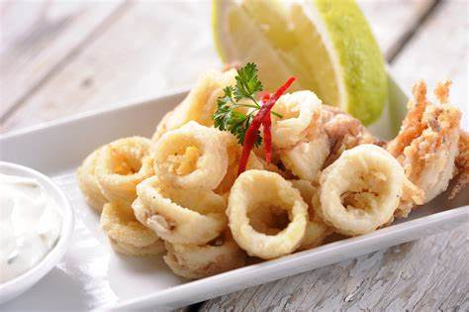

Mains
Welsh Cod and Chips – 10.49
(With tartare sauce and peas. 1465 or mushy peas + 36kcal)
Hand-Battered Halloumi and Chips – 9.99
(With tartare sauce and peas. 1247 kcal or mushy peas +36kcal)
Beef Chilli and Basmati Rice – 9.99
(Served with nachos, sour cream, tomato salsa, or cauliflower rice. 880 kcal)
Glazed Belly Pork – 17.99
(With cabbage, smoked bacon, pomme puree, and mustard sauce. 1614 kcal)
Roast Rump of Lamb – 19.95
(With feta cous-cous, homous, broccoli, and red wine jus. 1067 kcal)
Roast Welsh Topside of Beef – 15.95
(Served with roast potatoes, vegetables, and homemade gravy. 1321 kcal)
Roasted Chicken Breast – 16.95
(Wrapped in Prosciutto, mashed potato, roast carrot, and tarragon jus. 1226 kcal)

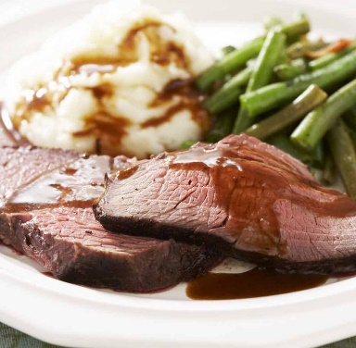

Desserts
Chocolate Fudge Cake – 4.95
(With custard cream 747 kcal, or cream 988kcal or vanilla ice cream. 782 kcal)
Vanilla Cheesecake – 4.95
(Served with rhubarb sorbet. 382 kcal)
Welsh Salted Caramel – 5.49
(With a tart, tonka bean, and raspberry. 516kcal)
Welsh Cheese Board (1043 kcal) – 6.95
Buttermilk Pudding, Honeycomb, and Pear (616 kcal) – 7.49
Warm Mini Brownie Bites – 5.49
(With caramel and raspberry sauce.444 kcal)

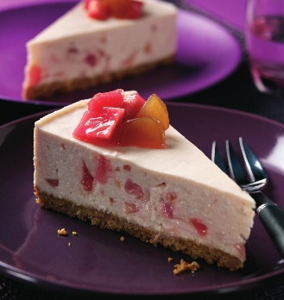

Sides
Crunchy fries (420 kcal) – 3.49
Welsh Sweet Potato Fries (510 kcal) – 3.99
Onion Rings (397 kcal) – 2.99
Garlic Bread – 3.49
(With melted cheese. 378 kcal)
Roasted Baby Potato (149 kcal) – 2.89

Wines pairing
Cabernet Sauvignon 500ml – 19.95
(Pairing perfectly with the beef dish from the main menu)
Chardonnay 500ml – 16.49
(Pairing perfectly with the chicken breast dish from the main menu)
Chenin Blanc 500ml – 15.95
(Pairing perfectly with the goat cheese from the starter menu)



References:
Goldstein, E. (2010) Daring Pairings : A Master Sommelier Matches Distinctive Wines with Recipes from His Favorite Chefs. Berkeley, CA: University of California Press,. doi:10.1525/9780520945562.
Slice Swansea (2022) Menu. [online] Available at: http://sliceswansea.co.uk/ (Accessed on: 10 June 2022)
Beachhouseocwich.co.uk (2022) Desserts. [online] Available at: https://beachhouseoxwich.co.uk/wp-content/uploads/Desserts-June-2022.pdf (Accessed on: 10 June 2022)
Heathcockcardiff.com (2021) Restaurant menu. [online] Available at: https://heathcockcardiff.com/wp-content/uploads/2021/10/Restaurant-Menu-429-791x1024.jpg (Accessed on: 9 June 2022)
Cru Wine (2022) A Simple Guide to Wine Pairing for Every Beginner. [online] Available at: https://www.cru-wine.com/guide-wine-pairings-every-beginner/ (Accessed on: 11 June 2022)
Hope Family Wines (2022) What Foods Pair Best with Chardonnay Wine? [online] Available at: https://hopefamilywines.com/blog/what-foods-pair-best-with-chardonnay-wine/#:~:text=%20Chardonnay%20Wine%20Food%20Pairings%20%201%20Cheeses%0AWine,with%20a%20light%2C%20delicious...%203%20Seafood%20More%20 (Accessed on: 11 June 2022)
Wine Scribble (2022) Wine and Food Pairing: Your Ultimate Guide. [online] Available at: https://winescribble.com/wine-and-food/ (Accessed on: 11 June 2022)
Spccs1.co.uk (2022) Menu. [online] Available at: https://www.spccs1.co.uk/MenuPdf/1CLS_FEB22_FM_PB3_3.pdf (Accessed on: 8 June 2022)
The River House (2022) RH Menu April 2022. [online] Available at: https://app.box.com/s/dgks2bmpkn4yh7oitjgd0hdybrw881jc (Accessed on: 9 June 2022)

