Green issues and
Eco-friendly hotels

DATE: 03 June 2024
WORD COUNT: 1928
STUDENT NAME/ ID NUMBER: Ovidiu-Mario Trasc/ 2206244
MODULE TITLE/CODE: Sustainable Hospitality & Tourism Management/ BMIH5006
LECTURER NAME: Ruth Taylor Davies

Executive Summary
This report will define green issues in the field of hospitality and discuss the types of eco certification. Green Key is a well-known certification that is closely related to sustainability and will present the membership criteria as well as development goals. Then the advantages of becoming eco-friendly for hotels, benefits such as resource conservation, pollution reduction and improved operational efficiency will be highlighted. The report will also outline the actions hotels need to take to achieve eco credentials, as well as the benefits and challenges associated with integrating sustainability. It will end with the discussion on the future of hotels in relation to green issues.
Contents
- Green issues…..………………………….…………………………………………….3
2. Green Key certification 3
2.1 Most known theories associated with sustainability in hospitality industry 3
2.2 About Green Key initiatives 5
2.3 Green Key criteria 5
2.4 Green Key and the Sustainable Development Goals 6
3. Meaning of eco-friendly hotels 7
3.1 Eco-certificated hotels 7
3.2 Benefits of eco-friendly hotels: conservation of resources 7
3.3 Reduced pollution 8
3.4 What hotels need to implement to be granted sustainable accreditation 8
3.5 Benefits associated with integrating sustainability into hotels daily operations 9
3.6 Challenges associated with integrating sustainability 10
3.7 The future of hotels in regards with green issues 11
4. Conclusions 11
5. References 12

- Green issues :
Hotel sustainability involves implementing practices and policies aimed at reducing environmental impact, promoting social responsibility, and maintaining economic viability. This comprehensive approach includes measures such as enhancing energy efficiency, reducing waste, conserving water, and sourcing goods ethically. The goal is to provide an exceptional guest experience while maintaining profitability. (Hospitalitynet.org, 2024)
Green issues refer to environmental concerns that impact the health of our planet. These include challenges related to pollution, resource depletion, waste management, climate change, and biodiversity loss. In the context of industries, addressing green cCissues involves implementing sustainable practices to mitigate these environmental impacts.
The hospitality industry is a significant consumer of energy, primarily for heating, cooling, lighting, and appliances. High energy usage contributes to greenhouse gas emissions and climate change. Hotels consume large amounts of water for guest services, maintenance, and landscaping. Overconsumption can lead to water scarcity and negatively impact local water resources. Also generates substantial waste, including food waste, single-use plastics, and packaging materials. Improper waste management leads to pollution and landfill overuse. (Kasim, A, 2007)

- Green Key certification:

  - Most known theories associated with sustainability in hospitality industry:

Certifications such as Green Key, LEED (Leadership in Energy and Environmental Design), and EarthCheck are among the most recognized in the hotel industry. These certifications not only help hotels improve their operational efficiency and environmental impact but also serve as a marketing tool to attract eco-conscious travellers, enhancing the hotel’s reputation and competitive edge.
- Earth Check is an Australian-based global certification scheme for the travel and tourism industry, assessing sustainability for businesses ranging from boutique hotels like Memmo Alfama in Lisbon to communities and destinations like the Snæfellsnes Peninsula in western Iceland (earthcheck.org).
- Green Globe, headquartered in the USA with worldwide partners, offers a 'certified member' standard along with gold and platinum awards for businesses certified for five and ten years respectively (greenglobe.com).
- Green Key is an international ecolabel managed by the Foundation for Environmental Education (FEE) in Copenhagen, Denmark, with nearly 3,000 members in over 55 countries. It includes various types of accommodations and attractions. In Wales, it's managed by Keep Wales Tidy, and a notable recipient is Larkhill Yurt and Tipis in Carmarthenshire, which has been using renewable energy for 25 years (greenkey.global).
- Green Leaders is a Tripadvisor badge that highlights eco-friendly practices of B&Bs and hotels. It’s not an accredited scheme but allows businesses to showcase their green initiatives, such as recycling and using local organic food. The Platinum badge signifies the highest level of eco-friendliness (tripadvisor.co.uk).
- Travelife, operated by the UK Travel Association (ABTA), certifies hotels in over 50 countries, often seen in travel brochures from major tour operators like TUI and SAGA. Certification involves an on-site assessment by an independent auditor based on criteria including energy efficiency and human rights. Top properties receive Travelife Gold Certification, valid for two years (travelife.info).
- Blue Flag is a longstanding environmental certification for beaches, marinas, and boat operators in regions like Europe, Africa, New Zealand, Canada, and the Caribbean. Spain has the most Blue Flag sites, followed by France, Turkey, Greece, Italy, and Portugal. UK examples include New Quay Harbour and Whitby West Cliff. Certified European boat operators include Cabrera Sea Fun in Majorca and Scorpion Yachting in Greece (Blueflag.global).

  - About Green Key initiatives:

Green Key is a standard of excellence. The Green Key certificate is a premier benchmark in environmental responsibility and sustainable operations within the tourism industry. This prestigious certification signifies a business’s commitment to meeting the stringent criteria set by the Foundation for Environmental Education (FEE). A Green Key symbolizes an establishment’s pledge to guests that their choice of accommodation supports environmental and sustainability efforts. These establishments uphold high environmental standards through thorough documentation and regular audits. ( Greenkey.global, 2024)

2.3 Green Key criteria:

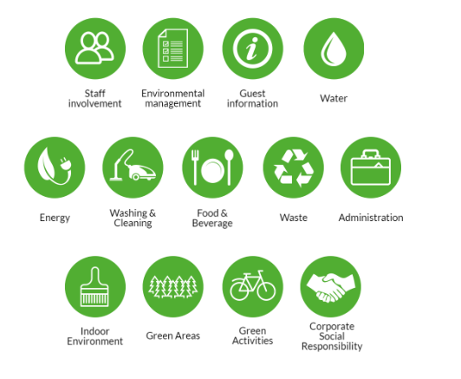
Fig. 1 Green Key criteria (Greenkey.global, 2024)

  - Green Key and the Sustainable Development Goals

Green Key is a premier standard of excellence in sustainable tourism, helping tourism establishments contribute to achieving the 17 Sustainable Development Goals set by the UN. ( GreenKey, 2024)
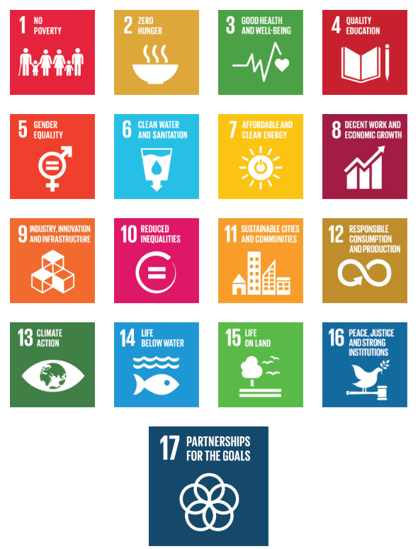
Fig.2 17 Sustainable Development Goals (Greenkey.global, 2024)

- Meaning of eco-friendly hotels
  - Eco-certificated hotels:
Eco-friendly hotels, also known as green hotels, are accommodations that prioritize sustainable practices to reduce their environmental impact. These practices can include energy efficiency, waste reduction, water conservation, and the use of sustainable materials. Eco-certifications from organizations like Earth Check, Green Globe, and Green Key help identify hotels that adhere to specific environmental standards.

  - Benefits of eco-friendly hotels: conservation of resources:
There are a lot of benefits of becoming eco-friendly and most of them are in close contact with conservation of resources and consequently savings in costs for water, electricity and heating. In the following will be presented the main benefits divided in different categories:
- Environmental Impact Reduction:
Energy and Water Conservation: Implementing energy-efficient systems and water-saving measures significantly reduces the environmental footprint of hotels (Chen and Chang, 2013).
Waste Management: Effective waste management practices, including recycling and composting, help minimize landfill contributions and enhance sustainability efforts.
- Operational Cost Savings:
Energy Savings: Utilizing energy-efficient appliances and renewable energy sources can reduce utility bills significantly.
Water Efficiency: Installing low-flow fixtures and implementing water recycling systems can lower water costs and contribute to resource conservation (Chen and Chang, 2013).
- Market Differentiation and Branding
Competitive Advantage: Eco-certification can set a hotel apart from competitors, attracting environmentally conscious travelers (Han, Hsu, and Sheu, 2010).
Brand Image: Commitment to sustainability can enhance a hotel's reputation, leading to increased customer loyalty and positive reviews.

- Regulatory Compliance and Incentives:
Compliance: Proactively adopting eco-friendly practices can help hotels stay ahead of environmental regulations, avoiding future penalties.
Incentives: Governments and organizations often provide financial incentives, such as tax breaks or grants, for implementing sustainable practices (Font, 2002).
- Employee Satisfaction and Retention:
Work Environment: Eco-friendly practices can improve workplace conditions, making it healthier and more enjoyable for employees.
Corporate Social Responsibility: Employees often take pride in working for environmentally responsible organizations, boosting morale and retention (Han, Hsu, and Sheu, 2010).

  - Reduced pollution:
Hotels contribute to air, water, and soil pollution through emissions, wastewater, and improper disposal of chemicals and waste. Implementing pollution control measures and using environmentally friendly cleaning products can reduce pollution. Some methods to reduce pollution will be presented and analyzed in the following:
- Implementing solar panels, wind turbines, and geothermal energy systems can significantly lower reliance on fossil fuels and reduce greenhouse gas emissions.
- Installing low-flow showerheads, faucets, and toilets reduces water usage and the energy required for water heating and reusing water from sinks, showers, and laundry for irrigation and other non-potable uses helps conserve water resources.
- Use biodegradable, non-toxic cleaning products in order to reduce the release of harmful chemicals into the environment and opt for cleaning products that have green certifications. (Mensah, 2006)

  - What hotels need to implement to be granted sustainable accreditation:
To be granted sustainable accreditation, hotels need to implement a range of environmentally and socially responsible practices.
- Hotels should adopt energy-saving technologies such as LED lighting, energy-efficient appliances, and smart energy management systems, that can be easily integrated with dimming and smart control systems to adjust lighting levels based on occupancy and natural light availability. Additionally, renewable energy sources like solar panels are encouraged to reduce the carbon footprint (Kang et al., 2012).
- Implementing water-saving devices such as low-flow showers, faucets, and toilets, low-flow faucets typically have a flow rate of 1.5 gpm or lower, as opposed to standard faucets that can use up to 2.2 gpm (WaterSense, 2021). They often incorporate aerators, which mix air with water to maintain pressure while using less water (Gleick, 2010), as well as water recycling systems for landscaping and laundry, is essential for sustainability certification (Bohdanowicz et al., 2005).
- Effective waste management practices, including recycling programs, composting, and reducing single-use plastics, are crucial. Hotels should aim to minimize waste generation and enhance waste segregation practices (Mensah, 2006).
- Engaging with local communities through employment, supporting local businesses, and participating in community projects is important for socio-economic sustainability. This fosters a positive relationship with the community and promotes sustainable development (Mensah, 2006) - Incorporating sustainability into operations helps hotels meet CSR expectations, which is increasingly important for business travelers and corporate clients looking to align with responsible partners (Kang et al., 2012).
  - Benefits associated with integrating sustainability into hotels daily operations:
Integrating sustainability into hotel operations offers a range of benefits that enhance both environmental stewardship and business performance. The main benefits are:
- Cost savings by implementing energy-efficient lighting, HVAC systems, and water-saving devices can significantly reduce utility bills. For example, water-saving measures like low-flow fixtures and gray water recycling can reduce water usage, leading to lower operational costs.
- Enhanced Brand Image, sustainability certifications and green awards bolster a hotel's reputation, positioning it as a leader in environmental responsibility. This can lead to positive media coverage and stronger brand loyalty among environmentally conscious consumers (Kang et al., 2012).
- Enhanced guest experience: Sustainable practices contribute to a healthier environment for guests. For instance, using non-toxic cleaning products reduces exposure to harmful chemicals, improving indoor air quality and creating a safer atmosphere for guests, especially those with allergies or sensitivities (Prud’homme & Raymond, 2013).Incorporating biophilic design elements, such as indoor plants and natural lighting, can improve the psychological well-being of guests. Natural elements are known to reduce stress and enhance overall satisfaction, contributing to a more relaxing and rejuvenating stay (Kellert & Calabrese, 2015).

  - Challenges associated with integrating sustainability:
1. Initial Costs: High upfront investment for sustainable technologies and infrastructure. Upgrading to energy-efficient systems, such as solar panels, LED lighting, and advanced HVAC systems, requires substantial upfront investment. For instance, the InterContinental Hotel Group (IHG) faced significant costs when implementing its Green Engage program, which includes energy-saving technologies and sustainable design practices (Mensah, 2006). Implementing sustainable practices often involves extensive renovations, which can disrupt normal operations and guest experiences. For example, during the refurbishment of the Radisson Blu Hotel in Frankfurt to meet sustainability standards, the hotel faced operational challenges and guest inconveniences (Han et al., 2011).
2. Staff Training: Continuous training is required to maintain sustainability standards. Transitioning to sustainable operations requires training staff on new systems and processes, which can be time-consuming and costly. Ensuring that all employees understand and follow sustainable practices consistently can be challenging, especially in large hotels with high staff turnover (Mensah, 2006).
3. Complexity and Compliance: Sustainability regulations and standards can vary significantly across regions, making it difficult for international hotel chains to implement a unified sustainability strategy. For example, what qualifies as sustainable in one country might not meet the standards in another, complicating compliance efforts for global brands like Marriott and Hilton.

3.7 The future of hotels in regards with green issues:
By integrating sustainability, hotels are better prepared to adapt to future market trends and consumer preferences. This adaptability ensures they remain competitive and relevant in an evolving market landscape.
Technological Innovations: Advances in green technology will facilitate more efficient and eco-friendly operations.
Regulatory Pressures: Governments are likely to enforce stricter environmental regulations.
Consumer Demand: Growing environmental awareness will continue to drive demand for sustainable accommodations.
Global Initiatives: Participation in global sustainability initiatives will become more prevalent, pushing the industry towards comprehensive eco-friendly standards.

- Conclusions:
Becoming an eco-friendly hotel offers numerous advantages, including environmental benefits, market differentiation, cost savings, regulatory compliance, and enhanced employee satisfaction. However, these benefits come with challenges such as high initial costs, ongoing maintenance, potential limited ROI, and complex certification processes. Despite these drawbacks, the long-term advantages often outweigh the disadvantages, making eco-certification a valuable pursuit for many hotels.

References
Bohdanowicz, P., Simanic, B., & Martinac, I. (2005). Environmental training and measures at Scandic Hotels, Sweden. Tourism Review International.
Blueflag.global (2024) Pure water, clean coasts, safety and access for all. Available at: Blue Flag ( Accessed on: 22nd May 2024)
Chen, Y.S. and Chang, C.H. (2013). Greenwash and Green Trust: The Mediation Effects of Green Consumer Confusion and Green Perceived Risk. Journal of Business Ethics.
Destinet.eu (2024) Certified Green Hotel. Available at: Certified Green Hotel | Tourism2030 (destinet.eu) ( Accessed on: 16th May 2024)
Font, X. (2002). Environmental Certification in Tourism and Hospitality: Progress, Process and Prospects. Tourism Management.
Gleick, P. H. (2010). The World's Water Volume 7: The Biennial Report on Freshwater Resources. Island Press.
Greenglobe.com (2024) Green Globe Certification. Available at: What is Green Globe Certification? — Green Globe. ( Accessed on: 17th May 2024)
Greenkey.global (2024) Our Programme. Available at:Green Key — Green Key Programme (Accessed on: 16th May 2024)
Han, H., Hsu, L.T.J., and Sheu, C. (2010). Application of the Theory of Planned Behavior to Green Hotel Choice: Testing the Effect of Environmental Friendly Activities. Tourism Management.
Hospitalitynet.org (2024) Hotel sustainability: A full guide for hotel owners. Available at: Hotel sustainability: A full guide for hotel owners (hospitalitynet.org) ( Accessed on: 16th May 2024)
Kang, K. H., Stein, L., Heo, C. Y., & Lee, S. (2012). Consumers’ willingness to pay for green initiatives of the hotel industry. International Journal of Hospitality Management.
Kasim, A. (2007). Towards a Wider Adoption of Environmental Responsibility in the Hotel Sector. International Journal of Hospitality & Tourism Administration, 8(2), pp.25-49.
Kellert, S. R., & Calabrese, E. F. (2015). The Practice of Biophilic Design. Available at:www.biophilic-design.com. ( Accessed on: 18th May 2024)
Mensah, I. (2006). Environmental Management Practices among Hotels in the Greater Accra Region. International Journal of Hospitality Management, 25(3), pp.414-431.
Prud’homme, B., & Raymond, L. (2013). Sustainable development practices in the hospitality industry: An empirical study of their impact on customer satisfaction and intentions. International Journal of Hospitality Management.
Static1.squarespace.com (2024) Green Key and the Sustainable Development Goals 2015 – 2030. Available at: Green+Key+and+the+Sustainable+Development+Goals+(SDGs).pdf (squarespace.com) ( Accessed on: 16th May 2024)
Static1.squarespace.com (2024) Green Key criteria and explanatory notes Hotels & Hostels. Available at: THE GREEN KEY (squarespace.com) ( Accessed on: 16th May 2024)
Travelife (2024) Welcome to Travelife. Available at: Travelife for Tour Operators and Travel Agents. ( Accessed on: 17th May 2024)
Tripadvisor (2024) Green Leaders. Available at: Green Hotels: The GreenLeaders Programme from Tripadvisor. ( Accessed on: 17th May 2024)
WaterSense. (2021). WaterSense Faucets. U.S. Environmental Protection Agency. Available at: https://www.epa.gov/watersense/faucets. ( Accessed on: 27th May 2024)

