Name: Raja Mohammed Ejaz Khan
Student Number: 2331800
Module Title and code: LCLM 5005-BRIM
Module Name: ORGANISATIONAL CULTURE
Lecturer Name: Dingning Liu

Organisational Culture: Individual Report

Table of Contents
1. Introduction 2
2. Organisational Culture Impacting Structure and Decision-Making 3
3. Determining Organisational Culture based on Theoretical Frameworks 4
3.1 Schein’s Three Levels of Culture 4
3.2 Culture Dimensions of Hofstede 5
3.3 Handy’s Cultural Types 6
4. Existing Organisational Culture 6
5. Organisational Culture and Response to External Environment 7
6. Culture as a Strength or Impact 9
7. Organisational Culture and Impact on Performance 10
8. Improvement Recommendations 11
9. Conclusion 12
Reference 14

1. Introduction
Organisational culture forms a pivotal aspect of the manner in which organisations operate, give decisions and reaction to internal and external threats. It figures out the mutual values, beliefs, presumptions and behavioural conventions that affect the way employees socialise and carry out in an organisation. Mullins and Christy (2016) state that culture has tremendous influence on organisational processes in decision-making, structural design, motivation, job satisfaction, and management control systems. The role of organisational culture is particularly crucial in the framework of globalisation since multinational organisations need to absorb the employees of different cultural backgrounds into a harmonious and productive working team. An effective and dynamic culture can thus be a strategic resource that promotes the effectiveness of organisations and their overall sustainability.
This report is a critical evaluation of the impact of organisational culture on the structure and decision-making process in Toyota. The report also uses major theoretical models, such as the model of organisational culture by Schein, the cultural dimensions by Hofstede and cultural typology by Handy to define the cultural features of the organisation as well as to establish the dominant culture of the organisation. These models offer analytical views of the functioning of culture in various levels and how culture affects managerial practices.
Toyota is noted to have a good organisational culture which is based on the following principles; continuous improvement (Kaizen), respect of people, teamwork and operational excellence. All these philosophies are enshrined in the Toyota Production System (TPS) that has made its way in the international market as a model of efficiency and quality in the manufacturing industries (Liker, 2004). The culture of the organisation has been a key to its international achievement, since it has allowed it to ensure top rates in quality, innovation and customer satisfaction. The knowledge of the functioning of the culture of Toyota can be instrumental in informing the relationship between organisational culture and leadership practices and the performance results.

2. Organisational Culture Impacting Structure and Decision-Making
Organisational culture directly and substantially impacts on the organisational structure and decision-making by the managers. Toyota has a fairly decentralised and highly standardised organisation structure, as it has adopted the cultural values of teamwork, employee empowerment, and continuous improvement. In contrast to the old hierarchical organisations when the top-down authority is central and most employees are restricted and limited to lower levels, Toyota is promoting the participation of employees at various levels by enabling them to generate ideas to improve and solve problems (Goa and Low,2014). This methodology proves that culture has been able to influence the design of structure by facilitating interdepartmental cooperation and knowledge exchange.
Genchi genbutsu, which translates to go and see is one of the most significant cultural principles applied in making decisions at Toyota ( Soliman,2023). This philosophy urges managers to see the issues in operation first-hand and make decisions, and thus the solution is made using real information and not assumptions. This is unlike the purely hierarchical decision making methods which are strongly represented in the western system of management where decision making can be done without much direct interaction with the realities in operation. Toyota equally encourages decision-making by consensus based on ringi system where a proposal is passed through various levels of an organisation to invite opinions and agreement after which a final decision can be made (Liker, 2004). This will make employees more engaged and will own more but may also take more time to make decisions.
Structurally, Toyota has a matrix-based organisational structure that combines both functional expertise and product based teams. Such an organisation structure facilitates cross-functional teamwork and ongoing improvement programs, which are in line with the organisational cultural beliefs of shared accountability and long-term orientation. Culture is thus a coordination system, there is less need to rely on official rules and controls as employees have shared expectations as to performance and behaviour.
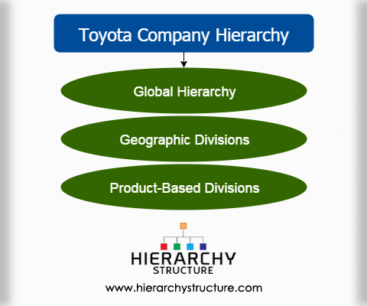
Schein (2010) argues that well-developed organisational cultures diminish the levels of uncertainty as there is implicit rules of behaviour and staff members are ready to behave in a very similar manner without being monitored all the time. This can be seen in the case of Toyota where employees are taught to stick to the standardised processes but which are also offered the chance to detect areas that could be improved. Strong cultures do however have their limitations. The slow organisational response to a crisis or fast-paced environment may be caused by consensus based decision-making. An example is the major vehicle recall incidences that Toyota had to endure where there was a perception that decision making processes were slow because of the need to have massive consultation involving organisational levels. This shows how organisational culture may be helpful and limiting to effectiveness in different situations.

3. Determining Organisational Culture based on Theoretical Frameworks

3.1 Schein’s Three Levels of Culture
Edgar Schein hypothesised that organisational culture can exist at three related levels: artefacts, espoused values and basic underlying assumptions. The framework gives a detailed insight into the culture working in Toyota.
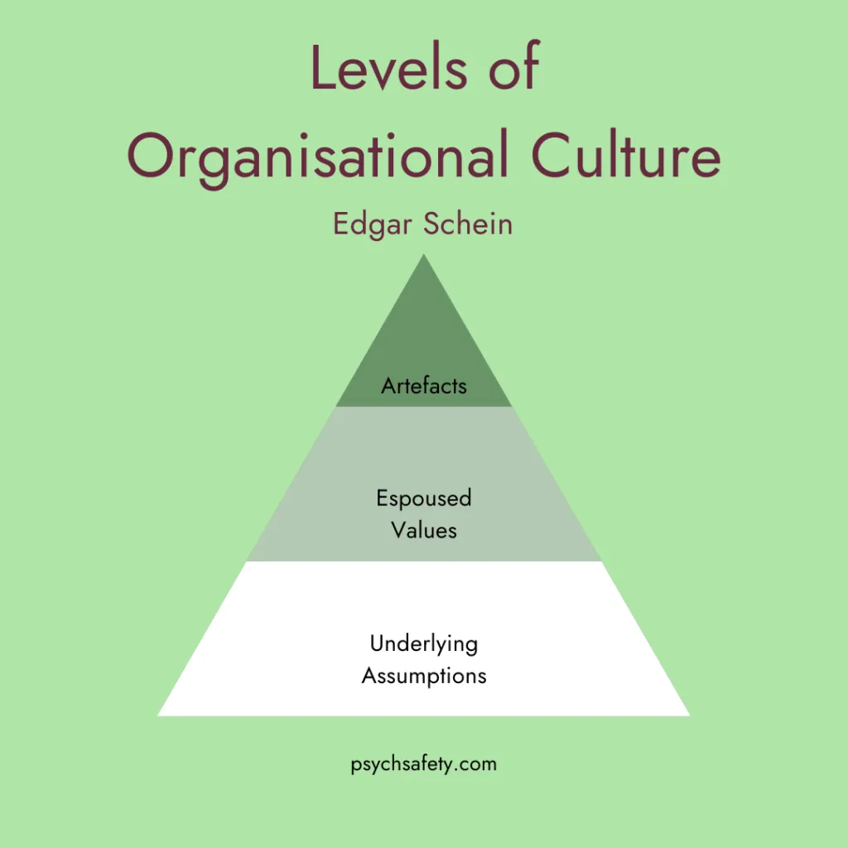
Artefacts
Artefacts are the external forms of organisational culture. Within Toyota, these include:
- Standard work process and working manuals.
- Performance boards, performance boards and similar visual management systems.
- The system of continuous improvement suggestions.
- Standardised manufacturing procedures and methods of organising the work place.
These observable practices represent organisational beliefs that are more fundamental in terms of efficiency, discipline, and quality.
Espoused Values
Espoused values are the principles and goals of the organisation. The publicly promoted values at Toyota include (Soliman,2016):
- Continuous improvement (Kaizen)
- Respect for people
- Long-term organisational thinking.
- Quality excellence dedication.
These values affect the managerial behaviour, expectations of employees as well as priorities of an organisation.
High Level Underlying Assumptions
The lowest cultural level comprises of unconscious beliefs underlining behaviour. The assumptions that Toyota would make are:
- Solutions are challenges to be improved instead of failures.
- Employees are good sources of knowledge and they need to be empowered.
- Financial gains in the short run are less significant than success in the long-term.
It is based on these assumptions that Toyota is willing to make huge investments on employee development and regular training programmes. The model by Schein shows that the culture of Toyota is not superficial but entrenched in the organisation to make it resilient and sustainable.

3.2 Culture Dimensions of Hofstede
Geert Hofstede created the cultural dimensions which describe how the national culture affects the organisational behaviour. Toyota is representative of a few of the traits linked to the Japanese cultural values (Sosnovskikh,2016).
High Uncertainty Avoidance
The company focuses on standardisation, quality control, and risk minimisation by using elaborate procedures and monitoring systems at Toyota.
Collectivism
Decision making processes are dominated by group harmony and teamwork and employees are focused on organisational goals rather than individual interests.
Long-Term Orientation
Toyota places emphasis on sustainability, innovation and reputation rather than short term profitability, which has shown strategic forbearance and an investment in new technology.
Such cultural aspects can be used to understand why Toyota is a company that believes in quality and innovation. But to conduct business worldwide one has to adapt to the culture. Toyota has had more liberal management practices in the Western markets that are in line with the local employee expectations and regulations. This proves how national and organisational culture interrelate in multinational corporations.

3.3 Handy’s Cultural Types
Charles Handy established four types of organisational culture that include power, role, task, and person culture. Toyota exhibits a hybrid culture with an aspect of both role and task culture(Niihara,2010).
Role Culture
There is structure, responsibility, and a sense of hierarchy in production operations that brings about efficiency and uniformity.
Task Culture
There is promotion of team based problem solving, innovation, and cross-functional collaboration within the organisation.
The prevailing culture in Toyota can thus be described as task-oriented where organisational success is greatly relied on teamwork and improvement of performance than on individual authority. This mixed culture helps in operational performance, as well as, innovativeness.

4. Existing Organisational Culture
The existing culture at Toyota could be said to be a continuous improvement culture that is learning-oriented. The culture is authorised by a high rate of employee participation, process discipline and collaborative problem-solving habits.
The major features are:
- Empowerment and involvement of the employees in decision making.
- Strategic orientation over a long term.
- Good discipline of processes and quality control.
- Mutual respect and teamwork
- Innovation Incremental Improvement.
The cultural profile fits the Denison model of organisational culture whereby involvement and consistency plays a major role in organisational performance (Denison, 1990). High productivity and quality results are supported by Toyota with its focus on the engagement of employees and operational stability.
More importantly, this organisational culture of Toyota is not fixed but is dynamic because of the commitment of its leaders, organisational learning and adjusting to the environment. As mentioned by Adeoye et al.(2023), leadership is important in strengthening cultural values by training, communication, and performance management systems. This flexibility justifies why Toyota has still stayed competitive even with major market changes and technological conditions globally.

5. Organisational Culture and Response to External Environment
Organisational environments are dynamic and complex due to technological changes, rivalry, regulatory policies, economic cycles, and globalisation. The extent to which an organisation can adequately respond to these external influences usually lies in the quality with which the internal culture of the organisation facilitates adaptability and innovativeness. At Toyota, organisational culture serves as a strategic capability that helps in responsiveness to environmental change and at the same time offers operational stability.
Technological disruption, especially the worldwide move to electric vehicles (EVs), autonomous driving technologies, and digital mobility solutions, is one of the most important external factors in the automotive industry. The culture of continuous improvement (Kaizen) at Toyota has encouraged innovation by ensuring that it has invested in research and development over a long period (Graban and Swartz, 2018). Among the interesting ones is the early pioneering of technology in hybrid vehicles with the introduction of the Prius which shows how the organisation can be able to predict the environmental trends and react proactively to sustainability issues. This indicates the cultural concept of long-term orientation, where organisational decisions put more emphasis into the future competitiveness, as opposed to short-term profitability.
The other significant environmental issue is strong competition in the world. Toyota has to compete with such key automotive producers as Volkswagen Group and Tesla, and the company needs to introduce modern advancements in efficiency, innovativeness, and customer value (Okanga, 2022). The organisational culture of Toyota contributes to the excellence of operations by encouraging lean manufacturing and reduction of waste as a means to enable Toyota to remain cost competitive and provide high-quality products. As Porter (2008) explains, organisations gain sustainable competitive advantage when the internal capabilities are in line with the external market needs. The culture of Toyota avails such an alignment by incorporating efficiency, quality as well as innovation.
Legal force is also associated with the environmental sustainability and emissions reduction, which also has a great impact on the organisational strategy. There is an increase in tougher laws on carbon emissions and fuel efficiency as governments across the world demand automotive firms to come up with environmentally friendly technologies. The long-term strategic orientation of Toyota promotes investment in alternative energy solutions, such as hydrogen fuel cell technology, which proves how organisational culture can assist compliance and innovation at the same time.
In spite of these advantages, there are also problems with the adaptation to the environment. According to some industry analysts, the conservative and risk-averse culture at Toyota has initially delayed its conversion to fully electric vehicles relative to other automobile companies like Tesla. This also points out one of the most severe constraints of strong organisational cultures namely they bring stability and consistency, but they also introduce strategic inertia and opposition to disruptive change. According to Schein (2010), assumptions that are deeply embedded may be counterproductive to organisational learning in situations where the environment is changing at a high rate.
In general, Toyota shows that they can use organisational culture as an environmental responsiveness tool, which balances risks and innovations. Nonetheless, to remain competitive in fast changing technological situations, it is necessary to ensure that the culture continues to evolve.

6. Culture as a Strength or Impact
Organisational culture may either act as enabler or as a barrier based on its ability to fit well within the organisational strategy and demands in its environment. Culture in the case of Toyota is more of an enabler; however, in certain circumstances, some of the characteristics can become the constraint.
Culture as an Enabler
The culture of Toyota is also a positive factor which has a number of significance on organisational effectiveness.
Operational Efficiency:Focus on standardisation, lean operations and continuous improvement is a major contributor to productivity and minimization of waste in operations. The employees are also educated to see inefficiencies and suggest the solutions, and this will have long-term performance gains.
Engagement and Motivation of Employees:The principle of respect towards people encourages empowerment, teamwork and employee participation in decision making activities. Organisational behaviour studies have revealed that employee involvement enhances motivation, job satisfaction and organisational commitment that eventually lead to improved organisational performance.
Innovation and Learning: The company culture of problem-solving at Toyota promotes incremental innovation and cross-organisational sharing of knowledge (Dyer and Nobeoka,2000).The continuous improvement initiatives make learning integrated in day-to-day operations and not confined in the research departments.
Global Brand Reputation: Cultural dedication to quality excellence boosts the positive reputation of Toyota in the world in terms of reliability and customer satisfaction. The reputation of the brand is considered as an intangible resource that leads to the success of the organisation in the long run.
According to research by Cameron and Quinn (2011) organisations that have weak cultures fail to perform well since their employees do not have the same goals and expectations as far as their behaviour is concerned.
Culture as a Barrier
In some cases, the Toyota culture can be a hindrance to organisational effectiveness, although it has been useful in other cases.
Slow Decision-Making: Decision making processes that are based on consensus are able to postpone organisational reactions in case of crisis or when the market environment changes very fast (Mehra,2025). Although consensus encourages inclusivity and accuracy, it can have less agility in cases where urgent decisions need to be made.
Disruptive Innovations Resistance:Incremental improvement could be strongly emphasized and thus prevent radical innovation. Some organisations that focus on stability and efficiency are not always able to adopt disruptive technologies in a fast manner.
Communication Problems at the Hierarchy: The crisis of vehicle recalling globally revealed the lack of communication skills as the problems were not reported fast enough with the levels of organisation (Bowen and Zheng, 2015). This implies that under some circumstances, the hierarchical cultural norms could prevent open communication.
Thus, the culture of Toyota is a strong and a weakness element at the same time. Culture is effective at the contextual level, depending on leadership and how the organisation has been able to fit the cultural practice in changing environments.

7. Organisational Culture and Impact on Performance
The organisational culture has been instrumental in the success and performance performance of Toyota in the global context. A connection between culture and performance can be evaluated on a variety of dimensions.
Financial Performance: Efficiency in operations which is the result of lean manufacturing will save on costs of production, increase margins and make a profit. The quality processes help Toyota to stay competitive in the markets where prices are sensitive and yet maintain the quality (Junior,n.d.).
Quality Leadership : In all markets of the world, Toyota has continued to rank high in terms of reliability, durability and customer satisfaction (Cole and Flynn, 2009). This is the culture of quality control, continual improvement, and accountability of employees.
Innovation Capability: Continuous improvement culture helps in technological development by incremental innovation. Though Toyota has been occasionally seen to be lagging in the radical innovation fronts, due to its long-term investment strategy, the company is secure in its technological development.
Employee Productivity: The empowerment of employees and teamwork helps to increase their productivity level and minimize the number of operational mistakes. The motivated employees tend to bring in new ideas and deliver at a standard level.
Nevertheless, a failure in changing the organisational culture to meet the changes in the environment can lead to poor performance. The technological discontinuity is forcing organisations to maintain a balance between stability and flexibility. Thus, to maintain the performance over the long-term, it is necessary to engage in the ongoing cultural development.

8. Improvement Recommendations
A number of evidence-based solutions are recommended in order to streamline organisational performance and ensure competitive advantage.
1. Increase Strategic Agility
The Toyota company needs to strike a balance between the consensual decision-making process and a quicker executive decision-making process in case of crisis or an uncertain situation of high uncertainty. Employee involvement might be saved, and responsiveness can be increased by introducing hybrid decision models (Evans-Uzosike,2021).
2. Promoting Disruptive Innovation
Although incremental improvement cannot be ignored, radical innovation initiatives should be encouraged at the organisation, especially with regards to electric mobility, artificial intelligence, and digital services. Special innovation departments that are more autonomous might help speed up technology change.
3. Enhance Intercultural integration
Toyota is a multinational organisation and as such, it has to learn to adjust cultural practices in various regional contexts without sacrificing on some values. Integration and communication may be improved by cross-cultural leadership training and international collaboration platforms.
4. Build a Digital Transformation Culture
The introduction of digital skills, data analysis, and automation features into corporate cultural context will enhance the competitiveness in Industry 4.0 environments (Serafimova, V. and Vasilev, 2024). Promoting use of data to make decisions can supplement the conventional operational knowledge.
5. Leadership Development and Psychological Safety
Leaders are expected to create psychological safety, in which employees will not be afraid to criticize the current processes or to present new ideas without any adverse consequences. It has been shown that psychologically safe environments improve creativity and organisational learning.
These tips support the works of Kotter and Heskett (1992) who opine that in dynamic environments, adaptive cultures work better than rigid cultures since they facilitate innovation, adaptation, and responsiveness.

9. Conclusion
The report has critically assessed the impact of organisational culture on the Toyota structure, decision making and the performance of this firm. The analysis based on the theoretical schemes like the model proposed by Schein, cultural dimensions by Hofstede, and cultural typology by Handy shows that Toyota has an effective task-focused and continuous improvement culture that facilitates operational excellence and employee participation. The organisation successfully utilises its culture to suit the changing external environment, such as technological upheaval, competition, and regulatory forces. But sometimes cultural rigidity and decision-making based on consensus may be the obstacle towards quick innovation and responsiveness. This underscores the two aspects of organisational culture as an enabler and constraint. In general, Toyota organisational culture is a major success contributor and competitive edge in the long run. Agility, disruptive innovation, cross-cultural integration, and digital transformation will be strategic improvements that will boost the performance of the organisation and guarantee sustainability in the ever-changing global environment where competition is developing at an extremely rapid pace.

Reference
Adeoye, M.A., Jimoh, H.A. and Abdulkareem, H.B. (2023) ‘Leadership and organizational cultural roles in promoting sustainable performance appraisal and job satisfaction among academic staff’, ASEAN Journal of Economic and Economic Education, 2(2), pp. 115–124.
Bowen, S.A. and Zheng, Y. (2015) ‘Auto recall crisis, framing, and ethical response: Toyota’s missteps’, Public Relations Review, 41(1), pp. 40–49.
Cameron, K.S. (2011) Diagnosing and Changing Organizational Culture: Based on the Competing Values Framework. San Francisco: Jossey-Bass.
Cole, R.E. and Flynn, M.S. (2009) ‘Automotive quality reputation: Hard to achieve, hard to lose, still harder to win back’, California Management Review, 52(1), pp. 67–93.
Denison, D.R. (1990) Corporate Culture and Organizational Effectiveness. New York: Wiley.
Dike, P. (2013) The Impact of Workplace Diversity on Organizations. Available at: relevant publisher/source.
Dobbin, F. and Jung, J. (2010) ‘Corporate board gender diversity and stock performance: The competence gap or institutional investor bias’, North Carolina Law Review, 89, p. 809.
Dyer, J.H. and Nobeoka, K. (2000) ‘Creating and managing a high‐performance knowledge‐sharing network: The Toyota case’, Strategic Management Journal, 21(3), pp. 345–367.
Evans-Uzosike, I.O., Okatta, C.G., Otokiti, B.O. and Gift, O. (2021) ‘Hybrid workforce governance models: A technical review of digital monitoring systems, productivity analytics, and adaptive engagement frameworks’, International Journal of Multidisciplinary Research and Growth Evaluation, 2(3), pp. 589–597.
Gao, S. and Low, S.P. (2014) ‘The Toyota Way’, in Lean Construction Management: The Toyota Way. Singapore: Springer, pp. 49–100.
Graban, M. and Swartz, J.E. (2018) Healthcare Kaizen: Engaging Front-Line Staff in Sustainable Continuous Improvements. Boca Raton: CRC Press.
Handy, C. (1993) Understanding Organizations. London: Penguin.
Hofstede, G. (2011) ‘Dimensionalizing cultures: The Hofstede model in context’, Online Readings in Psychology and Culture, 2(1), p. 8.
Júnior, O.G.G. and Albuquerque Júnior, C.R.F. (n.d.) Title unavailable. Available at: source required.
Kotter, J.P. and Heskett, J.L. (1992) Corporate Culture and Performance. New York: Free Press. Available at: https://www.hbs.edu/faculty/Pages/item.aspx?num=139
Liker, J.K. (2004) The Toyota Way. New York: McGraw-Hill.
Mehra, N. (2025) Bridging Business Cultures: Japan’s Relationship-Driven Model vs. the West’s Transactional Approach. Available at: SSRN 5167932.
Mullins, L.J. and Christy, G. (2016) Management and Organisational Behaviour. 11th edn. Harlow: Pearson. Available at: https://www.amazon.com/Management-Organisational-Behaviour-11th-ed/dp/1292088486
Niihara, H. (2010) Hybrid Car Creates Hybrid Organization: Development of Toyota’s First Prius Model and Limits that Traditional Development Organization at Toyota Confronted. Available at: publisher/source.
Okanga, B. (2022) ‘Radical and incremental innovations as critical leveragers of a firm’s financial performance: Best practices from Tesla and Toyota’, Universal Journal of Financial Economics, 2(2), pp. 1–22.
Porter, M.E. (2008) ‘The five competitive forces that shape strategy’, Harvard Business Review, 86(1), p. 78.
Schein, E.H. (2010) Organizational Culture and Leadership. 4th edn. San Francisco: Jossey-Bass.
Serafimova, V. and Vasilev, V. (2024) ‘Digital culture as a competitive advantage in the sustainable development of organizations’, Agora International Journal of Economical Sciences, 18(1), pp. 210–222.
Soliman, M.H.A. (2016) Hoshin Kanri: How Toyota Creates a Culture of Continuous Improvement to Achieve Lean Goals. Personal Lean Publications.
Soliman, M.H.A. (2023) Toyota Production System Concepts: The Guidebook to Toyota’s Corporate Strategy and Leadership (Series Books 1 to 6). Personal Lean Publications.
Sosnovskikh, S. (2016) ‘Toyota Motor Corporation: Organizational culture’, Philosophy Study, 6(7), pp. 442–454.
Toyota Motor Corporation (2023) Annual Report. Toyota City: Toyota. Available at: company website.-----------------------------------------------------

