Effective Teamworking
&
Communication

(BMSW4002_LON)

- Models of Communication
- Communication – Verbal & Non-Verbal Communication
- Listening

Prepared by:
Justin Sanches - 2029870

Lecturer:
Lloyd Beharry

Introduction

Communication is the exchange of thoughts, information, or ideas that results in mutual understanding between two or more people (Griffiths & Dunham 2017). In the workplace an effective communication is crucial for a better understanding between members, which improves productivity and common goal. In the other hand, a poor communication can contribute for misunderstanding and frustration that can lead to a poor collaboration, productivity and even a team break up.

To contribute to a better communication, many theories, studies and models have been presented in the last century. In this report, I will describe the 3 models of communication presented throughout the decades of 40, 50 and 60, highlighting their main similarities and differences. After understanding the basics of the communication, I will introduce communication, types of communication and listening.

Models of Communication

Shannon and Weaver’s Model (1948/49)

Model of Shannon and Weaver, considered the mother of all models, was the first model of communication being presented in 1948, by Shannon and Weaver, where the mathematician and the scientist illustrated a mathematical theory arguing that communication can be divided into 6 key concepts. Those key concept as you can verify on the diagram below are, Information Source, transmitter, channel, noise, receiver and destination. This was a linear communication model, and it argues that a message can be distorted or interfered with noise.

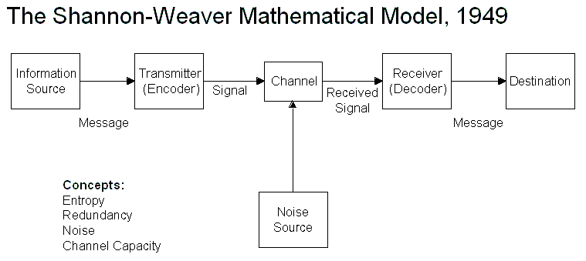
Source: https://moodle.uwtsd.ac.uk/course/view.php?id=7030 / Models of communication -Shannon and Weaver

To put the all model into perspective, let’s consider the case study about a phone conversation between a couple named Pedro and Maria. Pedro works in a construction site, and one day Maria his wife, called him during his shift, to bring chicken on his way home. Due to the noise, Pedro misunderstood what Maria said and came directly home after his shift and went to the kitchen to see Maria. When both met, Maria asked Pedro for the chicken she had asked earlier and Pedro replied, “What chicken? I thought you said to see you in the kitchen.”

I live outside London where unfortunately the network coverage is not so great and, a simple phone conversation can be a real challenge in some specific areas. I also work in a hotel as front office manager where often I have the need of calling some of my off-work colleagues, for a last-minute shift cover of someone that has called sick. It has happened that while speaking with my colleague requesting a shift cover, my message was not received clearly as I expected it to be, due to either poor network or noisy background as we were outside.

However, this was the mother of all the other models, the communication was not completed as something was missing, which bring us into our second model of communication:

Schramm’s Model of Communication (1954)

The 2nd communication model, called Schramm’s Model of Communication, came in, in 1954, adding something that as mentioned earlier, was missing in Shannon and Weaver’s model of communication. - Feedback. With this addition, considering our case study, feedback would solve the problem in the Pedro and Maria’s case study, because Schramm argues that a message is not completed unless there’s a feedback. Hence Pedro would give feedback to Maria that would correct the original message she sent to Pedro.

In my case, my colleagues have either called me back, or message me asking the reason of my call, because they could not understand what I was saying, and I would then repeat what I was saying so they can understand. With this model, the communication with my colleagues would be complete as there would be a feedback for a clear understanding of the reason of my call.
Unlike the previous model, this model is not linear but circular, as shown on the diagram below.

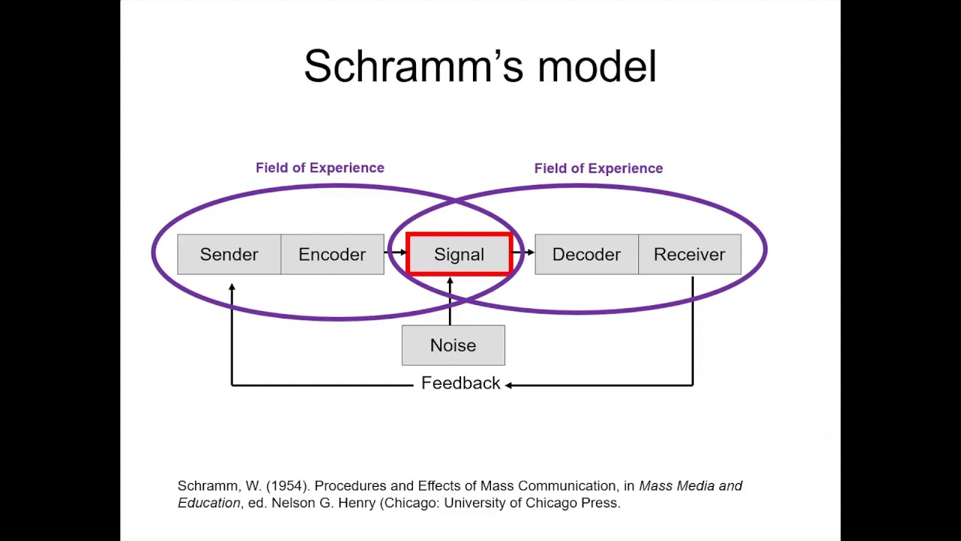
Source: https://moodle.uwtsd.ac.uk/course/view.php?id=7030/ models of communication schramm

Berlo’s Model of Communication (1960)

The 3rd model of communication is Berlo’s model of communication, a linear model of communication presented in 1960, which unlike the 2 previous models, takes into account non-verbal communication and the emotional aspect of the message (businesstopia 2018). In this model also, all 5 human senses are used to communicate, and people need to be at same level of knowledge, communication skills attitude etc, for the communication to occur. To put this into perspective, let’s consider the case study - The Professor and The Village people, that talks about a university English professor that lived near to a small village where people were uneducated. One night, the professor fell asleep while smoking his pipe, which later set the all house on fire. The professor run into the village screaming “The Edifice is being consumed by a great conflagration”. As the people from the village didn’t understand him, they ignored him, and as result the house was destroyed by fire.


Source: https://moodle.uwtsd.ac.uk/course/view.php?id=7030/ model of communication - Berlo

As I mentioned earlier, I work in the hospitality industry, which is a multi-cultural environment and, also, we have technical terms that we use with each other. Although there are people from same nationalities which can understand each other, English is the only language that we are allowed to speak unless there’s a guest that does not speak English and a member are able to speak his/her language. Technical terms are also not permitted while talking to a guest as he/she will not understand what we are talking about. Considering this module, this procedures in place at my workplace, is to ensure that everyone involved are on the same level of knowledge so there can be an effective and complete communication.

Communication

In our day-to-day life, we feel the need of interaction with our surroundings. Either at home, workplace or in the street, we want to receive and emit information or messages with goal of understanding and being understood despite the noise I have mentioned earlier in some model of communication.

What is communication?

According to Griffiths & Dunham 2017, communication is an exchange between 2 or more people, with the goal of a mutual understanding. This exchange can be thoughts, information or ideas.

It requires a minimum of 2 people, where 1 must be the sender, another the receiver, and a message that is transmitted through a transmission medium.

Source: Maund A. 2017, Certificate in Highier Education: Skills for the workplace student yearbook, SAGE Publications.

Verbal and Non-Verbal Communication

For a better understanding, we can say that verbal communication is the things we say, and non-verbal communication is those that we do not say however, we do communicate through our body, called body language.

Verbal Communication

Verbal communication is the most common used way to communicate by individuals, either orally, or written. When working in group, it helps members to learn the most effective way to interact with one another where, hundreds if not thousands of statements are exchanged so the problems are understood and managing projects. Considering that members do not always know the exact intent of another’s comments, there can be many interpretations in one’s comment, which might lead to misunderstanding or even the message itself can have hidden meaning or multiple layers of meaning (Griffiths and Dunham, 2017).

Written Communication

A written communication can be in form of letters, memo, emails, reports etc. It also can be formal or informal, Internal or external. When communicating in written, for a successful communication we need to consider, factors such as words, sentences, paragraphs and last but not the least, the tone we want to convey on the messages we are transmitting.

Por example, in my workplace I deal with emails and other written messages, either to my colleagues internally or to the customers externally which I must consider the above factors when writing. For an internal email, I do not need the level of formality that is required when emailing a customer, however on both occasions, I need to be professional, clear on the message that I want to transmit and imply a positive tone. Such formality per example is not required if I am sending a personal email to a friend.

Non-verbal Communication

While a verbal communication is occurring, an equal important non-verbal communication such as smile, eye contact, or fidgetiness is also occurring, helping the receiver interpret and perceive subconsciously the message that is being transmitted (Griffiths and Dunham, 2017).

Listening

Studies show that an average person remembers between 25 and 50 Percent of what he /she hears (Crockett 2011). It is important to emphasise the difference between hearing and listening, as they do not mean the same thing.

According to Quintanilla & Wahl (2017), hearing is a physical ability to detect sounds which does not require concentration, while listening is not a physical ability and it requires concentration on verbal and non-verbal messages being receive so the meaning can be determined.

As per definition listening requires concentration and barriers such as Failing to limit our distractions, focussing on the message are part of the main reasons why we fail to actively listen (Quintanilla & Wahl, 2017). However, HEURIER model provides a framework with six interrelated component such as Hearing, Understanding, Remembering, Interpreting, Evaluating and Responding that can improve your listening (Brownell 1994,1996).

In my workplace per example, every morning at 10 o’clock, all the head of departments and the general manager meets for a brief morning meeting, where every issue, yesterday’s numbers, message from different departments are communicated, along with common tasks that different departments have to co-operate to perform, and the general manager give comments and target for the day to each department that needs to be passed to the rest of the team that are not present on the meeting. We do not only have to understand the target, but we have also to communicate it to our team so everyone are able to work for a common goal and we achieve that trough listening. In my particular case, I have been implementing partially the framework described in HEURIER Model according to Brownell 1994,1996.

Conclusion

In conclusion, we can say that all the 3 models of communication, include the fundamental elements of communication, however they all differ into the particular ways that we have mention while describing each one.

Regarding communication and listening, we can say that both, verbal and non-verbal communication combined, helps to improve significatively the interpretation and perception of the receiver about the message being transmitted.

According to Quintanilla and Wahl (2017), co-workers, family and friends, do not hear half of the message you communicate., However, that is not intentional or due to lack of memory. Most of us simply do not listen well and those who are good listeners regularly engage in mental activity while listening, review and summarize the conversation (Nicholas and Stevens 1957).

References

Brownell (1994,1996) in (Quintanilla, Wahl 2017) in Maund, A. 2017, Certificate in higher education: skills for the workplace student yearbook, SAGE Publications

businesstopia in Communication, 2018, Shannon and Weaver Model Of Communication, available at https://www.businesstopia.net/communication/shannon-and-weaver-model-communication [accessed 20 October 2021]
Crockett (2011) in Quintanilla, Wahl (2017) in Maund, A. 2017, Certificate in higher education: skills for the workplace student yearbook, SAGE Publications
Griffiths B. A. and Dunhan E.B (2017) in Maund, A. (2017), Certificate in higher education: skills for the workplace student yearbook, SAGE Publications
Nicholas and Stevens (1957) in (Quintanilla, Wahl 2017) in Maund, A. 2017, Certificate in higher education: skills for the workplace student yearbook, SAGE Publications
(Quintanilla, Wahl 2017) in Maund, A. 2017, Certificate in higher education: skills for the workplace student yearbook, SAGE Publications

