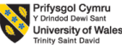
Module Code: LCBB4004
Module: Marketing Fundamentals

Assessment 1: Blogging to communicate

Student name :Mariana Kahel
Student ID:2113218
Module Lecturer :Tushara Balendran

Blog Post 1: Creative Brief and Background of Adidas
Adidas AG, which manufactures sporting goods and footwear was found in Herzogenaurach, Germany. Adidas AG was established in the first decade of the twenty-first century. This sportswear manufacturer (with a global market share second only to Nike) (Khan, 2020). In both the Adidas "trefoil" emblem and the Adidas mountain logo, the three-stripe Adidas design is used. The company's headquarters are in Herzogenaurach, Germany.

Owner and founder Adolf "Adi" Dassler went by the moniker "Adi" (written "Adidas" by the corporation).
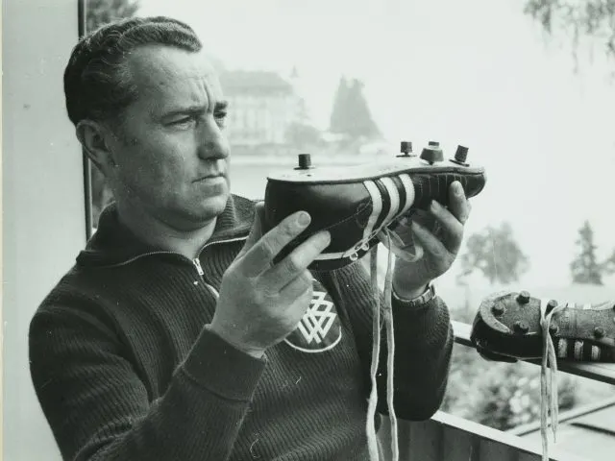

In 1919, the Dassler family started producing shoes. When Jesse Owens participated in Berlin Olympics in 1936, he wore a supposedly Adi Dassler-gifted tee shirt. The Olympic gold medals won by Owens helped increase the company's global profile. They worked tirelessly to restore the Dassler company after the war, but by 1948, the rift between Adi and Rudolf "Rudi" Dassler was too severe to bridge. In the end, Rudi's and Adi's brands were renamed Puma and Adidas, respectively, due to this divide (Turner, 2015).

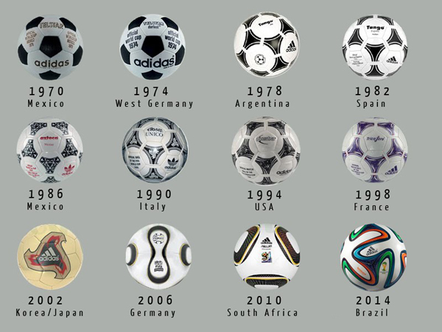

In the following four years, Adidas' clothing line was launched. For a long time, Adidas was the most recognizable name in sports footwear. In the 1970s, Nike, for example, increased the level of competitiveness. Even though they sponsored Run-D.M.C., the rap group responsible for the classic song "My Adidas," Adidas' market share declined in the 1980s (Holtbrügge and Schuster, 2017).

Bernard Tapie, a scandal-plagued French business mogul, tried unsuccessfully to revive Adidas from 1990 to 1993. Bernard Tapie is a fraud. A French native, Robert Louis-Dreyfus, was named CEO and chairman when the company was purchased by investors. Salomon's acquisition was overseen by him in 1997. TaylorMade, a golf brand owned by Salomon, is well-known for skiing and snowboarding, two winter activities. Adidas changed their name to Adidas-Salomon AG in 2001, taking a cue from Nike's success. Successfully, the business collaborated with Stella McCartney in 2004.

TaylorMade was purchased by Adidas in 2005 for $1.5 billion, and the name was preserved intact. In the following year, Adidas AG was rebranded, but kept its former name. Rockport shoes from Reebok were bought by Adidas in 2006, and adidas bought the outdoor sports shoe manufacturer Five Ten the following year. 2017 saw the acquisition of TaylorMade by Adidas. It was written at the time this article was published (Birch, 2019).

When it comes to sportswear, "the Adidas Group wants to be the global athletic goods market leader," reads the company's mission statement.

Blog Post 2: Product Range of Adidas
"Adidas is all in," Adidas' motto for worldwide marketing, was first used by the brand in 2011. They were able to design a single image that contained all of their favorite brands and labels for people interested in sports, street style, music, and pop culture.

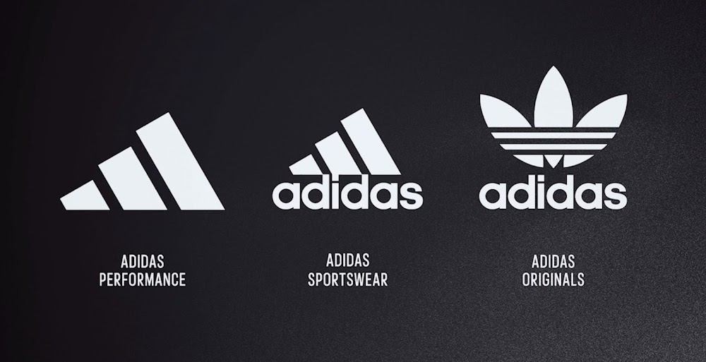

They all serve a specific purpose in Adidas' four divisions. A good place to start shopping for company apparel and footwear is Adidas. As a part of adidas, Reebok recently overtook adidas in profitability and is one of two subsidiaries in the company. Both Taylor Made and Reebok specialize in golf equipment and accessories, although Reebok focuses more on outdoor footwear and clothing (Krüger et al., 2012). Reebok at the top of the market capitalization list, followed by Adidas.

There are numerous products available from Adidas. In the world of sports, Adidas is best recognized for its shoes or sneakers. This ensures that Adidas shoes are durable, useful, and available in a wide range of designs. Apparel and accessories are merely a secondary product of the company's core business. Shorts and a tee shirt are in high demand these days because of their versatility. As far as garments go, Adidas and Reebok are both excellent, but Reebok has a reputation for footwear.
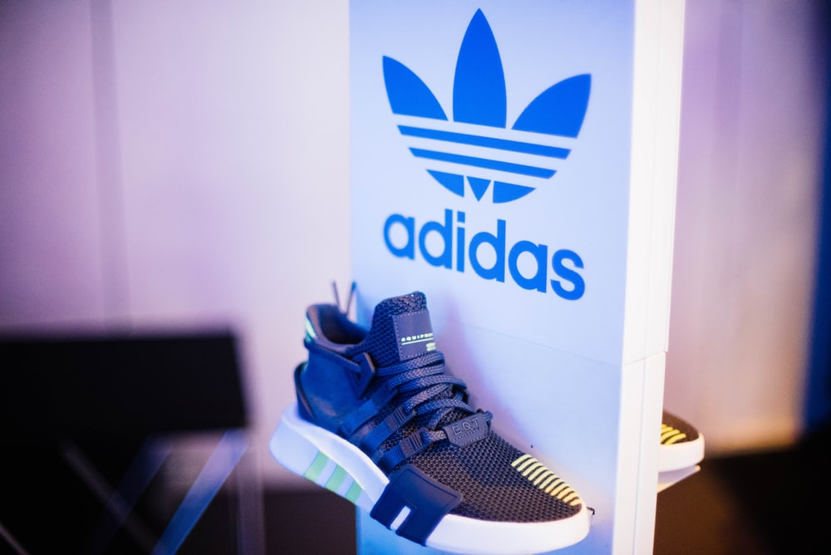

With cutting-edge technology and cutting-edge design, Adidas aims to produce the best possible footwear on the market today. Honestly, they don’t necessarily depend on demand. Customers buy shoes because of their objectives and goals. Physically intensive activities like these necessitate the use of running gear, for example. It is worn by young people who want to make a fashion statement despite its athletic background (Grainger, et al., 2015).

Apparel
Adidas t-shirts, coats, hoodies, and leggings are available for both men and women, and may be purchased online. Adidas' first piece of clothing was the tracksuit, which Franz Beckenbauer created in 1967. Athletic bras made by Adidas AG have become the most popular in Europe and around the globe (Crasto, et al., 2020).
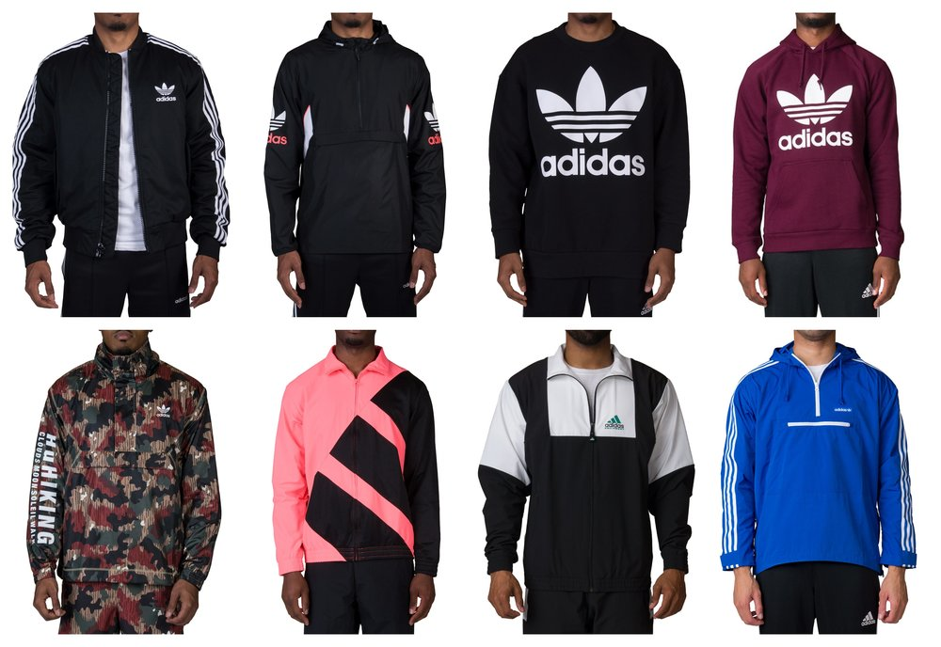

Sportswear
Association Football
The Football Sportswear Association is dedicated to promoting the value of Adidas football apparel. There are many national and international football teams who use Adidas clothing.

Adidas referee costumes are used by several countries and leagues during international competitions. Copa Mundial molded boot from 1979 serves as an excellent illustration of the company's sports footwear innovation. Since its inception, it has been the most popular boot on the market. "World Cup" is still accessible in the soft-ground version.

FIFA, the world football governing body, has ordered custom-made World Cup footballs since 1970. FIFA ordered the Adidas Telstar in 1970 to be the first official World Cup ball. The enhanced range of the "Teamgeist" soccer balls contributed to more long-range goals at the 2006 World Cup. In general, goalkeepers voiced their dissatisfaction with the ball's design and construction (Wuisan, et al., 2020).

Adidas unveiled the Jabulani in time for the World Cup in 2010. The ball was designed and developed by Loughborough University and Bayern Munich. A World Cup football with a fan-inspired design for the first time has been created by Adidas for the 2014 Brazuca ball.

The Adidas Finale can only be used as the official match ball if Adidas is the competition's official sponsor. Adidas also makes the adiPure football boot, which includes the Adidas Predator, as previously noted. This year's UEFA Euro 2016 competition will have an official match ball named the Beau Jeu, which means "The Beautiful Game" in English. Adidas is the official provider of uniforms and gear for every MLS team.

Baseball
Players in Japan's Major League Baseball (MLB) and Nippon Professional Baseball (NPB) have worn Adidas gear. Adidas Baseball has awarded a hard product license to Dick's Sporting Goods. From 1997 through 2008, Adidas was the major sponsor of the New York Yankees.

Basketball
Adidas Superstar and Pro Model sneakers are known as "shelltoes" because of their hard rubber toe box design popularized by UCLA basketball coach John Wooden. In the early 1980s, Nike, a relative unknown, surpassed Adidas and Converse in the basketball shoe market. Adidas' striped polyester apparel and the Adidas Superstar were hugely popular 1980s hip-hop streetwear trends because of this.

Reebok was purchased by Adidas in 2006, which resulted in the NBA's 30 teams wearing Adidas uniforms from 2006 to 2017. At the conclusion of the 2016–17 season, Nike took over as the league's official uniform supplier from Adidas (Iglesias, et al., 2020).

Cricket
Australia has been Adidas' primary cricket footwear market since the 1970s. The new boots, which are lighter, more flexible, and less protective of the toes than traditional leather cricket boots, represent a major shift in footwear. The company entered the bat manufacturing business in 2006 after many years of developing cricket footwear. From Pellara, Incurza, Libro, and the M-Blaster, these bats are currently on sale.

When they signed Sachin Tendulkar in the 1990s, Adidas began making shoes for him. Adidas sponsored Sachin Tendulkar's cricket bat from 2008 to his retirement. The 'Adidas MasterBlaster Elite' is his brand-new bat.
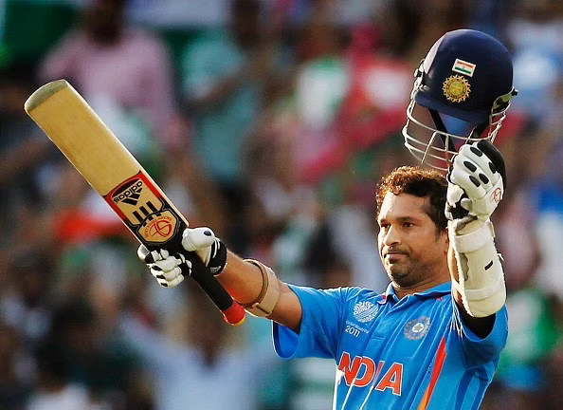

After Kevin Pietersen's Woodworm contract was terminated owing to financial concerns in 2008, Adidas stepped in to sponsor him.

As a result, Ian Bell from the United Kingdom, Salman Butt from Pakistan, and Ravindra Jadeja from India all joined the squad shortly after. The Mumbai Indians and Delhi Daredevils have been sponsored by Adidas for eight years in the Indian Premier League (IPL). After two years of sponsorship by them and several other firms, the financial crisis pushed the Pune Warriors India out of the Indian Premier League in 2012. Adidas sponsored the Royal Challengers Bangalore during the 2015 season (Mahdi, et al., 2015).

Gymnastics
USA Gymnastics and Adidas worked together to supply gymnastics equipment to the USOC between 2000 and 2012. The contract between USA Gymnastics and Adidas expired at the end of 2012. From leotards for ladies and men, to shirts, shorts, and pants for all four seasons, Adidas has been a major player in the leotard market since 2006. Adidas has been supplying gymnastics equipment to Elegant Sports since the spring of 2013 after replacing Elegant Sports' previous partnership with GK Elite. For example, Adidas sponsors McKale Maroney, Jake Dalton and Danell Leyva of the US Olympic Gymnastics Team.

Accessories
Adidas also makes and sells a wide range of accessories, including slip-on sandals and cell phone accessories, in addition to footwear. Men and women can choose from a variety of Adidas deodorants, fragrances, aftershaves, and lotions.

In 2014 August, Adidas launched a $199 Fit Smart bracelet that monitors your activity levels (Ismail, et al., 2019). Adidas' miCoach app will be used, which functions as a personal trainer.
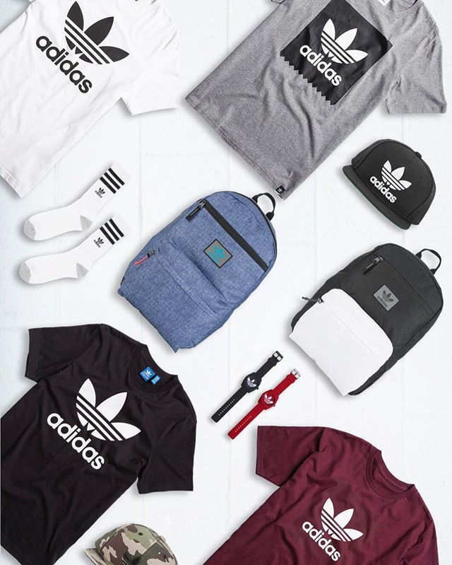

Blog Post 3: Price Range of Adidas Products
Adidas items are designed, presented, and marketed with low prices in mind. They use skimming rates and competitive pricing simultaneously. Unlike Nike, Reebok and Puma, Adidas sells its everyday products at a competitive price. If a new product has a distinct look, Adidas uses price skimming to get the best price.

As a result of Adidas's ownership of the textile company, the brand's products are more expensive than they otherwise would be (Farquhar, 2013). Upper-middle- and high-end consumers are both part of Adidas' target market. Adidas does not use penetrative price techniques to protect the brand's value. This makes achieving a cost-benefit ratio that balances both is easier since buyers assume that higher costs signify higher quality. Hence, Adidas rarely lowers their prices.

Blog Post 4: Where can you find Adidas Products? (Place)
The majority of Adidas products are sold at brick-and-mortar locations. As a result, Adidas has its own retail outlets where it sells all of the essential accessories and equipment. Furthermore, Adidas will be sold in multi-brand stores. A distributor supplies the inventory for these multi-brand showrooms. The third and last delivery mechanism is the internet. Both Myntra.com and Adidas.com sell the apparel (Moser, et al., 2016).
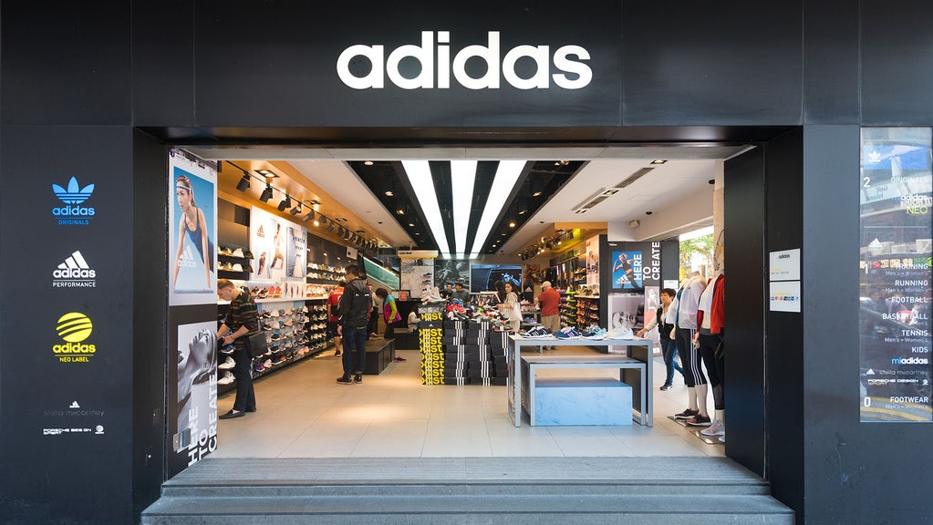 Adidas' whole supply chain is depicted in the diagram below. Adidas production and retail outlets' wholesaler of multibrand showrooms is as follows:

- Production Adidas Outlets Customers
- Multi-brand stores Producers Distributors
- Customers Producers Online pages and websites

For this reason, Adidas has a significant stake in the brand of the company it distributes. The more satisfied distributors are with the company, the more likely they are to promote it.

Blog Post 5: Adidas Promotion
Adidas does the vast bulk of their advertising via television and product placements. Adidas advertisements are notorious for evoking powerful emotions in viewers because to the company's in-house creative staff. A well-chosen marketing message makes these adverts stand out.

Adidas' slogan, "Impossible is nothing," conveys a powerful message to the public.

As a second form of advertising, Adidas uses product placement in television commercials. Lionel Messi, Ronaldinho, and Sachin Tendulkar are just a few of the world's top athletes to support the product.
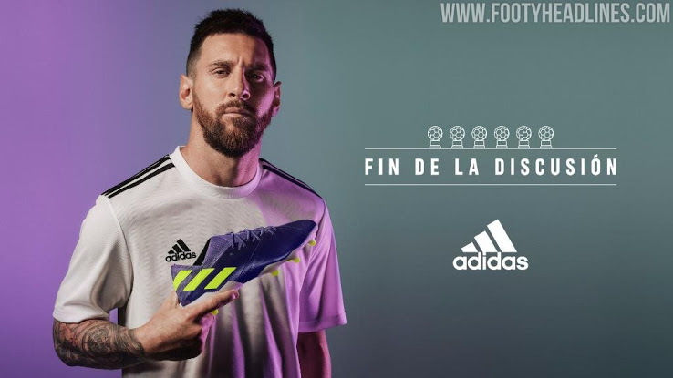

Real Madrid, France, Britain, and South Africa are just a few of Adidas's sports teams who have partnered with the sportswear company (Xin, 2019).

Creative marketing and event marketing are two of Adidas' most well-known strengths. Social media is another method by which this company reaches out to people around the world. In terms of social media, Adidas has tens of millions of followers on platforms such as Facebook and Instagram. They have a more fascinating and engaging social media presence because of the sports element in it.

A virtual investor and media day served as the stage on which Adidas presented its newest campaign, "Own the Game." The campaign has two objectives: to improve the company's environmental initiatives and to raise the company's brand's trustworthiness. This campaign's sales and profits are expected to rise through 2025.

References
Birch, R., (2019). Adidas: A Strategic Audit.

Crasto, S.G., Kee, D.M.H., Xin, C.W., Juin, H.X., Man, L.K. and Pandey, D., (2020). Product innovation by Adidas Group through sustainability. Journal of the Community Development in Asia (JCDA), 3(1), pp.1-7.

Farquhar, K., (2013). Gaining and Losing Respect of the New Zealand Public: Adidas' 2011 Rugby World Cup Jersey Pricing Crisis (Doctoral dissertation, University of Waikato).

Grainger, A.D., Newman, J.I. and Andrews, D.L., (2015). Global adidas: sport, celebrity and the marketing of difference. Global sport sponsorship, pp.89-105.

Holtbrügge, D. and Schuster, T., (2017). The Internationalization Strategy of Adidas. The Internationalization of Firms. Case Studies from the Nürnberg Metropolitan Region, p.19.

Iglesias, O., Ind, N. and Schultz, M., (2020). History matters: The role of history in corporate brand strategy. Business Horizons, 63(1), pp.51-60.

Ismail, S.A.S., Iberahim, N.I. and Ahmad Rosli, N., (2019). Motivation of Adidas: sports footwear, apparel and accessories.

Khan, S., (2020). Nike and Adidas: A Rivalry Made in Heaven?. SAGE Publications: SAGE Business Cases Originals.

Krüger, N., Stieglitz, S. and Potthoff, T., (2012), December. Brand Communication In Twitter-A Case Study On Adidas. In PACIS (p. 161).

Mahdi, H.A.A., Abbas, M., Mazar, T.I. and George, S., (2015). A Comparative Analysis of Strategies and Business Models of Nike, Inc. and Adidas Group with special reference to Competitive Advantage in the context of a Dynamic and Competitive Environment. International Journal of Business Management and Economic Research, 6(3), pp.167-177.

Moser, K., Muller, M. and Piller, F.T., (2016). Transforming mass customisation from a marketing instrument to a sustainable business model at Adidas. International Journal of Mass Customisation, 1(4), pp.463-479.

Turner, T., (2015). German sports shoes, basketball, and hip hop: the consumption and cultural significance of the adidas ‘Superstar’, 1966–1988. Sport in History, 35(1), pp.127-155.

Xin, Z., (2019). Impact of brand loyalty on sportswear customers--A case study of Adidas. International Core Journal of Engineering, 5(9), pp.265-278.

